Methods of Classifying Obesity from a Dataset of Physical and Behavioral Characteristics

Abstract
A popular dataset of lifestyle and physical factors related to obesity is examined. The dataset is described with frequency counts and other measures. Then three classification methods, eXtreme Gradient Boosting, Logistic Regression, and a neural network (MLP), are trained. Finally, the three methods are compared to determine their accuracy. The best model was eXtreme Gradient Boosting, with 96% precision, followed by the Neural Network (MLP) with 92% and Logistic Regression had 82%.

Introduction
Obesity in humans can lead to many health difficulties, including type 2 diabetes, heart disease, cancers, and arthritis (Mayo, 2025). It is becoming increasingly prevalent (World Health Organization [WHO], 2025) and is therefore a subject of much study and concern, particularly in determining correlations that can be ameliorated and further investigated.
A publicly available dataset that collected physical and lifestyle data was published in 2019 (Estimation, 2019; Palechor & Manotas, 2019). It contains data gathered from Peru, Colombia, and Mexico, and has been investigated by the original authors (De-La-Hoz-Correa et. al., 2019) and several others, such Gozukara Bag et al., 2023; Alqahtani et al., 2021; Yağın et al., 2023; Yang, 2024; and Cahya Putri Buani & Nuraeni, 2023. Since the dataset contains the height and weight of the survey participants, an obesity level can be simply calculated (see below) as a target variable. The authors of these studies used data science classification methods to predict the obesity level of the participants. Primarily these were to assess the suitability of models for predicting obesity based on similar data.
Table 1 contains the reported accuracies from the cited studies for the models tested. Notice that Neural Network (NN), LR, and XGBoost (XGB) are bolded, as those are the ones selected to be replicated in this paper. The decision to use NN and XGBoost is based on their consistently high accuracy, as reported in the literature. LR was chosen for its frequency of usage in the literature.

Table 1 Methods Key
Code | Classification Method
C45 | Decision Tree Classifier C4.5 (J48 in Java)
NB | Naïve Bayes
LR | Logistic Regression
RF | Random Forest
XGB | eXtreme Gradient Boosting (XGBoost)
NN | Neural network (MLP)
SVM | Support Vector Machine
kNN | k Nearest Neighbor (Fuzzy)
FURIA | Fuzzy Unordered Rule Induction Algorithm
RS | Rough Sets
RT | Random Tree
DT | Decision Table

Table 1 Accuracy by method for each study.
Method | C45 | NB | LR | RF | XGB | NN
De-La-Hoz-Correa et al., 2019 | 97.4% | 90.1% | 90.4%
Gozukara Bag et al., 2023 |  |  | 98.99% | 96.17% | 95.77%
Alqahtani et al., 2021 |  |  |  | 96.70% |  | 95.06%
Yağın et al., 2023 |  |  |  |  |  | 93.06%
Yang, 2024 |  |  | n/a
Cahya Putri Buani & Nuraeni, 2023 | 93.53% | 43.85% | 79.34% | 95.43% | 96.69%
Dirik, 2023 | 95.22% | 67.41% |  | 95.78% |  | 94.36%
Mean | 95.38% | 67.12% | 89.58% | 96.02% | 96.23% | 94.15%

Method | SVM | kNN | FURIA | RS | RT | DT
De-La-Hoz-Correa et al., 2019
Gozukara Bag et al., 2023
Alqahtani et al., 2021
Yağın et al., 2023
Yang, 2024
Cahya Putri Buani & Nuraeni, 2023 | 53.15% | 88.01%
Dirik, 2023 | 84.23% | 78.16% | 95.07% | 87.83% | 87.30% | 84.89%
Mean | 68.69% | 83.09% | 95.07% | 87.83% | 87.3% | 84.89%

Data
The dataset was collected for an original paper by De-La-Hoz-Correa et al. (2019). The dataset was also described by Palechor & Manotas (2019) when it was released to the public for open use in data science. There are some differences in the descriptions of the dataset in these sources, and difference between the sources and the actual data, and those that seem important are noted.
The dataset was originally gathered in a web page as part of an anonymous survey from undergraduates in Barranquilla, Colombia; Lima, Peru; and Mexico City, Mexico. The data were preprocessed in the following ways.
- The values were converted from the values in the dropdowns in the survey to the values in the downloaded dataset (see Table 2).
- The obesity level (the target) was calculated from the BMI and a set of boundaries. Details below.
- Additional records must have been added to the dataset before released for public use, as the age range is 14 to 61 in the data and the age range in De-La-Hoz-Correa et al. (2019) is stated to be 18 to 25 (p. 68). See Figure 1 for the distribution of ages in the first 498 records, which seem to be the actual data.
- This last step was to add synthetic data using SMOTE, described below. The intention was to roughly balance the classes. See Figures 2 and 3 for Obesity Level counts before and after the creation of the synthetic data.
Figure 1
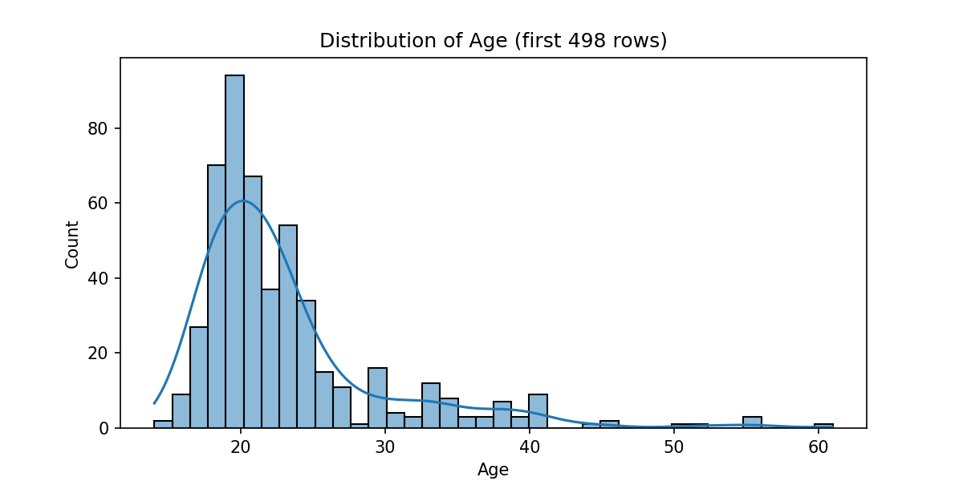
The overall count in the public dataset after preprocessing is 2111.

Division Between Actual and Synthetic Data
It seems that in the downloaded dataset the actual survey results were the first rows, with the synthetic data added below them. This could be determined by looking at the data. There are attributes--Age, Height, Weight, FVCV, NCP, CH2O, FAF, and TUE--that show a change of type from whole numbers to floating-point numbers at row 500, which indicates that is where the synthetic data begins. That would make the last actual record in row 499, and since there is a header row, the actual data is the first 498 records.
This count differs from the documentation in Palechor & Manotas (2019), which specified 485 records. This is only a small amount.

BMI Calculation
According to Palechor & Manotas (2019) the target field is determined by partitioning the Body Mass Index, or BMI, into named classes (p. 3).
The BMI calculation is
Mass Body Index = Weight / (Height * Height)
resulting in an output of meters/kilograms squared.
Secretaría de Salud (2010) is the Mexican standard for obesity, and cited by De-La-Hoz-Correa et al. (2019) and Palechor & Manotas (2019). In this document obesity is defined as a BMI greater than or equal to 30, and greater than or equal to 25 for people of short stature. Overweight is defined as a BMI between 25 and 29.9, and 23 to 25 for people of short stature. Short stature is defined as less than 1.5 meters for females and 1.6 meters for males. Notice that this means that the classes are dependent on the height of the person.
De-La-Hoz-Correa et al. (2019) and Palechor & Manotas (2019) also state that the classes and their ranges were based on the World Health Organization. The WHO standard (WHO, 2025), though, did not use the short stature condition, and as the ranges in Table 2 show, neither did De-La-Hoz-Correa et al. (2019). That can be determined by examining the recalculated ranges of BMI of the first 498 records.
Table 2
Class in studies | Range in studies | Class in data | Range in data | Range in first 498
Underweight | < 18.5 | Insufficient_Weight | <19.08 | <18.42
Normal | 18.5 to 24.9 | Normal_Weight | 18.49 to 24.91 | 18.49 to 24.9
Overweight | 25.0 to 29.9 | Overweight_Level_I | 22.8 to 28.77 | 25.08 to 26.90
 |  | Overweight_Level_II | 25.71 to 30.36 | 26.98 to 29.9
Obesity I | 30.0 to 34.9 | Obesity_Type_I | 29.91 to 35.17 | 30.11 to 34.89
Obesity II | 35.0 to 39.99 | Obesity_Type_II | 34.05 to 39.79 | 35.00 to 39.25
Obesity III | >40  Note: not >= 40 | Obesity_Type_III | >36.77 | >40.64

The ranges in the first 498 match to that in the documentation, although Overweight was divided into two levels in the data. Since Palechor & Manotas (2019) indicate that the calculation of the obesity level occurred before the generation of the synthetic data, that is a further indication that the first 498 records is the actual data collected in the survey.

Generation of Synthetic Data
SMOTE (Chawla & Bowyer, 2002) is the tool used to generate synthetic data to balance the classes. The justification is that imbalanced datasets tend to result in the diminution of the strength of non-majority samples when certain algorithms are used. Since those samples are often the interesting ones for study, it is better to err on the side of over-classifying based on the minority sample.
SMOTE generates synthetic data by joining the nearest neighbors in the feature space of each instance of the underrepresented class with line segments and then randomly selecting points on that line segment. The process is to first find K nearest neighbors, and, depending on the amount of oversampling required, a number of these neighbors is selected randomly, line segments are drawn between the sample and each neighbor, and then a point is randomly chosen on that line segment.
In our dataset, the imbalance is caused by the over-representation of persons of normal weight. We are most interested in the persons who are obese. The non-normal classes, therefore, are oversampled.
Figures 2 shows the obesity class counts of the first 498 rows, and Figure 3 shows the entire dataset, which includes the synthetic data.
Figure 2: Obesity class counts in the actual data
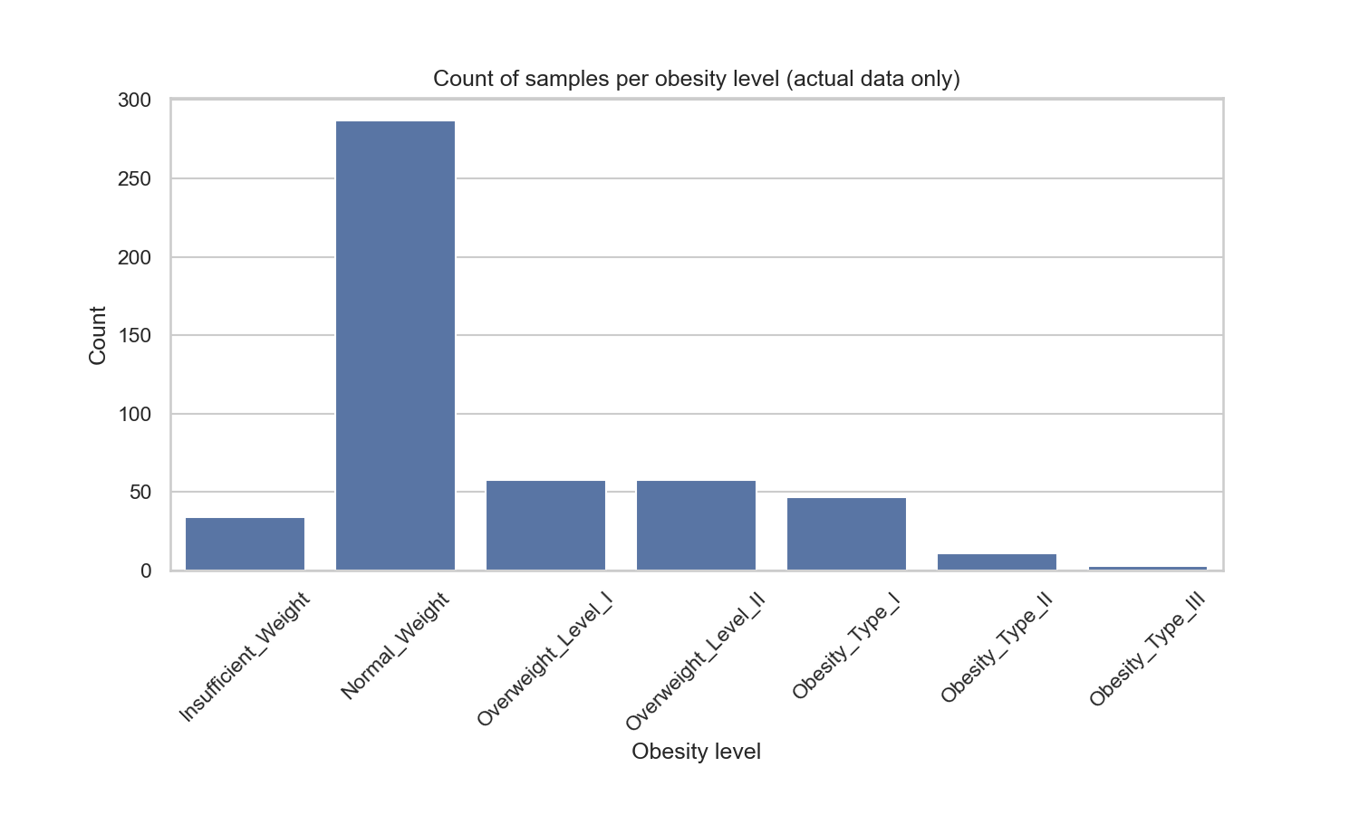
Figure 3: Obesity class counts in the entire dataset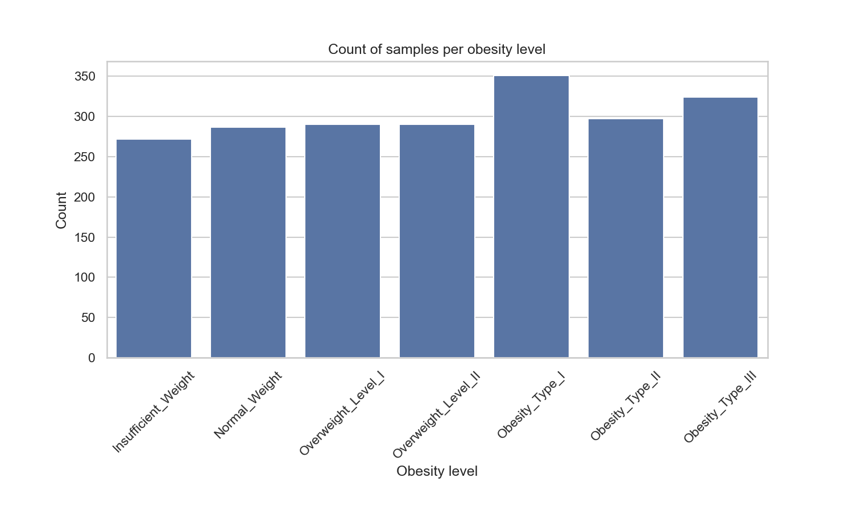

Attributes
Table 3 lists the fields from the dataset. The question from the survey is noted for some fields to clarify the meaning of the label.
Table 3
Variable Name | Type | Notes
Gender | Categorical | Female | Male
Age | Continuous | Range 14-61
Height | Continuous | Meters, Range 1.45-1.98
Weight | Continuous | Kilograms, Range 39-173
family_history_with_overweight | Binary | “yes” | “no”
FAVC | Binary | Do you eat high caloric food frequently?  “yes” | “no”
FCVC | Integer | Do you usually eat vegetables in your meals?  1-3, for never, sometimes, always.
NCP | Continuous | How many main meals do you have daily? The options for the question were “between 1 and 2”, “three”, and “more than 3”. This looks to have been changed to 1, 3, and 4. So no 2 except in the synthetic data.
CAEC | Categorical | Do you eat any food between meals?  “no” | “Sometimes” | “Frequently” | “Always”
SMOKE | Binary | Do you smoke?  “yes” | “no”
CH2O | Continuous | How much water do you drink daily?  <1 liter | 1-2 liters | >2 liters. This became 1-3 in the data.
SCC | Binary | Do you monitor the calories you eat daily?  “no” | “yes”
FAF | Continuous | How often do you have physical activity?  “I do not have” | “1 or 2 days” | “2 or 4 days” | “4 or 5 days”. This became 0, 1, 2, or 3.
TUE | Integer | How much time do you use technological devices such as cell phone, videogames, television, computer and others? In hours (presumably per day)  0-2 | 3-5 | > 5. This became integers from 0 to 2 in the dataset.
CALC | Categorical | How often do you drink alcohol?  “I do not drink” | “Sometimes” | “Frequently” | “Always”.  These have the same values in the data except the first became “no”.
MTRANS | Categorical | Which transportation do you usually use?  “Automobile” | “Motorbike” | “Bike” | “Public_Transportation” | “Walking.”

The target (Table 4) is a single field, which is the result of classifying obesity by means of BMI ranges. (Palechor & Manotas, 2019).

Table 4
Variable Name | Type | Description
NObeyesdad | Categorical | Obesity level

There are no missing values in the dataset.

Attribute Correlations
Figure 4 is the correlation matrix for the numerical attributes using Pearson correlations. There is an unsurprising moderate correlation (0.46) between weight and height. The is also a weak negative correlation (-0.30) between age and technology use, also unsurprising.
Based on these correlations, there seems no a priori reason to remove these fields for analysis, as removing any of them would reduce information content.
Figure 4
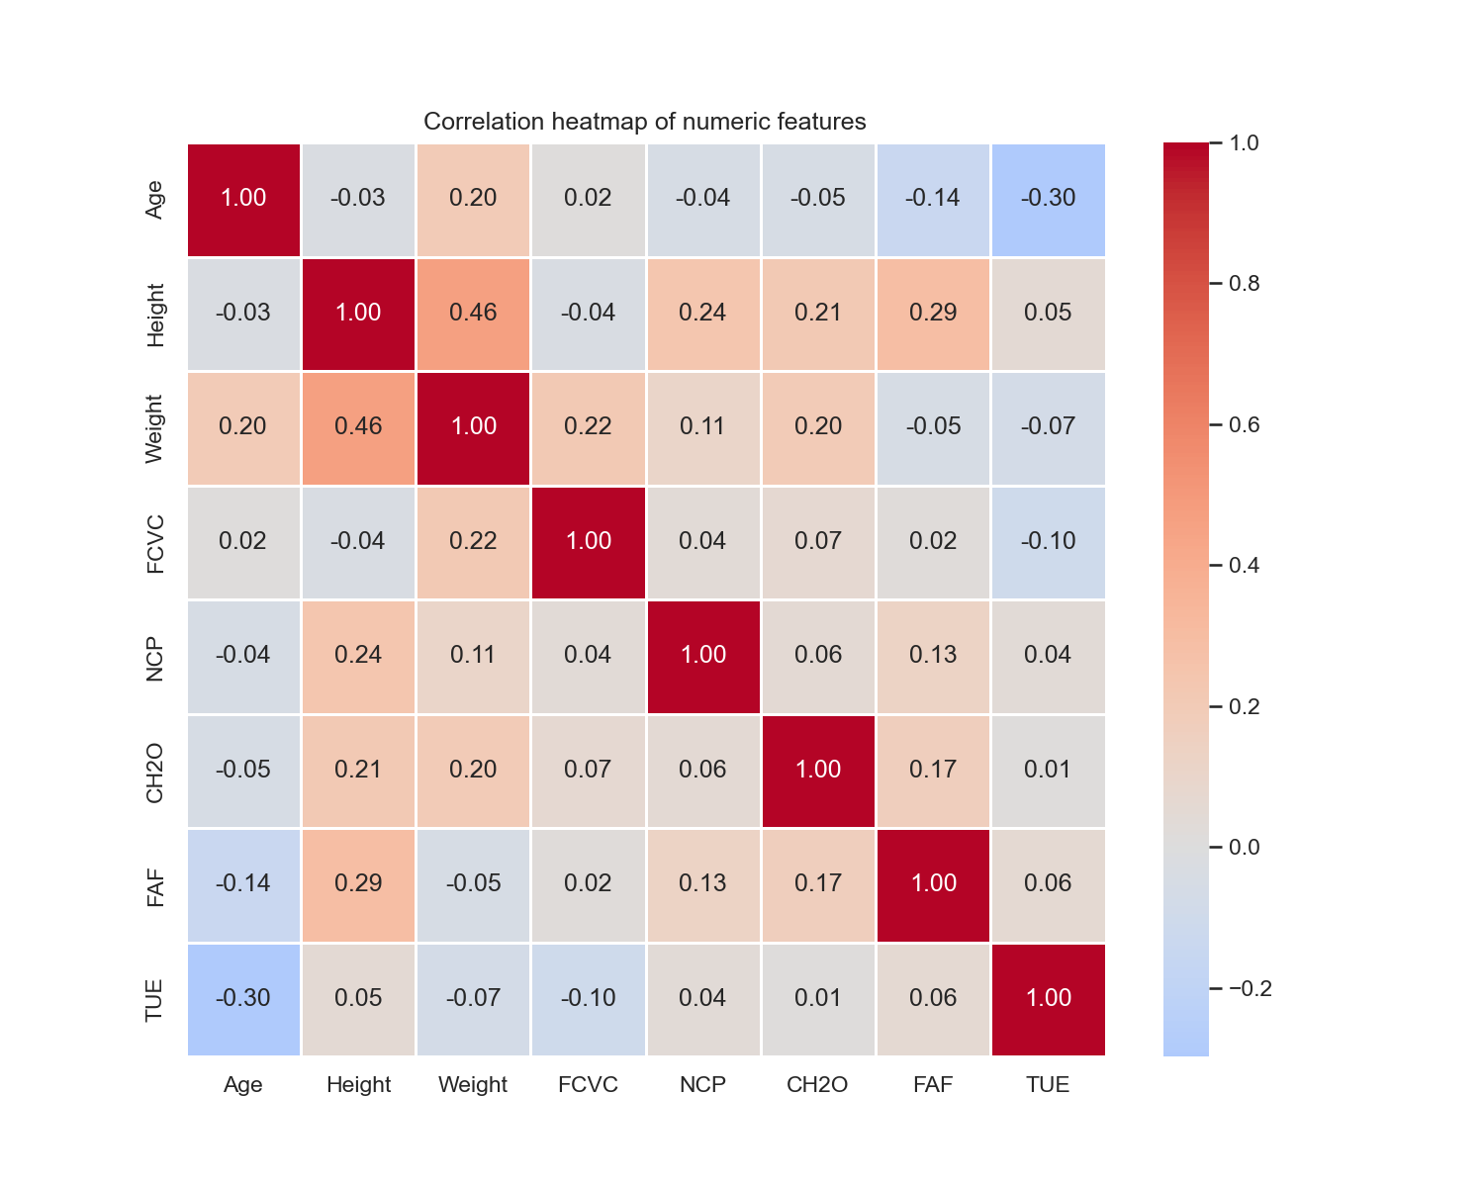

Figure 5 shows the categorical predictors. The follow observations can be made.
- There is a slight correlation between gender and obesity, where males show a higher frequency the higher the BMI. Females have a fairly flat distribution, except for the highest obesity level, and that means that there are relatively more females in the insufficient weight and normal categories.
- Two of the obesity levels are exclusively gendered. Obesity_Type_II is male excepting one female, while Obesity_Type_III is entirely female. There is no stated explanation for this. One possible explanation is that, with the tiny numbers in the actual data, perhaps it is an artifact of the collection that got reinforced in the synthetic data.
- Family History with Overweight and High Caloric Food positively correlated with obesity level, as did Sometimes Eating Between Meals. However, Frequently Eating between Meals is strongly correlated with normal and insufficient weight.
Figure 5
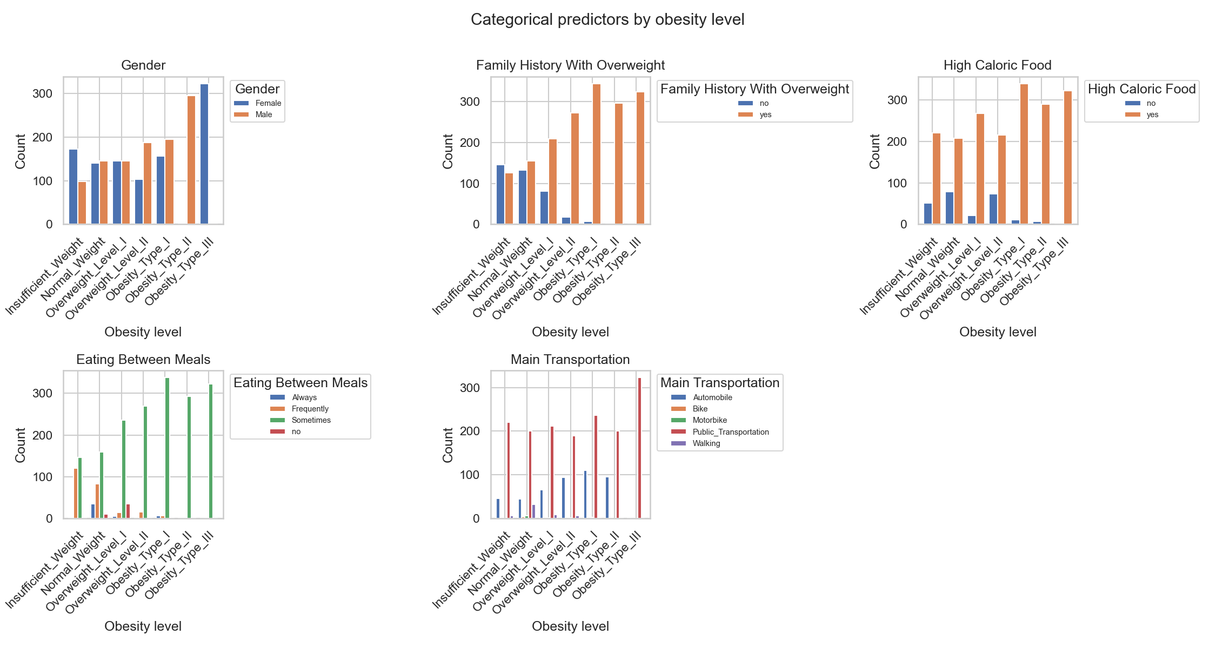

Methods
We chose to explore classification with XGBoost, a neural network (MLP) of three layers, and a logistic regression model. Many hyperparameters were determined by using GridSearchCV, a tool in scikit to determine optimal hyperparameters, with a set of parameter options determined during experimentation with each model.

eXtreme Gradient Boosting
eXtreme Gradient Boosting, or XGBoost, is a complex algorithm for generating and optimizing decision trees. (Chen & Guestrin, 2016). It is effective for sparse data (like high-dimension data), is relatively fast, and can be subdivided into tasks that can run in parallel (p. 1).
XGBoost is a type of Gradient Boosting Algorithm. Gradient Boosting is where weak learning functions are successively generated until they no longer help with the overall prediction. In XGBoost these functions are decision trees. The prediction of each target class based on the instance data is the sum the values of the leaves for that instance from all the trees.
Trees are trained one at a time. The first model is a simple tree that outputs a single value for all the instances (typically this is the mean of the values in the training data). Then we determine the errors between the output of the tree and the actual target value—in other words, an error value is generated for each instance of the data. These errors, called residuals, constitute a new data set, and a new tree of those data points is generated, again using the training data. And so on, until there is no improvement or a hard limit is reached on the number of trees (set by a hyperparameter).
To decide on how many leaves and levels of a tree, and to determine where the splits should be, a similarity score is computed, first for the whole tree and then for each one of the sides of each potential split. The similarity score is the square of the sum of all the residual values divided by the number of values, and there is also a factor added to the denominator to ensure the improvement is large enough to justify the split, i.e. to help with overfitting.
A gain is calculated for each potential split by adding the similarity scores on each side of the split together and then subtracting the similarity score for the whole tree. The split with the most gain is added to the tree as a branch, segregating the data based on the value that divides the scores, or if there is no gain (higher than a threshold) to be found in the tree, the splitting stops and the tree is complete. Also, a limit set by a hyperparameter can be used to prevent further increasing the depth of the tree, and may also result in considering the tree complete.
To determine where the splits should be attempted, all possible divisions could be tried. But this is quite expensive. Instead XGBoost uses a weighted quartile sketch algorithm, which is too complex to describe here. See the Appendix of Chen & Guestrin (2016).
The value of each leaf is the mean of the residual values in that leaf but reduced by a limiting factor to allow further trees to improve the classification iteratively.
Experimenting with the hyper parameters and using a grid search produces these optimal settings, based on the accuracy.

Table 5
Parameter | Usage
n_estimators = 300 | Number of boosting rounds, i.e. trees. This is plenty, and it stops early.
learning_rate = 0.1 | Adjustment that reduces the value of each leaf of each tree. This value seems to converge quickly and adjusting this does not increase precision.
max_depth = 5 | Max depth of trees. Reducing this below 4 starts to harm precision. Increasing has no effect.
subsample = 0.8 | A subsample of data used for each step, with lower values helping with overfitting. Lower than 0.8 decreases precision. Higher has no effect.
colsample_bytree = 0.8 | Decrease # of features for trees to avoid overly complex trees. By experiment 0.8 is best.
gamma = 0.0 | Specifies the minimum gain in order to split.
min_child_weight = 1 | Minimum size of a leaf.
tree_method = "hist" | Other methods (auto, exact, approx) had lower precision, and hist is still quite fast.

Neural Network
A neural network (or Multilayer Perceptron, MLP) was trained to predict obesity based on the obesity dataset. A neural network model is constructed of a hidden set of weighted layers between the input variables and the output prediction. Figure 6 shows a schematic of the model.
Data instances are run through the model, and the resulting prediction is compared to the actual class the person belongs to. The model is trained by backpropagation, meaning setting the relative weights of the hidden internal layers based on the predicted vs. actual target variable.
Table 6
Parameter | Usage
hidden_layer_sizes = [512, 128] | Number and size of the hidden layers. Increasing the layers or increasing the size of the layers hurt accuracy, as did reducing them.
activation = "tanh" | The other activation function (“relu”) performed worse.
solver = “adam” | The default learning strategy. Other values are “lbfgs” and “sgd”.
alpha = .00005 | Lower values increase tree complexity, higher prevents overfitting. This is a balance determined experimentally.
learning_rate_init = 0.001 | Used with “sgd” and “adam” solvers.
batch_size = 64 | Number of samples processed before updating weights. Lower values produce higher variation, allowing the optimization to jump out of local minima. Higher values converge faster.
Max_iter = 1000 | Number of attempts before failing.

Through experiment and an exhaustive grid search of hyperparameters, it seems that wide and shallow hidden layers and using the correct activation function (“tanh”), was the most important adjustments in achieving the best prediction.

Figure 6
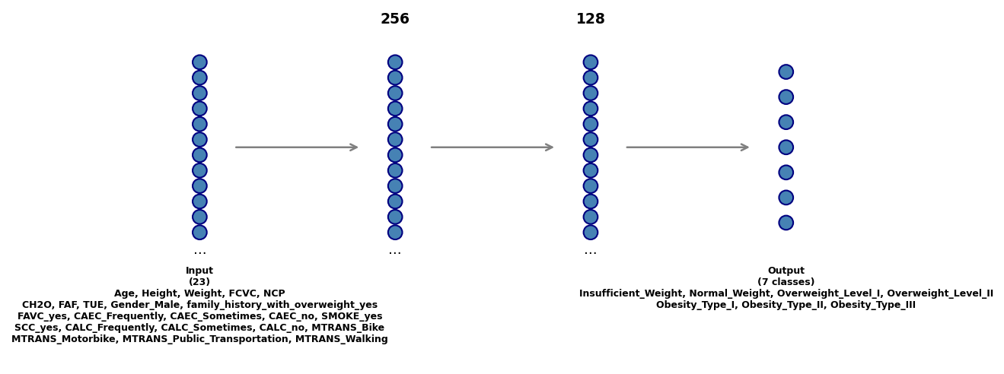

Logistic Regression
Logistic Regression (LR) is a simple but powerful method of classification. It has the advantages of being more stable in high-dimensional space since it does not calculate distances. However, it is a linear model, a special case of a Generalized Linear Model (GLM), and as a result it often stumbles with oddly shaped distributions.
Table 7
Parameter | Usage
solver = “newton-cholesky” | The other solvers appropriate for multiclass datasets (i.e. "newton-cg", "saga") had worse accuracy.
max_iter = 1000 | This was sufficient for the values to converge.
C = 10 | Larger or smaller values negatively affected the accuracy.
class_weight = “balanced” | None was also tried, but it produced worse accuracy.
l1_ratio = 0 | Elastic-net mixing parameter.
tol = .01 | Tolerance for the stopping criteria.
fit_intercept = False | If True a constant should be added to the decision function.

Results
The results of the three models were as listed in Table 8, with the best and mean values from the literature.
Table 8
Model | Accuracy | Table 1 Mean | Table 1 Best
eXtreme Gradient Boosting | 98.11% | 96.23% | 96.69% (Cahya Putri Buani & Nuraeni, 2023)
Neural Network (MLP) | 92.20% | 94.16% | 95.06% (Alqahtani et al., 2021)
Logistic Regression | 87.47% | 89.58% | 98.99% (Gozukara Bag et al., 2023)

Relative Importance
In a neural network the relative contribution of each variable to generating the prediction is not determinable, but for XGBoost and LR, it can be determined as a side effect of training.
For XGBoost, the relative contributions to the prediction are listed in Figure 7. Gender Male was the most important, followed by Not Eating Between Meals. Weight was also important, which is not surprising. Eating Vegetables is the second behavioral characteristic that was most relevant.
Figure 7
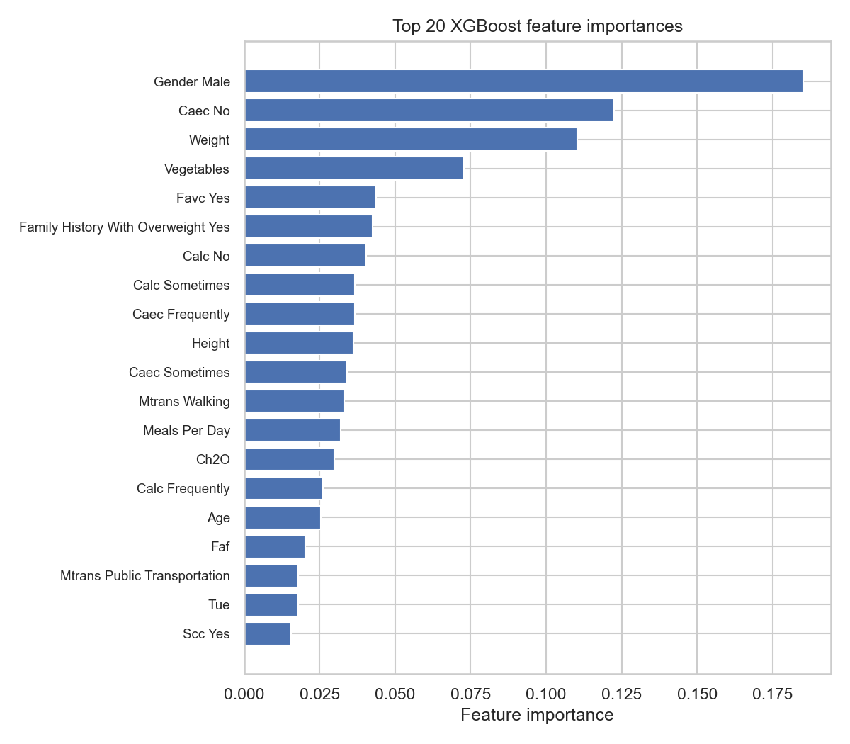
For Logistic Regression, Gender Male was significant, as in XGBoost, but weight is not that important, and Height was significantly more important than in XGBoost. See Figure 8. For behavioral characteristics, Alcohol use--No, Sometimes, and Frequently (but not the Always option)—were the most significant, followed by eating high-caloric foods.

Figure 8
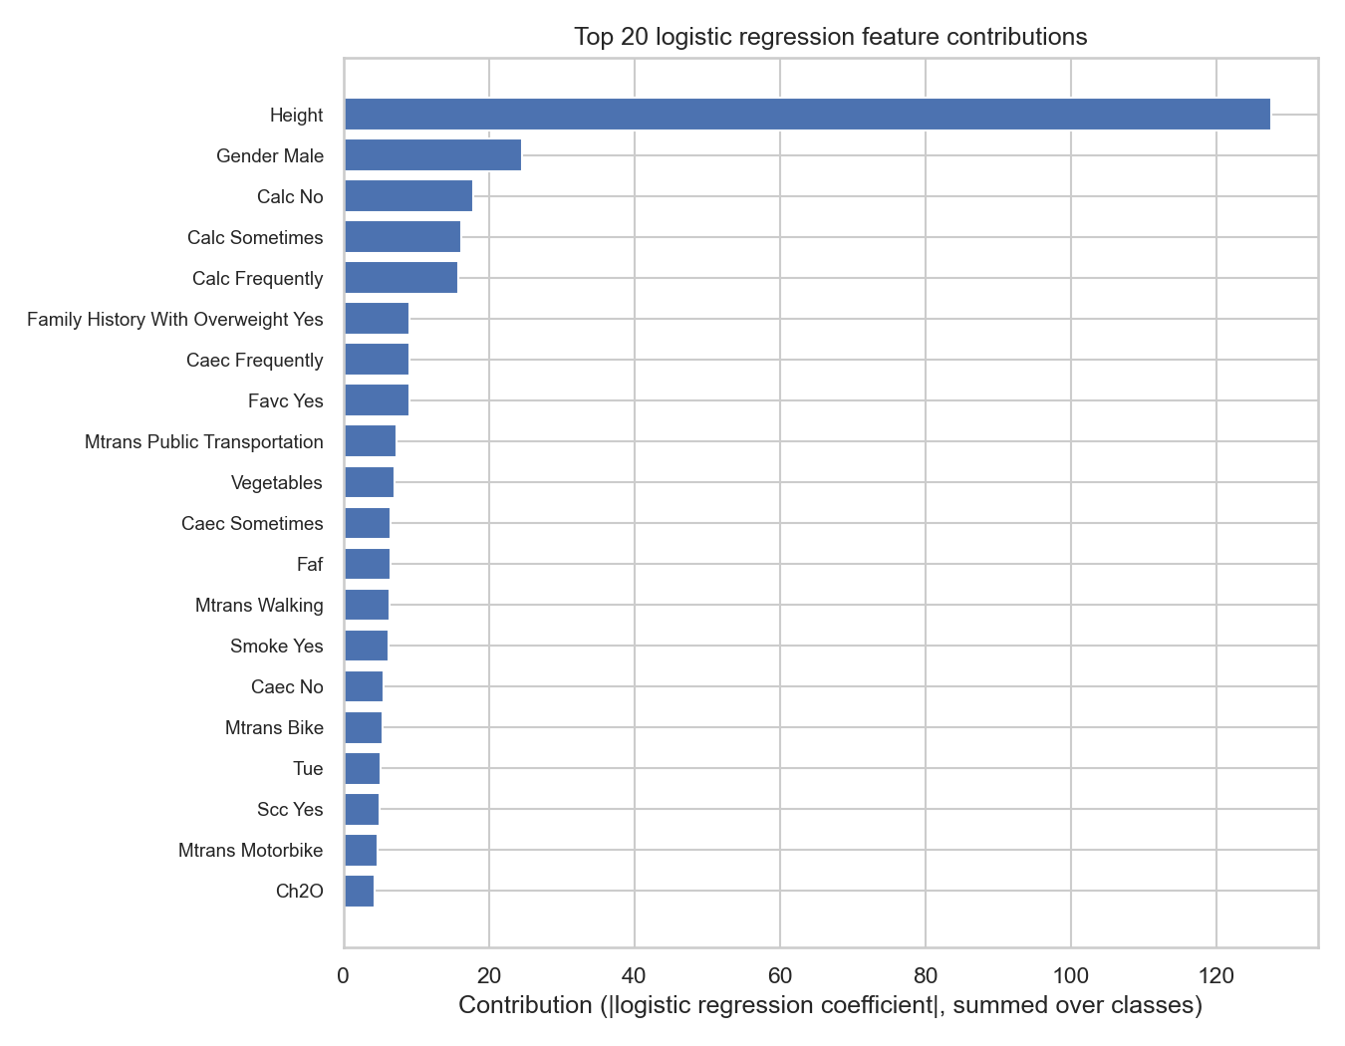

Comparison to Best Methods
There were differences between the approaches in this paper compared to the best approaches in the literature.
Gozukara Bag et al. (2023) had the highest accuracy for Logistic Regression. Instead of a grid search they used Baysian optimization techniques for the hyperparameters and ended up with different hyperparameter values. For LR, their C value was 2^11 whereas this paper used 0.1, which by experiment was optimal. Also, the max iterations they chose was only 280, meaning their training converged sooner.
They further attempted to remove features using Recursive Feature Elimination (RFE). It helped slightly. For the best result, only Gender, Height, Weight, Family History of Overweight, Frequency of Eating Vegetables (FCVC), and Frequency of Physical Activity (FAF) was used (p.10).
The highest reported accuracy for XGBoost was by Cahya Putri Buani & Nuraeni (2023). They did not describe their method in any detail, and neither did the list the values of the hyperparameters. The XGBoost result for accuracy in this paper, however, was slightly better than Cahya Putri Buani & Nuraeni (2023). See the hyperparameters for XGBoost to replicate.
The best Neural Network (MLP) implementation was reported by Alqahtani et al. (2021). Their approach used the Weka meta-learner search methodology (p.107), but other than the learning rate of 0.3, no other hyperparameters were reported. They did determine, however, that there was a disadvantage to removing features, as the accuracy was significantly lower when features were removed (p. 108-9).

Conclusion
The publicly available obesity dataset has been used for much model training, and the results are varied. More details on the methods would be helpful for uncovering the ideal approaches, in particular the full list of hyperparameters and perhaps even code samples.
Conclusions about correlations with obesity for particular behaviors and characteristics can be determined best, perhaps, by examining the section in this paper on the relative importance of the features in Logistic Regression and XGBoost.
Since obesity is so prevalent, damaging, and increasing in frequency, lifestyle changes for persons with the correlated features may be a medical necessity. Efforts to generate models to predict obesity can serve as a guide to doctors and health professionals when advising patients on lifestyle changes.

References
Alqahtani, A., Albuainin, F., Alrayes, R., Al muhanna, N., Alyahyan, E., & Aldahasi, E. (2021). Obesity level prediction based on data mining techniques. IJCSNS International Journal of Computer Science and Network Security, 21(3), 103–111. https://doi.org/10.22937/IJCSNS.2021.21.3.14
Cahya Putri Buani, D., & Nuraeni, N. (2023). Application of XGB Classifier for Obesity Rate Prediction. Jurnal Riset Informatika.
Chawla, N. V., Bowyer, K. W., Hall, L. O., & Kegelmeyer, W. P. (2002). SMOTE: Synthetic minority over-sampling technique. Journal of Artificial Intelligence Research, 16, 321–357. https://doi.org/10.1613/jair.953
Chen, T., & Guestrin, C. (2016). XGBoost: A Scalable Tree Boosting System. Proceedings of the 22nd ACM SIGKDD International Conference on Knowledge Discovery and Data Mining.
De-La-Hoz-Correa, E., Mendoza-Palechor, F.E., De-la-Hoz-Manotas, A., Morales-Ortega, R.C., & Adriana, S.H. (2019). Obesity Level Estimation Software based on Decision Trees. Journal of Computer Science.
Dirik, M. (2023). Application of machine learning techniques for obesity prediction: a comparative study. Journal of Complexity in Health Sciences, 6(2), 16–34. https://doi.org/10.21595/chs.2023.23193
Secretaría de Salud. (2010). NORMA Oficial Mexicana NOM-008-SSA3-2010, Para el tratamiento integral del sobrepeso y la obesidad. Diario Oficial de la Federación. https://www.dof.gob.mx/normasOficiales/4127/Salud/Salud.htm
Estimation of Obesity Levels Based On Eating Habits and Physical Condition [Dataset]. (2019). UCI Machine Learning Repository. https://doi.org/10.24432/C5H31Z.
Gozukara Bag, H.G., Yağın, F.H., Gormez, Y., González, P.P., Çolak, C., Gülü, M., Badicu, G., & Ardigò, L.P. (2023). Estimation of Obesity Levels through the Proposed Predictive Approach Based on Physical Activity and Nutritional Habits. Diagnostics, 13.
Mayo Clinic Staff. (2025, December 2). Obesity. https://www.mayoclinic.org/diseases-conditions/obesity/symptoms-causes/syc-20375742
Palechor, F.M., & Manotas, A.D. (2019). Dataset for estimation of obesity levels based on eating habits and physical condition in individuals from Colombia, Peru and Mexico. Data in Brief, 25.
Scikit-learn developers. (2025a). train_test_split. Scikit-learn 1.8.0 documentation. https://scikit-learn.org/stable/modules/generated/sklearn.model_selection.train_test_split.html
Secretaría de Salud. (2010, August 4). NORMA Oficial Mexicana NOM-008-SSA3-2010, Para el tratamiento integral del sobrepeso y la obesidad. Diario Oficial de la Federación. https://www.dof.gob.mx/normasOficiales/4127/Salud/Salud.htm
World Health Organization. (2025). Obesity and overweight. https://www.who.int/news-room/fact-sheets/detail/obesity-and-overweight
Yağın, F.H., Gülü, M., Gormez, Y., Castañeda-Babarro, A., Colak, C., Greco, G., Fischetti, F., & Cataldi, S. (2023). Estimation of Obesity Levels with a Trained Neural Network Approach optimized by the Bayesian Technique. Applied Sciences.
Yang, C. (2024). Factors Influencing Obesity Levels in Mexico, Peru, and Colombia. Highlights in Science, Engineering and Technology.

