1.1

accuracy 0.94

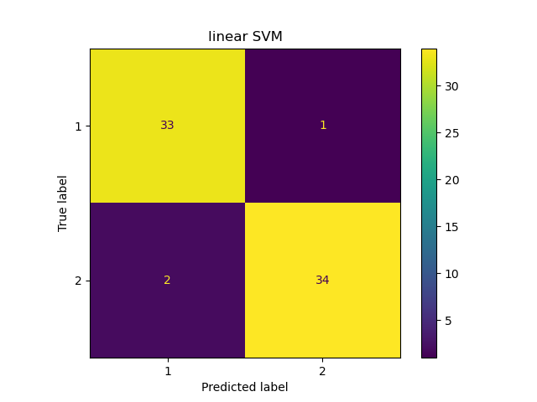

1.2

accuracy 0.91

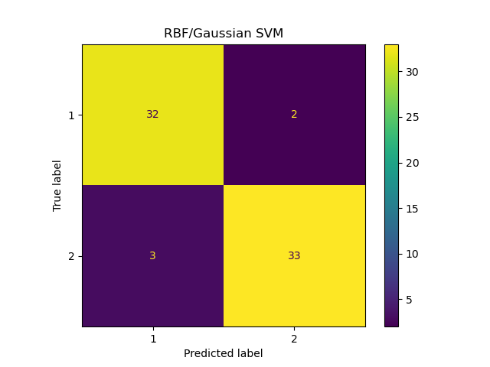

1.3

accuracy 0.91

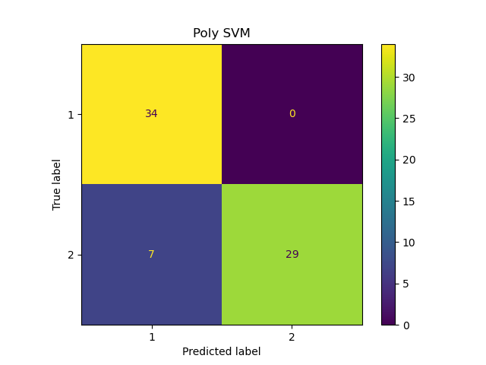

2

logistic regression

accuracy 0.91

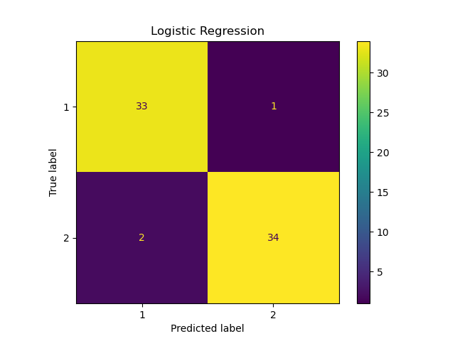

|  |  |  |  |  |  |  |  |
| --- | --- | --- | --- | --- | --- | --- | --- |
| Model | TP | FP | TN | FN | Accuracy | TPR | TNR |
| Linear SVM | 33 | 2 | 34 | 1 | 0.95714 | 0.97059 | 0.94444 |
| Gaussian SVM | 32 | 3 | 33 | 2 | 0.92857 | 0.94118 | 0.91667 |
| Poly SVM | 34 | 7 | 2 | 0 | 0.83721 | 1.00000 | 0.22222 |
| Logistic Regres | 33 | 2 | 34 | 1 | 0.95714 | 0.97059 | 0.94444 |

Linear SVM has the highest accuracy amount all SVM models, which likely means that the correlations between each class are linear correlation. As results, Logistic Regression performed the same as Linear SVM and I believe it is largely due to Logistic regression is considered a generalized linear model and matches how Linear SVM uses linear algorithms to classified classes.

3.1

By using the knee method, when k=3 is the last k value that has significant drops

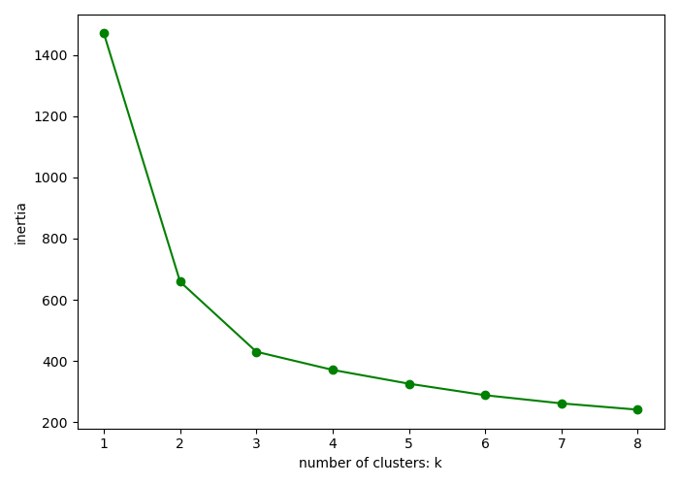

3.2

#Centroids are in the middle of each colored cluster, and colored classes have a visual distinctive separation from each other

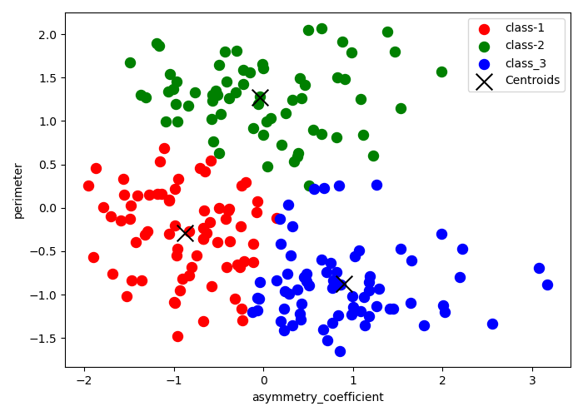

3.3

Centroid [-0.87131449 -0.28962854] assigned label is 1

Centroid [-0.0342861 1.27072831] assigned label is 2

Centroid [ 0.90274342 -0.87520574] assigned label is 3

3.4

Overall Accuracy for KMeans: 0.8761904761904762

3.5

[[58 1]

[ 4 65]]

accuracy 0.96

the accuracy is higher than all three SVM predictions as well as the logistic regression. I would say KMeans has a better outcome than the SVM.