Assignment 5: 2D Game Engine Mod Planning

I haven’t used Unity much so I’m a little nervous for this assignment (as of writing this) but the plinko game seems simple enough and I already have a couple ideas for it.
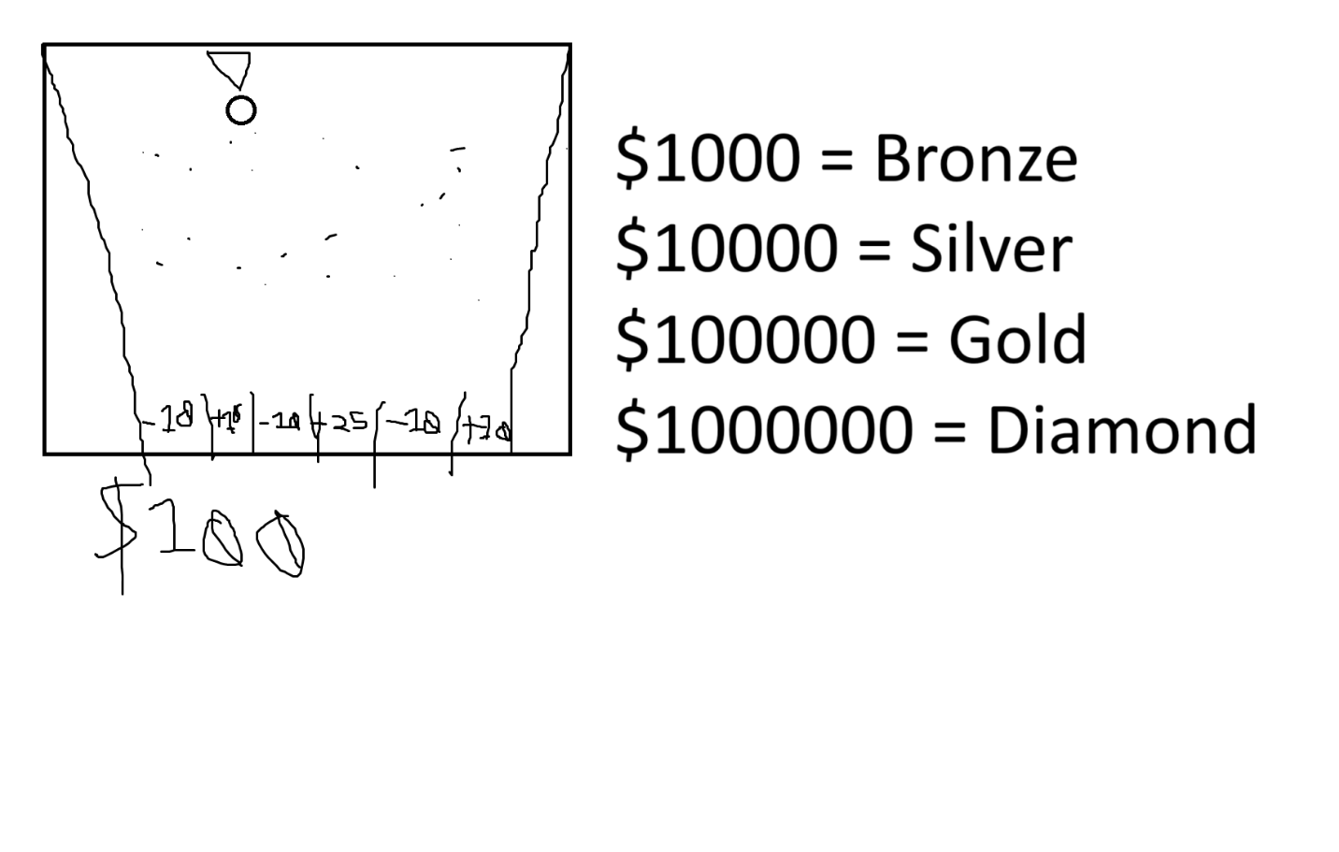
You can only drop 5 tokens before you have to restart again.
The money system, you start with $100, and replaying the game costs $25, although the first try is free (so you would have $100 to start and after your first game, the you keep the $100 until you try again) Depending on where your disk lands, you can win or lose more money, the goal is to get the top prize which I’ll say for now would be $1000000. You can “redeem” your prize anytime you finish a game, but the starting prize is $1000 so you can’t just instantly win the game. (I scrapped this for time’s sake, but this is still included on the process work here just to show that I was planning on implementing this)
Depending on your prize, you can win a medal. Winning no medal loses the game but the lowest prize gets you a bronze medal. Your goal is the top prize: a Diamond Medal, this adds to the replay value of the game. The medal system would be like bronze, silver, gold, and diamond.

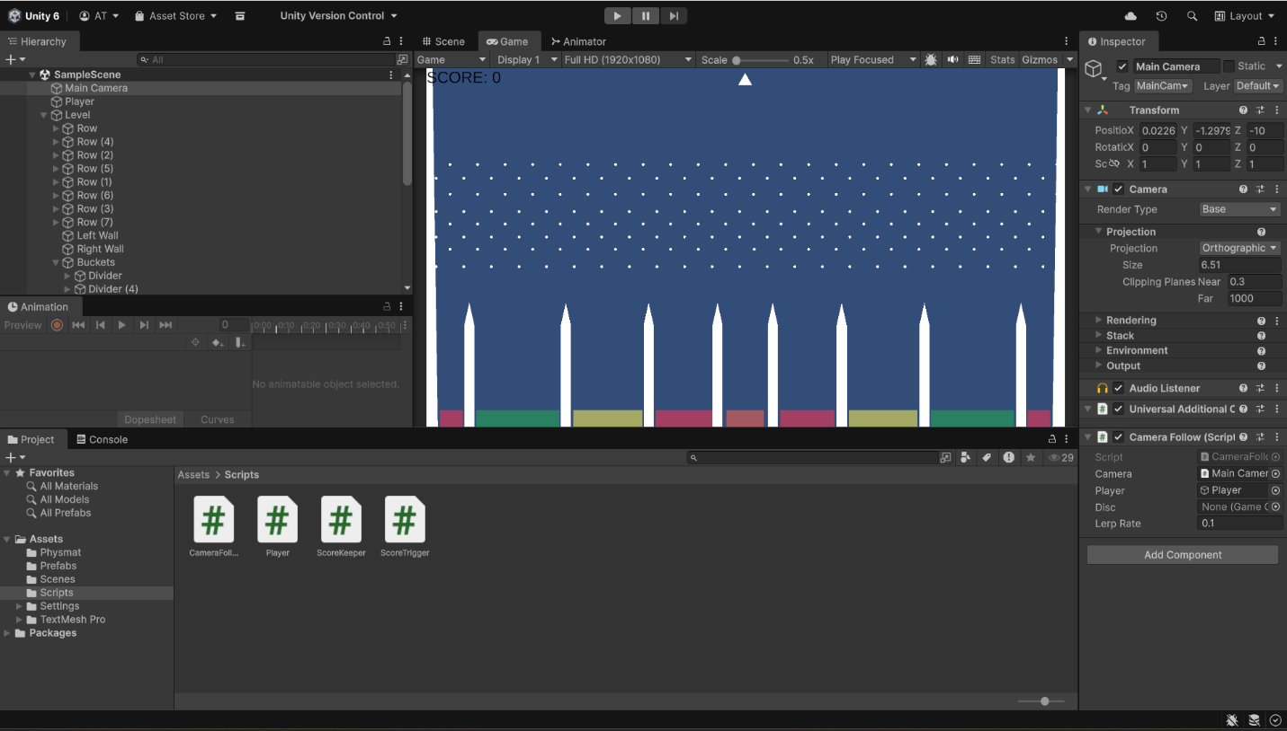
So now I’ve followed the instructions, and I have a basic plinko game in Unity now. So now, it’s time to implement my mods.
First I have the “Discs Left” feature implemented, which means the game checks to see how many discs are left and if you run out, the game ends and you have to restart.
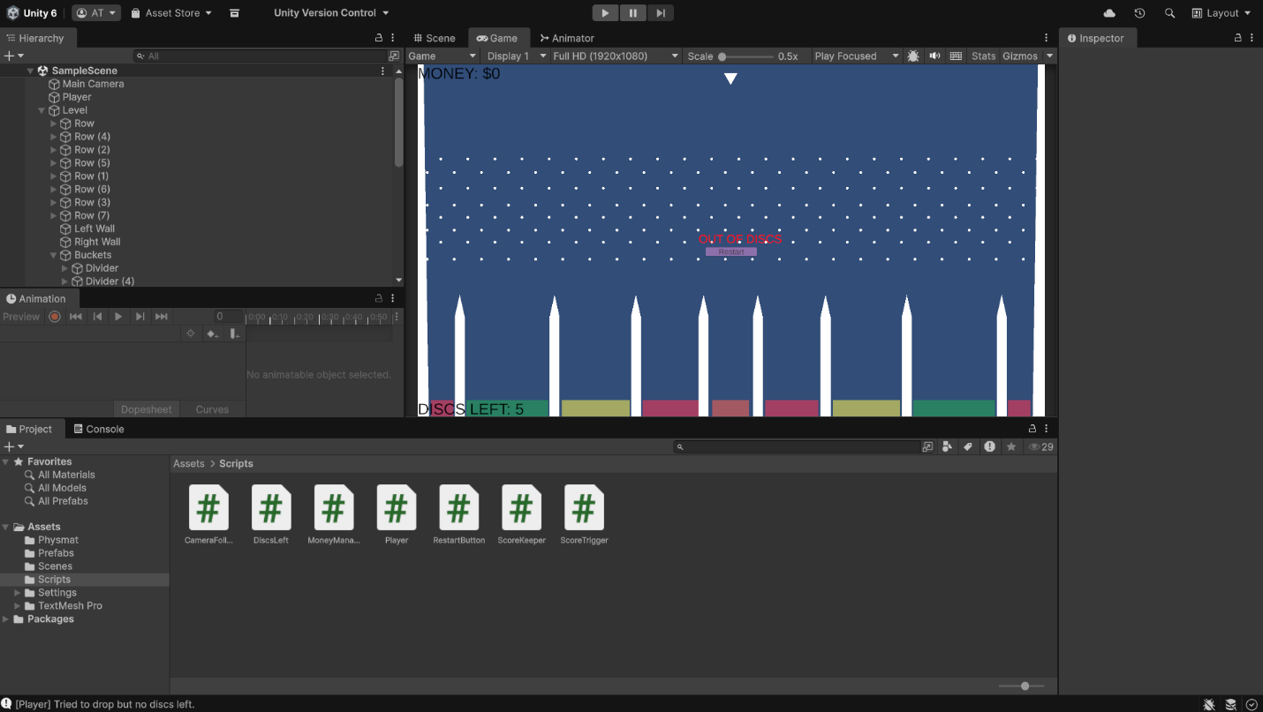
Unfortunately for the sake of time, I’m scrapping the money system due to increasing errors and frustration since the score no matter what keeps resetting to 0 when the game restarts. So, I’m going to keep the medal system but just make it much simpler. If I had more time to work on this, I would be able to create the money system but because I’m running out of time, I have to just skip it for now.
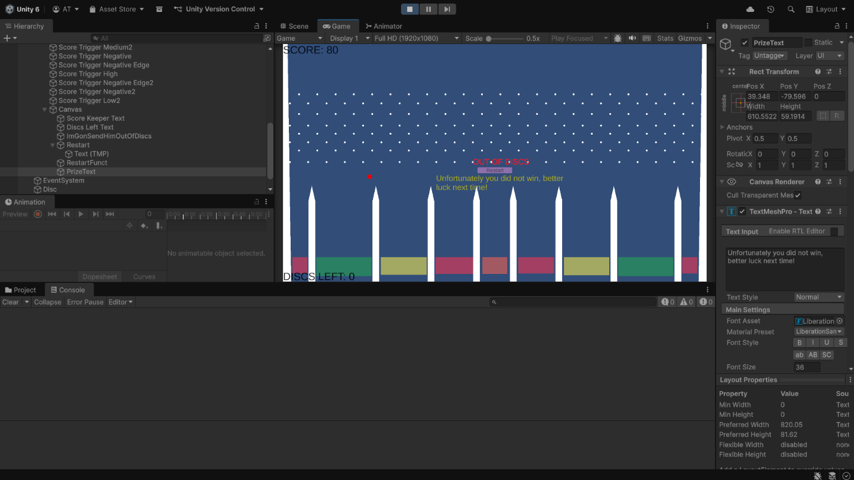
Now I have the prize system implemented, and I would say at this point I’m done. Not the full extent of what I wanted to do but I would say it’s good enough for what little time I have left.

