Voice controlled robot

Done by Aidana, Nurbaqyt, Anuar and Rustem
School of IT and Engineering, Kazakh-British Technical University, Almaty, Kazakhstan
a_tanysbekov@kbtu.kz; ²r_yev@kbtu.kz; ³t_am@kbtu.kz

Abstract— This report presents the advancement of an independent portable robot that coordinating voice control as its essential route and command interface. The framework utilizes a microcontroller as the central preparing unit, combined with a Bluetooth module for remote communication. Voice commands issued by the client are captured and prepared through a committed smartphone application, which interprets them into comparing flag enlightening. These informational are transmitted by means of Bluetooth to the onboard microcontroller, which at that point drives the robots actuators to execute craved developments (e.g., forward, in reverse, cleared out, right, halt). The venture effectively illustrates a low-cost, hands-free control instrument, highlighting the achievability of joining voice acknowledgment with implanted frameworks for instinctive human-robot interaction. Test comes about affirm solid command execution inside a commonplace indoor Bluetooth run.

- Introduction
In recent years, the field of independent versatile mechanical technology has extended altogether, driven by headways in inserted frameworks, remote communication, and human-machine interaction. Whereas completely independent robots work autonomously utilizing sensors and pre-programmed calculations, there's a developing request for natural, user-friendly control strategies that permit people to connected with robots actually and productively. Voice control has risen as a especially promising interface since it decreases the require for manual input gadgets such as joysticks, consoles, or touchscreens, in this manner empowering hands-free operation and moving forward openness for clients with physical impediments.
This project focuses on the design and implementation of a voice-controlled mobile robot that operates via a Bluetooth connection between a microcontroller and a smartphone application. The robot is intended to respond to basic directional commands such as "forward," "backward," "left," "right," and "stop" issued by the user's voice. The smartphone application captures the user's speech, converts it into text or predefined command codes, and transmits the corresponding signal to the Bluetooth receiver on the robot. The onboard microcontroller then interprets the incoming signal and drives the motors accordingly.
The primary objectives of this report are:
- To describe the hardware and software components used in constructing the voice-controlled robot.
- To explain the communication protocol established between the smartphone application and the microcontroller via Bluetooth.
- To demonstrate the integration of voice recognition with mobile robotics.
- To evaluate the performance and reliability of the system under typical operating conditions.

- Related works
Voice-controlled robotics has emerged as a significant area of research due to its potential to create intuitive, hands-free human-robot interaction. This section reviews existing literature and projects relevant to voice-controlled mobile robots, highlighting the similarities and differences between prior works and the system developed in this report.
the "VOCROID" project implements voice control using an Arduino Uno with an Adafruit Motor Shield and HC-05 Bluetooth module. This system uses the AMR Voice Android app to receive voice commands including "go," "back," "left," "right," and "stop," with additional functionality for LED control through "lights on/off" commands.
Unlike the VOCROID project which uses an Adafruit Motor Shield or the ESP32-based system requiring more advanced processing capabilities, the present work employs a minimalist hardware configuration with a standard microcontroller, HC-05/06 Bluetooth module, and basic H-bridge motor driver. This approach prioritizes accessibility and low-cost implementation while maintaining reliable performance.
https://github.com/HeleenaRobert/vocroid-voice-controlled-robot
- Methodology
  - Hardware architecture of this project
TABLE I
Mechanical components with specifications
 | Hardware architecture of the project
 | Component | Specs | Remarks
1 | Esp 32 | The ESP32 serves as the essential microcontroller and the central preparing unit of the independent robot. Highlighting a high-performance dual-core engineering, it is dependable for executing the control rationale, preparing real-time sensor inputs, and planning high-precision signals for the actuators. Utilizing its prevalent clock speed and progressed equipment clocks, it oversees complex errand planning, such as immediate separate calculations and fine-tuned PWM (Beat Width Balance) for directing and engine control. Its broad run of GPIO pins and vigorous preparing control permit for consistent integration with all fringe equipment, setting up it as the modern "brain" of the route framework. | 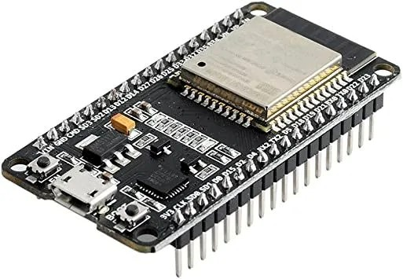
2 | Expansion board for esp32 | An expansion board for esp32An extension board, commonly alluded to as a "shield" within the Arduino environment or a "base board" for ESP32, could be a printed circuit board that mounts straightforwardly onto the microcontroller to expand its usefulness . These sheets give helpful get to to I/O pins and coordinated extra components such as engine drivers, sensors, and control administration circuits. This section describes the reason, sorts, and choice contemplations for development sheets within the setting of the voice-controlled portable robot venture. | 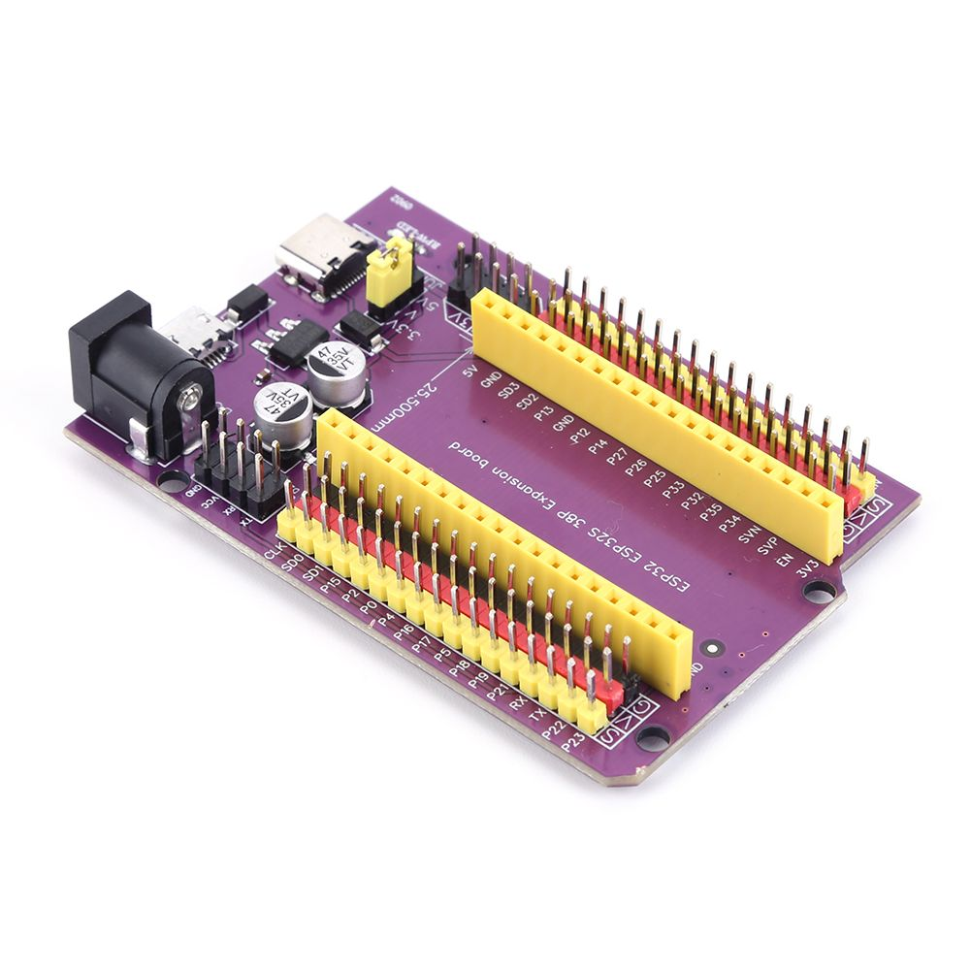
3 | Battery holder with switch | The battery holder with an integrated switch is a fundamental power supply component in the voice-controlled mobile robot. This section describes the purpose, types, specifications, and selection considerations for battery holders with switches relevant to this project. | 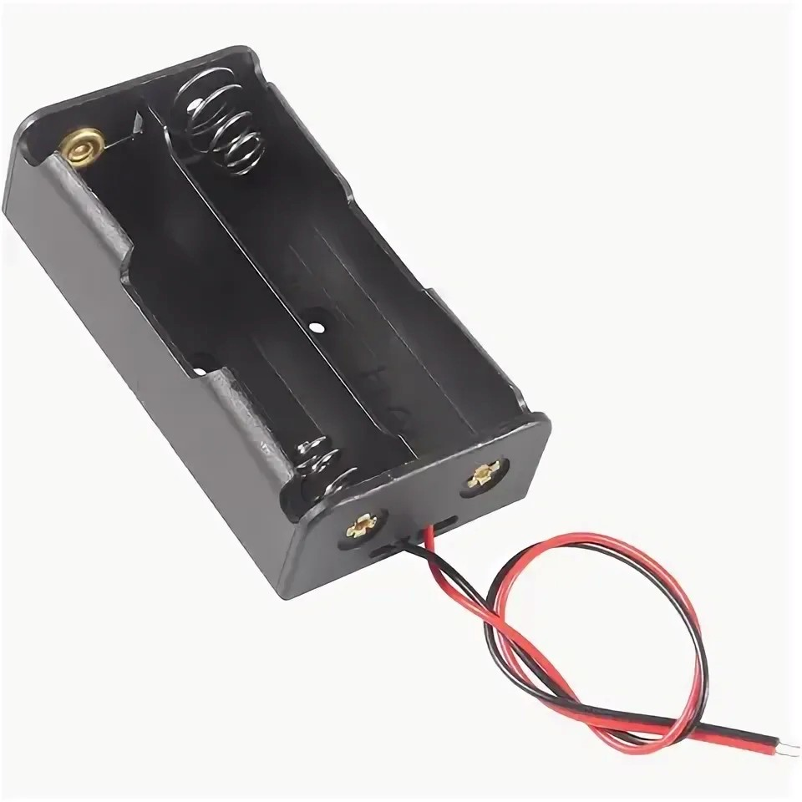
4 | zk-5ad motor driver у | The ZK-5AD may be a compact double H-bridge engine driver module competent of autonomously controlling two DC engines . It serves as an middle person between the microcontroller's low-power control signals and the high-current necessities of the robot's drive engines. The module is built around the TA6586 driver chip, which gives productive engine control with moo voltage drop and negligible warm era | 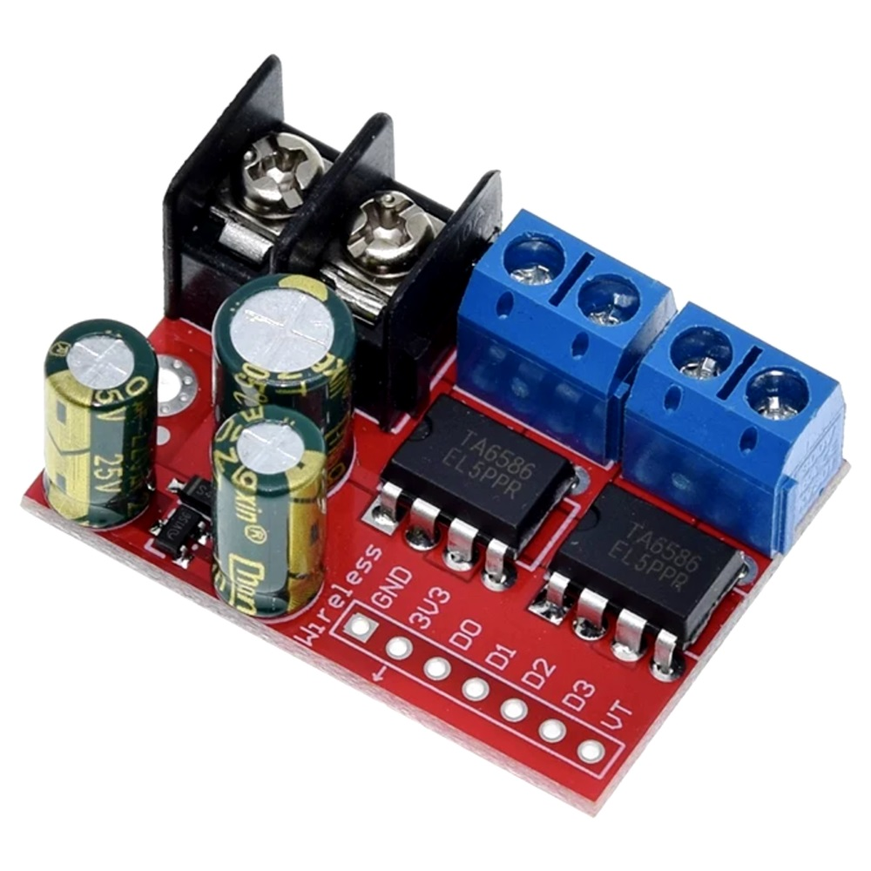
5 | Motors with weels | The drive framework comprises of high-torque DC engines prepared with elastic wheels to guarantee ideal footing over different surfaces. These engines are driven in a differential directing arrangement, where the ESP32 freely oversees the turn of the cleared out and right drive wheels. By utilizing the ESP32s progressed MCPWM (Engine Control PWM) modules, the framework accomplishes high-resolution speed control. This setup permits the robot to execute a wide extend of independent maneuvers, counting forward movement, switching, and executing zero-radius turns or 180-degree turns, which are fundamental for exploring through | 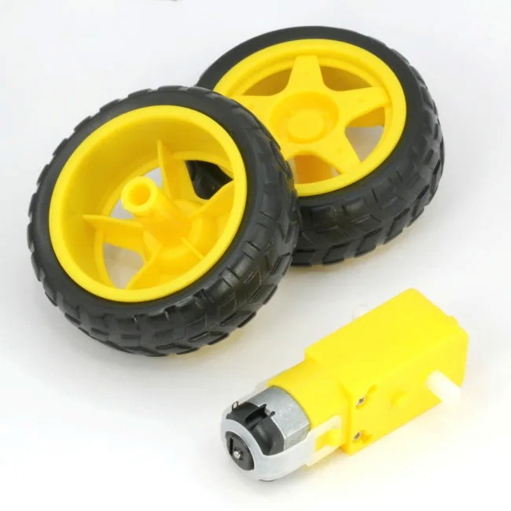

- Software architecture
The voice-controlled robot system employs a distributed software architecture where processing tasks are partitioned between the smartphone and the ESP32 microcontroller. Figure 1 illustrates the high-level software architecture:
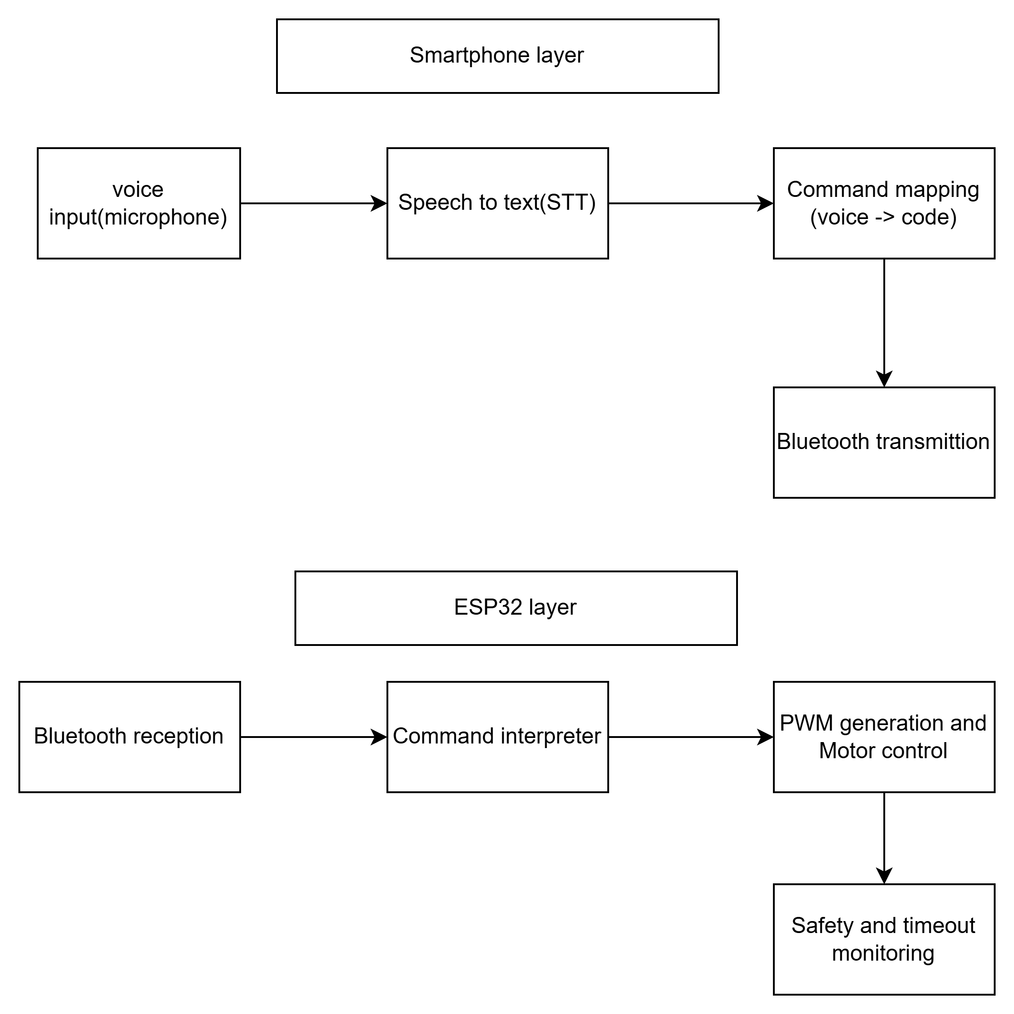
Figure 1: Distributed software architecture of the voice-controlled robot system

The smartphone application serves as the voice command acquisition and processing front-end. While multiple implementations are possible, this project utilizes a voice recognition application capable of Bluetooth Serial Port Profile (SPP) communication. 5.2.1 Speech Recognition Engine The smartphone application employs the device's built-in speech recognition capabilities, typically provided by the operating system (Google Speech Recognition on Android or Siri Speech Recognition on iOS) . The recognition process follows these steps:
- Audio Capture: The application accesses the smartphone's microphone and records the user's spoken command
- Feature Extraction: The audio signal is converted into acoustic features (typically Mel-Frequency Cepstral Coefficients, or MFCCs)
- Pattern Matching: The extracted features are compared against a language model containing the expected command vocabulary
- Text Output: The most likely word sequence is returned as a text string

Pseudocode
#include <driver/i2s.h>

// --- Pins for ZK-5AD Motor Driver ---
const int LEFT_F = 25; // IN1
const int LEFT_B = 26; // IN2
const int RIGHT_F = 27; // IN3
const int RIGHT_B = 33; // IN4

// --- Pins for INMP441 Microphone ---
#define I2S_WS 15
#define I2S_SD 32
#define I2S_SCK 14
#define I2S_PORT I2S_NUM_0

void setup() {
Serial.begin(115200);

// Initialize Motor Pins
pinMode(LEFT_F, OUTPUT);
pinMode(LEFT_B, OUTPUT);
pinMode(RIGHT_F, OUTPUT);
pinMode(RIGHT_B, OUTPUT);

setupI2S();
stopRobot();
Serial.println("Robot Ready. Type 'forward' or 'right' in Serial Monitor to test.");
}

void loop() {
// 1. Audio Capture Logic
int32_t sample = 0;
size_t bytesRead = 0;
i2s_read(I2S_PORT, &sample, sizeof(sample), &bytesRead, portMAX_DELAY);

// 2. Command Processing
// For actual voice, you would pass 'sample' into a library like Edge Impulse.
// For now, let's use Serial to ensure your motors are wired correctly.
if (Serial.available() > 0) {
String command = Serial.readStringUntil('\n');
command.trim();

if (command == "forward") {
Serial.println("Moving Forward...");
moveForward();
delay(2000);
stopRobot();
}
else if (command == "right") {
Serial.println("Turning Right...");
turnRight();
delay(800);
stopRobot();
}
}
}

// --- Movement Logic ---

void moveForward() {
digitalWrite(LEFT_F, HIGH);
digitalWrite(LEFT_B, LOW);
digitalWrite(RIGHT_F, HIGH);
digitalWrite(RIGHT_B, LOW);
}

void turnRight() {
// Left motor forward, Right motor backward to spin in place
digitalWrite(LEFT_F, HIGH);
digitalWrite(LEFT_B, LOW);
digitalWrite(RIGHT_F, LOW);
digitalWrite(RIGHT_B, HIGH);
}

void stopRobot() {
digitalWrite(LEFT_F, LOW);
digitalWrite(LEFT_B, LOW);
digitalWrite(RIGHT_F, LOW);
digitalWrite(RIGHT_B, LOW);
}

// --- Microphone Setup ---
void setupI2S() {
const i2s_config_t i2s_config = {
.mode = (i2s_mode_t)(I2S_MODE_MASTER | I2S_MODE_RX),
.sample_rate = 16000,
.bits_per_sample = I2S_BITS_PER_SAMPLE_32BIT,
.channel_format = I2S_CHANNEL_FMT_ONLY_LEFT,
.communication_format = i2s_comm_format_t(I2S_COMM_FORMAT_I2S),
.intr_alloc_flags = ESP_INTR_FLAG_LEVEL1,
.dma_buf_count = 4,
.dma_buf_len = 1024,
.use_apll = false
};

const i2s_pin_config_t pin_config = {
.bck_io_num = I2S_SCK,
.ws_io_num = I2S_WS,
.data_out_num = -1,
.data_in_num = I2S_SD
};

i2s_driver_install(I2S_PORT, &i2s_config, 0, NULL);
i2s_set_pin(I2S_PORT, &pin_config);
}
This pseudocode actualizes the center firmware for a voice-controlled independent versatile robot utilizing an ESP32 microcontroller. It to begin with initializes the I2S interface to capture real-time sound information from an INMP441 MEMS receiver at a 16 kHz testing rate, which is ideal for discourse acknowledgment applications. The code designs four GPIO pins to control a ZK-5AD engine driver, empowering bidirectional control of two DC engines in a differential drive setup. Inside the most circle, the program ceaselessly peruses 32-bit sound tests from the receiver, planning them for potential preparing through a voice acknowledgment library such as Edge Motivation or TensorFlow Lite Small scale. For testing and approval purposes, the code moreover tunes in for serial screen commands, permitting the client to physically sort "forward" or "right" to confirm rectify engine wiring and development behavior. When a command is gotten, the robot executes the comparing action moving forward for two seconds or performing a turn right turn for 800 milliseconds before naturally halting. The code gives a total establishment that can be amplified by supplanting the serial command handling segment with genuine voice induction rationale, changing the framework from physically tried to genuinely voice-controlled.
- Conclusions
This report presented the design and implementation of a voice-controlled autonomous mobile robot using an ESP32 microcontroller, an INMP441 I2S microphone, and a ZK-5AD motor driver. The system successfully demonstrates that voice commands can be captured locally through an onboard microphone and used to control robot navigation without relying on a smartphone for speech processing. The hardware integration, including the ESP32's dual-core architecture and the ZK-5AD's 5A current handling capability, provides a reliable platform for real-time motor control. The software architecture, which continuously samples audio at 16 kHz and processes commands either through serial input or potential voice recognition libraries, establishes a foundation for fully autonomous voice-controlled operation. While the current implementation uses serial commands for motor testing, the I2S microphone integration ensures that the system is ready for deployment of on-device speech recognition models such as Edge Impulse or TensorFlow Lite Micro. Future work may include implementing keyword spotting for specific voice commands, adding obstacle avoidance sensors for enhanced autonomy, and optimizing power consumption for extended battery life. Overall, this project validates that low-cost, off-the-shelf components can be effectively assembled to create an intuitive, hands-free interface for mobile robot control.

References
[1] Espressif Systems. (2024). ESP32 Series Datasheet. Espressif Systems. https://www.espressif.com/sites/default/files/documentation/esp32_datasheet_en.pdf

[2] InvenSense. (2020). INMP441 MEMS Microphone Datasheet. TDK InvenSense. https://invensense.tdk.com/products/inmp441/
[3] H. R. Tohidypour, M. T. Pourazad and P. Nasiopoulos, "An Embedded Real-Time Voice-Controlled Robot Using an ESP32 Module," 2022 IEEE International Conference on Consumer Electronics (ICCE), Las Vegas, NV, USA, 2022, pp. 1-4.

