**6장 카프카 운영 가이드**

**6.1 필수 카프카 명령어**

/user/local/kafka/bin/ : 카프카 기본적 제공 명령어들



**6.1.1 토픽 생성**

|  |
| --- |
| ./kafka-topics.sh \  --zookeeper peter-zk001:2181,peter-zk002:2181,peter-zk003:2181/peter-kafka \  --replication-factor 1 --partitions 1 –topic peter-topic --create |

**6.1.2 토픽 리스트 확인**

|  |
| --- |
| ./kafka-topics.sh \  --zookeeper peter-zk001:2181,peter-zk002:2181,peter-zk003:2181/peter-kafka \  --list |

**6.1.3 토픽 상세보기**

|  |
| --- |
| ./kafka-topics.sh \  --zookeeper peter-zk001:2181,peter-zk002:2181,peter-zk003:2181/peter-kafka \  --topic peter-topic --describe |

**6.1.4 토픽 설정 변경**

**주기 설정**

|  |
| --- |
| ./kafka-configs.sh \  --zookeeper peter-zk001:2181,peter-zk002:2181,peter-zk003:2181/peter-kafka \  --alter --entity-type topics --entity-name peter-topic –add-config retention.ms=3600000 |

**주기 삭제**

|  |
| --- |
| ./kafka-configs.sh \  --zookeeper peter-zk001:2181,peter-zk002:2181,peter-zk003:2181/peter-kafka \  --alter --entity-type topics --entity-name peter-topic –delete-config retention.ms=3600000 |

**6.1.5 토픽의 파티션 수 변경**

|  |
| --- |
| ./kafka-topics.sh \  --zookeeper peter-zk001:2181,peter-zk002:2181,peter-zk003:2181/peter-kafka \  --alter --topic peter-topic --partitions 2 |

**6.1.6 토픽의 리플리케이션 팩터 변경**

**rf.json**

{"version":1,

"partitions":[

        {"topic":"peter-topic4","partition":0, "replicas":[1,2]},

        {"topic":"peter-topic4","partition":1, "replicas":[2,3]}

]}

|  |
| --- |
| ./kafka-reassign-partitions.sh \  --zookeeper peter-zk001:2181,peter-zk002:2181,peter-zk003:2181/peter-kafka \  --reassignment-json-file /usr/local/kafka/rf.json --execute |

**6.1.7 컨슈머 그룹 리스트 확인**

-오프셋을 주키퍼로 저장 : 올드 컨슈머 (--zookeeper)

-오프셋을 카프카로 저장 : 뉴 컨슈머 (--bootstrap-server)

|  |
| --- |
| ./kafka-consumer-groups.sh \  --bootstrap-server peter-kafka001:9092, peter-kafka002:9092, peter-kafka003:9092  --list |

**6.1.8 컨슈머 상태와 오프셋 확인**

|  |
| --- |
| ./kafka-consumer-groups.sh \  --bootstrap-server peter-kafka001:9092, peter-kafka002:9092, peter-kafka003:9092  --group peter-consumer --describe |

**6.2 주키퍼 스케일 아웃**

|  |
| --- |
| /usr/local/zookeeper/bin/zkServer.sh status |

ZooKeeper JMX enabled by default

Using config: /Users/simjunbo/var/zookeeper/zk1/conf/zoo.cfg

Mode: follower

+ /Users/simjunbo/var/zookeeper/zk2/bin/zkServer.sh status

ZooKeeper JMX enabled by default

Using config: /Users/simjunbo/var/zookeeper/zk2/conf/zoo.cfg

Mode: leader

+ /Users/simjunbo/var/zookeeper/zk3/bin/zkServer.sh status

ZooKeeper JMX enabled by default

Using config: /Users/simjunbo/var/zookeeper/zk3/conf/zoo.cfg

Mode: follower

리더에서 해당 명령 수행하면 팔로워 숫자 확인가능

administratorui-MacBook-Pro:leader simjunbo$ echo mntr | nc localhost 2182 | grep zk_synced_followers

zk_synced_followers 2

**6.3 카프카 스케일 아웃**

broker.id 부분만 다른 서버와 겹치지 않게 추가한 후 실행.

**CLI에서 확인**

|  |
| --- |
| /usr/local/zookeeper/bin/zkCli.sh |

[zk: localhost:2181(CONNECTED) 0] ls /

[kafka_C01, zookeeper]

[zk: localhost:2181(CONNECTED) 1] ls /

[kafka_C01, zookeeper]

[zk: localhost:2181(CONNECTED) 2] ls /kafka_C01/brokers/ids

[1, 2, 3, 4, 5]

[zk: localhost:2181(CONNECTED) 3]

**6.4 카프카 모니터링**

**6.4.1 카프카 JMX 설정 방법**

|  |
| --- |
| /usr/local/zookeeper/bin/kafka-server-start.sh  export JMX_PORT=9999 추가 |

**6.4.2 JMX 모니터링 지표**

**Overview**

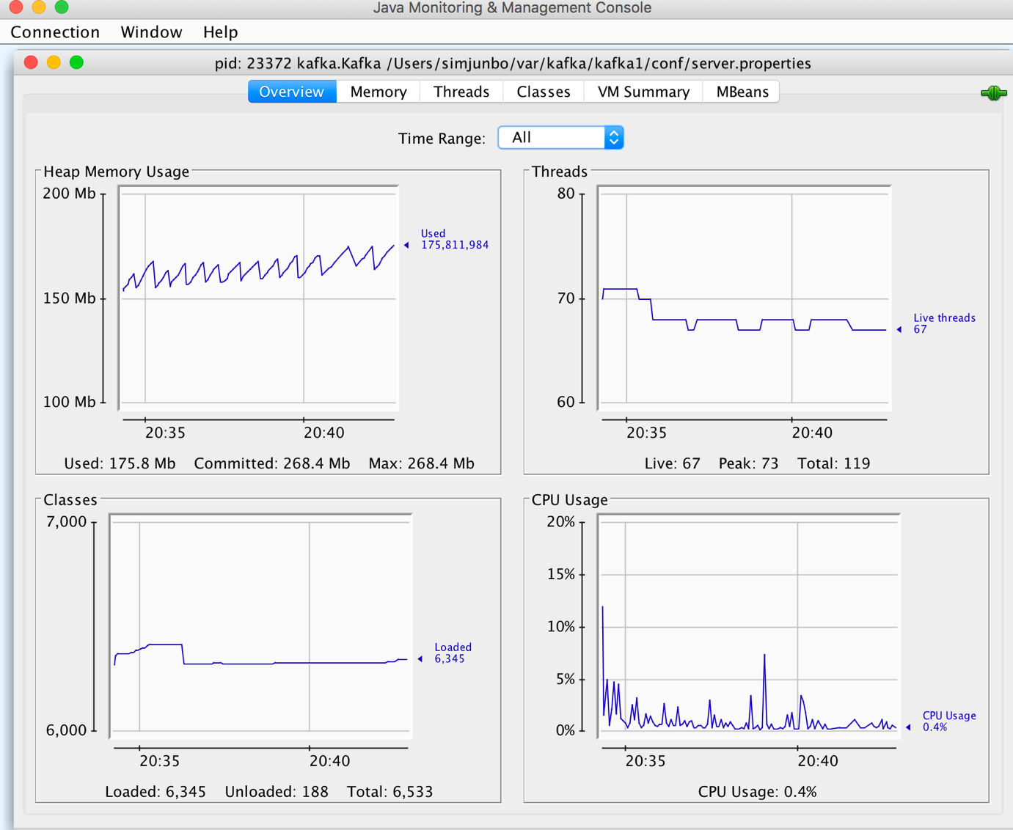

**MBeans**

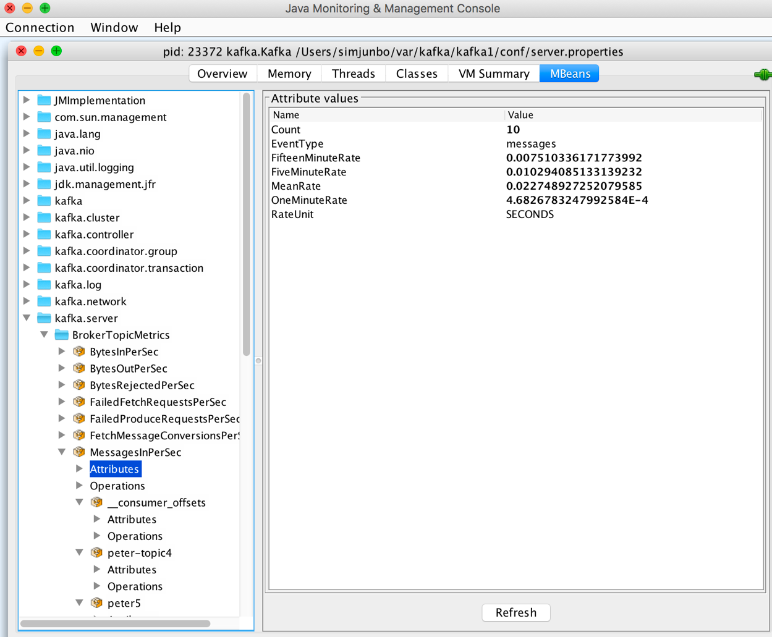

**kafka-manager**

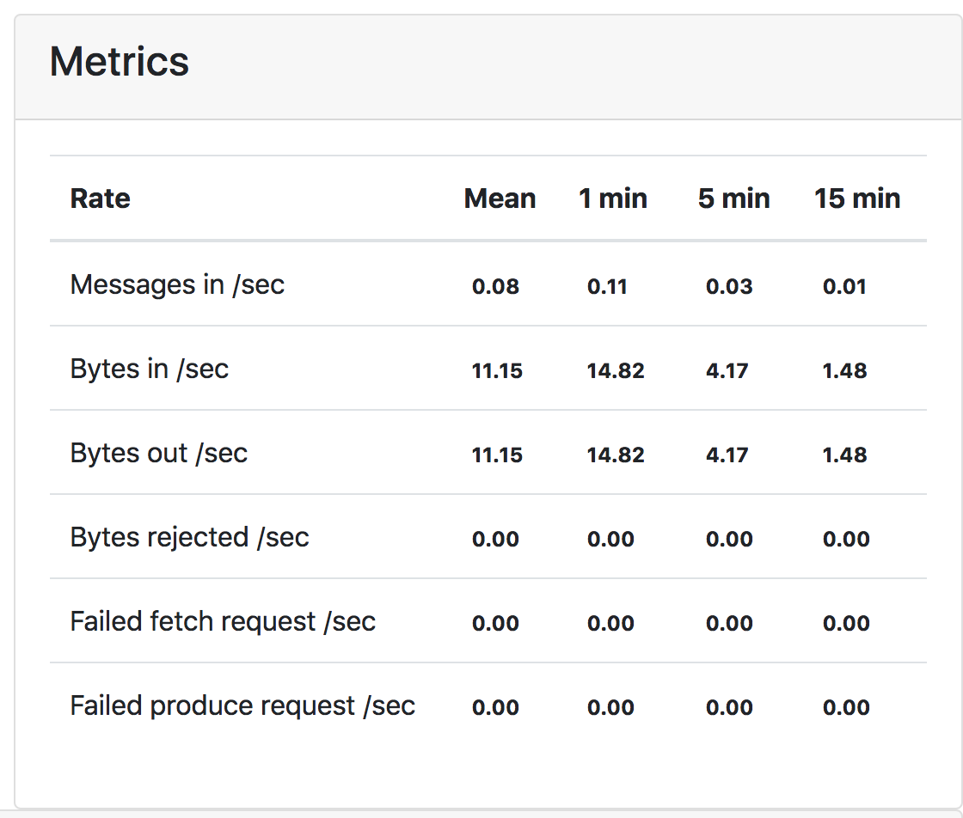

**6.5 카프카 매니저 활용**

다운 : <https://github.com/yahoo/kafka-manager>

**설치 (압축해제 후)**

|  |
| --- |
| ./sbt clean dist |

**실행**

|  |
| --- |
| /usr/local/kafka-manager-1.3.3.17/bin/kafka-manger –Dconfig.file=/usr/local/kafka-manager-1.3.3.17/conf/application.conf –Dhttp.port=9000 |

**화 면**

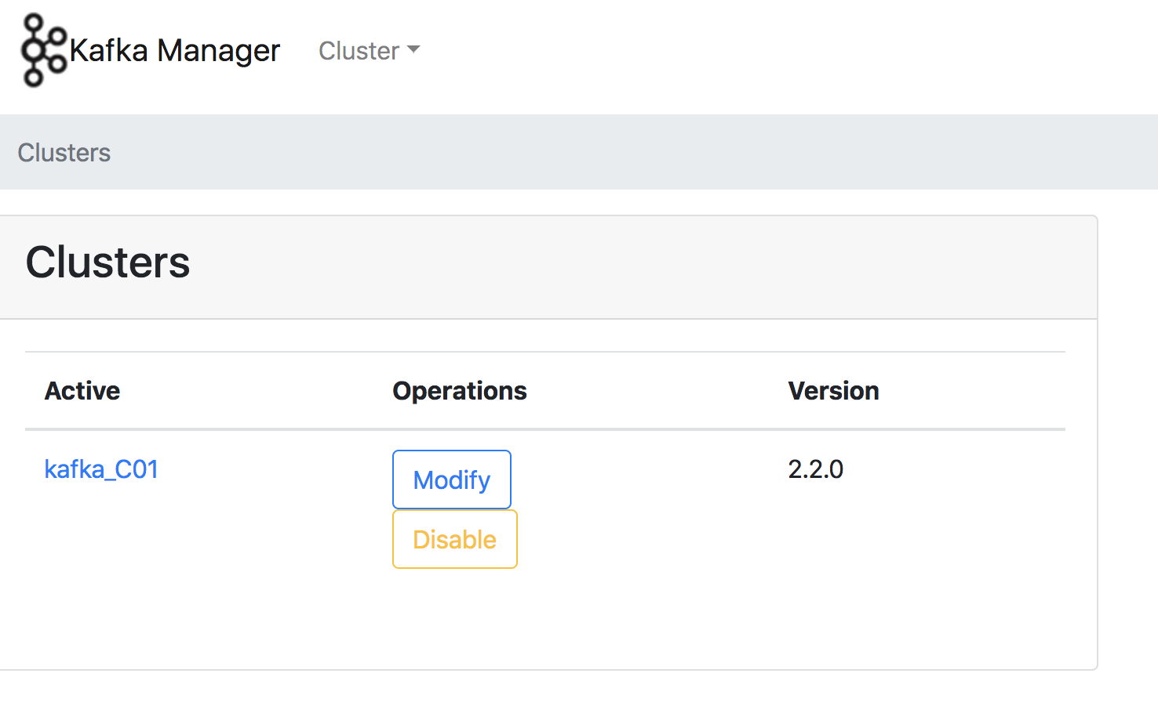

나머지는 카프카 매니저 화면을 보면서 …