DevSecOps (ITAS-276)

Lab 2 – Using GitHub Actions for CI

Date due: January 19, 2026 2:00 pm

Learning Objectives

Upon successful completion of this lab exercise, the student will be able to:
- Create a GitHub repo with Actions that will automatically run when code is updated
- Set up automatic unit tests to run against code
- Use YAML and TOML to set up GitHub repo with actions
- Experience a pipeline catching bugs in software

To do:

Lab Set-Up

- Create a folder named YourFirstInitialYourLastName_276L01 in the folder you are using for this course and create an empty document called YourFirstInitialYourLastName_276L01.docx inside that folder. This is the document you will complete to answer the lab.
- Part A of this lab is to be done in your assigned pairs. Part B is to be done on your own. Both partners must hand in both parts of the lab.

Part A

- Use uv init to create an app called yourusername-calculator-app.

- Create a venv file in the created folder and activate it.

- Create a file called calculator.py (yes lower case…this is the new standard even for classes in Python). In it create a class called Calculator with 4 methods: add, subtract, multiply and divide that do exactly what you think. Each gets passed two parameters along with the class name. There are no attributes to the Calculator class.
  - For the divide method, add a check so that if the second parameter is 0, a ValueError is raised with the message “Cannot divide by zero”
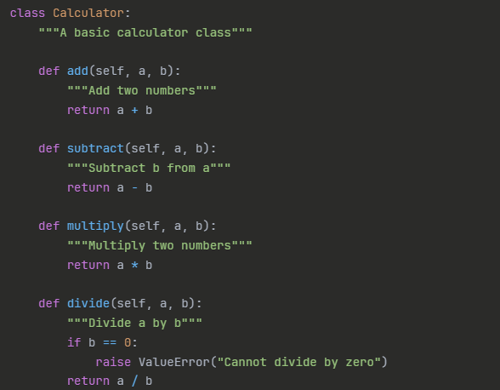

- Add a FUNCTION outside the class called main creates a calculator object and calls the 4 functions to make sure they work. The main function is called if __name__ == “__main__”
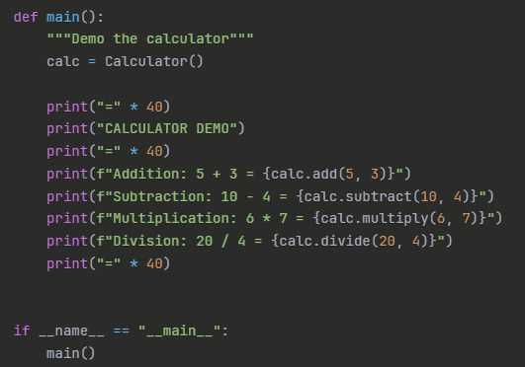

Part B

- Create a file called test_calculator.py. We are going to use pytest (not part of the standard python library) to unit test the Calculator class. Pytest uses test classes with different methods to run its tests.

- In the test_calculator.py file import pytest and Calculator from calculator.py that you created in part A.

- Create a class called TestCalculator.

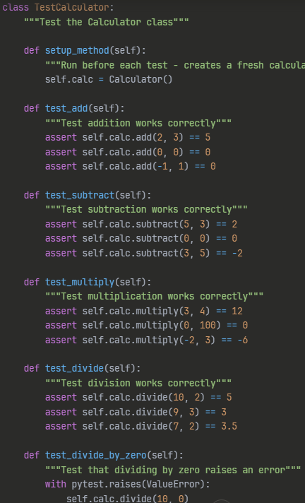

- Create a requirements.txt file and add in pytest and pytest-cov

- Use pip install (inside uv) to install the libraries from requirements.txt

Part C

- Make sure the calculator.py file works by running it uv run calculator.py
- Run the test cases uv run pytest -v (note you should not have to, but if this doesn’t work specify the test file explicitly.

- All 5 tests should pass and be displayed in green

- Run the tests with coverage using uv run pytest --cov=calculator --cov-report=term-missing

- Now introduce a coding error…change the add method to add 1 (return a + b + 1). Save a run the tests again (do NOT change the tests). This will show you what an error looks like in pytest.

- Fix it back and make sure it goes back to 100%

Part D

- Create a GitHub repository called username-calculator-ci. You can do this from the command line (using git init) or in GitHib and then cloning the repository and moving all your files into the repository and adding them. Share the repo with me (armcdonald)

- Make sure you add a .gitignore file for your environment. You can do this in GitHub when you create the repository. Make sure your .gitignore contains:
# Virtual Environment (LOCAL DEVELOPMENT ONLY)
.venv/
venv/
ENV/

# Python files
__pycache__/
*.pyc
.pytest_cache/
.coverage
htmlcov/

# IDE files
.vscode/
.idea/

# OS files
.DS_Store

- Add, commit and push your local files to your new repo.

- Make sure your virtual environment is NOT added to your repo.

Part E

- Makre a folder called .github/workflows

- Add the given file called ci-cd.yml to the folder. This file will set up the git actions that will run whenever a change is made to your file. The YAML program language is white-spaced based and can be a little confusing. All the IDEs have a YAML plug-in that should be added.

- The file I gave you may need to be tweaked a little bit. With uv being so new, it make not work in all environments.

- Here’s what this file means:
on:
push:
branches: [ main ]
means to run this whenever code is pushed to the main branch.

- Job 1 – checks out the code, sets up Python, installs pytest, runs the tests with coverage and makes sure there is 80% coverage.

- Job 2 – runs in parallel with test and checks the code quality using the linter pylint to ensure the code follows best practices.

- Job 3 – the build summary only runs if both test and lint pass and only runs on pushes to main (not pull requests) and generates a summary of the successful build.

Part F

- Create a README.md file that has the following sections with the appropriate information in each section (you provide this)
# Simple Calculator to show GitHub Actions
## Features
## Local Development Setup
## CI/CD Pipeline
## Project Structure
## Why uv and Virtual Environments
## Code Coverage

- Commit and push the pipeline (both the YML and the README. Make sure you have a good commit message.

- Go to the Actions tab in GitHub and watch your Actions run. Click on the workflow name and you should see 3 jobs. “Run Tests” and “Code Quality” run in parallel. Click on each log to see the details. They should all pass (green checkmark)

Part G

- Let’s break it! Introduce the same bug as before in the add method of the LoanCalculator class. Save the file and push the buggy code to GitHub. Use an appropriate commit message.

- Go to the GitHub actions tab and click on the latest workflow run. The “Run Tests” job should fail and the “Build Summary” should not run. Take a screenshot of the expanded Run Tests and of the summary screen.

- Fix the bug, push it to GitHub and make sure it is fixed.

Part H

- We are going to add a new method called power to the Calculator class. Power returns the base ** exponent (return base ** exponent), Make sure you call the parameters by the correct names.

- In main in calculator.py add a print to test the power function like:
print(f’Power: 2 ^ 3 = {calc.power(2, 3)”).

- Add tests to the test file by defining a method called test_power that asserts power(2, 3) is 8; 5, 2 is 25, 10, 0 is 1 and 3, 3, is 27.

- Run the tests locally and make sure you have the coverage and they work.

- Push the changes to the repo and check the Actions to make sure the new code runs and works and the Build Summary is displayed.

To submit
When you have completed the lab exercise hand in the following in a folder:
- GitHub repo URL
- Screenshot of local environment showing .venv and that it is activated
- Screenshot of ‘git ls-files’ to show .venv is NOT in repo.
- Screenshot of successful pipeline showing Actions and all jobs “green”
- Screenshot of failed pipeline showing red X and details of what failed.
- A short reflection (7 – 10 sentences NO MORE) answering:
  - CI/CD Value: How did the CI/CD pipeline catch your bug? What would have happened without it?
  - Parallel Jobs: Why did we run tests and linting in parallel? What's the advantage?
  - Code Coverage: Why is 100% code coverage important? How does the pipeline enforce it?
  - Team Collaboration: How would this setup help a team of 10 developers working together?

