Swift （SAIO）

# Environment

Linux: on Ubuntu 16.04.1

Local Net IP: 127.0.0.1

Swift Client Version:3.6.0

Memcached: 1.4.25

# Framework

Node {Proxy Node, Auth Node}

Storage {account, container, object}

Ring {Storage→Physical Device}

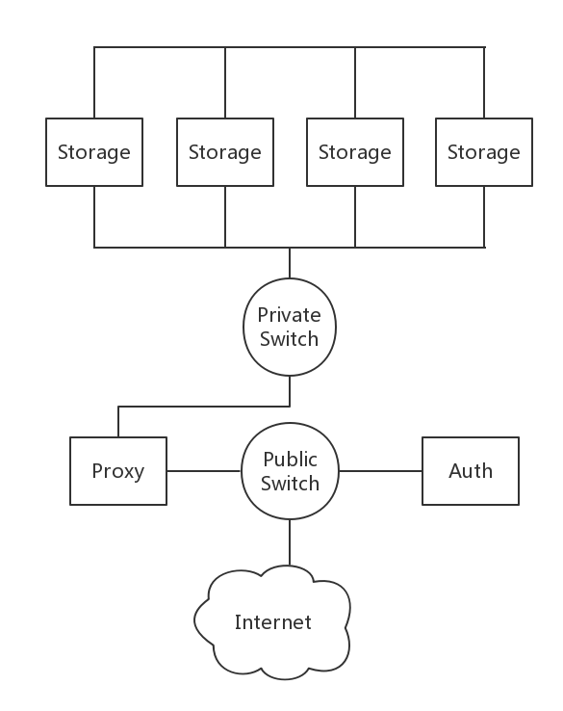

Local Storage: Loopback Device and XFS file

Storage Framework:

Objects1

Objects2

……

Container1

Container2

……

# Storage Framework Example

Swift -A <http://10.0.2.15:8080/auth/v1.0> -U test:tester -K testing stat

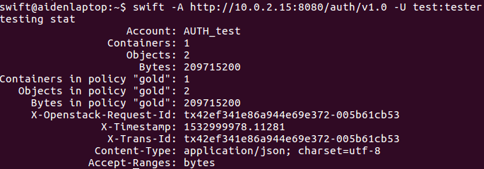

When using

Swift -A <http://10.0.2.15:8080/auth/v1.0> -U test:tester -K testing post su

There will be a new directory named *su* in this account. And the number of *Containers* will increase by 1. So the directory in Swift is regarded as *Container.* Similarly, each time we upload a file, the *Objects* number will increase, so file is regarded as *Object.*

**Different containers may have different policies, for now I found the policy mainly effect the number of replication of an object(“gold” policy may have 3 replication copies while “silver” only have 2 copies) This can be setting manually.**

**But, maybe policy has other effects as well..**

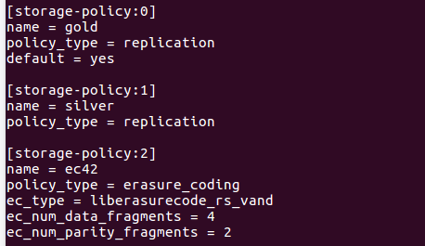

(not sure what the policy2(erasure_coding) mean..)

# Upload and Download Speed Test

According to the Ring setting, an account can set the copy of an object it wants.

In this test we set the copy number to 3. It means uploading a 100M file takes up 400M space in Storage Node.

## Using HTTP ; Single User

Download a 209.7M file (copy number: 3)

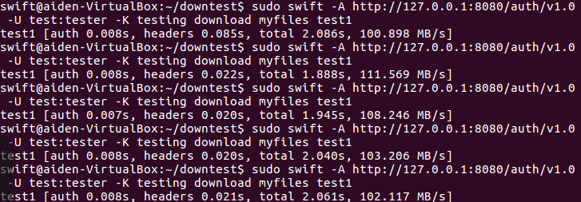

Data:

|  |  |  |  |
| --- | --- | --- | --- |
| Auth/s | Headers/s | Total/s | Speed/MBs-1 |
| 0.008 | 0.085 | 2.086 | 100.898 |
| 0.008 | 0.022 | 1.888 | 111.569 |
| 0.007 | 0.020 | 1.945 | 108.246 |
| 0.008 | 0.020 | 2.040 | 103.206 |
| 0.008 | 0.021 | 2.061 | 102.117 |

Ave:

0.008 105.2072

Download a 209.7M file(copy number: 1)

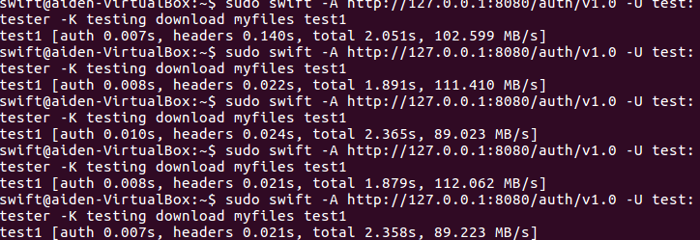

When decreasing the number of copy, there’s no significance difference between download speed in two situations.

So the download speed has no relation with copy number.

Download a 2.1M file(copy number1)

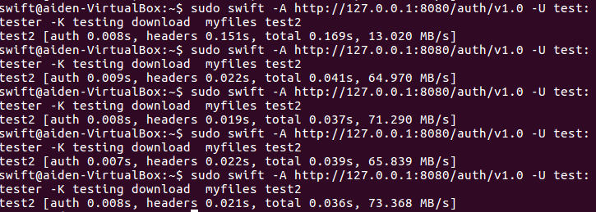

|  |  |  |  |
| --- | --- | --- | --- |
| Auth/s | Headers/s | Total/s | Speed/MBs-1 |
| 0.008 | 0.151 | 0.169 | 13.020 |
| 0.009 | 0.022 | 0.041 | 64.970 |
| 0.008 | 0.019 | 0.037 | 71.290 |
| 0.007 | 0.022 | 0.039 | 65.839 |
| 0.008 | 0.021 | 0.036 | 73.368 |

Compared to bigger file, the time spent on Headers becomes bigger part in download process.

The auth and headers time is nearly equal even if file size is different.

**Approximately every 2 minute, the time spent on Headers become bigger(About 0.15s)(maybe is due to forming new Timestamp?)**

## Using FTP

Download a 2.1MB file

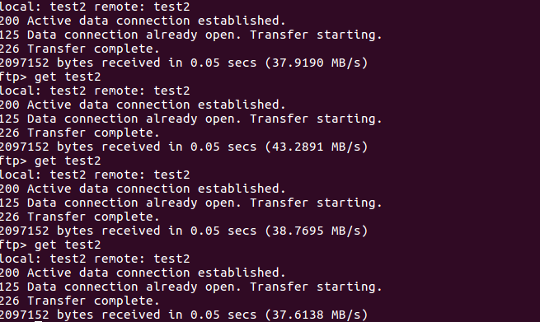

Download a 209.1MB file

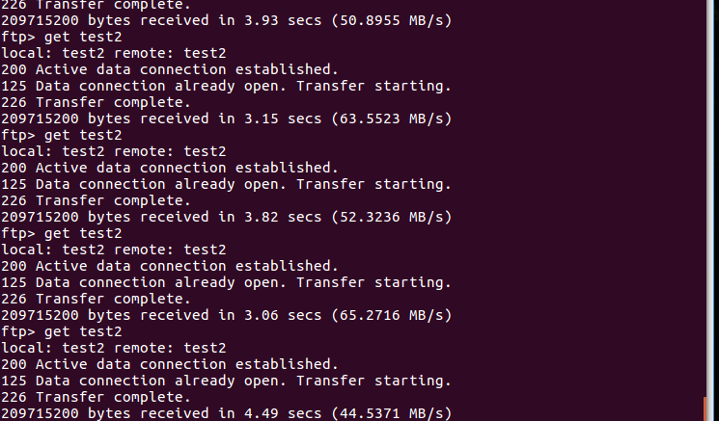

So compare FTP to HTTP, the former one will take longer time on average, when downloading the same size file.