## Weekly Target:

1. Find the .py file which controls the process when upload and download a file to cloud storage.

2.Try to modify the method so that the file can be edited.

3.Find a way to debug…

In /swift/swift/obj

Server.py

## Method : PUT

#This method handles a upload process

The method create a class defined by Swift called disk_file, the write chunk into the class.

So this method should be where the encryption function could be implanted.

Difficulty: What is a chunk? How to modify chunk’s content?

## Method: GET

#This method handles a download process

So this method should be where the decryption function could be implanted.

# Try to modify the method

In method PUT

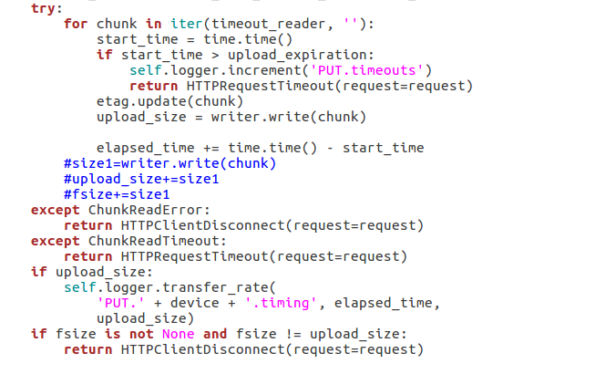

I try to edit the disk_file code by writing something.(the blue color code)

The upload process still works after code being modified , but the download process will get error message like “**object not found**”……

Found in Method GET

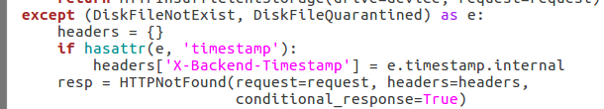

Maybe it’s because of the fsize doesn’t match the attribute in request.headers[‘content-length’]

The request it’s formed in proxy/controller/obj.py

So the attribute of an objection could be considered to append in this script…

So it’s may be result of wrong fsize

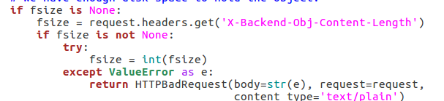

The Swift already has encryption system on client end.

In swift/swift/common/middleware/crypto/encrypter.py

By default, the encryption filter will by default encrypt all data/metadata when handling PUT and POST.

# Problem

1.How does the method (crypto Encrypt) been called??

I found the crypto functions in /swift/common/middleware. It should be called by some functions, but they are no where to be found.

Seems like they use a thing called “PasteDeploy”…

2.Which end is the encrypt-function should be implanted?

Client end or Server end? Swift already have an Encrypt-function on Client-end. Should I modified and improved it, or restart a new function working on Server-end?

3What is PasteDeploy?