*Aiden Guerin (30635659)*

*Word Count: 913*

*Visualisation:* <https://aidenguerin.github.io/fit3179-vis02/>

*FIT3179*

DATA VISUALISATION 2

# Domain, Who, Why

The domain of this visualisation aims to compare the different offerings of a handful of the most popular multi-resort ski passes available. This visualisation is aimed at people who are in the market for a ski pass and want an aggregated view of the benefits of each pass and drill-down by resort without having to view various web pages from sites such as onthesnow.com . The purpose of this is to help these people decide which pass is of the best value to them.

# What

The data used for this visualisation was scraped from On The Snow (*OnTheSnow,* 2022) using the selenium library in python. On The Snow provides information about ski resorts including, lift passes, terrain, snowfall, and chairlifts. Geospatial information was collected using the Google geocoding API to pass in resort names and return latitude and longitude as well as country and state for each resort.

By using On The Snow (*OnTheSnow,* 2022) we have access to information about all of the relevant ski resorts for each pass on a single website. This allowed for time saving as the information can be scraped from a single source and then geocode the names. Basic data manipulation and cleaning was performed in python using the pandas library to join, filter, derive columns and aggregate data.

# Why and How

Several idioms have been used in this visualisation. This consists of 2 maps, a normalised bar chart, a grouped bar chart, and 2 standard bar charts.

The first idiom used are maps. These show the locations of each resort for US/Canada and Australia/New Zealand, here each pass has been encoded by the colour of the point. This is intended to give the user an idea of the locations of each resort included in each pass, this may influence their selection as they may have specific locations in mind prior to purchase.

The next idiom used is a normalised bar chart. This shows the proportion of terrain for each skill level. Each stack indicates a resort, and the colour encoding uses the standard colours for each run type (Beginner through to expert). This aims to give a quick overview of the distribution of available terrain provided with each pass. Based on the skill level of the viewer they may be interested in purchasing a pass more suited to their capabilities.

The next idiom used is a grouped bar chart, alongside a regular bar chart. This idiom shows the average monthly snowfall, both by pass and by individual resort. Colour has been used to encode each of the passes for both idioms. This aims to inform the viewer of which passes provide access to mountains with the most snow, as well as snow as specific times of the year. This again aims to inform decision making, for example, a person more interested in spring skiing (April/May for northern hemisphere) may be more interested in the ikon pass as there is greater average snowfall in these months.

The final idiom is a bar chart. This idiom shows the total number of lifts for each resort on a given pass. This aims to inform the reader of the capacity of each resort. Resorts with more lifts are likely to have greater upload capacity and thus less wait time at the lifts. Here the readers can look and see which passes have the largest number of lifts and the number for each given resort.

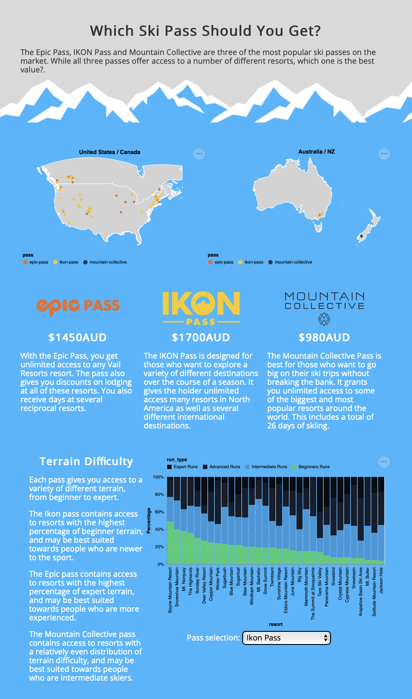

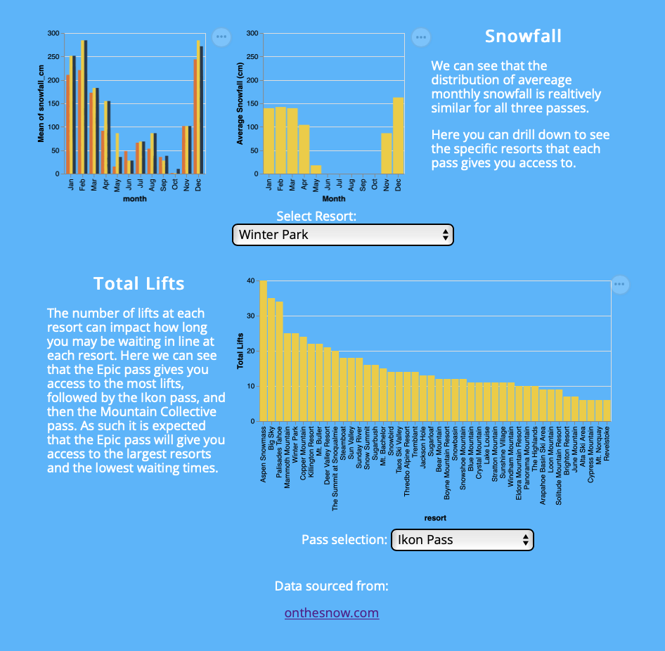

# Design

## Layout

The layout is structured mainly in rows to group similar information. Each row has a varying number of columns depending on the amount of information to be shown. This allows for the grouping of related information and selection of the order information is shown to the reader.

## Colour

The colours used in the report have been selected of several colour palettes. The overall theme of the page is blue, white and grey. This is used to tie in with the domain of the visualisation, skiing and snow. This has been consistently applied through all the text on the page except for the header which has been inverted in order to draw initial attention and ensure readability on the background. The standard colours for terrain difficulty have been used for the normalised bar chart, that is green, blue, black to signify beginner, intermediate and advanced respectively. Finally, the colours for any pass comparison has been selected from the colours of each pass logo and this has been consistently applied throughout each visualisation.

## Figure Ground

The row layout alongside the use of headers have been used to create visual hierarchy. There is strong contrast between the white text used to bring them forward from the background. The row layout and grouping allows for a clear order and hierarchy as read down the page.

## Typography

The typeface selected is a sans-serif font. Headings and paragraphs use consistent weighting to ensure hierarchy and clear order when reading. This has been applied consistently throughout the visualisation to ensure that the visual is readable and clear.

## Storytelling

The reader is guided through the visual through both the layout and the text. The top of the report contains a brief introduction, followed by overview maps and summary for each pass, and then followed by text adjacent to each chunk providing some information about the visuals.

OnTheSnow. (2022). *OnTheSnow*. Retrieved from <https://www.onthesnow.com>

Munzner, T., & Maguire, Eamonn. (2015). *Visualization analysis & design*.

Appendix A: Five Design Sheets

