An Analysis Report about Predicting Star Type
CSCI 3360 Group 18: Aiden Hammond, Sneha Kummarapurugu, Juan Hernandez

Needed info: The report should provide details of the entire process of data analysis with supporting figures, results, interpretations, what you learned, etc

Introduction:
The objective of this course project was to apply the machine learning algorithms and models utilized in class onto a real-world application. It was necessary to select a real-world dataset with actual measurements and values instead of a dummy dataset. Looking at many datasets published online from various sources such as Kaggle, the one that interested us the most was the “Star dataset to predict star types”. This dataset includes 6 features for 240 stars, mostly collected from the web: temperature, luminosity, radius, absolute magnitude, star color, and spectral class. This data was used to plot the Hertzsprung-Russell diagram illustrate how star types could be predicted based on its features. Hence, the goal of this project was to use the key stellar features to build and evaluate classification models that predict a star's type into one of the target labels. The target labels for prediction are: Red Dwarf, Brown Dwarf, White Dwarf, Main Sequence, Supergiants, and Hypergiants. We developed 3 different models to predict the target variable: Decision Trees, K-Nearest Neighbors (KNN), and OPTICS.

Exploratory Analysis:
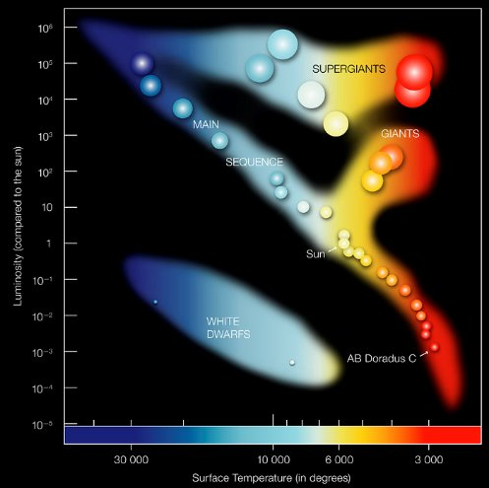
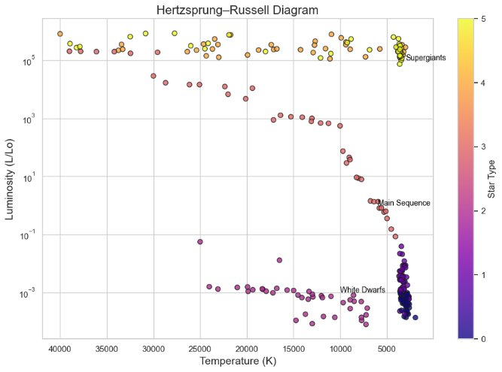
First, we constructed the Hertzsprung–Russell diagram by plotting Temperature (K) against Luminosity (L/Lo) and labeling the star types. We then compared the diagram’s structure with the scatterplot to see how well they matched.
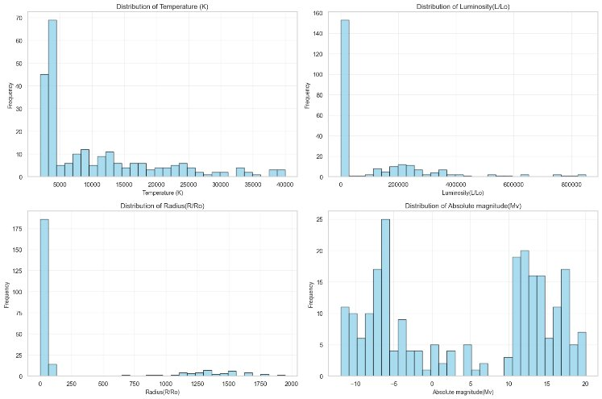
We also created additional visualizations such as bar charts, scatterplots, and line graphs to show feature distributions and possible variable relationships. The next four histograms show the distributions for the numerical features. It illustrates the skewness of each variable, the spread of the data, and any peaks or dips within the distribution.
The top left histogram is the distribution for Temperature (K) among the 240 stars in the dataset. It is heavily right skewed with about half of the stars having a temperature less than 5000 Kelvin.
The top right is the distribution for Luminosity (L/Lo). It is heavily right skewed with more than 150 stars hugging on the leftmost value.
The bottom left is the distribution for Radius (R/Ro). It is heavily right skewed with most having a radius less than 250.
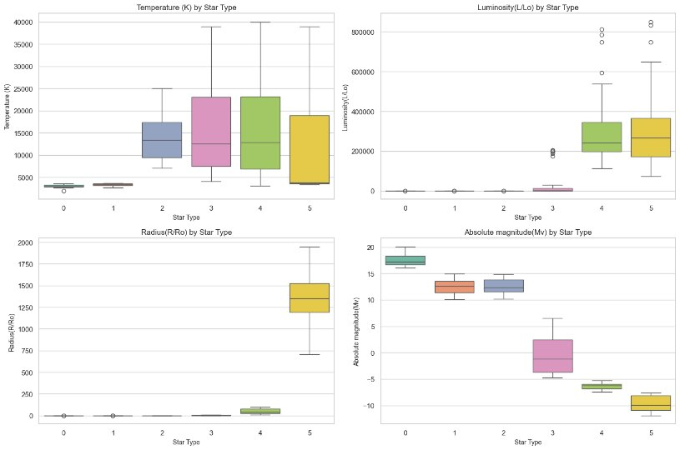
The bottom right is the distribution for Absolute Magnitude (Mv). It seems to have two groupings with one on the left and one on the right.
Box and whisker plot

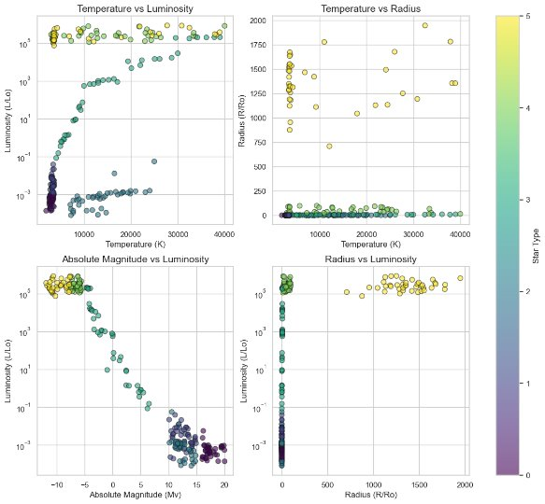
Features graphed to one anther: relationships and description of chart
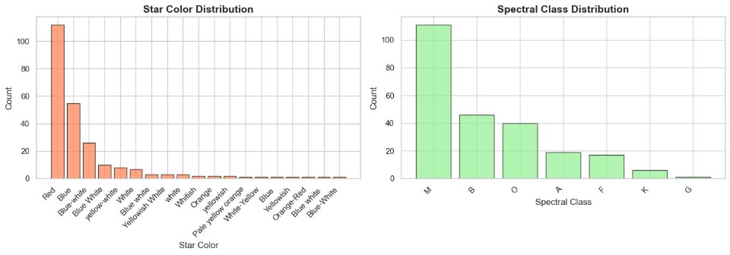
Distribution of categorical features: color and spectral class
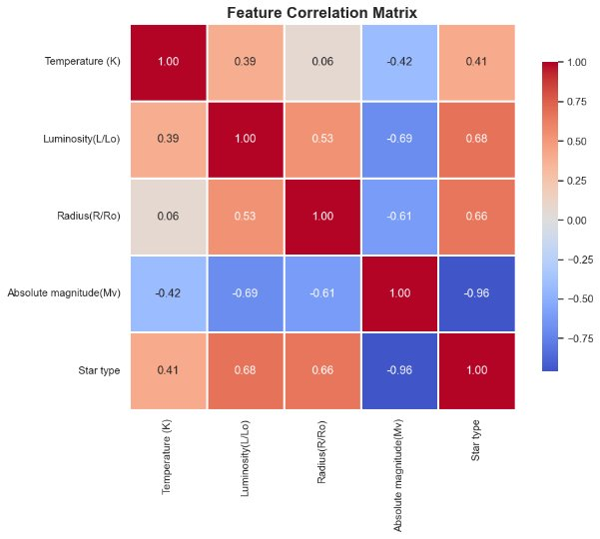
Feature correlation matrix: talk about relationships and features

Predicting Star Types using Decision Trees:
*****xxxa
Predicting Star Types using K-Nearest Neighbors (KNN):
To implement the K-Nearest Neighbors (KNN) algorithm onto the star dataset, it was important to infer back into our classroom notes. Although the notebook example is not exact, the steps taking the dataset splitting it into training and testing data along with the features and target variables is similar. However, a major point to state is that since not all our features were numerical in property (star color and spectral class), I decided to ignore these features. Whether it had significant impact or not onto the model’s learning with or without has not been tested but, the impact can be considered negligible when we discuss about the results.
Before using the remaining features, it is necessary to standardize all the values, especially since they are using very different metrics with large and small values. This standardization was implemented using StandardScaler() library and ensured that our distance-based algorithm can function properly. Our training and testing data was derived from a 80/20 split.
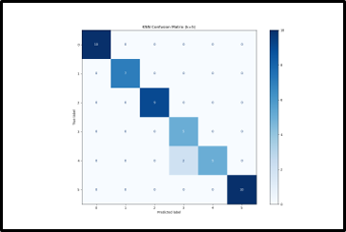
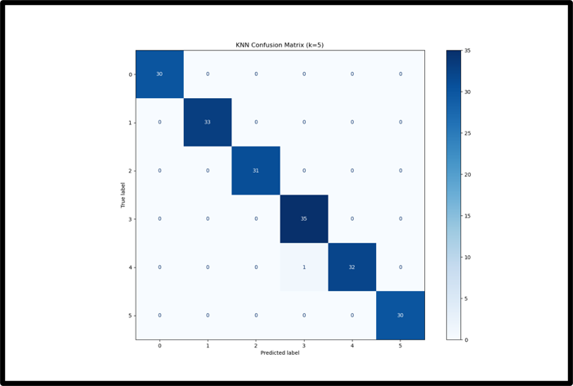
An initial experiment of K=5 was ran with the following results from our training and testing set. As we can see in left confusion matrix, the training set almost predicted all the star types with perfect classification. It seems to only misclassify 1 star predicting it to be a Main Sequence but it is a Supergiant. Although close to a perfect score, it is important to do the next step of evaluating our model testing it onto unseen data to acknowledge, if any possible overfitting may have occurred with a K-value so low.
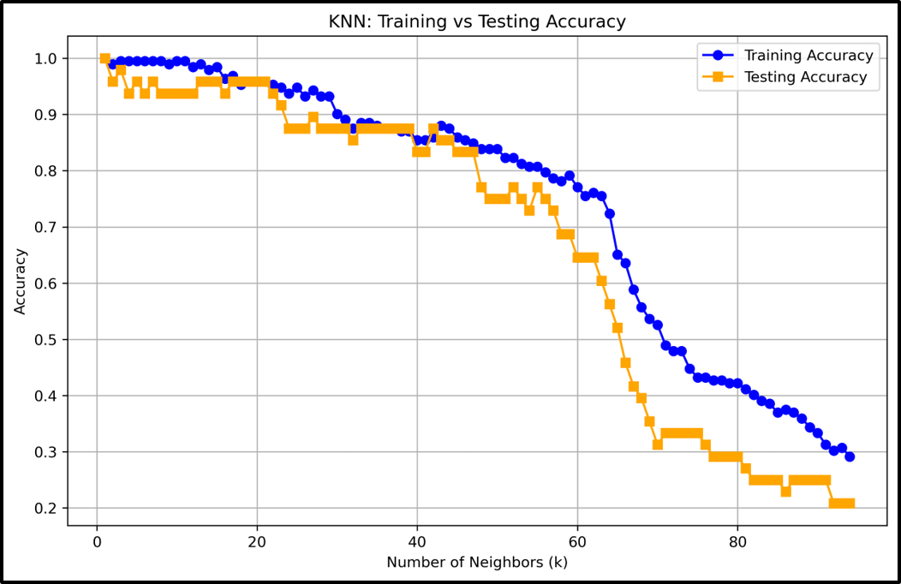
The confusion matrix on the right is the model’s performance on the testing set. It performed a little worse than the training set, but it is to be expected and is a good sign. Our model did not overfit on the training and was capable on predicting unseen data. It had an overall accuracy of 95.83%, a similar result from the Decision Tree model. It also shows that our implementation of KNN onto this dataset is a very good fit for classifying and predicting star types. But this is only one iteration with a K=5, I was interested in seeing how in performed on however many K’s from 1 to however much the program could handle. Hence, many different experimentations of differing Ks with train and test accuracy presented in the line graph below.
At a K=1, the model had a perfect accuracy of 100% for both the training and testing set.
Predicting Star Types using OPTICS:
*****xxx

