

**Higher Diploma in Science**

**in Computer Science (Level 8)**

**June Onsite**

**2018**

**Programme Handbook**

**14th and 15th June**

**School of Lifelong Learning & Education**

**Waterford Institute *of* Technology**



**Table of Contents**

Welcome to the new look ICT Skills Summer School. 3

Summer School Dates 4

Overall Programme Schedule 4

Speaker Biographies 7

John Daly - CGM 9

Brian Robinson - Dataworks 10

Owner Dataworks Ltd Ireland 10

Aine de Leastar - FundRecs 11

Michael Foy - FundRecs 12

Claire Hennebry - FundRecs 13

Colm Carew - Errigal 14

Bernard Butler - TSSG 15

Shane McCormack - Sunlife Financial 16

Claire Kelly - se2 17

Ger Ryan - Red Hat 18

Aiden Keating - Red Hat 19

Staff Contact Details 20

## Welcome to the June ICT Skills Onsite

This is the 6th year the summer school has run in Arclabs in Carriganore. In this year’s version, we will have variety of workshops, each with a distinct focus. These workshops will further evolve your core programming, computer systems, database skills and explore areas we haven’t encountered in the programme so far. They will also expose you to some of the Industry partners we work with on the Programme – giving you a flavour of their interests and opportunities. The intention of the Summer School is to give you the space and time to get into the discipline in more depth, without the pressing deadlines and assessments that have been part of your experience in semester 1.

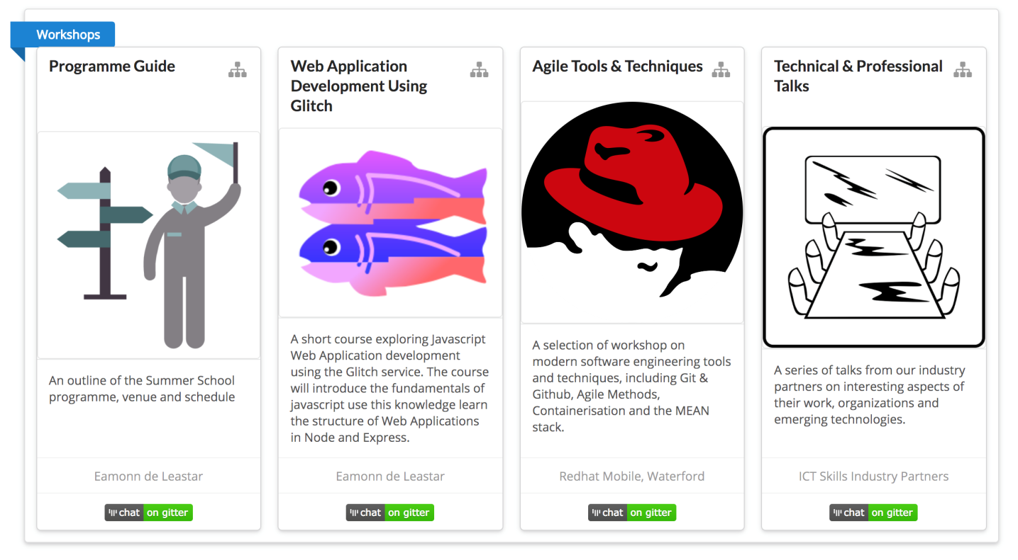

We hope the experience will be rewarding and the content stimulating. We also hope that you can take advantage of the Arclabs location to meet and mingle with researchers, software engineers and entrepreneurs who work here. Indeed, you will find many past pupils of the ICT Skills programme!

Best of Luck

Eamonn de Leastar

## **Summer School Dates**

## Overall Programme Schedule

The summer school will run over a 2-day period commencing on Thursday, **June 14thand concluding on Friday 15th June 2018** in the ArcLabs Board Room in Carriganore**.**

**Schedule:**

**Thursday:**

09:00 - 09:30: Welcome + Agenda (work placement overview)

09:30 - 01:00: Computer Systems Workshop (Frank Walsh and Caroline Cahill)

14:00 - 14:30: CGM

14:30 - 15:00: Dataworks

15:00 – 15:30: Break

15:30 - 16:00: Fundrecs

16:00 - 16:30: Errigal

**Friday:**

09:00 - 09:30 TSSG

09:30 - 11:30: Database Workshop (Rosanne Birney and Mary Lyng)

12:00 - 12:30: Sunlife

12:30 - 13:00: SE2

14:00 – 17:00: ICT Skills Workshop I (in association with Red Hat)

15:00: Break

15.30 – 17:00 ICT Skills Workshop II (in association with Red Hat)

The purpose of the summer school is to

• Continue with Programming / Databases /Computer Systems

• Potentially follow up and interact with TSSG Researchers and local companies

• Read and think! (with a bit of learning!) FTG24 in the main campus will be available on these days should you wish to use WIT facilities

* Commence placement preparation through developing your CV, LinkedIn Profile and start NETWORKING!
* Or start scoping out project ideas with your employer.

**Seminar Series Thursday 14th and Friday 15th June**

|  |  |  |  |
| --- | --- | --- | --- |
| Date/Time | Presenter | Organisation | Topic |
| Thursday 14th June | | | |
| 14.00 – 14.30 | **Gerard Kehoe /John Daly** | **CGM** | **‘IT roles in CGM & Managing process improvements’** |
|  |  |  |  |
| 14.30 – 15.00 | **Brian Robinson** | **Dataworks** | **‘Redefining Possibilities - a day in the life of a Custom Software Development Company’** |
| Q&A & Tea break |  |  |  |
| 15.30 – 16.00 | **Aine de Leastar/Michael Foy/Claire Hennebry** | **FundRecs** | **‘Entering the Workplace 101’** |
|  |  |  |  |
| 16.00 – 16.30 | **Colm Carew** | **Errigal** | **‘Errigal - Who We Are & What We Do’** |

|  |  |  |  |
| --- | --- | --- | --- |
| Date/Time | Presenter | Organisation | Topic |
| Friday June 15th June | | | |
| 09.00 – 09.30 | **Bernard Butler** | **TSSG** | **‘Challenges of the Internet of Things and Big Data’** |
|  |  |  |  |
| 12.00 – 12.30 | **Shane McCormack** | **Sunlife** | **‘Managing a multi-site development team’** |
|  |  |  |  |
| 12.30 – 13.00 | **Claire Kelly** | **SE2** | **‘SE2– Our Mission and Vision’** |
| 13.00 – 14.00 LUNCH |  |  |  |
| 14.00 – 15.00 | **Ger Ryan/Aiden Keating** | **Red Hat** | **‘ICT Skills Workshop Part 1’** |
| 15.00 – 15.30 | **Break** |  |  |
| 15.30 – 17.00 | **Ger Ryan/Aiden Keating** | **Red Hat** | **‘ICT Skills Workshop Part 2’** |

## Speaker Biographies



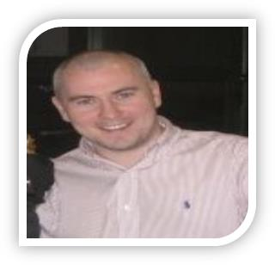

**Gerard Kehoe -­ CGM**

**General Manger**

**Company Profile:**

CGM, LLC is a software development firm that designs, develops, and delivers software systems and outsourced solutions to Telecom Service Providers in the United States.   
CGM has developed a wide variety of Revenue Assurance and Cost Analysis software systems, which automatically audits and generates credit requests for Wholesale Telecom Invoices; provides customized Collection and Management Reporting for billing; and provides editing, auditing, and tracking of Lifeline Reimbursement requests. In addition CGM offers many customized solutions involving provisioning, Help Desk, and product line profitability analysis.

The main functions of the Irish operation in Waterford include quality assurance, testing, project planning and support development activities for CGM’s online enrolment and auditing systems.

**Personal Profile:**  Gerard has been in his role from March 2016 to present.  His duties include the creating, staffing and managing the CGM Office in Ireland.  Previously he was Director of IT at Sun Life Ireland and then Delaware Life from 2005 to 2016, which involved managing all Analysis needs for the Annuities and Life US business.  He also worked as a Senior Software Engineer with Ericsson from 1998-2005, which involved QA and BSA roles on both AXE and mobile platforms.  Gerard graduated with a degree in Applied Computing from Waterford Institute of Technology in 1998 and also completed a Diploma in Project Management from Institute of Project Management of Ireland in 2016.

**Contact Details:**

**Address:** ArcLabs, WIT West Campus, Carriganore, Waterford.

**Web:**               [https://www.cgmllc.net/](http://https/www.cgmllc.net/)

**Email:**              [Gerard.kehoe@cgminc.com](mailto:Gerard.kehoe@cgminc.com)



## John Daly - CGM

**Senior Project & Release Planner**

**Company Profile:**

CGM, LLC is a software development firm that designs, develops, and delivers software systems and outsourced solutions to Telecom Service Providers in the United States.   
CGM has developed a wide variety of Revenue Assurance and Cost Analysis software systems, which automatically audits and generates credit requests for Wholesale Telecom Invoices; provides customized Collection and Management Reporting for billing; and provides editing, auditing, and tracking of Lifeline Reimbursement requests. In addition CGM offers many customized solutions involving provisioning, Help Desk, and product line profitability analysis.

The main functions of the Irish operation in Waterford include quality assurance, testing, project planning and support development activities for CGM’s online enrolment and auditing systems.

**Personal Profile:**

John has been in his role from August 2016 to present.  His duties include the gathering requirements and planning software releases at CGM.  Previously he was Business Analyst and Team Manager at Sun Life Ireland and then Delaware Life and SE2 from 2008 to 2016, which involved Business Analysis and Testing needs for the Annuities and Life US systems. John graduated with a degree in Business Information Systems from University College Cork in 2006.

**Contact Details:**

**Address:** ArcLabs, WIT West Campus, Carriganore, Waterford.

**Web:**               [https://www.cgmllc.net/](http://https/www.cgmllc.net/)

**Email:**              [John.Daly@cgminc.com](mailto:John.Daly@cgminc.com)

Dataworks Email Signature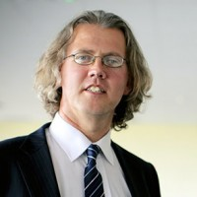

## Brian Robinson - Dataworks

## Owner Dataworks Ltd Ireland

**Company Profile:**  Dataworks applies technology to drive real change, improved efficiencies and cost reduction for its customers. We redefine possibilities – what’s possible with technology, and what’s possible in your organisation by the correct application of technology to continuous improvement initiatives. Dataworks uses a unique hybrid of custom software solutions and market leading commercial off the shelf software to deliver innovative solutions to our clients, including automation, manufacturing intelligence, mobile and cloud based solutions.

**Specialties:** Software Development, Software Validations, Continuous Improvement through the application of technology, Business Process Automation.

**Personal Profile:**  For the last fifteen years, Brian has been one of the main Project Management resources at Dataworks. Projects have ranged from small internal software development projects to large inter-department business re-engineering projects.   
Brian’s experience gained from working with many diverse companies coupled with his knowledge of software development and his inherent problem solving ability gives him a unique perspective. For over fifteen years, Brian has been designing Software Systems that not only meet the user requirements but do so in a user-friendly and intuitive way. He has been trained in various methodologies including UML and has developed the templates and procedures that are used in Dataworks. Although not involved as much in development Brian has many years of experience mainly using Microsoft Visual Basic from version 3 up to .Net 2008. His specialties include: Business Process Automation, SPC Integration, Microsoft Dynamics CRM Design and Implementation.

**Contact Details:**

**Address:** Unit 4i, Six Cross Roads Business Park, Waterford, Ireland

**Web:** [www.dataworks.ie](http://www.dataworks.ie/)

**E-mail:** [brobinson@dataworks.ie](mailto:brobinson@dataworks.ie)

## Aine de Leastar - FundRecs

**Software Developer**

****Having completed a Bachelor’s Degree in Social Science, major in Social Policy and minor in Sociology in 2013, I found it very difficult to get a job in my chosen field outside Dublin. Having a lifelong interest in computers and technology, that I had never acted upon officially, I decided to succumb to advice received from a well-informed relative and applied for the Higher Diploma in Science in Computer Science. I loved the course, found it tough going but have fared well landing a fulltime position from my internship with FundRecs and now work alongside a fellow graduate from the course, Claire Hennebry.

In our company we use Groovy on Grails and JQuery along with SQL databases to build financial reconciliation software on the cloud using Amazon Web Services. Part of my internship is/was to develop a Proof of Concept of a new module for two clients, and at the time of writing this it is still ongoing. It is really interesting, engaging work which keeps me on my toes and helps me to constantly learn and evolve the tech side of my brain. Having not come from a technological background at all I’ve found it surprisingly easy to adjust to the environment and work and couldn’t imagine myself in any other field than IT now.

**Contact Details:**

**Address:** ArcLabs Research & Innovation Building, WIT West Campus, Carriganore, Co. Waterford

**Web:** <https://www.fundrecs.com>

**Email:** [aine@fundrecs.com](mailto:aine@fundrecs.com)

## Michael Foy - FundRecs

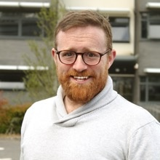**Company Profile:**

Fund Recs was founded in 2013 when the company founders were approached by a large bank to develop a new reconciliation platform for it's Fund Administration unit. With over 25 years operational and technology experience between them the team are building a platform to transform how data is managed, processed and leveraged by the Funds Industry.

Fund Recs recently launched [VELOCITY](https://www.fundrecs.com/velocity.html) platform for Fund Administrators empowers Administrators to process valuations faster and with increased oversight. Taking the latest technology and approaches from the best loved consumer software applications, the Fund Recs team are combining consumer user experience and interfaces with enterprise accuracy, security and availability.

The team at Fund Recs believes that the software we use in day-to-day business activities should be as well designed and easy to use as the consumer applications we enjoy every day in our personal life.  By combining ease of use with powerful processing, flexible data import and key Industry knowledge we have set out on our mission towards developing the most efficient, powerful and cost effective reconciliation software available.

**Personal Profile:**

Michael is currently on placement with Fund Recs as an intern from the ICT Skills Diploma in Computer Science at WIT. Previous to the course in WIT, Michael completed a degree in Fine Art from CIT and spent many years abroad as an English teacher before developing an interest in web and software development. As a member of the Fund Recs team, Michael has been honing his skills as a developer and has been learning about the system across the stack in addition to contributing to production code.

“I had spent some years abroad teaching English following a degree in Fine Art from CIT, when I developed an interest in web design and programming. Upon finding myself at a crossroads in 2015 I undertook the course of which you are now participants at WIT. Having enjoyed the course  I started as an intern with Fund Recs in January, and since then have been busy learning their system and contributing to the source code. As part of my internship with Fund Recs I have also been tasked with developing an updated and improved version of an existing module of their system.”

**Contact Details:**

**Web:** [**https://www.fundrecs.com/**](https://www.fundrecs.com/)

**Email:** [**michael@fundrecs.com**](mailto:michael@fundrecs.com)

## Claire Hennebry - FundRecs

**Company Profile:**

Fund Recs was founded in 2013 when the company founders were approached by a large bank to develop a new reconciliation platform for it's Fund Administration unit. With over 25 years operational and technology experience between them the team are building a platform to transform how data is managed, processed and leveraged by the Funds Industry.

Fund Recs recently launched [VELOCITY](https://www.fundrecs.com/velocity.html) platform for Fund Administrators empowers Administrators to process valuations faster and with increased oversight. Taking the latest technology and approaches from the best loved consumer software applications, the Fund Recs team are combining consumer user experience and interfaces with enterprise accuracy, security and availability.

The team at Fund Recs believes that the software we use in day-to-day business activities should be as well designed and easy to use as the consumer applications we enjoy every day in our personal life.  By combining ease of use with powerful processing, flexible data import and key Industry knowledge we have set out on our mission towards developing the most efficient, powerful and cost effective reconciliation software available.

**Personal Profile:**

After completing a B.A. in History and Politics and a M.A. in Law and Government I found that job opportunities were slim and without experience virtually impossible to get. In order to increase my desirability as a candidate I undertook a night course in Databases with SQL at the School of Lifelong Learning and Education in WIT. It was while completing this course that I became interested in computing and applied for the Higher Diploma in Science in Computer Science in WIT.

As part of the course I did 6 months’ work experience with Fund Recs. Once the placement finished, the team offered me a permanent full-time contract as a Software Developer: a role I have held since. We work primarily in Groovy/Grails and JQuery building cloud solutions to financial reconciliation. During my time in Fund Recs I have built new modules for the company, which are being used by all our clients; added features to our existing products; helped put in place release guidelines; documented Fund Recs products and releases; undertook troubleshooting and bug fixes; met with clients to help shape business requirements for new products; researched new technologies; and built multiple POCs for a potential clients.

**Contact Details:**

**Web:** [**https://www.fundrecs.com/**](https://www.fundrecs.com/)

**Email:** [**claire@fundrecs.com**](mailto:claire@fundrecs.com)



## Colm Carew - Errigal

**Test Engineer**

**Errigal Factoids:**

• Located in Silicon Valley

• Founded in 1996

• Telecom expertise sets our software apart

• Extremely high quality and customer satisfaction

• Mobile network management software and DAS NOC support

**Company Profile:** Headquartered in Silicon Valley, with a development office in Waterford, Ireland, Errigal delivers operations and support system (OSS) software to the mobile network industry. Since 1996, Errigal has developed a reputation for robust and trusted solutions in the Network/Fault Management, Performance Management and Configuration Management/Inventory arenas.

Errigal is a specialist in Distributed Antenna System (DAS) Network monitoring. Our specialist

monitoring software monitors more DAS nodes than anyone else in the business. With substantial engineering expertise grounded in the telecom industry, Errigal has developed

products and services that can be employed in multi-vendor, mission critical network environments.

**Personal profile:**

Colm Carew is a Software Engineer with Errigal. Colm joined the company in June 2015 having completed his BEng (Hons) in Electronic Engineering at WIT and is currently undertaking the MSc. In Communication Software. Colm’s main role is that of a full stack developer for Errigal’s suite of applications. His role involves the design and implementation of UIs, APIs, Data Modelling and various Scripting/Automation tasks. Languages & Technologies include: React, Spring Boot, Java, Ansible, Groovy, Grails, Tomcat, MySQL. The most recent project Colm has worked on is using Ansible to automate the creation of development and testing databases as to greatly reduce manual effort.

**Address:** 10 Wallace House, Canada Street, Waterford

**Web:** <http://www.errigal.com>

**Email:** [colm.carew@errigal.com](mailto:colm.carew@errigal.com)

TSSG logo

## Bernard Butler - TSSG

**Senior Researcher TSSG**

TSSG is an internationally-recognised centre of excellence for **ICT research and innovation.** It carries out a wide spectrum of industry-informed research in Information and Communications Technologies (ICT), particularly technologies enabling communications and information services.

Its technical research areas include Mobile Platforms and Services,Data Analytics and Social Computing,  Adaptive Networks and Services, Emerging Network paradigms and Augmented and Virtual Reality (AR/VR). TSSG creates economic impact by translating its knowledge and innovation into leading edge products and services, engaging with Industry in collaborative R&D, knowledge generation and transfer.

Over the past five years, TSSG delivered innovative solutions to over 210 start-ups based in Ireland and has worked extensively with multinationals such as IBM, Intel and Cisco through its world class research programmes, such as the Science Foundation Ireland (SFI) [Connect Centre.](https://www.tssg.org/research/connect-centre-page/) TSSG  has also created 14 spin out companies, including the award-winning  [FeedHenry,](http://www.feedhenry.com/)a ground-breaking mobile cloud platform company (acquired by RedHat NYSE: RHT in 2014 for €65 million), [KodaCall](http://www.kodacall.com/) a new ‘Click to Call’ Technology and [Immersive VR Education](http://immersivevreducation.com/), a leader in Virtual Reality education technologies, such as the award-winning Apollo 11 experience.

**Personal Profile:**

Bernard is a postdoc in the Emerging Networks Laboratory, currently (co-)supervising 4 PhD students and assigned to the SFI-funded CONNECT Research Centre. Current research interests include resource management in networks (especially near the network edge)

performance modelling and prediction of networks and systems (e.g., in fog computing),

knowledge engineering (e.g., for rule-based system specification and optimisation), machine learning (e.g., for deriving control actions from network and system monitoring data), ensuring privacy and other user rights are maintained as data is collected and used (e.g., from IoT sensors)

Bernard has an MSc in Applied Maths from UCC and an MSc in Communication Software from WIT. His PhD thesis related to specifying access controls in IT systems, predicting their performance, and using this knowledge to specify better access controls.

**Contact:** [www.tssg.org](http://www.tssg.org), +353 51 84 5695, [bbutler@tssg.org](mailto:bbutler@tssg.org)



## Shane McCormack - Sunlife Financial

**Director of Application Development at Sun Life Financial**

**Company Profile:**

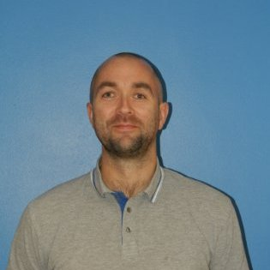Sun Life Financial, is a leading global financial services organisation with 150 years experience. We provide a diverse range of wealth accumulation and insurance products. You'll find us just about everywhere including Canada, the U.S., the U.K., Ireland, Hong Kong, the Philippines, Japan, Indonesia, India, China, Australia, Singapore, Vietnam, Malaysia and Bermuda.

In Ireland, Sun Life Financial is based in the vibrant city of Waterford in the sunny South East. Employing 310 people (at December 31, 2014), our Waterford office provides software development, business administration and technical service desk services to our North American and International divisions.

**Personal Profile:**

Shane has over 14 years of industry experience in the J2EE world in both the telecommunications and financial sector. Specialties: Java 1-8, J2EE, JPA, Hibernate, Spring, MQ Series, SQL, JSP, Drools, Flex, CF, UML.

Shane graduated with a bachelor degree in Information Technology and Telecommunications from University of Limerick in 200, and he was further awarded a **MSc in Telecommunications and Software** at Waterford Institute of Technology in 2003.

Other qualifications: PRINCE 1 certification in Project Management.

**Email:** [**Shane.McCormack@sunlife.com**](mailto:Shane.McCormack@sunlife.com)

**Web:** [**https://www.linkedin.com/in/shane-mccormack-88b7b112/?ppe=1**](https://www.linkedin.com/in/shane-mccormack-88b7b112/?ppe=1)



## Claire Kelly - se2

**Manager IT & Analysis**

**Company profile:**

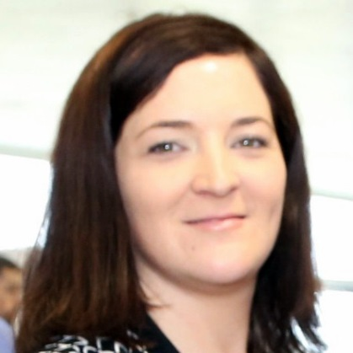SE2 is a leading technology and third party administration company focused on the North American life and annuity insurance industry. SE2 has an unmatched track record in optimizing back-office operations to future-proof insurance companies. SE2 combines peerless industry domain knowledge with a leading-edge administration technology platform to help clients launch products rapidly, improve efficiencies, shift to a variable cost model and maximize profits while dramatically improving the customers’ experience. SE2 supports more than 20 direct clients, represents more than 35 carriers in North America and services more than 1,000 life and annuity products. SE2 has approximately $100 billion in assets under administration and has been recognized as an industry-leading innovator.

Personal Profile:

Claire Kelly is Business Analysis Senior Manager at SE2 leading a team of associates in Ireland and across the US. She has over fifteen years’ experience in the Financial Services industry focusing on IT solution and design. Prior to joining SE2 she worked in various IT roles in Waterford Institute in Technology, Dawn Meats Group, Sunlife Financial and Delaware Life. She graduated with honours and was awarded a BA in Economics and Computer Science and an MSc in Computer Science from University College Cork. In addition to her management, solutionist and designer role she is also a wife, mother and mentor. On the rare occasion that she has spare time she really likes writing about herself in the third person!

**Contact details:**

Web: <http://se2.com/>

Email: [Claire.Kelly@se2.com](mailto:Claire.Kelly@se2.com)

## http://blogs-images.forbes.com/kurtmarko/files/2014/06/redhat-logo.jpgGer Ryan - Red Hat

**Associate Software Engineer**

**Company Profile:**

Red Hat is the world's leading provider of open source solutions.

We help more than 90% of Fortune 500* companies to solve business challenges, align their IT and business strategies, and prepare for the future of technology. We do this by providing secure solutions through an open business model and an affordable, predictable subscription model.

**Personal Profile:**

Ger is an engineer on the mobile team at Red Hat. He is a free (libre) software and open standards enthusiast. In his spare time he contributes to an open source operating system called Fedora, where he learned to use Git before he learned to write any code!

**Address:** Communication House, Cork Road, Waterford

**Web:** <https://www.redhat.com/en>

**Email:** [gryan@redhat.com](mailto:gryan@redhat.com)

## http://blogs-images.forbes.com/kurtmarko/files/2014/06/redhat-logo.jpgAiden Keating - Red Hat

**Associate Software Engineer**

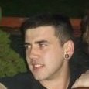**Company Profile:**

Red Hat is the world's leading provider of open source solutions.

We help more than 90% of Fortune 500* companies to solve business challenges, align their IT and business strategies, and prepare for the future of technology. We do this by providing secure solutions through an open business model and an affordable, predictable subscription model.

**Personal Profile:**

Aiden holds a BSc (Hons) in Applied Computing from Waterford Institute of Technology. Aiden has spent two years working as a Software Engineer within the Mobile Engineering team at Red Hat. Aiden has worked in areas such as mobile CI/CD tooling and data synchronisation. His current work is in client-side SDK development, mainly developing software for Android, iOS and Xamarin mobile applications.

**Address:** Communication House, Cork Road, Waterford

**Web:** <https://www.redhat.com/en>

**Email:** [akeating@redhat.com](mailto:akeating@redhat.com)

## 

## Staff Contact Details

**Martina Mullally Eamonn de Leastar**

ICT Skills Placement Coordinator Course Leader – HDIP in Science in Comp. Science

School of Lifelong Learning & Education Department of Computing, Maths & Physics

Waterford Institute of Technology Waterford Institute of Technology

Cork Road Cork Road

Waterford Waterford

**Tel:** 051-302849

**Email:** [mmmullally@wit.ie](mailto:mmmullally@wit.ie) **Email:** [edeleastar@wit.ie](mailto:edeleastar@wit.ie)

**Web:** [www.wit.ie](http://www.wit.ie) **Web:** [www.wit.ie](http://www.wit.ie)

 