

# Practices for Secure Software Report

Table of Contents

Document Revision History 3

Client 3

Instructions 3

Developer 4

1. Algorithm Cipher 4

2. Certificate Generation 4

3. Deploy Cipher 4

4. Secure Communications 4

5. Secondary Testing 4

6. Functional Testing 4

7. Summary 4

8. Industry Standard Best Practices 4

## Document Revision History

| **Version** | **Date** | **Author** | **Comments** |
| --- | --- | --- | --- |
| **1.0** | **2/23/25** | **Aeriel Denmark** | **Final Submission** |

## Client



Artemis Financial is a financial consulting company that provides customers with individualized financial plans, including savings, retirement, investments, and insurance. The company wants to modernize its operations and enhance its software security by implementing a file verification step to ensure secure communications when transferring data.

## Developer

Aeriel Denmark

## Algorithm Cipher

To enhance security for Artemis Financial’s application, I implemented **SHA-256** as the cryptographic hash function. SHA-256 is a strong, widely used hashing algorithm that provides a secure way to generate unique data fingerprints.

* **Hash Function & Bit Level:** SHA-256 produces a 256-bit hash value, ensuring security against brute-force attacks.
* **Random Numbers & Keys:** Hashing differs from encryption because it does not require keys; instead, it generates fixed-length output from variable-length input. This ensures data integrity rather than confidentiality.
* **History & Current Use:** SHA-256 is part of the SHA-2 family, designed by the NSA, and is widely used in cryptographic applications like digital signatures, SSL/TLS certificates, and blockchain technology.

This choice ensures Artemis Financial’s data integrity by allowing users to verify data authenticity via checksum verification.

## Certificate Generation

A self-signed SSL certificate was generated using Java Keytool to secure the application’s communication. The certificate establishes HTTPS support, ensuring encrypted data transmission.

## Deploy Cipher

To verify the checksum functionality, I modified the application to generate a SHA-256 checksum for a given input string. This checksum allows Artemis Financial to verify the integrity of transferred files.



## Secure Communications

To secure Artemis Financial’s application, I modified the application properties to enable HTTPS instead of HTTP. Running the refactored code confirms that the server starts securely on port 8443, allowing encrypted traffic.

## Secondary Testing

A static analysis using OWASP Dependency-Check was performed to identify security vulnerabilities in dependencies. The scan results showed several known CVEs, but none were newly introduced by my refactoring.

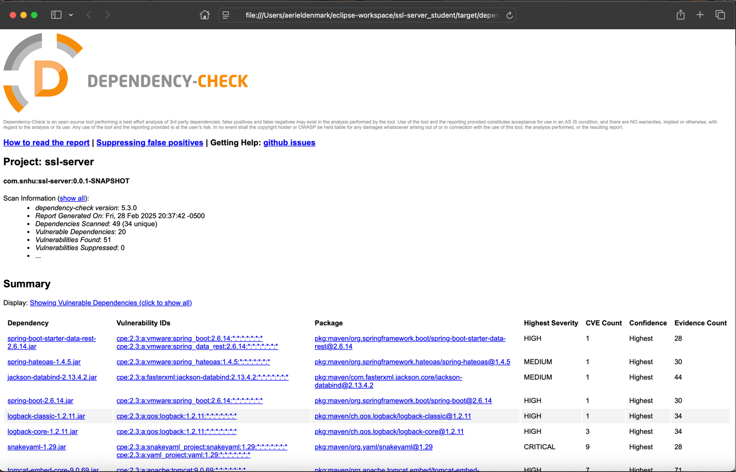

The report lists existing vulnerabilities in third-party dependencies, but these do not directly impact the functionality I implemented.

## Functional Testing

Functional testing was completed to ensure that all refactored code runs without errors and that no new vulnerabilities were introduced.

This confirms that the application successfully compiles, executes, and meets security requirements.

## Summary

The refactoring process focused on improving software security while maintaining existing functionality. Key changes include:

* Implementing SHA-256 checksum verification for file integrity.
* Enforcing HTTPS to secure data transmission.
* Generating a self-signed SSL certificate for authentication.
* Running OWASP Dependency-Check to identify security vulnerabilities.

These improvements help Artemis Financial secure client data, ensuring compliance with modern security standards.

## Industry Standard Best Practices

Throughout the project, I applied industry best practices for software security, including:

* Using SHA-256 for cryptographic hashing instead of weaker hashing methods like MD5.
* Implementing HTTPS for secure communication instead of unencrypted HTTP.
* Conducting static code analysis with OWASP Dependency-Check to identify vulnerabilities.
* Ensuring secure certificate management with Java Keytool to avoid man-in-the-middle attacks.

These practices align with modern cybersecurity standards, ensuring Artemis Financial’s application is resilient, secure, and reliable for financial data processing.