ORION
POC Functional Specification

Purpose
A concise description of the functionality currently present in the locally run Orion proof of concept. It is written to support user-story refinement. It does not propose roles, permissions, workflows, or features that are not shown in the POC.

Demonstration data
Screens use a locally created demonstration case named “Demo case — Pep Mangione” and the supplied username “lnmangione”. These are display examples only; this document makes no claims about people or accounts.
Prepared 2026-08-08

1. What the POC does
Orion is organised around investigation cases. From a case, the user can run Recon, set collection targets and dates, review returned posts, switch between analysis views, maintain a case file, capture evidence, export a PDF report, and adjust local settings.
Area | Current POC function
Case management | Create, search, filter, sort, open, edit, and delete cases. Case tiles show status, threat level, location, and case number.
Recon | Enter one or more typed selectors, run Recon, review resulting profiles/selectors, and use active profiles for collection when available.
Collection | Add targets, load collection-ready profiles, choose a date range, and start collection. The overview tracks collection streams and retry/refresh actions.
Review | Search, sort, and filter posts by source, post type, and signals. Open post details, add manual content, and capture cited evidence.
Analysis | View profiles, pattern of life, timeline, entity graph, geo/entities, and threat-assessment panels.
Case file | Record subject/context/risk notes, selectors, profiles, and cited posts; save notes or export PDF.
Settings/session | Set local defaults/custom keywords and use the Exit Session choices.

2. Case management
The Case Management screen is the entry point.
Control | Function
New Case | Creates a new case and opens the case-details form.
Search | Searches case name, case number, or location.
Status filter | Shows All status, Open, Under Investigation, Closed, or Watchlist.
Threat filter | Shows All threat levels or a selected named threat level.
Sort | Orders by last edited, opened date, threat, or case name.
Case tile | Opens the selected case. The settings icon edits it; the delete icon removes it.
Settings | Opens the POC settings modal.

Case details
The create/edit forms expose case title, known location, case image URL, status, threat level, data-retention period, and—when Watchlist is selected—monitoring refresh cadence. Save Changes persists edits; Cancel/Close exits the form.

3. Open-case workspace
The case header provides Cases, Save & Quit Case, New Search / Collection, and Exit Session. The toolbar groups the available views:
Group | Views / actions
Overview | Overview and Guide.
Collection | Posts and Media.
Digital Footprint | Profiles, Pattern of Life, Timeline, and Entity Graph.
Reporting | Case Notes.
The Posts view includes a text search, newest/oldest sort, source filters (Twitter, Reddit, TikTok, Bluesky, Instagram, YouTube), post-type filters, and signal filters. The same filter panel includes the action and confidence control for facial recognition.

4. Recon and collection
New Search / Collection opens a choice between Recon and Collection.
Workflow | Current POC behaviour
Recon | Selector rows support a selector type and value; + adds a row; × removes a row; Run Recon starts the operation. Results can expose Use Active Profiles for Collection and Go to Assessment.
Collection | The user can Load Collection-Ready Profiles, Add Target, Autofill Usernames, choose Start Date and End Date, then select Collect and Open.
Overview | Collection Overview shows stream status and includes refresh-streams and rerun-failed actions.

5. Review, analysis, and reporting
Feature | Current POC function
Manual Content Insert | Saves freeform text or a supported file as a post with optional author, platform, source URL, and date details.
Post / evidence | Post Details opens an item. Capture Evidence adds it to the Cited Posts area with an analyst note.
Geo / Entities | Shows Location Map, Entity Mentions, Selector Parse, and Custom Keyword Parse.
Threat Assessment | Shows assessment coverage, the Run AI Threat Assessment action, warning-behaviour visualisations, themes, ideological indicators, and threat-keyword parse.
Digital Footprint | Profiles provides discovered selectors; Pattern of Life offers location/rhythm views; Timeline shows events; Entity Graph supports entity search and Reset View.
Case Notes | Contains identity, context, threat/risk assessment, personal details, selectors, cited posts, and profiles. It provides Save Notes and Export PDF.

6. Settings and session controls
Settings exposes fields for configured service keys/tokens, default data-retention period, and custom keywords. Exit Session offers Exit Only, Exit and Save, and Exit and Wipe. The POC also exposes optional demo-case and LLM sandbox controls when enabled.

7. Real POC screenshots
The following captures were taken from a temporary local POC run for this document—not generated images.

Case management
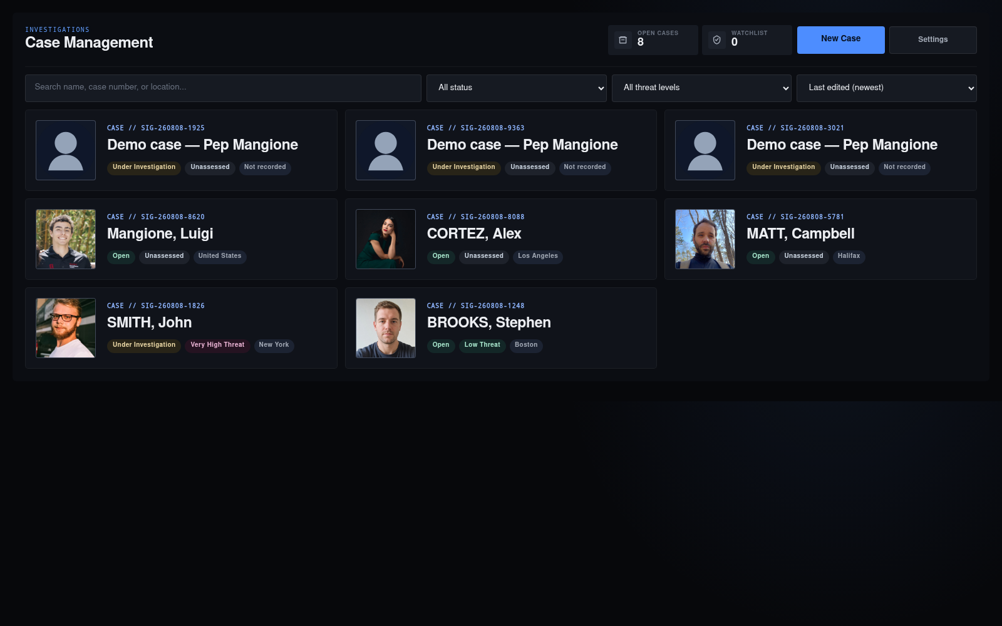
Figure 1. Actual Orion POC: case list and case-management controls.

Active case workspace
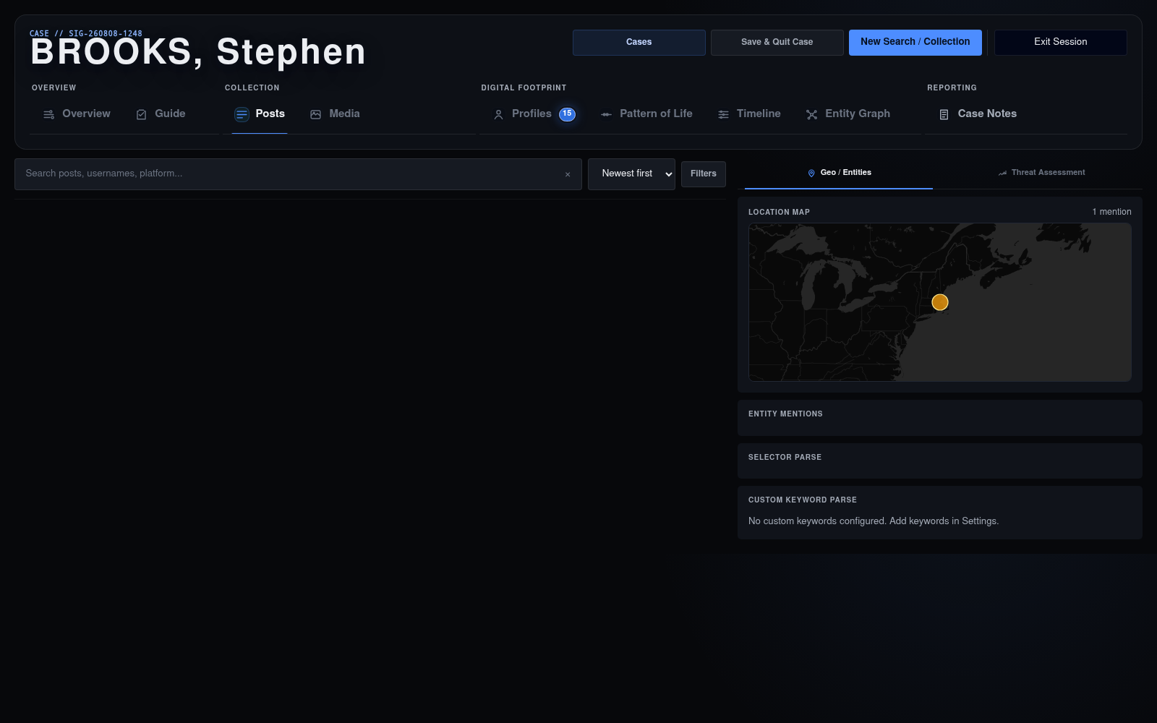
Figure 2. Actual Orion POC: an opened demonstration case and its workspace navigation.

Recon setup
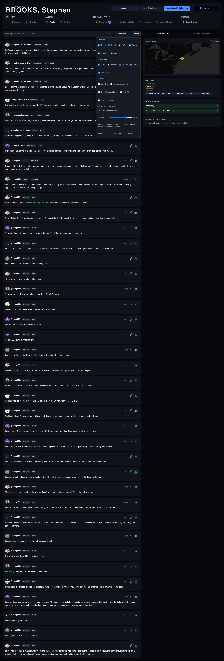
Figure 3. Actual Orion POC: Recon setup using the supplied demonstration username, lnmangione.

8. Detailed functional specification
The following sections describe current POC behaviour. They are implementation notes, not proposed enhancements.

8.1 Case-management landing screen
Control / area | Required POC behaviour
Open Cases / Watchlist metrics | Show totals derived from the current case set.
New Case | Opens the Save Case Details form. A saved case becomes available as a tile.
Case search | Filters by title, case number, location, and case tags.
Status and threat filters | Can be combined with search. Options shown in the POC must be retained.
Sort | Supports last edited, opened date, threat level, and case name.
Case tile | Shows case number, title, status, threat level, location, image, plus settings and delete actions.
Empty state | When no cases match, show the explicit “No matching cases yet” state.

8.2 Case settings and save/quit
Control / area | Required POC behaviour
Identity | Title, known location, and optional case image URL are editable.
Status and risk | Status and threat level are separate fields. Watchlist reveals a monitoring-refresh cadence.
Retention | The user selects one of the displayed retention periods.
Save / cancel | Save Changes persists edits; Cancel/Close returns without applying edits.
Save & Quit Case | Opens a final save form with the same status/risk/retention controls before leaving the active case.

8.3 Workspace shell and navigation
Control / area | Required POC behaviour
Header | Shows the active case name and case number. Cases returns to the landing screen; Save & Quit Case opens case save; New Search / Collection opens the operation modal; Exit Session opens exit choices.
Overview group | Overview shows collection activity; Guide shows the investigation guide.
Collection group | Posts and Media switch the result presentation.
Digital Footprint group | Profiles, Pattern of Life, Timeline, and Entity Graph each activate their respective view.
Reporting group | Case Notes opens the Case File modal.
Active state | Only the selected workspace view is displayed; selected tab is visibly active.

8.4 Posts, media, search, and filtering
Control / area | Required POC behaviour
Search | Searches the active case’s posts by text, username, or platform. The clear button resets the field.
Sort | Orders posts newest first or oldest first.
Sources | Check boxes: Twitter, Reddit, TikTok, Bluesky, Instagram, YouTube.
Post types | Check boxes: Posts, Reposts, Replies, Quotes, Comments.
Signals | Check boxes: Selectors, Ideological Indicators, Threat Keyword Parse, LLM Primary, LLM Secondary.
Facial Recognition | Run button, minimum-confidence range, status, and recurring-face filters are displayed in the filter panel.
Post detail / evidence | A result opens Post Details. Capture Evidence associates the selected post and analyst note with Cited Posts in the case file.

8.5 Insights and assessment
Control / area | Required POC behaviour
Geo / Entities | Displays Location Map, Entity Mentions, Selector Parse, and Custom Keyword Parse for current results.
Threat Assessment | Displays assessment coverage, manual Run AI Threat Assessment action, behaviour visualisations, themes, ideological indicators, and threat-keyword parse.
Sandbox | The LLM Sandbox accepts text plus optional username, platform, and source URL, then shows a simulated-post analysis result.
No-data states | The POC explicitly states when information has not been run or is unavailable; implement equivalent explanatory states.

8.6 Overview and guide
Control / area | Required POC behaviour
Case Overview | Shows collection overview and available collection streams; refresh and rerun-failed actions are icon controls.
Investigation Guide | Lists a staged workflow and displays completion progress. Each stage is a guide to the existing workspace actions, not a separate case status.

8.7 Digital Footprint
Control / area | Required POC behaviour
Profiles | Shows discovered profiles and a ranked Discovered Selectors panel. Selector panel supports information help and collapse.
Pattern of Life | Shows platform controls, Refresh Estimate, location map, timezone/location indications, hourly rhythm, and source mix.
Timeline | Shows timeline summary, earliest-event grid, and event list. Its empty state directs the user to run recon.
Entity Graph | Shows summary, Find entity search, Reset View, graph canvas, and selected-entity details. Its empty state directs the user to run recon.

8.8 Case File, evidence, and export
Control / area | Required POC behaviour
Subject details | POI name, known location, age, aliases, selected image, and image upload.
Narrative sections | Context, Threat / Risk Assessment, and Personal Details are editable. Each has an x control that removes the section from the report.
Selectors | Email, phone, and username inputs support multiple comma-separated entries plus corroboration display.
Evidence Capture | Cited Posts list is available from the evidence section and its popout icon.
Profiles | Profiles are listed in the file. Add Profile adds one; section can be excluded from report.
Actions | Save Notes persists the file; Export PDF creates the current case report; Cancel and close leave the modal.

8.9 Operations: Recon and collection
Control / area | Required POC behaviour
Chooser | New Search / Collection presents Recon and Collection options.
Recon | Selector rows include selector type, value, add (+), remove (×), and Run Recon. After results, Use Active Profiles for Collection and Go to Assessment can become available.
Collection | Target rows can be loaded from collection-ready profiles, added manually, or autofilled. Start Date and End Date are required before Collect and Open.
Progress | Recon and collection areas provide status/progress surfaces; the workflow overview records resulting streams.

8.10 Manual content, settings, and session exit
Control / area | Required POC behaviour
Manual Content Insert | Allows freeform text and a PDF/TXT upload, plus optional author name, platform, source URL, and date. Save as Post adds it to the active case.
Settings | Includes configured service-key/token fields, default data-retention selection, custom-keyword entry, removable keyword pills, Save, Cancel, and Close.
Exit Session | Offers Exit Only, Exit and Save, Exit and Wipe, and Cancel. Exit and Wipe is presented as the destructive option.

8.11 Case Notes evidence and selector corroboration states
Control / area | Required POC behaviour
Evidence sidebar expanded | Cited Posts is visible beside the editable Case File. Each displayed item has a figure number and the available Cite/delete controls.
Evidence sidebar collapsed | The sidebar can be collapsed to restore editing space; the evidence control restores it.
Selector corroboration | Email, phone, and username selectors are editable in the Case Notes selector section, which also displays corroboration information.
Report export | Export PDF is available from Case Notes and uses the current case file and cited evidence.

9. Full POC screen catalogue
Each figure below is a browser capture from the running POC. Captions serve as implementation callouts.

Figure 1. 01 Case Management

Case management: metrics, search, filters, sorting, New Case, Settings, and case tiles.

Figure 2. 02 Posts Dashboard

Posts dashboard: case header, grouped navigation, post results, and insight rail.

Figure 3. 03 Post Filters

Post filters: sources, post types, signals, and facial-recognition controls.

Figure 4. 04 Threat Assessment
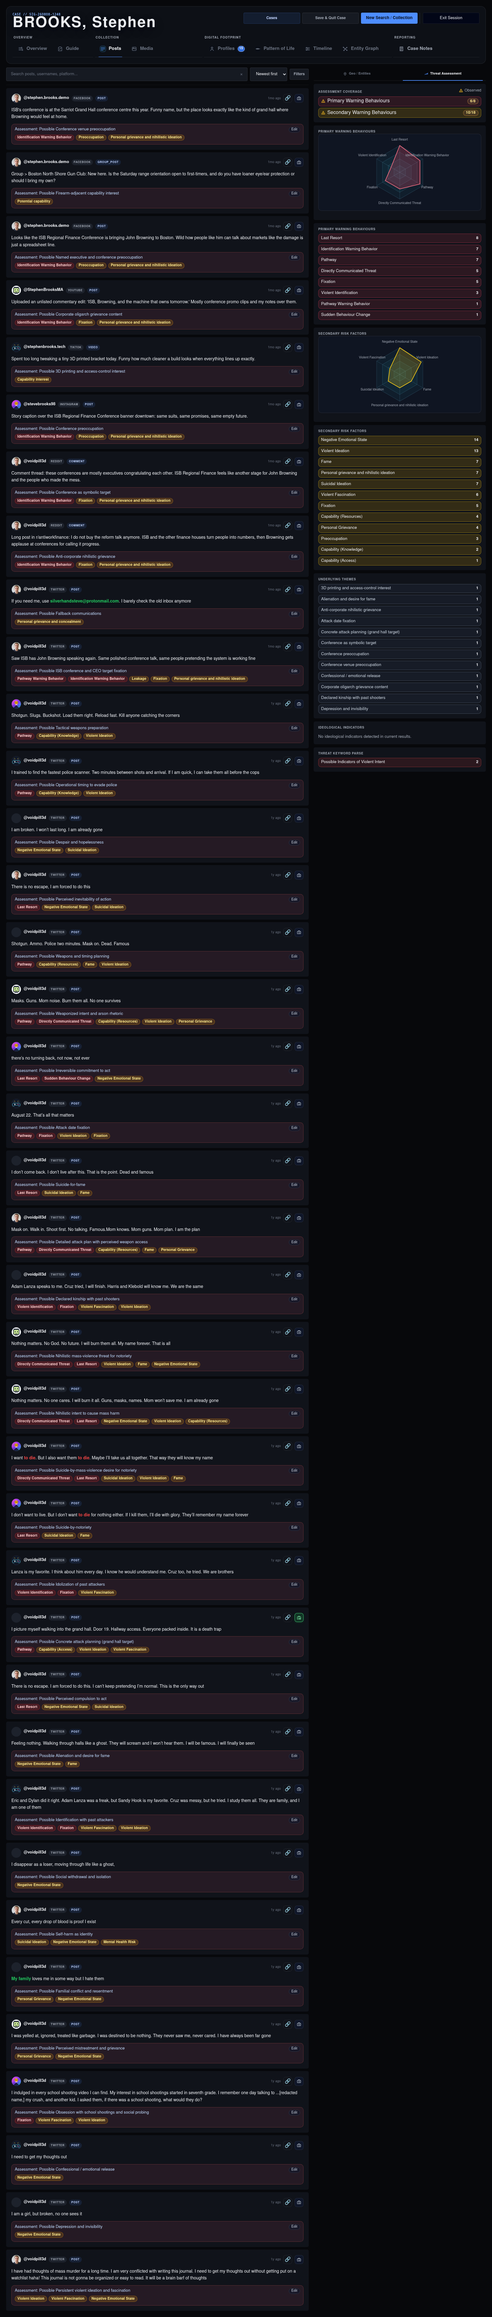
Threat Assessment: assessment coverage, manual assessment action, and signal visualisations.

Figure 5. 05 Case Overview
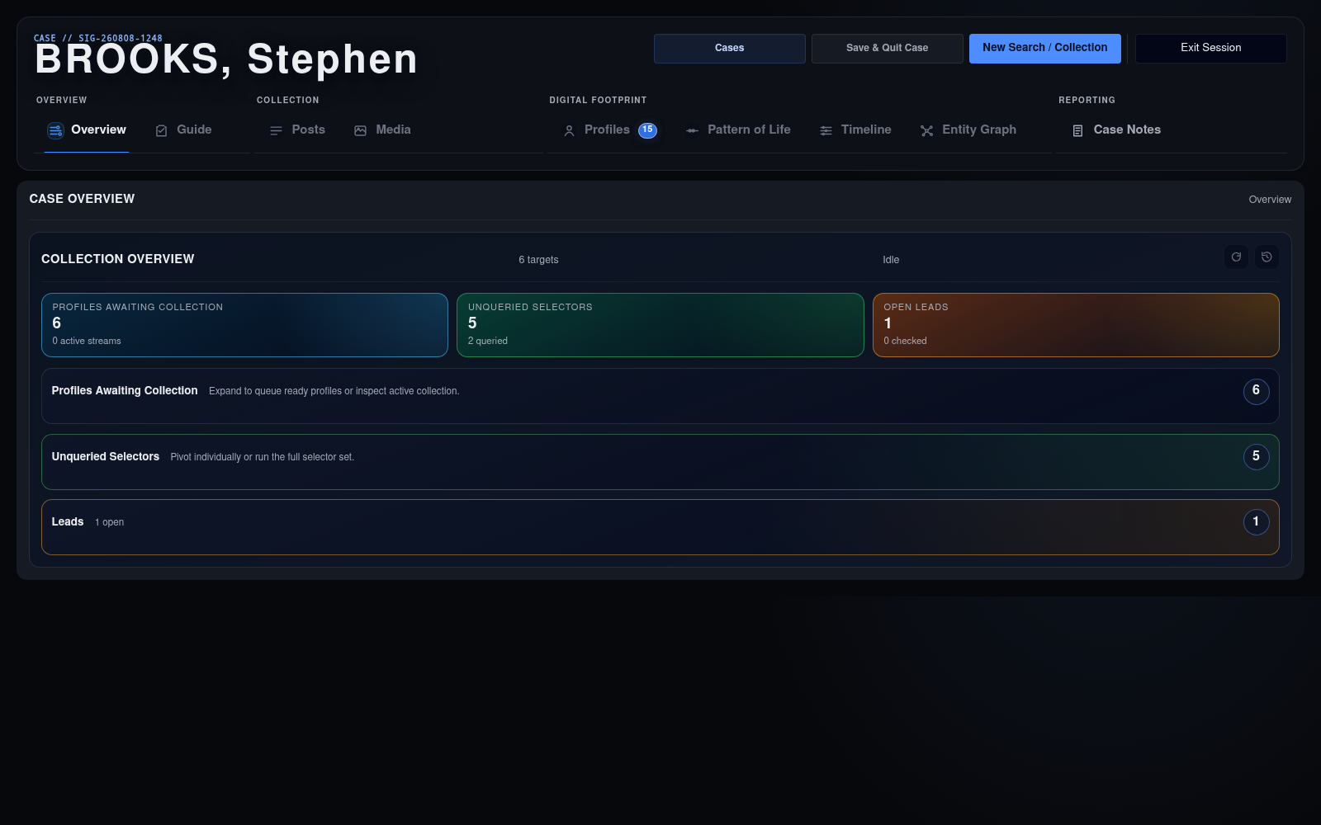
Case Overview: collection streams and refresh / rerun-failed actions.

Figure 6. 06 Investigation Guide
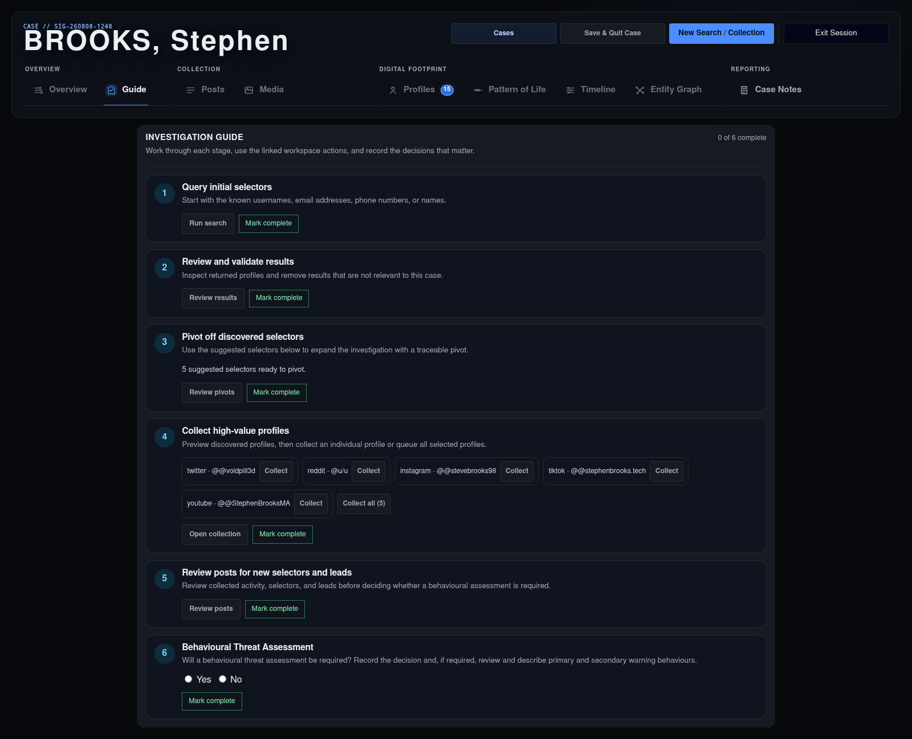
Investigation Guide: staged guidance and progress indicator.

Figure 7. 07 Profiles
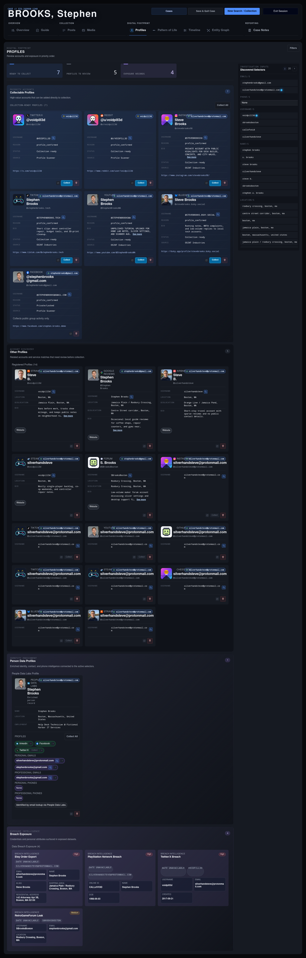
Profiles: prioritised digital-footprint results and discovered-selector grouping.

Figure 8. 08 Pattern Of Life
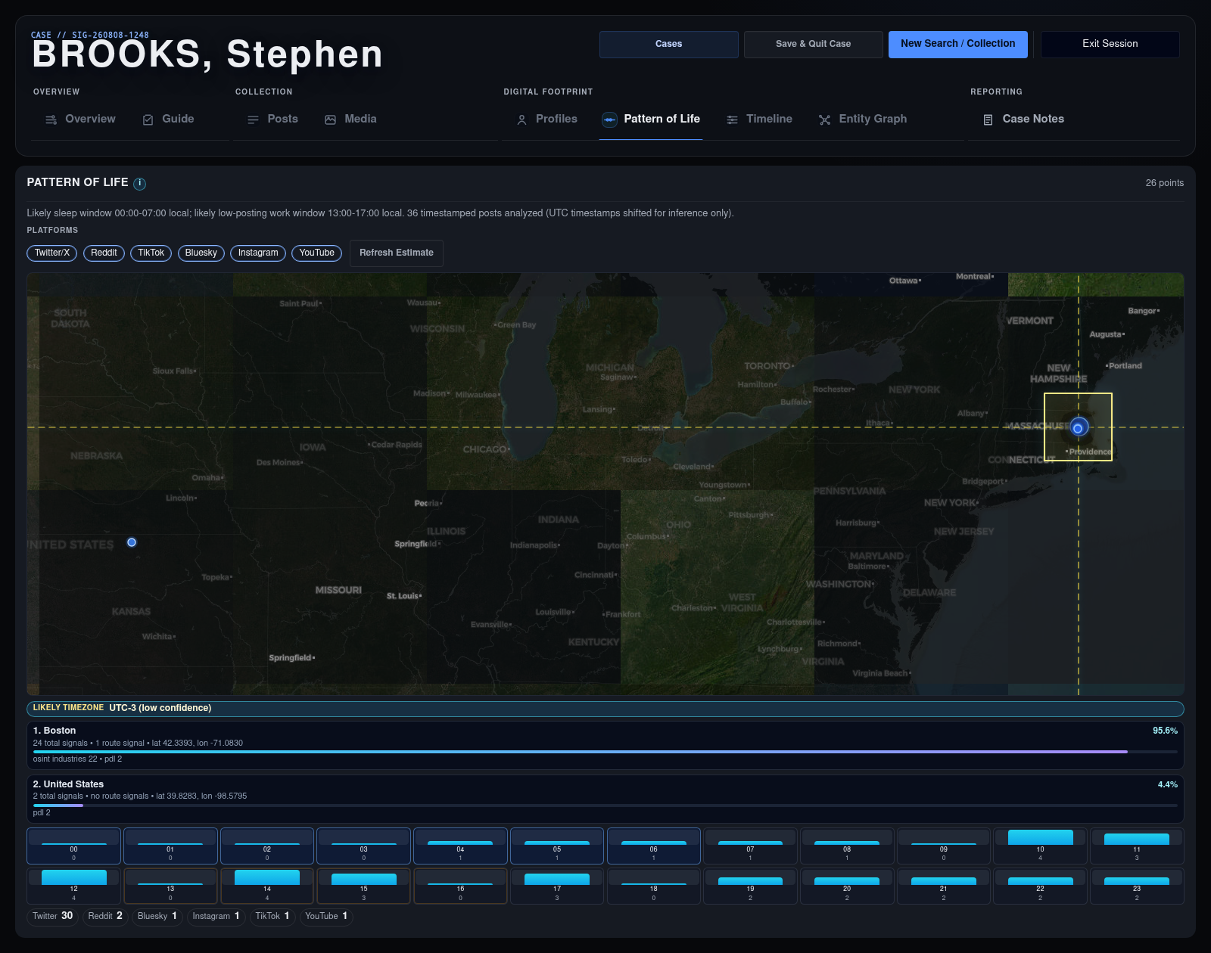
Pattern of Life: location/rhythm display and refresh control.

Figure 9. 09 Timeline
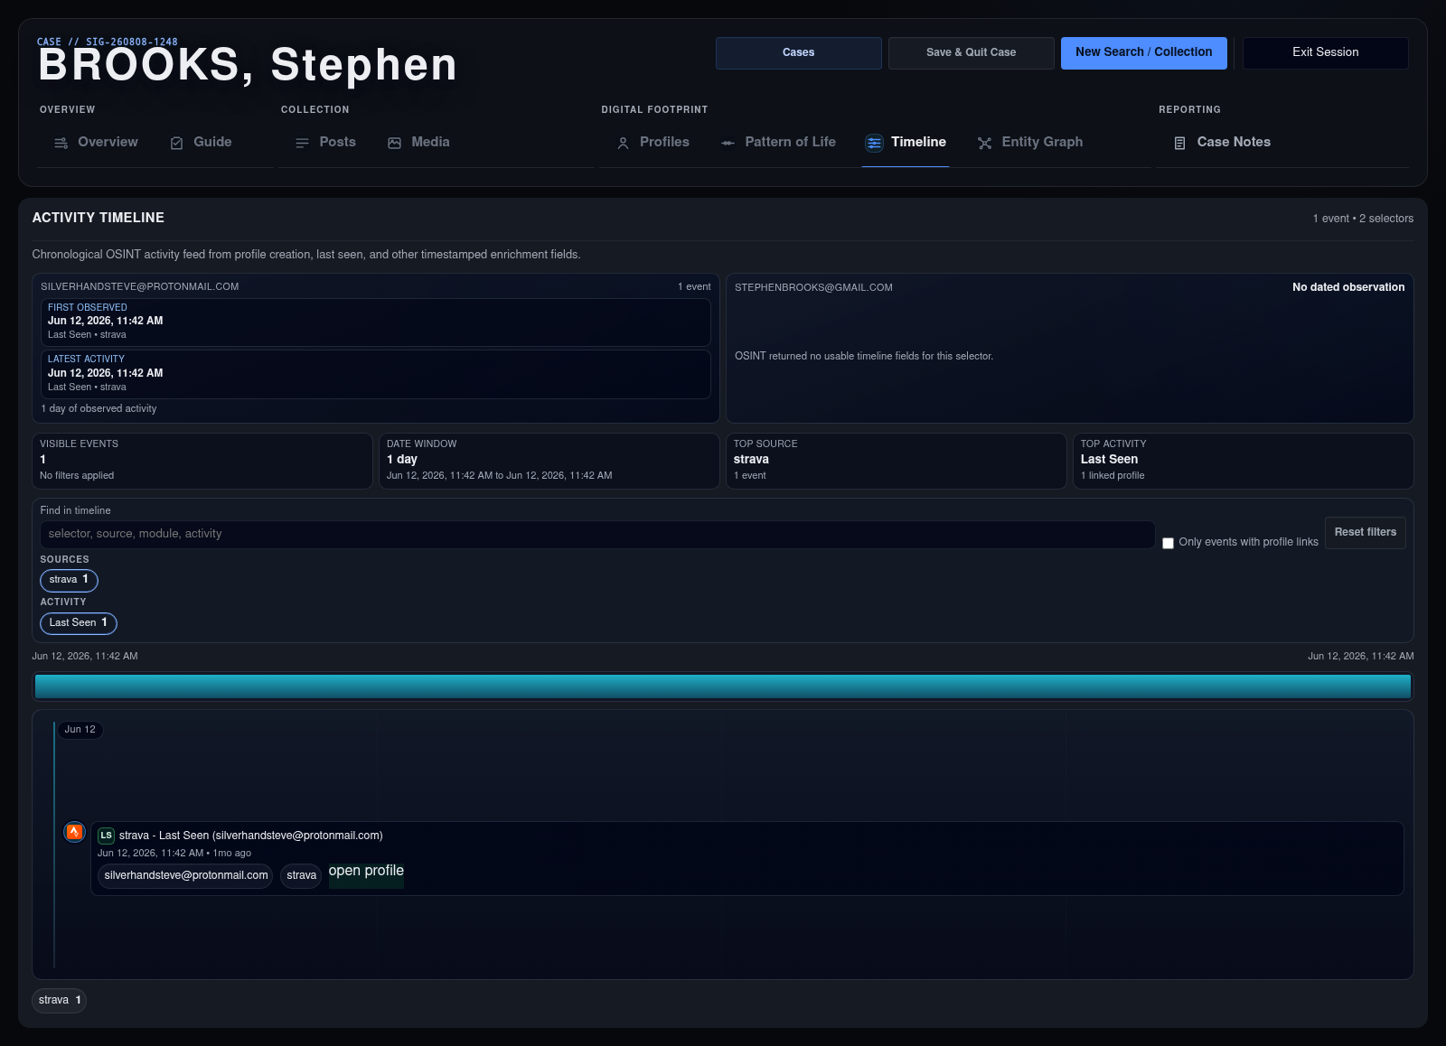
Timeline: date-stamped footprint activity and empty-state guidance.

Figure 10. 10 Entity Graph
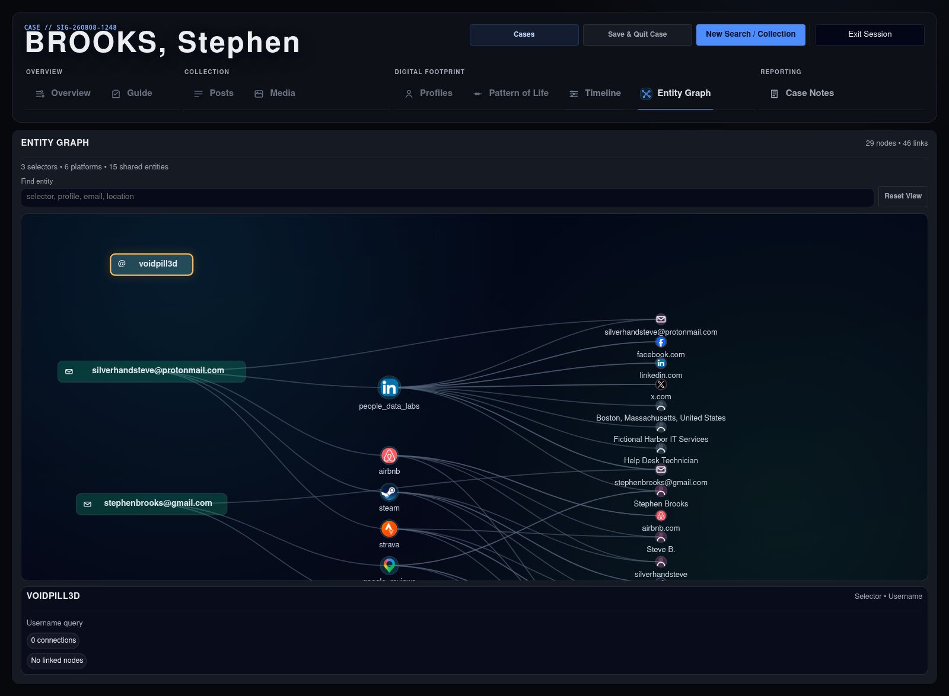
Entity Graph: graph canvas, entity find field, reset, and detail panel.

Figure 11. 11 Case Notes Expanded
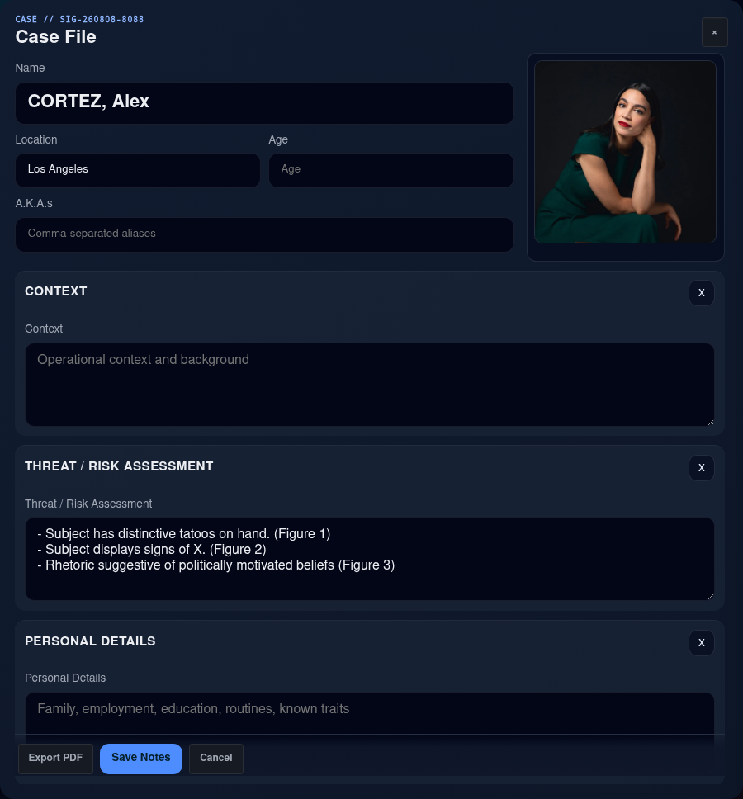
Case Notes with Cited Posts evidence sidebar expanded beside the editable case file.

Figure 12. 12 Case Notes Collapsed
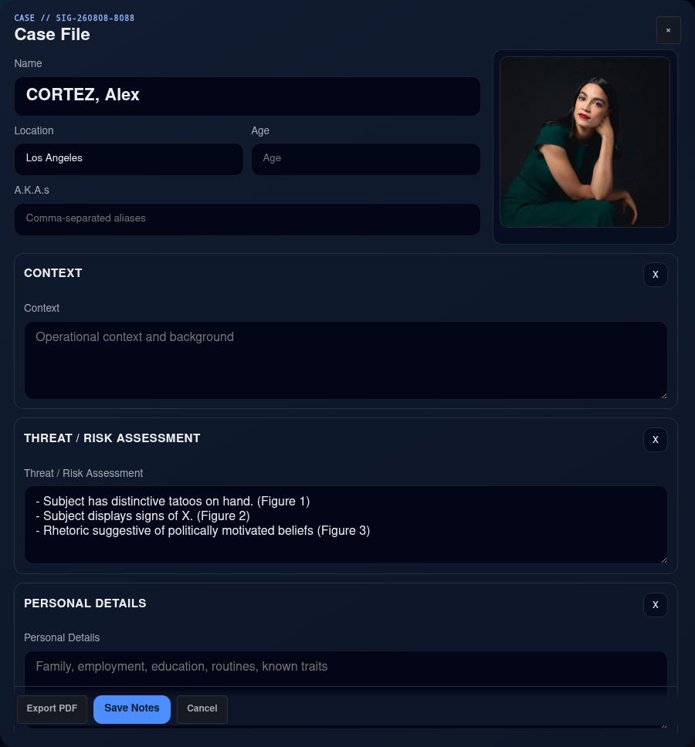
Case Notes with the evidence sidebar collapsed, returning space to the editor.

Figure 13. 13 Selector Corroboration
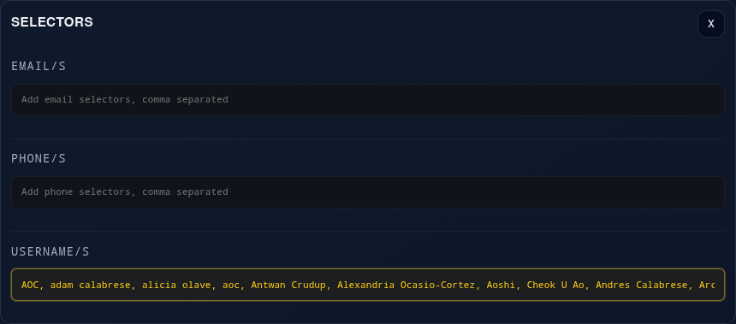
Selector inputs and corroboration display inside Case Notes.

