ORION
POC Functional Specification

Purpose
A concise description of the functionality currently present in the locally run Orion proof of concept. It is written to support user-story refinement. It does not propose roles, permissions, workflows, or features that are not shown in the POC.

Demonstration data
Screens use a locally created demonstration case named “Demo case — Pep Mangione” and the supplied username “lnmangione”. These are display examples only; this document makes no claims about people or accounts.
Prepared 2026-08-08

1. What the POC does
Orion is organised around investigation cases. From a case, the user can run Recon, set collection targets and dates, review returned posts, switch between analysis views, maintain a case file, capture evidence, export a PDF report, and adjust local settings.
Area | Current POC function
Case management | Create, search, filter, sort, open, edit, and delete cases. Case tiles show status, threat level, location, and case number.
Recon | Enter one or more typed selectors, run Recon, review resulting profiles/selectors, and use active profiles for collection when available.
Collection | Add targets, load collection-ready profiles, choose a date range, and start collection. The overview tracks collection streams and retry/refresh actions.
Review | Search, sort, and filter posts by source, post type, and signals. Open post details, add manual content, and capture cited evidence.
Analysis | View profiles, pattern of life, timeline, entity graph, geo/entities, and threat-assessment panels.
Case file | Record subject/context/risk notes, selectors, profiles, and cited posts; save notes or export PDF.
Settings/session | Set local defaults/custom keywords and use the Exit Session choices.

2. Case management
The Case Management screen is the entry point.
Control | Function
New Case | Creates a new case and opens the case-details form.
Search | Searches case name, case number, or location.
Status filter | Shows All status, Open, Under Investigation, Closed, or Watchlist.
Threat filter | Shows All threat levels or a selected named threat level.
Sort | Orders by last edited, opened date, threat, or case name.
Case tile | Opens the selected case. The settings icon edits it; the delete icon removes it.
Settings | Opens the POC settings modal.

Case details
The create/edit forms expose case title, known location, case image URL, status, threat level, data-retention period, and—when Watchlist is selected—monitoring refresh cadence. Save Changes persists edits; Cancel/Close exits the form.

3. Open-case workspace
The case header provides Cases, Save & Quit Case, New Search / Collection, and Exit Session. The toolbar groups the available views:
Group | Views / actions
Overview | Overview and Guide.
Collection | Posts and Media.
Digital Footprint | Profiles, Pattern of Life, Timeline, and Entity Graph.
Reporting | Case Notes.
The Posts view includes a text search, newest/oldest sort, source filters (Twitter, Reddit, TikTok, Bluesky, Instagram, YouTube), post-type filters, and signal filters. The same filter panel includes the action and confidence control for facial recognition.

4. Recon and collection
New Search / Collection opens a choice between Recon and Collection.
Workflow | Current POC behaviour
Recon | Selector rows support a selector type and value; + adds a row; × removes a row; Run Recon starts the operation. Results can expose Use Active Profiles for Collection and Go to Assessment.
Collection | The user can Load Collection-Ready Profiles, Add Target, Autofill Usernames, choose Start Date and End Date, then select Collect and Open.
Overview | Collection Overview shows stream status and includes refresh-streams and rerun-failed actions.

5. Review, analysis, and reporting
Feature | Current POC function
Manual Content Insert | Saves freeform text or a supported file as a post with optional author, platform, source URL, and date details.
Post / evidence | Post Details opens an item. Capture Evidence adds it to the Cited Posts area with an analyst note.
Geo / Entities | Shows Location Map, Entity Mentions, Selector Parse, and Custom Keyword Parse.
Threat Assessment | Shows assessment coverage, the Run AI Threat Assessment action, warning-behaviour visualisations, themes, ideological indicators, and threat-keyword parse.
Digital Footprint | Profiles provides discovered selectors; Pattern of Life offers location/rhythm views; Timeline shows events; Entity Graph supports entity search and Reset View.
Case Notes | Contains identity, context, threat/risk assessment, personal details, selectors, cited posts, and profiles. It provides Save Notes and Export PDF.

6. Settings and session controls
Settings exposes fields for configured service keys/tokens, default data-retention period, and custom keywords. Exit Session offers Exit Only, Exit and Save, and Exit and Wipe. The POC also exposes optional demo-case and LLM sandbox controls when enabled.

7. Real POC screenshots
The following captures were taken from a temporary local POC run for this document—not generated images.

Case management
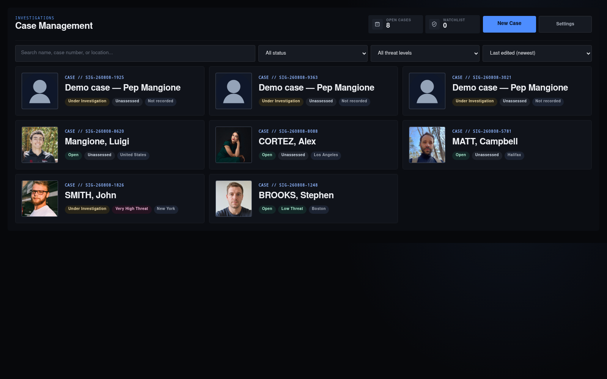
Figure 1. Actual Orion POC: case list and case-management controls.

Active case workspace
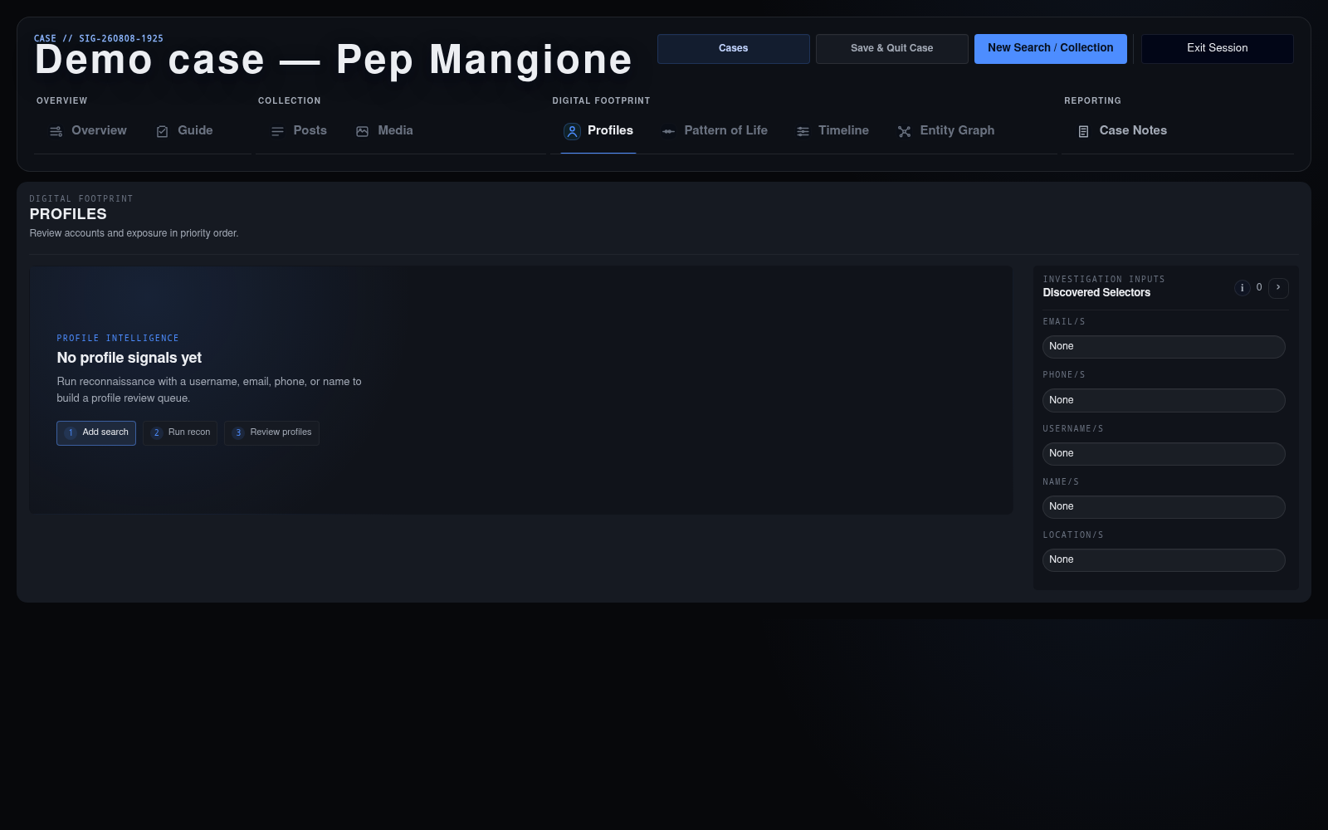
Figure 2. Actual Orion POC: an opened demonstration case and its workspace navigation.

Recon setup
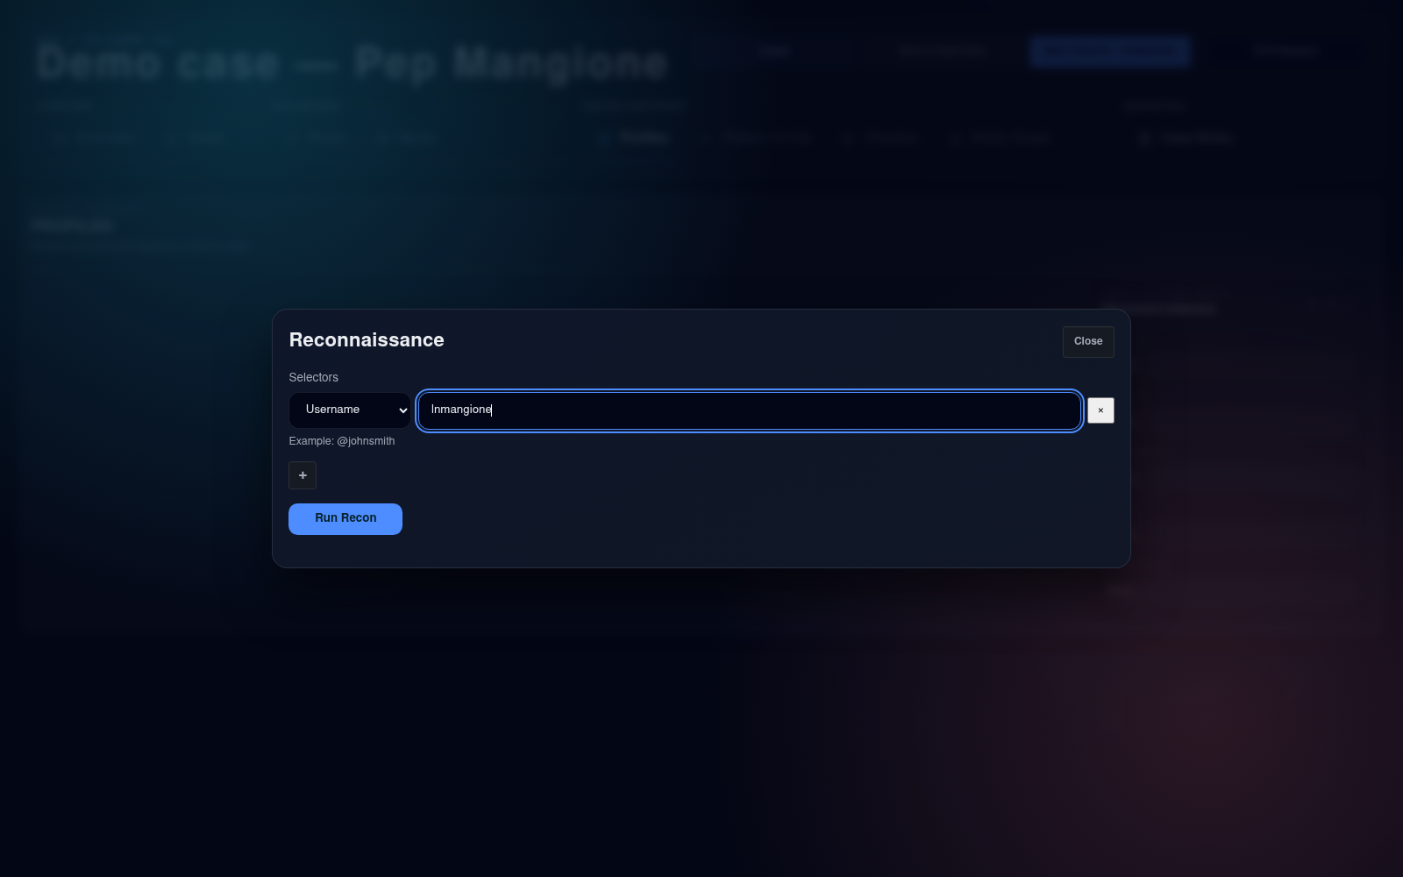
Figure 3. Actual Orion POC: Recon setup using the supplied demonstration username, lnmangione.

