Storefront: what we’re building
A doc for Varun.

What it is
One place at Headout to bring a tool idea. It tells you whether something like it already exists, helps you decide if it is worth making, and gets you moving on the right version of it.

Why we are building it
- No reliable way to tell if something already exists. People ask around in Slack and rebuild instead of reusing it. Three separate reconciliation tools got built for Finance before anyone noticed an engineering team had already solved it.
- Nobody decides whether an idea is worth building, or what shape it should take, before work starts. Ideas that should not exist get built anyway, and the ones worth building often get built wrong.
- Non-engineers can get to a good decision and still have nowhere to go to actually build it. Most give up right there, and they are most of who is asking.

How it works
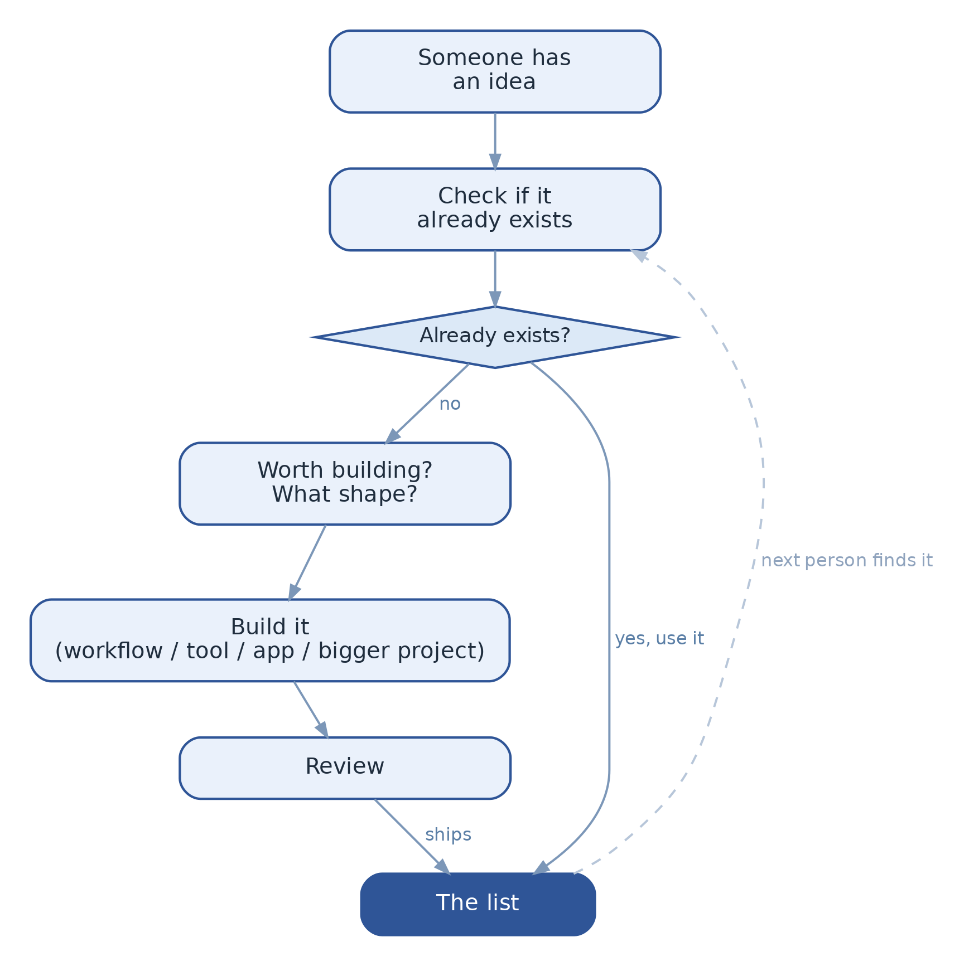
- Serves as a knowledge base for all past and present work
- Stores context at three levels:
  - Individual: skills, plugins
  - Team: apps, dashboards
  - Org: products, AI agent pipelines, MCP setups
- Everything easily findable, usable, and shareable

Future vision
- Evolves into a discovery and building agent
- Becomes the single source of truth for everything built at Headout
- "Tool idea" is the wrong framing: it is one place to store everything ever worked on
- Storefront provides a base to make building streamlined for anyone who wants to create

