TABLE OF CONTENTS
1. INTRODUCTION
1.1 Purpose
1.2 Scope
2. SYSTEM ANALYSIS
2.1 Existing System
2.2 Proposed System
2.3 Feasibility Analysis
2.3.1 Technical Feasibility
2.3.2 Economical Feasibility
3. SYSTEM ARCHITECTURE
3.1 System Overview
3.2 OCR Processing Module
3.3 RAG & Vector Search Module
3.4 Data Flow Diagram
3.5 System Flow Diagram
4. OVERALL DESCRIPTION
4.1 Product Perspective
4.2 Product Functions
4.3 User Characteristics
4.4 Operating Environment
4.5 Constraints
5. TECHNOLOGY OVERVIEW
5.1 Python
5.2 PyMuPDF
5.3 Tesseract OCR
5.4 Sentence Transformers
5.5 FAISS
5.6 Ollama LLM
5.7 Streamlit
6. PROJECT DESCRIPTION
6.1 Introduction
6.2 Module Description
6.3 Processing Workflow
7. SCREENSHOTS
8. CODING
9. BIBLIOGRAPHY

1. INTRODUCTION
The AI PDF Question Answering System is an offline, desktop-based application designed to facilitate quick and accurate information retrieval from PDF documents, including those with scanned text. It implements a Retrieval-Augmented Generation (RAG) architecture using local, open-source models, enabling live-streaming answers and support for Optical Character Recognition (OCR).

1.1 Purpose:
The objective of the AI PDF Question Answering System is to allow a user to upload any PDF and instantly query its content, effectively turning the document into a searchable knowledge base. This system rectifies the manual difficulty of searching through lengthy documents, providing fast, context-aware answers.

1.2 Scope:
The system stores, processes, and indexes the entire text of a single uploaded PDF. It utilizes a local embedding model for vector storage and a local LLM via Ollama for generation, making it an entirely offline solution.

2. SYSTEM ANALYSIS

2.1 Existing System: Manual PDF Search
The current, or existing, system involves manually reading, searching, or using basic text search functions within PDF viewers. This is time-consuming, especially for finding conceptual answers or information hidden in non-searchable scanned pages. This manual process is often inefficient and prone to missing relevant context.

2.2 Proposed System - AI PDF Question Answering System
The proposed system addresses these issues by:
- Automated Text Extraction: Extracts all text, including a fallback to OCR for image-based pages.
- Semantic Search (RAG): Allows users to ask natural language questions, retrieving context semantically rather than just by keywords.
- Live Streaming: Provides a smooth, user-friendly experience by streaming the LLM's answer in real-time.
- Offline Operation: Utilizes local models for enhanced security and faster performance without relying on cloud APIs.

2.3 Feasibility Analysis

2.3.1 Technical Feasibility:
This system is technically feasible as it relies on established Python libraries (Streamlit, PyMuPDF, Faiss, Pytesseract) and the readily available open-source LLM server, Ollama. All necessary resources and technologies for development and maintenance are easily accessible.

2.3.2 Economical Feasibility
Development of this application is highly economically feasible. The system utilizes open-source software (Python, Streamlit, Ollama, Faiss) and local resources, avoiding recurrent subscription or API service fees associated with cloud-based LLMs.

3. SYSTEM ARCHITECTURE
The system follows a Retrieval-Augmented Generation (RAG) architecture, primarily composed of three stages: Document Processing, Retrieval, and Generation.

3.1 Overall System Architecture
The system's flow begins with the user uploading a PDF via the Streamlit interface.
- PDF Upload & Extraction: The Streamlit frontend accepts the PDF file. The system then extracts text, attempting standard text extraction first and falling back to OCR (pytesseract) for image-based or scanned pages.
- Chunking & Indexing: The extracted raw_text is split into smaller, overlapping chunks (using RecursiveCharacterTextSplitter). These chunks are then converted into numerical embeddings using SentenceTransformer and indexed by Faiss for high-speed similarity search.
- Question & Retrieval: When a question is entered, it is also converted into an embedding. Faiss searches the index to retrieve the top $K$ most similar text chunks (the context).
- Generation: The retrieved context and the question are formatted into a prompt and sent to the Ollama LLM (mistral) via an HTTP POST request. The LLM generates the final answer, which is streamed back to the Streamlit UI.

3.2 Modules
The system's logic is modularized into the following functional components:
Module | Description | Key Components/Function
UI Module | Handles user input (file upload, question) and displays all output. | streamlit, @st.cache_resource, st.file_uploader, st.text_input
Extraction Module | Extracts text from the PDF, including OCR fallback for scanned pages. | extract_pdf_text_with_ocr(), fitz (PyMuPDF), pytesseract (OCR)
Vector Store Module | Chunks text, creates embeddings, and builds the Faiss index. | chunk_text(), build_vector_store(), SentenceTransformer, Faiss
RAG/Retrieval Module | Finds the most relevant text chunks (context) for a given question using vector search. | retrieve_context(), Faiss index.search()
LLM Streaming Module | Generates the final, structured answer from the LLM and streams it to the UI. | stream_llm_answer(), requests (to Ollama), LLM_MODEL (mistral)

3.3 Data Flow Diagram
Figure: Data Flow Diagram (AI PDF QA System)
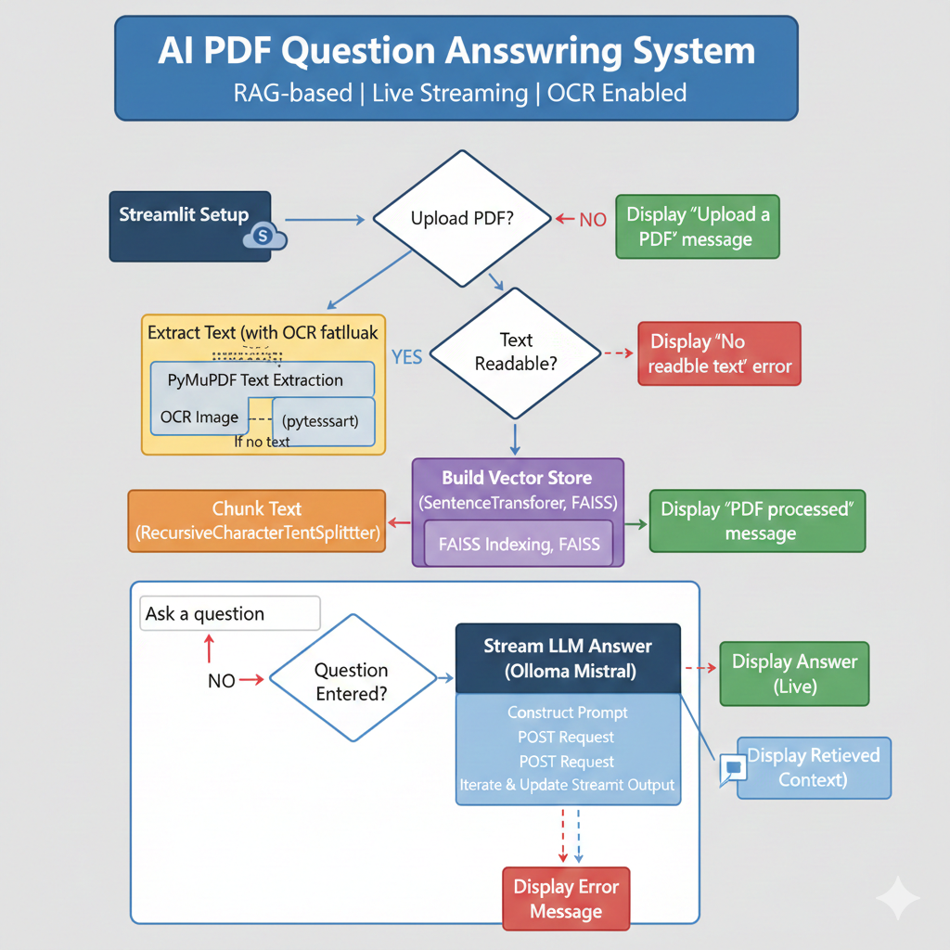
The Data Flow Diagram (DFD) illustrates the movement of information through the system.

4. OVERALL DESCRIPTION

4.1 Product Perspective:
The AI PDF Question Answering System is a stand-alone, single-file application built using Python and the Streamlit framework. It is designed to be an entirely self-contained, offline product, relying only on a locally hosted Ollama server and its required Python dependencies.

4.2 Product Functions:
The product supports a single user role (the User) with the following core features:
- PDF Upload (OCR Enabled): Allows uploading any PDF, ensuring all text is extracted, even from scanned pages.
- Document Processing: Automatically handles chunking and indexing of the document content.
- Question Answering: Enables the user to input natural language questions related to the document.
- Live Streamed Answer: Delivers the LLM-generated response in real-time to the user interface.
- Context Transparency: Provides an expandable section to view the specific retrieved context used by the LLM to form its answer.

4.3 User Classes and Characteristics:
There is one class of user for this product:
- User: Any individual who needs quick, precise answers from a PDF document. Requires a basic understanding of computer use and the ability to operate the Streamlit web interface.

4.4 Operating Environment:
The product runs in a local environment, requiring:
- OS: Any operating system supporting Python (Windows, macOS, Linux).
- Server: Local running instance of Ollama serving the mistral LLM.
- Interface: Any modern web browser (the application is served via Streamlit).

4.5 Constraints:
- Offline Dependency: Requires the Ollama server to be running locally at http://localhost:11434.
- Language: Assumes the document and queries are primarily in English (due to the LLM and OCR setup).
- File Type: Limited to PDF files.

4.6 Use Case Model:
Use Case | Brief Description
Upload and Process PDF | The user uploads a PDF. The system extracts text (with OCR), chunks it, and builds the Faiss vector index.
Ask Question | The user inputs a question into the text box.
Retrieve Context | The system converts the question to an embedding and retrieves the top 3 relevant text chunks from the Faiss index.
Stream Answer | The system sends the retrieved context and question to Ollama and streams the response token by token to the UI.
View Context | The user can expand a UI element to see the exact context used for the answer.

5. TECHNOLOGY OVERVIEW
The technology selected for implementing the AI PDF Question Answering System is built on a modern, open-source RAG stack.

5.1 Python
Python is the core programming language used to implement all the logic, from the Streamlit UI to PDF processing, vector indexing, and communication with the LLM server.

5.2 Streamlit
Streamlit is the application framework used to create the graphical, interactive web interface. It allows for rapid development of the front-end components, such as file uploaders, text input, and the dynamic output box for streaming.

5.3 PyMuPDF (fitz) and PyTesseract
- PyMuPDF: A highly efficient library used to extract text and image data from PDF files.
- PyTesseract: The Python wrapper for Google's Tesseract OCR engine, used as a fallback mechanism to extract text from scanned pages or images within the PDF.

5.4 Faiss and SentenceTransformer
- SentenceTransformer: Used to load the all-MiniLM-L6-v2 model, which generates high-quality vector embeddings (numerical representations) of the text chunks and the user's question.
- Faiss: A library for efficient similarity search and clustering of dense vectors. It is used to build the vector index, enabling fast retrieval of context chunks.

5.5 Ollama and Mistral
- Ollama: A powerful framework used to run and manage large language models locally. It provides a simple API endpoint (http://localhost:11434/api/generate) for interaction.
- Mistral: The specific LLM (LLM_MODEL = "mistral") selected for its superior reasoning capabilities and efficiency for RAG-based question answering.

6. PROJECT DESCRIPTION

6.1 Introduction
The AI PDF Question Answering System solves the problem of information overload in large documents by applying RAG. It ensures that the LLM's response is grounded only in the document's content, reducing hallucination and providing verifiable answers.

6.2 Description Of Core Functions
Function Name | Description | Key Code Sections
load_embedder() | Loads the SentenceTransformer model once and caches it for performance. | @st.cache_resource, SentenceTransformer(EMBED_MODEL)
ocr_image() | Performs OCR on image bytes extracted from the PDF. | pytesseract.image_to_string(image)
extract_pdf_text_with_ocr() | Iterates through PDF pages, extracts text, and falls back to ocr_image() if a page has no searchable text. | fitz.open(), page.get_text(), page.get_images()
chunk_text() | Splits the raw text into manageable chunks with overlap for contextual continuity. | RecursiveCharacterTextSplitter (chunk_size=500)
build_vector_store() | Embeds the text chunks and creates the Faiss index for storage and search. | embedder.encode(), faiss.IndexFlatL2(), index.add(embeddings)
retrieve_context() | Encodes the question and searches the Faiss index to return the top 3 relevant text chunks. | index.search(q_emb, TOP_K)
stream_llm_answer() | Constructs the RAG prompt with the context, calls the Ollama API, and streams the decoded response to the Streamlit output box. | requests.post(OLLAMA_URL, stream=True), response.iter_lines()

7. SCREENSHOTS
Figure 7.1: PDF Upload and Processing Interface

Figure 7.1: Successful PDF Processing and Initial Query
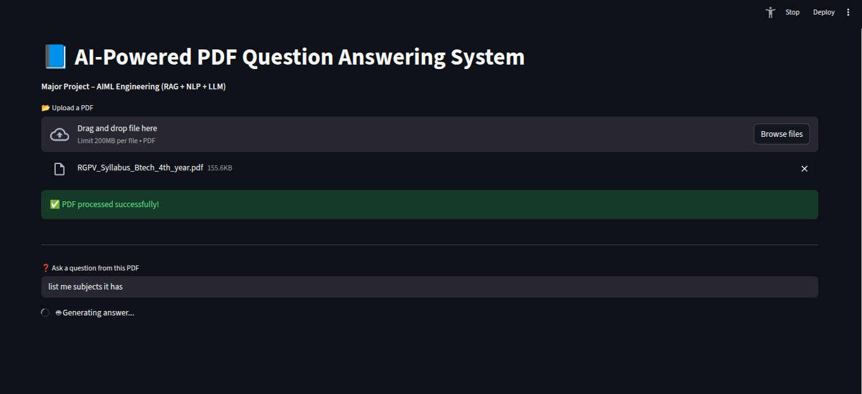

Figure 7.2: RAG Answer Streaming with Context Retrieved
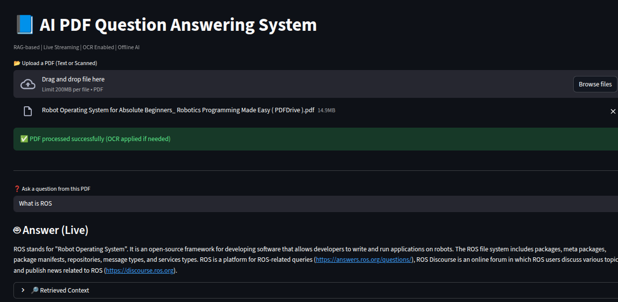

8. CODING
Python
# =========================================================
# AI PDF Question Answering System
# RAG + LIVE STREAMING + OCR SUPPORT
# Single File | AIML Major Project
# =========================================================

import streamlit as st
import fitz # PyMuPDF
import faiss
import numpy as np
import requests
import json
import pytesseract
from PIL import Image
import io

from sentence_transformers import SentenceTransformer
from langchain_text_splitters import RecursiveCharacterTextSplitter

# ---------------- CONFIG ----------------
EMBED_MODEL = "all-MiniLM-L6-v2"
LLM_MODEL = "mistral" # better reasoning than llama3
TOP_K = 3
MAX_CONTEXT_CHARS = 1500
OLLAMA_URL = "http://localhost:11434/api/generate"

# ---------------- STREAMLIT SETUP ----------------
st.set_page_config("AI PDF Chat with OCR", layout="wide")
st.title("📘 AI PDF Question Answering System")
st.caption("RAG-based | Live Streaming | OCR Enabled | Offline AI")

# ---------------- LOAD EMBEDDER ----------------
@st.cache_resource
def load_embedder():
return SentenceTransformer(EMBED_MODEL)

embedder = load_embedder()

# ---------------- OCR FROM IMAGE ----------------
def ocr_image(image_bytes):
image = Image.open(io.BytesIO(image_bytes)).convert("RGB")
return pytesseract.image_to_string(image)

# ---------------- PDF TEXT EXTRACTION (TEXT + OCR) ----------------
def extract_pdf_text_with_ocr(uploaded_file):
doc = fitz.open(stream=uploaded_file.read(), filetype="pdf")
full_text = ""

for page_num, page in enumerate(doc):
page_text = page.get_text().strip()

# If text exists, use it
if page_text:
full_text += page_text + "\n"
else:
# OCR fallback for scanned page
images = page.get_images(full=True)
for img in images:
xref = img[0]
base_image = doc.extract_image(xref)
image_bytes = base_image["image"]
ocr_text = ocr_image(image_bytes)
full_text += ocr_text + "\n"

return full_text

# ---------------- TEXT CHUNKING ----------------
def chunk_text(text):
splitter = RecursiveCharacterTextSplitter(
chunk_size=500,
chunk_overlap=100
)
return splitter.split_text(text)

# ---------------- VECTOR STORE ----------------
def build_vector_store(chunks):
if not chunks:
raise ValueError("No readable text found in PDF.")

embeddings = embedder.encode(chunks)

if len(embeddings.shape) == 1:
embeddings = np.array([embeddings])

embeddings = embeddings.astype("float32")
dim = embeddings.shape[1]

index = faiss.IndexFlatL2(dim)
index.add(embeddings)

return index, chunks

# ---------------- RETRIEVAL ----------------
def retrieve_context(question, index, chunks):
q_emb = embedder.encode([question]).astype("float32")
_, idxs = index.search(q_emb, min(TOP_K, len(chunks)))
context = "\n".join(chunks[i] for i in idxs[0])

# Deduplicate lines
context = "\n".join(dict.fromkeys(context.split("\n")))
return context[:MAX_CONTEXT_CHARS]

# ---------------- STREAMING LLM ----------------
def stream_llm_answer(context, question, output_box):
prompt = f"""
You are an intelligent academic assistant.

INSTRUCTIONS:
- Use the context ONLY as a knowledge source
- Do NOT copy sentences verbatim
- Explain in your own words
- Be clear and structured
- If not found, say: "Not found in the document"

Context:
{context}

Question:
{question}

Final Answer:
"""

payload = {
"model": LLM_MODEL,
"prompt": prompt,
"stream": True,
"options": {
"temperature": 0.3,
"num_predict": 250,
"top_p": 0.9
}
}

response = requests.post(
OLLAMA_URL,
json=payload,
stream=True,
timeout=30
)

full_answer = ""

for line in response.iter_lines():
if line:
data = json.loads(line.decode("utf-8"))
token = data.get("response", "")
full_answer += token
output_box.markdown(full_answer)

return full_answer

# ---------------- UI ----------------
uploaded_pdf = st.file_uploader("📂 Upload a PDF (Text or Scanned)", type=["pdf"])

if uploaded_pdf:
with st.spinner("📄 Extracting text (OCR enabled)..."):
raw_text = extract_pdf_text_with_ocr(uploaded_pdf)

if len(raw_text.strip()) < 50:
st.error("❌ No readable text detected, even after OCR.")
st.stop()

with st.spinner("✂️ Chunking text..."):
chunks = chunk_text(raw_text)

with st.spinner("🧠 Building vector database..."):
index, stored_chunks = build_vector_store(chunks)

st.success("✅ PDF processed successfully (OCR applied if needed)")

st.divider()
question = st.text_input("❓ Ask a question from this PDF")

if question:
with st.spinner("🔍 Retrieving context..."):
context = retrieve_context(
f"In the context of the document, {question}",
index,
stored_chunks
)

st.subheader("🤖 Answer (Live)")
answer_box = st.empty()

try:
stream_llm_answer(context, question, answer_box)
except Exception as e:
st.error(f"❌ Error: {e}")

with st.expander("🔎 Retrieved Context"):
st.write(context)

else:
st.info("⬆️ Upload a PDF to begin")

9. BIBLIOGRAPHY
(Note: Replace your old bibliography with the sources relevant to the new technology stack.)
- Python Documentation
- Streamlit Documentation
- PyMuPDF (fitz) Documentation
- Faiss Documentation (Facebook AI Similarity Search)
- Sentence-Transformers Documentation
- Ollama Documentation
- Tesseract OCR Documentation

