Web Science

Quiz 1: March 6, 2014

100 points max

1. HTML 5 (25 points): One of the first things we covered was HTML 5
   1. (5) How do we let the browser know that we are using HTML5?

Use the following Document Type:

<!Doctype html>

<html lang=‘en’>

That doctype will even work with older browsers. It just engages Standard mode if the browser does not support HTML5.

* 1. (5) How does the browser know how to decode the tags properly?

The browser knows what the tags are from the Document Type Definition. If the specific browser supports the markup language, it will recognize the tags and decode them properly.

* 1. (10) How would we represent a thematic grouping of content in an HTML document?

We would use a section tag to clump content together into logical groups. Section tags can be used to divide up the content of a page into… sections in order to organize and arrange together similar content.

* 1. (5) Describe the difference between cookies and local storage

Cookies are primarily used to store server side data, whereas local storage can only be accessed client side. Cookies have expiration dates, but also are unencrypted and can be manipulated easily. Cookies are sent with EVERY http request, whereas local storage data is not.

1. node.js : (25 points) Create a webserver in node.js which will output a simple html page when a request is received on http://localhost:port/

port is: 4321

Node.js Code (server.js):

var http = require('http'),

fs = require(‘fs');

fs.readFile('./index.html', function (err, html) {

if (err) {

throw err;

}

http.createServer(function(request, response) {

response.writeHeader(200, {"Content-Type": "text/html"});

response.write(html);

response.end();

}).listen(4321);

});

html code (index.html) :

<!DOCTYPE html>

<html lang="en">

<head>

</head>

<body>

<h1> Hello, World!</h1>

</body>

</html>

1. the MVC model (25 points)
   1. (5) What is it?

An architecture used to develop web applications. It is primarily used to decouple business logic and data presentation to the user.

* 1. (5) Why do we use it?

Data is separated from the presentation layer. It gives us the ability to have multiple views of singular data. It is easier to make modifications to the business logic or the data layer due to the separation of the two. It also gives us the ability to have a variety of interfaces for one application.

* 1. (10) Describe, and give an example of the View layer?

A VERY simple example of a View layer would be the window that you see when you run your computer’s calculator. It presents the current state of model data and allows a user to , when you press the equals sign, send their data (query) to the program. The window also displays resultant data from the computations that the program performs.

* 1. (5) Name an MVC framework other than Struts that we covered in class.

JavascriptMVC is an example of an MVC framework. It utilizes a Model, View, and a Controller in the following ways:

Model: There exists a model class that provides basic functionality to organize the application’s data layer.

View: Javascript MVC uses EJS templates to render HTML data in controllers. It then directly injects into the DOM.

Controller: JavascriptMVC Implements a variety of controller functions that get called back when the appropriate event happens.

1. APIs (10 points)
   1. (5) What are APIs and why do we use them?

An API is an Application Programming Interface. A large scale application naturally collects and stores tons and tons of data. In order to aid other developers, applications may make this data publicly available and accessible through an API (an interface).

A developer’s application will get data from a target API and use the data gathered for it’s own needs. The other reason that large scale applications develop API’s in the first place is that it allows the application to spread it’s name and advertise itself. It also encourages consumers (users, developers, etc) to use their application.

* 1. (5) Give an example of a Web API

Twitter API. User’s can register an application that they’re working on with Twitter. Twitter will then give them keys (essentially random strings) that they will need to connect to the twitter api. Using these keys, a developer can make his application connect to the twitter API and pull real-time data from it.

1. (15) Explain *in detail* what the following code does;

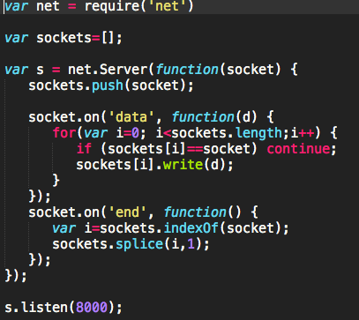

1: Node loads the net module. If the net module does not load, the program stops execution.

2: Declare an empty array named sockets

3: Create a TCP server that gets socket data and stores it in the socket variable

4: Pushes the data in the socket variable into the back of the sockets array

5: When the socket gets data, run the following function where d is the data object we got

6: for every item in the sockets array:

7: if the current item in the sockets array is identical to the socket that the server got, continue looping through

8: if the current item is not equal to the socket that the server got, write the data in the d variable to the current item’s location

9: when the socket gets an end signal execute the following function:

10: find the index of the current socket in the sockets array, and set i equal to it.

11: use the splice function to remove the item at i.

12: start the server as a listener on port 8000.