Web Science
Quiz 1: March 6, 2014
100 points max

- HTML 5 (25 points): One of the first things we covered was HTML 5
  - (5) How do we let the browser know that we are using HTML5?

  - (5) How does the browser know how to decode the tags properly?

  - (10) How would we represent a thematic grouping of content in an HTML document?

  - (5) Describe the difference between cookies and local storage

- node.js : (25 points) Create a webserver in node.js which will output a simple html page when a request is received on http://localhost:port/

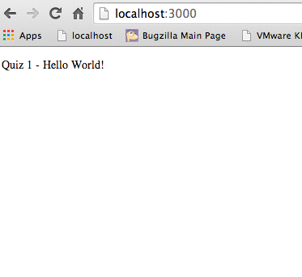

- the MVC model (25 points)
  - (5) What is it?

  - (5) Why do we use it?

  - (10) Describe, and give an example of the View layer?

  - (5) Name an MVC framework other than Struts that we covered in class.

- APIs (10 points)
  - (5) What are APIs and why do we use them?

  - (5) Give an example of a Web APi

- (15) Explain in detail what the following code does;

