SafeBreast web page outiine and user interface

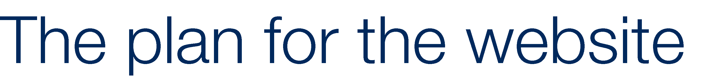

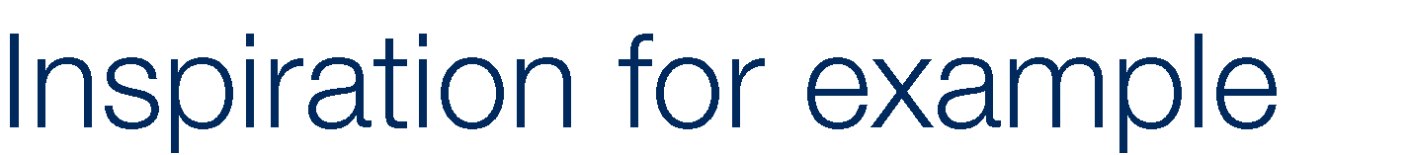

●

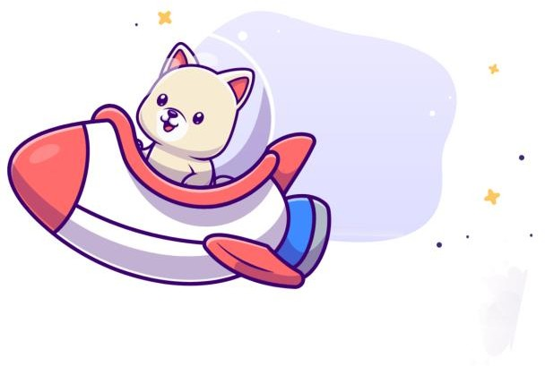●

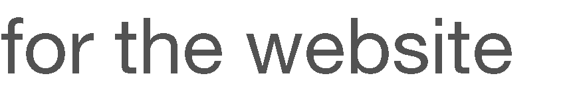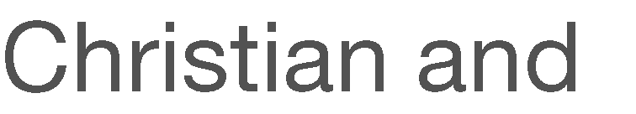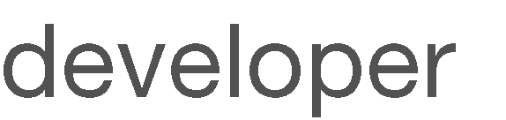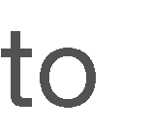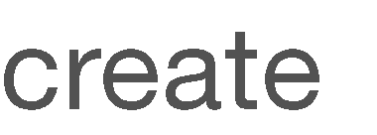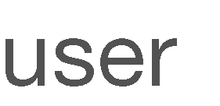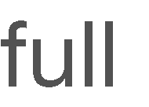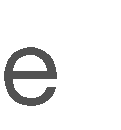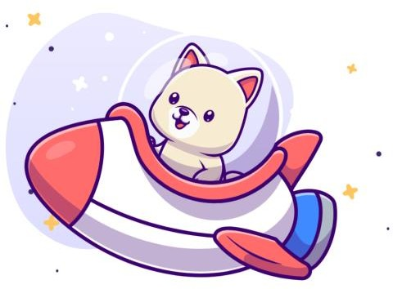

● ●

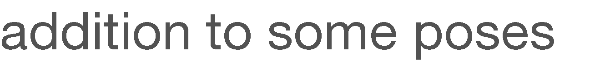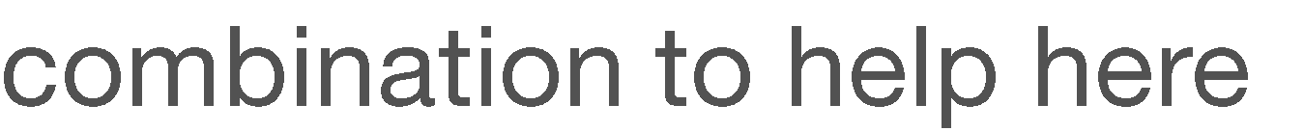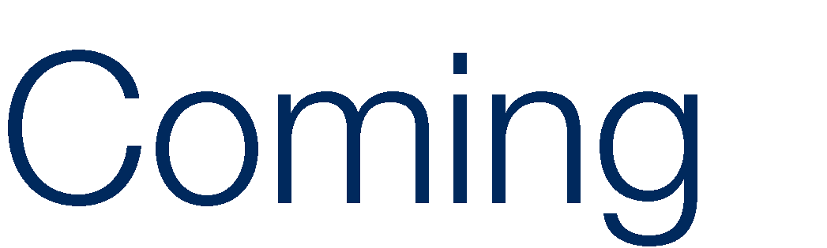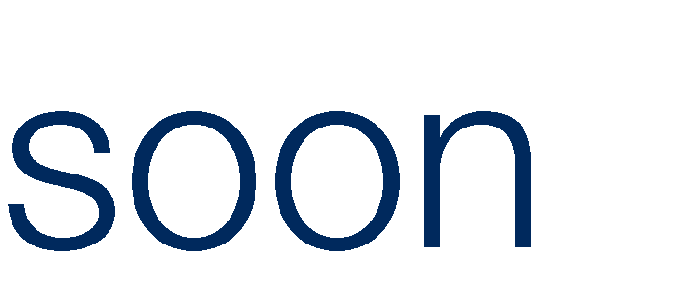

● 

●

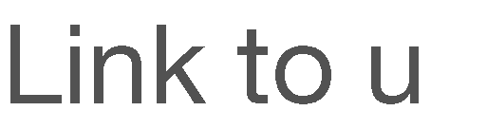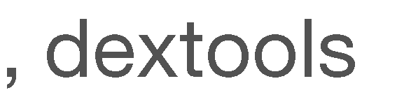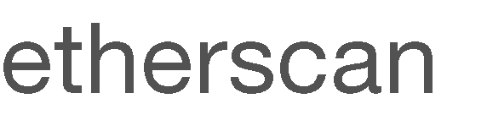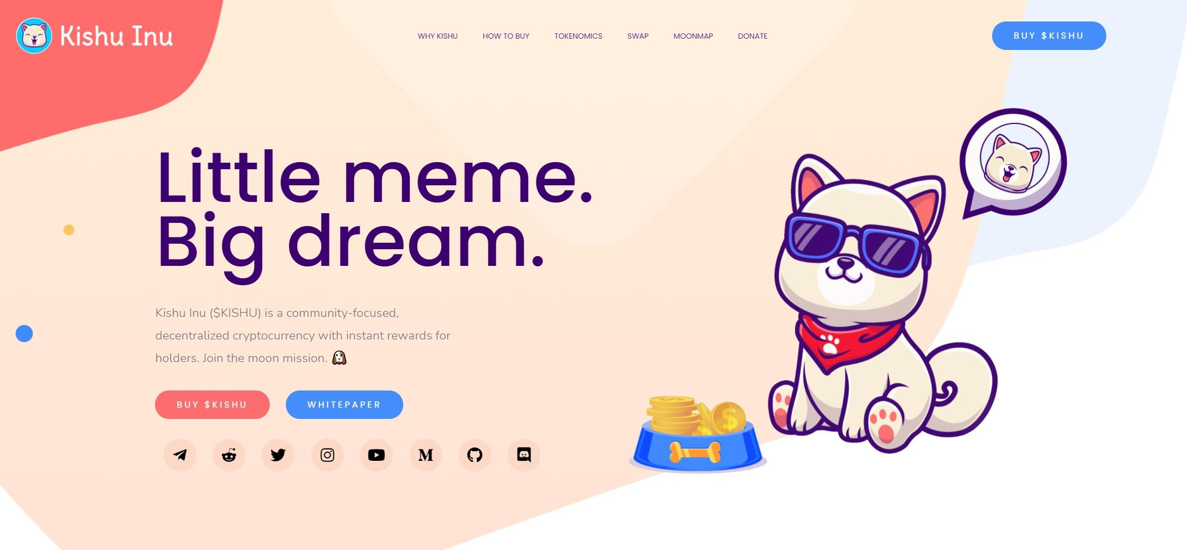

●

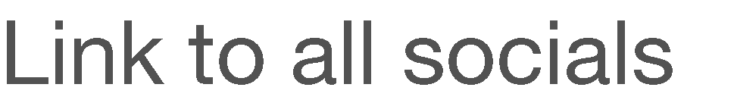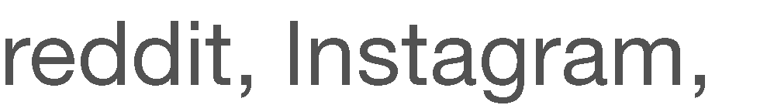

●

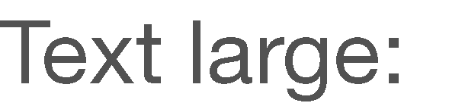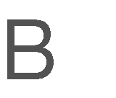

●

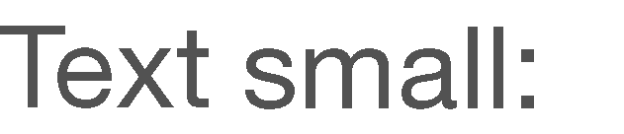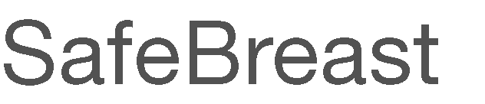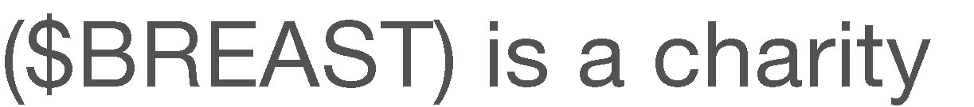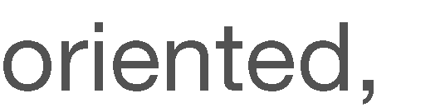

●



Tabie of contents for fuii website

Intro page (no need to incl in table of contents

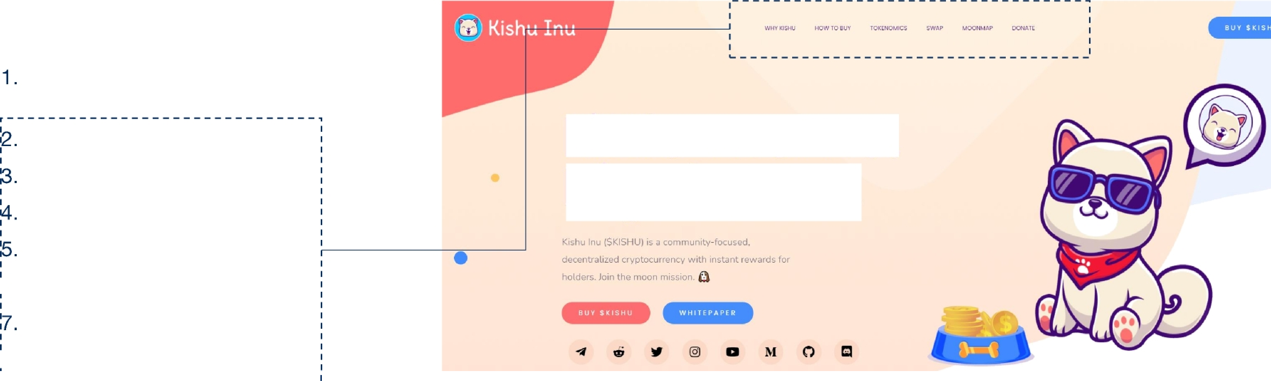

#### WHY SAFEBREAST HOW TO BUY TOKENOMICS SWAP

1. MOONMAP

CHARITY

##### !8. FAQ

Little meme. Big dream.

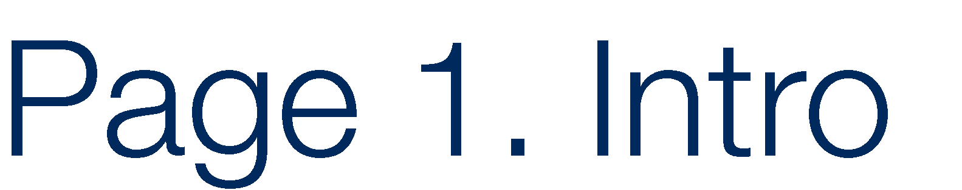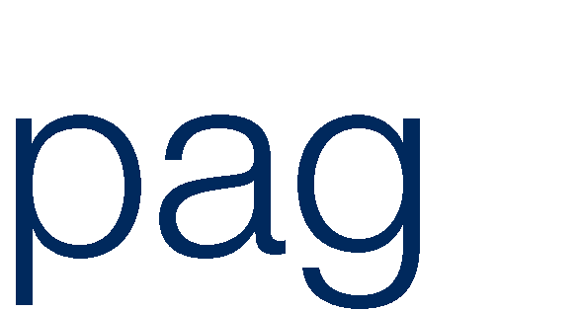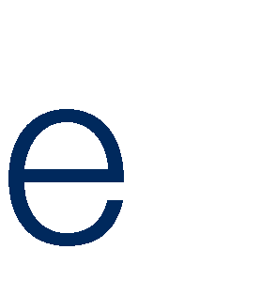

●

●

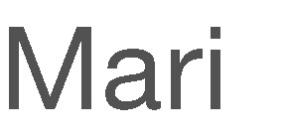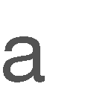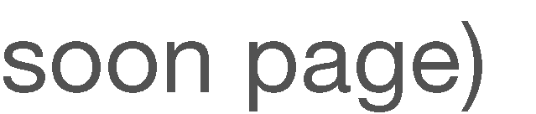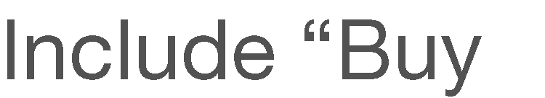

●

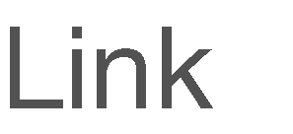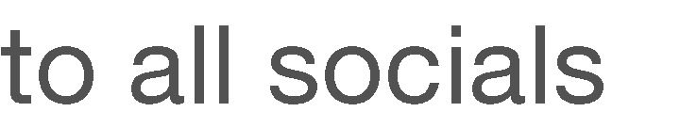

● 

●

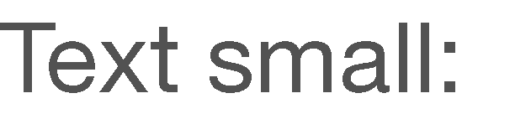

●

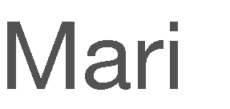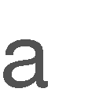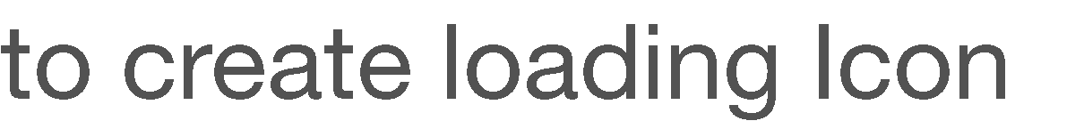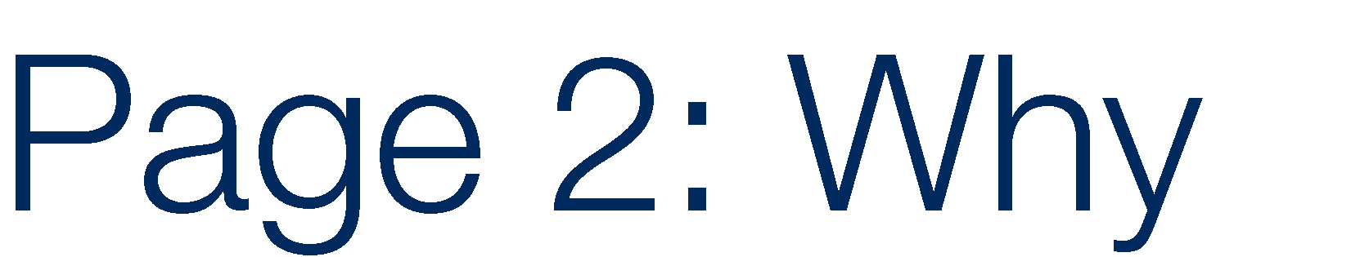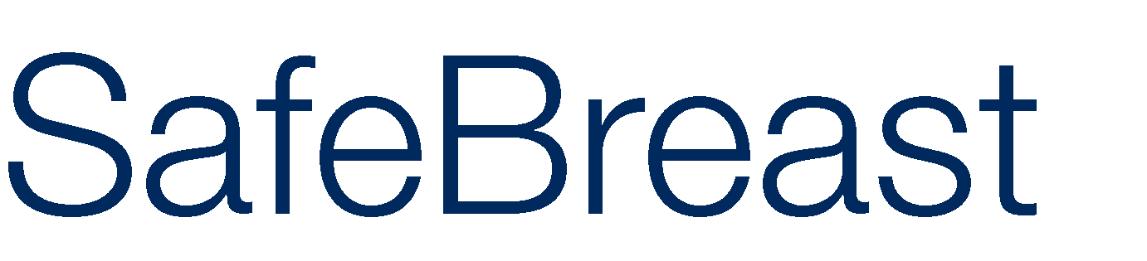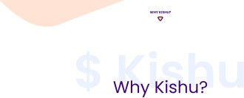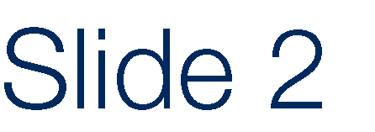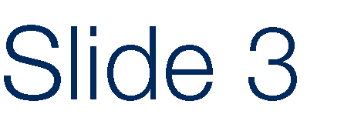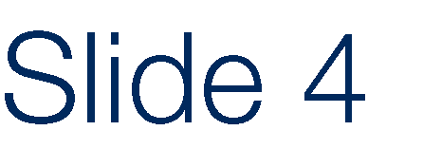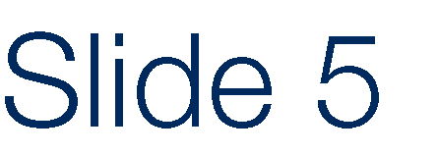

● ● ● ●

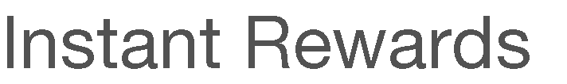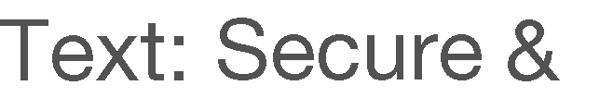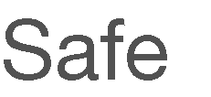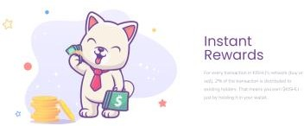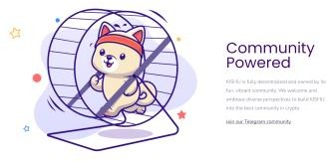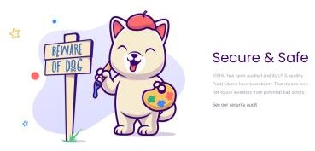

– – – –

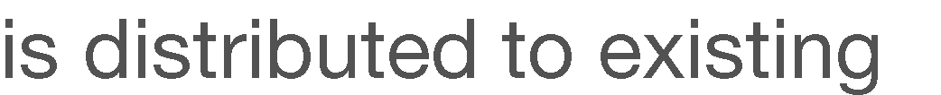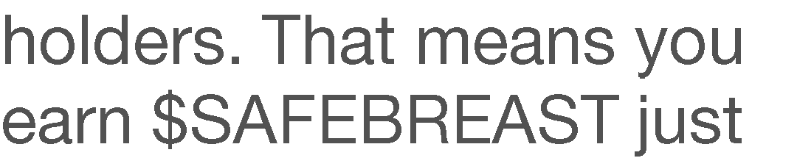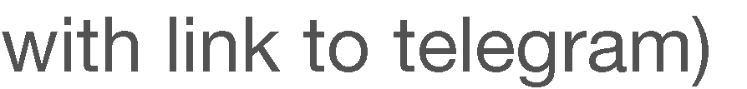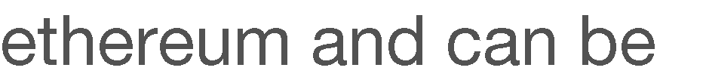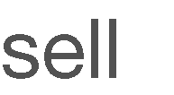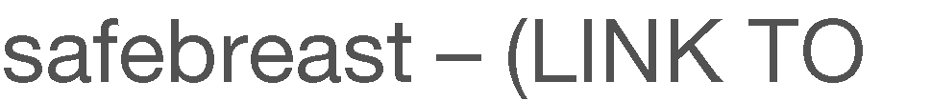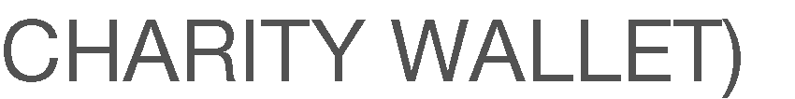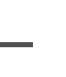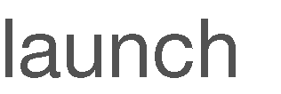

●

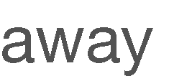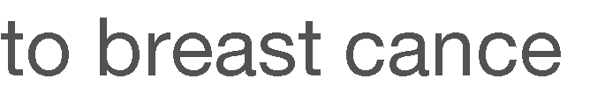

# Page 3: HOW TO BUY

### Inspiration



* + Lets make two of these with a two buttons above

HOW TO BUY HOKK



* Metamask button: will show exact same as this
* Trustswallet button: will show the same steps as this but with the trustwallet logo

How 7o Buy

* + Exchanges will only include uniswap for now and SafeBreast Swap

step 3: Connect To Hokkx step 4• swop SETH For

EXCHANGES

white IT J bitrue Si Ki @ LBANK

BKEX GB COM O LATOKEN B ilo xy



# Page 4: TOKENOMiCS

### Inspiration

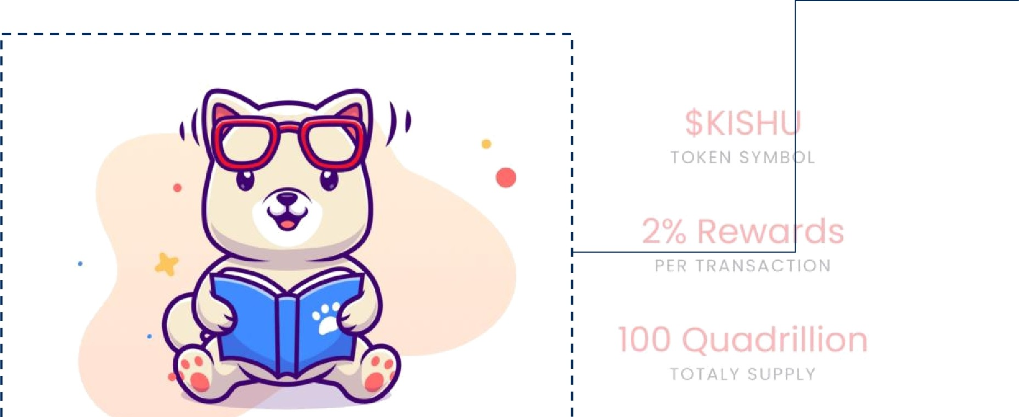

* Maria to create something

##### $BREAST TOKEN SYMBOL

* 2% donated PER TRANSACTION
* 2% rewards PER TRANSACTION
* 2% + liquidity PER TRANSACTION
* 1 Trillion TOTAL SUPPLY

##### XXXX HOLDERS

* XXXX MARKET CAP

##### XXXX CURRENT PRICE

* Price chart (link to dext tools)

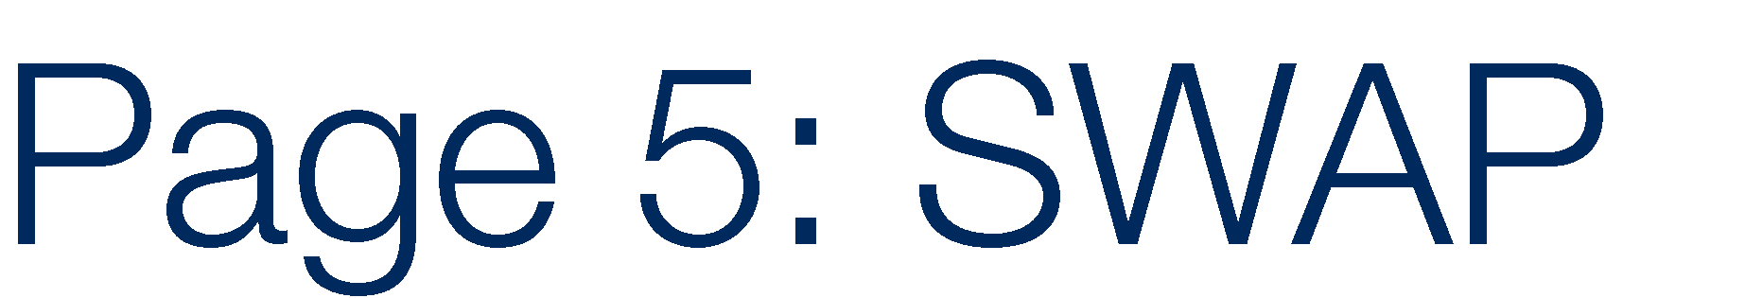

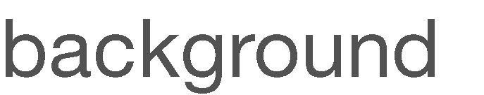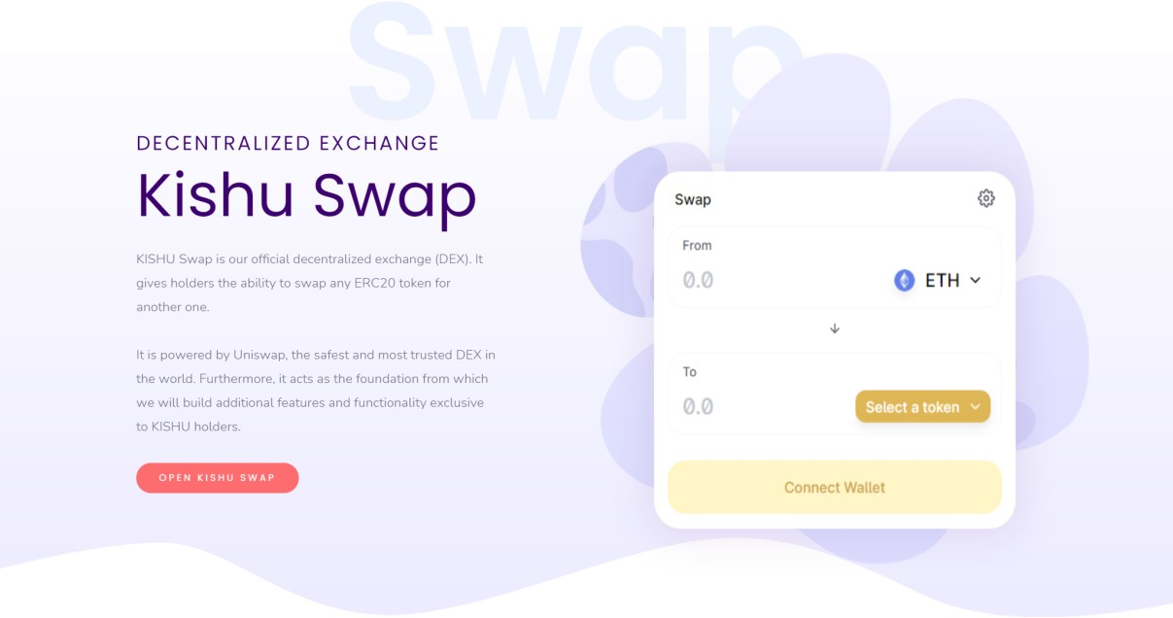

●

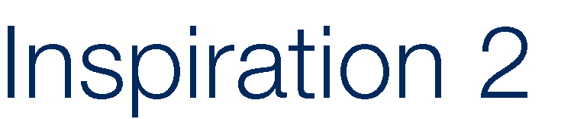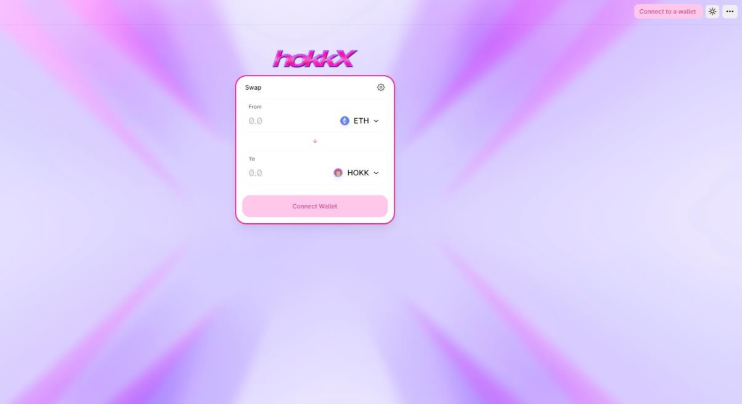

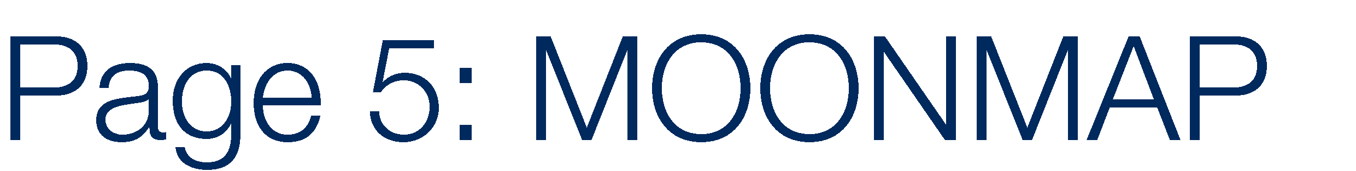



●

●

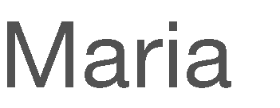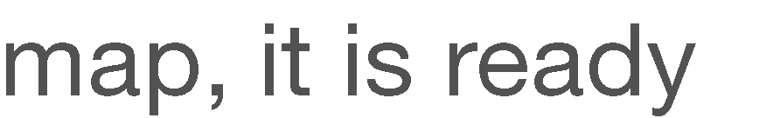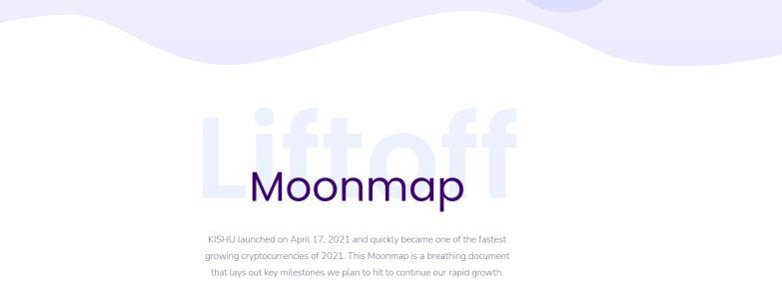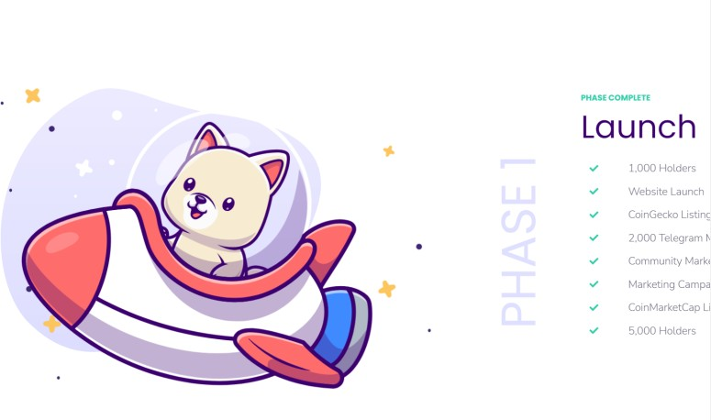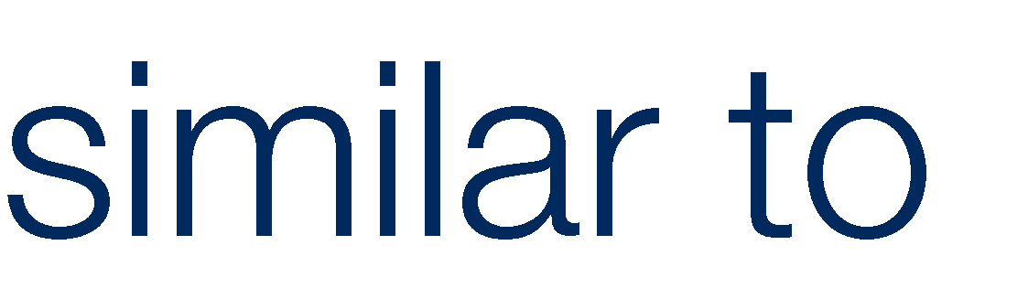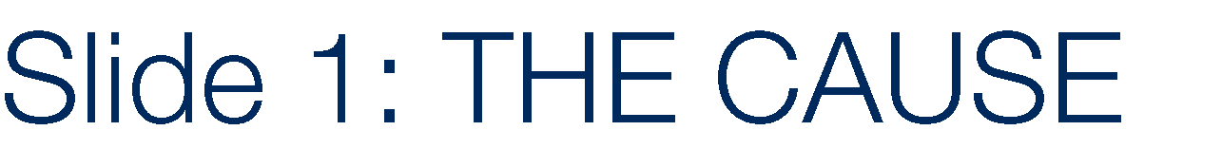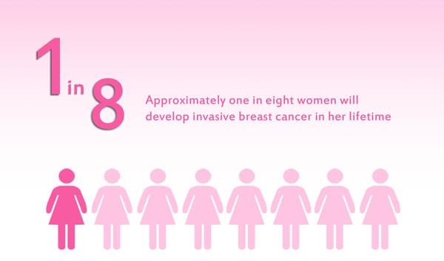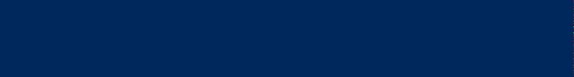

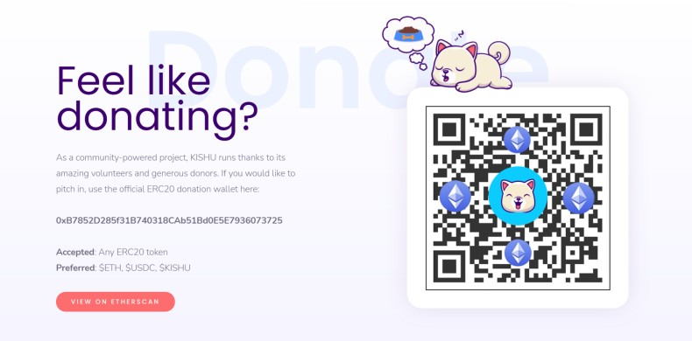● ●

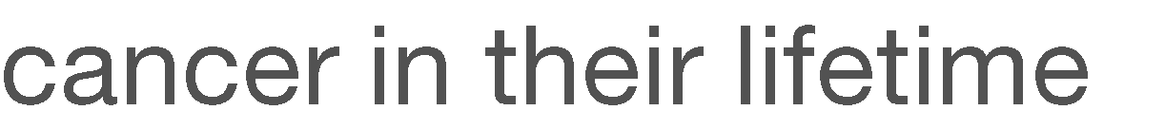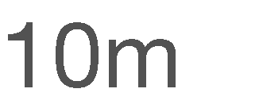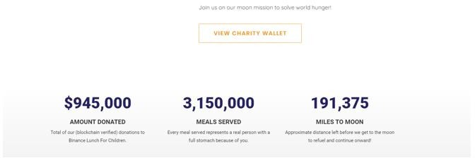

●

●

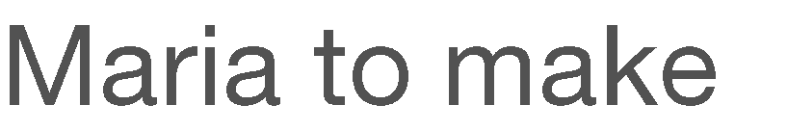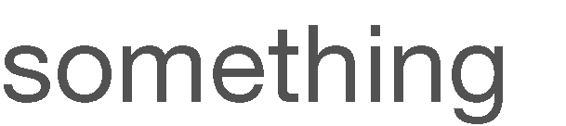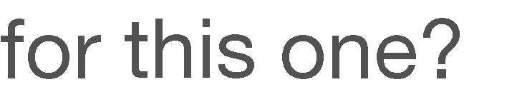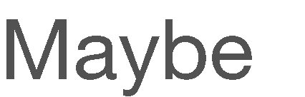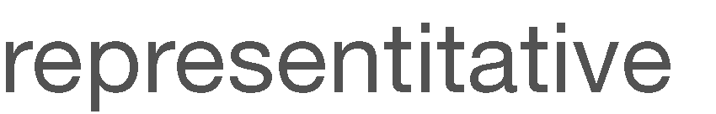

●

●



Page 7: FAQ

Inspiration 1

Hove Any questions?

Freouently asked questions (FAQ) or Questions and Answers (g&A), ore listed questions and answers, all supoosed to be commonly asked in some con text

* • uot is HOKK7
* wh I hold HOKK
* con I ansure I'm eligib e for 2S ARF Rewards*
* • .t ore gas fees and why ore thay so high*

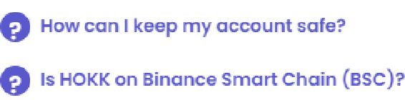

* *••Y* • I gatting on error when tr Y”•g to buy on HOKKX or Uniswap* -+

## Inspiration 2

FAQ



What is T he cont r d dress for *oanu I nu*

FAQ

General



God eno mie s?

oJa you burn the suppiy to vitaiik's #adrcss?