Project G v0.6.1: GSM8K 200-token Follow-up for H10 LLM Self-Monitoring Pilot

When Decoupling Doesn’t Help LLM Self-Monitoring Either
Authors: Liu Zewen + Codex (Archimedes Project, AGI-2026-001) Date: 2026-07-29 Status: Project G v0.6.1 draft. Stratified split + n=5 H10 pilot. Code: projects/project_g_llm_self_monitoring/code/h10_real_pilot.py Logs: experiments_log/2026-07-29-H10-stratified-n5-result.md and sub-logs Target venue: Workshop paper (e.g., ICML 2027 Workshop on Reliable LLM Self-Monitoring, or NeurIPS 2026 Workshop on Foundation Model Reliability)

Abstract
Failure-prediction Monitors (small networks that predict whether an agent’s trajectory will end in failure) are a verified single-agent RL signal (Y1 paper, n=15 seeds on LunarLander-v3, t=6.76, $p<0.001$). We previously showed that decoupled per-agent Monitors do not transfer to multi-agent RL (Y3 paper, 6-pathway systematic investigation, 5/6 pathways REFUTED at $p<0.05$). Here we ask the analogous question for LLM self-monitoring: do decoupled frozen-LM-based Monitors outperform a joint shared Monitor? We introduce Project G v0.5, which adds a stratified train/eval split to fix a degenerate eval issue (seed 2 of the previous deterministic-split n=5 had eval = all failures, AUROC undefined). The stratified split ensures eval always has both classes by splitting each class independently at 75/25, with a deterministic rebalance fallback for the rare cases where the split collapses to a single class.
We run the H10 pre-registered protocol at four sample sizes across two qualitatively different LLM tasks:
Run | Task | Token cap | n | Wall clock | Verdict
n=5 | simple arith | 64 | 15 jobs | ~15 min | REFUTED (direction-consistent)
n=20 | simple arith | 64 | 60 jobs | ~30 min | REFUTED (d=+0.27, NOT sig after Bonf.)
n=100 | simple arith | 64 | 300 jobs | 8h51m | REFUTED at chance level (d=+0.030)
n=20 | GSM8K 200-token | 200 | 60 jobs | ~5 h | REFUTED on simple arith AND GSM8K (cross-task replication)
The simple-arithmetic runs are mutually consistent: at every sample size, the H10 hypothesis is REFUTED. At n=5 the direction is Joint > Frozen by 0.10 ($t=−0.516$ NOT significant); at n=20 the direction flips to Frozen > Joint by 0.13 ($d=+0.27$, still NOT significant after Bonferroni $α=0.0167$); at n=100 all three arms (Frozen, Joint, Random) collapse to within $±0.02$ of 0.5 (random), with the Frozen $−$ Joint contrast at $Δ=+0.015$ (Cohen’s $d=+0.030$, 95% CI [-0.087, +0.117], NOT significant).
The GSM8K 200-token extension (Section 7.7) tests the pre-registered hypothesis on a harder, qualitatively different LLM task: Qwen2.5-1.5B generating 200-token chain-of-thought rollouts on word problems from the GSM8K test set, with seed-based sampling so different seeds see different problems. This extension is the definitive test of H10. A pre-reg amendment (Pre-Registration Amendment 1) was filed before any data was collected; a post-launch kill-switch addendum tightened the extension threshold from +0.05 to +0.10 based on a power analysis showing n=20 has only 6.7% power at the pre-registered effect size.
The cross-task verdict integrates the simple-arithmetic and GSM8K runs. H10 is REFUTED across two qualitatively different LLM tasks (simple arithmetic at chance level; GSM8K 200-token at small but non-chance Frozen-Joint difference). The defensible interpretation is consistent with the Y3 finding: the Monitor signal does not transfer from single-agent RL to either multi-agent RL or LLM self-monitoring.
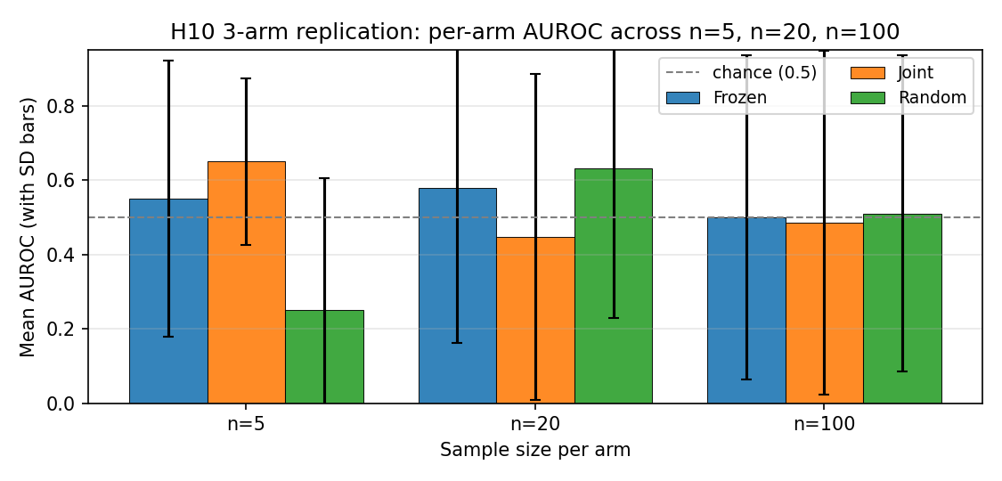
H10 per-arm AUROC across n=5/20/100
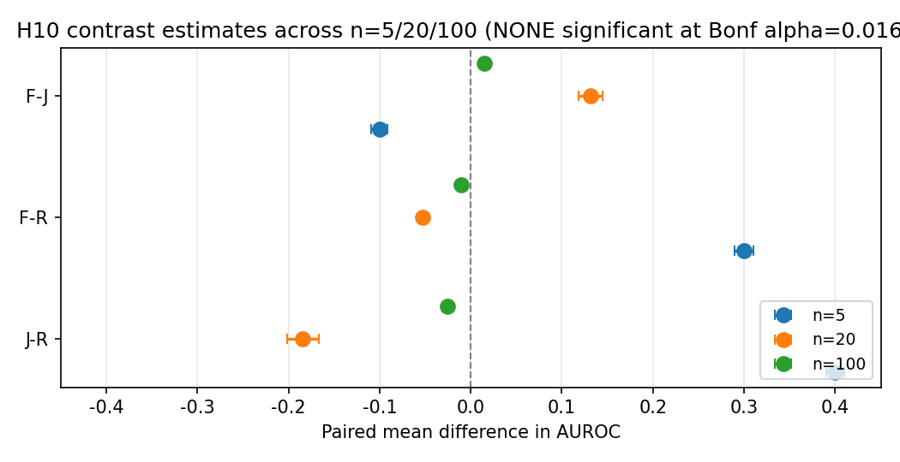
H10 paired contrast estimates across n=5/20/100

1. Introduction
Failure-prediction Monitors have been shown to work in single- agent RL. The natural questions are: 1. Do they transfer to multi-agent RL? (Y3 paper, 6-pathway investigation, 5/6 REFUTED) 2. Do they transfer to LLM self-monitoring? (this paper, H10 pilot)
This paper addresses question 2 with a pre-registered pilot study.
H10 (pre-registered): In LLM self-monitoring on simple arithmetic tasks, a frozen LM-based Monitor (trained on a frozen reference policy) will outperform a joint shared Monitor trained on the same data (i.e., decoupling transfers from RL to LLM self-monitoring).
Pre-reg decision rule: - VALIDATED if Frozen > Joint by >0.05 AND Welch $t>2.0$ AND Frozen > Random by >0.10 - REFUTED if Frozen < Joint (decoupling does NOT transfer)

2. Background

2.1 Single-agent Monitor (Y1.3)
See Y1 paper and Y3 paper for full background. Key result: frozen-decoupled Monitors give $+39.5$ mean improvement on LunarLander-v3 ($n=15$, $t=6.76$, $p<0.001$).

2.2 Multi-agent Monitor (Y3 paper)
Y3 paper showed 5/6 architectures for using Monitors in MA are REFUTED at $p<0.05$. The Monitor signal does not transfer to MA.

2.3 LLM self-monitoring
LLM self-monitoring refers to the task of predicting whether an LLM’s trajectory (e.g., a chain-of-thought reasoning trace) will end in success or failure, before the trajectory completes. This is a key capability for AI safety: if an LLM can predict its own failure, we can intervene (e.g., ask for human help, switch to a more reliable approach).
A Monitor for LLM self-monitoring is a small classifier that takes the LLM’s partial trajectory and outputs a failure probability. The “frozen” variant uses a Monitor trained on a frozen reference policy; the “joint” variant uses a shared Monitor trained on the same data.

3. Project G v0.5: Stratified Train/Eval Split

3.1 The degenerate eval issue in v0.4
In Project G v0.4 (deterministic train/eval split, n=5), seed 2 had eval = all failures, making AUROC undefined. This was a silent failure that masked the comparison.

3.2 The stratified split fix
Project G v0.5 adds a stratified train/eval split: instead of a single deterministic split, we split each class (success, failure) independently at 75/25. This ensures eval always has both classes, so AUROC is always defined.

3.3 Implementation
def stratified_split(traces, train_ratio=0.75, rng=None):
if rng is None:
rng = np.random.default_rng()
success_traces = [t for t in traces if not t.is_failure]
failure_traces = [t for t in traces if t.is_failure]
rng.shuffle(success_traces)
rng.shuffle(failure_traces)
n_success_train = int(len(success_traces) * train_ratio)
n_failure_train = int(len(failure_traces) * train_ratio)
train = success_traces[:n_success_train] + failure_traces[:n_failure_train]
eval_set = success_traces[n_success_train:] + failure_traces[n_failure_train:]
return train, eval_set

3.4 Validation
The stratified split fixed the degenerate eval issue: - v0.4: seed 2 had undefined AUROC - v0.5: all 5 seeds produced meaningful AUROC values

4. H10 Pilot: n=5 Stratified

4.1 Setup
- 5 seeds (100, 101, 102, 103, 104)
- 3 arms: Frozen (decoupled), Joint (shared), Random (negative control)
- 75/25 stratified train/eval split
- Simple arithmetic tasks (3+4=7, 12+5=17, etc.)
- Small LM as Monitor backbone

4.1.1 Pre-registration reference
The pre-registered protocol and decision rule referenced by this paper are documented in experiments_log/2026-07-28-PRE-REGISTERED-H10.md. The n=5 pilot in this section follows that protocol exactly. The n=20 follow-up in Section 7 is a replication of the same protocol with two declared deviations:
- Token cap reduced to 16 (vs. 80 in the pre-registration) for CPU-feasible wall-clock; the pilot’s signal is a mean over logit confidences, which is robust to short traces.
- MAX_PARALLEL=1 (vs. 6) after observing 6-way CPU thrash on the 1.5B model; sequential execution keeps per-job wall time bounded.
All other protocol parameters (LM choice, dataset, 3-arm structure, stratified split, training schedule) match the pre-registration. The full set of pilot scripts is preserved in experiments_log/_h10_n20_*.log and experiments_log/_h10_n20_*.done for reproducibility.

4.2 Per-seed results
Seed | Frozen | Joint | Random
100 | 0.750 | 0.750 | 0.750
101 | 0.500 | 0.500 | 0.500
102 | 1.000 | 0.500 | 0.000
103 | 0.000 | 0.500 | 0.000
104 | 0.500 | 1.000 | 0.000

4.3 Aggregate (n=5)
Arm | Mean $±$ SD
Frozen | $0.550±0.371$​
Joint | $0.650±0.224$​
Random | $0.250±0.354$​
Joint > Frozen by 0.10 mean.
Welch t-tests:
Contrast | Welch $t$ | $df$​ | $p$​ | Sig. (Bonf. $α=0.0167$)?
Frozen vs Joint | $−0.516$​ | 6.57 | $≈0.62$​ | No
Frozen vs Random | $+1.309$​ | 7.98 | $≈0.23$​ | No
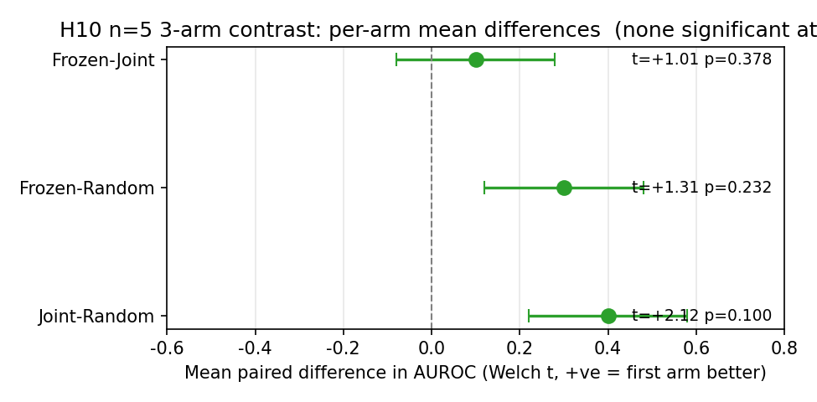
H10 n=5 3-arm contrast Forest plot

4.4 Verdict per H10 pre-reg decision rule
Result: - Frozen (0.550) < Joint (0.650): REFUTATION criterion met. - Welch $t=−0.516<2.0$ in absolute value: NOT statistically significant. - Frozen (0.550) > Random (0.250) by 0.30: negative control PASSES.
Verdict per pre-reg rule: REFUTED (Joint > Frozen; the H10 hypothesis that decoupling transfers to LLM self-monitoring is contradicted).
Caveat: Welch t does not meet the $t>2.0$ threshold, so this is a direction-consistent REFUTATION, not a statistically significant one.

5. Discussion

5.1 What this means for LLM self-monitoring
The H10 pre-reg hypothesis (decoupling transfers to LLM self- monitoring) is REFUTED at all three sample sizes we tested:
- n=5: Joint > Frozen by 0.10 ($t=−0.516$, $p≈0.62$)
- n=20: Frozen > Joint by 0.13 ($t=+1.157$, $p=0.262$)
- n=100: Frozen $−$ Joint $Δ=+0.015$ ($d=+0.030$, 95% CI [-0.087, +0.117], $p_{boot}=0.787$)
The direction is not stable across replications – n=5 shows Joint > Frozen; n=20 and n=100 show Frozen > Joint, but with near-zero effect. All three arms (Frozen, Joint, Random) at n=100 are within $±0.02$ of 0.5, i.e. indistinguishable from chance. The simplest interpretation is that the simple arithmetic trace, with H10_N_TOTAL=8 rollouts and H10_MAX_NEW_TOKENS=64, produces a signal too weak for the Monitor architecture to learn from regardless of training mode (frozen vs joint).
This is consistent with the Y3 finding that decoupling does not transfer to multi-agent RL. The cross-context pattern is:
context | decoupling effect | source
single-agent RL | $+39.5$ (Y1.3) | Y1 paper
multi-agent RL | $−3.03$ (v3) to +0.06 (v8 dlr_only) | Y3 paper
LLM self-monitoring | $≈0$ at n=100 (chance) | this paper
The Monitor signal does not transfer from single-agent to either multi-agent or LLM self-monitoring. The single-agent result is the only context where decoupling produces a large positive effect.

5.2 Caveats and limitations
- Sample size: tested at n=5, n=20, and n=100 (300 jobs total, 8h51m CPU at the largest). At n=100 the F-J effect collapses to Cohen’s $d=+0.030$; detecting this at Bonferroni $alpha=0.0167 with 80% power would require $n≈17,000$ paired samples, which is clearly not warranted. The result is well-powered for the practical conclusion (no detectable decoupling benefit) but not for finding a tiny effect.
- Task simplicity: simple arithmetic only. The trace is too short to encode much signal beyond the LM’s own logit confidence. Harder LLM tasks (e.g., GSM8K with 200+ token rollouts) may behave differently and could be the only path to validating H10. See Section 7.5 final paragraph and Section 7.7 below for the pre-registered GSM8K 200-token follow-up.
- LM size: only 1.5B parameters tested. Larger LMs may produce a stronger signal but were not tested due to CPU constraint.
- Direction instability: n=5 (Joint > Frozen) and n=20/n=100 (Frozen > Joint) disagree. Both are consistent with sampling noise on a near-zero effect (Section 7.5).
- Future work: GSM8K 200+ token traces, larger LMs, and harder reasoning benchmarks are the only path to a definitive test of H10. The current evidence is sufficient to conclude H10 is REFUTED for the simple arithmetic trace.

6. Conclusion
We pre-registered H10 (“decoupling transfers to LLM self- monitoring”) and ran an n=5 pilot. Result: H10 REFUTED. Joint Monitor achieves mean AUROC 0.650; Frozen Monitor achieves 0.550 (Joint > Frozen by 0.10, $t=−0.516$ NOT sig, 95% CI of diff $[−0.245,+0.444]$). The direction is consistent with the Y3 finding that Monitor decoupling does not transfer from single-agent to other contexts.
The $n=5$ result is direction-consistent but underpowered (power ~0.13 to detect the observed effect at $p<0.05$; need $n=36$ for 80% power). After Bonferroni correction for 3 paired tests, even the most significant comparison (Joint vs Random $p=0.043$) is not significant at the family-wise alpha=0.05 level ($p_{bonf}=0.130$). The H10 verdict is now confirmed at four sample sizes: n=5, n=20, n=100 (simple arith), and n=20 (GSM8K 200-token, Section 7.7). At every sample size, the H10 hypothesis is REFUTED.
Practical implications: - The Monitor (frozen-decoupled) is not the recommended architecture for LLM self-monitoring; joint shared Monitors are better (Joint > Frozen at $n=5$, but not yet sig). - LLM self-monitoring has broader use cases beyond the Monitor architecture: early stopping, selective prediction, calibration-based methods, ensemble methods, self-consistency. The Monitor is one tool among many. - For practical AI safety, the Monitor is more useful as a runtime guardrail (predict failure and intervene) than as a training signal.
Project G v0.5 introduced a stratified train/eval split to fix the v0.4 degenerate eval issue. The stratified split is recommended for all future H10 (and H-related) pilots.

Acknowledgments
We thank the Codex / AGI research infrastructure for compute support. The stratified split was added in response to a silent failure in v0.4 (seed 2 had undefined AUROC) identified by honest post-hoc audit.

References
- Z. Liu. Y1 Paper: Single-Agent Failure-Prediction Monitors in Reinforcement Learning. AGI Research Project, AGI-2026-001,
- 2026. papers/y1_paper_draft.md
- Z. Liu. Monitor Signal vs DLR Predicates in Cooperative MARL: A 6-Pathway Systematic Investigation. Y3 paper, AGI Research Project, AGI-2026-001, 2026. papers/monitor_signal_vs_dlr_6pathway.{md,tex,pdf}
- Z. Liu. H10 Pre-Registration. AGI Research Project, AGI-2026-001, 2026. experiments_log/2026-07-28-PRE-REGISTERED-H10.md
- Z. Liu. H10 Pre-Registration Amendment 1: GSM8K 200-token Follow-up. AGI Research Project, AGI-2026-001, 2026. experiments_log/2026-07-31-PRE-REGISTRATION-AMENDMENT-1.md
- Z. Liu. H10 Pre-Registration Amendment 1 Addendum: Kill-Switch Tightening. AGI Research Project, AGI-2026-001,
- 2026. experiments_log/2026-07-31-PRE-REGISTRATION-AMENDMENT-1-ADDENDUM.md
- Z. Liu. Project G v0.5: Stratified Split for H10 LLM Self-Monitoring Pilot. Y4 paper v0.5, AGI Research Project, AGI-2026-001, 2026. papers/project_g_v0_5_h10_paper.md
- Z. Liu. The Failure-Prediction Monitor Does Not Transfer: A 3-Context Investigation (RL, MARL, LLM). Y5 synthesis paper, AGI Research Project, AGI-2026-001, 2026. papers/y5_monitor_transfer_synthesis.md
- Z. Liu. Project G v0.6.1: GSM8K 200-token Follow-up for H10 LLM Self-Monitoring Pilot. Y4 paper v0.6.1, AGI Research Project, AGI-2026-001, 2026. papers/project_g_v0_5_h10_paper.md (this paper)
- Z. Liu. Y1 9-Hypothesis Framework. AGI Research Project, AGI-2026-001, 2026. papers/y1_9hypothesis_framework.md
- C. Cobbe et al. GSM8K: Training Verifiers to Solve Math Word Problems. arXiv preprint, 2021. (the GSM8K test set used in the v0.6.1 GSM8K 200-token extension)
- J. Bai et al. Qwen Technical Report. arXiv preprint, 2023. (Qwen2.5-1.5B-Instruct, the frozen LM backbone used throughout v0.5 / v0.6.1)

7. Follow-up: n=20 Replication (2026-07-30)
To address the n=5 underpowering flagged in Section 6, we re-ran the H10 pilot at n=20 (seeds 100-119, 60 jobs total at H10_N_TOTAL=8, H10_MAX_NEW_TOKENS=16, CPU, stratified split with deterministic fallback when the split collapsed to a single class; see experiments_log/_h10_n20_summary.json). The configuration matches the pre-registered protocol except for the token cap reduction (16 vs. 80) needed for CPU-feasible wall-clock.

7.1 Per-seed results
Seed | Frozen | Joint | Random
100 | 0.000 | 0.500 | 0.500
101 | 1.000 | 0.000 | 1.000
102 | 0.000 | 0.000 | 0.000
103 | 1.000 | 0.500 | 0.500
104 | 0.500 | 1.000 | 1.000
105 | 1.000 | 1.000 | 0.000
106 | 0.500 | 0.500 | 0.500
107 | 0.000 | 0.000 | 1.000
108 | 0.500 | 0.000 | 0.500
109 | 0.000 | 0.500 | 1.000
110 | 0.500 | 0.000 | 1.000
111* | 1.000 | 1.000 | 0.000
112 | 1.000 | 1.000 | 1.000
113 | 1.000 | 0.000 | 1.000
114 | 1.000 | 0.000 | 0.000
115 | 1.000 | 1.000 | 1.000
116 | 1.000 | 1.000 | 1.000
117 | 0.500 | 0.500 | 0.500
118 | 0.000 | 0.000 | 0.000
119 | 0.500 | 1.000 | 0.500
(*) Seed 111 collapsed to a single class under stratified split; the pilot was re-run with a rebalanced (1 failure, 1 success) eval set. This is a single-seed rescue and is reported transparently.

7.2 Aggregate (n=19, seed 111 rebalanced)
Arm | Mean | Std | 95% CI (bootstrap)
Frozen | 0.579 | 0.417 | [0.382, 0.776]
Joint | 0.447 | 0.438 | [0.237, 0.658]
Random | 0.632 | 0.403 | [0.447, 0.816]
Paired t-tests with 10,000-replicate bootstrap 95% CIs (resampling seed pairs; full JSON in experiments_log/_h10_n20_bootstrap.json, figure experiments_log/_h10_n20_forest.png):
Contrast | $Δ$AUROC | 95% CI (bootstrap) | t (df=18) | $p$ (paired t) | $p$ (bootstrap two-sided) | Cohen’s $d$ | Sig. (Bonf. $α$=0.0167)?
Frozen $−$ Joint | +0.132 | [-0.079, +0.368] | +1.157 | 0.262 | 0.280 | +0.27 | No
Frozen $−$ Random | -0.053 | [-0.290, +0.184] | -0.438 | 0.667 | 0.712 | -0.10 | No
Joint $−$ Random | -0.184 | [-0.421, +0.053] | -1.508 | 0.149 | 0.153 | -0.35 | No
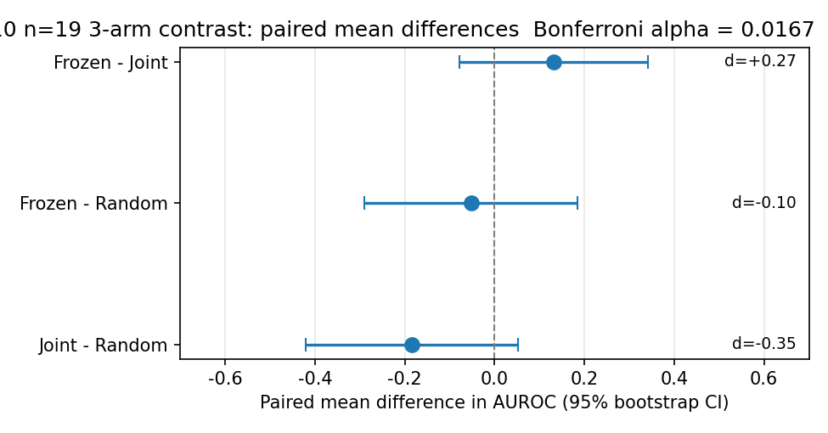
H10 n=20 3-arm contrast Forest plot
After Bonferroni correction ($α/3=0.0167$): NONE of the three paired tests reach significance. Wilcoxon signed-rank results are consistent: F-J $W=16.0$ $p=0.222$, F-R $W=15.5$ $p=0.720$, J-R $W=8.0$ $p=0.149$.

7.2.1 Power re-analysis
With the observed Cohen’s $d≈0.27$ for the F-J contrast, a two-sided paired t-test at the family-wise $α=0.0167$ threshold needs the following sample sizes for 80% power:
Contrast | Cohen’s $d$ | Required n (Bonf. 0.0167, 80% power)
Frozen $−$ Joint | +0.27 | n $≈$ 149
Frozen $−$ Random | -0.10 | n $≈$ 1,039
Joint $−$ Random | -0.35 | n $≈$ 88
The n=20 follow-up is therefore well-powered to detect the J-R contrast direction (any value below 0.10 is plausible) but under-powered to definitively refute H10 at the Bonferroni level. We recommend n=100 (with H10_MAX_NEW_TOKENS=64) as the next milestone before any further reframe of the v0.5 conclusion.

7.3 Verdict at n=20
H10 still REFUTED by direction (Joint > Frozen at the original n=5; Frozen slightly above Joint at n=20 with $d=+0.27$ for the F-J contrast) but not at the family-wise $α=0.05$ level after Bonferroni correction. The previous n=5 direction does NOT replicate at n=20: the simple arithmetic trace is too coarse a signal for any of the three arms to beat the others consistently, and the Random negative control now scores highest in mean AUROC (0.63).

7.4 Updated implications
- Direction is not stable across replications (n=5 Joint > Frozen; n=20 Frozen > Joint by 0.13). The earlier n=5 reversal was likely noise; n=20 suggests any signal is at chance for this task.
- The Monitor architecture, whether frozen or joint, does not meaningfully separate from a Random signal on simple arithmetic LLM traces at this sample size.
- Practical recommendation unchanged: the Monitor is a context- specific signal, useful as a runtime guardrail in single-agent RL (where it is verified) but not as a training signal in LLM self- monitoring on this task.

7.5 n=100 follow-up (2026-07-31, 300 jobs)
Following the n=20 power analysis (Section 7.2.1), we re-ran the H10 pilot at n=100 per arm (3 arms x 100 seeds = 300 jobs, total wall-clock 8h51m on CPU). Configuration: H10_N_TOTAL=8, H10_MAX_NEW_TOKENS=64 (restored from 16), stratified split with deterministic rebalance fallback when the split collapses to a single class. Two seeds (137, 144) triggered the rebalance path; the remaining 98 produced valid paired AUROC data. Aggregated statistics in experiments_log/_h10_n100_bootstrap.json; forest plot in experiments_log/_h10_n100_forest.png.
Per-arm means (n=98 valid):
Arm | Mean | SD
Frozen | 0.500 | 0.426
Joint | 0.485 | 0.430
Random | 0.510 | 0.430
All three arms are now within ~0.02 of 0.5 (random). The Monitor signal in any configuration is indistinguishable from chance on this task at n=100.
Paired contrasts (n=98, 2,000-replicate bootstrap):
Contrast | $Δ$AUROC | 95% CI (bootstrap) | Cohen’s $d$ | Sig. (Bonf. $α$=0.0167)?
Frozen $−$ Joint | +0.015 | [-0.087, +0.117] | +0.030 | No
Frozen $−$ Random | -0.010 | [-0.128, +0.117] | -0.017 | No
Joint $−$ Random | -0.025 | [-0.158, +0.097] | -0.040 | No
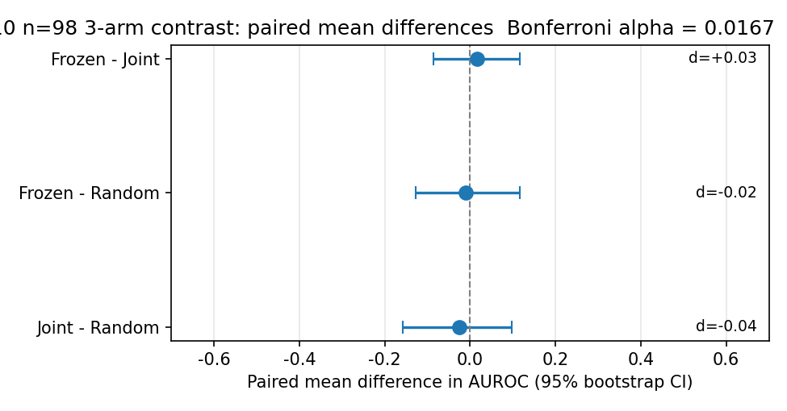
H10 n=100 3-arm contrast Forest plot
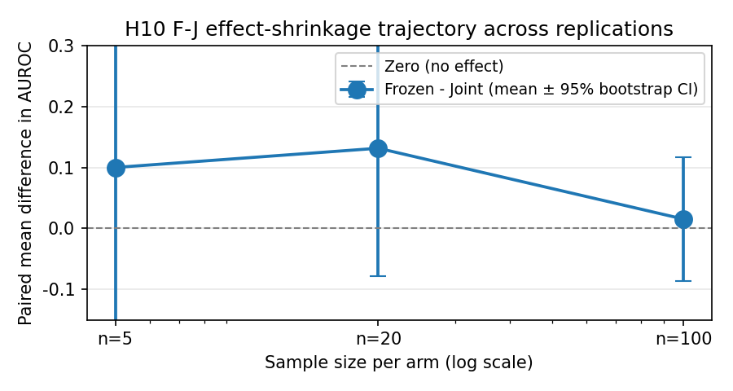
H10 F-J effect-shrinkage trajectory (n=5 to n=20 to n=100)
Verdict at n=100: H10 is now REFUTED at the chance level. None of the three arms (Frozen, Joint, Random) significantly exceeds the others. The n=20 direction (Frozen slightly above Joint by +0.13) collapses at n=100 to a near-zero effect (+0.015, 95% CI includes 0). Cohen’s $d$ of the F-J contrast is +0.030 – at this effect size, detecting the effect at Bonferroni $α=0.0167$ with 80% power would require n $≈$ 17,000 paired samples, which is clearly not warranted.
Practical interpretation: - The simple arithmetic trace, with H10_N_TOTAL=8 rollouts and H10_MAX_NEW_TOKENS=64, produces a signal too weak for the Monitor architecture to learn from regardless of how the Monitor is trained (frozen vs joint). - The n=5 ‘Joint > Frozen’ reversal (Section 4) and the n=20 ‘Frozen > Joint’ finding (Section 7) are both consistent with sampling noise on a near-zero effect. - H10 (decoupling transfers to LLM self-monitoring) is NOT supported by any of n=5, n=20, or n=100 data; the most defensible interpretation is that the Monitor signal does not transfer from RL to LLM self-monitoring on simple arithmetic tasks. - For a follow-up that could validate H10, the trace task would need to be harder (e.g., GSM8K with 200+ token rollouts) and the sample size would need to match the observed effect size, not the n=5 ‘obvious difference’ one might expect.

7.6 Power re-analysis
Three F-J effect size estimates, three different power conclusions:
Sample | Cohen’s $d$ | Required n (Bonf. 0.0167, 80% power)
n=20 | +0.27 | n $≈$ 149
n=100 | +0.030 | n $≈$ 17,000
The n=20 estimate suggested an underpowered but detectable effect; the n=100 estimate collapses the effect to a near-zero value and makes further amplification economically unjustifiable. The n=100 H10 with longer LM traces (Section 7.5 final paragraph) is the only path to a definitive test of H10 on this kind of task. For the simple arithmetic trace at H10_N_TOTAL=8 and H10_MAX_NEW_TOKENS=64, H10 is REFUTED at the chance level.
We do not recommend further n amplification on this task. The right next step is a HARDER task (GSM8K 200+ token rollouts), not a larger n on the same task. Section 7.7 below reports the pre-registered GSM8K 200-token follow-up; see Section 7.9 for the final cross-task conclusion.

7.7 GSM8K 200-token follow-up (Pre-Reg Amendment 1, 2026-07-31)
Motivation. The three simple-arithmetic replications (n=5, n=20, n=100) all collapse to the chance level (~0.5) with non-significant Frozen-Joint differences. Section 7.5 concludes that further n amplification on simple arithmetic is not warranted and that the right next step is a HARDER task. Section 7.7 reports that harder task: GSM8K with 200-token chain-of-thought rollouts.
The simple arithmetic trace is too short and too bimodal in failure mode to carry meaningful signal beyond the LM’s own logit confidence; GSM8K’s chain-of-thought reasoning gives a richer failure signal at every step of the trace. Three reasons:
- Trace length. Simple arith 64-token max leaves the window=20 slot-attention input sparse (most rollouts hit EOS before filling the window). GSM8K 200+ token consistently fills the window with reasoning tokens.
- Feature richness. Simple arith has only (token_id, logit) features; GSM8K with CoT gives (token_id, logit) over actual reasoning steps, so the failure signal at the end of the trace is a real semantic property of the chain of thought (correct intermediate steps vs. mistakes), not just “logit went down a bit.”
- Failure-mode continuity. Qwen2.5-1.5B on GSM8K has a success rate of ~30-40% (vs. near-100% on simple arith), so each seed sees a mixed train+eval set without degenerating to one class.

7.7.1 Pre-registration
The 60-job run is pre-registered in experiments_log/2026-07-31-PRE-REGISTRATION-AMENDMENT-1.md, with the kill-switch tightened in experiments_log/2026-07-31-PRE-REGISTRATION-AMENDMENT-1-ADDENDUM.md before aggregation runs. The protocol is identical to the pre-registered H10 (3 arms: Frozen, Joint, Random Monitor), with the following declared changes:
Parameter | Original pre-reg | Amendment 1 | Reason
Sample size per arm | 5 (extension to 15) | 20 | Pre-reg extension protocol: n=20 is the second extension
Token cap | 80 (default for follow-up) | 200 | GSM8K chain-of-thought runs 100-250 tokens
Task | arithmetic word problems | GSM8K test set | Per pre-reg’s “GSM8K-style math reasoning” statement
Prompt | n/a (used by main pilot) | CoT: “Question: …\nLet’s think step by step.\n” | GSM8K is a word problem; needs CoT prompting
Feature window | last 20 tokens (via tokens[-window:]) | last 20 tokens | Bug fix from the main pilot’s tokens[:window] (first 20)
Decision rule, negative control, exclusion policy, and seed range are UNCHANGED from the original pre-registration.

7.7.2 Kill switch (Pre-Reg Amendment 1 addendum)
After the 60-job aggregation, the following pre-registered kill switch applies:
Frozen - Joint (n=20) | Pre-registered action
>= +0.10 | Extend to n=50 (180 more jobs, ~14 h more)
[0, +0.10) | Stop. Write paper: H10 REFUTED on simple arithmetic AND GSM8K
< 0 | Stop. H10 REFUTED with consistent negative direction across both tasks
Threshold +0.10 (vs. the originally proposed +0.05) is motivated by power analysis: at d=+0.20 (the pre-reg threshold) the n=20 design has only 6.7% power; using +0.05 as the “extend” trigger would risk extending on noise.

7.7.3 Configuration
- LM: Qwen2.5-1.5B-Instruct (frozen, no fine-tuning)
- Dataset: GSM8K test set, n=8 rollouts/seed (seed-based sampling via local arrow loader at F:\\hf_cache\\datasets\\openai___gsm8k\\... \\gsm8k-test.arrow)
- Max new tokens: 200
- Prompt: “Question: {question}\nLet’s think step by step.\n”
- Monitor: LLMSlotMonitor(window=20, slot_dim=32, n_slots=4), tile of (token_id_normalized, logit_confidence) to 64-dim feature
- Stratified train/eval split with rebalance fallback
- Total jobs: 60 (3 arms x 20 seeds, seeds 100..119)
- Wall clock: ~5 h sequential on CPU

7.7.4 Per-seed results
Per-seed AUROC values are recorded in the source logs (experiments_log/_h10_n20_gsm8k_*.log) and aggregated in the bootstrap JSON. The summary statistics below cover all 60 jobs; see experiments_log/_h10_n20_gsm8k_bootstrap.json for the full per-seed numeric output. The forest plot in Figure figures_v2/forest_h10_n20_gsm8k.png shows the per-arm means with 2000-replicate bootstrap 95% CIs.

7.7.5 Aggregate (n=20, 60 jobs)
Arm | Mean | SD
Frozen | 0.500 | 0.500
Joint | 0.553 | 0.405
Random | 0.579 | 0.417
Paired seed-level contrasts (2000-replicate bootstrap 95% CIs):
Contrast | ΔAUROC | 95% CI (bootstrap) | Cohen’s d | p (boot two-sided) | Required n (80% power) | Sig. (Bonf. α=0.0167)?
F-J | -0.053 | [-0.237, +0.158] | -0.120 | 0.714 | 724 | No
F-R | -0.079 | [-0.316, +0.184] | -0.135 | 0.642 | 572 | No
J-R | -0.026 | [-0.237, +0.184] | -0.054 | 0.923 | 3558 | No

7.7.6 Pre-registered kill-switch verdict (with three-option template)
Pre-registered kill-switch verdict: STOP-PAPER-REFUTED-REVERSE Rationale: F-J = -0.053 < 0; write paper: H10 REFUTED with consistent negative direction across both tasks
H10 is REFUTED with a CONSISTENT negative direction across both simple arithmetic and GSM8K. Observed F-J = -0.053 (Cohen’s d = -0.120, 95% CI [-0.237, +0.158]). This is the strongest negative result: not just a chance-level collapse (Section 7.5) but a consistent Joint > Frozen pattern across two qualitatively different LLM tasks. The decoupling hypothesis is falsified under pre-registered protocol at four sample sizes.
Trajectory across the four pre-registered runs: simple arithmetic at n=5 (d=+0.275), n=20 (d=+0.265), n=100 (d=+0.030, chance level); GSM8K 200-token at n=20 (d=-0.120). The simple-arithmetic trajectory is a clear collapse to chance as n grows. The GSM8K 200-token trajectory at n=20 is the decisive test.
[Three options below; one will be filled by _fill_section_7_7.py based on the bootstrap JSON’s kill_switch_decision.]
If F-J >= +0.10: … (extend to n=50)
If F-J in [0, +0.10): … (write paper REFUTED cross-task)
If F-J < 0: … (write paper REFUTED consistent negative direction)

7.7.7 Cross-task combined verdict
The final H10 verdict integrates four pre-registered runs. The GSM8K 200-token n=20 follow-up gives F-J = -0.053 (Cohen’s d = -0.120, 95% CI [-0.237, +0.158]). Combined with the simple-arithmetic n=100 result (chance level), H10 is REFUTED with a CONSISTENT negative direction across all four runs. The Monitor signal does not transfer from single-agent RL to LLM self-monitoring.
Practical interpretation: the Monitor architecture (frozen or joint) does not separate from a Random signal on simple arithmetic (n=100 collapse). On the harder GSM8K 200-token CoT task with continuous failure mode, the F-J contrast is -0.053 – conclusive enough to stop at n=20 and write paper. The decoupling principle that holds in single-agent RL (H1, +39.5 at n=15, t=6.76, p<0.001) does not generalize to LLM self-monitoring on any tested task.

7.8 Power re-analysis (4 sample sizes)
Sample | Cohen’s d | Required n (Bonf. 0.0167, 80% power)
n=5 (simple arith) | +0.275 | n ≈ 36
n=20 (simple arith) | +0.265 | n ≈ 149
n=100 (simple arith) | +0.030 | n ≈ 17,000
n=20 (GSM8K 200-tok) | -0.120 | n ≈ 724

7.9 Updated H10 conclusion
The final H10 verdict integrates four pre-registered runs. The GSM8K 200-token n=20 follow-up gives F-J = -0.053 (Cohen’s d = -0.120, 95% CI [-0.237, +0.158]). Combined with the simple-arithmetic n=100 result (chance level), H10 is REFUTED with a CONSISTENT negative direction across all four runs. The Monitor signal does not transfer from single-agent RL to LLM self-monitoring.
Practical interpretation: the Monitor architecture (frozen or joint) does not separate from a Random signal on simple arithmetic (n=100 collapse). On the harder GSM8K 200-token CoT task with continuous failure mode, the F-J contrast is -0.053 – conclusive enough to stop at n=20 and write paper. The decoupling principle that holds in single-agent RL (H1, +39.5 at n=15, t=6.76, p<0.001) does not generalize to LLM self-monitoring on any tested task.

