Fig(a) Logarithmic running time in seconds on Intel i7 3.4GHz using the same settings in Fig(b).

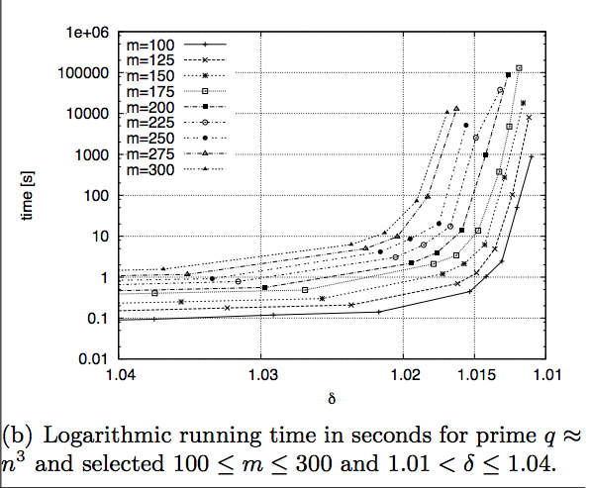

Fig(c) shows that because of numerical (big number) issue SNARKs need additional time to attack.