Kenneth Aidoo

251129019

Ece 4436A

**Lab # 1: Wireshark and SMTP Lab**

Task 1

**Q1:**

IPv4 IP address: 192.168.4.36

IPv6 IP address: is fe80::1044:b7f4:7c45:ee8

In line 4 and 7 the IPv6 addresses appear rather than the IPv4 addresses.

**Q2:**

8 packets in total were captured.

**Q3:**

4/677 = 0.59% of packets were UDP

673/677 = 99.4% of packets were TCP

Total: 677 packets

Task 2

Q4: IP address 128.119.245.12

Q5: 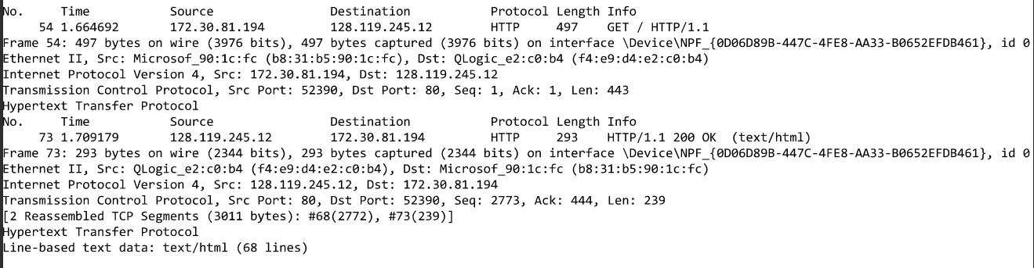

Q6. First difference: 0.044487 and the Second Difference 0.042451

Q7: It was 0.002036s faster the second time than the first time.





Q8. The request is cached to the local server, thus when we refresh the page the request is sent to the local server rather than the remote server. Making the request for the webpage faster.

Task 3

**Q1:**

I chose Gmail as the service to use for this task.

**Q2.**

Google has programmed Gmail so that by default, it always tries to use TLS when sending emails. A secure TLS connection requires both the recipient and the sender to use TLS. If not Gmail delivers this message but as an unsecure connection. So, adding Secure Transport Compliance setting allows for a secure connection amongst those with specified email addresses or domains. So its is using Transport Layer Security TLS in short.