# **AN ALGORITHM DEVELOPMENT OF TERRESTRIAL OIL SPILL MODELLING AND OIL VOLUME CALCULATION WITH GIS**

Calculation of oil droplet size distribution and surface oil spill modeling: experimental study and Algorithm development/ment

# ABSTRACT

The oil spill has very hazardous effects on the environment. The spill caused by oil platforms and oil pipeline networks in water bodies kills thousands of marine creatures because oil pollution in the ocean destroys marine creatures' food sources and makes it hard to breathe and move. Moreover, the oil contamination devastates agricultural areas, and these lands become infertile on terrestrial sites. This type of contamination generally occurs in the same way as water body oil spills. The terrestrial oil spill has a danger of turning into the water-based oil pollution due to oil spill can reach water streams, freshwater sources, and seas. The excellent site of the oil spill is that the trigger point of pollution can be predictable because energy transportation companies know where oil pipelines lie down as petroleum exploration and production companies know the exact coordinates of drilling wells. To minimize the harmful effects of oil contamination on the land site, petroleum companies should prepare scenarios before the disaster happens.

In this study, terrestrial oil spill volume and distribution route on the surface was modeled using Digital Elevation Model (DEM) on Geographic Information System (GIS) technology with its powerful tools on ArcGIS and PostGIS. At the end of the study, the volume of oil that will leak along the pipe route has been calculated according to the topography. Then the oil flow path with puddles location and accumulated oil volume is extracted before a possible oil spill happens. The study will help assess whether sites of oil pipeline valves are selected efficiently or not, how much area will be affected by pollution, and whether oil reaches freshwater supplies.

**Keywords**; modeling oil spills on land, terrestrial oil pollution analysis, oil path extraction, GIS

# 1-INTRODUCTION

Due to the necessity of oil, exploration technology, production sites, and companies' budgets have been expended. For example, Ultra-deep wells can go down to up to 8000 m. depth [1], US field production of crude oil was about 6700 thousand barrels per day in 2008, but it increased to about 16500 thousand barrels per day in 2021 [2]. Five oil and two automobile companies were in the top 10 of the global fortune 500's 2020 list [3].

Whereas negative impacts of petroleum products seriously threaten our future, we might not build our modern civilization without it. After petroleum started to use as an industrial material, we received benefits in various areas such as transportation, electricity, heating, cooling, and clothing [4]. In recent years, our society has been searching for alternative energy sources because environmental pollution and global warming will cause dramatically decrease not only in animals but also in human populations soon. Due to necessity and dependency, sharply getting rid of oil and its products seem impossible in a short period.

Whether or not oil production has been done on a marine site, the petroleum refining process and a significant part of consumption have taken place in the terrestrial site. Most terrestrial oil spills occur during transportation. The leading causes of pipeline oil spills are faulty pipeline welds, landslides, equipment, operator-related causes, terrorist attacks, earthquakes, and corrosions [5, 6]. According to the CIA's factbook, there is more than 300,000 km of the oil pipeline in the world [7]. That means oil pipelines can cover about 7.5 times the world's circumference.

Moreover, the total offshore pipeline length to the onshore pipeline is about 5% because the investment cost of an offshore pipeline is about three times higher and carrying out maintenance and repair activities for an underwater pipeline is harder [8].

|  |  |
| --- | --- |
| **Total onshore construction (42,565 miles) beyond 2013 will cost nearly $132 billion** | **Total offshore construction (2,270 miles) beyond 2013 will cost more than $12 billion** |
| $2.9 billion for 4-10 inc. | $558 million for 4-10 inc. |
| $19.7 billion for 12-20 inc. | $3.8 billion for 12-20 inc. |
| $41 billion for 22-30 inc. | $7.9 billion for 22-30 inc. |

Table form Oil & Gas Journal[8]

The improving technologies in remote sensing allow detecting hydrocarbon accumulations, indicating visible and invisible oil seepage footprints. Visible-near infrared and short-wave infrared wavelengths can be used for invisible traces of oil seepage, and short and long wave infrared wavelengths can be used for the visible indicator of oil seepage [9-11]. Also, Synthetic Aperture Radar (SAR) can detect visible or invisible oil seepage existence [10-12].

Although terrestrial site oil pollution is at least as dangerous as the oil spill in water, there are many academic sources and risk modeling applications for the oil spill on water bodies [13-16]. Literature reviews show that researchers mainly focus on oil spill pollution's environmental impact on the land [17-19]. Some other researchers focus on how deep the leak can go, depending on the soil types at an incident with predefined or calculated oil volume [20-22]. These studies examined only the vertical distribution of the oil spill and evaluated whether the leakage could reach the aquifers or not. In other studies, GIS was used, researchers mostly modeled actual events, and after the oil spill, the impact of the environmental disaster was analyzed and mapped with actual variables [23, 24]. This study supports the literature for providing necessary tools for identifying possible leaks on the terrestrial site.

A GIS solution will calculate horizontal spill direction and possible spill volume on the ground. There are predefined flow direction and accumulation analysis tools on GRASS [25, 26] and ArcGIS [27, 28]. However, these analyses are not only enough for oil spills because flow direction and accumulation analyses calculate the flow directions of all pixels in the model and the total flood volume for the whole model [29]. Pipeline-induced oil spill starts from a single point and spread ground from that location. Therefore, a new spill direction approach has been developed for onshore oil spill accumulation, similar to the D8 (eight directions) method on GRASS [25, 26] and ArcGIS [27, 28], having different neighborhood relations. Furthermore, the Algorithm developed via GIS tools for calculating the volume of oil that may leak will be examined in this study.

# 2- MATERIALS AND METHOD

The leading causes of onshore oil spills are leaks at the drilling point, leaks in oil pipelines and storage tanks, and accidents during oil transportation. Since oil is valuable and oil spills cause severe damage to nature, the location and volume of the spill are known with almost certain accuracy. These locations and volumes are registered by US Environmental Protection Agency (USEPA) in USA, Environment Agencies such as European Environment Agency (EEA) in Europe. In addition to these Agencies, Pipeline and Hazardous Materials Safety Administration (PHMSA) in the USA European Gas Pipeline Incident Data Group (EGIG) in Europe are organizations that specifically record pipeline spill data.

As can be understood from the statistical information, pipelines are one of the most critical fundamental reasons for oil spills, whether onshore or offshore. When oil spills are analyzed, it is seen that tanker and pipeline spills are the root cause of offshore spills, and pipelines and oil storage tanks are the root cause of onshore leaks. In the USA, between 1990 and 1999, the biggest reason for the onshore oil spill into the environment with 22.4% is the pipelines on land, and the second-largest rate is oil storage tanks with 10.0% [30].

Although statistical information and records can be used to prevent future natural disasters, taking protective measures before these events occur is the most important thing. This study aims to determine the volume of oil that will leak according to topographic variables from a pipeline crack and to calculate the distribution of possible leakage in the horizontal and vertical directions using the GIS analysis capability.

## 2-1 Supervisory Control and Data Acquisition (SCADA)

SCADA is a system that provides monitoring, controlling, and data collecting in real-time via the control center of industrial systems. The data collected in SCADA systems can be used to quickly conclude with methods such as machine learning and artificial intelligence without human touch.

On pipeline systems, SCADA allows [31];

* Automatic start-up/shutdown. For example, start-up of a pump or shutdown of a pump.
* An emergency shutdown is performed when the pressure in the pipeline shows critically low, or leakage is detected.
* Pipeline configuration such as a valve is closed or open.
* Real-time modeling. For example, eliminate erroneous readings by examining many data sets simultaneously.
* Leak detection after detecting a severe drop in pressure and flow rate.
* Batch tracking, for example, sorting different shipments from each other at the destination point.
* Meter Proving. The pressure, temperature, density, and flow rate results of the transported product read at many different points can be compared.

And so on.

The information transfer between the SCADA system and the equipment can be done by copper cables, radio links, GPRS modems, fiber cables, etc. One or more of these methods can be used with redundancy on modern systems. After leakage is detected on the oil pipeline, the pump systems and valves positioned before and after the leak location are automatically shut down. Thus, the leakage volume is minimized, and safety is ensured.

## 2-2-Digital Elevation Model (DEM)

This study used DEM data for NASA's Shuttle Radar Topography Mission (SRTM). DEM defines a land surface as 3-Dimensional and is obtained from the elevation of the ground. In other words, DEM is a digital representation of Topography. SRTM data's resolution is 30 m horizontally and 16 m vertically [32], and this data is open to the public.

# 3- OIL SPILL VOLUME CALCULATION

Although the SCADA system and pipeline equipment are interconnected by fiber lines operating at high speeds, there will be as much flow as the time between leak detection and valve closure. In addition to this leakage, there will be some more flow from trapped oil since the atmospheric pressure balance is established.

## 3-1 Calculation of Leakage Volume from Oil Storage Tanks

The risk of onshore oil spills from the rupture of in-ground oil storage tanks is very low. Lightning, maintenance/hot work, operational error, equipment failure, and sabotage are the leading causes of rupture in oil storage tanks [33]. The greatest danger in oil storage tanks is the possibility of explosion. These tanks are designed with a floating roof to prevent oil evaporation, reducing the possibility of an explosion, but this measure does not mean that the risk is zero. Moreover, preventive and mitigation measures such as regular inspection and maintenance, lightning protection system, fire detectors, and tank cooling system will reduce the rupture risk in storage tanks [34]. If there is a rupture in the oil storage tank, the volume above it may leak. Volume to flow in a regular shaped storage tank.

• h [m]: Storage height

• l [m]: Rupture height from the bottom

• S [m2]: Base area of ​​regular shape

The volume of oil that will flow from the oil tank if no measures are taken

If the volume of the round, irregularly shaped storage tank is

## 3-2 Calculation of Leakage Volume from Oil Pipelines

The total leakage volume is the amount flowing between the pipe's reputing and the valve's closing, and the sum of the volume flows until the pressure balance is established after the valves are closed if no intervention is made in oil pipelines.

### 3-2-1 Leakage Volume in Time until Valves Shut-in

According to the US Department of the Interior, The Bureau of Ocean Energy Management has proposed two different methods that can be used to calculate the leakage volume for a pipeline break or rupture [35]. These methods do not apply to minor pipeline fractures or pinhole leaks.

• IDpipe [in]: Pipeline internal Diameter

• Lpipe [ft]: Pipeline length

•: Oil volume fraction at ambient pressure and temperature

•: Oil and gas densities at ambient pressure and temperature

• [lb/ft³]: Oil and gas densities at initial operational conditions

• [lb/ft³]: Oil and gas densities at ambient pressure and temperature

• GOR [scf/stb]: Gas-oil ratio at standard conditions in pipeline

• [lb/ft³] and γo [-] (specific gravity, dimensionless): Oil density at the standard condition in the pipeline

• [lb/ft³], γg [-] (Specific gravity, dimensionless): Pipeline gas density at the standard condition

• Q [stb/d]: Pipeline flow rate

• t [min]: Time until valve close

The basic formula is:

[bbls]

The advanced formula is:

Calculating of total volume of pipe

Calculating the initial mass

[lb]

Calculating the total mass

[lb]

Calculating the total mass released

[lb]

Calculating the gas mass fraction at standard conditions

[-]

Calculate the volume of oil releases. Also, this is the basic formula

[bbls]

Calculating the volume of oil released. This equation has taken from the advanced formula

[bbls]

### 3-2-2 Volume of Flow That May Occur after Valves Shut-In

Valves in oil pipelines are closed to minimize environmental pollution after leak detection. If no intervention is made, the flow will continue until the pipe's internal pressure equalizes the external pressure as mentioned above. The total volume of oil trapped between two valves:

But not all of this volume spills. The volume of oil that will flow trapped between two valves can be calculated by GIS analysis.

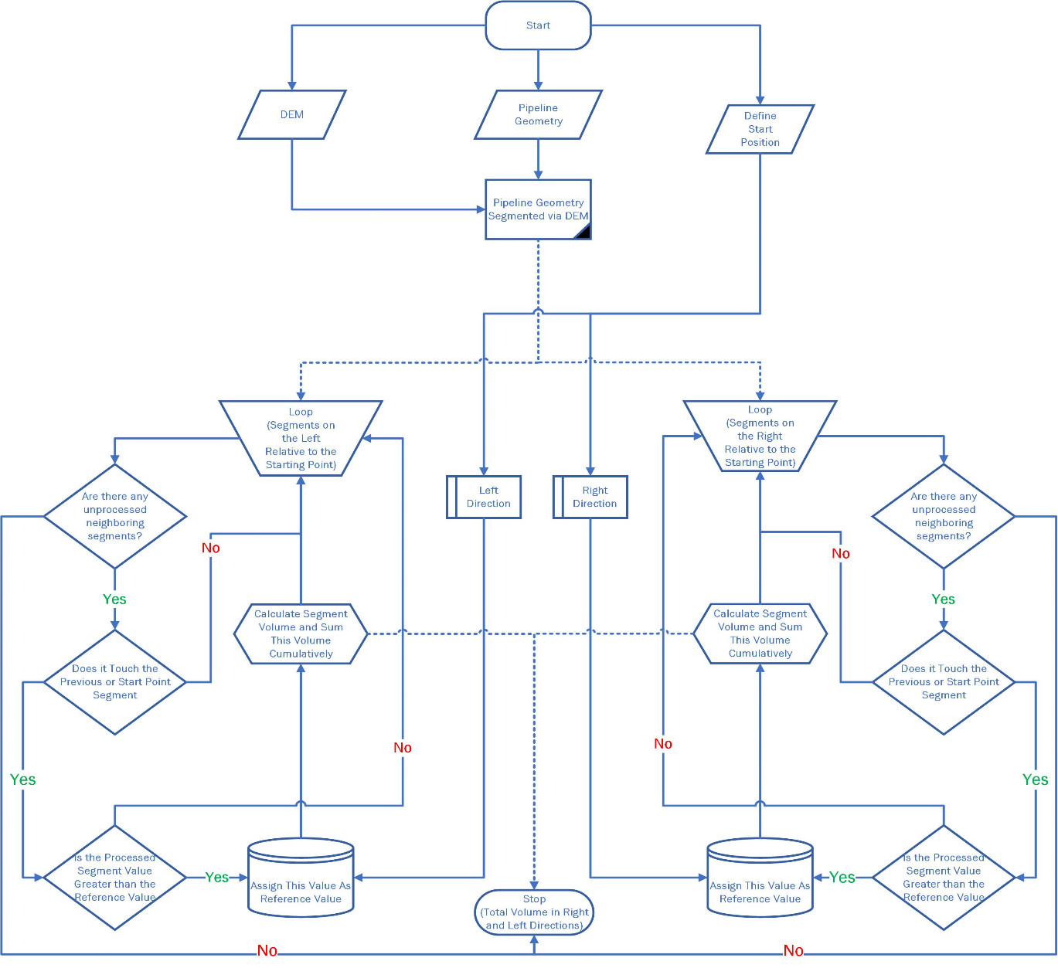

Figure-1 Calculation of the Volume of Oil to Flow after the Valves are Closed - Flow Chart

A GIS-based algorithm working on the PostgreSQL database has been developed and coded via Python programming language to calculate the volume of oil that will flow after the valves are closed. The Flow Chart of the developed Algorithm is shown in fig 1. If the working principle of the Algorithm is to be examined step by step;

1. DEM data of the region to be calculated, pipeline vector drawing with coordinates, and the coordinate of the leak location on the pipeline should be supplied as input.
2. Pipeline geometry and DEM data are overlapped. Pipeline geometry is segmented based on DEM data.
3. DEM data is intersected with the starting point. The randomly selected first segment (either can be in the right or left direction) is marked as the processed segment. The height value at the intersection point is recorded as a reference value.
4. Calculate the volume of the selected Pipeline segment. This volume is recorded as the total leakage volume, and the selected segment is marked as processed.
5. A loop starts until the inspection of all parts is finished on the pipeline route segmented with DEM
6. It is checked whether the selected segment has been processed before. If no action has been taken on this part before, a new segment is selected (Step 5 starts over). If not processed, the next step is taken.
7. Does the loop part geometrically touch the processed part? If yes, the next step is passed. If no, the new unprocessed segment is selected, and step 5 starts over.
8. The path is updated within each iteration in loops if the height value of the processed segment is smaller than the reference height. If the value is greater than or equal to the reference value, the height of the processed segment is assigned as the reference height value. Then, the volume of the processed segment is calculated, and the total leakage volume value is added to this value, then the new calculated volume is recorded as the total leakage volume. After that, this segment is marked as selected, and step 5 starts over with the new selected segment.
9. Switch to the unselected direction (right or left). The height value of the part where the DEM data and the starting point intersect is reassigned as the reference value.
10. Step 5 is repeated for the newly selected direction.

After the 7th step, the total leakage volume in the right and left directions is calculated.

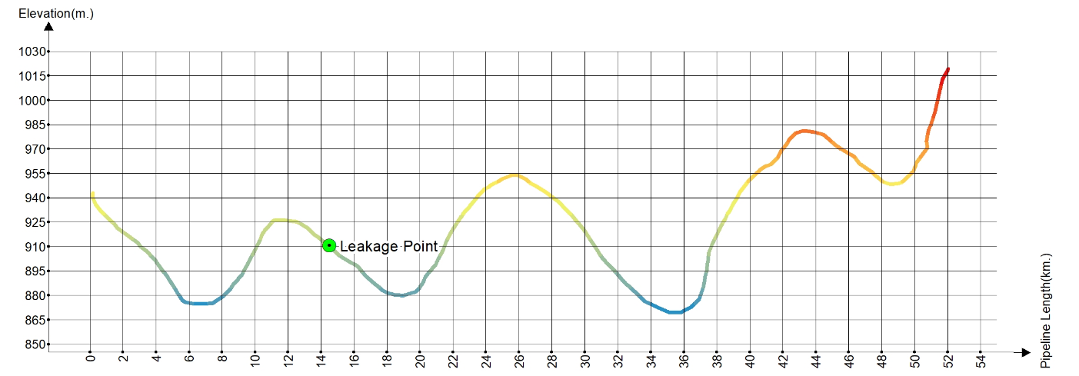

Figure-2 How Algorithm works diagram. The pipeline route is colored with the lowest elevation blue and the highest red

The developed Algorithm has been applied to a pipeline segment whose elongation section representation is like figure 2.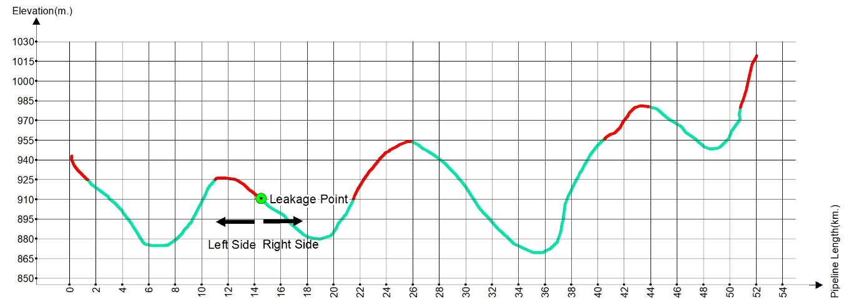

Figure-3 Algorithm result elongation section

As expected, satisfying results were obtained after the application ran in the right and left directions from the entered leak point. The areas in red in Figure-3 are marked as the oil will flow out. The green-colored areas are marked as the remaining oil segments due to the topography In Figure-3.

# 4-HORIZONTAL DISTRIBUTION OF OIL SPILL ON SURFACE

Some famous GIS-based hydrology analyses are flow direction, flow accumulation, and sink detection algorithm. Even if the names of these analyses seem applicable to an onshore oil spill, they could not apply. Because all of these algorithms simultaneously evaluate equal amounts of water drops to each cell on DEM, these algorithms analyze all cells. These analyses apply flood modeling or topographical structure extraction like ridges, stream channels, or holes [36].

Terrestrial oil spills are derived from a crack in the oil pipeline or an unintended accident on drilling rigs, so an amount of liquid gradually spreads to the ground from an exact location.

The first crucial criterion in calculating the oil spill route is if there is a hole on the stream path, liquid accumulates until it reaches the same height as the hole. Liquid flows from higher altitudes to lower ones. When we apply these rules on DEM for a GIS-based solution, liquid always flows to the lowest value neighbor cell, and if all neighbors are more significant than progressing cell, liquid accumulates as high as the value of the lowest neighbor.

The other fundamental parameter determining flow direction length is the soil's absorption rate. Some amount of liquid will be absorbed by the soil, and the absorption amount will be related to soil type. The solution to this problem on GIS-based analysis is defining the absorption amount of liquid base on soil type for a unit area.

In addition to these parameters, there will be some losses in the oil volume leaked due to some reasons such as evaporation, vegetation attachments in the soil and small cracks in the ground, etc.

The oil spill analysis algorithm should be ended when the total loss on the path is getting higher than the volume of oil for analysis.

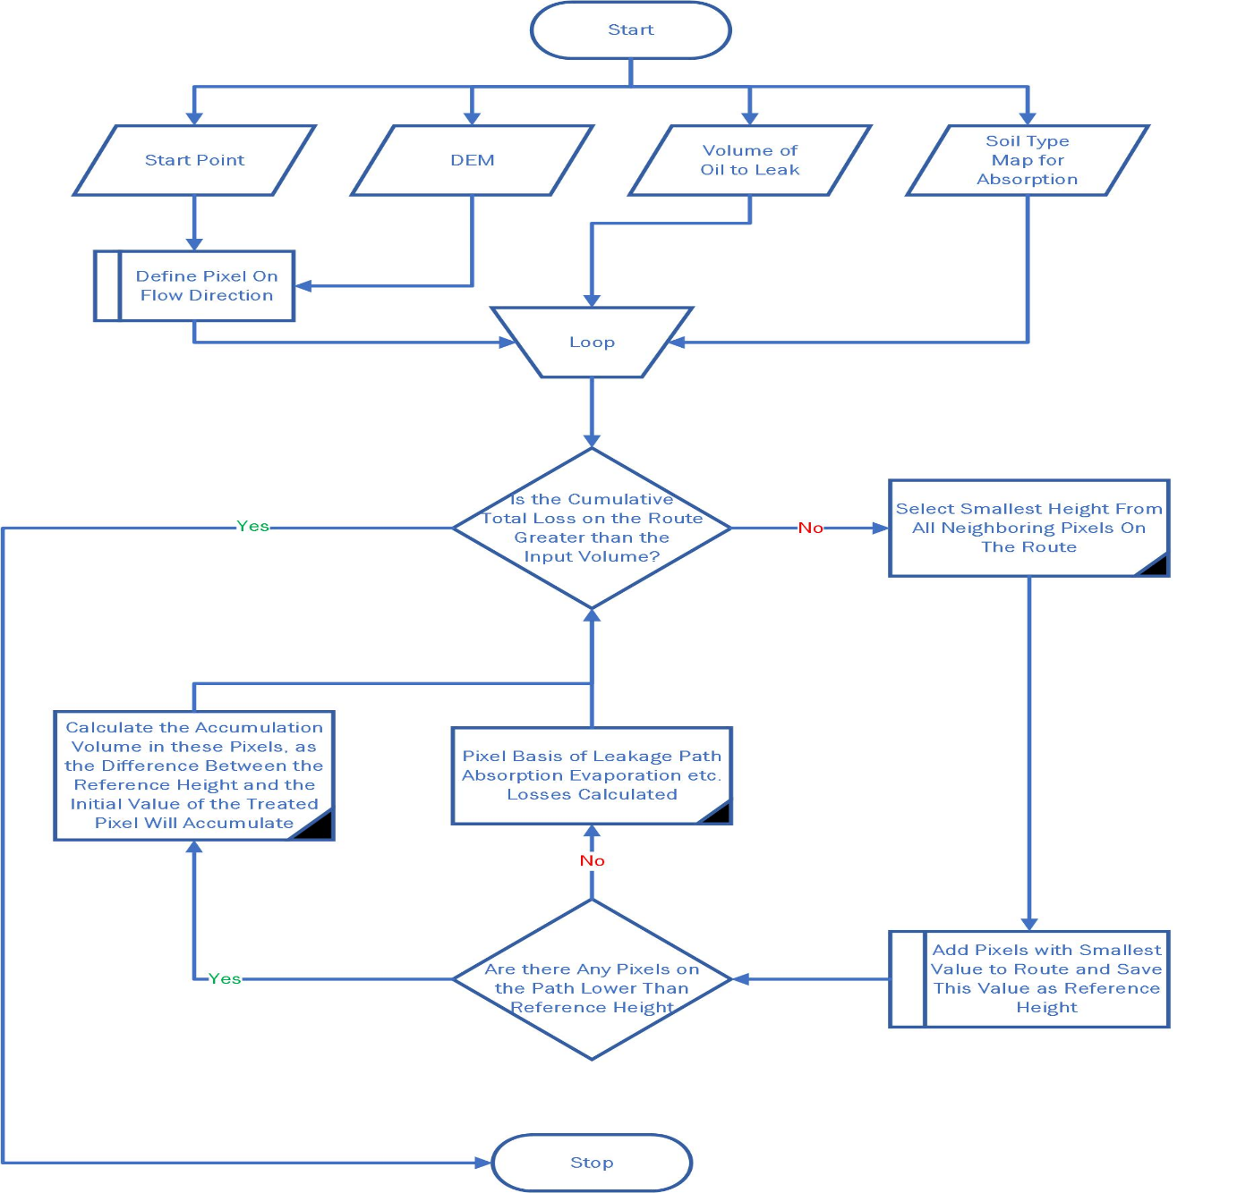

Figure-2 Onshore Oil Spill Distribution Algorithm- Flow Chart

Oil spill analysis was coded using the arcpy library on ArcGIS by following the steps below.

1- DEM data, leaked volume, soil type map, and leak start location are given to the application as input.

2- DEM and soil type data are transferred to a surface model where elevation and soil type are shown together by performing the intersection analysis in GIS. Rectangular pixels may deteriorate at this stage, but this will not affect the Algorithm.

3- GIS intersection analysis is applied to the starting point of the leak and DEM data. The intersecting pixel is recorded as the leak path, and the height value of this pixel is assigned as the reference height.

4- The loop is run until the total leak volume is greater than or equal to the calculated leak volume

1. The pixel with the smallest height value on the entire leak path is detected, and this value is assigned as the reference height value.
2. If there are pixels equal to the reference height value within the neighboring pixels of the entire leak path, these pixels are recorded as the reference path. This step is repeated within the pixels of the newly joined pixels using the endless loop or recursive function. (Similar to breath-search first Algorithm)
3. Accumulation will happen on the pixels with a height less than the reference height value on the calculated leak path. Therefore, the total accumulation volume is calculated by applying the following formula in pixels whose reference value is less than the height value.

Pixel-based Puddle Volume=Area of ​​the Processed Pixel* (Height of Reference Pixel - Height of the Processed Pixel)

1. The absorption amount is calculated for each DEM part based on the unit volume absorption amount according to the soil type.
2. A constant loss parameter proportional to the calculated path length is defined for losses from small surface cracks, evaporation, adhesion to vegetation, etc. There will be losses equal to multiplying the path length by the constant loss parameter.
3. The loop is stopped as soon as the sum of the volumes of the losses occurring in the c, d, and e steps are equal to or greater than the total leakage volume specified as the input parameter.

In the developed Algorithm, the soil type is an optional parameter. A fixed absorption rate is given if this data does not exist.

## 4-1 Lowest Neighbor Problem

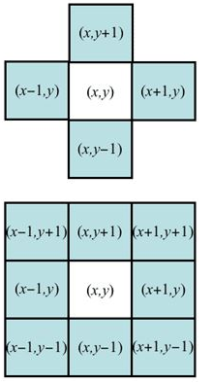Neighbors define in two ways on raster base analysis. The first one is the 4-pixel neighborhood relation. These four neighbors stay in the horizontal and vertical directions, and their coordinates are;

[(x, y+1), (x, y-1), (x+1, y), (x-1, y)]

The other relation is the 8-pixel neighborhood relation. In this type of relation, diagonal neighbors are also calculated. These 8 pixels coordinates are;

[(x, y+1), (x+1, y+1), (x+1, y), (x+1, y-1), (x, y-1), (x-1, y-1), (x-1, y), (x+1, y+1)]

On the contrary,

The concept of the neighbor pixel is quite different as it comprises all neighborhood cells around the calculated path on oil spill analysis. The neighborhood pixels also increase when the path gets larger with the number of processed pixels during the operation. If we try to solve oil spill analysis like a classical raster-based path determination problem, we should save all neighbors' pixels coordinate, and we must update them after a new pixel get in to flow. We converted DEM data to vector format with their elevation values to eliminate this computational complexity.

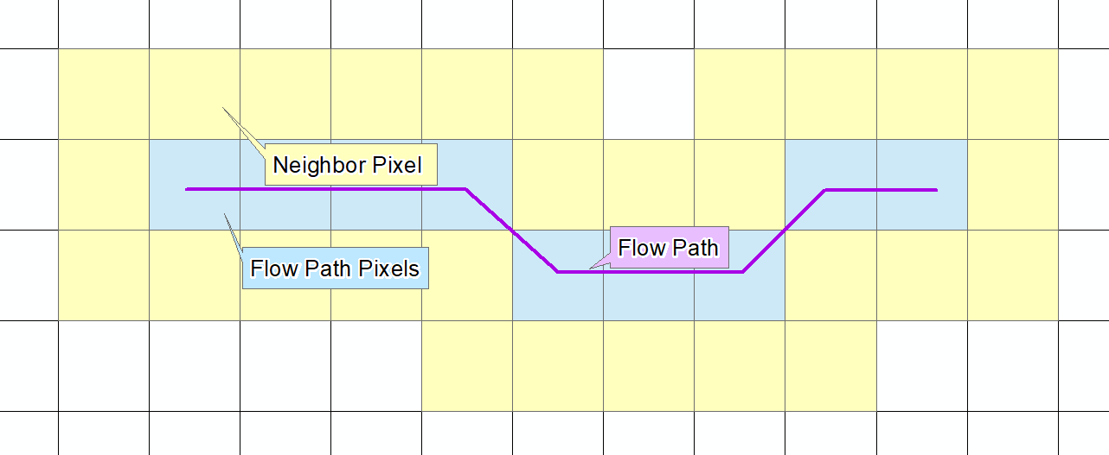

## 4-2 Oil Puddle Problem

In solving the oil spill problem, one of the critical parameters is finding barrier pixels on the path. Barrier pixels accumulate fluid until the height of the leak behind them equals the height of the pixel value.

Fluid accumulation occurs if the neighboring pixel with the smallest height is greater than the last processed pixel. The amount of buildup is calculated as the barrier pixel height value minus the height value of the pretreated pixel. The height value of all pixels on the calculated route is checked, and there will be accumulation in all pixels with a lower height than the last determined barrier pixel.

For example, in the image on the left side, after the 98 value is evaluated, all neighbors are greater than 98, so liquate starts to accumulate till the smallest neighbors. When we check the example, we can see that neighbor with the smallest height is 104. Therefore, the pixel with a height of 98 will accumulate 6 meters of water, and the pixel with a height of 100 will accumulate 4 meters of water.

## 4-3 Neighbor's Neighbor Problem

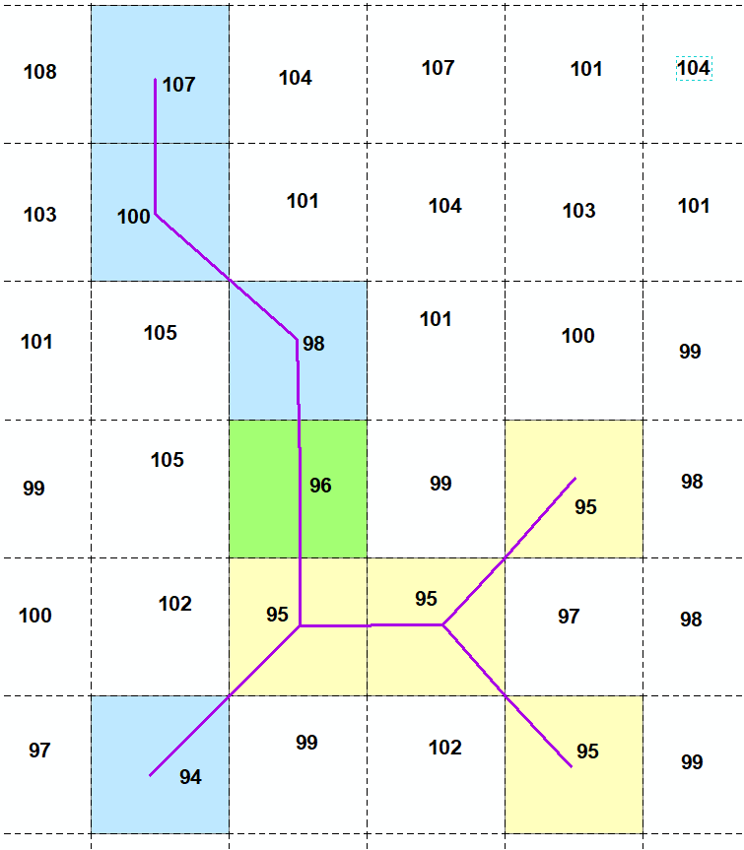In real life, liquid flows from top to bottom; in GIS, liquid flows from higher to lower cells. While calculating flow direction, the flat cells in DEM need to be considered. If more than one cell with the same elevation within the neighborhood relation, the liquid passes those cells.

In our analysis, after determining the lowest pixels on the flow path, we also must look up the same elevation values on neighbors of all these pixels whether or not the flow path pixels have a boundary to these cells having equal elevation values. This process extends the current flow path.

For example, the image above shows that liquid flows from 107 elevation value to 94 value. On the image, after the 96 (green) value processed application should appoint 95 (yellow) cells in the direction and search all neighbors of 95 cells for there are any cells whose elevation value equal to 95.

## 4-4 Soil Absorption Problem

Two fundamental parameters control the volume of liquate during the flow. The first one is oil puddles, and the other is soil absorption. The oil puddle problem explains the first parameter and how to puddle volume calculates. Soil absorption changes depend on soil type; therefore, using lithology gets more efficient results. In our application, we offer two options. First, if users have soil type maps, they can use soil water holding values from experimental studies or previous academic studies [37]. The second method is that the user can define a constant value as a standard soil water holding value for each pixel without soil type data.

## Resim 94-5 Sample Oil Path Results

The image on the left side shows a result without lithology data. Black numbers are elevation values gained from DEM data. Cells within blue boundaries are flow path cells. In the flow path, the top number shows progressing order. That means the flow direction sequentially tracks from 1 to 23 cells. The accumulation amount is displayed with red numbers at the bottom of the flow path.

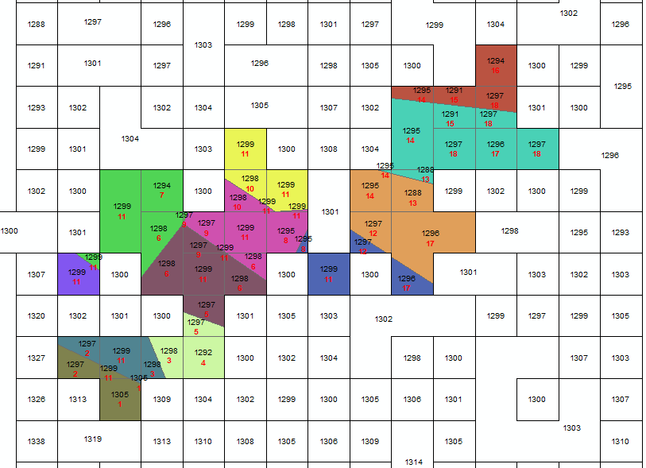

The image above illustrates the flow path direction of when the existence of soil type data. The pixels are divided into small pieces because of soil type data. Colorful cells show flow path pixels, and each color represents a different type of soil with different absorption rates. The red numbers under the flow path symbolize cells' progress order.

# 5- RESULTS AND DISCUSSIONS

This study was carried out to develop GIS analyzes to calculate the leakage volume according to the topographic changes of a leak that may occur on the oil pipelines and determine the leak's distribution route in the axis of the topographic changes. DEM data has been used to use topographic changes on the GIS system, and algorithms have been developed independently of the resolution of these data.

It is recommended to prepare soil type maps where oil pipelines are located and to determine the water holding capacity rates of the soil in laboratories. In this step, while the water holding capacity is added to the process, the water saturation of the soil should be evaluated, and it may be necessary to reduce or increase the rate. The other improvement can be made by solving the problem directly on rater data rather than vector data like we did. It ıs obvious that raster data results will provide more speed.

# 6-CONCLUSION

# REFERENCES

1. Wang, H., Y. Ge, and L. Shi, *Technologies in deep and ultra-deep well drilling: Present status, challenges and future trend in the 13th Five-Year Plan period (2016–2020).* Natural Gas Industry B, 2017. **4**.

2. EIA. *US Field Production of Crude Oil and Petroleum Products*. 2022 26.03.2021]; Available from: <https://www.eia.gov/dnav/pet/hist/LeafHandler.ashx?n=pet&s=mttfpus2&f=a>.

3. 500, F. *Global 500 List*. 2020 26.03.2021]; Available from: <https://fortune.com/global500/2020/>.

4. Hymel, M.L., *Globalisation, environmental justice, and sustainable development: the case of oil.* Macquarie Law Journal, 2007. **7**(2007): p. 125-153.

5. Freedman, B., *Environmental science*. 2018.

6. Popescu, C. and M.R. Gabor, *Quantitative Analysis Regarding the Incidents to the Pipelines of Petroleum Products for an Efficient Use of the Specific Transportation Infrastructure.* Processes, 2021. **9**(9): p. 1535.

7. CIA. *The World Factbook - Field Listing Pipelines*. 2022 27.03.2022]; Available from: <https://www.cia.gov/the-world-factbook/field/pipelines/>.

8. Smith, C.E., *Worldwide Pipeline Construction: Crude, products plans push 2013 construction sharply higher.* Oil and Gas Journal, 2013. **4**.

9. Asadzadeh, S. and C. Souza Filho, *Spectral remote sensing for onshore seepage characterization: A critical overview.* Earth-Science Reviews, 2017. **168**.

10. Fingas, M. and C. Brown, *Review of oil spill remote sensing.* Marine Pollution Bulletin, 2014. **83**(1): p. 9-23.

11. Fingas, M. and C.E. Brown, *A Review of Oil Spill Remote Sensing.* Sensors, 2018. **18**(1).

12. Jatiault, R., et al., *Monitoring of natural oil seepage in the Lower Congo Basin using SAR observations.* Remote Sensing of Environment, 2017. **191**: p. 258-272.

13. Lardner, R. and G. Zodiatis, *Modelling oil plumes from subsurface spills.* Marine Pollution Bulletin, 2017. **124**(1): p. 94-101.

14. Gług, M. and J. Wąs, *Modeling of oil spill spreading disasters using combination of Langrangian discrete particle algorithm with Cellular Automata approach.* Ocean Engineering, 2018. **156**: p. 396-405.

15. Nevalainen, M., I. Helle, and J. Vanhatalo, *Estimating the acute impacts of Arctic marine oil spills using expert elicitation.* Marine Pollution Bulletin, 2018. **131**: p. 782-792.

16. Balogun, A.-L., et al., *Oil spill trajectory modelling and environmental vulnerability mapping using GNOME model and GIS.* Environmental Pollution, 2021. **268**: p. 115812.

17. Rosell-Melé, A., et al., *Oil pollution in soils and sediments from the Northern Peruvian Amazon.* Science of The Total Environment, 2018. **610-611**: p. 1010-1019.

18. Ramadass, K., et al., *Ecological implications of motor oil pollution: Earthworm survival and soil health.* Soil Biology and Biochemistry, 2015. **85**: p. 72-81.

19. Yanxun, S., et al., *Analysis of the Groundwater and Soil Pollution by Oil Leakage.* Procedia Environmental Sciences, 2011. **11**: p. 939-944.

20. Ciriello, V., et al., *Impact of hydrogeological uncertainty on estimation of environmental risks posed by hydrocarbon transportation networks.* Water Resources Research, 2017. **53**(11): p. 8686-8697.

21. Liu, S., Y. Wang, and Y. Liang, *Environmental consequence analysis of oil spills from onshore pipelines with parametric uncertainty.* Process Safety and Environmental Protection, 2020. **141**: p. 123-134.

22. Bonvicini, S., G. Antonioni, and V. Cozzani, *Assessment of the risk related to environmental damage following major accidents in onshore pipelines.* Journal of Loss Prevention in the Process Industries, 2018. **56**: p. 505-516.

23. Durango-Cordero, J., et al., *Spatial Analysis of Accidental Oil Spills Using Heterogeneous Data: A Case Study from the North-Eastern Ecuadorian Amazon.* Sustainability, 2018. **10**(12): p. 4719.

24. Akinwumiju, A.S., A.A. Adelodun, and S.E. Ogundeji, *Geospatial assessment of oil spill pollution in the Niger Delta of Nigeria: An evidence-based evaluation of causes and potential remedies.* Environmental Pollution, 2020. **267**: p. 115545.

25. *Computes flowlines, flowpath lengths, and flowaccumulation (contributing areas) from a elevation raster map*. 2022 27.03.2022]; Available from: <https://grass.osgeo.org/grass80/manuals/r.flow.html>.

26. *Calculates hydrological parameters and RUSLE factors*. 2022 27.03.2022]; Available from: <https://grass.osgeo.org/grass78/manuals/r.watershed.html>.

27. Accumulation, A.D.H.D.-F. *Creates a raster of accumulated flow into each cell*. 2022 27.03.2022]; Available from: <https://desktop.arcgis.com/en/arcmap/latest/tools/spatial-analyst-toolbox/flow-accumulation.htm>.

28. Direction, A.D.H.D.-F. *Creates a raster of flow direction from each cell to its downslope neighbor, or neighbors, using D8, Multiple Flow Direction or D-Infinity methods*. 2022 27.03.2022]; Available from: <https://desktop.arcgis.com/en/arcmap/latest/tools/spatial-analyst-toolbox/flow-direction.htm>.

29. Neteler, M. and H. Mitasova, *Open source GIS: A GRASS GIS Approach*. Third Edition ed. Vol. 773. 2008.

30. Etkin, D.S. *Analysis of oil spill trends in the United States and worldwide*. in *International oil spill conference*. 2001. American Petroleum Institute.

31. Duong, T. *Modern SCADA systems for oil pipelines*. in *Industry Applications Society 42nd Annual Petroleum and Chemical Industry Conference*. 1995.

32. Durmaz, A.İ., E.Ö. Ünal, and C.C. Aydın, *Automatic Pipeline Route Design with Multi-Criteria Evaluation Based on Least-Cost Path Analysis and Line-Based Cartographic Simplification: A Case Study of the Mus Project in Turkey.* ISPRS International Journal of Geo-Information, 2019. **8**(4): p. 173.

33. Chang, J.I. and C.-C. Lin, *A study of storage tank accidents.* Journal of Loss Prevention in the Process Industries, 2006. **19**(1): p. 51-59.

34. Ibrahim, H., *Hazard Analysis of Crude Oil Storage Tank Farm.* International Journal of ChemTech Research, 2018.

35. Management, U.S.D.o.t.I.-B.O.O.E., *Pipeline Oil Spill Volume Estimator*. 2015: CreateSpace Independent Publishing Platform.

36. Jenson, S.K. and J.O. Domingue, *Extracting topographic structure from digital elevation data for geographic information system analysis.* Photogrammetric engineering and remote sensing, 1988. **54**(11): p. 1593-1600.

37. Piedallu, C., et al., *Mapping soil water holding capacity over large areas to predict potential production of forest stands.* Geoderma, 2011. **160**(3): p. 355-366.