“Course Evaluation Using Natural Language Processing”

A Major Project Report Submitted to

Rajiv Gandhi Proudyogiki Vishwavidyalaya



Towards Partial Fulfillment for the Award of

Bachelor of Technology in Computer Science & Engineering

Submitted by: | Guided by:
Abhishek Rawat (0827CS201011) | Prof. Ritika Bhatt
Aieshah Nasir (0827CS201018) | Computer Science and Engineering
Deepakshi Choudhary (0827CS201064) | Computer Science and Engineering
Deependra Singh Parihar (0827CS201065) | Computer Science and Engineering



Acropolis Institute of Technology & Research, Indore

Jul - Dec 2023

EXAMINER APPROVAL

The Major Project entitled “Real-Time Object Detection and Recognition”
submitted by Vedik Sharma (0827CS141117), Yash Sanskari (0827CS141119) has been examined and is hereby approved towards partial fulfillment for the award of Bachelor of Technology degree in Computer Science Engineering discipline, for which it has been submitted. It understood that by this approval the undersigned do not necessarily endorse or approve any statement made, opinion expressed, or conclusion drawn therein, but approve the project only for the purpose for which it has been submitted.

(Internal Examiner) (External Examiner)

Date: Date:

RECOMMENDATION

This is to certify that the work embodied in this major project entitled “Real Time Object Detection and Recognition” submitted by Vedik Sharma (0827CS141117), Yash Sanskari (0827CS141119) is a satisfactory account of the bonafide work done under the supervision of Dr. Kamal Kumar Sethi, is recommended towards partial fulfillment for the award of the Bachelor of Technology (Computer Science Engineering) degree by Rajiv Gandhi Proudyogiki Vishwavidhyalaya, Bhopal.

(Project Guide)

(Project Coordinator)

(Dean Academics)

STUDENTS UNDERTAKING

This is to certify that the major project entitled “Real-Time Object Detection and Recognition” has developed by us under the supervision of Dr. Kamal Kumar Sethi. The whole responsibility of the work done in this project is ours. The sole intension of this work is only for practical learning and research.

We further declare that to the best of our knowledge; this report does not contain any part of any work which has been submitted for the award of any degree either in this University or in any other University / Deemed University without proper citation and if the same work found then we are liable for explanation to this.

Vedik Sharma (0827CS141117)

Yash Sanskari (0827CS141119)

Acknowledgement

We thank the almighty Lord for giving us the strength and courage to sail out through the tough and reach on shore safely.

There are number of people without whom this project would not have been feasible. Their high academic standards and personal integrity provided me with continuous guidance and support.

We owe a debt of sincere gratitude, deep sense of reverence and respect to our guide and mentor Dr. Kamal Kumar Sethi, Professor, AITR, Indore for his motivation, sagacious guidance, constant encouragement, vigilant supervision, and valuable critical appreciation throughout this project work, which helped us to successfully complete the project on time.

We express profound gratitude and heartfelt thanks to Dr Kamal Kumar Sethi, Professor & Head CSE, AITR Indore for his support, suggestion, and inspiration for carrying out this project. I am very much thankful to other faculty and staff members of the department for providing me all support, help and advice during the project. We would be failing in our duty if do not acknowledge the support and guidance received from Dr S C Sharma, Director, AITR, Indore whenever needed. We take opportunity to convey my regards to the management of Acropolis Institute, Indore for extending academic and administrative support and providing me all necessary facilities for project to achieve our objectives.

We are grateful to our parents and family members who have always loved and supported us unconditionally. To all of them, we want to say “Thank you”, for being the best family that one could ever have and without whom none of this would have been possible.

Vedik Sharma (0827CS141117), Yash Sanskari (0827CS141119)

Executive Summary

Real-Time Object Detection and Recognition

This project is submitted to Rajiv Gandhi Proudyogiki Vishwavidhyalaya, Bhopal (MP), India for partial fulfillment of Bachelor of Engineering in Information Technology branch under the sagacious guidance and vigilant supervision of Dr. Kamal Kumar Sethi.

The project is based on Deep Learning, which is a sub field of machine learning, concerned with algorithms inspired by the structure and function of the brain called artificial neural networks. In the project, TensorFlow is used, which is an open-source software library created by Google for machine learning applications. It is used for detecting, identifying and tracking objects through the camera in real time. The project uses a pre-trained model on Microsoft Common Objects in Context (COCO) data set, which contains approximately all common objects. The purpose of this project is to implement 'Students and vehicles counter' in the college in real-time.

Key words: Image Processing, Neural Networks, Tensorflow

“Where the vision is one year, cultivate flowers;

Where the vision is ten years, cultivate trees;

Where the vision is eternity,

cultivate people.” - Oriental Saying

List of Figures

Figure 1-1: Counting people at wedding function 3

Figure 1-2: Counting of eggs and soda bottle 4

Figure 1-3: Counting people at railway stations and airport 4

Figure 3-1: Block Diagram 16

Figure 3-2: R-CNN: Regions with CNN Features 18

Figure 3-3: Fast R-CNN Architecture 18

Figure 3-4: YOLO Architecture 18

Figure 3-5: Faster CNN Architecture 19

Figure 3-6: Bounding-Box 20

Figure 3-7: Data Flow Diagram Level 0 20

Figure 3-8: Data Flow Diagram Level 1 20

Figure 4-1: Deep Learning 24

Figure 4-2: Neural Networks 25

Figure 4-3: TensorFlow Architecture 26

Figure 4-4: TensorFlow Working 27

Figure 4-5: Data Structure in JSON Format 29

Figure 4-6: Objects in training set 29

Figure 4-7: Instances per Category 30

Figure 4-8: Comparison Graphs 30

Figure 4-9: Screenshot 1 32

Figure 4-10: Screenshot 2 32

Figure 4-11: Screenshot 3 32
Figure 4-12: Test Case 1 output 34

Figure 4-13: Test Case 2 Output 1 35

Figure 4-14: Test Case 2 Output 2 35

List of Tables

Table 1: Types of Datasets 19

Table 2: Database Structure 21

Table 3: Types of Models 27

Table 4: Test Case 1 33

Table 5: Test Case 2 34

List of Abbreviations

Abbr1: R- CNN- Regional based Convolutional Neural Networks

Abbr2: COCO – Common Objects in context

Abbr3: OpenCV- Open Source Computer Vision

Abbr4: JSON- Java Script Object Notation

Abbr5: CIF- Count In Frame

Abbr6: GPU- Graphical Processing Unit

Abbr7: YOLO- You Only Look Once

Table of Contents

CHAPTER 1. | INTRODUCTION ........................................................................... | 1
1.1 | Overview ............................................................................... | 1
1.2 | Background and Motivation ................................................. | 2
1.3 | Problem Statement and Objectives ...................................... | 2
1.4 | Scope of the Project .............................................................. | 3
1.5 | Team Organization ................................................................ | 5
1.6 | Report Structure ................................................................... | 5

CHAPTER 2. | REVIEW OF LITERATURE ......................................................... | 7
2.1 | Preliminary Investigation ...................................................... | 7
 | 2.1.1 Current System ................................................................. | 7
2.2 | Limitations of Current System .............................................. | 8
2.3 | Requirement Identification and Analysis for Project ........... | 8
 | 2.3.1 Conclusion ...................................................................... | 14

CHAPTER 3. | PROPOSED SYSTEM ................................................................. |  | 15
3.1 | The Proposal ....................................................................... |  | 15
3.2 | Benefits of the Proposed System........................................ |  | 15
3.3 | Block Diagram ..................................................................... |  | 16
3.4 | Feasibility Study .................................................................. |  | 16
 | 3.4.1 | Technical ......................................................................... | 16
 | 3.4.2 | Economical...................................................................... | 17
 | 3.4.3 | Operational ..................................................................... | 17
3.5 | Design Representation........................................................ |  | 18
 | 3.5.1 | Data Flow Diagrams ........................................................ | 20
 | 3.5.2 | Database Structure ......................................................... | 21
3.6 | Deployment Requirements ................................................. |  | 21
 | 3.6.1 | Hardware ........................................................................ | 21
 | 3.6.2 | Software.......................................................................... | 22

CHAPTER 4. | IMPLEMENTATION .................................................................. |  | 23
4.1 | Technique Used .................................................................. |  | 23
 | 4.1.1 | Deep- Learning ............................................................... | 23
 | 4.1.2 | Neural Networks : ........................................................... | 24
4.2 | Tools Used ........................................................................... |  | 25
 | 4.2.1 | OpenCV ........................................................................... | 25
 | 4.2.2 | Tensor Flow .................................................................... | 26
 | 4.2.3 | Models ............................................................................ | 27
4.3 | Language Used .................................................................... |  | 31
4.4 | Screenshots ......................................................................... |  | 32
4.5 | Testing ................................................................................. |  | 33
 | 4.5.1 | Strategy Used.................................................................. | 33
 | 4.5.2 | Test Case and Analysis .................................................... | 33

CHAPTER 5. | CONCLUSION............................................................................... | 36
5.1 | Conclusion ........................................................................... | 36
5.2 | Limitations of the Work ...................................................... | 36
5.3 | Suggestion and Recommendations for Future Work ......... | 37
BIBLIOGRAPHY | .......................................................................................................... | 38

PROJECT PLAN…………………………………………………………………………………41

GUIDE INTERACTION SHEET…………………………………………………………...42

SOURCE CODE………………………………………………………………………………….43
Real-Time Object Detection and Recognition

Chapter 1. Introduction

Introduction

The modern world is enclosed with gigantic masses of digital visual information. To analyze and organize these devastating oceans of visual information, image analysis techniques are major requisite. In particular, useful would be methods that could automatically analyze the semantic contents of images or videos. The content of the image determines the significance in most of the potential uses. One important aspect of image content is the objects in the images that are required to be recognized.

The project uses image analysis for object detection and recognition in order to determine the activities and track objects. Here, Machine learning is used to train the machine for particular set of objects so that a system can be implemented for counting those objects by detecting and then recognizing them in real-time.

1.1 Overview

The project is based on image processing and analysis from a video that is captured from the camera in real-time. A camera placed at the entrance of the college is used to detect students who enter inside the campus.

A system is made in such a way that it detects students as objects “Person” and counts them. Along with counting the number of students, it is also able to enumerate vehicles and unwanted animals like dogs, cows etc. that may enter the campus.

1

Real-Time Object Detection and Recognition

A record is maintained for a particular entry, be it a person, vehicle or animal , as a log file in the database so it can be used for analysis purpose in the future.

1.2 Background and Motivation

As the holy grail of computer vision research is to tell a story from a single image or a sequence of images, object detection and recognition has been studied for more than four decades. Significant efforts have been paid to develop representation schemes and algorithms aiming at recognizing generic objects in images taken under different imaging conditions (e.g., viewpoint, illumination, and occlusion).

Object Detection and recognition becomes a necessity when there is a need of automation, where the identification is done by machines instead of doing it manually for better performance and reliability. Normally, there are people hired specially for counting the number of students and vehicles that enter in a college everyday and maintain their records manually in a register. Automation by this system provides a better way to perform the same work.

1.3 Problem Statement and Objectives

In our college, there are a large number of students and cars that enter through the main entrance everyday. To keep a record of the count of all the students and vehicles manually by a single person is a very tedious and time consuming task. Specially hiring people for this purpose is not a feasibile solution.

Thus, the system implemented has the following objectives :

- Objective 1: To count the number of students, vehicles that enter in the college campus ,by automation with the help of machine learning ,and thus reduce manual efforts and increase performance.

2

Real-Time Object Detection and Recognition

- Objective 2: To keep a record of all the objects such as persons, vehicles and animals as log files in database that can be retrieved whenever required for analysis

1.4 Scope of the Project

As the project uses image processing for detecting and counting the objects from the video in real-time, it can have a wide variety of applications in various areas. Some of them are given below :

- It can be used to count the number of students and vehicles that enter the college / school campus.

- People can be counted in crowdy public places such as temples, shopping malls, industrial and corporate areas, concerts etc.

- In weddings where the counting of guests is necessary for billing and other accounting purpose , the project can be used efficiently and easily.
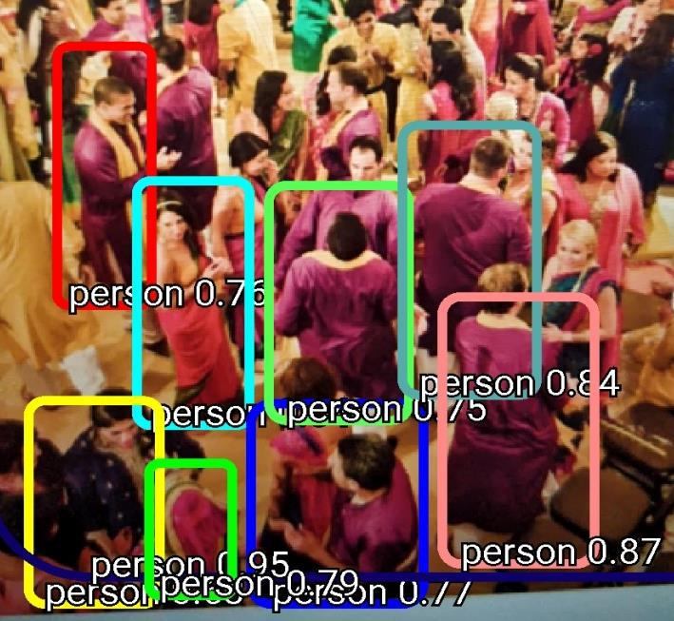

Figure 1-1 : Counting people at wedding function

3

Real-Time Object Detection and Recognition

- In packaging industries where the packed contents can be counted like bottles, eggs etc.
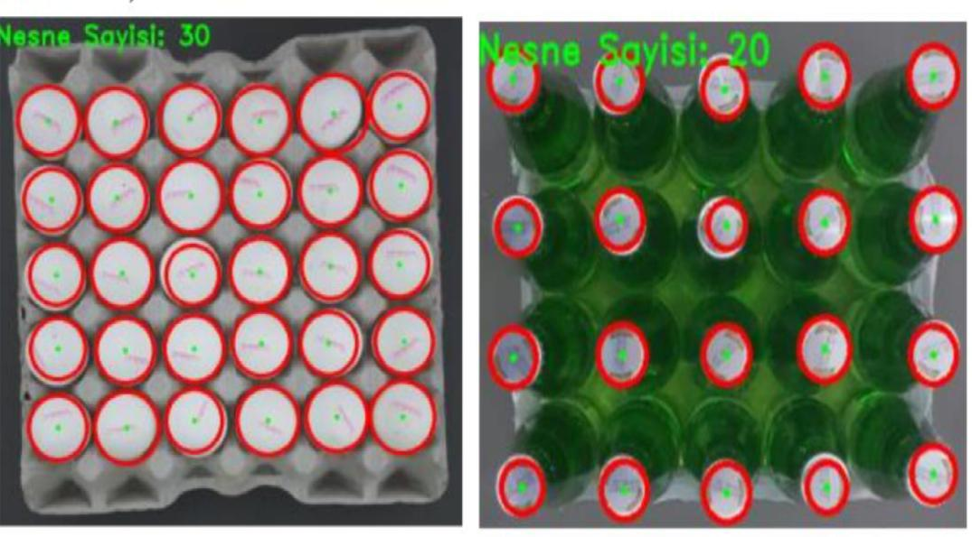

Figure 1-2: Counting of eggs and soda bottle

- It has its application at the railway stations, airports for counting persons.
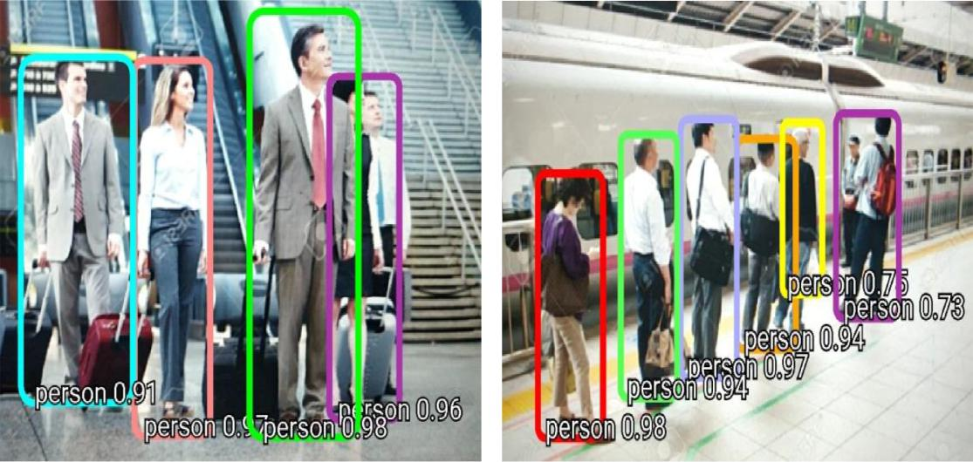

Figure 1-3 : Counting people at railway stations and airport

4

Real-Time Object Detection and Recognition

1.5 Team Organization

- Vedika Shrivastava :

Along with doing preliminary investigation and understanding the limitations of current system, I studied about the topic and its scope and surveyed various research papers related to the object detection and the technology that is to be used.
I also worked on the implementation of tensorflow framework and the working of counting of objects in the project.

Worked on creating database for storing results in database. Documentation is also a part of the work done by me in this project.
- Yash Bhawsar :

I investigated and found the right technology and studied in deep about it. For the implementation of the project , I collected the object data and trained the model for it. Implementation logic for the project objective and coding of internal functionalities is also done by me.

Also, worked on Back end design for storing results in database for maintaining logs.

1.6 Report Structure

The project Real-time Object detection and Recognition is primarily concerned with the Image processing in real-time and whole project report is categorized into five chapters.

Chapter 1: Introduction- introduces the background of the problem followed by rationale for the project undertaken. The chapter describes the objectives, scope and applications of the project. Further, the chapter

5

Real-Time Object Detection and Recognition

gives the details of team members and their contribution in development of project which is then subsequently ended with report outline.

Chapter 2: Review of Literature- explores the work done in the area of Project undertaken and discusses the limitations of existing system and highlights the issues and challenges of project area. The chapter finally ends up with the requirement identification for present project work based on findings drawn from reviewed literature and end user interactions.

Chapter 3: Proposed System - starts with the project proposal based on requirement identified, followed by benefits of the project. The chapter also illustrate software engineering paradigm used along with different design representation. The chapter also includes block diagram and details of major modules of the project. Chapter also gives insights of different type of feasibility study carried out for the project undertaken. Later it gives details of the different deployment requirements for the developed project.

Chapter 4: Implementation - includes the details of different Technology/ Techniques/ Tools/ Programming Languages used in developing the Project. The chapter also includes the different user interface designed in project along with their functionality. Further it discuss the experiment results along with testing of the project. The chapter ends with evaluation of project on different parameters like accuracy and efficiency.

Chapter 5: Conclusion - Concludes with objective wise analysis of results and limitation of present work which is then followed by suggestions and recommendations for further improvement.

6

Real-Time Object Detection and Recognition

Chapter 2 . Review of Literature

Review of Literature

Object Detection and Recognition is being studies for more than four decades now and significant efforts have been paid to develop representation schemes and algorithms aiming at recognizing generic objects in images taken under different imaging conditions. Within a limited scope of distinct objects, such as handwritten digits, fingerprints, faces, and road signs, substantial success has been achieved. Object recognition is also related to content-based image retrieval and multimedia indexing as a number of generic objects can be recognized. In addition, significant progress towards object categorization from images has been made in the recent years . Object recognition has also been studied extensively in psychology, computational neuroscience and cognitive science.

2.1 Preliminary Investigation

2.1.1 Current System

- The Current System for fulfilling the need is to have a single dedicated person who manually does all the work of counting the students and vehicles and keeping away the animals, that is done by this project by automation.

- The presence of a CCTV camera at the entrance of the college campus which has no real-time significance and having just a camera cannot solve the problem of counting the objects in real-time.

7

Real-Time Object Detection and Recognition

2.2 Limitations of Current System

The limitations of these are as follows :

- At the economic front, it is not feasible to have a person who only stands at the gate and counts the number of students entering the college or hiring a personnel just to check if dogs or other animals are entering the building.

- A lot of man power is wasted in doing the work manually.

- It is not possible for a person to stand for 24 hours and keep a record in a file but our system can be used 24X 7.

- When a CCTV camera is used, students or persons cannot be counted but in our system they can be counted in real-time.

2.3 Requirement Identification and Analysis for Project

Significant work has been done in the field of Object Detection and Recognition ; however, it is not easy to achieve desired results. The review of literature leads to draw certain major findings which are as under :

- The study brought out that moving targets are extracted from video-streaming and they are classified according to the pre defined categories. Objects are detected by using pixel wise difference between consecutive frames and they are categorized mainly as- humans, vehicles and background clutter. They are then tracked by template matching. There are two key elements which make the system robust - the classification system which is based on temporal consistency and the tracking system based on a combination of temporal differencing and correlation matching. [2]

- The paper presents a new approach to tracking of non-rigid objects which is based on features like color, texture.It is appropriate for a variety of objects with different color patterns. The mean shift iterations are employed to find the target candidate that is most similar to target model

8

Real-Time Object Detection and Recognition

and this similarity is based on a metric which in turn, is based on Bhattacharya coefficient. [3]

- The paper focused on the problem of learning to detect objects from a small training database. The performance depends crucially on the features that are used to represent the objects. Specifically, it shows that using local edge orientation histograms (EOH) as features can significantly improve performance compared to the standard linear features used in existing systems. For frontal faces, local orientation histograms enable state of the art performance using only a few hundred training examples. For profile view faces, local orientation histograms enable learning a system that seems to outperform the state of the art in real-time systems even with a small number of training examples. [4]

- The paper advocated the use of randomized trees as the classification technique. It is both fast enough for real-time performance and more robust. It also gives us a principled way not only to match keypoints but to select during a training phase those that are the most recognizable ones. This results in a real-time system able to detect and position in 3D planar, non-planar, and even deformable objects. It is robust to illuminations changes, scale changes and occlusions. [5]

- The work presents a real-time system for multiple objects tracking in dynamic scenes. A unique characteristic of the system is its ability to cope with long duration and complete occlusion without a prior knowledge about the shape or motion of objects. The system produces good segment and tracking results at a frame rate of 15-20 fps for image size of 320x240, as demonstrated by extensive experiments performed using video sequences under different conditions indoor and outdoor with long-duration and complete occlusions in changing background. [6]

- The work presented a real time robust human detection and tracking system for video surveillance which can be used in varying environments. This system consists of human detection, human tracking and false object detection. The human detection utilizes the background subtraction to segment the blob and use codebook to classify human being from other objects. The optimal design algorithm of the codebook is proposed. The

9

Real-Time Object Detection and Recognition

tracking is performed at two levels: human classification and individual tracking .The color histogram of human body is used as the appearance model to track individuals. In order to reduce the false alarm, the algorithms of the false object detection are also provided. [7]

- The paper advocates a general trainable framework for object detection in static images of cluttered scenes. The detection technique we develop is based on a wavelet representation of an object class derived from a statistical analysis of the class instances. By learning an object class in terms of a subset of an over complete dictionary of wavelet basis functions, we derive a compact representation of an object class which is used as an input to a support vector machine classifier. This representation overcomes both the problem of in-class variability and provides a low false detection rate in unconstrained environments. [8]

- The paper introduced a new real-time traffic light recognition system for on-vehicle camera applications. The approach is mainly based on a spot detection algorithm therefore able to detect lights from a high distance with the main advantage of being not so sensitive to motion blur and illumination variations. The detected spots together with other shape analysis form strong hypothesis we feed our Adaptive Templates Matcher with. a high rate of correctly recognized traffic lights and very few false alarms were noticed. Processing is performed in real-time on 640x480 images using a 2.9GHz single core desktop computer. [9]

- In this paper, a real-time vision system is described that can recognize 100 complex three-dimensional objects. In contrast to traditional strategies that rely on object geometry and local image features, the present system is founded on the concept of appearance matching. Appearance manifolds of the 100 objects were automatically learned using a computer-controlled turntable. A recognition loop was implemented that performs scene change detection, image segmentation, region normalizations, and appearance matching, in less than 1 second. [10]

- A novel algorithm for detection of certain types of unusual events was presented in this paper. The algorithm is based on multiple local monitors

10

Real-Time Object Detection and Recognition

which collect low-level statistics. Each local monitor produces an alert if its current measurement is unusual and these alerts are integrated to a final decision regarding the existence of an unusual event. Since the algorithm is not based on objects’ tracks, it is robust and works well in crowded scenes where tracking-based algorithms are likely to fail. [11]

- The paper focused on a computer vision based system for real-time robust traffic sign detection, tracking, and recognition. The proposed approach consists of two components. First, signs are detected using a set of Haar wavelet features obtained from Ada-Boost training. Compared to previously published approaches, the solution offers a generic, joint modeling of color and shape information without the need of tuning free parameters. Once detected, objects are tracked within a temporal information propagation framework. Second, classification is performed using Bayesian generative modeling. [12]

- In the work surveyed, a real-time vision system was developed that analyzes color videos taken from a forward-looking video camera in a car driving on a highway. The system uses a combination of color, edge, and motion information to recognize and track the road boundaries, lane markings and other vehicles on the road. Cars are recognized by matching templates that are cropped from the input data online and by detecting highway scene features, by temporal differencing and evaluating how they relate to each other and by tracking motion parameters that are typical for cars. Experimental results demonstrate robust, real-time car detection and tracking over thousands of image frames. [13]

- The paper describes a two level approach to solve the problem of real-time vision-based hand gesture classification. The lower level of the approach implements the posture recognition with Haar-like features and the Ada-Boost learning algorithm. With this algorithm, real-time performance and high recognition accuracy can be obtained. The higher level implements the linguistic hand gesture recognition using a context-free grammar-based syntactic analysis. Given an input gesture, based on the extracted postures, the composite gestures can be parsed and recognized with a set of primitives and production rules. [14]

11

Real-Time Object Detection and Recognition

- The paper brings in new techniques to detect and analyze periodic motion as seen from both a static and a moving camera. By tracking objects of interest, it computes an object's self-similarity as it evolves in time. For periodic motion, the self-similarity measure is also periodic and we apply Time-Frequency analysis to detect and characterize the periodic motion. The periodicity is also analyzed robustly using the 2D lattice structures inherent in similarity matrices. A real-time system has been implemented to track and classify objects using periodicity. Examples of object classification (people, running dogs, vehicles), person counting, and non-stationary periodicity are provided. [15]

- The paper advocated that Camera based systems are routinely used for monitoring highway traffic, supplementing inductive loops and microwave sensors employed for counting purposes. These techniques achieve very good counting accuracy and are capable of discriminating trucks and cars. However, pedestrians and cyclists are mostly counted manually.This paper described a new camera based automatic system that utilizes Kalman filtering in tracking and Learning Vector Quantization for classifying the observations to pedestrians and cyclists. [16]

- The paper presented a method for real-time 3D object detection that does not require a time consuming training stage, and can handle untextured objects. At its core, is a novel template representation that is designed to be robust to small image transformations. It tests only a small subset of all possible pixel locations when parsing the image, and to represent a 3D object with a limited set of templates. It showed that together with a binary representation that makes evaluation very fast and a branch-and-bound approach to efficiently scan the image, it can detect untextured objects in complex situations and provide their 3D pose in real-time. [5]

- According to paper, Robust object recognition is a crucial skill for robots operating autonomously in real world environments. Range sensors such as LiDAR and RGBD cameras are increasingly found in modern robotic systems, providing a rich source of 3D information that can aid in this task. However, many current systems do not fully utilize this information and have trouble efficiently dealing with large amounts of point cloud

12

Real-Time Object Detection and Recognition

data. The paper proposes VoxNet, an architecture to tackle this problem by integrating a volumetric Occupancy Grid representation with a supervised 3D Convolutional Neural Network (3D CNN). [17]

- This paper presents a general, trainable system for object detection in unconstrained, cluttered scenes. The system derives much of its power from a representation that describes an object class. The learning approach implicitly derives a model of an object class by training a support vector machine classifier using a large set of positive and negative examples. It quantifies how the representation affects detection performance by considering several alternate representations including pixels and principal components. It also describes a real-time application of our person detection system as part of a driver assistance system. [18]

- The paper brings in YOLO, a new approach to object detection. Prior work on object detection repurposes classifiers to perform detection. A single neural network predicts bounding boxes and class probabilities directly from full images in one evaluation. Since the whole detection pipeline is a single network, it can be optimized end-to-end directly on detection performance. Their base YOLO model processes images in real-time at 45 frames per second. A smaller version of the network, Fast YOLO, processes an astounding 155 frames per second while still achieving double the mAP of other real-time detectors. Compared to state-of-the-art detection systems, YOLO makes more localization errors but is less likely to predict false positives on background. Finally, YOLO learns very general representations of objects. It outperforms other detection methods, including DPM and R-CNN, when generalizing from natural images to other domains like artwork. [19]

- Paper proposes new method to quickly and accurately predict 3D positions of body joints from a single depth image, using no temporal information. An object recognition approach is taken, designing an intermediate body parts representation that maps the difficult pose estimation problem into a simpler per-pixel classification problem. The large and highly varied training dataset allows the classifier to estimate

13

Real-Time Object Detection and Recognition

body parts in variant to pose, body shape, clothing, etc. The system runs at 200 frames per second on consumer hardware. The evaluation shows high accuracy on both synthetic and real test sets, and investigates the effect of several training parameters. [20]

2.3.1 Conclusion

This chapter reviews the literature surveys that have been done during the research work. The related work that has been proposed by many researchers has been discussed. The research papers related to object detection and recognition of objects from 1985 to 2015 have been shown which discussed about different methods and algorithm to identify objects.

14

Real-Time Object Detection and Recognition

Chapter 3 . Proposed System

Proposed System

3.1 The Proposal

The proposal is to deploy a system at the entry gate which can identify various objects like person, animals through webcam or CCTV cameras and perform appropriate operations like counting and tracking of objects in real-time and save the information of that object in the database at that very moment.

It can also count the vehicles that come inside the college and classify them if it is car , motorcycle , bicycle , truck etc. and store that information in the database. It can give the individual count of different objects.

3.2 Benefits of the Proposed System

The current system had a lot of challenges that are overcome by this system :

- Economic : The proposed system is economic as there will not be any person required to keep a watch on the entrance.

- Real-Time Observation : Unlike CCTV, the objects can be identified also in real-time and can be saved for later use.

- Man Power : It does not require any person or their efforts to stand and count the number of people.

- 24 x 7 Availability : Camera implemented with this does not require the person to stand 24 hrs.

- Statistical analysis : The number of students and vehicles can be counted individually and kept a record for calculating various factors.

15

Real-Time Object Detection and Recognition

3.3 Block Diagram
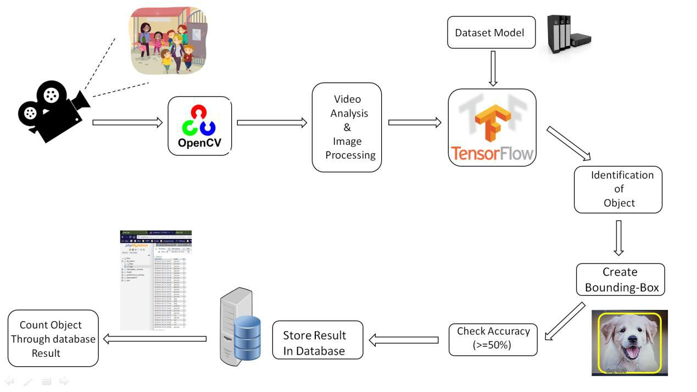

Figure 3-1 : Block Diagram

3.4 Feasibility Study

A feasibility study is an analysis of how successfully a system can be implemented, accounting for factors that affect it such as economic, technical and operational factors to determine its potential positive and negative outcomes before investing a considerable amount of time and money into it.

3.4.1 Technical

For any real-time detection system, there is a need to process images from the video. For this, the kind of framework used must be the one that is capable of extracting those objects from the images easily and accurately in real-time. The framework used in this is Tensorflow, which is a framework designed by Google for efficiently dealing with deep learning and concepts like neural networks , making the system technically feasible.

The system once set up completely, works automatically without needing any person to operate it. The result (count and other information),

16

Real-Time Object Detection and Recognition

gets automatically saved in the database, without requiring any manual effort for saving it.

For making the system technically feasible, there is a requirement of GPU built system with high processor for better performance.

3.4.2 Economical

For any real-time object detection system, there is a need of a High definition Camera for better and accurate results.

Since the system is completely automated, there is a need of continuous electricity supply for it to operate 24X7.

The Tensorflow framework used in the system works great with GPU built systems, which are a little on the expensive side.

Since the system uses high performance processors continuously, so to save any disaster from occurring due to very high temperatures, there is a requirement of a cooling system in the environment where it is implemented.

3.4.3 Operational

The main motto of our system is to reduce the manual efforts of counting the students and vehicles by automating it.

The system is able to do that accurately and efficiently making the system operationally feasible.

17

Real-Time Object Detection and Recognition

3.5 Design Representation
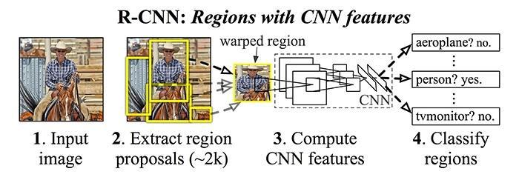

Figure 3-2: R-CNN: Regions with CNN Features
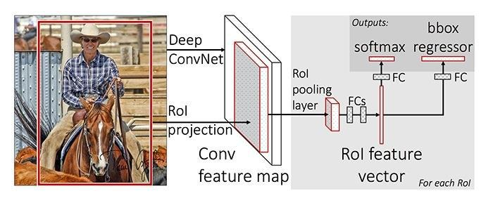

Figure 3-3 : Fast R-CNN Architecture
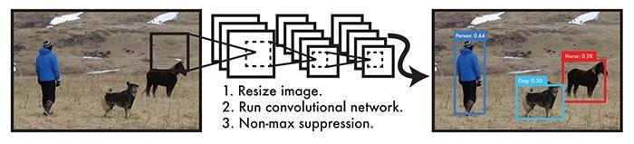

Figure 3-4: YOLO Architecture

18

Real-Time Object Detection and Recognition
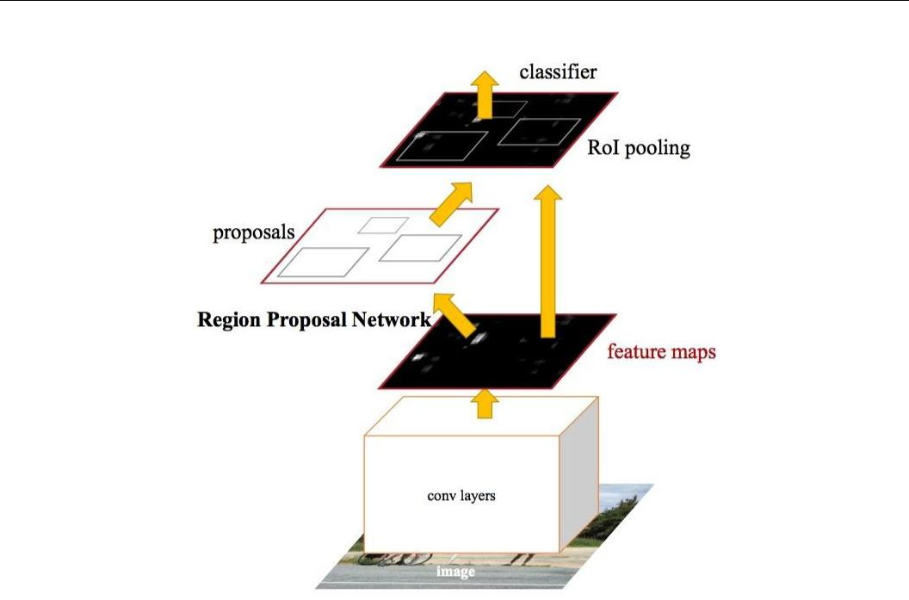

Figure 3-5: Faster CNN Architecture
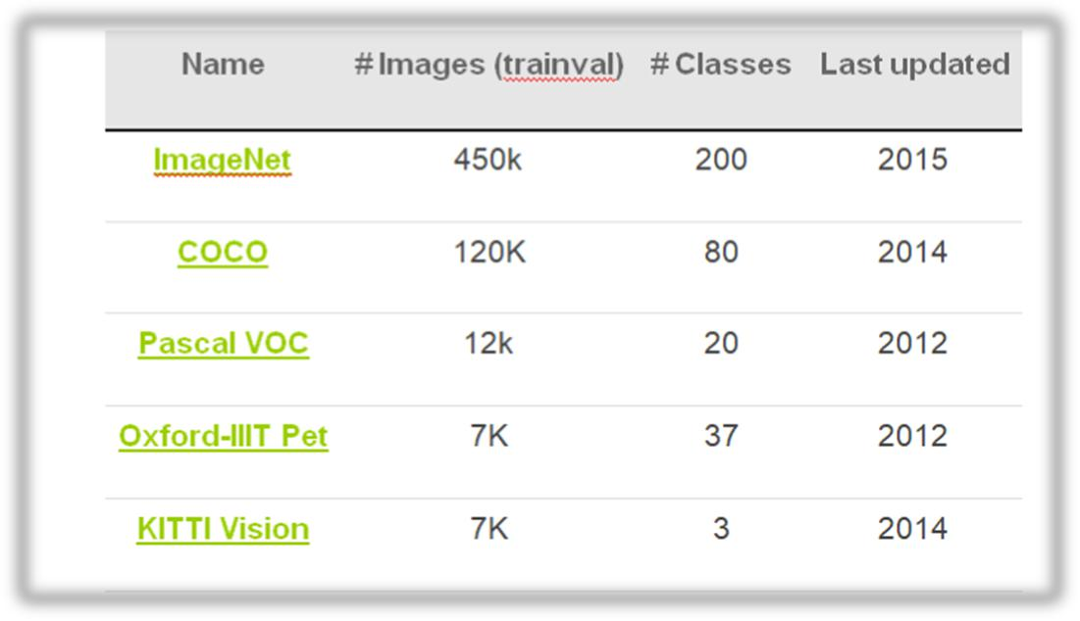

Table 1 : Types of Datasets

19

Real-Time Object Detection and Recognition
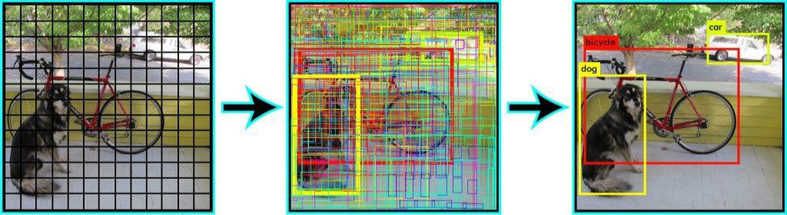

Figure 3-6 : Bounding-Box

3.5.1 Data Flow Diagrams
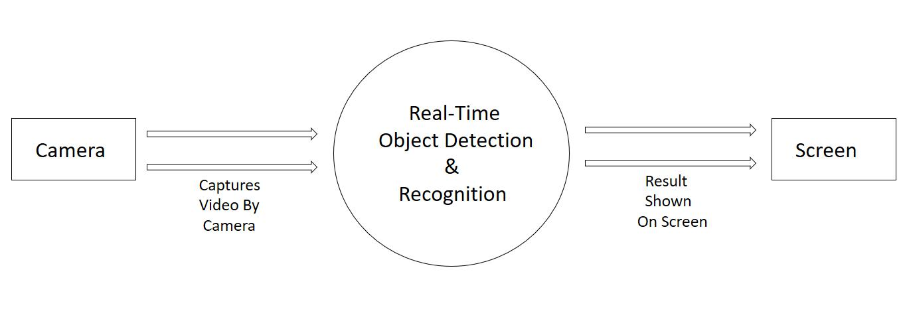

Figure 3-7 Data Flow Diagram Level 0
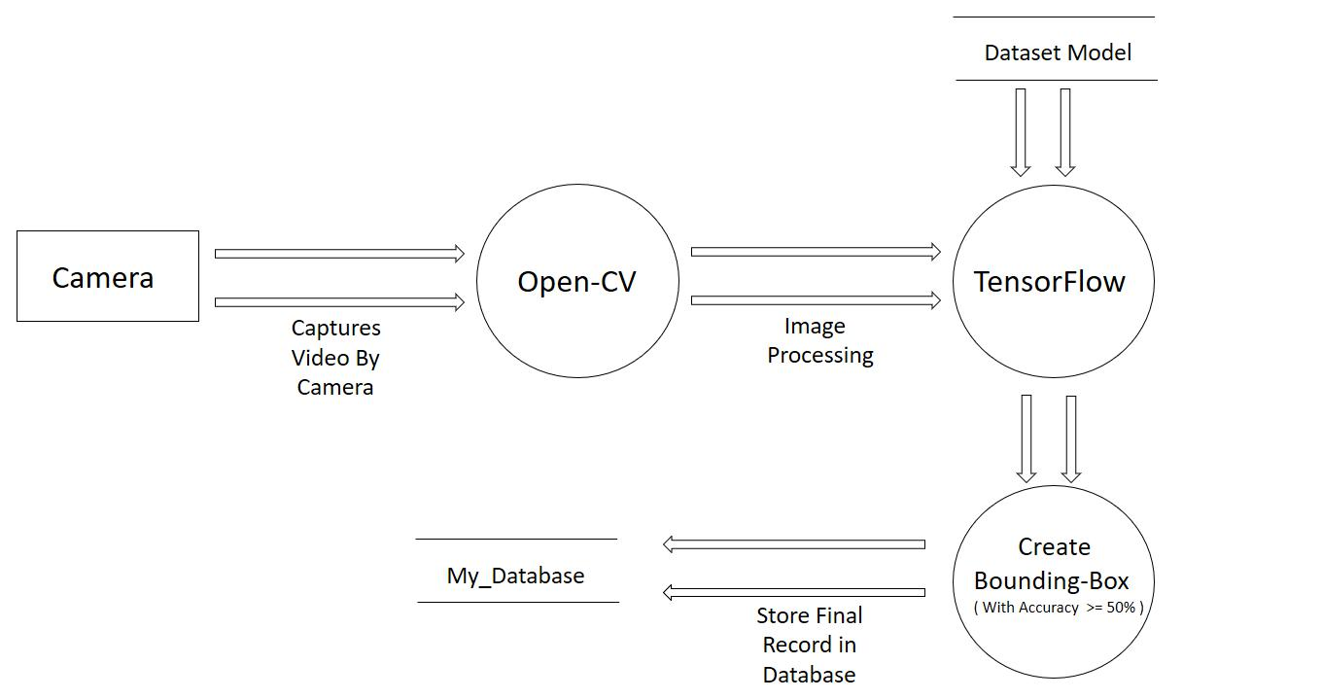

Figure 3-8 Data Flow Diagram Level 1

20

Real-Time Object Detection and Recognition

3.5.2 Database Structure

The name of the database created is “db_detect” and there is one table in the database named “logs” for storing the records.

The “Logs” table has the following structure :

 |  | Name |  | Data Type |  | Description
 |  | Datetime |  | Timestamp |  | Shows | the | complete
 |  |  |  |  |  | date and time when the
 |  |  |  |  |  | person/vehicle enters
 |  |  |  |  |  | and is identified
 |  | Type |  | Varchar2 |  | Displays | the | type of
 |  |  |  |  |  | object | for | example
 |  |  |  |  |  | Person, Car, Dog.
 |  | CIF |  | Number |  | Count per frame.It tells
 |  |  |  |  |  | the number of objects
 |  |  |  |  |  | in frame.

Table 2 : Database Structure

3.6 Deployment Requirements

There are various requirements (hardware, software and services) to successfully deploy the system. These are mentioned below :

3.6.1 Hardware

- 32-bit, x86 Processing system

- Windows 7 or later operating system

- High processing computer system without GPU or with GPU(high performance)

- High- definition Camera

21

Real-Time Object Detection and Recognition

3.6.2 Software

- OpenCV

- Python and its supported libraries

- Tensor Flow

- If Installing Tensorflow in GPU systems :

  - CUDA® Toolkit 9.0.

  - The NVIDIA drivers associated with CUDA Toolkit 9.0. cuDNN v7.0.
  - GPU card with CUDA Compute Capability 3.0 or higher

22

Real-Time Object Detection and Recognition

Chapter 4 . Implementation

Implementation

For the problem of counting the number of students and vehicles entering the college campus manually, the system is designed in such a way so as to automate the process by placing a camera at the entrance gate so that students, bikes and cars getting inside the college campus can be identified and counted.

4.1 Technique Used

4.1.1 Deep- Learning

Deep Learning is a subfield of machine learning concerned with algorithms inspired by the structure and function of the brain called artificial neural networks. Deep learning (also known as deep structured learning or hierarchical learning) is part of a broader family of machine learning methods based on learning data representations, as opposed to

task-specific algorithms. Learning can be supervised, semi-supervised or unsupervised.

Deep learning models are loosely related to information processing and communication patterns in a biological nervous system, such as neural coding that attempts to define a relationship between various stimuli and associated neuronal responses in the brain.

23

Real-Time Object Detection and Recognition
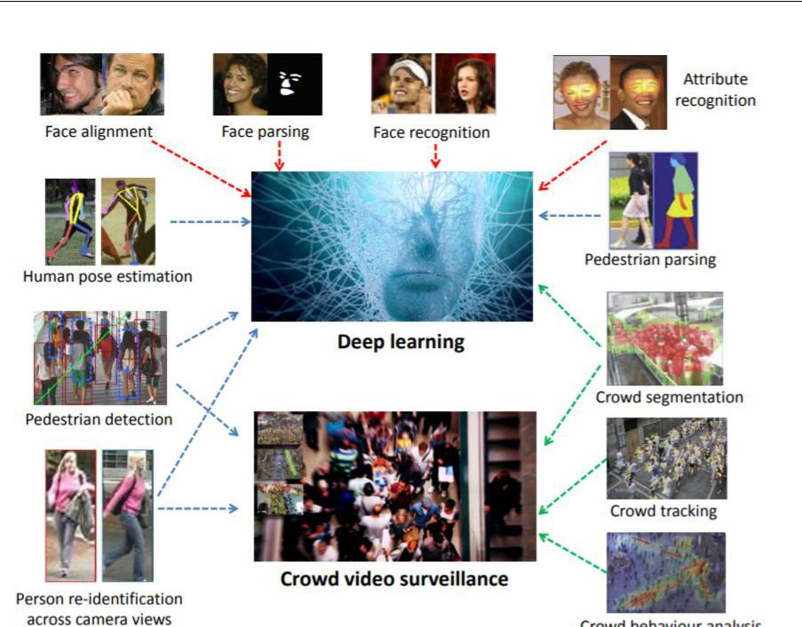

Figure 4-1 : Deep Learning

Deep learning architectures such as deep neural networks, deep belief networks and recurrent neural networks have been applied to fields including computer vision, speech recognition, natural language processing, audio recognition, social network filtering, machine translation, bioinformatics and drug design, where they have produced results comparable to and in some cases superior to human experts.

4.1.2 Neural Networks :

In machine learning, a convolutional neural network (CNN, or ConvNet) is

- class of deep, feed-forward artificial neural networks that has successfully been applied to analyzing visual imagery.

CNNs use a variation of multilayer perceptrons designed to require minimal preprocessing. They are also known as shift invariant or space invariant artificial neural networks (SIANN), based on their shared-weights architecture and translation invariance characteristics.

24

Real-Time Object Detection and Recognition
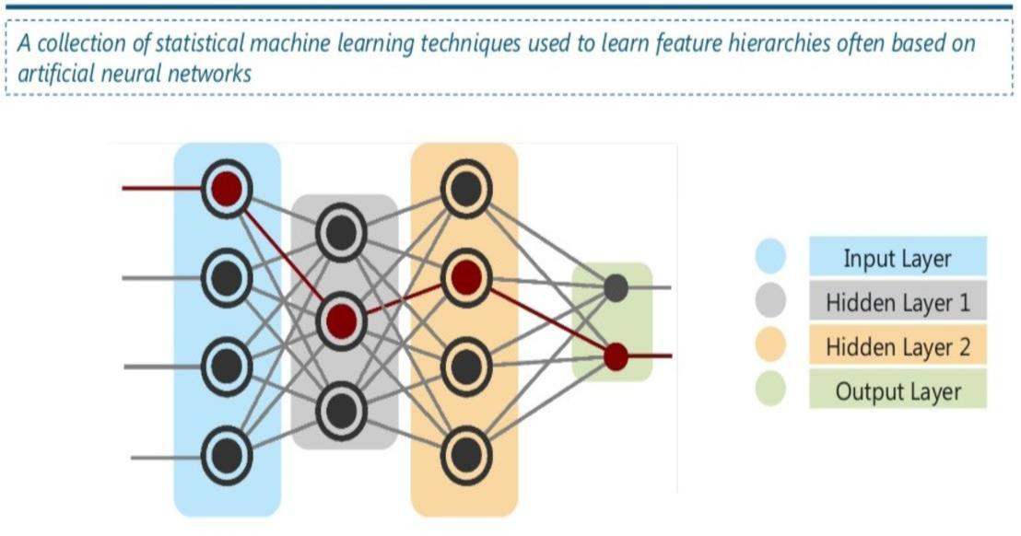

Figure 4-2 : Neural Networks

Convolutional networks were inspired by biological processes in that the connectivity pattern between neurons resembles the organization of the animal visual cortex. Individual cortical neurons respond to stimuli only in a restricted region of the visual field known as the receptive field. The receptive fields of different neurons partially overlap such that they cover the entire visual field. CNNs use relatively little pre-processing compared to other image classification algorithms. This means that the network learns the filters that in traditional algorithms were hand-engineered. This independence from prior knowledge and human effort in feature design is a major advantage. They have applications in image and video recognition, recommender systems and natural language processing.

4.2 Tools Used

4.2.1 OpenCV

OpenCV (Open Source Computer Vision Library) is released under a BSD license and hence it’s free for both academic and commercial use. It has C++, Python and Java interfaces and supports Windows, Linux, Mac OS, iOS and Android. OpenCV was designed for computational efficiency and

25

Real-Time Object Detection and Recognition

with a strong focus on real-time applications. Written in optimized C/C++, the library can take advantage of multi-core processing. Enabled with OpenCL, it can take advantage of the hardware acceleration of the underlying heterogeneous compute platform.

Adopted all around the world, OpenCV has more than 47 thousand people of user community and estimated number of downloads exceeding 14 million. Usage ranges from interactive art, to mines inspection, stitching maps on the web or through advanced robotics.

4.2.2 Tensor Flow

TensorFlow is an open source software library for high performance numerical computation. Its flexible architecture allows easy deployment of computation across a variety of platforms (CPUs, GPUs, TPUs), and from desktops to clusters of servers to mobile and edge devices. Originally developed by researchers and engineers from the Google Brain team within Google’s AI organization, it comes with strong support for machine learning and deep learning and the flexible numerical computation core is used across many other scientific domains.
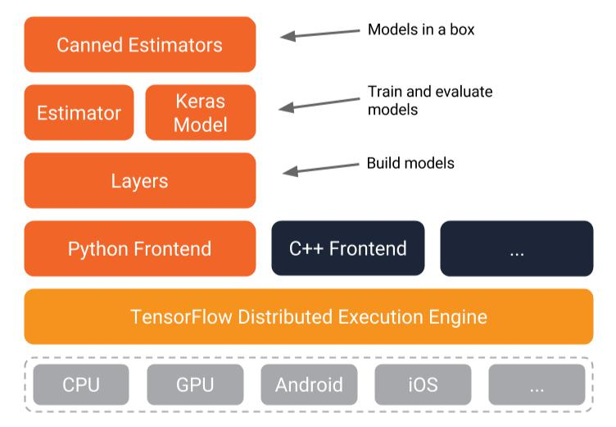

Figure 4-3 : TensorFlow Architecture

26

Real-Time Object Detection and Recognition


Figure 4-4 : TensorFlow Working

4.2.3 Models

The TensorFlow official models are a collection of example models that use TensorFlow's high-level APIs. They are intended to be well-maintained, tested, and kept up to date with the latest TensorFlow API. They should also be reasonably optimized for fast performance while still being easy to read.
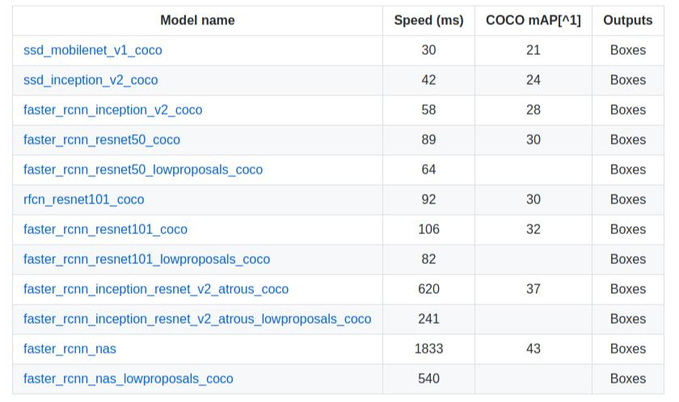

Table 3 : Types of Models

27

Real-Time Object Detection and Recognition

Below is a list of the models available.

- COCO: COCO is a large-scale object detection, segmentation, and captioning dataset.

- Mnist: A basic model to classify digits from the MNIST dataset.

- Resnet: A deep residual network that can be used to classify both CIFAR-10 and ImageNet's dataset of 1000 classes.

- Wide_deep: A model that combines a wide model and deep network to classify census income data.

The system uses COCO data set Model which is Common Object in Context designed by Mirosoft.

COCO Model :

This database has several features:

- Object Detection

- Recognition in context

- Superpixel stuff segmentation

- 330K images (>200K labeled)

- 1.5 million object instances

- 80 object categories

- 91 stuff categories

- 5 captions per image

- 250,000 people with keypoints

COCO currently has three annotation types: object instances, object keypoints, and image captions. The annotations are stored using the JSON file format. All annotations share the basic data structure below:

28

Real-Time Object Detection and Recognition
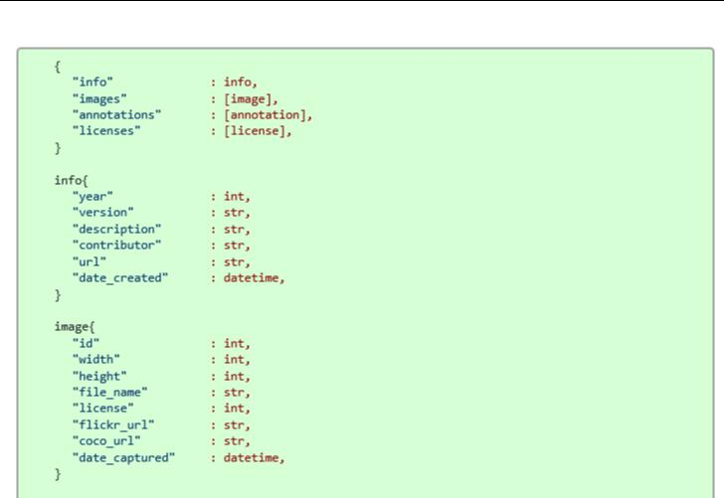

Figure 4-5 : Data Structure in JSON Format

The distribution of the objects in this database can be obtained from their website. In section Explore, it is possible to choose and combine each of the objects and observe how many images these objects appear. The distribution for each of the objects in training/validation set is shown in the following image:
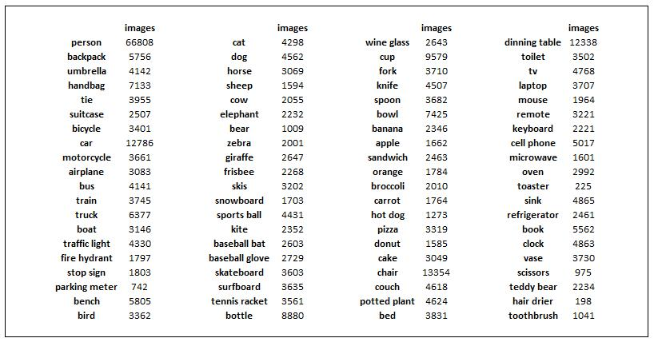

Figure 4-6 : Objects in training set

29

Real-Time Object Detection and Recognition

Finally, in order to understand better both databases, the following image shows some characteristics of them, comparing them with other important databases.
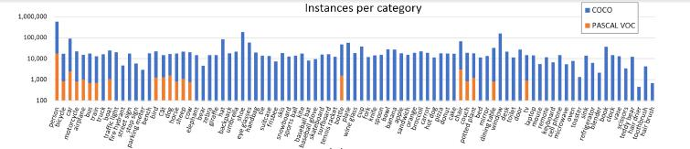

Figure 4-7 : Instances per Category
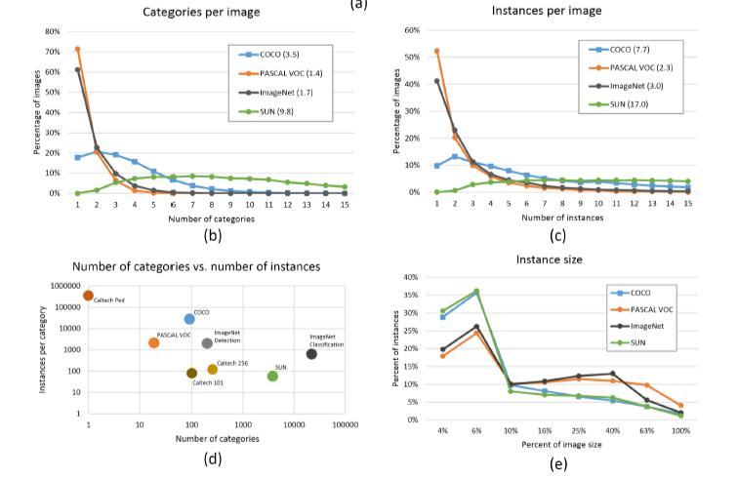

Figure 4-8 : Comparison Graphs

30

Real-Time Object Detection and Recognition

4.3 Language Used

Python language is used in the system due to the following Characterstics :

Simple :

Python is a simple and minimalistic language. Reading a good Python program feels almost like reading English (but very strict English!). This pseudo-code nature of Python is one of its greatest strengths. It allows you to concentrate on the solution to the problem rather than the syntax i.e. the language itself.

Free and Open Source :

Python is an example of a FLOSS (Free/Libre and Open Source Software). In simple terms, you can freely distribute copies of this software, read the software's source code, make changes to it, use pieces of it in new free programs, and that you know you can do these things. FLOSS is based on the concept of a community which shares knowledge. This is one of the reasons why Python is so good - it has been created and improved by a community who just want to see a better Python.

Object Oriented :

Python supports procedure-oriented programming as well as object-oriented programming. In procedure-oriented languages, the program is built around procedures or functions which are nothing but reusable pieces of programs. In object-oriented languages, the program is built around objects which combine data and functionality. Python has a very powerful but simple way of doing object-oriented programming, especially, when compared to languages like C++ or Java.

Extensive Libraries :

The Python Standard Library is huge indeed. It can help you do various things involving regular expressions, documentation generation, unit testing, threading, databases, web browsers, CGI, ftp, email, XML,

31

Real-Time Object Detection and Recognition

XML-RPC, HTML, WAV files, cryptography, GUI(graphical user interfaces) using Tk, and also other system-dependent stuff. Remember, all this is always available wherever Python is installed. This is called the "batteries included" philosophy of Python.

4.4 Screenshots

The Following are the screenshots of the result of the project :
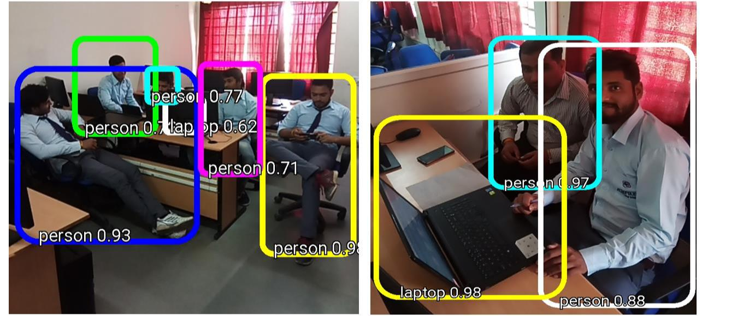

Figure 4-9 : Screenshot 1
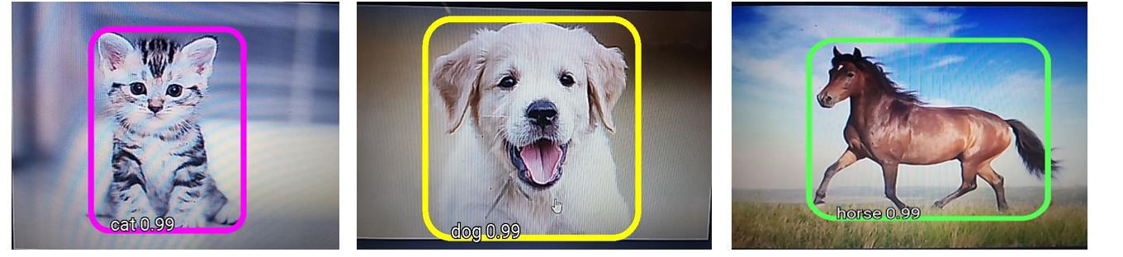

Figure 4-10 : Screenshot 2
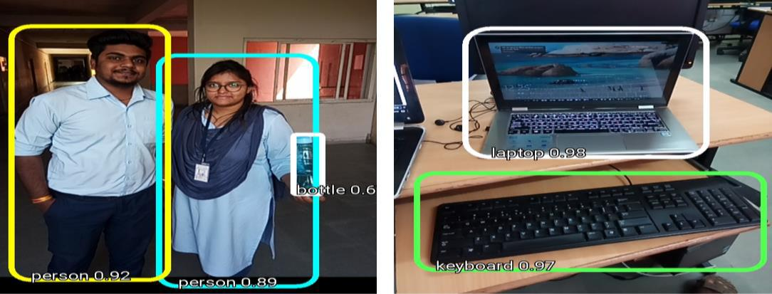

Figure 4-11 : Screenshot 3

32

Real-Time Object Detection and Recognition

4.5 Testing

Testing is the process of evaluation of a system to detect differences between given input and expected output and also to assess the feature of the system. Testing assesses the quality of the product. It is a process that is done during the development process. .

4.5.1 Strategy Used

Tests can be conducted based on two approaches –

- Functionality testing

- Implementation testing

The texting method used here is Black Box Testing. It is carried out to test functionality of the program. It is also called ‘Behavioral’ testing. The tester in this case, has a set of input values and respective desired results. On providing input, if the output matches with the desired results, the program is tested ‘ok’, and problematic otherwise.

4.5.2 Test Case and Analysis

TEST CASE: 1

Test Case ID | TC001
Test Case | It will check whether the system detects the students entering
Test Case | in the college with accuracy >=50% or not.
Summary | in the college with accuracy >=50% or not.
Test | Place and start the camera at the college entrance.
Procedure
Expected | The students must be detected with accuracy greater than
Result | 50%.
Actual Result | The Students with accuracy greater than 50% are detected.
Status | Pass
 | Table 4 : Test Case 1

33

Real-Time Object Detection and Recognition

TEST CASE 1 OUTPUT
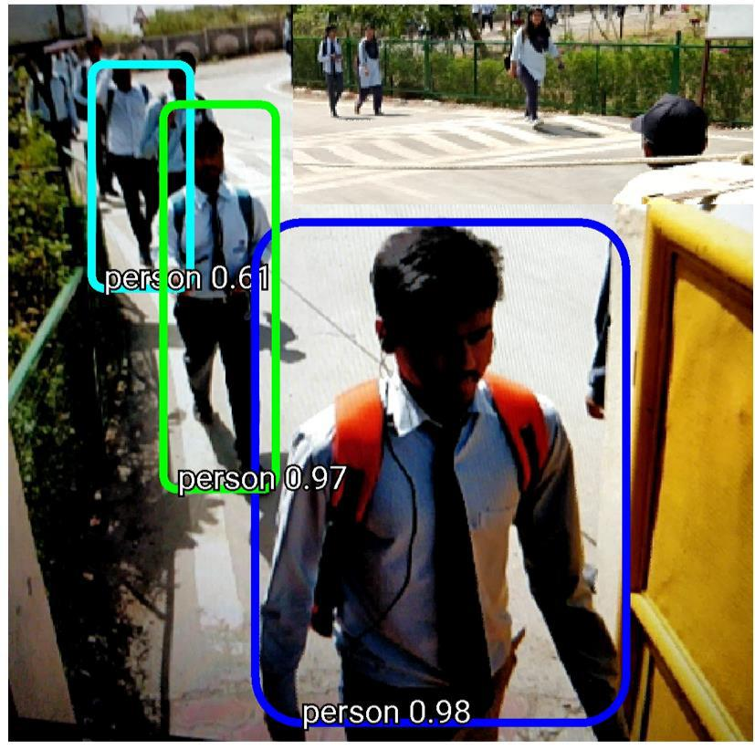

Figure 4-12 : Test Case 1 output

TEST CASE: 2

Test Case ID | TC002
Test Case | It will check whether the entry for each student | entering | in | The
Test Case | college is stored in the database with the timestamp or not.
Summary
Test | 1. Place and start the camera at the college entrance.
Test | 2. Check the database after detection.
Procedure | 2. Check the database after detection.
Expected | For each student, an entry must be there in the database.
Result
Actual Result | 3 students were detected and their entry was | present | in | The
Actual Result | database with the timestamp
Status | Pass
 | Table 5: Test Case 2

34

Real-Time Object Detection and Recognition

TEST CASE 2 OUTPUT
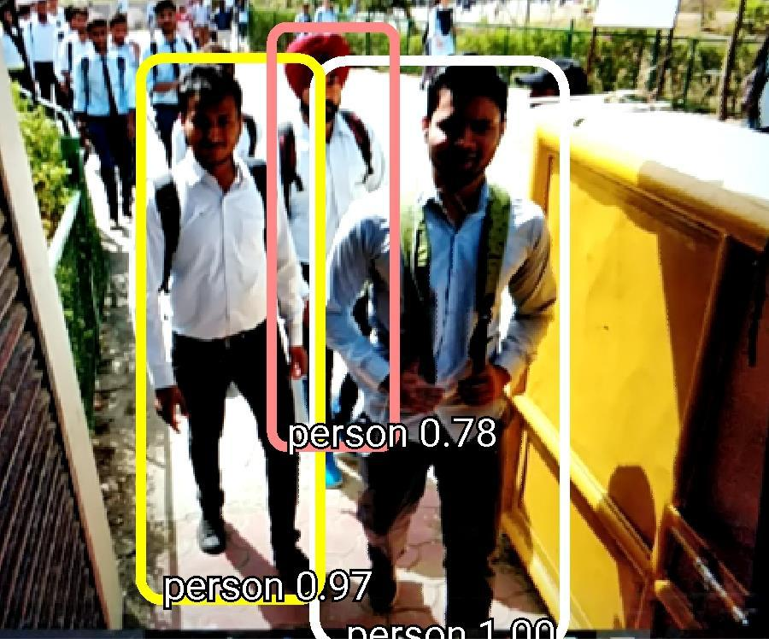

Figure 4-13 : Test Case 2 Output 1
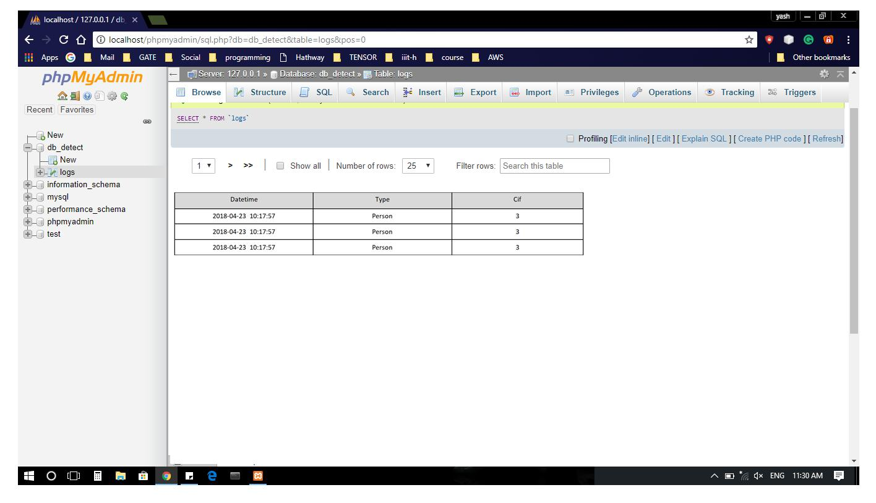

Figure 4-14 : Test Case 2 Output 2

35

Real-Time Object Detection and Recognition

Chapter 5.Conclusion

Conclusion

5.1 Conclusion

The aim of the project that was to automatically detect , identify and count the number of students, vehicles and animals and save their details in the database is successfully and accurately done by this project with the use of concepts like Deep learning, Convolutional Neural Networks, OpenCV and TensorFlow.

The work done manually can now be completely replaced by this automated system and it can reduce all the extra efforts of maintain the records.

5.2 Limitations of the Work

- The working of this project would be a little slow because framework like TensorFlow, & deep learning need high-processing hardware and GPU(graphical processing unit) systems but we are using CPU only.

- The models that we are using for identifying the objects are pre-trained models. So, if we want to train our own model, it takes a lot of time and processing.

- In the system, scanning of each frame is one per second but still it needs improvement. If the objects move too fast, it may not detect them.

36

Real-Time Object Detection and Recognition

5.3 Suggestion and Recommendations for Future Work

- The Model would be trained for detecting more number of objects.

- SNS service will be integrated in this project for alert notification when an unwanted object is detected.

- Currently, the bounding box technique is used which is bounding the targeted object within a rectangle. In future , Segmentation will be used.

37

Real-Time Object Detection and Recognition

Bibliography

- H. Fujiyoshi, A. J. Lipton and R. S. Patil, "Moving Target Classification and Tracking from Real-time Video," in Fourth IEEE workshop, 1998.

- D. Comaniciu, R. Vishwanathan and P. Meer, "Real-Time Tracking of Non-Rigid Objects using Mean Shift," in IEEE, 2000.

- K. Levi and Y. Weiss, "Learning Object Detection from a Small Number of Examples: the Importance of Good Features," in IEEE Computer Society Conference, 2004.

- V. Lepetit, P. Lagger and P. Fua, "Randomized Trees for Real-Time Keypoint Recognition," in IEEE Computer Society Conference, 2005.

- T. Yang, S. Z. Li and J. Li, "Real-time Multiple Objects Tracking with Occlusion Handling in Dynamic Scenes," in IEEE Computer Society Conference, 2005.

- J. Zhou and J. Hoang, "Real Time Robust Human Detection and Tracking System," in IEEE Computer Society Conference, 2005.

- C. P. Papageorgiou, M. Oren and T. Poggio, "A General Framework for Object Detection," in Center for Biological and Computational Learning Artificial Intelligence Laboratory, Cambridge, 2005.

- R. D. Charette and F. Nashashibi, "Real TimeVisual Traffic Lights Recognition Based on Spot Light Detection andAdaptive Traffic Lights Template," in IEEE, 2009.

38

Real-Time Object Detection and Recognition

- S. K. Nayar, S. A. Nene and M. Hiroshi, "Real-Time 100 Object Recognition System," in IEEE International Conference, 1996.

- A. Adam, E. Rivlin, S. Ilan and D. Reinitz, "Robust Real-Time Unusual Event Detection Using Multiple Fixed-Location Monitors," in IEEE, 2008.

- C. Bahlmann, Y. Zhu, R. Vishwanathan, M. Pelkoffer and T. Koehler, "A System for Traffic Sign Detection, Tracking, and Recognition Using Color, Shape, and Motion Information," in IEEE, 2005.

- M. Betke, E. Haritaoglu and L. S. Davis, "Real-time multiple vehicle detection and tracking from a moving vehicle," Machine Vision and Applications, p. 12, 2000.

- Q. Chen, N. D. Georganas and E. M. Petriu, "Real-time Vision-based Hand Gesture Recognition Using Haar-like Features," in IEEE Conference, 2007.

- R. Cutler and L. S. Davis, "Robust Real-Time Periodic Motion Detection, Analysis, and Applications," IEEE transactions on Pattern Analysis and Machine Intelligence, 2000.

- J. Heikkila and O. Silven, "A real-time system for monitoring of cyclists and pedestrians," Image and Vision Computing, 2004.

- D. Maturana and S. Scherer, "VoxNet: A 3D Convolutional Neural Network for Real-Time Object Recognition," in IEEE International Conference, 2015.

- C. Papageorgiou and T. Poggio, "A Trainable System for Object Detection," Internation Journal of Computer Vision, 2000.

39

Real-Time Object Detection and Recognition

- J. Redmon, S. Divvala, R. Girshik and A. Farhadi, "You Only Look Once: Unified, Real-Time Object Detection," in IEEE conference on Computer Vision and Pattern Rocgnition, 2016.

- J. Shotton, A. Fitzgibbon, M. Cook, T. Sharp, M. Finocchio, R. Moore, A. Kipman and A. Blake, "Real-Time Human Pose Recognition in Parts from Single Depth Images," Computer Vision and Pattern Recognition, 2011.

- K. P. A. Menon, "Management of Agriculture and Rural Development Programme: Problems and Prospects, India," J Extension Education, vol. 21, no. 1, pp. 94-98, 1985.

- S. Hinterstoisse, V. Lepetit, S. Ilic, P. Fua and N. Nassir, "Dominant Orientation Templates for Real-Time Detection of Texture-Less Object," in IEEE Conference, 2010.

40

Real-Time Object Detection and Recognition

Project Plan

Gantt Chart
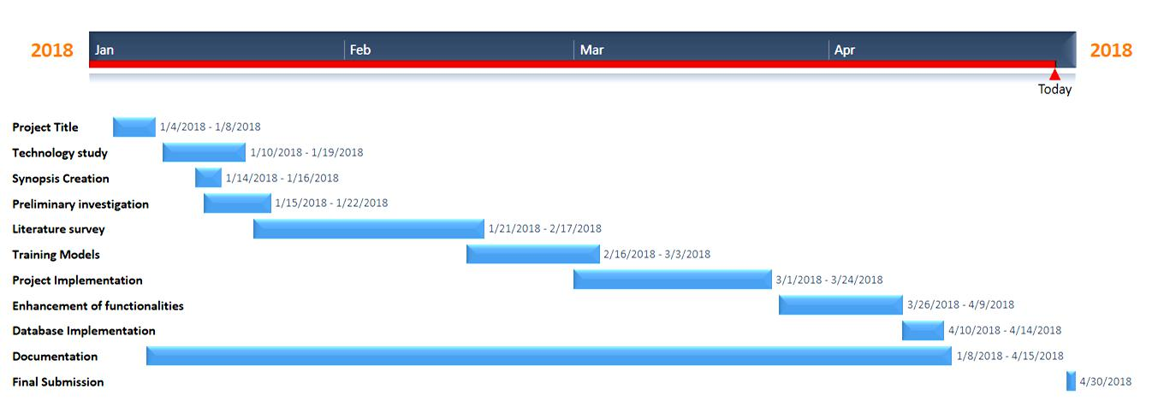

41

Real-Time Object Detection and Recognition

Guide Interaction Sheet

Date | Discussion | Action Plan
 | Discussed about the title of the | Real-time object detection
4/01/2018 | Discussed about the title of the | and Recognition was decided
4/01/2018 | Project | and Recognition was decided
 | Project | as the title.
10/01/2018 | Discussion on the technology to be | Tensorflow , OpenCV and
 | used for object detection in real-time | other tools were finalized
14/01/2018 | Discussion of the creation of | Gathering of information for
 | synopsis of the project | synopsis creation
 | Suggestions on how to do a literature | Many research papers were
17/01/2018 | survey and preliminary investigation | read , understood and their
 | on the topic | abstract were to be written.
 | Discussion on the implementation of | Using tensorflow and other
22/02/2018 | Discussion on the implementation of | tools, we decided to
 | the project | implement detection.
 | Discussion on the objective of the | Decided to Include the logic
15/03/2018 | project(counting of students at the | of counting students in the
 | entrance gate of college in real-time) | Program
 | Suggestion for counting the number | Took steps for adding and
26/03/2018 | of vehicles like cars, bikes, buses also | modifying the program for
 | at the college entrance | counting vehicles also
 | For generation of log files and | Action taken that for each
 | For generation of log files and | user an entry must be made
10/04/2018 | storing the result, database was | user an entry must be made
10/04/2018 | storing the result, database was | in the database so that count
 | advised to be added | in the database so that count
 | advised to be added | can be made easy
 |  | Decided to write the content
15/04/2018 | Discussion on project documentation | and integrate it in the proper
 |  | fomat of the report

42

