Hands-On
Basic Computer Networks
Topology
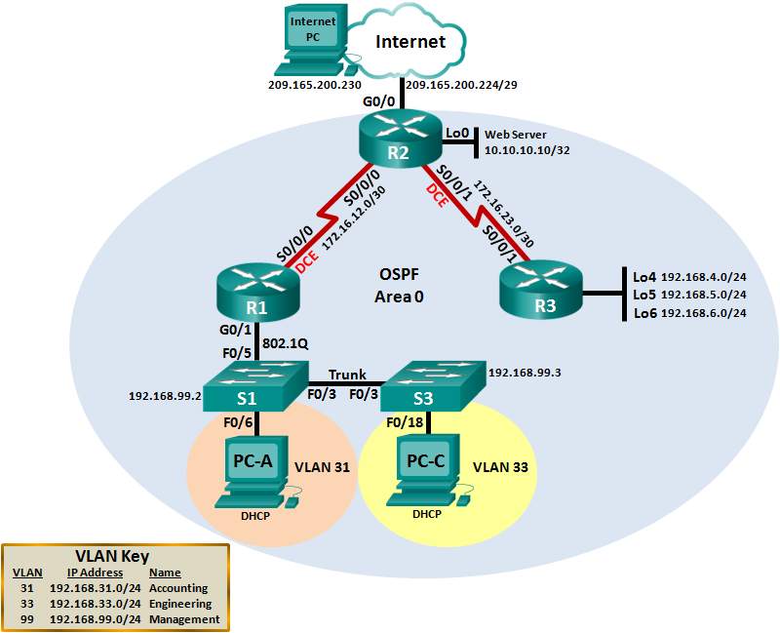
Assessment Objectives
Part 1: Configure Device Basic Settings
Part 2: Configure Switch Security, VLANs, and Inter-VLAN Routing
Part 3: Configure OSPFv2 Dynamic Routing Protocol
Part 4: Implement DHCP
Scenario
You will configure a small network. You will configure routers, switches, and PCs to support IPv4 connectivity, switch security, and inter VLAN routing. You will then configure the devices with OSPFv2, DHCP, and dynamic and static NAT You will test and document the network using common CLI commands throughout the assessment.
Required Resources
- 3 Routers (Cisco 1941 with Cisco IOS Release 15.2(4)M3 universal image or comparable)
- 2 Switches (Cisco 2960 with Cisco IOS Release 15.0(2) lanbasek9 image or comparable)
- 3 PCs
- Configure Device Basic Settings
  - Configure the Internet PC.
Configuration tasks for the Internet PC include the following (Refer to Topology for IP address information):
Configuration Item or Task | Specification | Note
IP Address | 209.165.200.230
Subnet Mask | 255.255.255.248
Default Gateway | 209.165.200.225
Note: It may be necessary to disable the PC firewall for pings to be successful later in this lab.
  - Configure PC-A and PC-C.
Configuration tasks for the PC-A:
Configuration Item or Task | Specification | Note
IP Address | 192.168.31.100
Subnet Mask | 255.255.255.0
Default Gateway | 192.168.31.1
Configuration tasks for the PC-C:
Configuration Item or Task | Specification | Note
IP Address | 192.168.31.101
Subnet Mask | 255.255.255.0
Default Gateway | 192.168.31.1

  - Configure S1.
Configuration tasks for S1 include the following:
Configuration Item or Task | Specification | Note
Go to Privileged EXEC Mode | enable
Go to Global Configuration Mode | config t
Disable DNS lookup | no ip domain lookup
Name the switch as S1 | hostname S1
Go to Line Console subconfiguration:  - sync the logging at the console  - exit from Console to Global Config | line con 0  logging sync  exit
  - Configure S3
Configuration tasks for S3 include the following:
Configuration Item or Task | Specification | Note
Go to Privileged EXEC Mode | enable
Go to Global Configuration Mode | config t
Disable DNS lookup | no ip domain lookup
Name the switch as S3 | hostname S3
Go to Line Console subconfiguration:  - sync the logging at the console  - exit from Console to Global Config | line con 0  logging sync  exit

  - Configure R1.
Configuration tasks for R1 include the following:
Configuration Item or Task | Specification/Command | Note
Go to Privileged EXEC Mode | enable
Go to Global Configuration Mode | config t
Disable DNS lookup | no ip domain lookup
Name a router as R1 | hostname R1
Go to Line Console subconfiguration:  - sync the logging at the console  - exit from Console to Global Config | line con 0  logging sync  exit
Select Interface S0/0/0:  - Set the Layer 3 IPv4 address. Use the first available address in the subnet.  - Set the clocking rate to 128000  - Activate Interface | interface s0/0/0  ip address 172.16.12.1 255.255.255.252  clock rate 128000  no shutdown
Configure a default route out S0/0/0. | ip route 0.0.0.0 0.0.0.0 s0/0/0

Configure R2.
Configuration tasks for R2 include the following:
Configuration Item or Task | Specification / Command | Note
Go to Privileged EXEC Mode | enable
Go to Global Configuration Mode | config t
Disable DNS lookup | no ip domain lookup
Name a router as R2 | R2
Go to Line Console subconfiguration:  - sync the logging at the console  - exit from Console to Global Config | line con 0  logging sync  exit
Select S0/0/0:  - Set the Layer 3 IPv4 address. Use the next available address in the subnet.  - Activate Interface | interface s0/0/0  ip address 172.16.12.2 255.255.255.252  no shutdown
Select S0/0/1:  - Set the Layer 3 IPv4 address. Use the first available address in the subnet.  - Set clocking rate to 128000  - Activate Interface | interface s0/0/1  ip address 172.16.23.1 255.255.255.252  clock rate 128000  no shutdown
Select Loopback 0  Set the Layer 3 IPv4 address. | interface loop0  ip address 10.10.10.10 255.255.255.255
Select G0/0:  - Set the Layer 3 IPv4 address.  - Activate Interface  - Exit from Interface G0/0 to Global Config | interface g0/0  ip address 209.165.200.225 255.255.255.248  no shutdown  exit
Configure a default route out G0/0. | ip route 0.0.0.0 0.0.0.0 g0/0
  - Configure R3.
Configuration tasks for R3 include the following:
Configuration Item or Task | Specification | Note
Go to Privileged EXEC Mode
Go to Global Configuration Mode
Disable DNS lookup
Name the router as R3
Go to Line Console subconfiguration:
- sync the logging at the console
- exit from Console to Global Config
Interface S0/0/1 | Set the Layer 3 IPv4 address. Use the next available address in the subnet.  Activate Interface
Interface Loopback 4 | Set the Layer 3 IPv4 address. Use the first available address in the subnet.
Interface Loopback 5 | Set the Layer 3 IPv4 address. Use the first available address in the subnet.
Interface Loopback 6 | Set the Layer 3 IPv4 address. Use the first available address in the subnet.
Default route | Configure a default route out S0/0/1.
  - Verify network connectivity.
Use the ping command to test connectivity between network devices.
Use the following table to methodically verify connectivity with each network device. Take corrective action to establish connectivity if a test fails:
From | To | Command | Ping Results | Note
PC-A | PC-C | ping 172.16.12.2 |  | @PC-A
PC-A | Gateway | ping 192.168.31.1 |  | @PC-A
Internet PC | Gateway | ping 209.165.200.225 |  | @Internet PC
PC-C | Internet PC | ping 209.165.200.230 |  | @PC-C

- Configure Switch Security, VLANS, and Inter VLAN Routing
  - Configure S1.
Configuration Item or Task | Command | Note
Create the VLAN database | vlan 31  name Accounting  vlan 33  name Engineering  vlan 99  name Management
Assign the management IP address | interface vlan 99  ip address 192.168.99.2 255.255.255.0
Assign the default-gateway | ip default-gateway 192.168.99.1
Force trunking on Interface F0/3 | interface F0/3  switchport mode trunk
Force trunking on Interface F0/5 | interface F0/5  switchport mode trunk
Configure all other ports as access ports | interface range F0/1-2, F0/4, F0/6-24, G0/1-2  switchport mode access
Assign F0/6 to VLAN 31 | interface F0/6  switchport access vlan 31
Shutdown all unused ports. | interface range F0/1-2, F0/4, F0/7-24, G0/1-2  shutdown
  - Configure S3.
Configuration Item or Task | Command | Note
Create VLAN database | vlan 31  name Accounting  vlan 33  name Engineering  vlan 99  name Management
Assign the management IP address | interface vlan 99  ip address 192.168.99.3 255.255.255.0
Assign default-gateway | ip default-gateway 192.168.99.1
Force trunking on Interface F03 | interface F0/3  switchport mode trunk  switchport trunk native vlan 1
Assign all other ports as access ports | interface range F0/1-2, F0/4, F0/6-24, G0/1-2  switchport mode access
Assign F0/18 to VLAN 33 | interface F0/18  switchport access vlan 33
Shutdown all unused ports. | interface range F0/1-2, F0/4, F0/6-17, F0/19-24, G0/1-2  shutdown
  - Configure R1.
Configuration Item or Task | Specification | Note
Configure 802.1Q subinterface .31 on G0/1 | interface g0/1.31  description Accounting LAN  encapsulation dot1q 31  ip address 192.168.31.1 255.255.255.0
Configure 802.1Q subinterface .33 on G0/1 | interface g0/1.33  description Engineering LAN  encapsulation dot1q 33  ip address 192.168.33.1 255.255.255.0
Configure 802.1Q subinterface .99 on G0/1 | interface g0/1.99  description Management LAN  encapsulation dot1q 99  ip address 192.168.99.1 255.255.255.0
Activate Interface G0/1 | interface g0/1  no shutdown
  - Verify network connectivity.
Use the ping command to test connectivity between the switches and R1.
Use the following table to methodically verify connectivity with each network device. Take corrective action to establish connectivity if a test fails:
From | To | IP Address | Ping Results | Note
S1 | R1, VLAN 99 address | 192.168.99.1
S3 | R1, VLAN 99 address | 192.168.99.1
S1 | R1, VLAN 31 address | 192.168.31.1
S3 | R1, VLAN 33 address | 192.168.33.1

- Configure OSPFv2 Dynamic Routing Protocol
  - Configure OSPFv2 on R1.
Configuration tasks for R1 include the following:
Configuration Item or Task | Command | IOS Commands
OSPF Process ID | router ospf 1
Router ID | router-id 1.1.1.1
Advertise directly connected Networks | network 172.16.12.0 0.0.0.3 area 0  network 192.168.31.0 0.0.0.255 area 0  network 192.168.33.0 0.0.0.255 area 0  network 192.168.99.0 0.0.0.255 area 0
Set all LAN interfaces as passive | passive-interface g0/1.31  passive-interface g0/1.33  passive-interface g0/1.99
  - Configure OSPFv2 on R2.
Configuration tasks for R2 include the following:
Configuration Item or Task | Command | Note
OSPF Process ID | router ospf 1
Router ID | router-id 2.2.2.2
Advertise directly connected Networks | network 172.16.12.0 0.0.0.3 area 0  network 172.16.23.0 0.0.0.3 area 0  network 10.10.10.10 0.0.0.0 area 0
Set the LAN (Loopback) interface as passive | passive-interface lo0

  - Configure OSPFv2 on R3.
Configuration tasks for R3 include the following:

Configuration Item or Task | Specification | IOS Commands
OSPF Process ID | router ospf 1
Router-ID | router-id 3.3.3.3
Advertise directly connected Networks | network 172.16.23.0 0.0.0.3 area 0  network 192.168.4.0 0.0.3.255 area 0
Set all LAN (Loopback) interfaces as passive | passive-interface lo4  passive-interface lo5  passive-interface lo6
  - Verify OSPF information.
Verify that OSPF is functioning as expected. Enter the appropriate CLI command to discover the following information:
Question | Command | Note
What command will display all connected OSPFv2 routers? | show ip ospf neighbor
What command displays a summary list of OSPF interfaces that includes a column for the cost of each interface? | show ip ospf interface brief
What command displays the OSPF Process ID, Router ID, Address summarizations, Routing Networks, and passive interfaces configured on a router? | show ip protocols
What command displays only OSPF routes? | show ip route ospf
What command displays detail information about the OSPF interfaces, including the authentication method? | show ip ospf interface
What command displays the OSPF section of the running-configuration? | show run | section router OSPF

- Implement DHCP for IPv4
  - Configure R1 as the DHCP server for VLANs 31 and 33.
Configuration tasks for R1 include the following:
Configuration Item or Task | Specification | Note
Reserve the first 20 IP addresses in VLAN 31 for static configurations | ip dhcp excluded-address 192.168.31.1 192.168.31.20
Reserve the first 20 IP addresses in VLAN 33 for static configurations | ip dhcp excluded-address 192.168.33.1 192.168.33.20
Create a DHCP pool for VLAN 31 | ip dhcp pool ACCT  network 192.168.31.0 255.255.255.0  dns-server 10.10.10.11  domain-name bmta.co.th  default-router 192.168.31.1
Create a DHCP pool for VLAN 33 | ip dhcp pool ENGNR  network 192.168.33.0 255.255.255.0  dns-server 10.10.10.11  domain-name bmta.co.th  default-router 192.168.33.1
  - Configure PC-A and PC-C for DHCP
Change from static IP to DHCP

  - Verify DHCP
Use the following tasks to verify that DHCP settings are functioning correctly.
Test | Command | Note
Verify that PC-A acquired IP information from the DHCP server | C:\> ipconfig /all  (Look at settings to determine if dhcp provided the correct network information.)
Verify that PC-C acquired IP information from the DHCP server | C:\> ipconfig /all  (Look at settings to determine if dhcp provided the correct network information.)
Verify that PC-A can ping PC-C. | C:\> ping 192.168.33.21  Type escape sequence to abort.  Sending 5, 100-byte ICMP Echos to 192.168.31.21, timeout is 2 seconds:  !!!!!

