Report Of LoRa Project

By ViraRobot

2020

Table of Contents

arduino, jetson and raspbaerrypi customization – 85967 Tony L. 3

INTRODUCTION 3

WHAT IS LoRa®? 3

**Gateways** 3

**How do gateways work?** 4

Local gateway configuration 4

Register a gateway on ttn server 6

Arduino programming 10

What is RESTFul API? 10

Configure IoT Server 11

# arduino, jetson and raspbaerrypi customization – 85967 Tony L.

## INTRODUCTION

## WHAT IS LoRa®?

LoRa® is the physical layer or the wireless modulation utilized to create the long range communication link. Many legacy wireless systems use frequency shifting keying (FSK) modulation as the physical layer because it is a very efficient modulation for achieving low power. LoRa® is based on chirp spread spectrum modulation, which maintains the same low power characteristics as FSK modulation but significantly increases the communication range. Chirp spread spectrum has been used in military and space communication for decades due to the long communication distances that can be achieved and robustness to interference, but LoRa® is the first low cost implementation for commercial usage. Long Range (LoRa®) The advantage of LoRa® is in the technology’s long range capability. A single gateway or base station can cover entire cities or hundreds of square kilometers. Range highly depends on the environment or obstructions in a given location, but LoRa® and LoRaWAN™ have a link budget greater than any other standardized communication technology. The link budget, typically given in decibels (dB), is the primary factor in determining the range in a given environment. Below are the coverage maps from the Proximus network deployed in Belgium. With a minimal amount of infrastructure, entire countries can easily be covered [1].

## WHAT IS LoRaWAN™?

LoRaWAN™ defines the communication protocol and system architecture for the network while the LoRa® physical layer enables the long-range communication link. The protocol and network architecture have the most influence in determining the battery lifetime of a node, the network capacity, the quality of service, the security, and the variety of applications served by the network. [1]

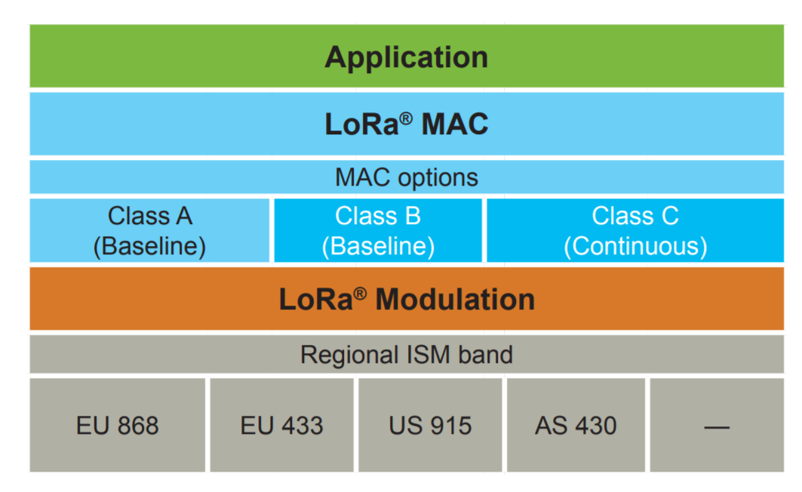

### Network Architecture

Many existing deployed networks utilize a mesh network architecture. In a mesh network, the individual end-nodes forward the information of other nodes to increase the communication range and cell size of the network. While this increases the range, it also adds complexity, reduces network capacity, and reduces battery lifetime as nodes receive and forward information from other nodes that is likely irrelevant for them. Long range star architecture makes the most sense for preserving battery lifetime when long-range connectivity can be achieved.

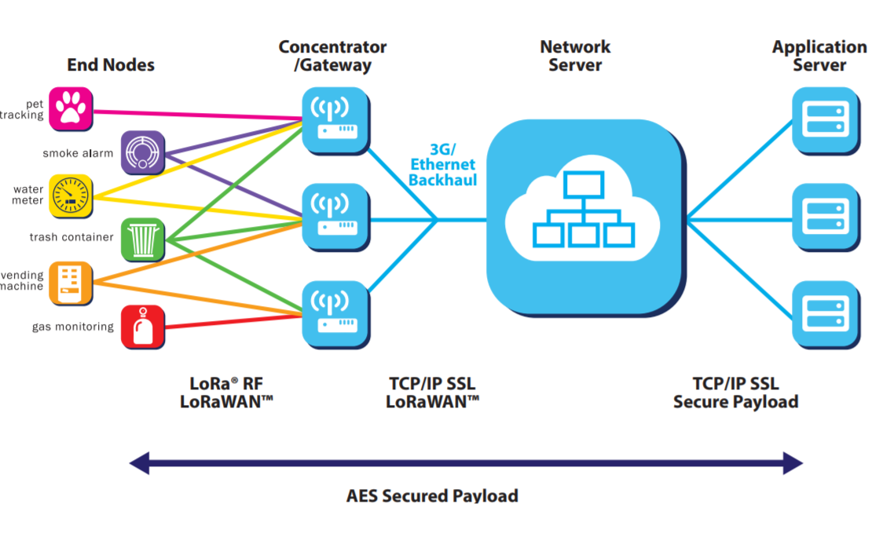

In a LoRaWAN™ network nodes are not associated with a specific gateway. Instead, data transmitted by a node is typically received by multiple gateways. Each gateway will forward the received packet from the end-node to the cloud-based network server via some backhaul (either cellular, Ethernet, satellite, or Wi-Fi). The intelligence and complexity is pushed to the network server, which manages the network and will filter redundant received packets, perform security checks, schedule acknowledgments through the optimal gateway, and perform adaptive data rate, etc. If a node is mobile or moving there is no handover needed from gateway to gateway, which is a critical feature to enable asset tracking applications–a major target application vertical for IoT.

### Battery Lifetime

The nodes in a LoRaWAN™ network are asynchronous and communicate when they have data ready to send whether event-driven or scheduled. This type of protocol is typically referred to as the Aloha method. In a mesh network or with a synchronous network, such as cellular, the nodes frequently have to ‘wake up’ to synchronize with the network and check for messages. This synchronization consumes significant energy and is the number one driver of battery lifetime reduction. In a recent study and comparison done by GSMA of the various technologies addressing the LPWAN space, LoRaWAN™ showed a 3 to 5 times advantage compared to all other technology options.

### Network Capacity

In order to make a long range star network viable, the gateway must have a very high capacity or capability to receive messages from a very high volume of nodes. High network capacity in a LoRaWAN™ network is achieved by utilizing adaptive data rate and by using a multichannel multi-modem transceiver in the gateway so that simultaneous messages on multiple channels can be received. The critical factors effecting capacity are the number of concurrent channels, data rate (time on air), the payload length, and how often nodes transmit. Since LoRa® is a spread spectrumbased modulation, the signals are practically orthogonal to each other when different spreading factors are utilized. As the spreading factor changes, the effective data rate also changes. The gateway takes advantage of this property by being able to receive multiple different data rates on the same channel at the same time. If a node has agood link and is close to a gateway, there is no reason for it to always use the lowest data rate and fill up the available spectrum longer than it needs to. By shifting the data rate higher, the time on air is shortened opening up more potential space for other nodes to transmit. Adaptive data rate also optimizes the battery lifetime of a node. In order to make adaptive data rate work, symmetrical up link and down link is required with sufficient downlink capacity. These features enable a LoRaWAN™ network to have a very high capacity and make the network scalable. A network can be deployed with a minimal amount of infrastructure, and as capacity is needed, more gateways can be added, shifting up the data rates, reducing the amount of overhearing to other gateways, and scaling the capacity by 6-8x. Other LPWAN alternatives do not have the scalability of LoRaWAN™ due to technology trade-offs, which limit downlink capacity or make the downlink range asymmetrical to the uplink range.

### Device Classes – Not All Nodes Are Created Equal

End-devices serve different applications and have different requirements. In order to optimize a variety of end application profiles, LoRaWAN™ utilizes different device classes. The device classes trade off network downlink communication latency versus battery lifetime. In a control or actuator-type application, the downlink communication latency is an important factor.

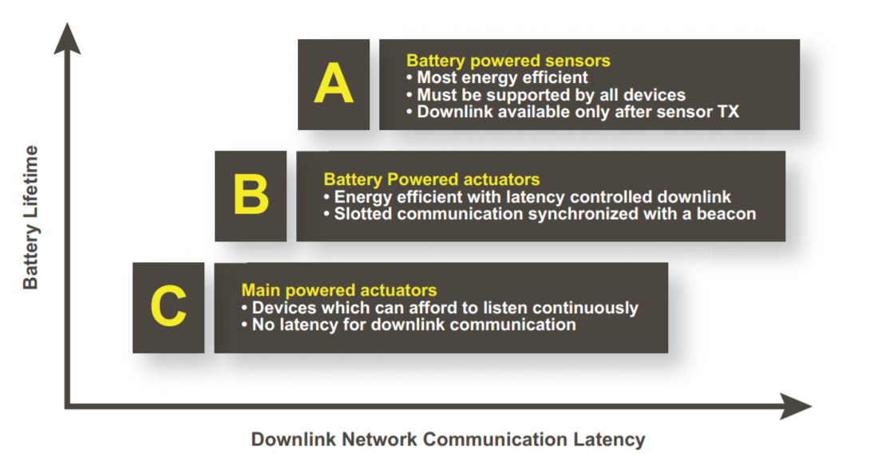

Bi-directional end-devices (Class A): End-devices of Class A allow for bi-directional communications whereby each end-device’s uplink transmission is followed by two short downlink receive windows. The transmission slot scheduled by the end-device is based on its own communication needs with a small variation based on a random time basis (ALOHA-type of protocol). This Class A operation is the lowest power end-device system for applications that only require downlink communication from the server shortly after the end-device has sent an uplink transmission. Downlink communications from the server at any other time will have to wait until the next scheduled uplink. Bi-directional end-devices with scheduled receive slots (Class B): In addition to the Class A random receive windows, Class B devices open extra receive windows at scheduled times. In order for the end-device to open its receive window at the scheduled time, it receives a time-synchronized beacon from the gateway. This allows the server to know when the end-device is listening. Bi-directional end-devices with maximal receive slots (Class C): End-devices of Class C have almost continuously open receive windows, only closed when transmitting.

### Security

It is extremely important for any LPWAN to incorporate security. LoRaWAN™ utilizes two layers of security: one for the network and one for the application. The network security ensures authenticity of the node in the network while the application layer of security ensures the network operator does not have access to the end user’s application data. AES encryption is used with the key exchange utilizing an IEEE EUI64 identifier. There are trade-offs in every technology choice but the LoRaWAN™ features in network architecture, device classes, security, scalability for capacity, and optimization for mobility address the widest variety of potential IoT applications.

## Gateways

Gateways form the bridge between devices and The Things Network. Devices use low power networks like LoRaWAN to connect to the Gateway, while the Gateway uses high bandwidth networks like WiFi, Ethernet or Cellular to connect to The Things Network.

**All gateways within reach of a device will receive the device’s messages and forward them to The Things Network.** The network will deduplicate the messages and select the best gateway to forward any messages queued for downlink. A single gateway can serve thousands of devices.

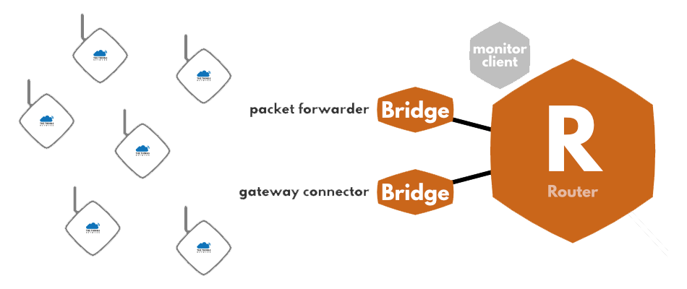

## **How do gateways work?**

Gateways are routers equipped with a **LoRa concentrator**, allowing them to receive LoRa packets. You can usually find two kinds of gateways:

* Gateways running on a **minimal firmware**, making them low-cost and easy to use (e.g. The Things Gateway), running only the packet forwarding software.
* Gateways running an **operating system**, for which the packet forwarding software is run as a background program (e.g. Kerlink IoT Station, Multitech Conduit). This gives more liberty to the gateway administrator to manage their gateway and to install their own software.

When deploying a new LoRaWAN gateway, a key decision is whether to build your own or to buy an off–the–shelf gateway. The number of options for gateways has increased dramatically since the start of this deployment in 2016. Commercial grade gateways are rugged, reliable, and have more advanced hardware, but are costly. Another option for gateway construction was using a LoRa interface and a Single Board Computer (SBC) [2]. There are now multiple different LoRa add on boards for SBC; representative examples are shown in Table 3. The lowest cost option to build a custom gateway is to use the same single channel LoRa HAT as used in the end nodes. While single channel operation is perfect for an end device, it is unsuitable for a gateway. Initially, this sort of gateway could be used for a low–cost development environment but has now been superseded by the release of the Things Indoor Gateway; see Table 4. Where a SBC based gateway was used in this deployment it was based around the iMST iC880A because it was the only low–cost LoRaWAN concentrator available. New concentrators have now been released, such as one by Pi Supply. These more recent concentrators have the advantage of supporting direct connection to the SBC without needing an adapter board such as the custom designed Pi-CoT [45]. The main advantages of these home built gateways are: price and flexibility—the ability to design the system connectivity and enclosure to best meet your requirements. The lower price point limits the possibility of including more advanced features, such as ns time stamp accuracy required for TDOA.

## Local gateway configuration

First we nee dto power up the gateway and connect it via lan to a pc. Now gateway is reachable in 10.130.1.1. the default pass word is “dragino”. After authentication you can see the status of the gateway.

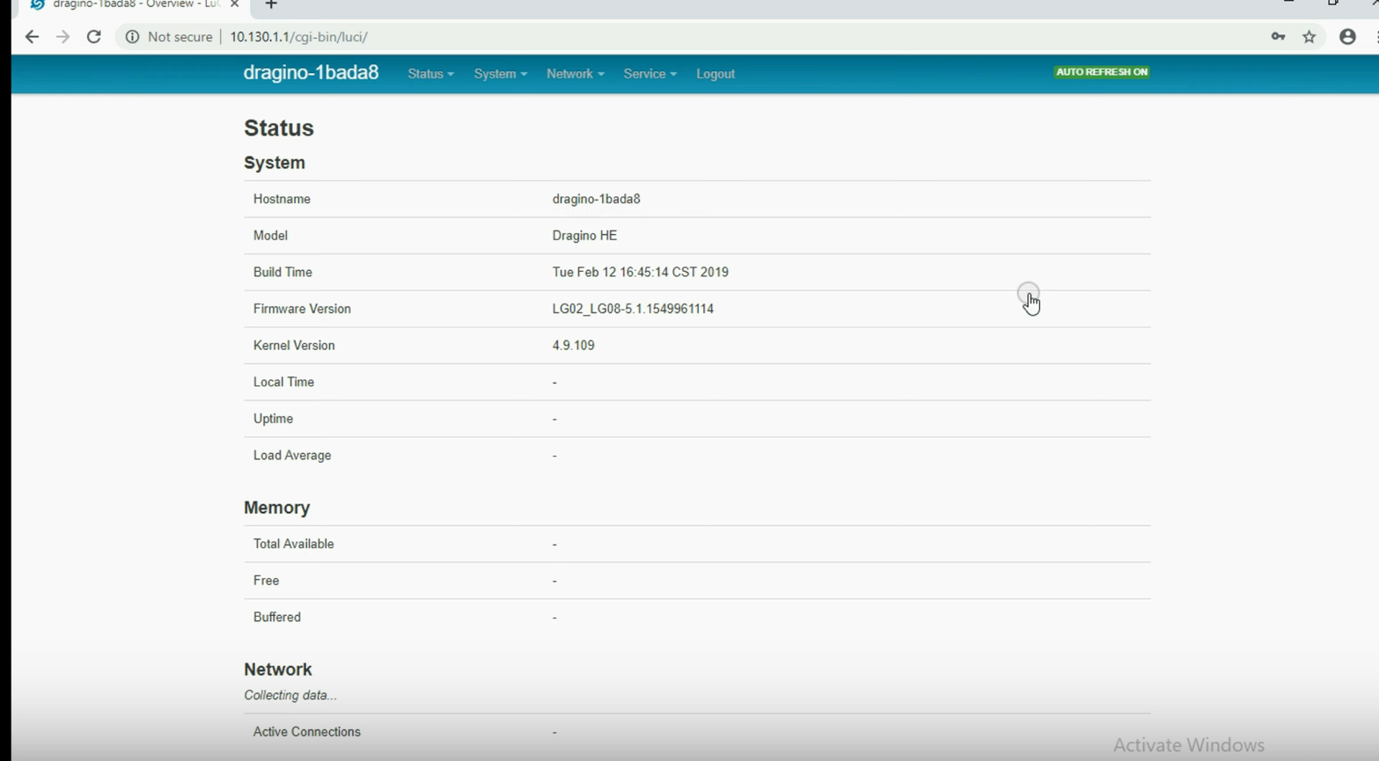

Figure 1 LoRa gateway status page

After authentication we have to connect to nearby wifi hot spot for internet connection. To do this click on network option and then click on wireless. Th gateway start scanning for nearby WIFI’s. Join your wifi According to your WIFI SSID. Enter your WPA Passphrase and your WIFI name. Then submit the form.

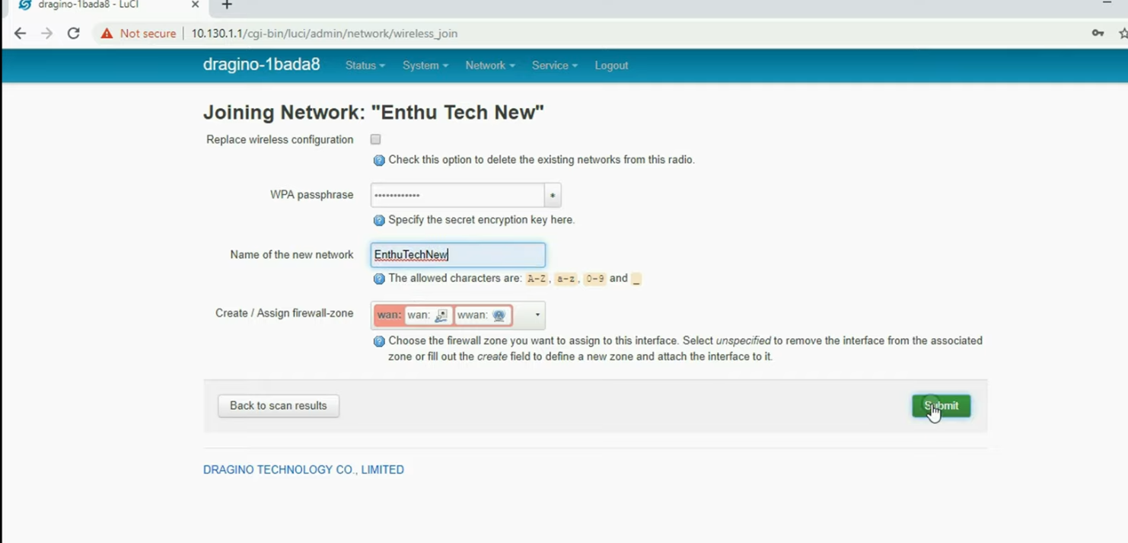Figure 2 Joining WIFI network

After submitting scroll down and click on “save & submit”.

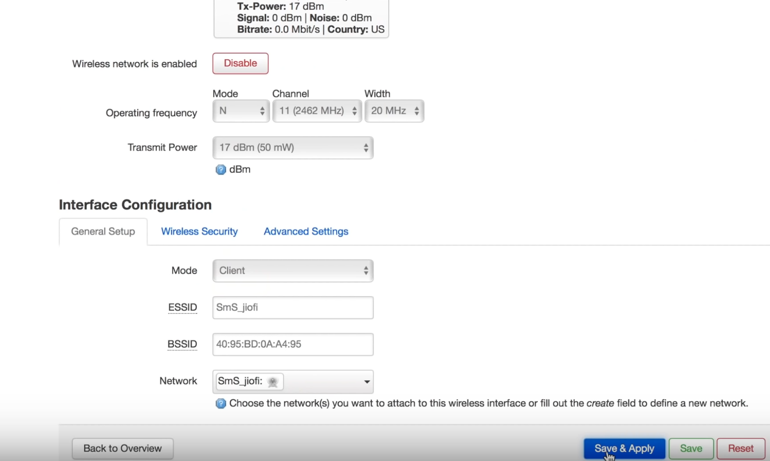

Figure 3 Save and submit WIFI

One of the way to check the connection is that you go to status page. In the network fields check if lora gateway is connected using lan or WIFI and you is the length of the wifi.

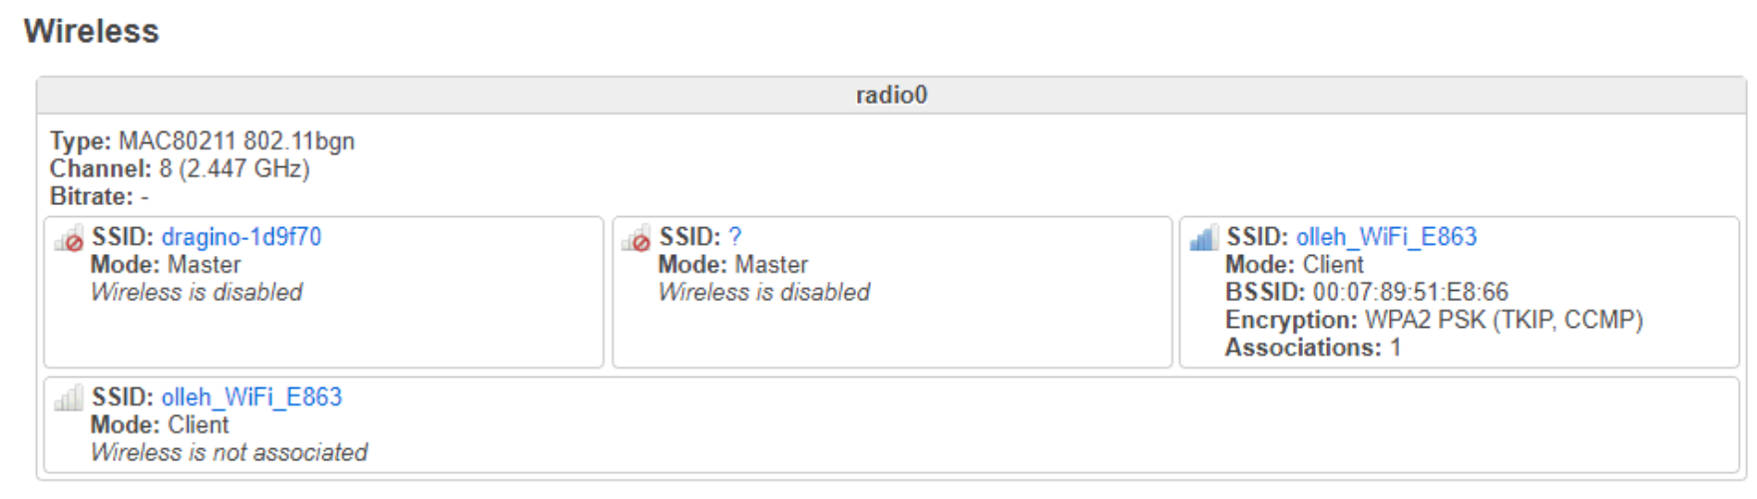

Figure 4 Check gateway connection

When the gateway is connected to internet its time to configure the LoRaWan Gateway in services so that gateway send data to server. On top menu bar click on service and then click on LoraWan gateway. A page like below will show up.

## Register a gateway on ttn server

Now it’s time to register out gateway on the ttn server. To do that go to this [link](https://console.thethingsnetwork.org/). Here is your console manager. You can add gateways and applications. Click on gateway.

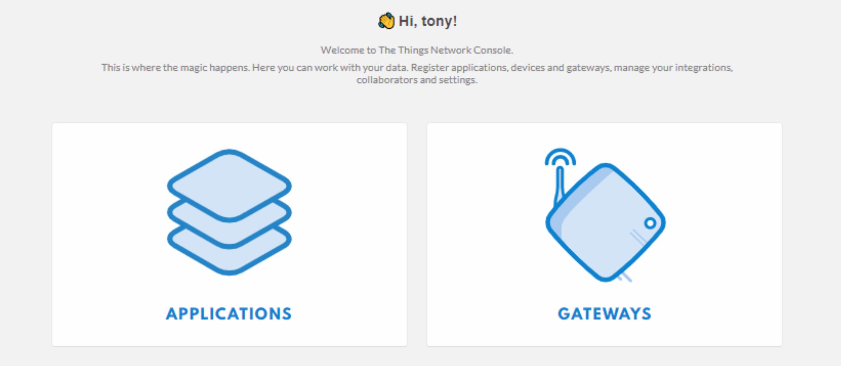

Create a gateway. Here you find a page like figure

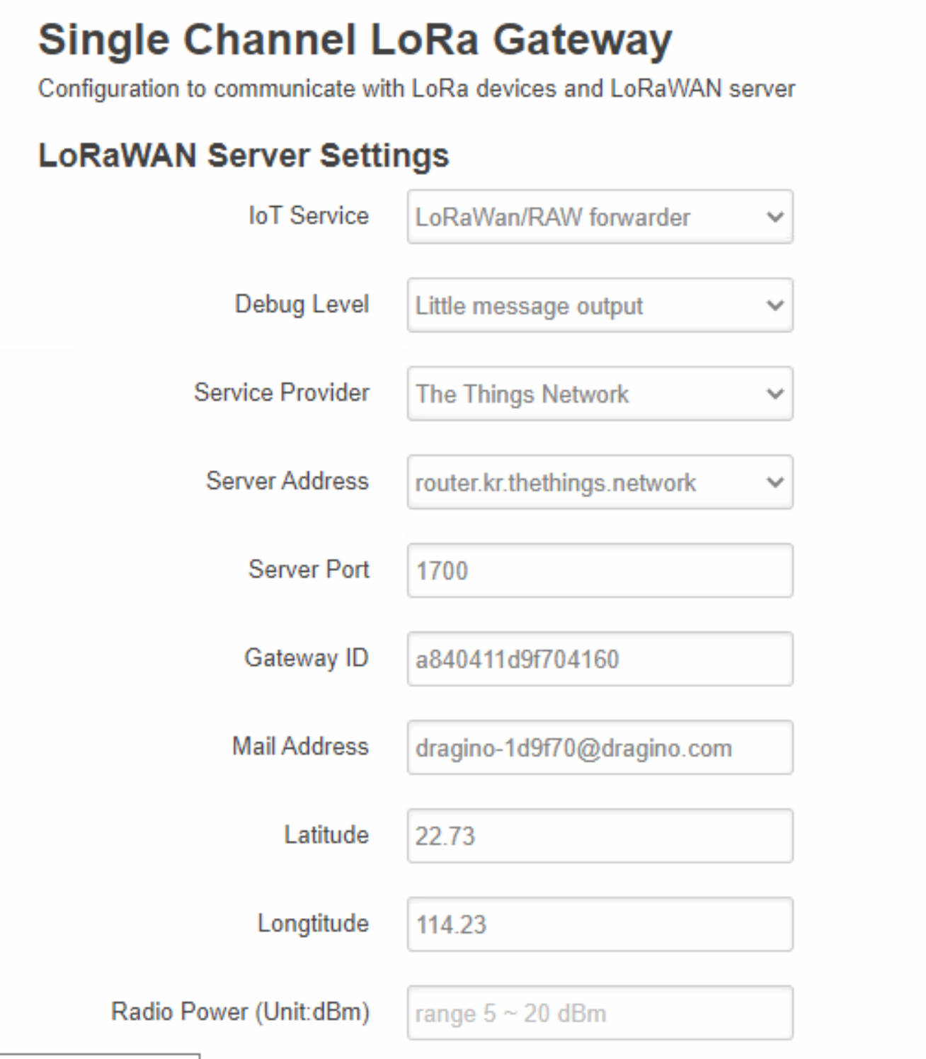

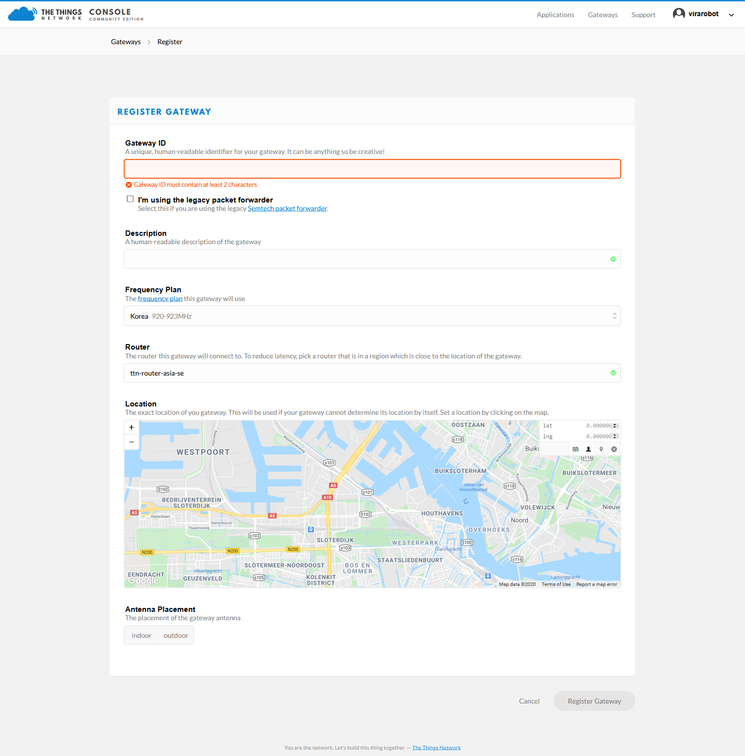

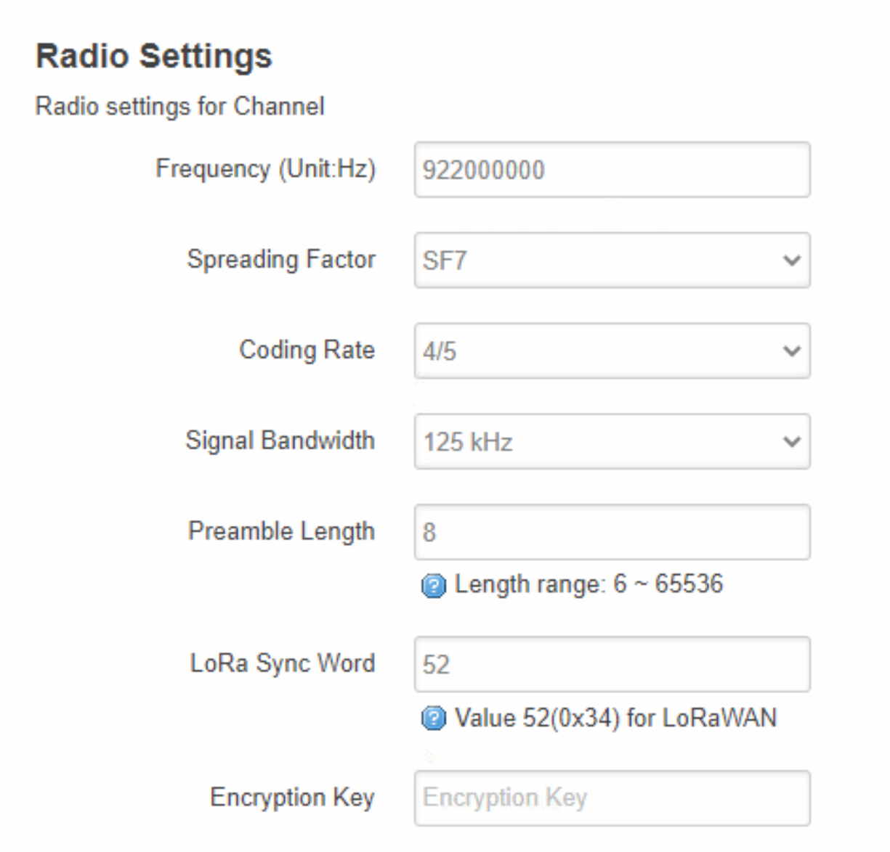

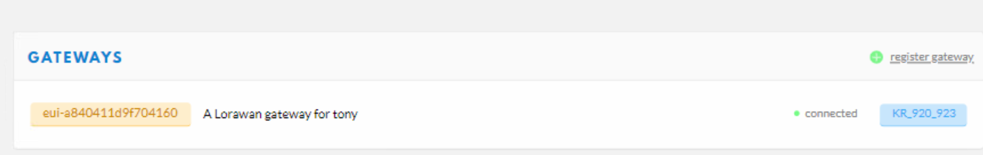

## Arduino programming

## What is RESTFul API?

A RESTful API is an application program interface (API) that uses HTTP requests to GET, PUT, POST and DELETE data. Many IoT services provide RESTful API as one of the uplink/downlink method for sensor date communication. This example will show how to use LG01 to communicate with IoT server via RESTful API, so to achieve the goal to upload sensor data to IoT server or download commands from IoT server.

## Configure IoT Server

Many servers support RESTful API, the server we use here is ThingSpeak which has an intuitive chart to show the test result for our test. The method here is general and can be used with other IoT servers for RESTful connection as well. To use the server, we need to register an account on Thingspeak. Then create a channel and type the channel info. As shown below, the Channel ID is the unique ID to store our data in ThingSpeak

# Bibliography

|  |  |
| --- | --- |
| [1] | T. M. W. 1.0, A technical overview of, 2015. |
| [2] | J. C. N. R. Harris, "Development and Range Testing of a LoRaWAN," *World Academy of Science, Engineering and Technology,* pp. 43-51, 2018. |