11/18/2021

Risk Assesment project docs

Admin Page
Image: 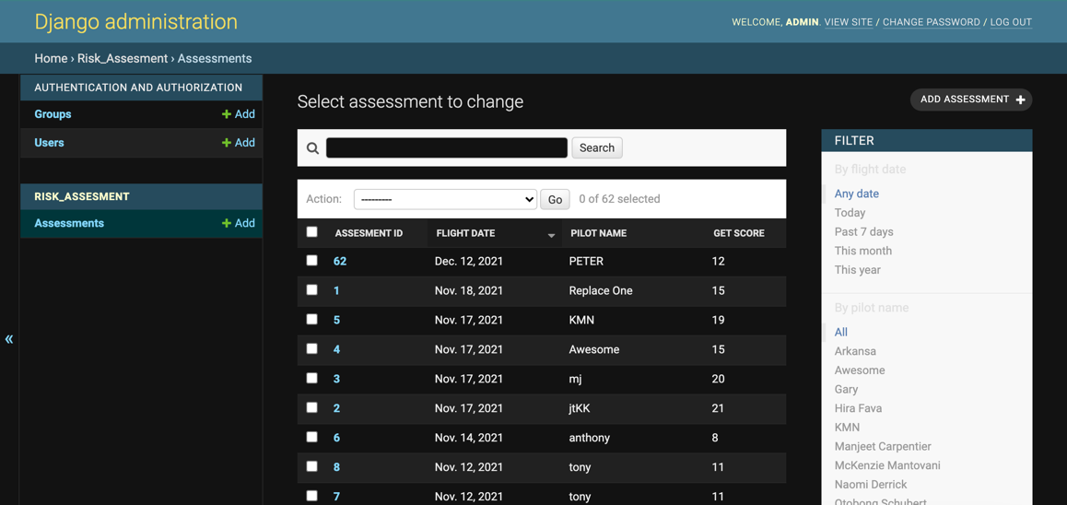

URL: /admin/risk_assesment/assessment/
MODEL(file): risk_assesment/models.py
VIEW(file): risk_assesment/admin.py

To create a new admin
- From the command line/base Run
  - python manage.py createsuperuser

Functionality
- Assessment’s manager
- Create, Update, Delete, Retrieve

Querying and Retrieving
- Search Field
  - Using the search field
    - Search for assessment using 'flight_date', 'pilot_name', 'flight from' and 'to'
- Querying Field
  - Using the filter panel on the right
    - filter for assessment using 'flight_date', 'pilot_name', 'flight_from' and 'to'

Notes
- the admin site is the only/recommended place to change, update and delete a assessment record
- When creating a new assessment from admin it better to leave the assessment id field empty, all assessment id must be unique to avoid data corruption
- When updating an assessment from admin avoid changing it assessment id
- All changes to data via admin site will automatically be update in all data storage including google sheet

API Page
Image:
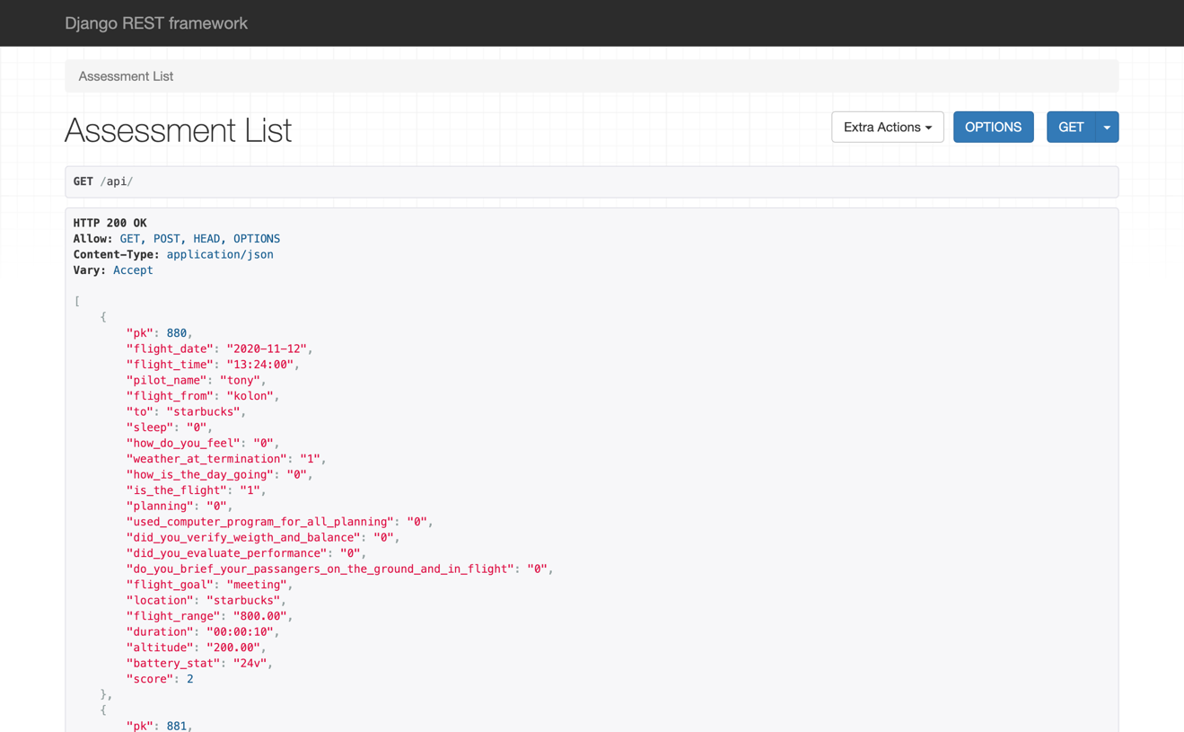
URL: /api/
MODEL(file): risk_assesment/models.py
VIEW(file): api/views.py

Functionality
- Assessment’s creation and Retrieval

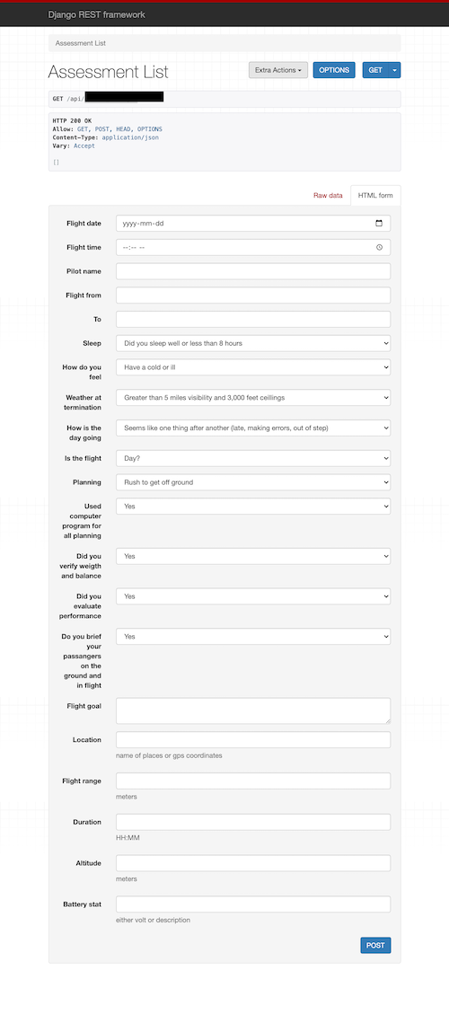
Creating Assessments
- Using web page -> see the image on the side
- Using API Call
  - Send a post request to
    - /api/
  - Post body
    - Must contain the field shown in the image or use the api form image for reference
    - Avoid sending assessment_id in the post request body, it will be generated automatically

Querying and Retrieving
- Using get parameter
  - GET /api/?<field_name>=<value>&<field2_name>=<value2>
    - field_name can be any of the model field i.e. Pilot name, format as lowercase and space to underscore
    - example
      - /api/?pilot_name=peter alabi & flight_from= tokyo
      - /api/?pilot_name=tony

Retrieving last 10 assessments records
- Retrieves the last ten assessments records of the given name
- URL: /api/last_ten/?pilot_name=<value>
  - i.e. /api/last_ten/?pilot_name=hira
- Note: the name must be exact and case sensitive

Search For Matching Pilot name(s)
- URL: /api/names/?pilot_name=<value>
  - i.e. /api/names/?pilot_name=pet
  - will return all pilot name that contain the character ‘pet’
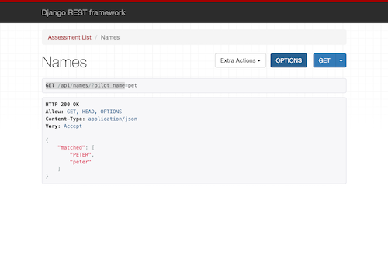
- See below image for reference

Note
- DELETE and UPDATE is not permitted using this api page

ASSESMENT Page
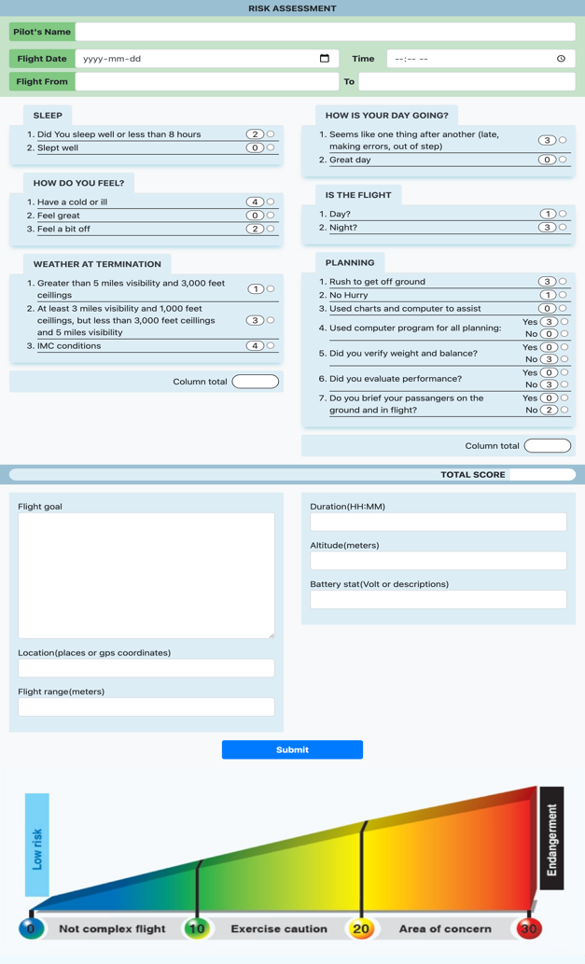
Image:
URL: /assesment/
MODEL(file): risk_assesment/models.py
VIEW(file): risk_assesment/views.py
CONTROLS(files):
- risk_assesment/views.py
  - render the html page using risk_assesment/forms.py
- risk_assesment/forms.py
- risk_assesment/templates/ risk_assesment/assessment.html
- Form Submission and Handling
  - Two ways
    - Ajax
      - Code script in: risk_assesment/templates/ risk_assesment/assessment.html
      - Send a post request to (URL): /api/
        - If no error, it will redirect to assessments result page using the pilot name as a result page get parameter 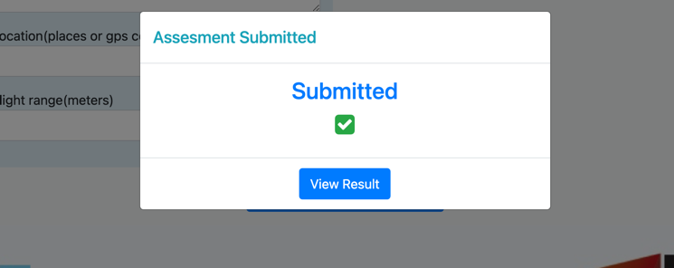
        - If Error in ajax form submission, a model will be display indicating form errors.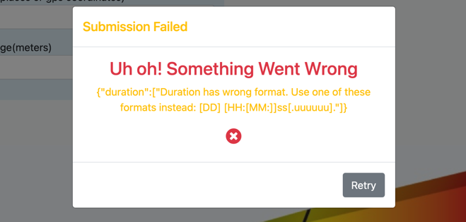
    - No JavaScript
      - Only if there is no javascript or ajax is not loaded properly

Assessment result Page
Image: 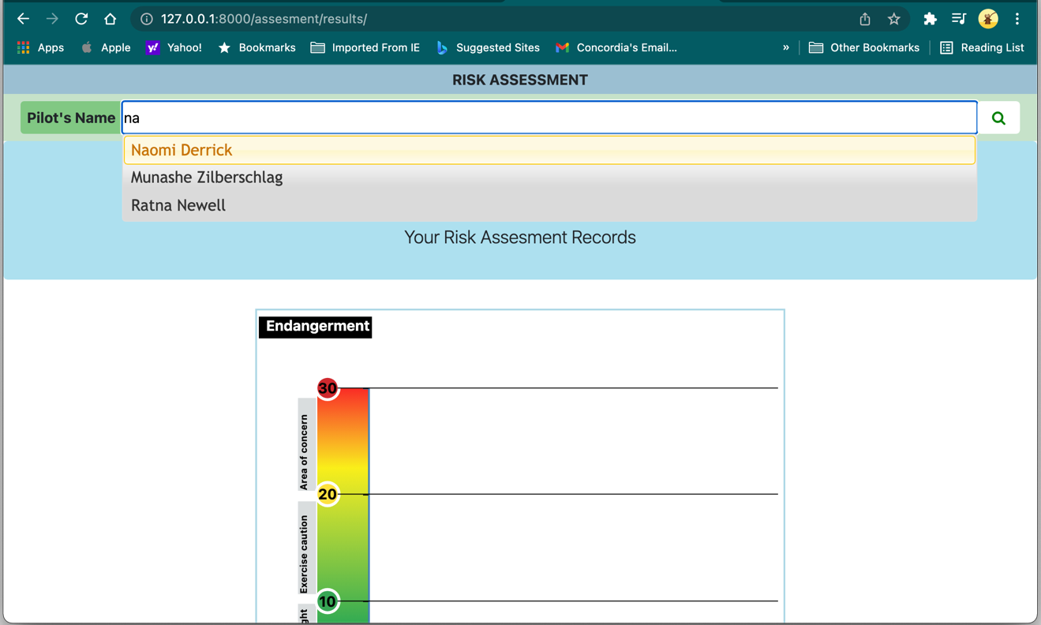

URL: /assesment/results/?name=<value>
MODEL(file): risk_assesment/models.py
VIEW(file): risk_assesment/views.py
CONTROLS(files):
- risk_assesment/views.py
  - render the html page
- risk_assesment/templates/risk_assesment/assessment_result.html
- risk_assesment/static/javascripts/assessment.js
  - autocomplete name retrieved via ajax
  - assesments records are retrieved via ajax to get last 10 record api
  - d3.js handles the drawing using the data to draw the time series graph
- NOTES:
  - jQuery Autocomplete:
    - ajax request (risk_assesment/static/javascripts/assessment.js line: 17-36) is not necessary if the data (if assesments records are provided and load into variable “availableTags “ , additional filtering and parsing of raw assesments data (i.e from db.json) is necessary to retrive only the matching names array)
  - D3.js databinding
    - Similar to jQuery Autocomplete, the ajax request to retrieve the last ten assesments record api to Django/sqlite (risk_assesment/static/javascripts/assessment.js line: 17-36) can be avoided by either:
      - Load/copy the content of db.json in the script file directly and bind to global variable “resData”
      - Or by using d3.json(path/to/db.json, <callback function>)
Note: this require a file server to serve the file to d3.
    - In either case necessary filter/parsing must be done to the data, to before d3 draws the graph
  - Changing d3 graph/graph format
    - The function makeSVG() is always called to draw the graph grid and template with or with the actual assesments data
    - The function showGraph() is responsible for drawing the assesments data on the graph, by using the following helper functions
      - makeSVG();
      - getChartConfig(svg);
      - drawHeatbar(config,svg);
      - drawLegend(config,svg);
      - getChartScales(data, config);
      - drawAxis(scales,config,svg,data);
      - drawGraph(data,config,svg,scales);
      - drawRangeText(config,svg,scales);
    - Any of the functions above can be called to modify the resulting d3 graph
      - Note: The actual main assessment data is binding is done in function drawGraph() line 175

Functionality
- D3 graph of assesment result over time
- Tooltiping
- Pilot name auto complete
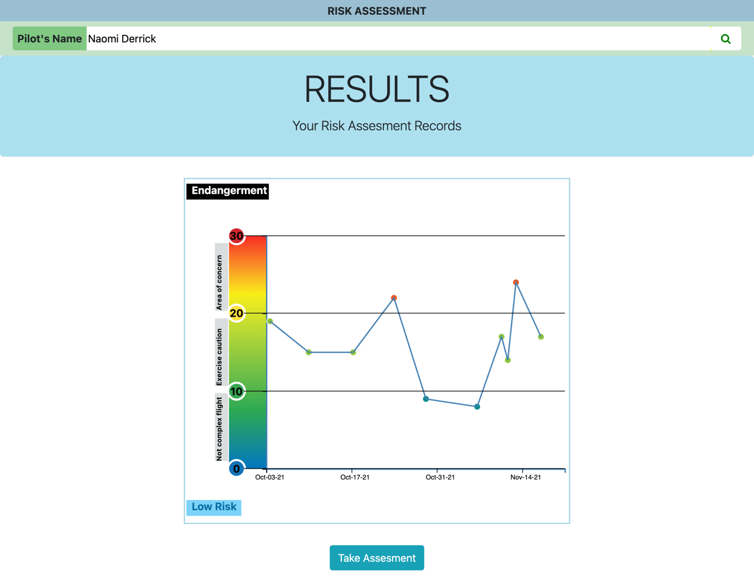

Notes
- The data for the graphs are retrieved using ajax get request to: /api/last_ten/?pilot_name=<value>
  - See API Page
- The autocompletes name are retrieved using ajax get request to URL: /api/names/?pilot_name=<value>
  - See Search For Matching Pilot name

MISCELLENEOUS

Google Sheet Page
Image:
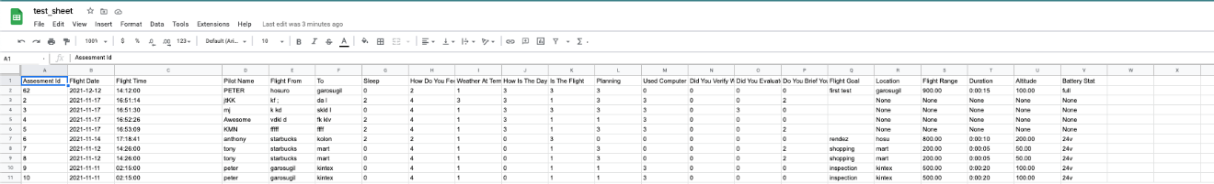
URL: N/A
MODEL(file): risk_assesment/models.py
CONTROLS(file):

Functionality
- Assessment’s manager/Storage
- Create, Update, Delete

Creating, Update and Deleting Assesment
Two ways to accomplish this
- Via Django App
  - Updating data from Django app either through api, admin, or assesment page will automatically update google sheet accordingly
  - Control/Logic
The automatic google sheet update is done as described below
    - Using Django signal
      - File: risk_assessment_project/risk_assessment/signal.py
      - Pre_save signal function
        - Updates google sheet when a new assessment is created or old one being modified
      - Post_delete signal functions
        - Updates google sheet when a assessment is being deleted
- Via Google Sheet
Because automatic data sync between Django app and google sheet is one directional, after any form data changes made in google sheet page should be updated to Django app by calling gsPull() function to resync the data.

Syncing Data between Django App and Google Sheet
- File: /risk_assesments_project/risk_assesment/gsScripts.py
- Model: risk_assesment/models.py
- Syncing Django App Assessment Data with Google Sheet Data
This will replace all Django app data with the data currently in google sheet
    - Controls
      - Functions: gsPull()
      - Logic
        - The all data in Django and db.json will be deleted and replace with the google sheet data
        - The try and except is used to ensure that no data will be lost if error occurs during syncing
        - Because the all new record added to Django will be given a new assessment id starting from 0 and order chronologically, the data on the google sheet will also be reupdated to reflect the new assesment ids by gsPull automatically calling gsPush
        - Environment variable is set to prevent Django signal from updating the google sheet while it being pull
- Syncing Sheet Data Assessment Data with Google Django App
This will replace all google sheet data with the data currently in Django app
    - Controls
      - Functions: gsPush()
      - Logic
        - The try and except is used to ensure that no data will be lost if error occurs during syncing

Notes
- The first row of the google sheet must the label and The first column of the sheet must be the assesment id
  - If the conditions are not met data communication between Django app and google sheet will not be possible and can lead to data corruptions
  - If the row and column are improperly configured or destroyed it better to called gsPush() to pull the Django app data to google as this will reset the column header and row to the proper value
  - During Pulling and Pushing there is one second delay(sleep) to prevent google maximum call exception
    - The sleep value @the bottom of gsPush() can be modified if needed!

jSON Database Syncing
URL: N/A
MODEL(file): risk_assesment/models.py
CONTROLS(file): /risk_assesment_project/db.json

Functionality
- Assessment’s manager/Storage
- Create, Update, Delete

Creating, Update and Deleting Assesment
Two ways to accomplish this
- Via Django App
  - Updating data from Django app either through api, admin, or assesment page will automatically update db.json accordingly
  - Control/Logic
The automatic db.json update is done as described below
    - Using Django signal
      - File: risk_assessment_project/risk_assessment/signal.py
      - Pre_save signal function
        - Updates db.json when a new assessment is created or old one being modified using the pk as the identifier
      - Post_delete signal functions
        - Updates db.json when a assessment is being deleted
- Via db.json
Because automatic data sync between Django app and google sheet or db.json is one directional, after any form of data changes made in db.json should be updated to Django app by calling jsonPull() function to update Django data.

Syncing Data between Django App and Google Sheet using db.json
- File: /risk_assesments_project/risk_assesment/gsScripts.py
- Model: risk_assesment/models.py
- Syncing Django App Assessment Data with db.json Data
This will replace all Django app data and google sheet with the data currently in db.json
    - Controls
      - Functions: jsonPull()
- Syncing Sheet Data Assessment Data with Google Django App
This will replace all db.json data with the data currently in Django app
    - Controls
      - Functions: jsonPush()
      - Logic
        - The try and except is used to ensure that no data will be lost if error occurs during syncing

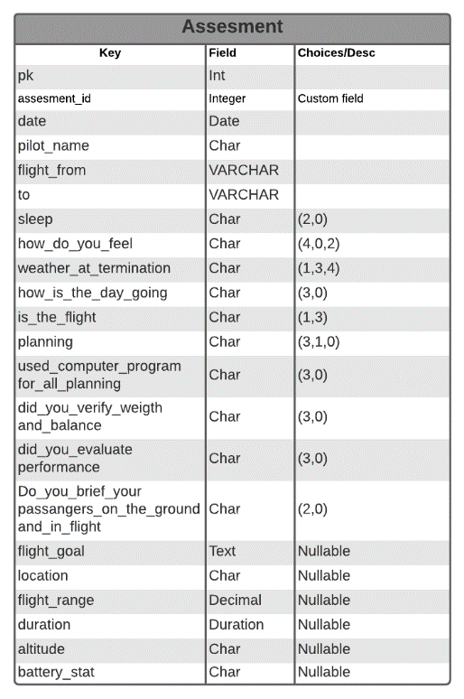
Model
MODEL(file): risk_assesment/models.py

Notes
- The assesment id field is custom PositiveIntegerField
  - See: /risk_assesment/models.py
    - Class OrderField
  - This custom field ensures that each newly created assessments has a assessments id to fill any gap in the number sequence.
    - Given that there are 10 assesment in the database, If assessments with assesment id 5 and 6 has being deleted the newly created assesment will be given assesment id of 5, if another assesment is added it will be given 6.

TEst
Model Test
- File: risk_assesment/tests/test_models.py
- Code: python manage.py test

API Test
- File: api/tests/test_views.py
- Test include
  - API Get, Post ,Put, Delete
Heroku deployed at https://myfaa.herokuapp.com/assesment or https://myfaa.herokuapp.com/assesment/results or https://myfaa.herokuapp.com/assesment/results/?pilot_name=tony

Googleseet read-only share link: https://docs.google.com/spreadsheets/d/1bpv_AgVnLxgVeVlwzUKW8JHxeJ6rya2IgvzN1zeSWHU/edit#gid=0

