Date: 08/11/2021

Project Proposal and Design

App and Software to use
Given the allocated time and money the following software will be use for the project.
- Python
- Django
- HTML
- Bootstrap 4
- JavaScript
- CSS

Model and Database
For the model I’ll be using Django ORM. Using this enables you to interact with your database, which will easily be setup to be compatible with your desired cloud storage. Django ORM was also chosen as it more suitable given the project database design requirement.
Abstract Model Design. (https://lucid.app/lucidchart/bfb24bd8-9df1-40f5-bcb6-7784df312c70/edit?viewport_loc=-83%2C-214%2C1064%2C629%2C0_0&invitationId=inv_1c95d9fa-41bf-4bf9-a267-340f28e7ff86)
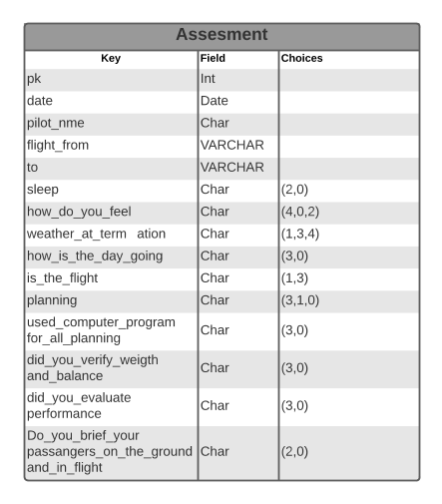

WebPage(UI)
- Forms => Django Form
- HTML and Django HTML template renderer
- JavaScript => For concurrent column total calculation
- Bootstrap => UIX design and page responsiveness
- SVG => Graph and assessment result

API
- Django Rest Framework
- Allows easy database and client query management
- Easy Testing
- Allow Operations => All assessment list retrieval, Single detailed assessment record retrieval, and Submit new assessment record

ADMIN/Management
- Django Admin Page
  - Manage assessments record
  - Easy Sort, create, and delete assessment methods

