Kubernetes-02
- Create a simple pod using YAML Task: Write a YAML file to create a pod named firstpod with an nginx container. Verify the pod creation using kubectl get pods and check the logs of the container using kubectl logs firstpod.
Step 1 – create the YAML file
Run the following command to create and edit a YAML file:

Vi pod.yaml

Add the below YAML content –
apiVersion: v1
kind: pod
metadata:
name: nginx-pod
labels:
app: nginx
spec:
containers:
-name: nginx
Image: nginx:latest
Ports:
-ContainerPort:80

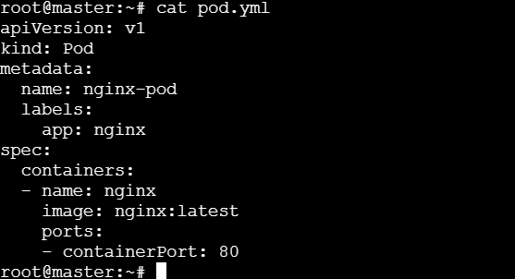
Step 2 – Apply the YAML to create the pod
Kubectl apply -f pod.yaml
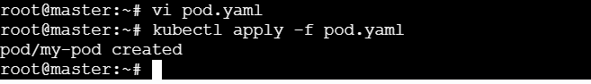
Step 3 – Verify the pod creation
Kubectl get pods
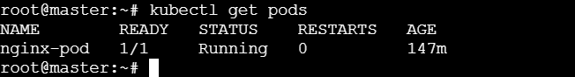

Step 4 – Check the container logs
Kubectl logs nginx-pod
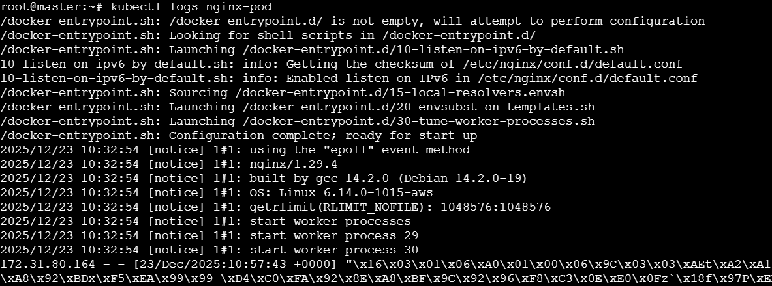

- Set Environment variables in apod Task: Modify the YAML fileto include environment variables myname: sabair and City: Hyderabad. Deploy the pod and use kubectl exec <pod_name> --env to check if the environment variables are set properly.

Step 1 – Update your YAML file
Edit your existing file:
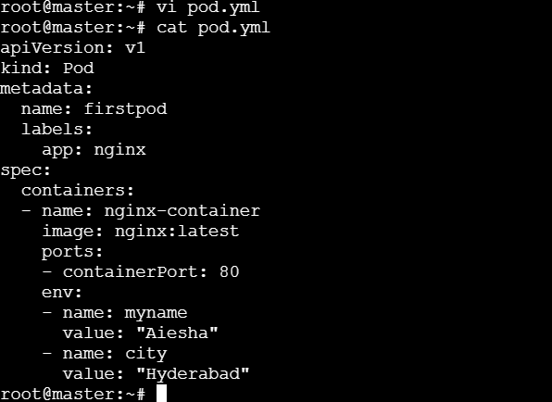

Step 2 – Apply the YAML
Kubectl apply -f pod.yaml
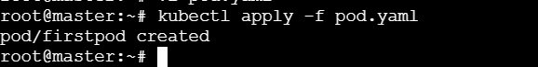

Step 3 – Verify pod status
Kubectl get pods
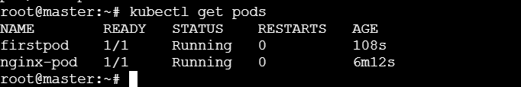

Step 4 – Check environment variables inside the pod
Use the kubectl exec command:
Kubectl exec -it firstpod -- env
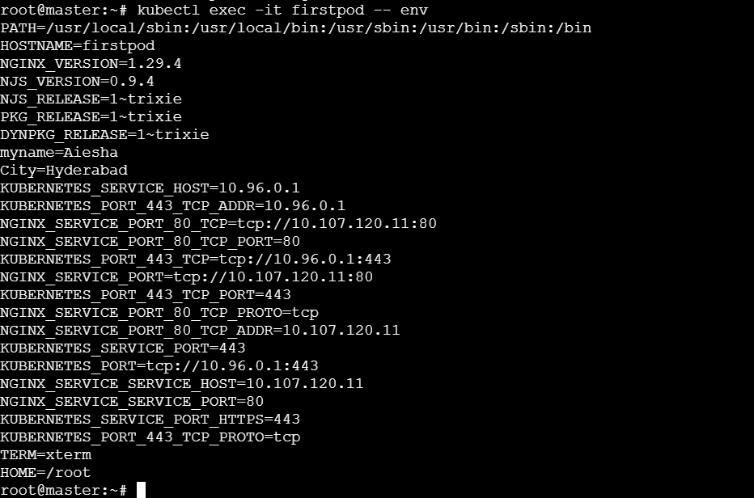

- Deploy a pod with commands (Args) in YAML Task: Modify the YAML file to add args that instruct the container to sleep for 50 seconds. Deploy the pod and use kubectl describe pod to verify the args are correctly passed to the container.

Step 1 – create or modify the YAML file
Open the pod file:
Vi pod.yaml

Add this YAML content:
apiVersion: v1
kind: Pod
metadata:
name: argspod
labels:
app: nginx
spec:
containers:
- name: nginx-container
image: nginx:latest
command: ["/bin/sh", "-c"]
args: ["sleep 50"]
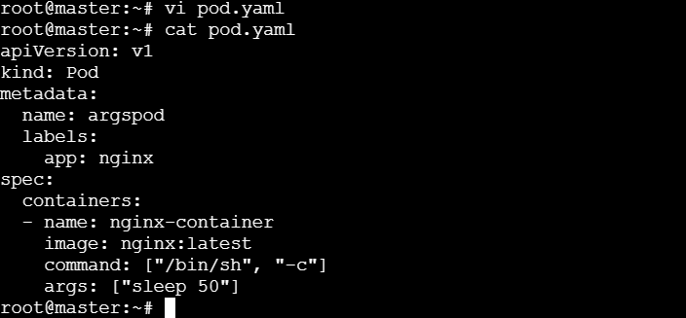

Step 2 – Deploy the pod
Kubectl apply -f pod.yaml
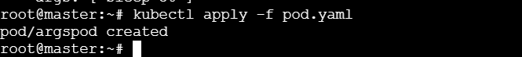

Step 3 – Verify the pod status
Kubectl get pods
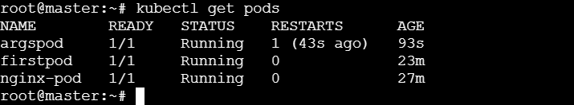

Step 4 – Verify Args in pod Description
Run:
Kubectl describe pod argspod
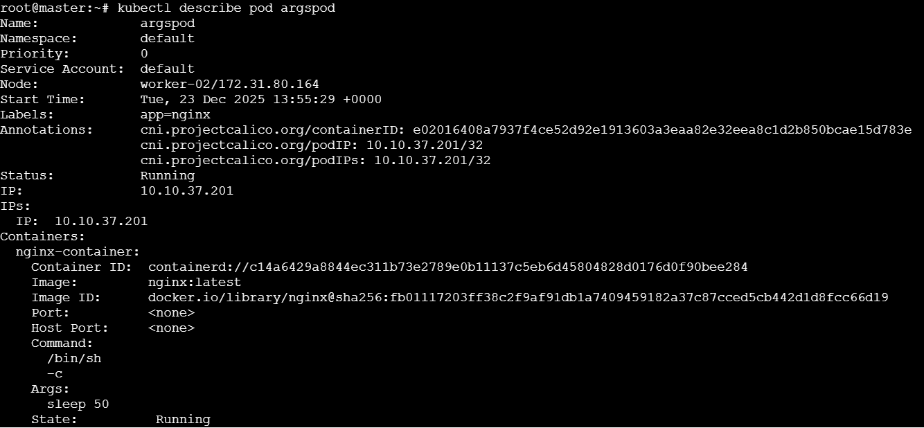

- Create a pod with Two Containers Task: Create a YAML file to define a pod with two nginx containers inside. Use kubectl exec to access both containers and verify that both containers can communicate through the same network (e.g.,using telnet between them)

Step 1 – Create the pod YAML
Open a new file:
Vi twocontainers.yaml
Add this YAML content:
apiVersion: v1
kind: pod
metadata:
name: twocontainers
labels:
app: web
spec:
containers:
- name: nginx1
image: nginx:latest
ports:
- containerport: 80
- name: nginx2
image: busybox
command: ["sh", "-c", "sleep 3600"] # keeps containers running

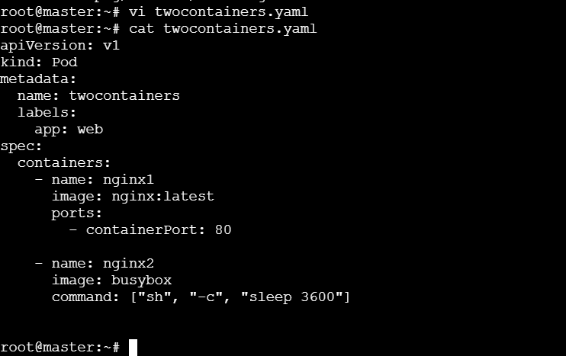

Step 2 – Deploy the pod
Kubectl apply -f twocontainers.yaml
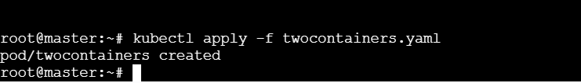

Step 3 – Verify both containers are running
Kubectl get pods
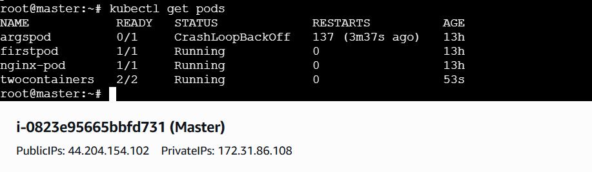

Step 4 – Access the BusyBox container
Kubectl exec -it twocontainers -c nginx2 – sh

Step 5 – Test communication with the Nginx container
Inside the BusyBox shell, run:
telnet localhost 80
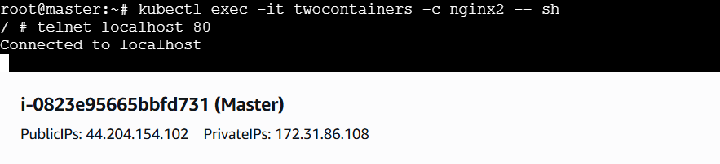
- Set up an Init Container in a pod Task: Modify the YAML to include an init container that sleeps for 30 seconds before the main containers start. Verify the init container’s execution using kubectl describe pod and check the logs to confirm its completion.

Step 1 – create or mdify the YAML file
Open the YAML:
Vi initpod.yaml

Paste the content in YAML FILE:
apiVersion: v1
kind: Pod
metadata:
name: initpod
labels:
app: web
spec:
initContainers:
- name: init-wait
image: busybox
command:
["sh", "-c", "echo 'Init container started' && sleep 30 && echo 'Init container completed'"]

containers:
- name: nginx
image: nginx:latest
ports:
- containerPort: 80
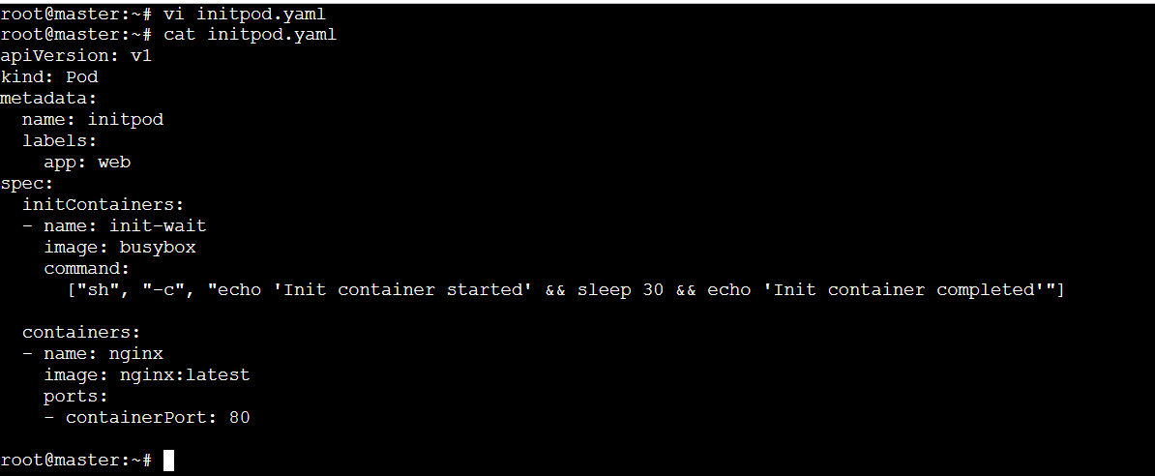

Step 2 – Deploy the pod
Kubectl apply -f initpod.yaml
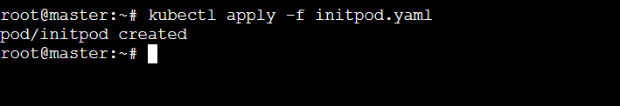

Step 3 – Watch the pod creation process
While the init containers run,
run: kubectl get pods -w
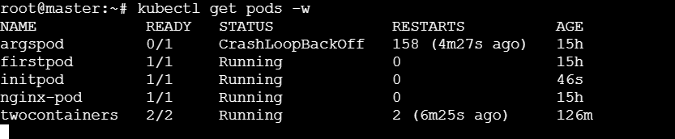

step 4 – Verify the init container execution
use:
kubectl describe pod initpod
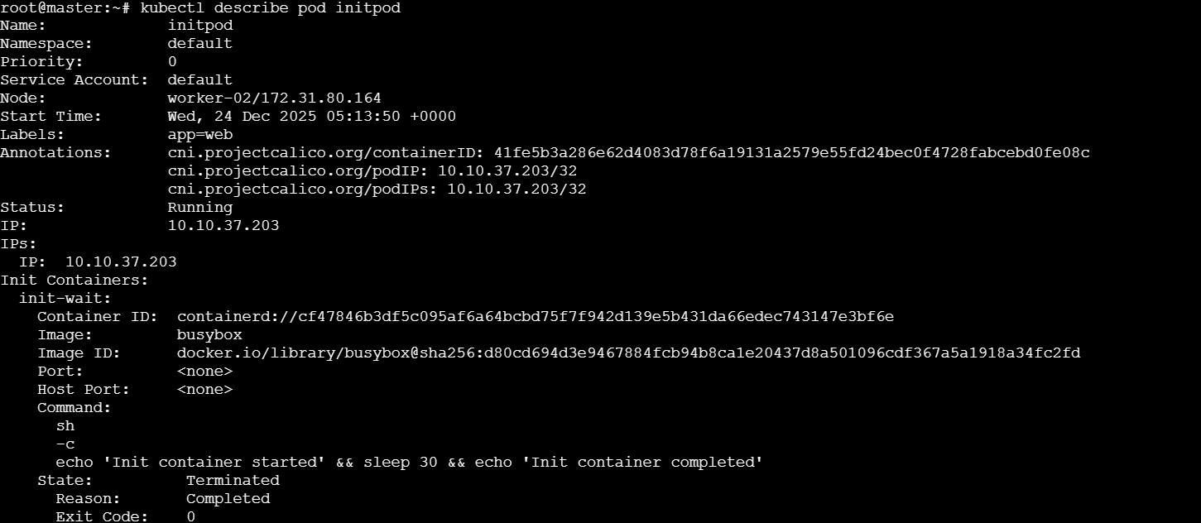

step 5 – Check init container logs
kubectl logs initpod -c init -wait
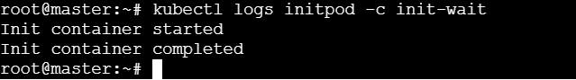

Then check the main container logs (optional):
Kubectl logs initpod -c nginx
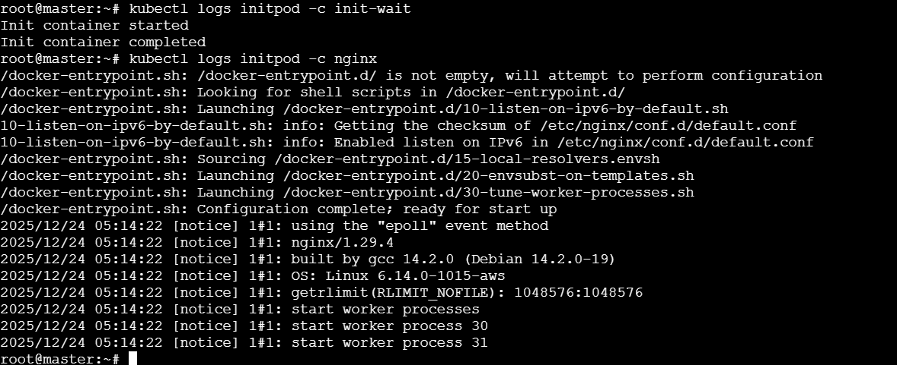

- Run the Dry Run Command to Generate YAML Task: Use the
kubectl run nginx --image=nginx --dry-run=client -o yaml command to generate a Pod YAML definition.Modify the generated YAML to suit specific requirements (e.g., labels or environment variables) and deploy it.

Step 1 – Generate the YAML file using dry-run
Run this command:
Kubectl run nginx --image=nginx --dry-run=client -o yaml > nginx-pod.yaml
Step 2 – Inspect the generated YAML
You can view it:
Cat nginx-pod.yaml
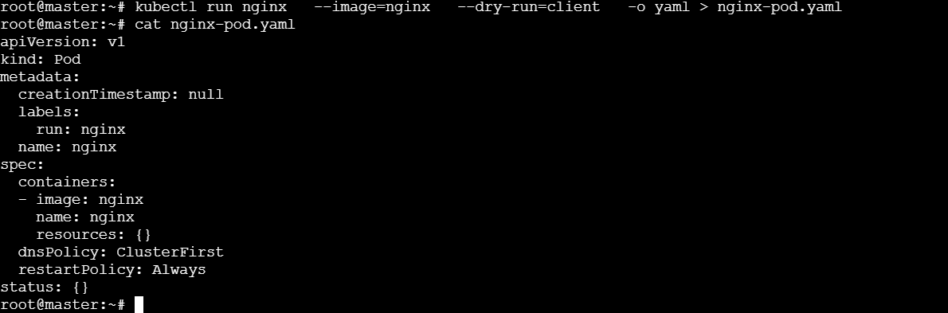

Step 3 – Modify the YAML
Now edit the file:
Vi nginx-pod.yaml
You can add:
- A custom label
- A container port
- Some environment variables
Example:
apiVersion: v1
kind: Pod
metadata:
name: nginx
labels:
app: web
env: dev
spec:
containers:
- name: nginx
image: nginx:latest
ports:
- containerPort: 80
env:
- name: MYNAME
value: "Aiesha"
- name: CITY
value: "Hyderabad"
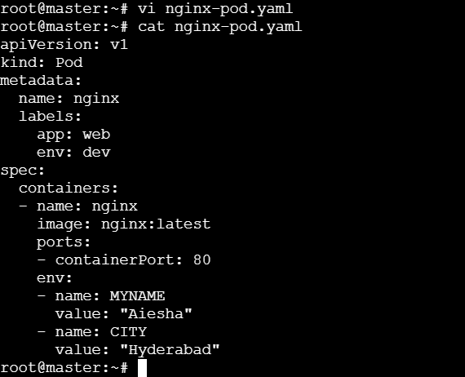

Step 4 – Deploy the Pod
Kubectl apply -f nginx-pod.yaml
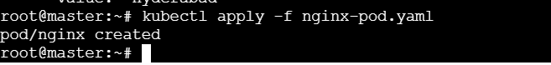

Step 5 – Verify the Pod
Kubectl get Pods
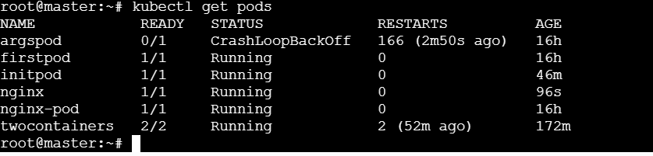

Step 6 – Check environment variables inside the Pod
Kubectl exec -it nginx – env
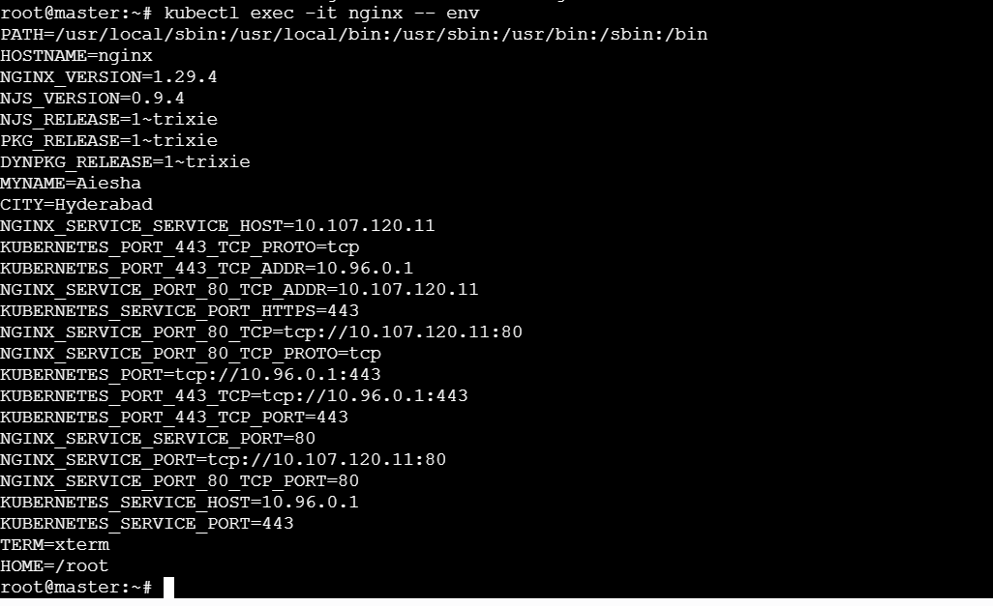

- Use kubectl apply vs kubectl create Task: Create a YAML file to define a pod. First, deploy it using kubectl create -f <file_name>.yml and then modify the YAML (e.g., change the image version). Use kubectl apply to redeploy and verify the difference between both commands.

Step 1 - Create a Pod YAML
Vi Pod-demo.yaml

Add the YAML content:
apiVersion: v1
kind: Pod
metadata:
name: demo-pod
labels:
app: demo
spec:
containers:
- name: nginx-container
image: nginx:1.19
ports:
- containerport: 80

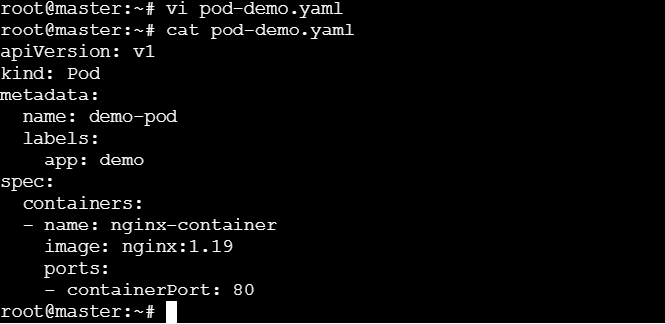

Step 2 – Deploy the Pod using kubectl create
Run:
Kubectl create -f pod-demo.yaml

Check the pod:
Kubectl get pods
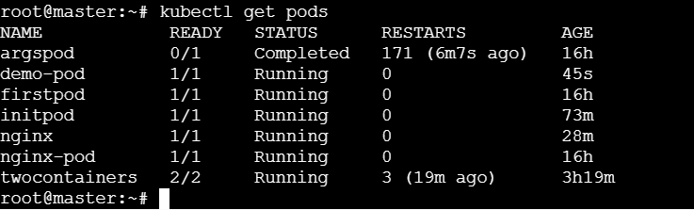

Step 3 – Modify the YAML
Update the container image version from 1.19 → nginx:1.21
Edit the file:
Vi pod-demo.yaml

Change this line:
Image: nginx:1.19
To
Image:nginx:1.21
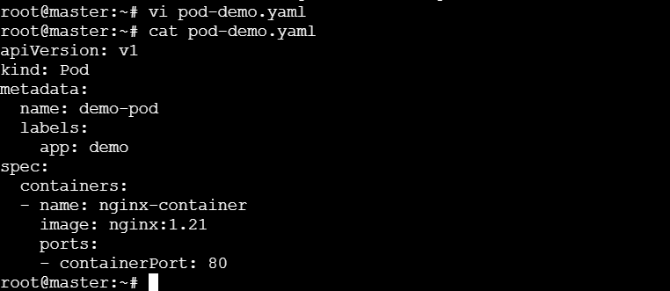

Step 4 – Try to redeploy using kubectl create
Kubectl create -f pod-demo.yaml

Step 5 – Use kubectl apply to update
Kubectl apply -f pod-demo.yaml

Step 6 – Verify the update
Check the image version changed or not:
Kubectl describe pod demo-pod | grep -I image
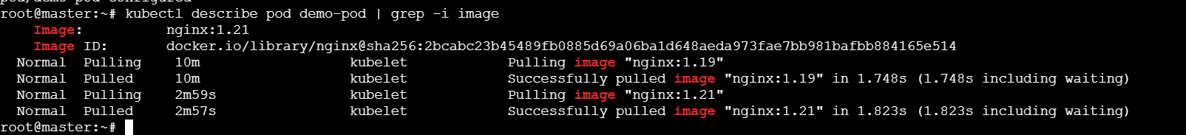

- Edit an Existing pod configuration Task: Use kubectl edit pod <pod_name> to modify the running pod’s environment variables or image. After making the chanfes, Verify if they took effect by checking the container logs or environment variables using kubectl exec.

Step 1 – start with a simple pod
If you already have one, skip this step.
If not create a simple nginx pod:
Kubectl run editpod –image=nginx:1.19 –restart=Never
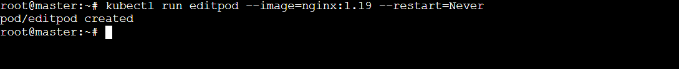

Check the status:
Kubectl get pods
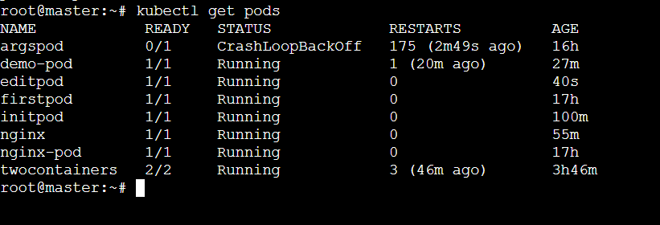

Step 2 – Edit the pod
Kubectl edit pod editpod
Change the image version
Look for the line:
Image: nginx:1.19 and
Change it to:
Image: nginx:1.21
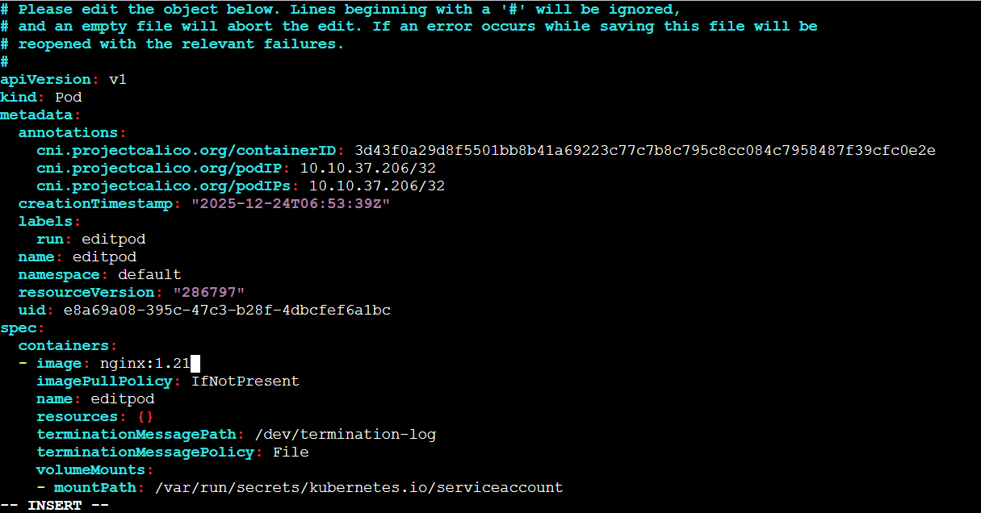
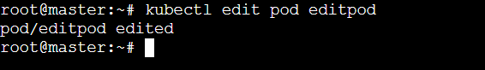

Step 3 – Verify the update
Check the pods new image:
Kubectl describe pod editpod | grep -I image
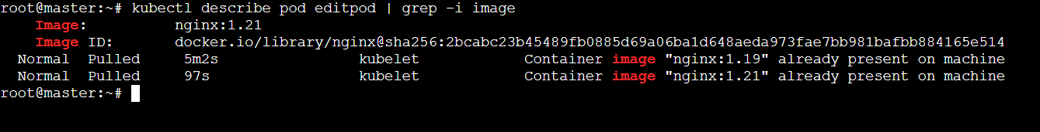

Step 4 – Verify via logs
After changing the image, check logs:
Kubectl logs editpod
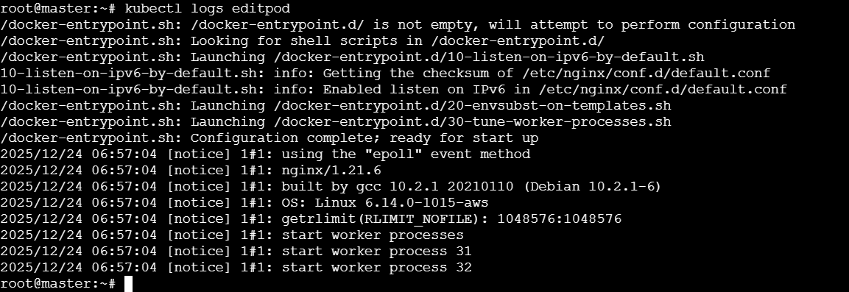

- Expose a pod Using a Service Task: Create a YAML file to expose your firstpod using a Service (ClusterIP). Ensure that your service is exposing the pod on port 80 and verify it using Kubectl get svc.

Step 1 – create the service YAML
Create a file named service.yaml:
Vi service.yaml

Paste the following content:
apiVersion: v1
kind: Service
metadata:
name: firstpod-service
labels:
app: nginx
spec:
selector:
app: nginx # Must match the Pod label
ports:
- protocol: TCP
port: 80 # Port exposed by the Service
targetPort: 80 # Port on the Pod container
type: ClusterIP
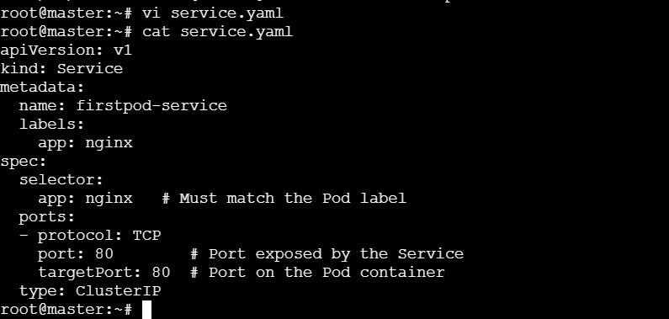

Step 2 – Deploy the service
Kubectl apply -f service.yaml

Step 3 – Verify thr service
Kubectl get svc
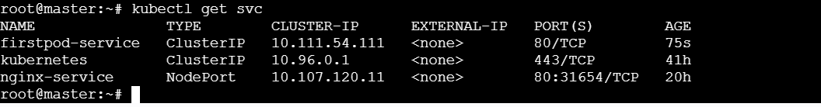

Step 4 – Test the service (from inside the cluster)
To confirm the service is routing traffic correctly, you can run a temporary Pod and access it:
Kubectl run testpod –image =busybox:latest -it –rm –restart=Never – sh
Inside the shell,run:
Wget -qO- http://firstpod-service:80
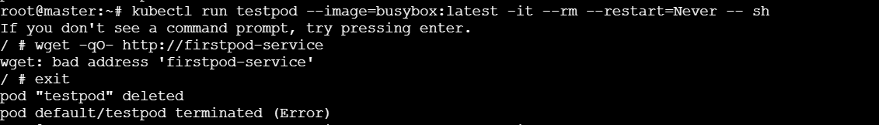

Here , while encountering a “wget:bad address” error I got in my Kubernetes cluster.
Means coreDNS is unable to resolve the service name firstpod-service to an IP address.
So, check if the service exists:
Kubectl get svc firstpod-service
It confirms that the firstpod-service exists and has a valid clusterIP of 10.111.54.111 on port 80

→ Now test via IP Address (Bypass DNS)
kubectl run testpod --image=busybox:1.28 --rm -it --restart=Never -- wget -qO- http://10.111.54.111:80
→ if this works the network is fine, and the problem is with coreDNS
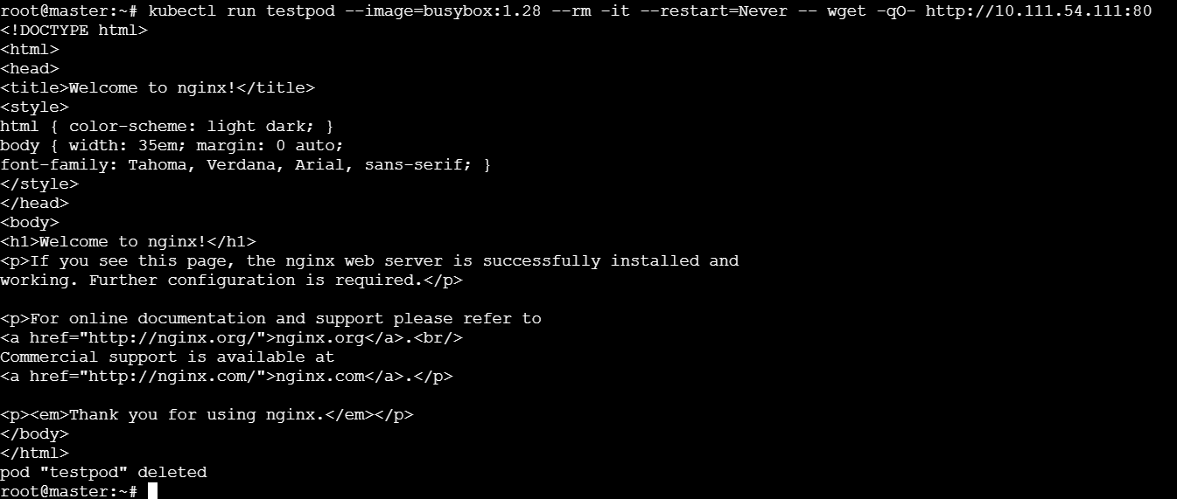

Check for Namespace Mismatch
Kubernetes DNS works by searching within the local namespace first.
If the testpod is running in the default namespace but firstpod-service was created in a different one (dev or prod). So firstpod-service won’t resolve.

Using the Full Qualified Domain Name:
wget -qO- http://firstpod-service.default.svc.cluster.local
default → firstpod-service

Bypass DNS to test connectivity:
Run:
kubectl run testpod --image=busybox:latest -it --rm --restart=Never – sh

inside the testpod run:
wget -qO- http://10.111.54.111:80
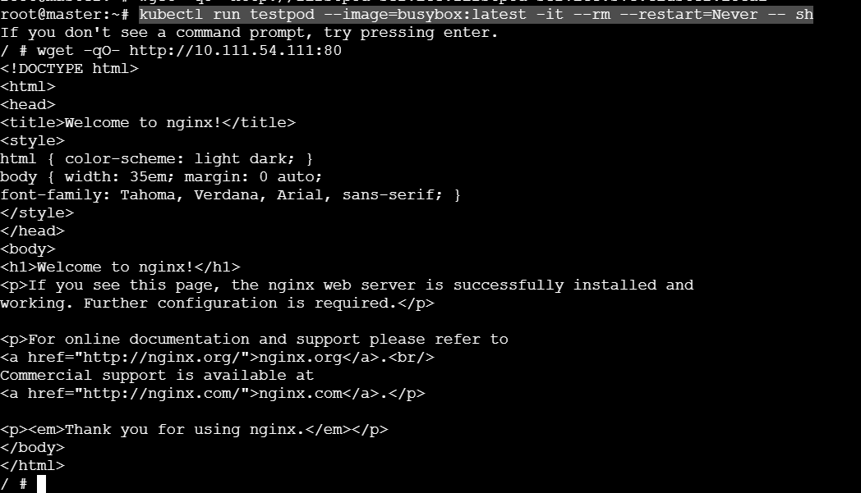

- Pod with Resources Limits and Requests Task: Add resource requests and limits to the containers in your YAML file. Specify CPU and memory requests/limits for both containers and deploy the Pod. Use kubectl describe Pod to verify if the resource configurations are correctly applied.

Step 1 – create or edit your Pod YAML
Create a Pod name resourcelimits-Pod with two containers (nginx and budybox).
Vi resourcelimits-pod.yaml

Add the conent to YAML file:
apiVersion: v1
kind: Pod
metadata:
name: resourcelimits-pod
labels:
app: web
spec:
containers:
- name: nginx
image: nginx:latest
ports:
- containerPort: 80
resources:
requests:
cpu: "100m" # requests 0.1 CPU core
memory: "128Mi" # requests 128 MB memory
limits:
cpu: "200m" # can use up to 0.2 CPU core
memory: "256Mi" # can use up to 256 MB memory

- name: busybox
image: busybox
command: ["sh", "-c", "sleep 3600"]
resources:
requests:
cpu: "50m" # requests 0.05 CPU core
memory: "64Mi" # requests 64 MB memory
limits:
cpu: "100m" # can use up to 0.1 CPU core
memory: "128Mi" # can use up to 128 MB memory
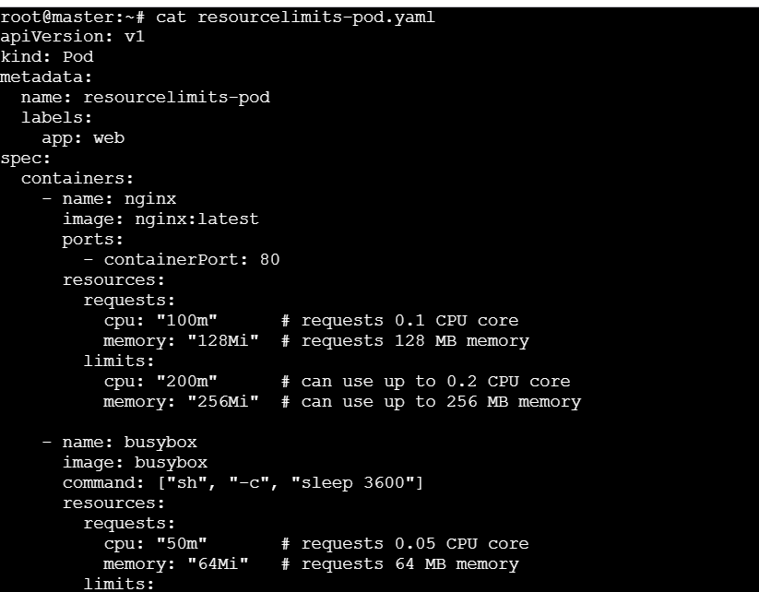
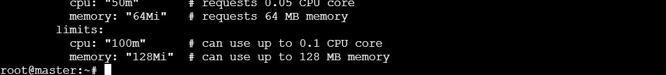

Step 2 – Deploy the Pod
Kubectl apply -f resourcelimits-pod.yaml

Step 3 – Verify Pod status
Kubectl get pods
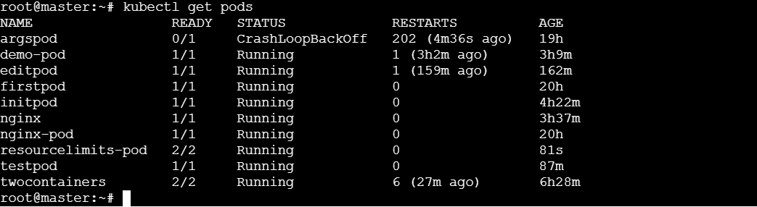

Step 4 – Verify resource configurations
Run:
Kubectl describe pod resourcelimits-pod
