Kubernetes-03
1.Create a ClusterIP service for an Apache web server Pod.
Step 1 – Create the Apache Pod (apache-pod.yaml)
Vi apache-pod.yaml

Add the content to YAML file:
apiVersion: v1
kind: Pod
metadata:
name: apache-pod
labels:
app: apache
spec:
containers:
- name: apache-container
image: httpd:latest
ports:
- containerPort: 80
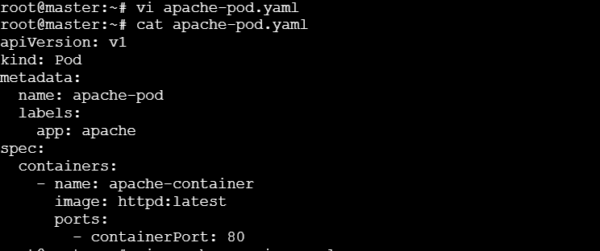

Step 2 – Create a ClusterIP service (apache-service.yaml)
Vi apache-service.yaml

Add the content to the apache-service.yaml file:
apiVersion: v1
kind: Service
metadata:
name: apache-service
spec:
type: ClusterIP
selector:
app: apache
ports:
- port: 80 # Service port
targetPort: 80 # Pod port
protocol: TCP
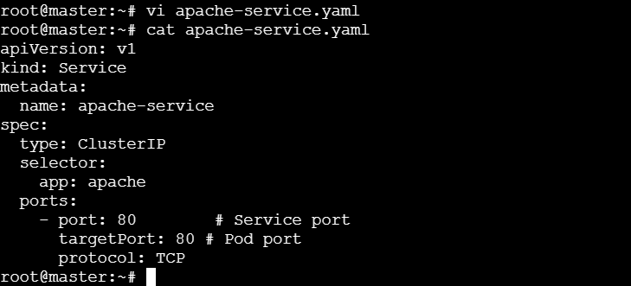

Step 3 – Commands to apply and verify
Kubectl apply -f apache-pod.yaml
Kubectl apply -f apache-service.yaml
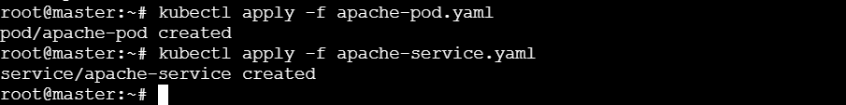

Run:
Kubectl get pods
Kubectl get service
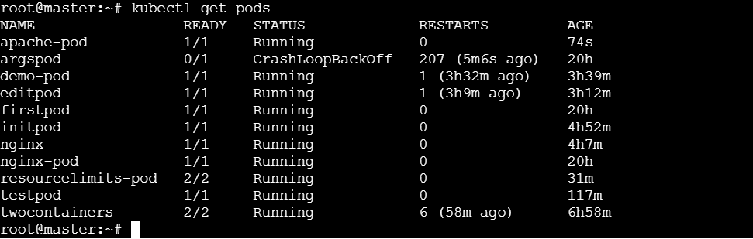
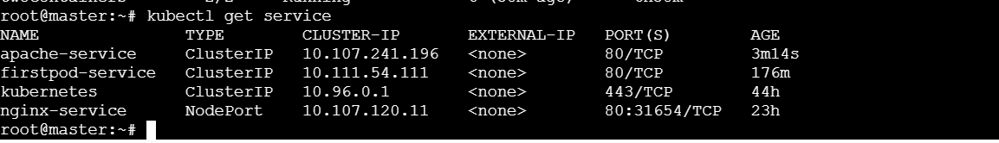
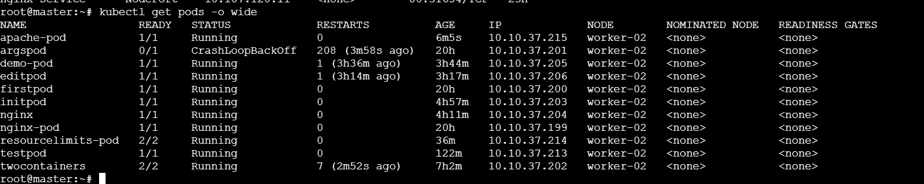

2. Expose an Nginx Pod externally using a NodePort service.
Step 1 – Create the nginx Pod
vi nginx-pod.yaml

Add the content to the YAML file:
apiVersion: v1
kind: Pod
metadata:
name: nginx-pod
labels:
app: nginx
spec:
containers:
- name: nginx-container
image: nginx:latest
ports:
- containerPort: 80
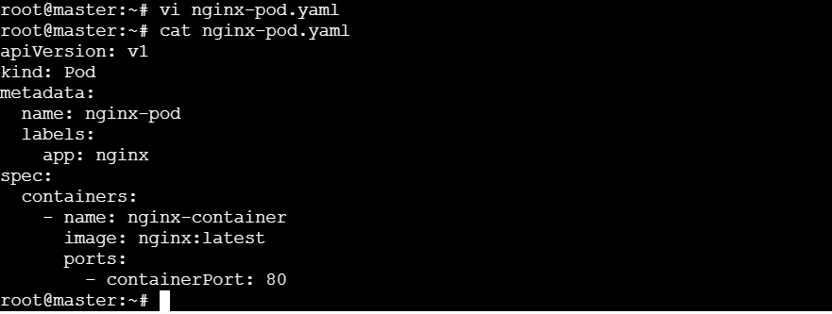

Step 2 – create a Node Port service
Vi nginx-service.yaml

Add the content to YAML file:
apiVersion: v1
kind: Service
metadata:
name: nginx-nodeport-service
spec:
type: NodePort
selector:
app: nginx
ports:
- port: 80 # Service port (cluster internal)
targetPort: 80 # Pod container port
nodePort: 30080 # External port on each Node (range:30000-32767)
protocol: TCP
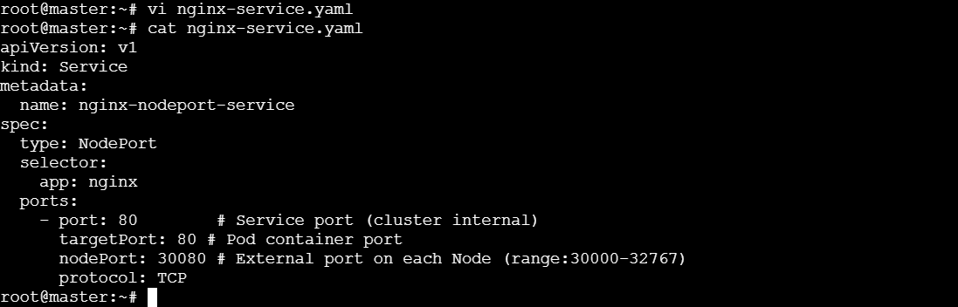
Step 3 – Apply and verify
kubectl apply -f nginx-pod.yaml
kubectl apply -f nginx-service.yaml
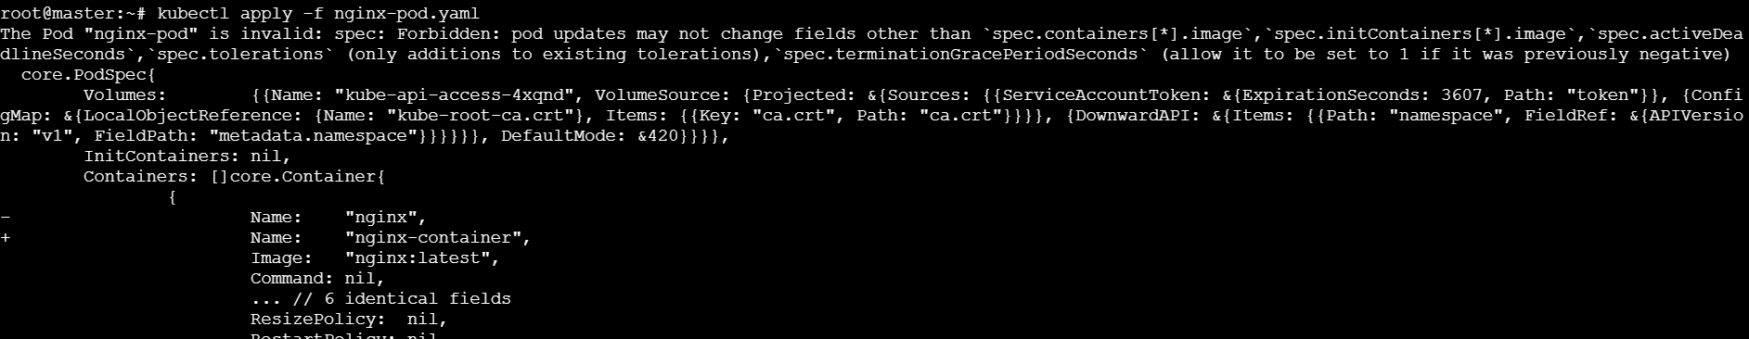
Here I got the error.
Because I’m trying to update an existing Pod, which Kubernetes does not allow.

So, delete and recreate the pod.
kubectl delete pod nginx-pod
kubectl apply -f nginx-pod.yaml
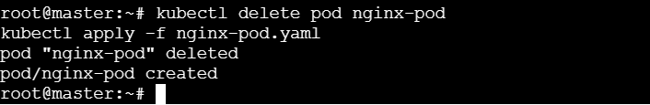

kubectl apply -f nginx-service.yaml

Step 4 – Check resources
Kubectl get pods
Kubectl get service
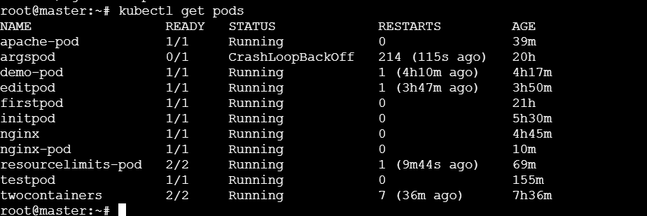
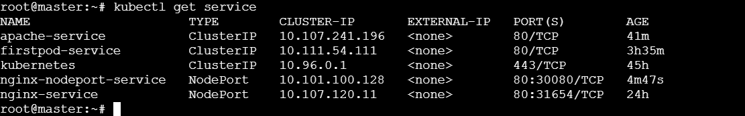

Step 5 – Access Nginx
http://<public-ip>:30080/
http:// 44.204.154.102:30080/
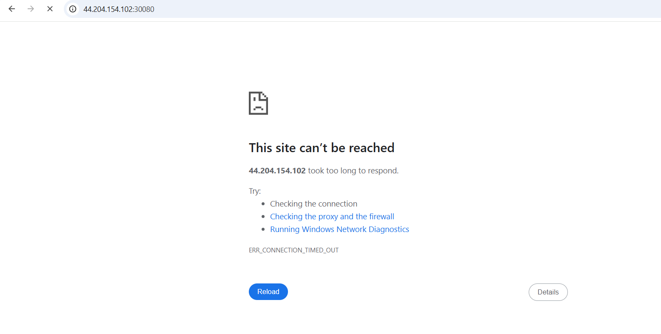
run:
Kubectl get nodes -o wide
The status of worker-02 is ready.
Change the worker node security group inbound rules:
Custom TCP → Port: 30080 → source:0.0.0.0/0
And save the changes.

Now Access using worker public IP
http://<worker-02-public-ip>:30080
http:// 3.89.219.118:30080

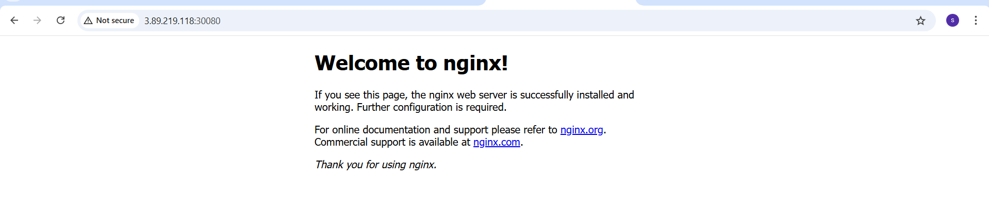
3. Deploy a ReplicationController to maintain 3 replicas of an Nginx Pod.
Step 1 – ReplicationController
Create a ReplicationController YAML file:
Vi nginx-rc.yaml

Add the content to the YAML file:
apiVersion: v1
kind: ReplicationController
metadata:
name: nginx-rc
spec:
replicas: 3
selector:
app: nginx
template:
metadata:
labels:
app: nginx
spec:
containers:
- name: nginx-container
image: nginx:latest
ports:
- containerPort: 80
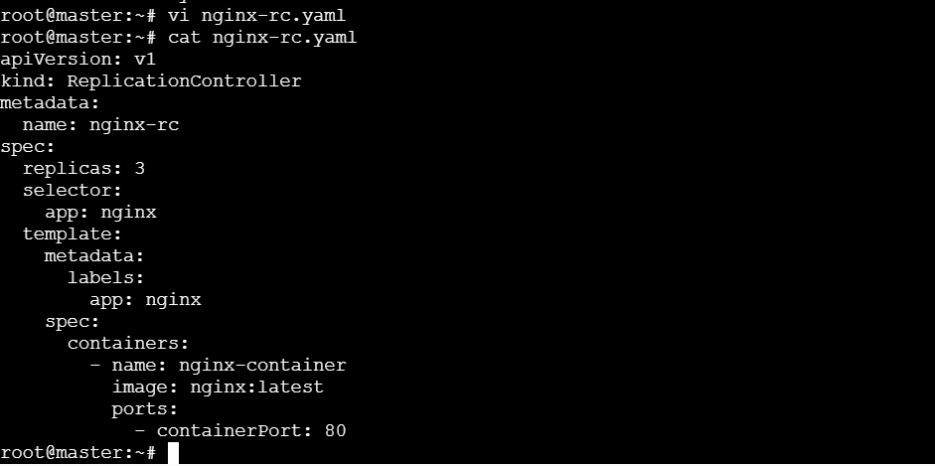

Step 2 – Apply and verify
kubectl apply -f nginx-rc.yaml

Check the ReplicationController and Pods:
kubectl get rc
kubectl get Pods
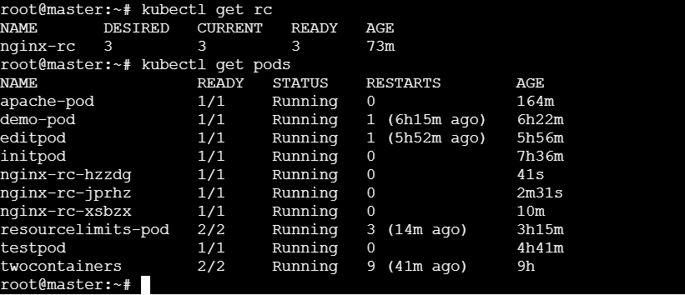

4. Scale the ReplicationController from 3 replicas to 5 replicas.
Step 1 – using kubectl command
We can scale directly from the command line:
Kubectl scale rc nginx-rc –replicas=5
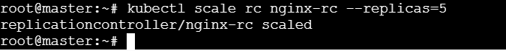

Step 2 – verify after running the command
kubectl get rc
kubectl get pods
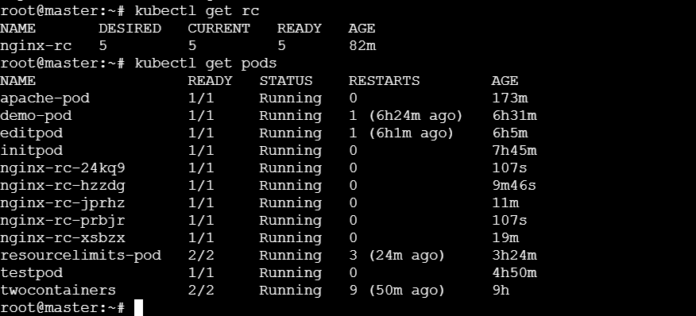

5. Create a ReplicaSet to manage pods based on multiple labels (prod and test).
step 1 – create ReplicaSet YAML (nginx-replicaset.yaml)
vi nginx-replicaset.yaml

Add the content to the YAML file:
apiVersion: apps/v1
kind: ReplicaSet
metadata:
name: nginx-rs
spec:
replicas: 3
selector:
matchExpressions:
- key: app
operator: In
values:
- nginx
- key: env
operator: In
values:
- prod
- test
template:
metadata:
labels:
app: nginx
env: prod # Can be prod or test
spec:
containers:
- name: nginx-container
image: nginx:latest
ports:
- containerPort: 80
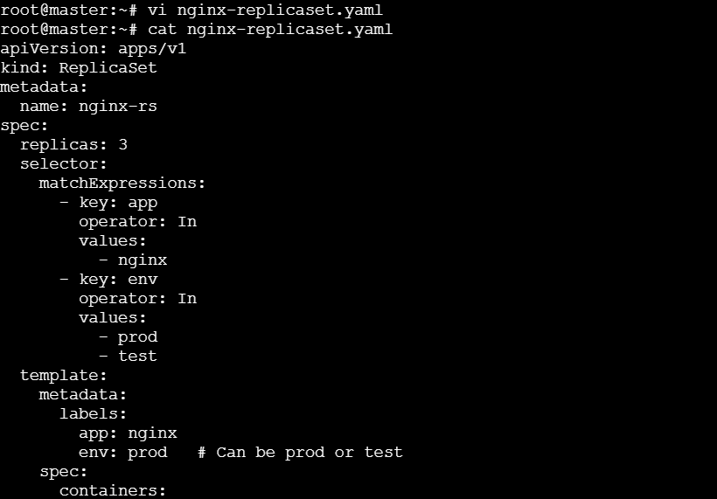
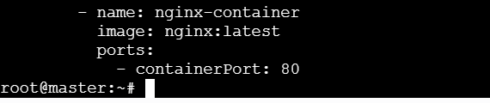
Step 2 – Apply and verify
kubectl apply -f nginx nginx-replicaset.yaml
kubectl get rs
kubectl get pods
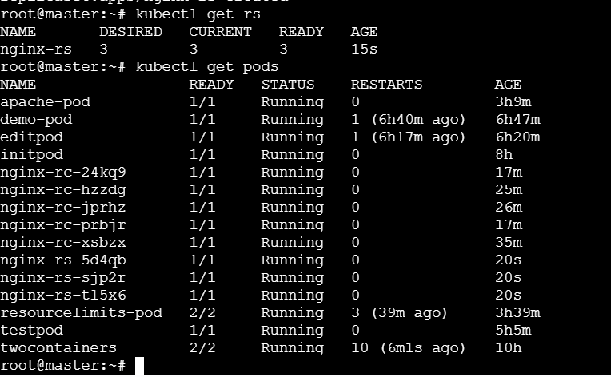

6. Deploy a ReplicaSet that excludes pods with the label backend.
Step 1 – create a repicaset YAML file
Vi nginx-rs-exclude-backend.yaml

Add the content to the YAML file:
apiVersion: apps/v1
kind: ReplicaSet
metadata:
name: nginx-rs-exclude-backend
spec:
replicas: 3
selector:
matchExpressions:
- key: app
operator: In
values:
- nginx
- key: backend
operator: DoesNotExist
template:
metadata:
labels:
app: nginx
spec:
containers:
- name: nginx-container
image: nginx:latest
ports:
- containerPort: 80
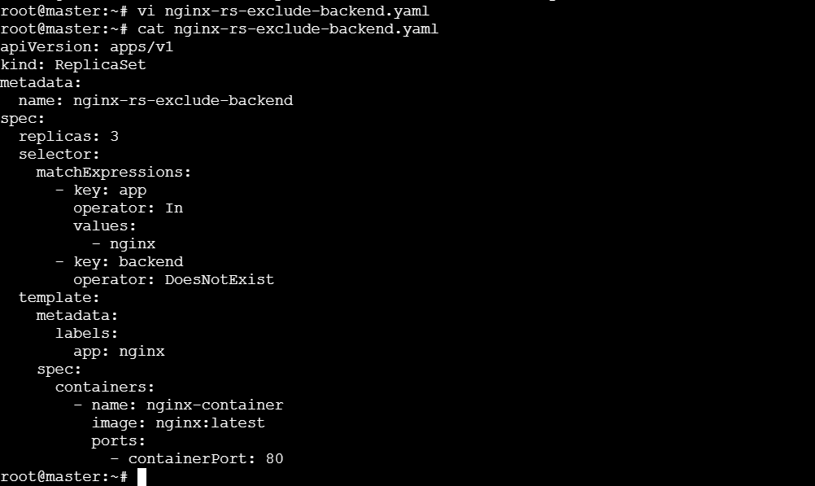

Step 2 – Apply and Verify
kubectl apply -f nginx-rs-exclude-backend.yaml
kubectl get rs
kubectl get pods
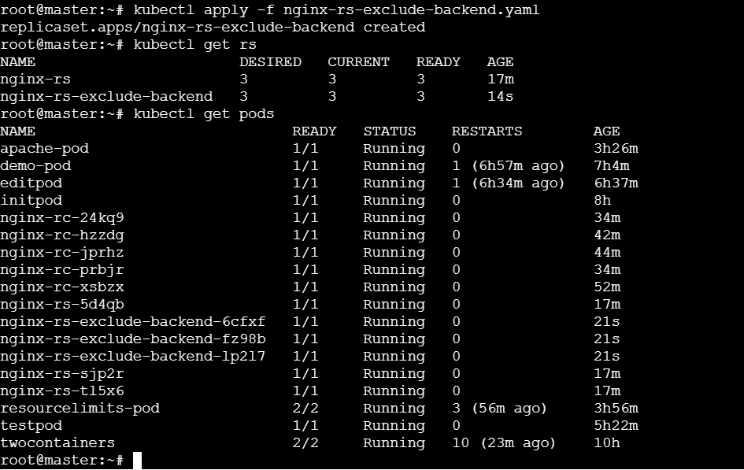

7. Test load balancing across multiple pods using a Node Port service.
step 1 – Create a ReplicaSet with multiple Nginx Pods
create a file with nginx-replicaset.yaml

add the content to the Yaml file:
apiVersion: apps/v1
kind: ReplicaSet
metadata:
name: nginx-rs
spec:
replicas: 3
selector:
matchLabels:
app: nginx
template:
metadata:
labels:
app: nginx
spec:
containers:
- name: nginx
image: nginx:latest
ports:
- containerPort: 80

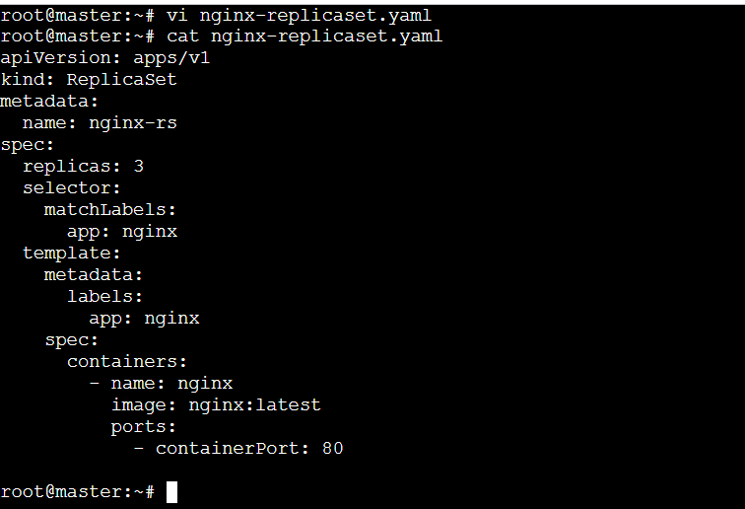
Apply it:
Kubectl apply -f nginx-replicaset.yaml
Verify:
Kubectl get pods -I app=nginx

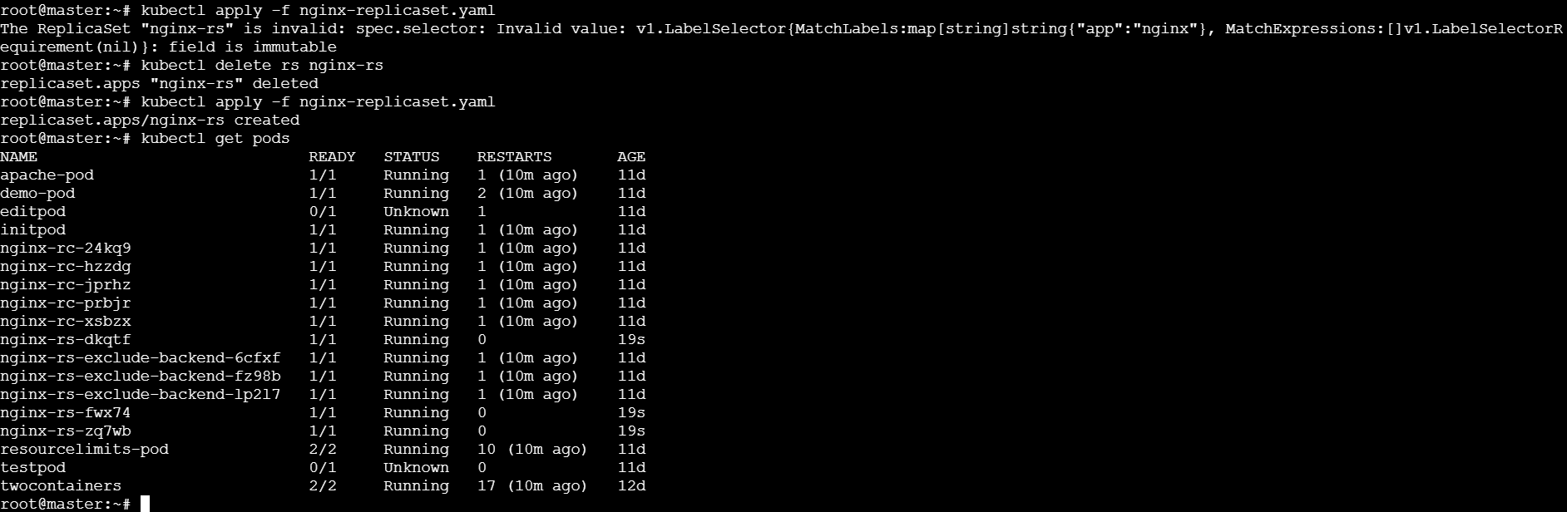

Step 2 – Create a NodePort service
create a file named nginx-nodeport.yaml

apiVersion: v1
kind: Service
metadata:
name: nginx-nodeport
spec:
type: NodePort
selector:
app: nginx
ports:
- port: 80
targetPort: 80
nodePort: 30081 # must be in between 30000-32767
protocol: TCP
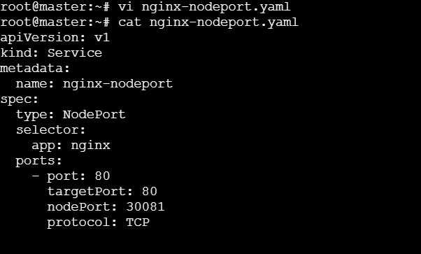

Apply it:
Kubectl apply -f nginx-nodeport.yaml
Check Service details:
Kubectl get service
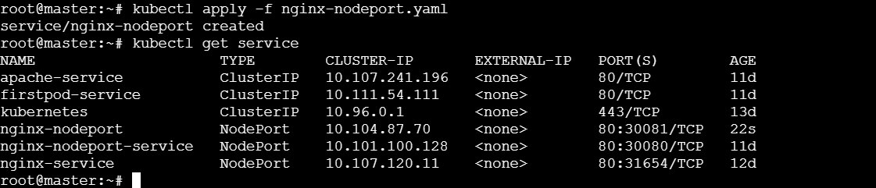

9. Delete a Replication controller without affecting the running pods.

Commands to Delete an RC without Deleting its pods
Kubectl delete rs <replicationcontroller-name> --cascade=orphan
Then:
- The Replicationcontroller object is deleted.
- The pods remain running in the cluster.
- The pods are now unmanaged – no controller will recreate them if they crash.
