- Create mariadb db on ec2.
Step-1:
Launch instance
Go to AWS Console → EC2 → Launch instance.
Choose Amazon linux 2 or ubuntu
Select t2 or t3 micro
Create/ Select existing key-pair
Configure security group → Type : MySQL/Aurora
Port no : 3306
Source : Your IP
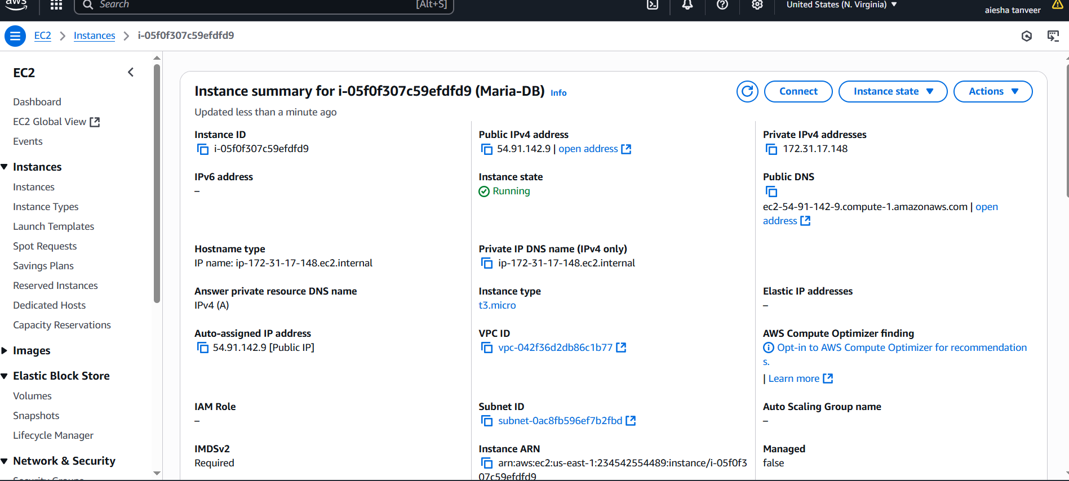
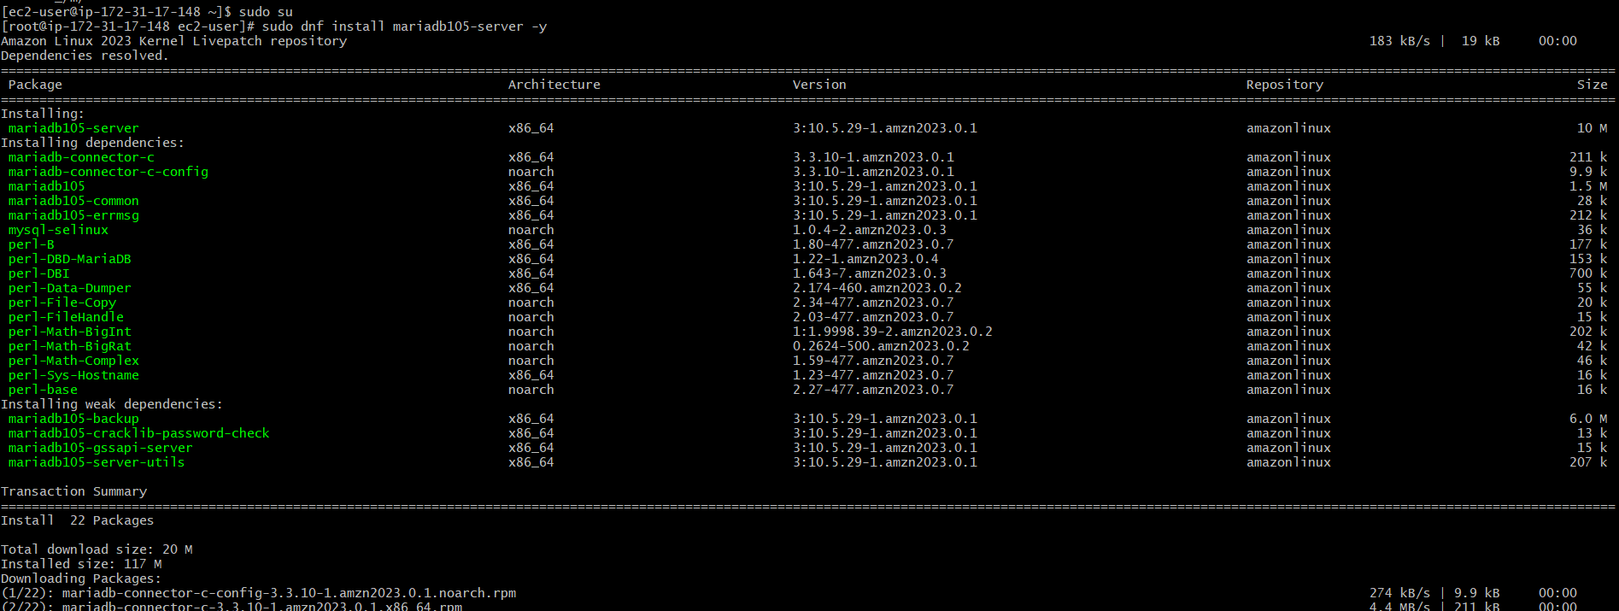
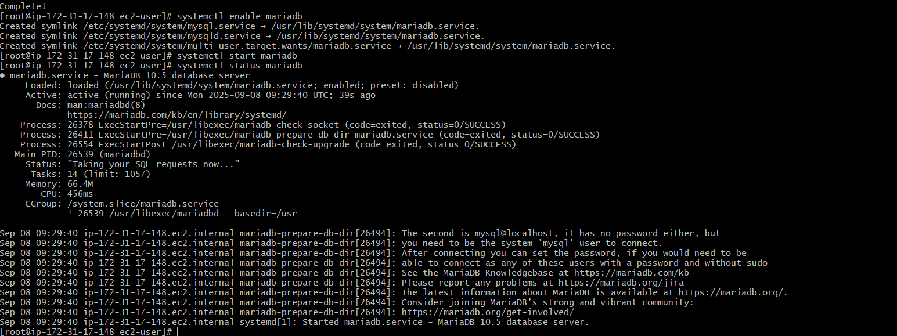
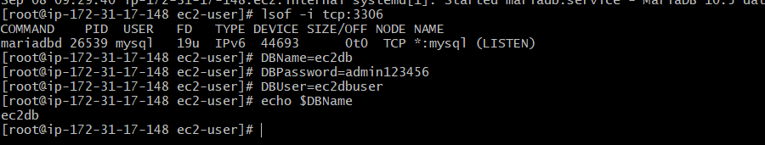
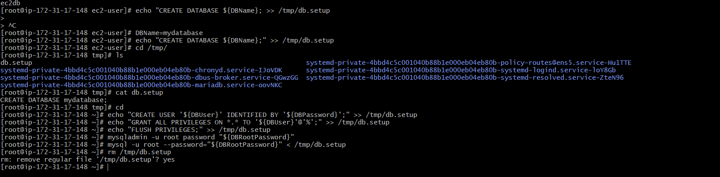
- Insert some dummy data.
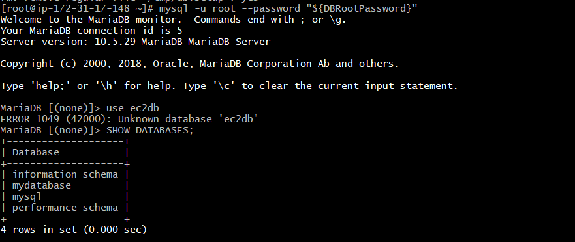
Name VARCHAR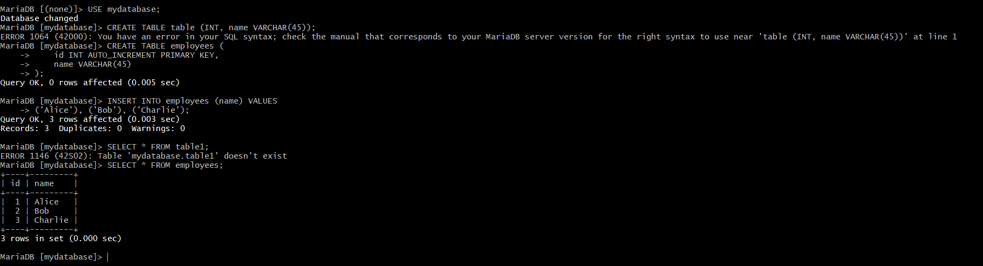3. Take the backup of dummy data on ec2.
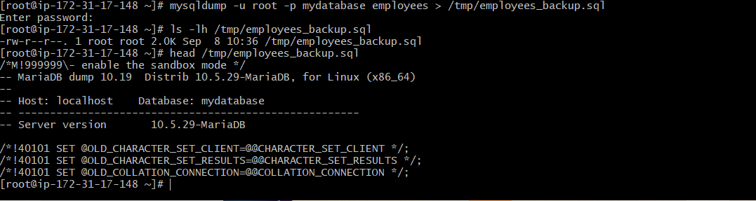
- Launch MariaDB RDS instance.
- Login to AWS Management console
Go to RDS Service → Open the RDS Dashboard → Click on Create database
Select Standard Create
Under Engine options, Select MariaDB
Version : MariaDB version
Templates : Free tier
Settings : DB instance identifier : Name : Maria-DB
Master Username :xxxxxx
Master Password : xxxxxx
Confirm Password.

Instance Configuration : Select DB instance class →(i.e: db.t3.micro )
Storage type : General purpose SSD (gp2) → Allocated Storage : 20
Connectivity : Select Don’t connect to EC2Compute resource → VPC :default
→ DB subnet group : default → Public access : No → Existing VPC Security groups : default → Availability Zone : Select 1 AZ (i.e: Us-east-1c)

Additional Configuration → Database port : 3306
Create Database
Wait for the instance state →(i.e: Available)
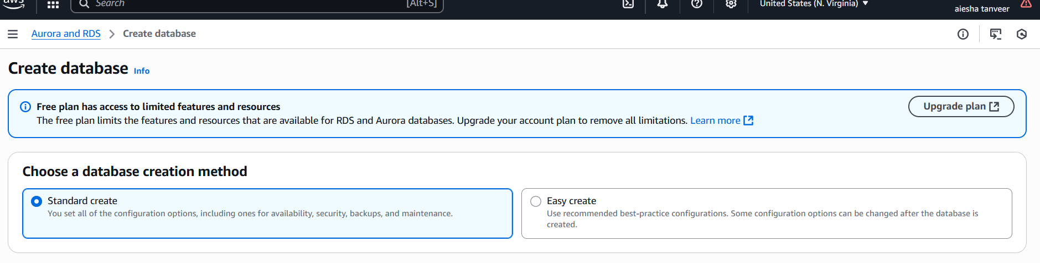
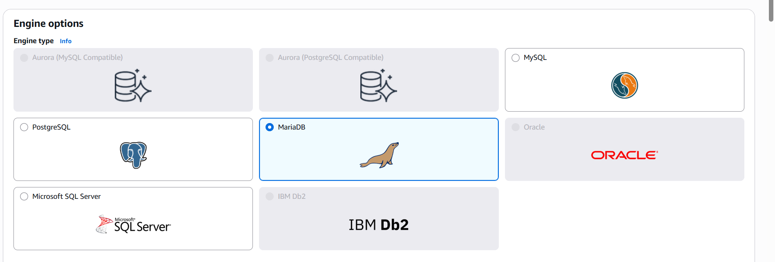
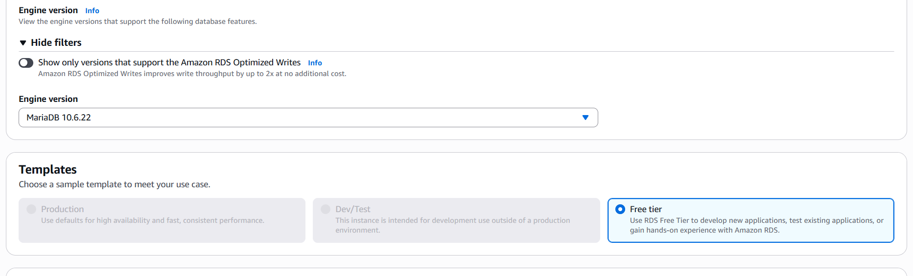
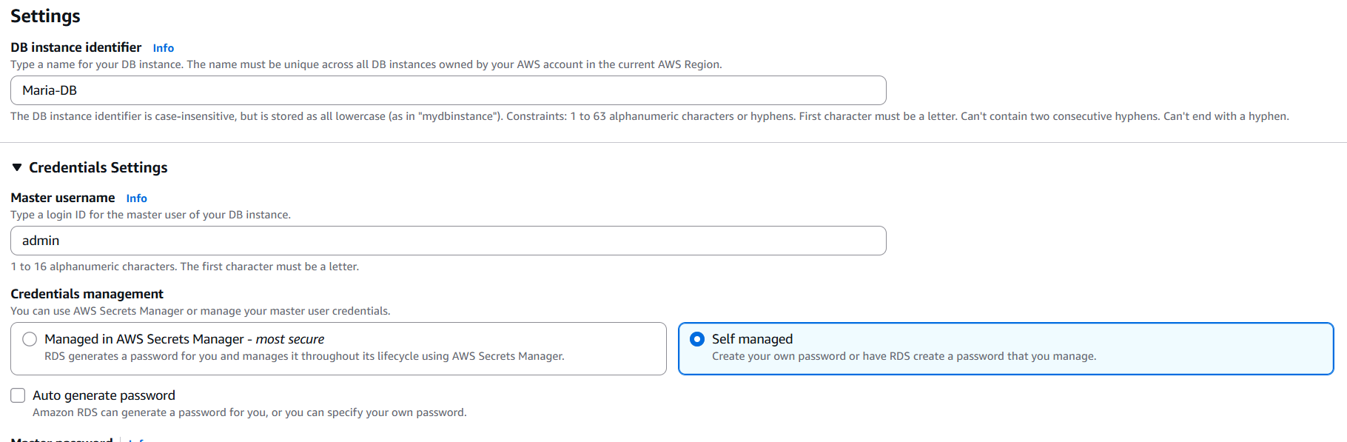
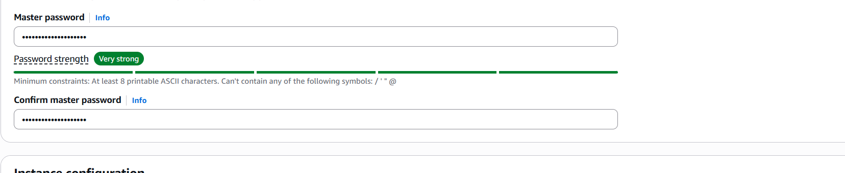
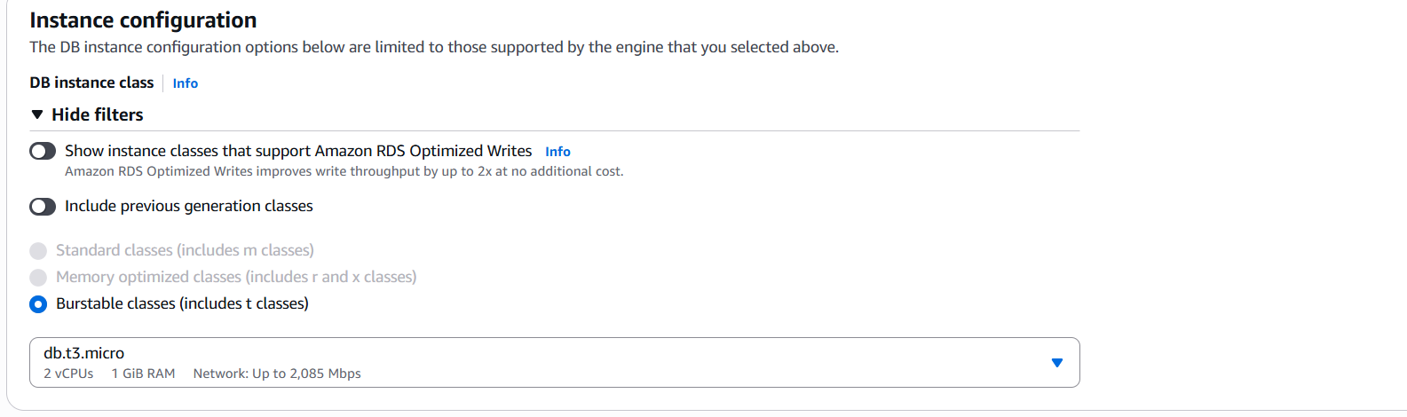
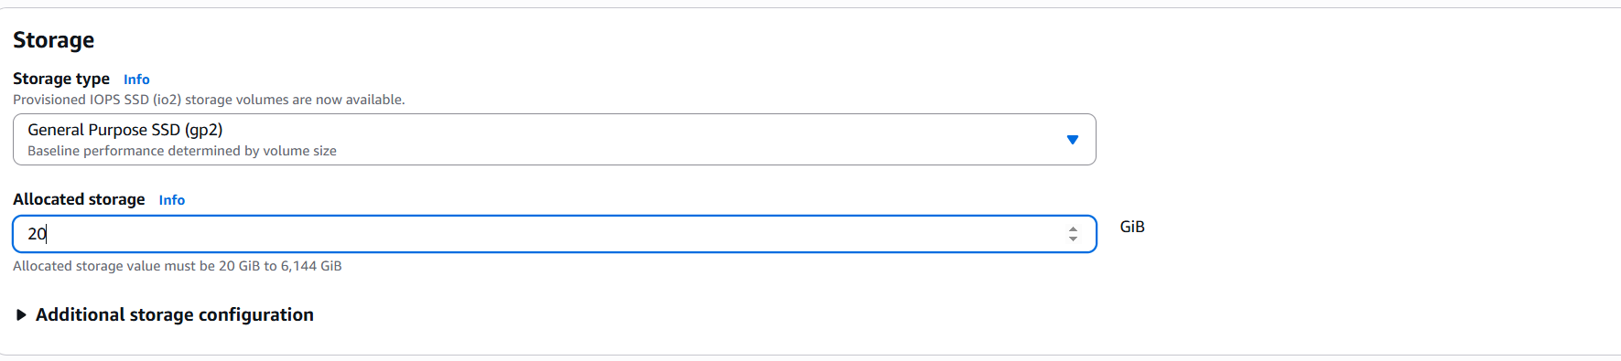
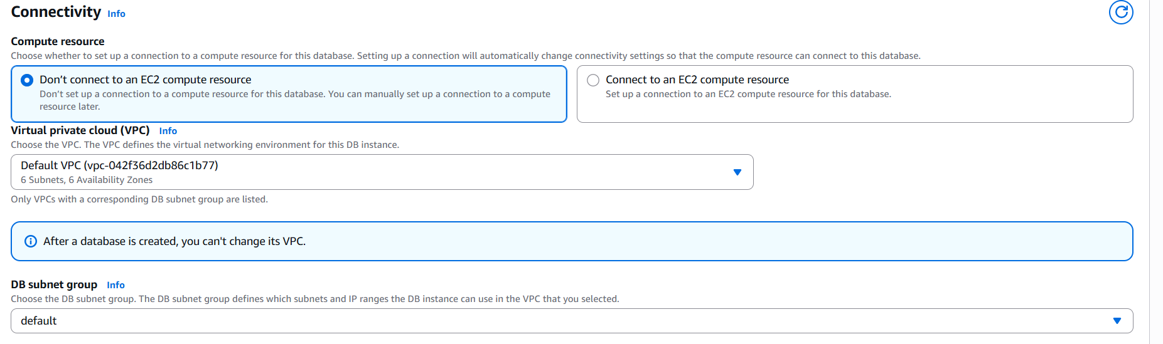
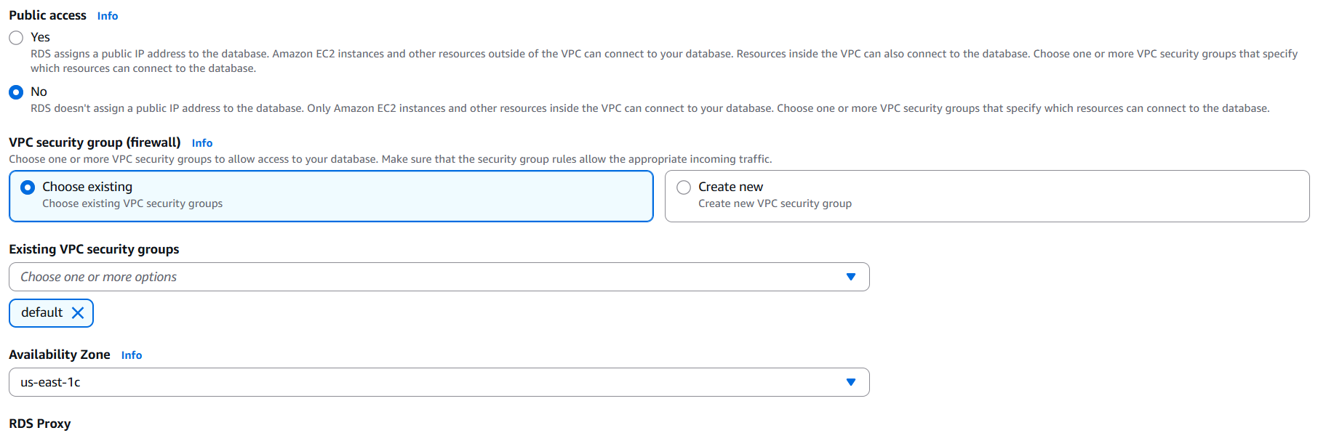
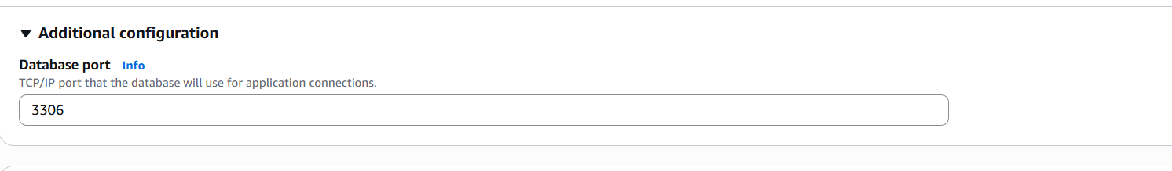
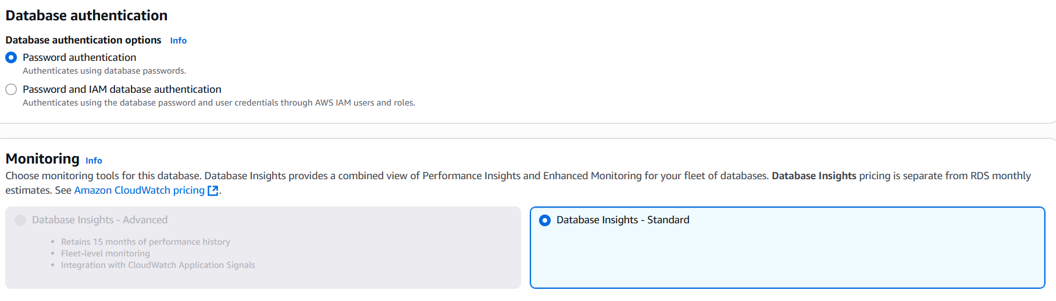
- Clock on Create database.
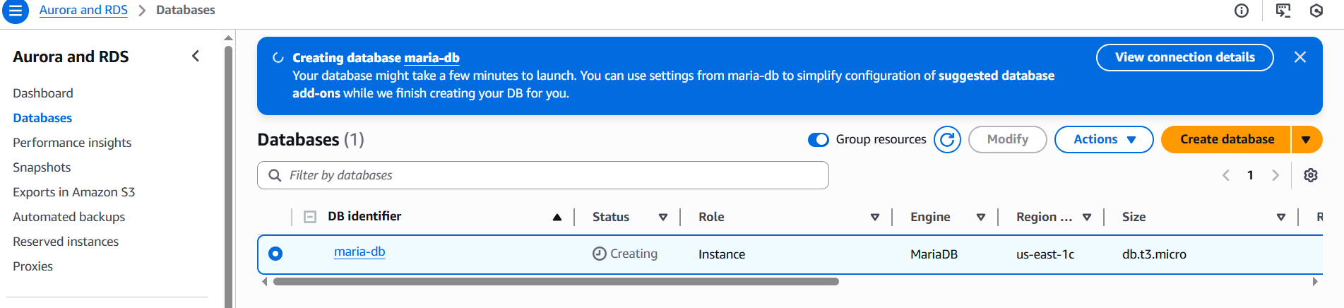
Wait for the instance to become Available
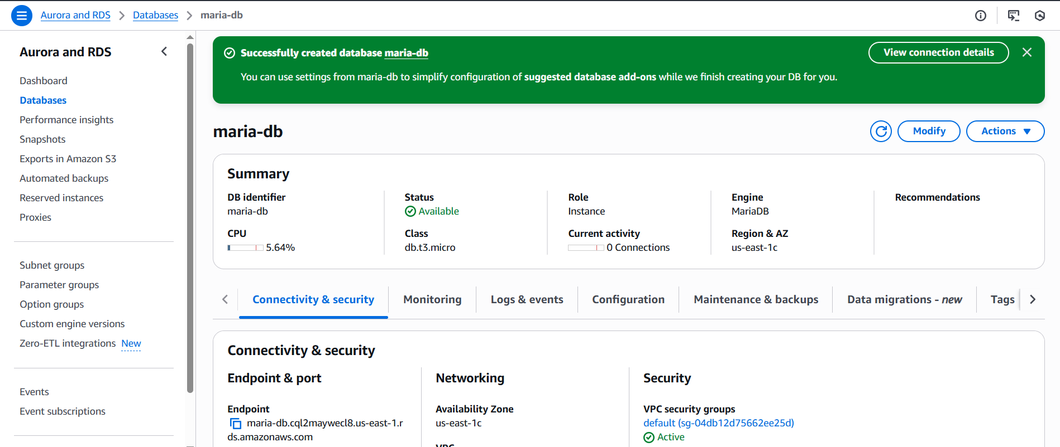5. Migrate database from ec2 to RDS.
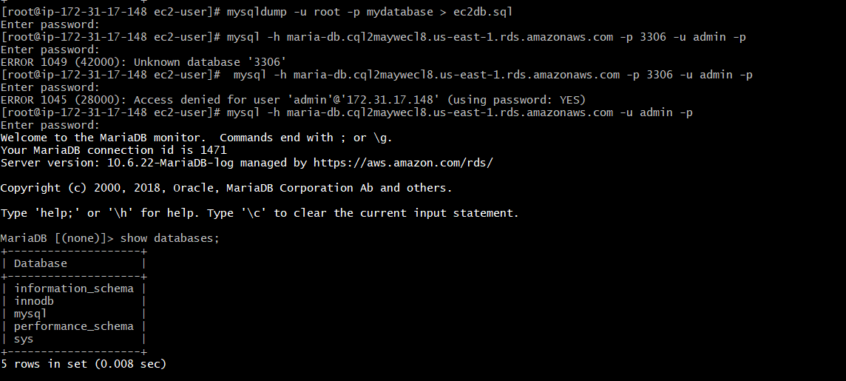
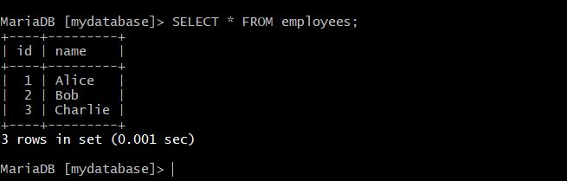
6.Install MYSQL DB on ec2.
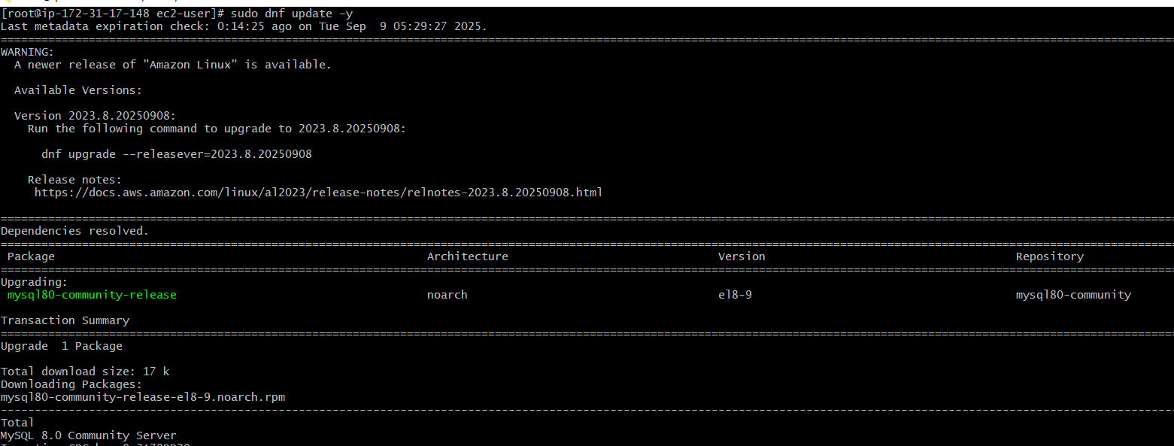
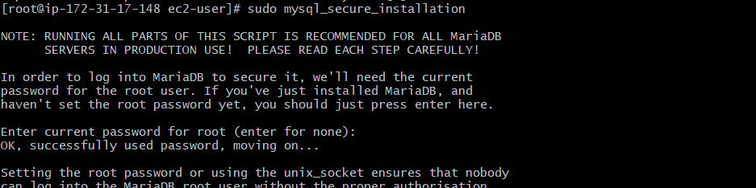
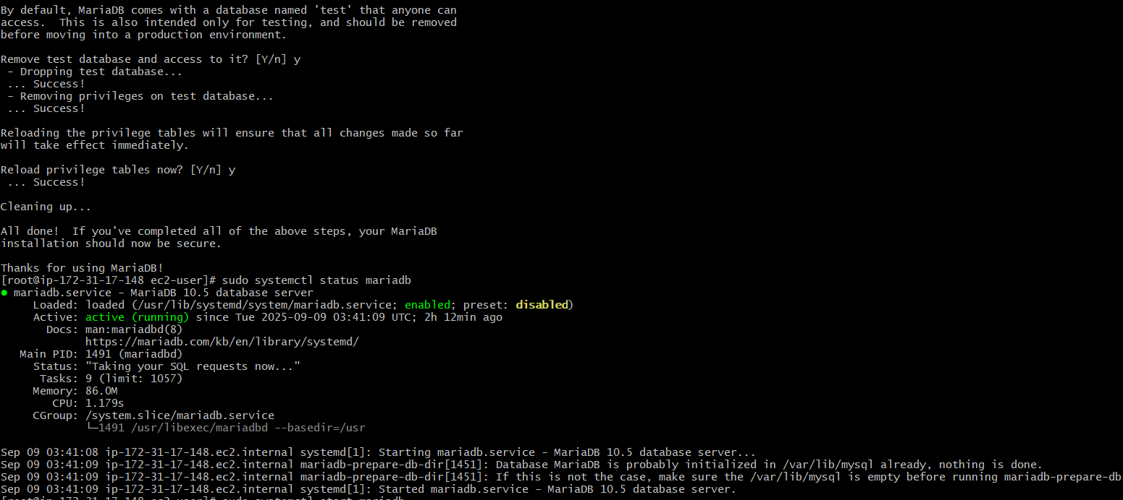
7. Launch MYSQL RDS image.
* Sign in to aws console
Go to RDS → databases → Create database
* Choose database creation method
. Standard create (gives full control)
Or Easy create (simpler,but fewer options)
Choose standard create for more fiexibility
Engine Options → Engine type: Select MySQL
Version : choose stable version (e.g; MySQL 8.0.x LTS)
Templates
Choose based on use case
Relational database task → . production ( Multi-AZ, backups enabled, more costly)
. Dev/Test (Single-AZ, cheaper)
Settings: DB Instance identifier → mydb-mysql
Master username → e.g; admin
Master password → choose strong password (or auto-generate and download)
Instance configuration: → instance type: db.t3.micro
Workloads → Storage → General purpose (gp3)
Connectivity: vpc → choose default
Subnet: → default
Public access: yes
Vpc security group : create/attach one which allows port no:3306 from your ip)
Additional config :
- Initial database name → e.g: appdb
- Automatic backups : Enable → set retention : 7 days)
- Encryption : Enable
- Monitoring : Enable
Create Database
- Click create database → AWS will provision your RDS instance
Wait for 5-10 minutes
Connect to RDS
Once status is Available → copy the endpoint → connect from ec2 or laptop.

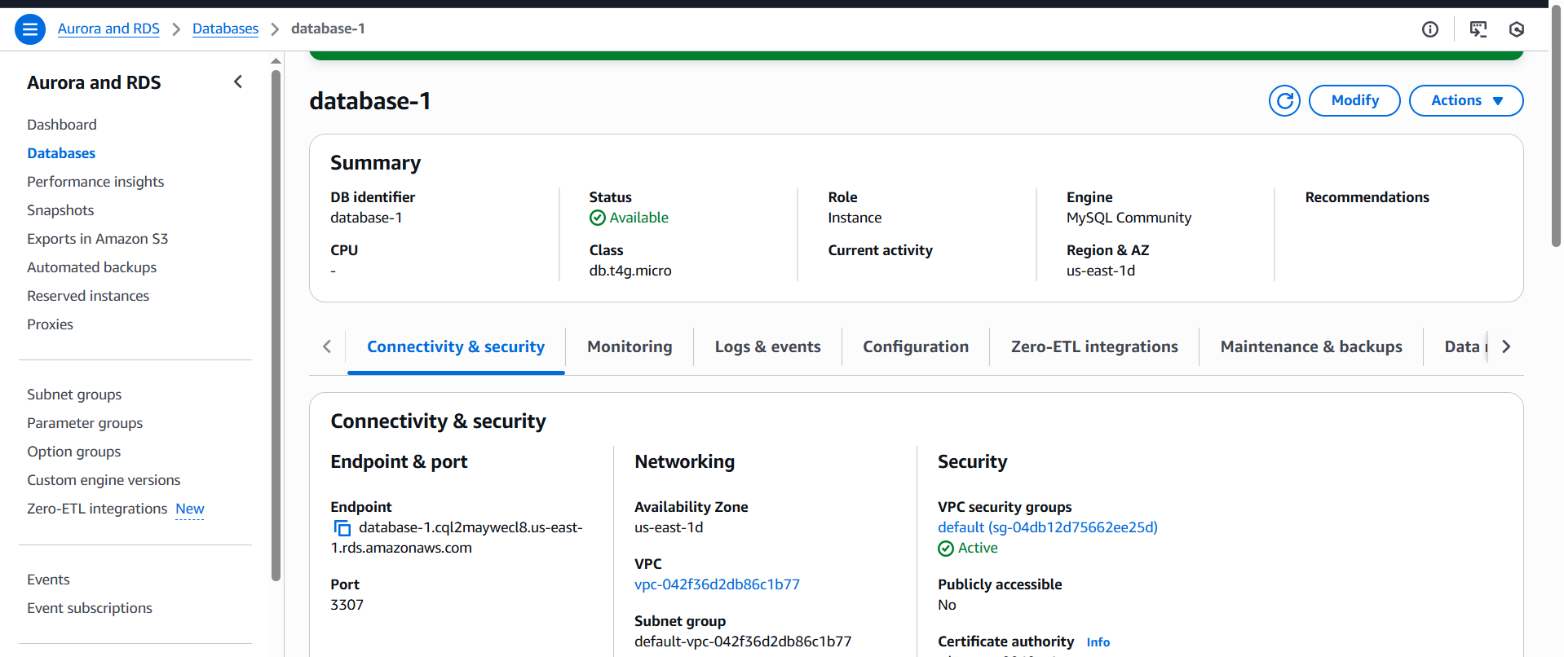
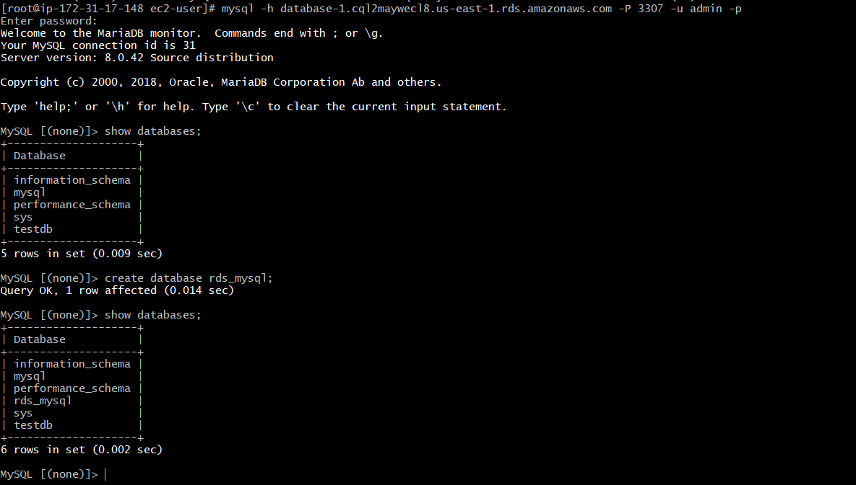
8. Configure multi AZ.
RDS → Select your DB → modify / actions: → convert to multi-AZ.
Under Availability& duration → Enable Multi-AZ deployment
Apply.
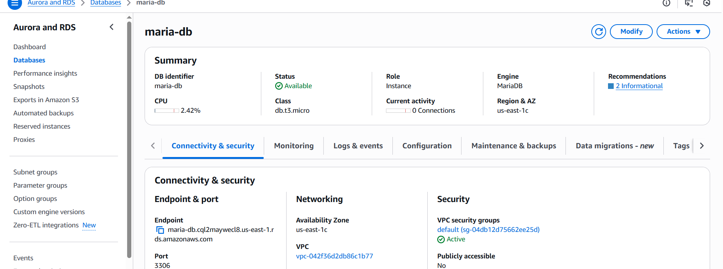

In Configuration tab we can check multi-AZ us-east-1d
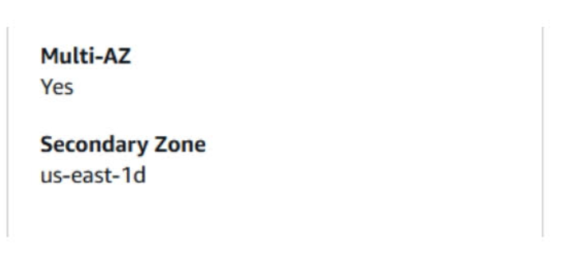

9. Take the Backup of DB and Restore the DB.
Go to Actions → Snapshot and name it and create
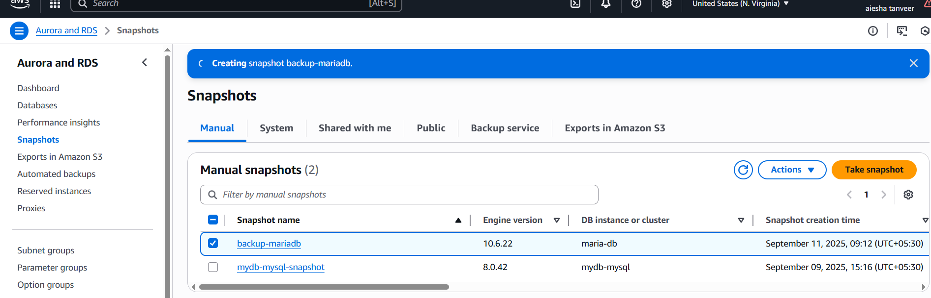
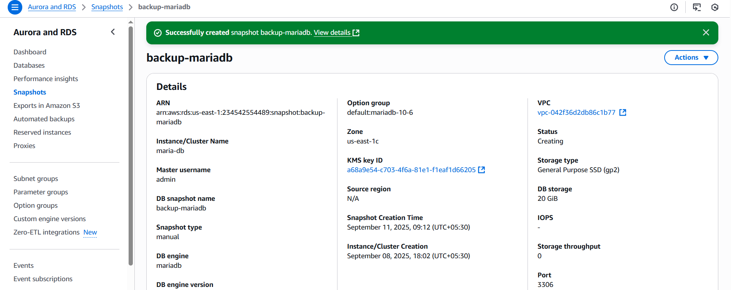
10. Create Read Replica.
Go to RDS → Databases
Click on the database you want to replicate
Click Actions → Create read replica.
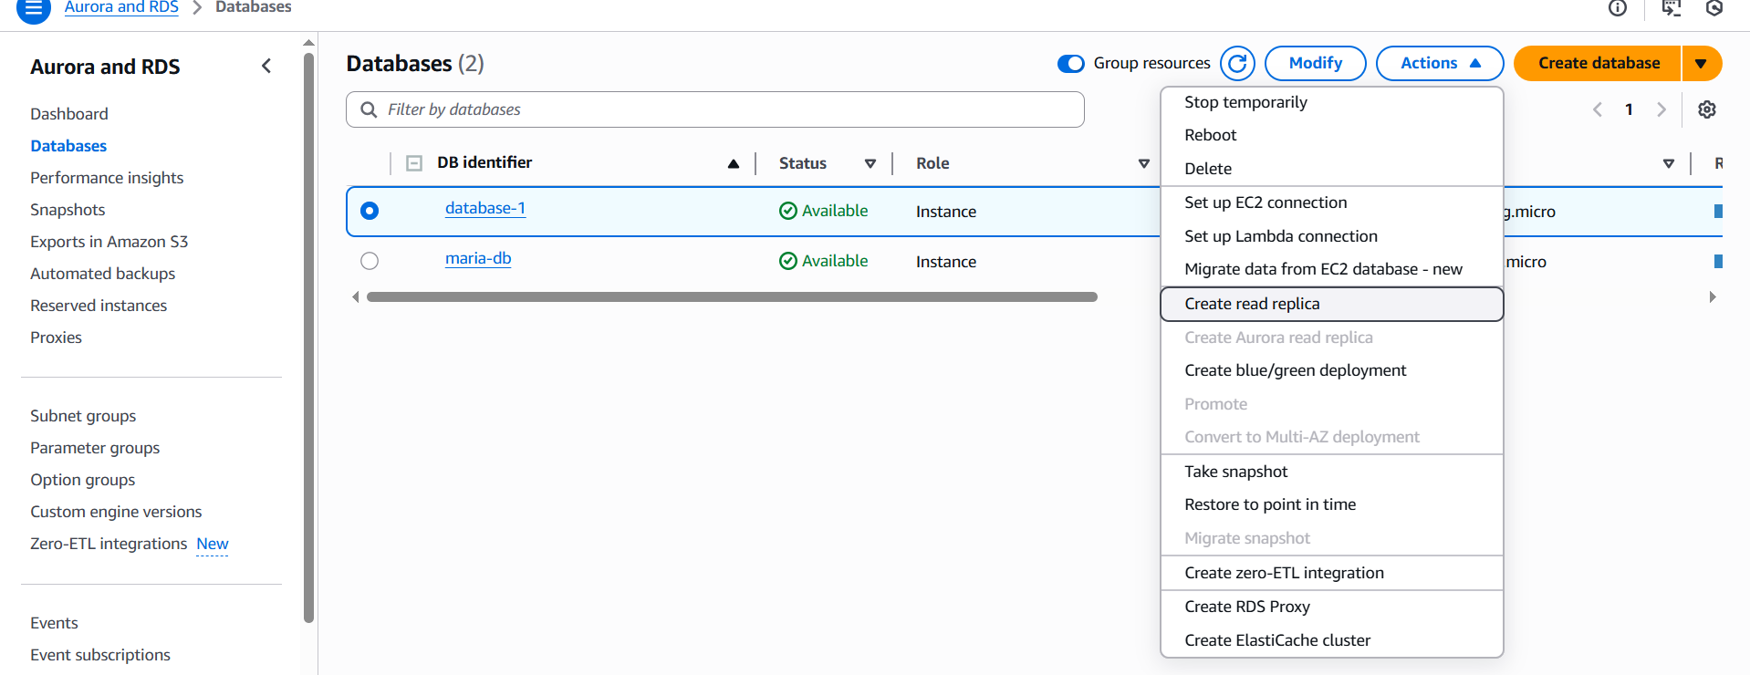
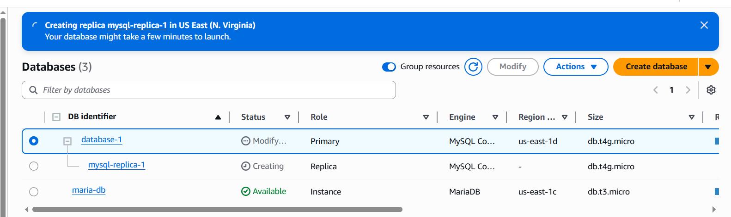
Wait for 5-10 minutes to get “Available”.
