Kubernetes-01
1.Setup minikube in your local machine.
Step 1 – Install docker
Minikube can use Docker as a driver.
Follow the official guide:
Install Docker Desktop on windows.
After installation:
- Make sure Docker is running
- Open powershell and check:
Docker -version
Step 2 – Install oracle virtualbox (optional)
Install virtualbox on windows
Step 3 – Install Minikube
https://minikube.sigs.k8s.io/docs/start/
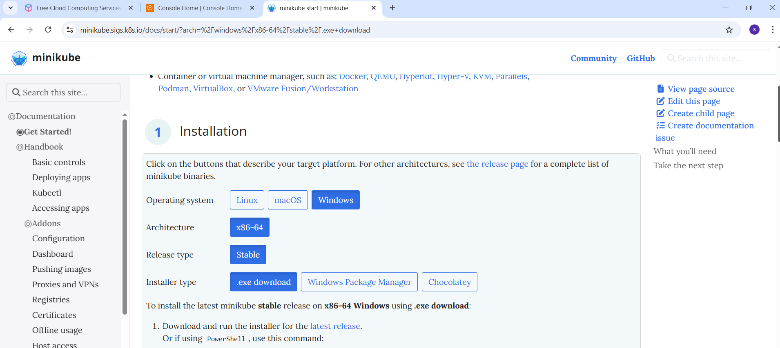
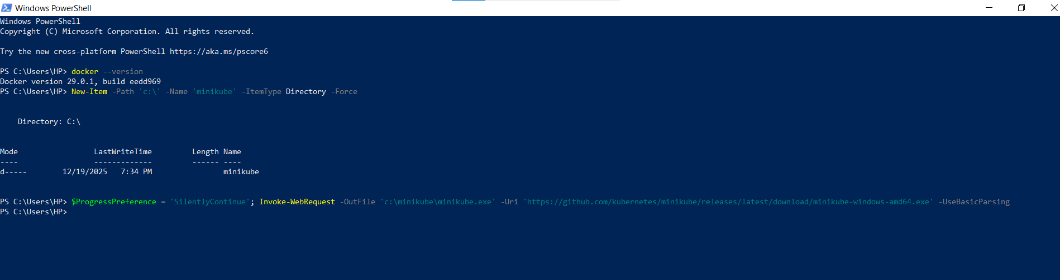
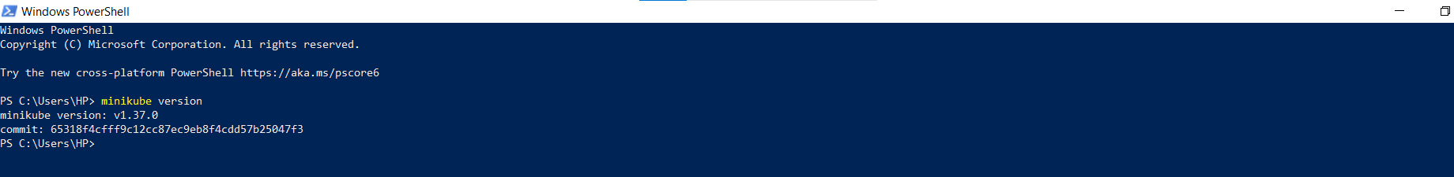Step 4 – set Minikube path Environment Variable
setx PATH “$($env:PATH);C:\minikube”
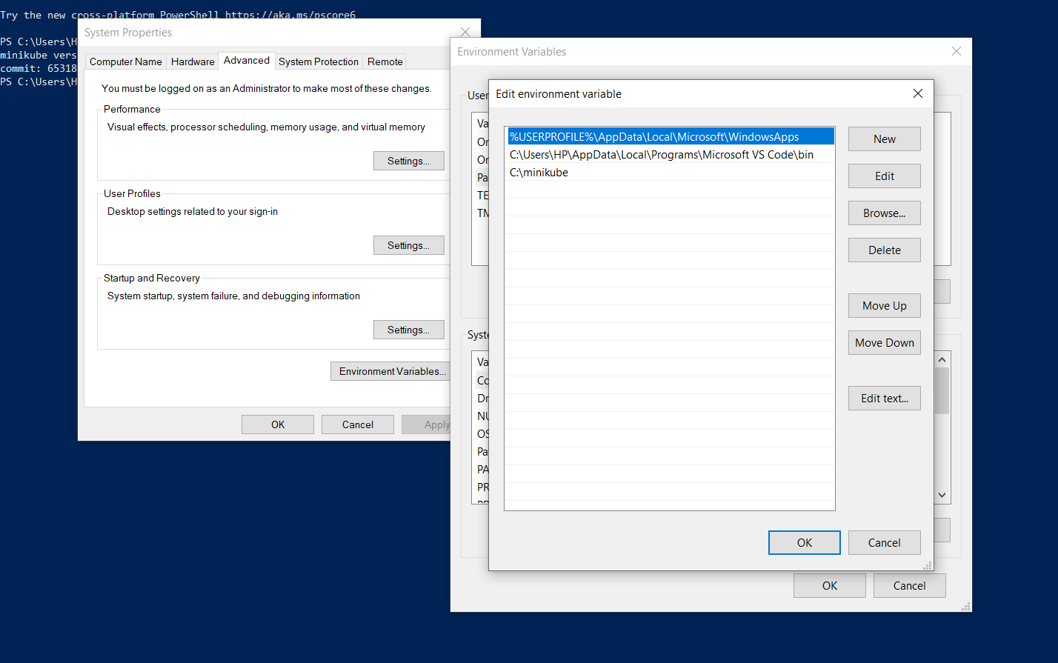
Step 5 - Then restart powershell and start minikube:
minikube start
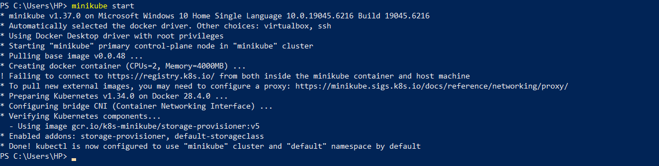
Step 6 – verify setup
Check cluster status:
Minikube status

Get minikube IP:
minikube ip

SSH into Minikube:
Minikube ssh
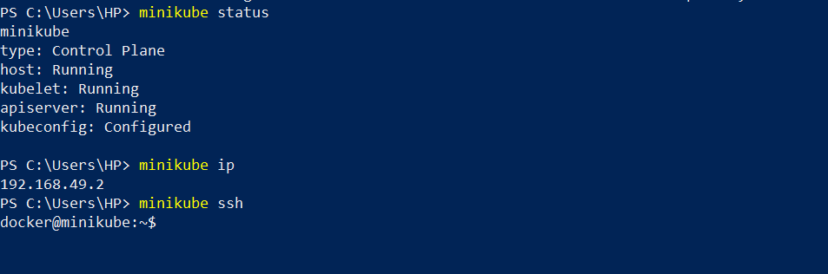

2. Setup k8s master and two worker nodes on ubuntu.
Step 1 – launch 3 instances with 20gb memory
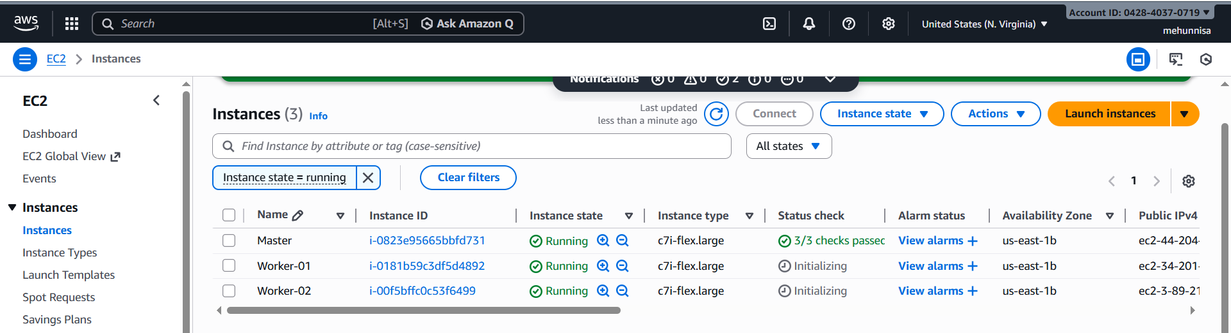step 2 – Set Hostnames
Run on each instance:
Sudo hostnamectl set-hostname master # on master
Sudo hostnamectl set-hostname worker-01 # on worker-01
Sudo hostnamectl set-hostname worker-02 # on worker-02

Then verify:
Hostname
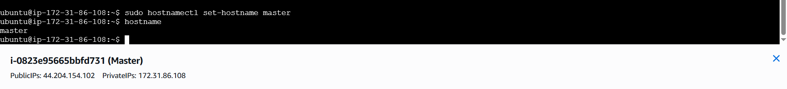
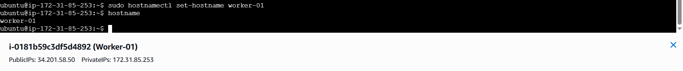
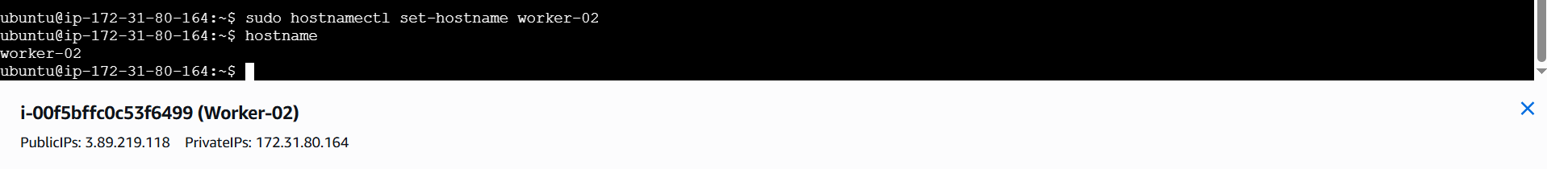
Step 3 – update the /etc/hosts File for Hostname Resolution
Sudo vi/etc/hosts
Add private ip’s of nodes in all the server machines
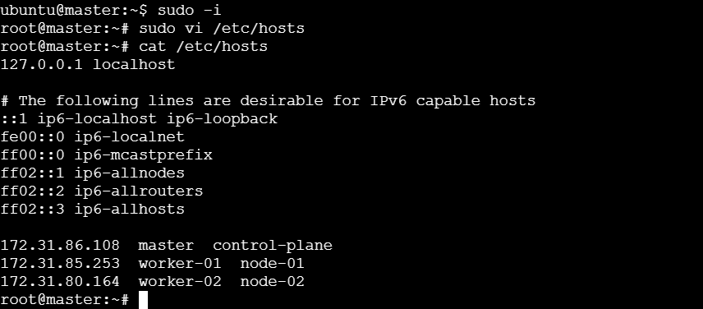
Step 4 – setup the IPV4 bridge on all nodes
Cat <<EOF | sudo tee /etc/modules-load.d/k8s.conf
Overlay
br_ netfilter
EOF
Sudo modprobe overlay
Sudo modprobe br_netfilter
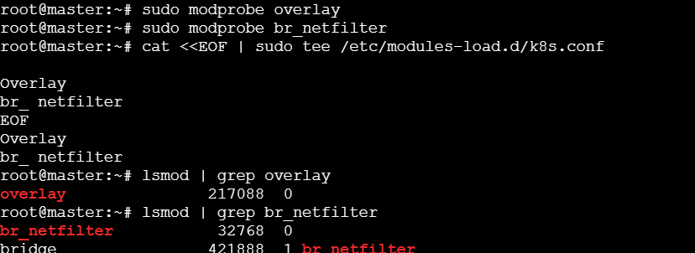

# sysctl params required by setup, params persist across reboots
Cat <<EOF | sudo tee /etc/sysctl.d/k8s.conf
net.bridge.bridge-nf-call-iptables = 1
net.bridge.bridge-nf-call-ip6tables = 1
net.ipv4.ip_forward = 1
EOF

#Apply sysctlparams without reboot
Sudo sysctl-system
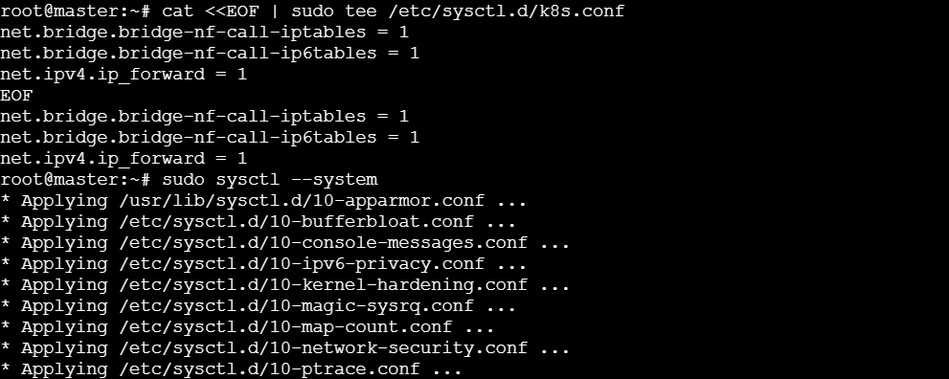
Step 5 – install kubelet, kubeadm, and kubectl on each node

Update system & install required packages:
Sudo apt-get update
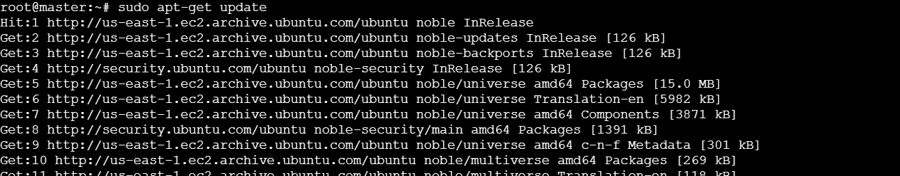
Sudo apt-get install -y apt-transport-https ca-certificates curl
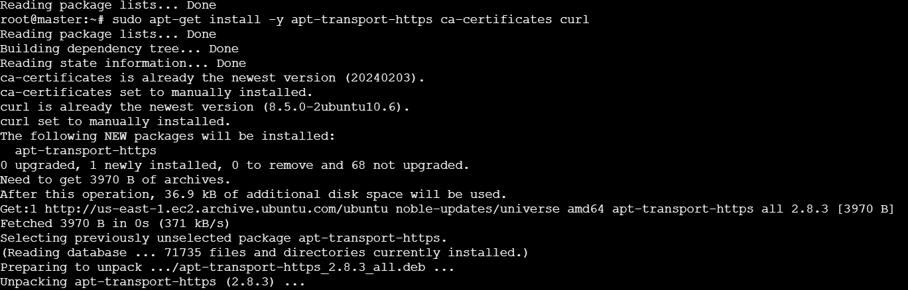
Add Kubernetes signing key:
Curl -fsSL https://pkgs.k8s.io/core:/stable:/v1.29/deb/Release.key | sudo gpg --dearmor -o /etc/apt/keyrings/Kubernetes-apt-keyring-gpg

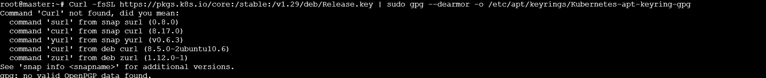
Remove broken key file and re-create keyrings directory
Sudo mkdir -p /etc/apt/keyrings
wget -qO- https://pkgs.k8s.io/core:/stable:/v1.29/deb/Release.key | sudo gpg --dearmor -o /etc/apt/keyrings/kubernetes-apt-keyring.gpg
Verify the key file:
ls -lh /etc/apt/keyrings/kubernetes-apt-keyring.gpg

Add Kubernetes repository:
echo ‘deb [signed-by=/etc/apt/keyrings/kubernetes-apt-keyring.gpg] https://pkgs/k8s.io.core:stable:/v1.29/deb/ /’ |sudo tee /etc/apt/sources.list.d/Kubernetes.list
Sudo apt update

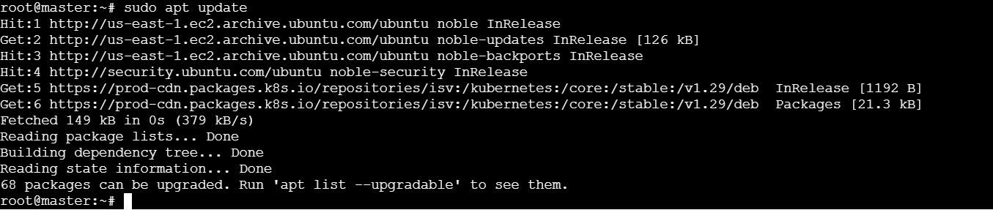
Sudo apt install -y kubelet kubeadm kubectl
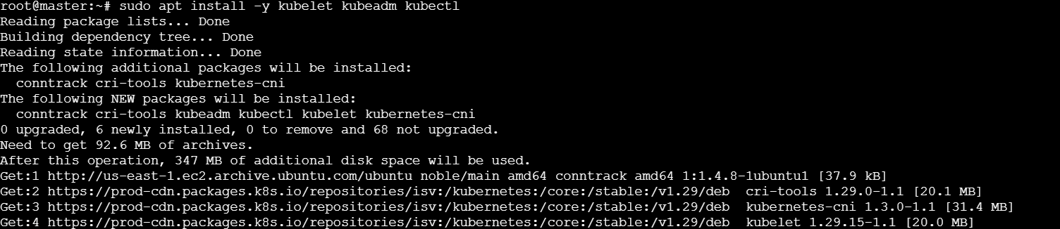
Step 6 – install docker
Sudo apt install docker.io
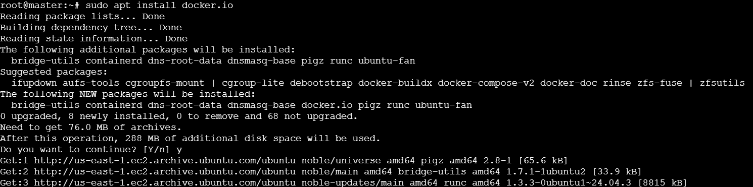
Sudo mkdir /etc/containerd
Sudo sh -c “containerd config default > /etc/containerd/config.toml”
Sudo sed -I ‘s/ SystemdCgroup = false/ Systemdgroup = true/’ /etc/containerd/config.toml
Sudo systemctl restart containerd.service
Sudo systemctl restart kubelet.service
Sudo systemctl enable kubelet.service
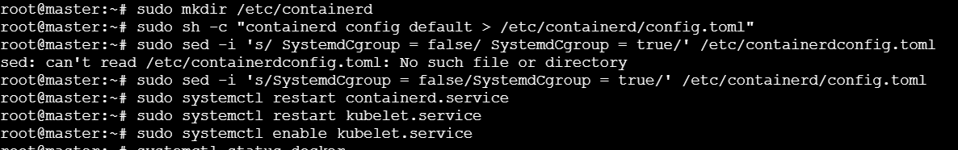
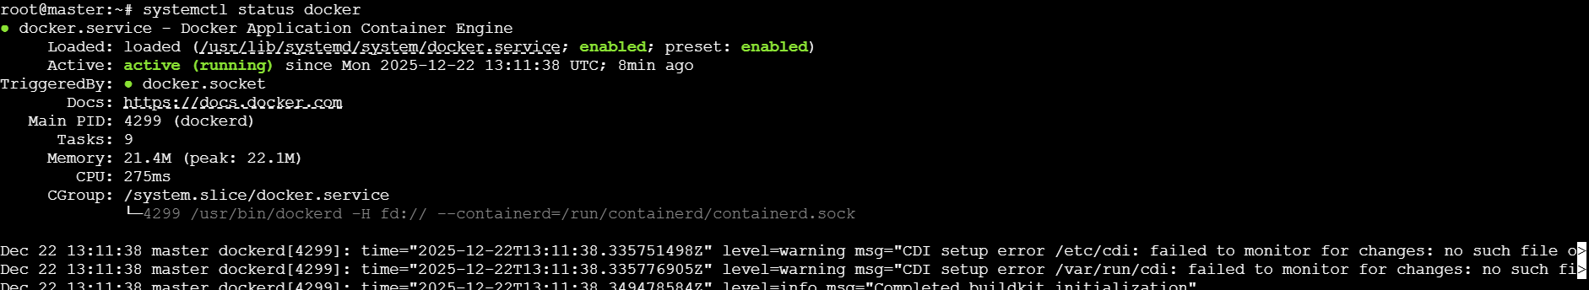
Step 7 – Initialize Kubernetes clusteron master node
Execute on Master Node only:
# pre-download required Kubernetes container images
Sudo kubeadm config images pull
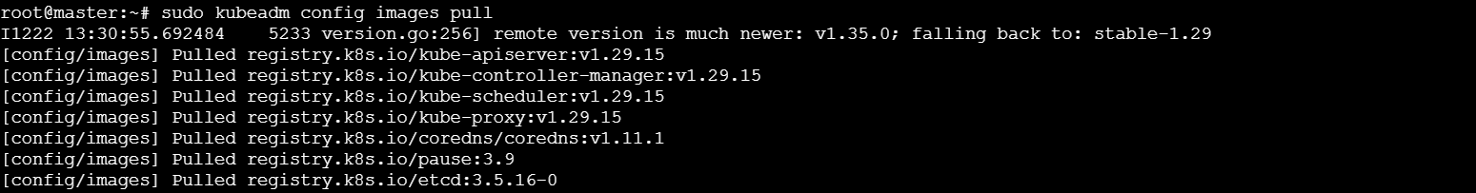
# Initialize the Kubernetes control plane
sudo kubeadm init --pod-network-cidr=10.10.0.0/16
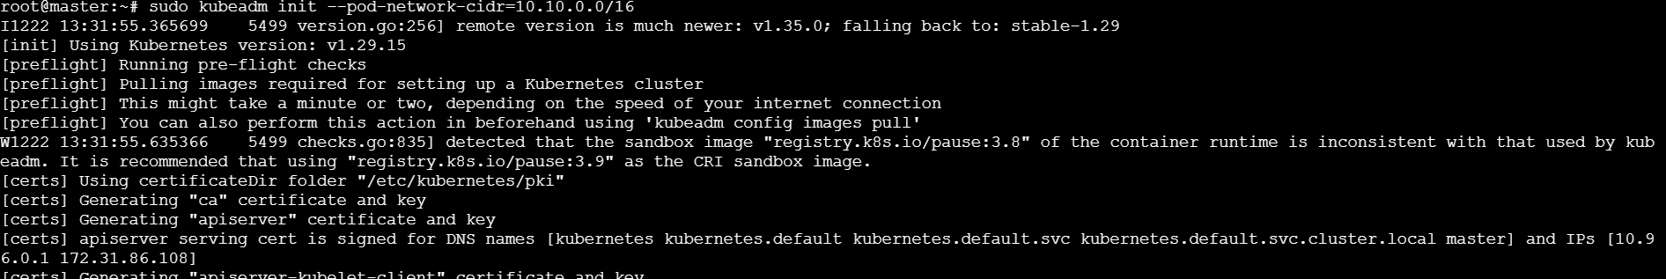
# set up local kubectl configuration
Mkdir -p $HOME/.kube
Sudo cp -I /etc/kubernetes/admin.conf$HOME/.kube/config
Sudo chown $(id -u):$(id -g) $HOME/.kube/config

Step 8 – Install and configure calico network plugin
Execute on MASTER NODE after initialization:

# Deploy calico operator
Kubectl creat -f https://raw.githubusercontent.com/projectcalico/calico/v3.26.1/manifests/tigera-operator.yaml
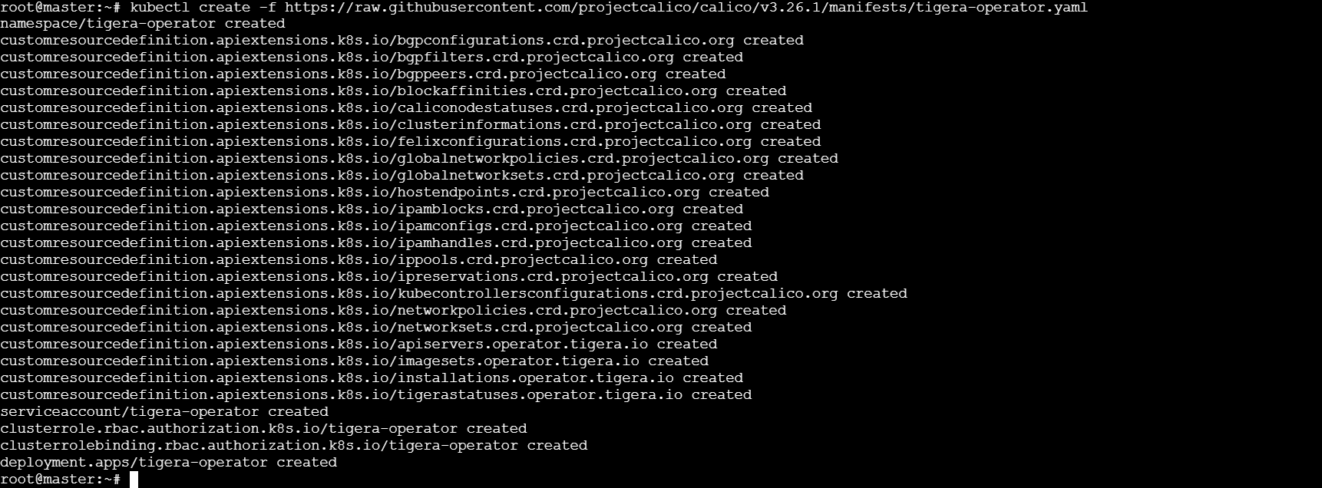
# Download calico custom resources manifest
Curl -O
https://raw.githubusercontent.com/projectcalico/calico/v3.26.1/manifests/custom-resources.yaml
# Update CIDR to match Kubernetes pod network
Sed -I ‘s/cidr: 192\.168\.0\.0\/16/cidr: 10.10.0.0\/16/g’ custom-resources.yaml
# Apply calico configuration
Kubectl create -f custom-resources.yaml
Here, calico custom-resources already exists. So, if we try to create again ,it will fail.
Instead of create , use apply
Kubectl apply -f custom-resources.yaml
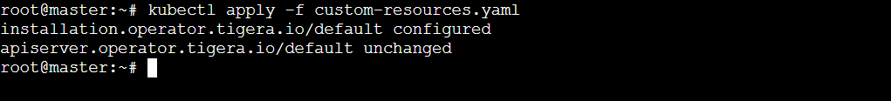Step 9 – join worker nodes to cluster
Execute on each worker node:
# Use the join command provided by kubeadm init output
First, run the kubeadm token create –print-join-command
Then we will get the output as:

Now paste the entire command in worker nodes as :
Sudo kudeadm join 172.31.86.108 :6443 –token auzdo8.gz7p3da83b4va90s --discovery-token-ca-cert-hash
Sha256:3e78501c10d14b7deb8add2e204fd47a2c0c107c71f2bfbd66a74743d92a2bfd
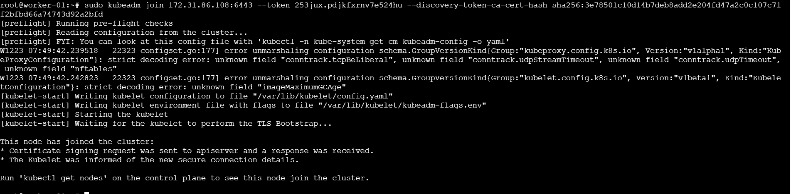
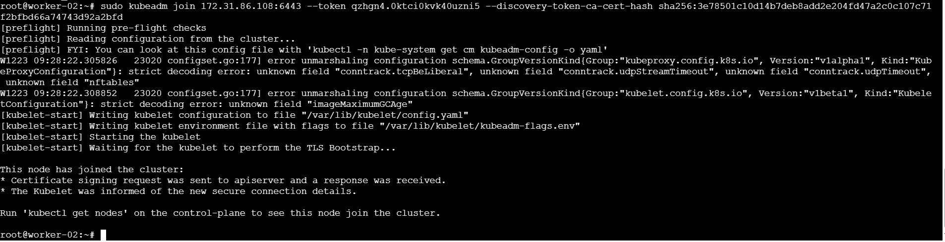

step 10 – Verify cluster status
Execute on MASTER NODE after worker nodesjoin:
# check all cluster nodes and their status
Kubectl get nodes
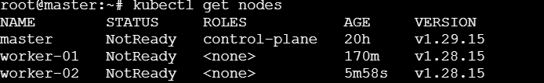

# Verify all system pods are running
Kubectl get pods –all-namespaces
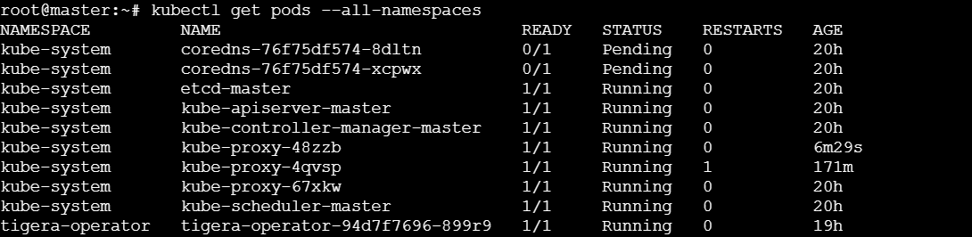

# check cluster info
Kubectl cluster-info
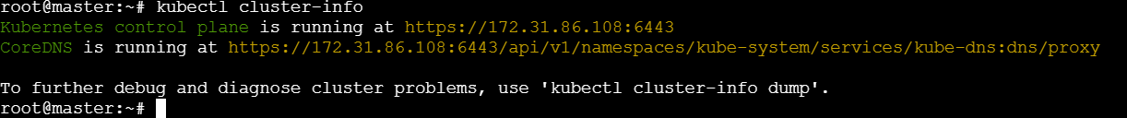

Run one nginx pod.
Step 1 – Create pod.yaml file
Vi pod.yaml
Step 2 – write this in your yaml file:
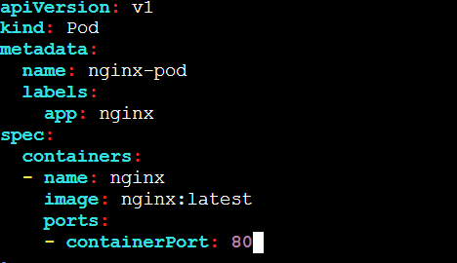
Step 3 – Deploy the pod
Kubectl apply -f pod.yaml
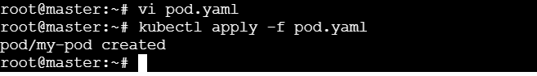
Step 4 - Verify
Kubectl get pods
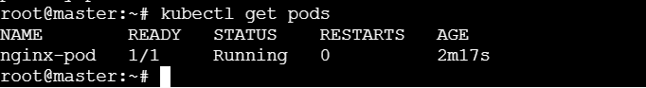

Step 5 – Expose as service
Kubectl expose pod nginx-pod nginx-pod –type=Nodeport –port=80 –name=nginx-service
Kubectl get svc
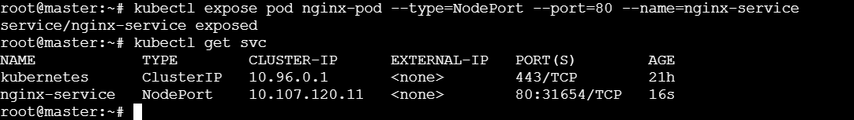

→ Let’s check on which node is our pod running
Kubectl get pods -o wide

→ Even though the pod runs on one node, the NodePort service makes it accessible via ANY node’s IP + the NodePort.

NodePort opens the port on all nodes, but for reliable access you should use the IP of the node where the pod is actually running, or use a LoadBalancer.
Check in browser as → http://<public-ip-of-worker-02>:port
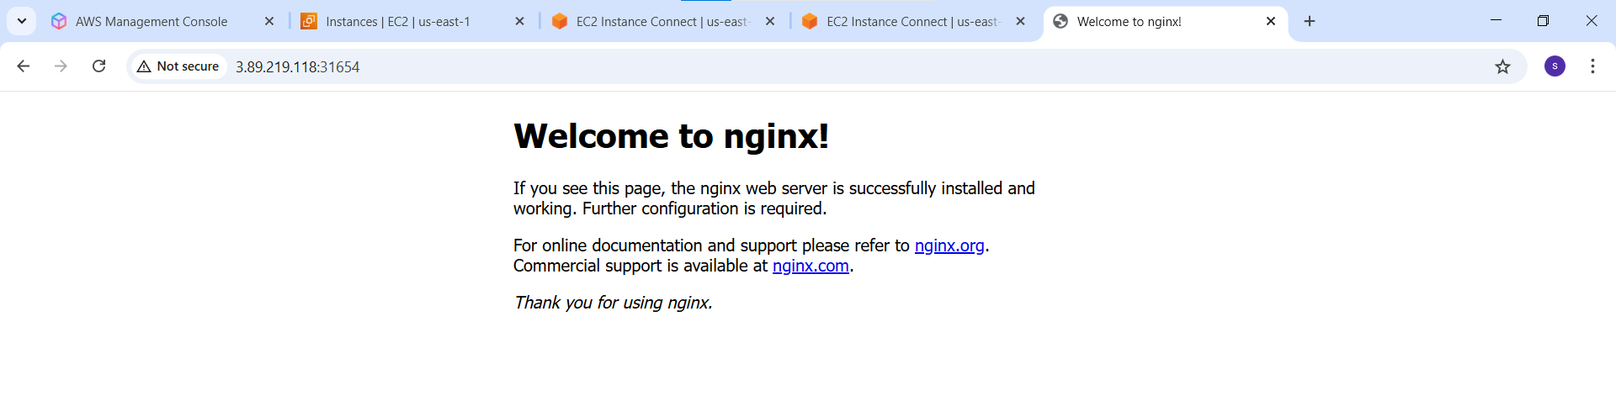
→ Mug up master and slave components on k8s.

What is Kubernetes?
Kubernetes, often called k8s, is an open-source container orchestration tool that was originally developed by Google. It helps us manage and deploy containerized applications across multiple servers. Think of it as a smart system that automatically handles where your applications run and how they scale.

Why Do We Need Kubernetes?
When we have many applications running in containers, it becomes difficult to manage them manually. Kubernetes helps by:
- Keeping our applications highly available so users never experience downtime
- Automatically scaling applications up when there is more traffic
- Scaling down when traffic decreases to save resources
- Recovering failed applications automatically

Main components of Kubernetes

Pods
→ A pod is the smallest building block in Kubernetes. It is like a wrapper that can contain one or more containers.
→ Each pod gets its own IP address, but pods are temporary. If they fail, they should get replaced with the new one.

ReplicaSets
→ A ReplicaSet makes sure that the desired no.of identical pods are always running.
→ If one pod crashes, the ReplicaSet notices this and creates a new pod to replace it.
This is how Kubernetes provides self-healing capabilities.

Deployments
Deployments are used to manage updates and changes to our applications.they use a strategy called rolling updates which means they gradually place old versions with the new ones without causing any downtime for users.

Services
since pods are temporary and get new IP addresses when replaced.
We need services to provide a permanent access point. A service gives us a stable IP address that load balances traffic to all the pods behind it.

Namespaces
Namespaces help us to organize our applications into separate virtual workspaces. This is useful when multiple teams are using the same Kubernetes cluster, as each team can have their own namespace.

How Kubernetes is organized

Master Node (The Brain)
The master node controls the entire cluster and has four main components:
1. API Server – This is the front door to Kubernetes. All communication goes through here.
2. etcd – this is the cluster’s memory where all configuration data is stored.
3. Scheduler – this decides which worker node should run each pod.
4. controller Manager – This constantly monitors the cluster and fixes any problems.

Worker Nodes (The Muscle)
Worker nodes are where our applications actually run. Each workr has three components:

- Container Runtime – this runs the containers like Docker
- Kublet – This is the node agent that makes sure containers are running properly.
- kubeProxy – This handles networking and makes sures pods can communicate with each other.

Simple Real-World Example (Bus Transportation System 🚌)
Imagine a city bus transportation system:
Master Node (Control Plane) is like the central bus control office.
It does not drive buses but:
- Decides which bus should go on which route
- Monitors all buses
- Fixes problems if a bus breaks down

*Worker nodes are the buses.
They actually carry passangers (run applications).

*Pods are like bus trips.
A trip may carry many passengers, and if one trip fails, a new one is scheduled automatically.

*ReplicaSets ensure there are always enough buses on busy routes.
If one bus breaks down, another bus is sent immediately.

*Deployments help change routes smoothly. Old routes are replaced with new new ones without stopping the service.

*Services are like bus stops
Passengers always go to the same bus stop, even though different buses arrive there.

*Namespaces are like different city Zones.
For example:
- One zone for city buses
- One zone for interstate buses
This keeps everything organized and separate

