Docker-01
- Setup a virtual machine using Ubuntu image.

Step-1 : Download Requirements.
1.Download virtualbox from https://www.virtualbox.org/wiki/Downloads
2.Download Ubuntu ISO. From https://ubuntu.com/download/desktop
→ choose ubuntu 22.04LTS (long term support)

Step-2 :
we need a software to run a VM. Popular options:virtualbox (free, easy to use)

step-3 : create a new virtual machine
1.open virtualbox.
2.click new → give a name (ex:ubuntu-vm)
3. choose type → linux
Version → ubuntu (64-bit)

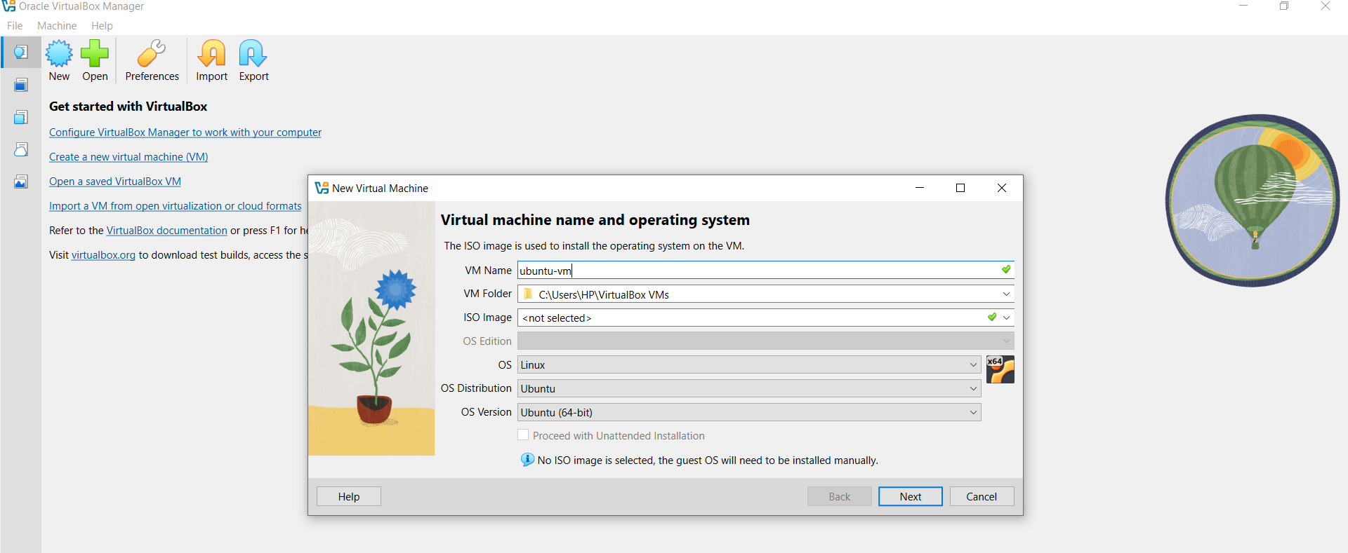
4.Assign RAM:atleast 2 GB (4 GB recommended).
5.create a virtual Hard disk:
* select VDI (virtualbox Disk image)
* choose dynamically allocated.
* size:20 GB or more
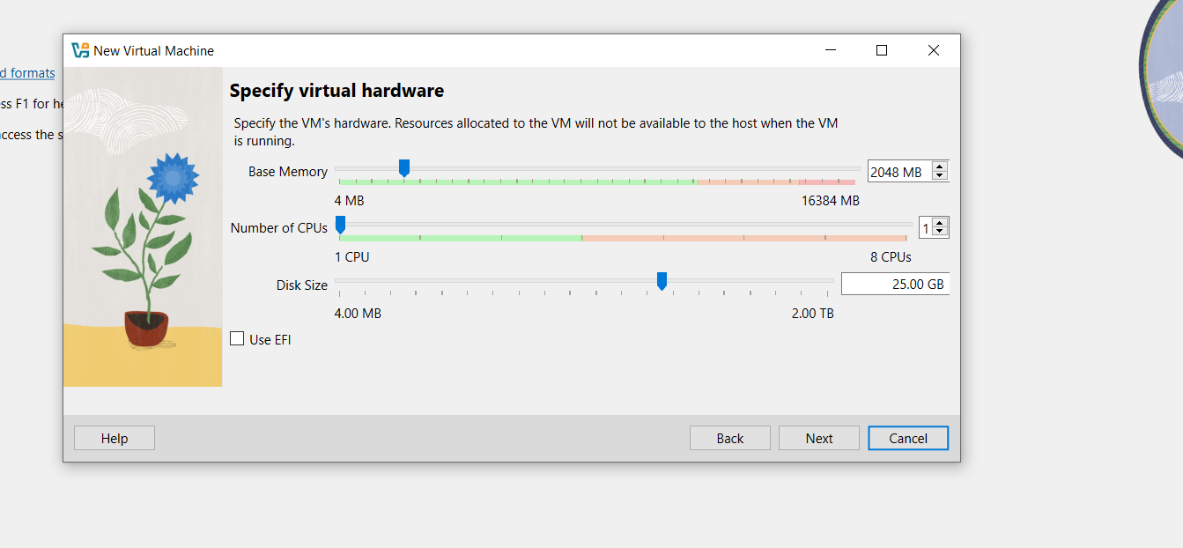

Step-4 : start the VM & install ubuntu
1.click start.
2.VM boots from ISO → select install ubuntu.
3.follow setup wizard:
* language and keyboard layout.
* normal installation (includes utilities and browser)
* install updates and third-party software → check ✔️
* disk setup → use entire virtual disk
* create username and password

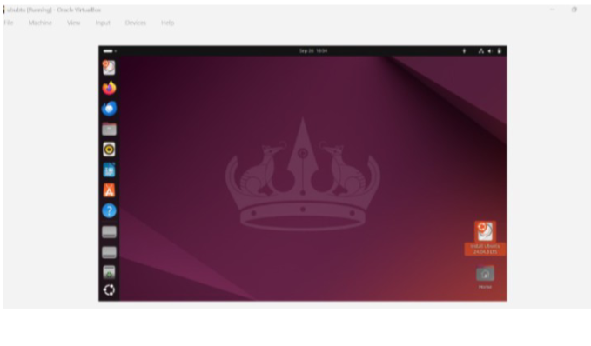

- Install docker on ec2.
Step-1 : launch EC2 instance.
1.In AWS console → lauch instance
2.Select Amazon Linux 2 AMI
3.instance type : t3.large
4.launch instance.
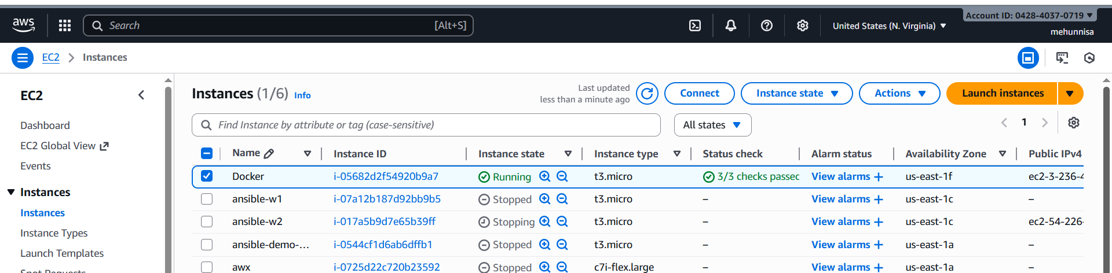
Step-2 : connect to ec2
From local terminal :
ssh -i key.pem ec2-user@<public_ip>
→ sudo yum update -y
Install docker
→ sudo yum install docker
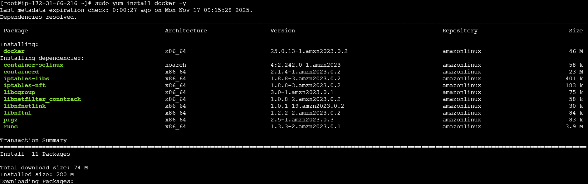
Start docker service
→ sudo systemctl start docker.
→ sudo systemctl enable docker.
→ sudo systemctl status docker.
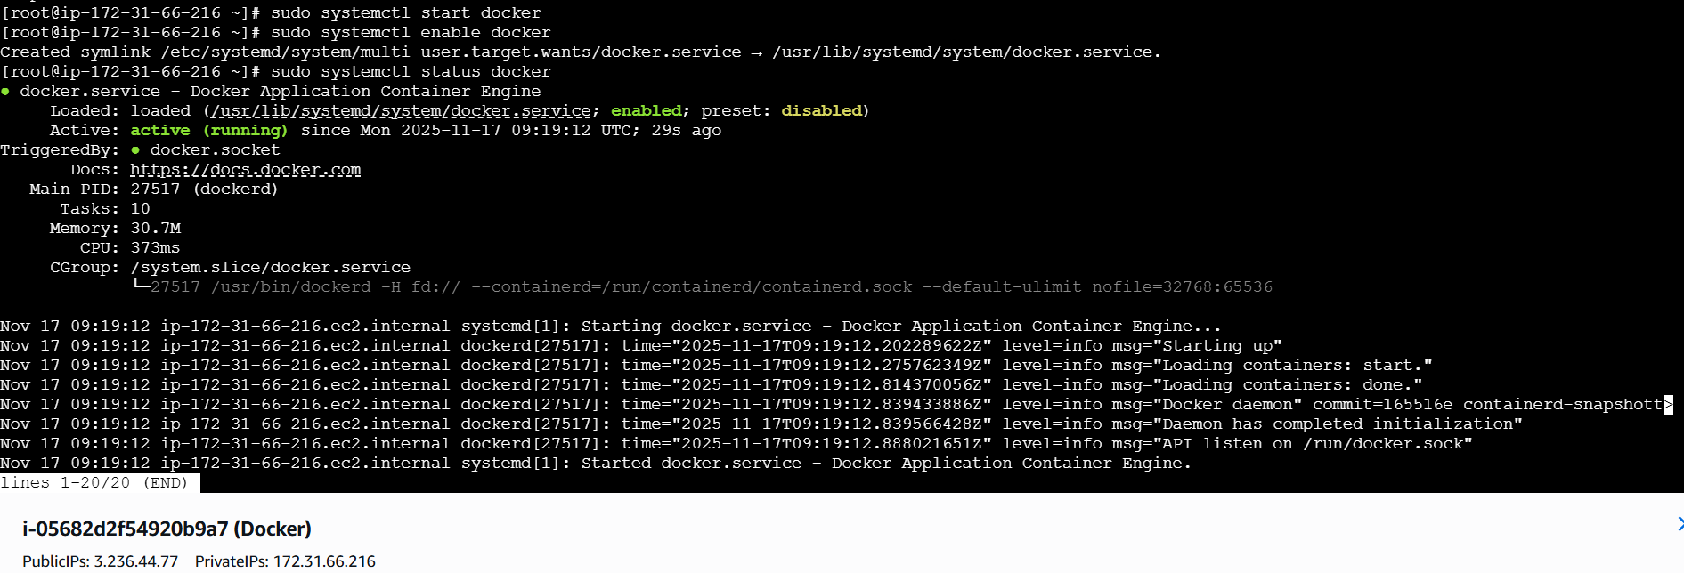

- Pull 5 docker images.(nginx, Apache tomcat, ubuntu, Jenkins,sonarqube)
Step-1 : Make sure Docker is running.
Docker –version
Sudo systemctl status docker.
Step-2 : pull images
Run these commands:
Nginx: docker pull nginx:latest
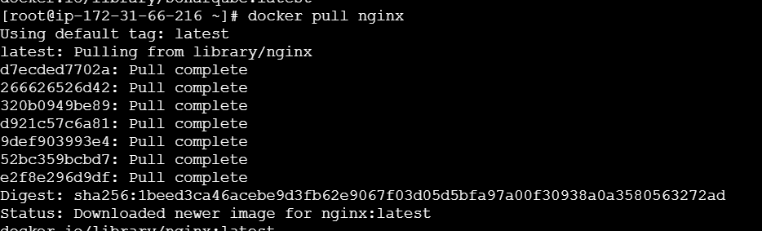

Apache tomcat: docker pull tomcat
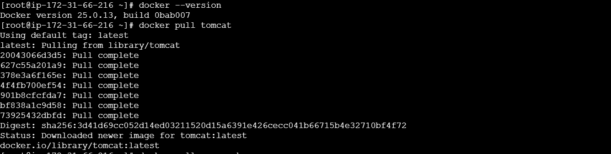

Ubuntu: docker pull ubuntu:latest
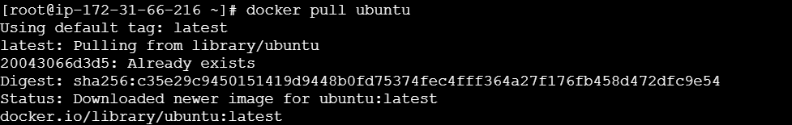

Jenkins: docker pull Jenkins:2.60.3
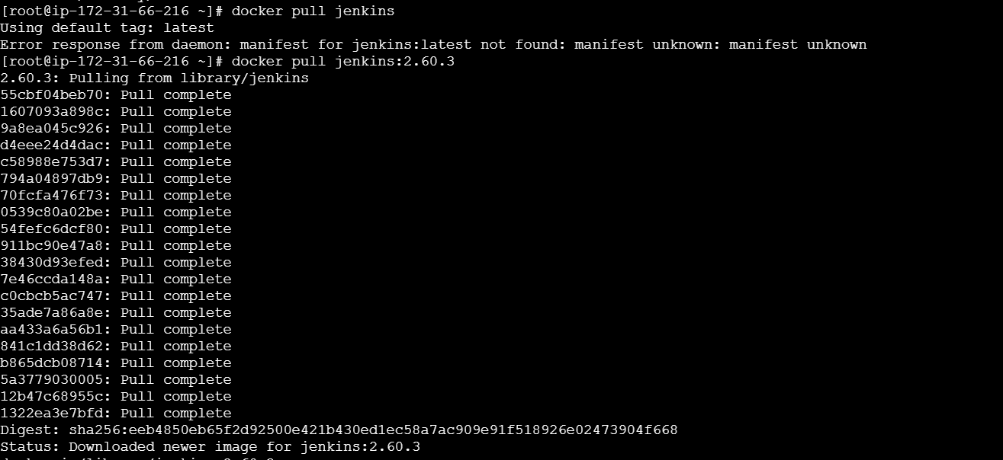

Sonarqube: docker pull sonarqube:latest
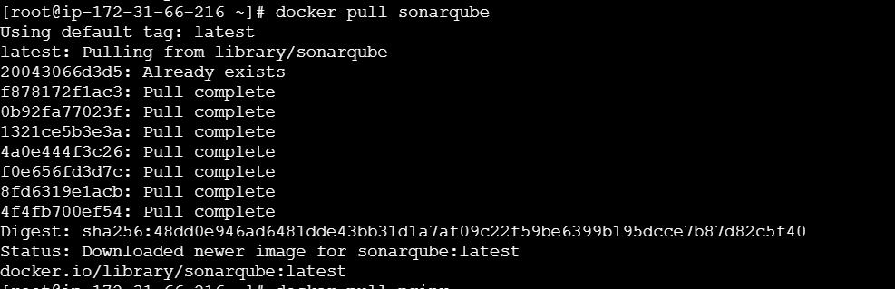

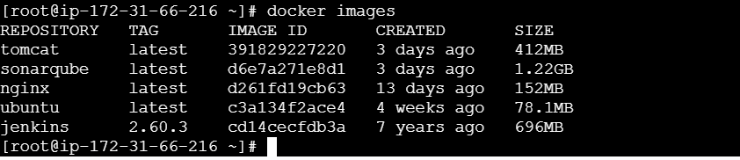
- Run nginx container and expose on port 81.
Step-1 : make sure docker is running.
Sudo systemctl start docker
Sudo systemctl enable docker
Step-2 : run nginx container on port 81
docker run -itd -p 81:80 nginx
- d → detachrd mode (runs in background)
- p 81:80 → maps host port 81 → container port 80 (Nginx default)
step-3 : verify container is running
docker ps
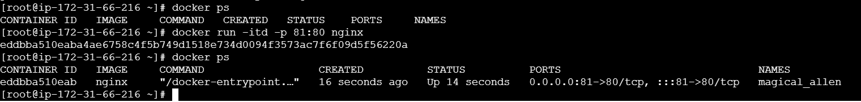
Now check in browser using public_ip whether the nginx is running on port 81:
http://<public_ip>:81
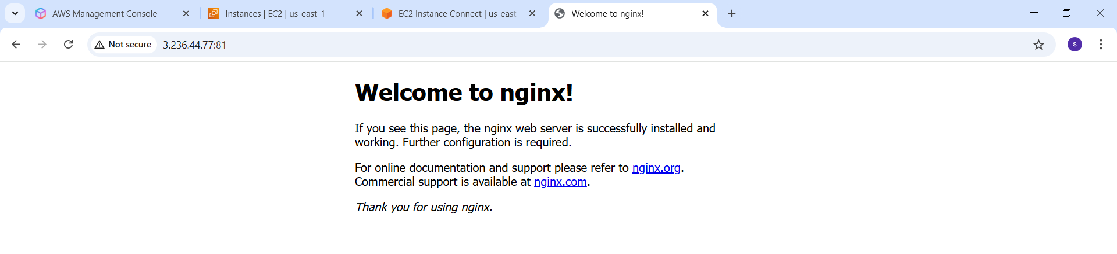
- delete the apache tomcat image from local.
First stop and remove any container
docker stop tomcat
docker rm tomcat
Then remove the image :
docker rmi tomcat:latest
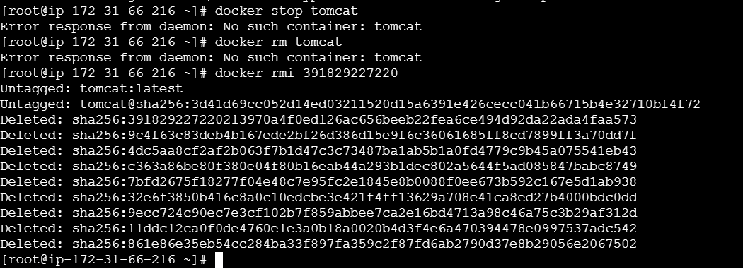
Check whether tomcat image has been deleted or not.
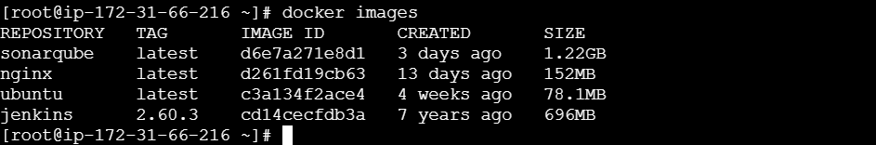
- Inspect the Jenkins image, SonarQube image.
Inspect Jenkins image:
docker inspect Jenkins/Jenkins:Its
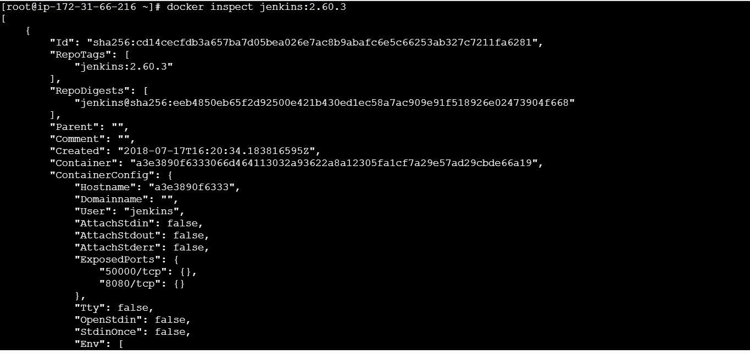
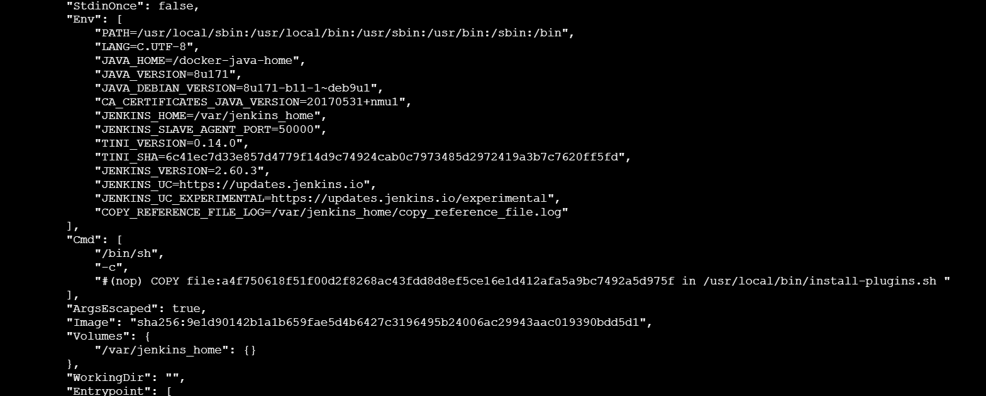

- Run Jenkins container and run one sample job.
Step-1 :run Jenkins container
docker run -d --name jenkins -p 8080:8080 -p 50000:50000 jenkins/jenkins:lts
- 8080 → web UI port
- 50000 → for agent communication
- Container runs in background (-d)

Step-2 : Get jenkins Admin password
Check logs:
Docker logs Jenkins
Look for a line like:
****************************************

Jenkins initial setup is required. An admin user has been created.
Admin password:1234567890abcdef
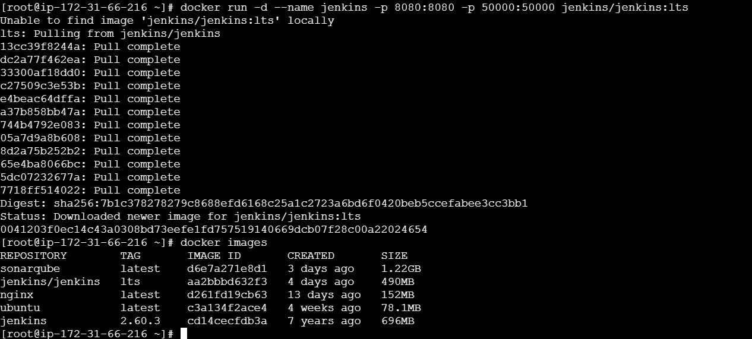
Step-3 : Access Jenkins UI
1.Go to security group of the instance, allow inbound rule for port 8080 and 50000
2.open in browser:
http://<EC2_Public_ip>:8080
3.Enter the admin password which was coped.
4.Choose install suggested plugins.
5.Create a new admin user.

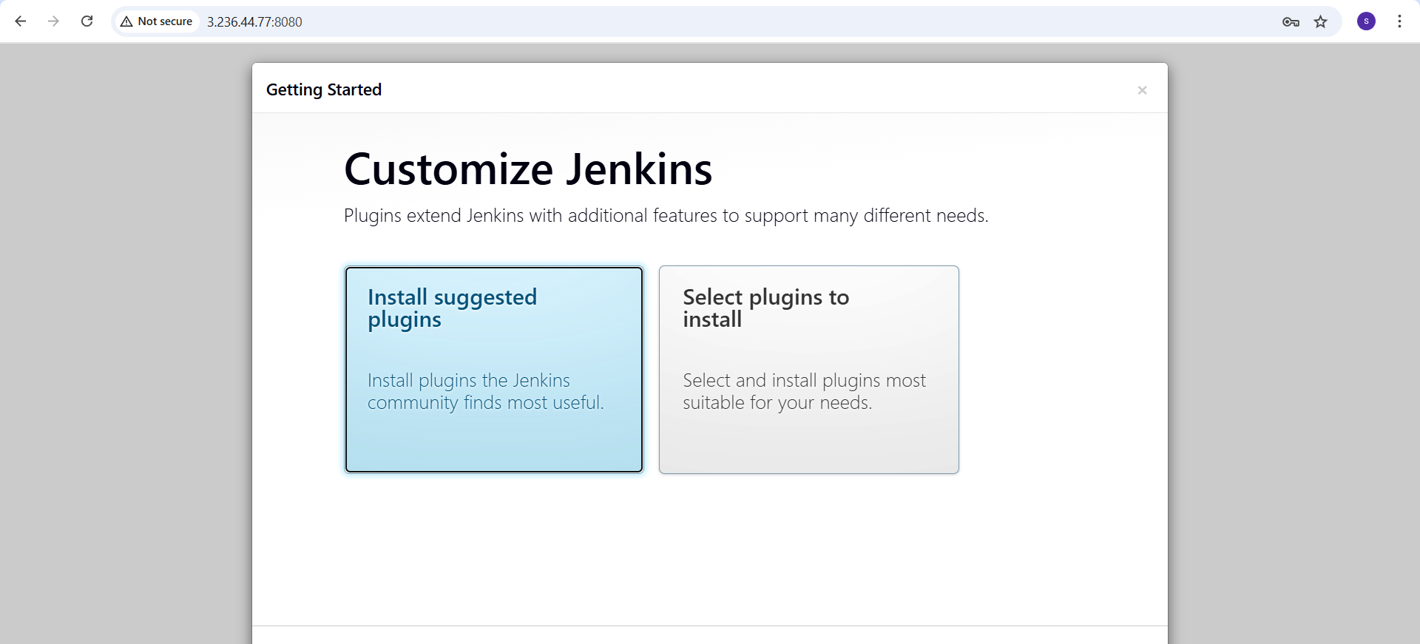
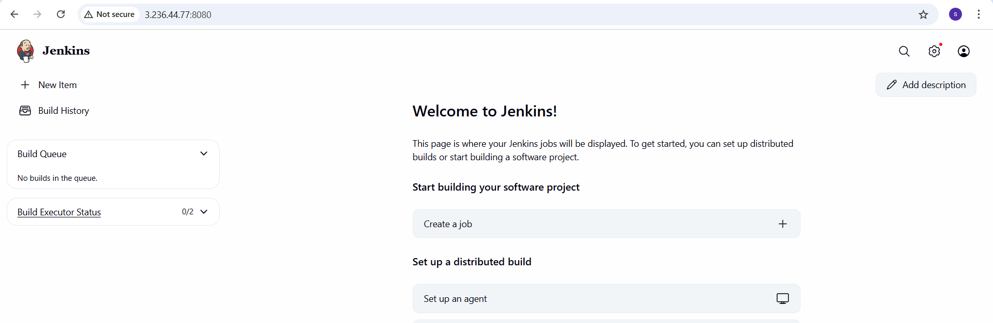
step-4 : create a sample job.
1.From Jenkins dashboard → click new item
2.Enter name: docker-job
3.Select free-style project and then click ok.
4.In build section → add build step → execute shell.
5.Enter command
6.echo “welcome! Jenkins running on Docker!”
