Kubernetes-05
1.Create a namespace dev-environment and apply a resource-based quota that restricts the number of pods to 3 and services to 2.

Step 1 – create the namespace + quota file
File:dev-environment-quota.yaml
Vi dev-environment-quota.yaml
Paste this YAML content:
apiVersion: v1
kind: Namespace
metadata:
name: dev-environment
---
apiVersion: v1
kind: ResourceQuota
metadata:
name: dev-quota
namespace: dev-environment
spec:
hard:
pods: "3"
services: "2"
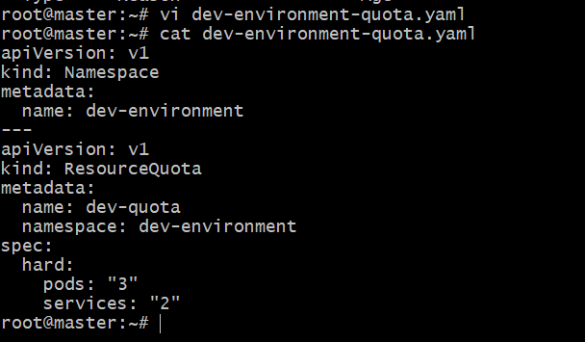
Apply it:
Kubectl apply -f dev-environment-quota.yaml
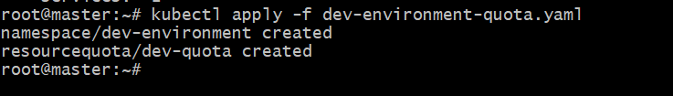

Step 2 – Verify namespace + quota
Kubectl get ns
Kubectl get resourcequota -n dev-environment
Kubectl describe resourcequota dev-quota -n dev-environment
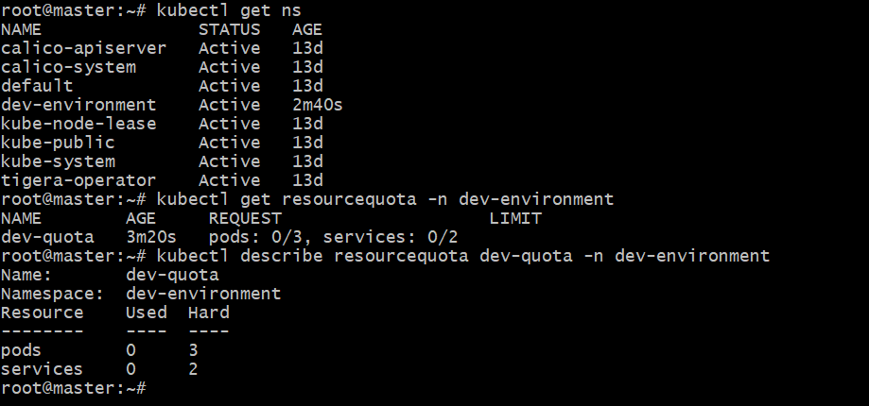

Step 3 – Create 3 pods
File:test-pods.yaml
Vi test-pods.yaml

Paste the content:
apiVersion: v1
kind: Pod
metadata:
name: pod1
namespace: dev-environment
spec:
containers:
- name: nginx
image: nginx
---
apiVersion: v1
kind: Pod
metadata:
name: pod2
namespace: dev-environment
spec:
containers:
- name: nginx
image: nginx
---
apiVersion: v1
kind: Pod
metadata:
name: pod3
namespace: dev-environment
spec:
containers:
- name: nginx
image: nginx
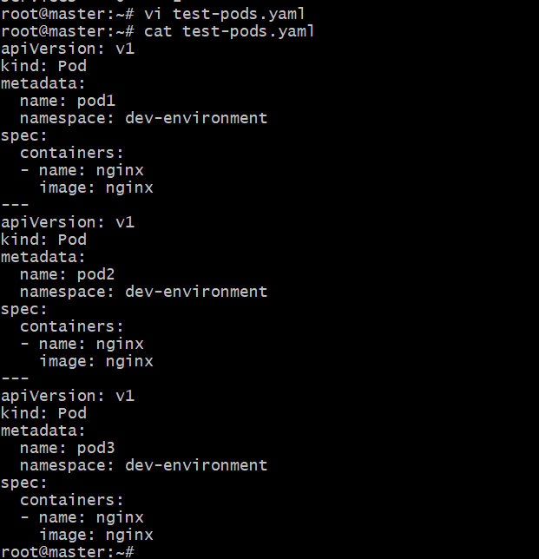
Apply :
Kubectl apply -f test-pods.yaml
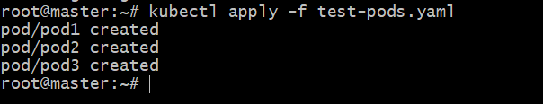
Check pods:
Kubectl get pods -n dev-environment
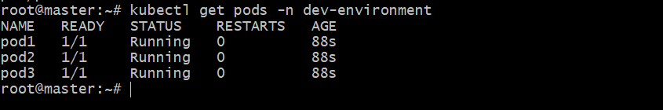

Step 4 – Try creating a 4th pod (should fail)
Kubectl run pod4 --image=nginx -n dev-environment
Expected error:

Step 5 – Check quota usage again
Kubectl describe resourcequota dev-quota -n dev-environment
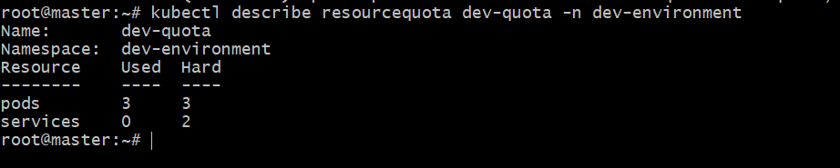

2. Create a pod in the prod-environment namespace with 0.2 CPU and 200Mi memory requests, and 0.5 CPU and 500Mi memory limits.
Step 1 – create a file
File:prod-environment-pod.yaml
apiVersion: v1
kind: Namespace
metadata:
name: prod-environment
---
apiVersion: v1
kind: Pod
metadata:
name: prod-pod
namespace: prod-environment
spec:
containers:
- name: nginx
image: nginx:latest
resources:
requests:
cpu: "200m" # 0.2 CPU
memory: "200Mi" # 200 MiB
limits:
cpu: "500m" # 0.5 CPU
memory: "500Mi" # 500 MiB
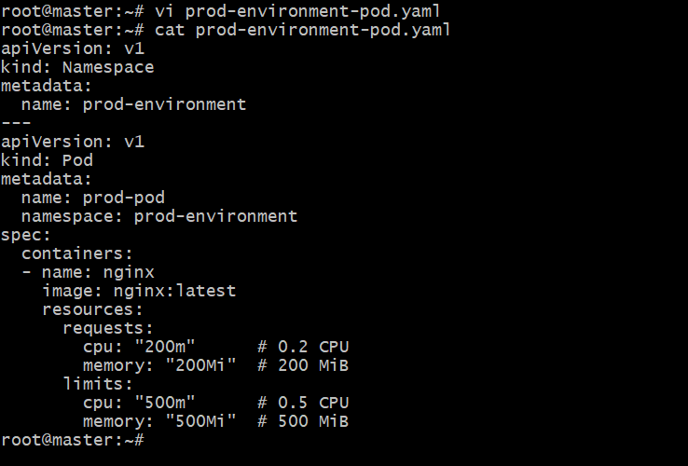

Step 2 – Apply the configuration
Kubectl apply -f prod-environment-pod.yaml
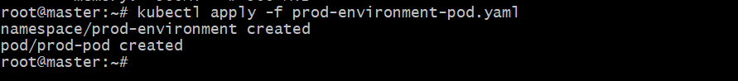

Step 3 – Verify the pod
Kubectl get pods -n prod-environment
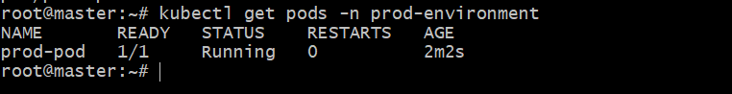

Step 4 – Describe the pod to verify CPU/memory requests and limits
Kubectl describe pod prod-pod-n prod-environment
Look under:
Containers → resources → Requests/Limits
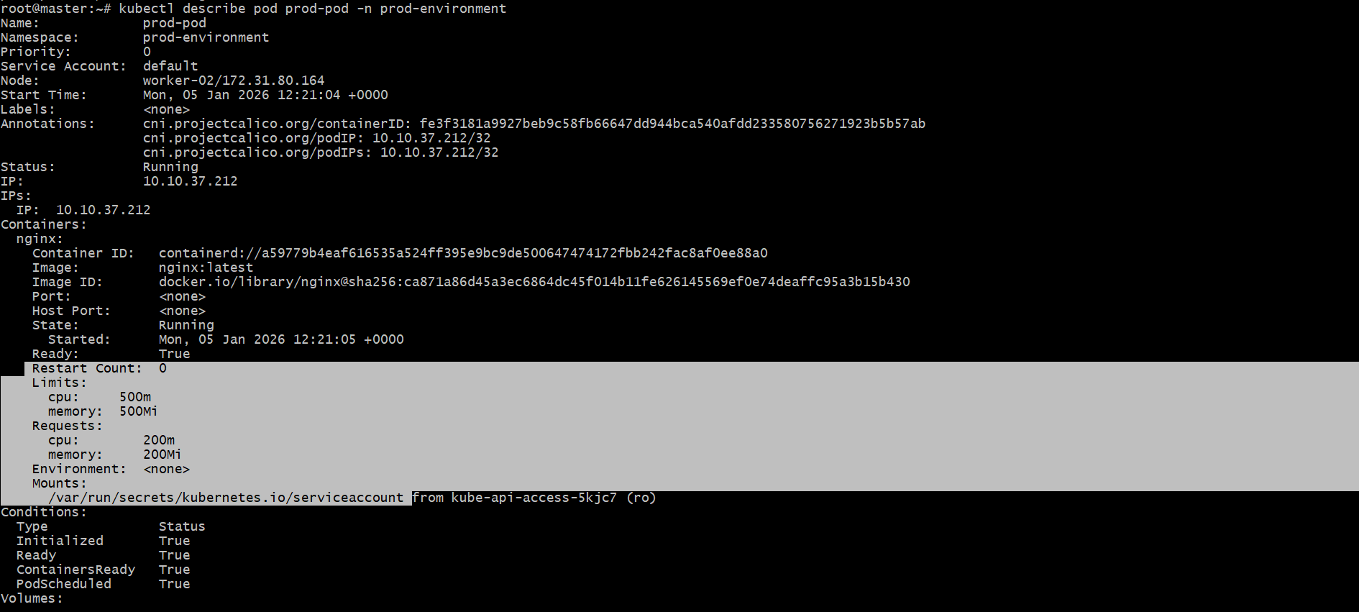

3. In the staging-environment namespace, set a Limit Range that assigns default CPU and memory limits (300m CPU, 600Mi memory) and applies a minimum and maximum CPU.
Step 1 – Create the file
File:staging-limitrange.yaml
apiVersion: v1
kind: Namespace
metadata:
name: staging-environment
---
apiVersion: v1
kind: LimitRange
metadata:
name: staging-limits
namespace: staging-environment
spec:
limits:
- type: Container
default:
cpu: "300m" # Default CPU limit
memory: "600Mi" # Default Memory limit
defaultRequest:
cpu: "200m" # Default CPU request
memory: "400Mi" # Default Memory request
min:
cpu: "100m" # Minimum CPU
memory: "200Mi" # Minimum Memory (optional)
max:
cpu: "500m" # Maximum CPU
memory: "1Gi" # Maximum Memory (optional)
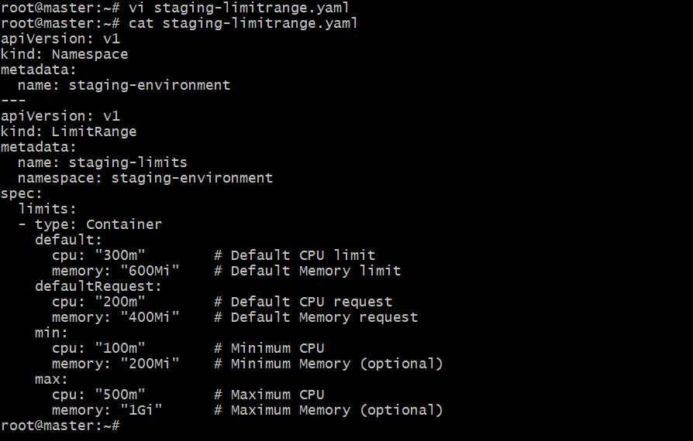

Step 2 – Apply the LimitRange
Kubectl apply -f staging-limitrange.yaml
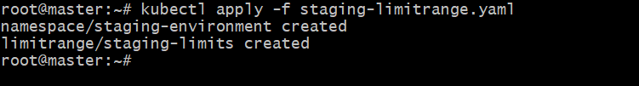
Step 3 – Check LimitRange created
Kubectl get limitrange -n staging-environment

Step 4 – Describe LimitRange for full details
Kubectl describe limitrange staging-limits -n staging-environment
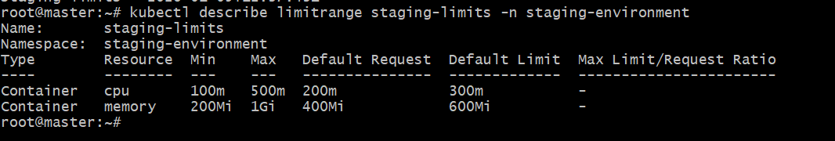

4. Create a pod and a Node port service in the default namespace, then create another pod in the test namespace and communicate between them using service DNS.
Step 1 – create the file
File: default-test-communication.yaml
# 1. Pod in default namespace
apiVersion: v1
kind: Pod
metadata:
name: web-pod
namespace: default
labels:
app: web
spec:
containers:
- name: nginx
image: nginx:latest
ports:
- containerPort: 80
---
# 2. NodePort Service in default namespace
apiVersion: v1
kind: Service
metadata:
name: web-service
namespace: default
spec:
type: NodePort
selector:
app: web
ports:
- port: 80
targetPort: 80
nodePort: 30082 # NodePort range: 30000–32767
---
# 3. Namespace: test
apiVersion: v1
kind: Namespace
metadata:
name: test
---
# 4. Pod in test namespace
apiVersion: v1
kind: Pod
metadata:
name: client-pod
namespace: test
spec:
containers:
- name: curl
image: curlimages/curl:latest
command: ["sleep", "3600"]

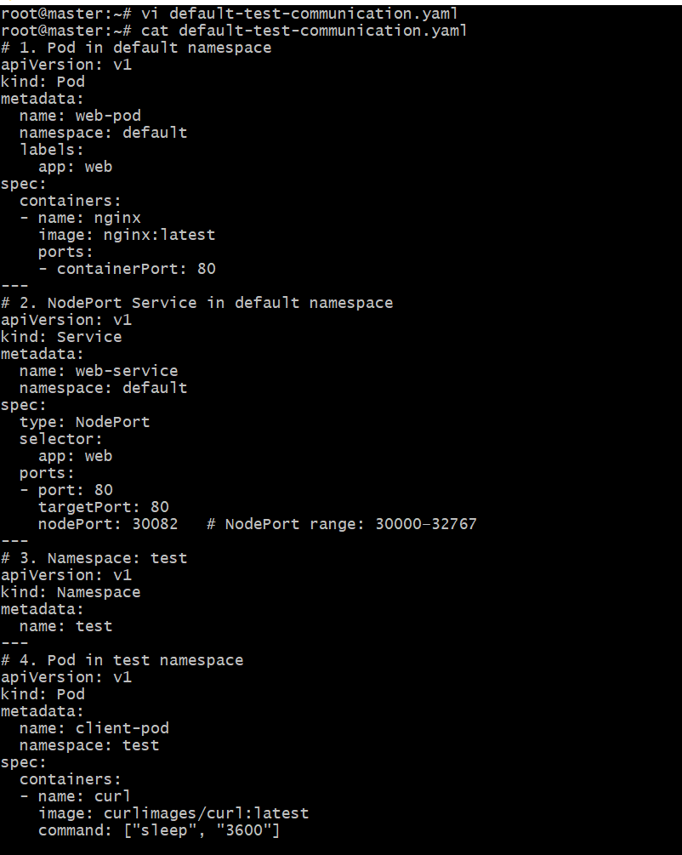

Step 2 – Apply the YAML
Kubectl apply -f default-test-communication.yaml
Port no:30080 is already allocated. So change the port no:30080 → 30082
Again run:
Vi default-test-communication.yaml
Here, edit portno:30080 to 30082
And run:
Cat default-test-communication.yaml
And apply again
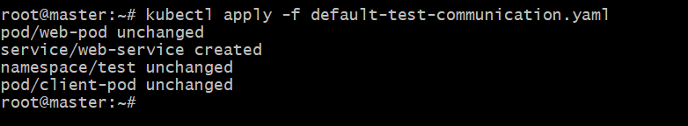

Step 3 – Wait for pods to running
Kubectl get pods -n default
Kubectl get pods -n test
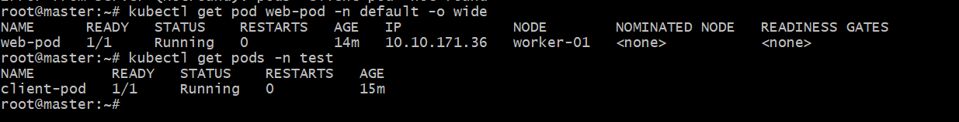

Step 4 – service DNS Format
Kubernetes service use:
<service-name>.<namespace>.svc.cluster.local
For our service:
Web-service.default.svc.cluster.local

Step 5 – Test communication from test namespace pod
Kubectl exec -n test client-pod --curl web-service.default.svc.cluster.local
Here, I got an error.
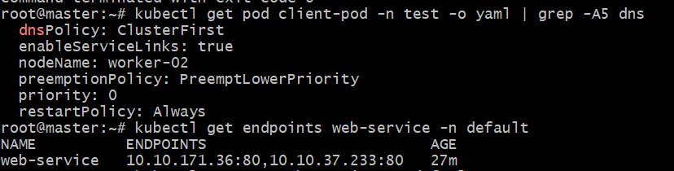
Through cluster ip , we can test
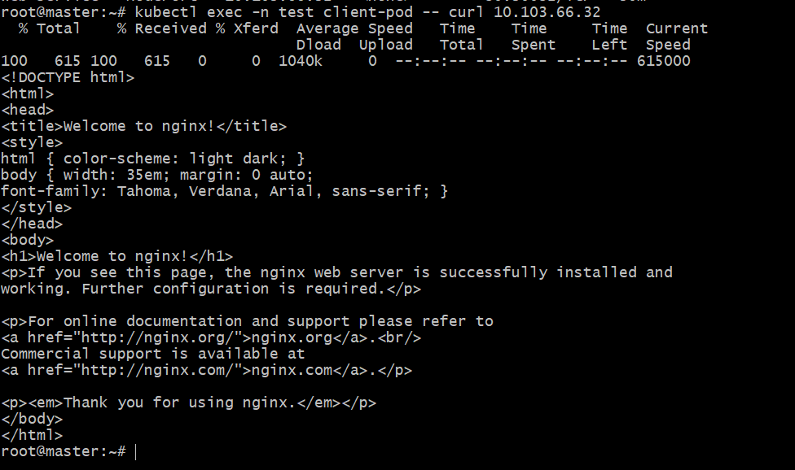

5. Apply a Limit Range with a max limit/request ratio of 2 for memory in the performance-environment namespace, and test by creating a pod with mismatched resource requests and limits.

Step 1 – Create the performance-environment namespace + LimitRange
File: performance-limitrange.yaml
# Namespace
apiVersion: v1
kind: Namespace
metadata:
name: performance-environment
---
# LimitRange with maxLimitRequestRatio = 2 for memory
apiVersion: v1
kind: LimitRange
metadata:
name: performance-limits
namespace: performance-environment
spec:
limits:
- type: Container
maxLimitRequestRatio:
memory: 2
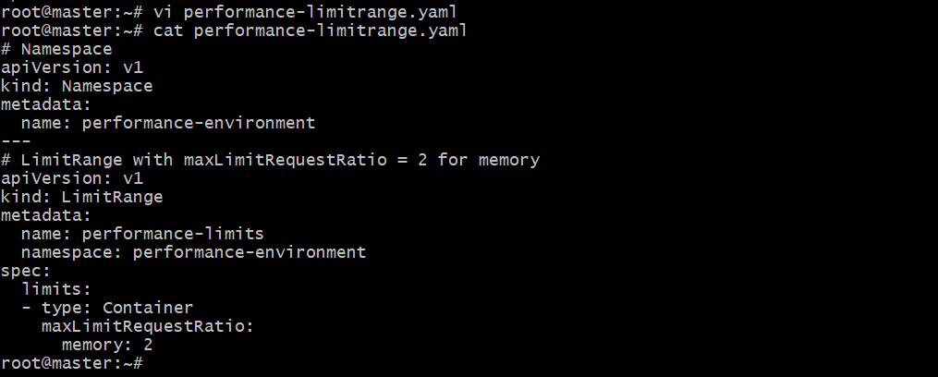

Step 2 – Apply the LimitRange
Kubectl apply -f performance-limitrange.yaml
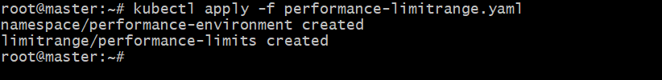

Step 3 – Verify the LimitRange
Kubectl describe limitrange performance-limits -n performance-environment
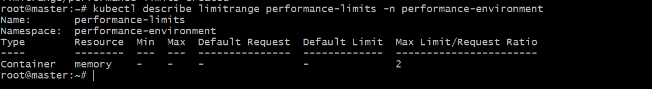
Step 4 – Test with a violating pod (should fail)
Memory ratio = limit/request = 500Mi / 200Mi=2.5 → ❌ not allowed
File: perf-test-pod.yaml
apiVersion: v1
kind: Pod
metadata:
name: perf-test-pod
namespace: performance-environment
spec:
containers:
- name: nginx
image: nginx:latest
resources:
requests:
memory: "200Mi"
limits:
memory: "500Mi" # ❌ ratio = 2.5 (not allowed)
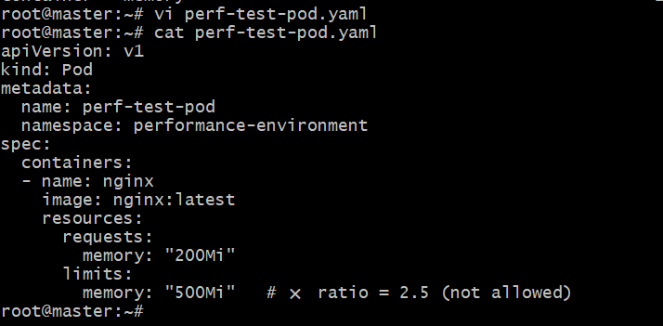
Apply it:
Kubectl apply -f perf-test-pod.yaml

Step 5 -Apply a corrected pod (should succeed)
Correct ratio: 400Mi / 200Mi = 2.0 → ✅ allowed
Update the file or create a new one:
File: perf-test-pod.yaml(correct version)
Paste the content in YAML file:
apiVersion: v1
kind: Pod
metadata:
name: perf-test-pod-ok
namespace: performance-environment
spec:
containers:
- name: nginx
image: nginx:latest
resources:
requests:
memory: "200Mi"
limits:
memory: "400Mi" # ✔ ratio = 2 (allowed)
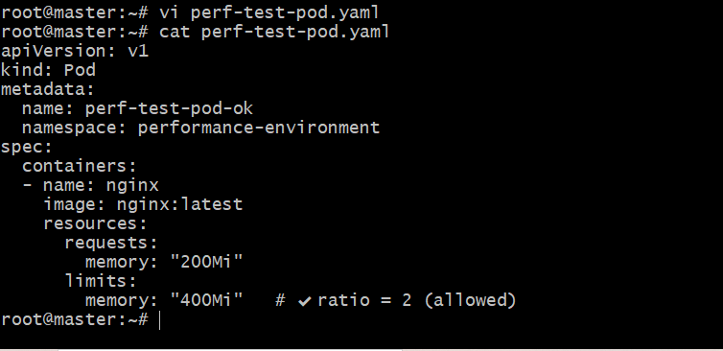
Apply:
Kubectl apply -f perf-test-pod.yaml
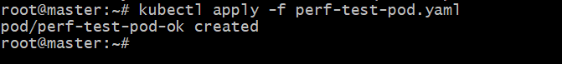
Check pod:
Kubectl get pods -n performance-environment
