- Configure 2 slave machines in Jenkins master.
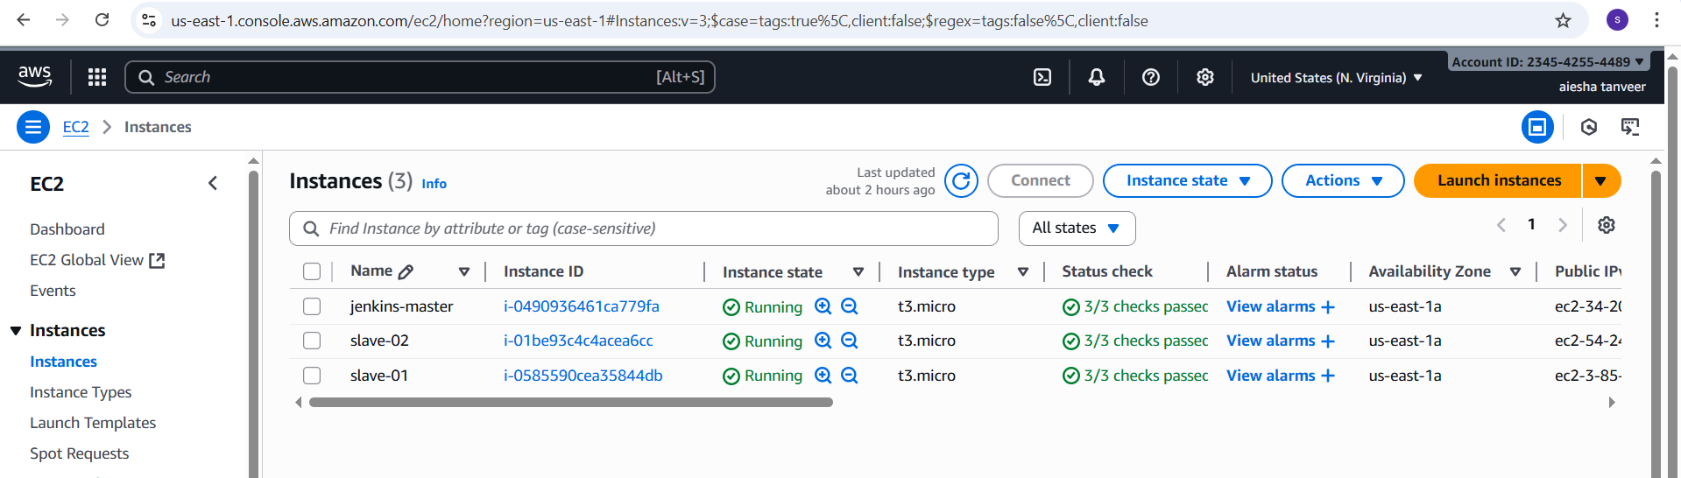
Step-1: Create slave-01 ec2
Login to slave machine
Switch to root user
dnf install -y java-17-amazon-corretto
Create ssh-keygen
Cat id_rsa.pub>authorized_keys
Chmod 700 authorized_keys
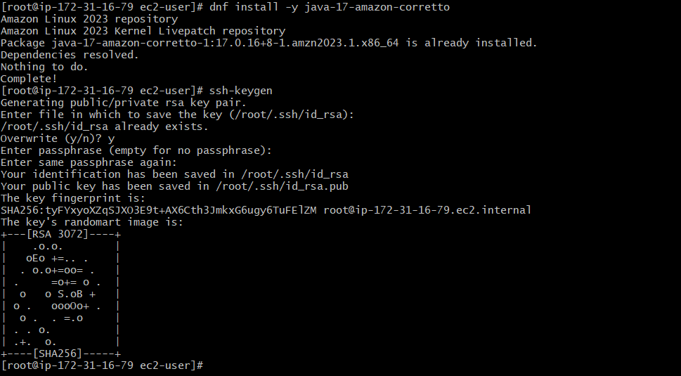

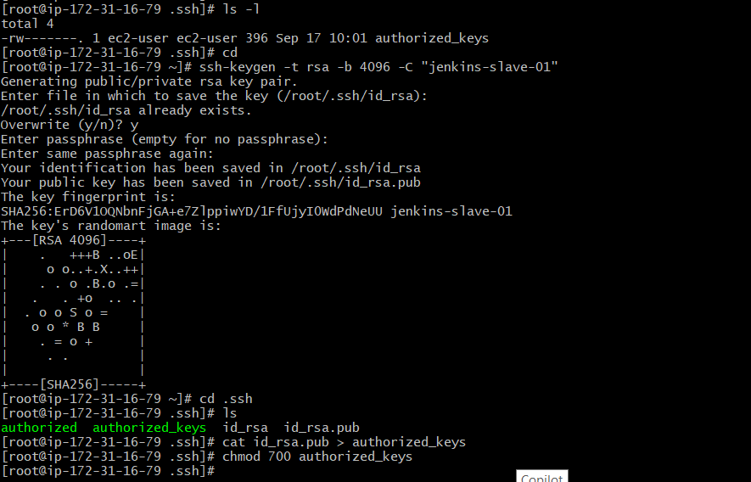
Login to master machine
Switch to root user
mkdir -p /var/lib/Jenkins/.ssh
cd /var/lib/Jenkins/.ssh
ssh-keyscan -H SLAVE-NODE-IP-OR-HOSTNAME >> /var/lib/Jenkins/.ssh/known_hosts
# ssh-keyscan -H 34.207.82.178 >> /var/lib/Jenkins/.ssh/known_hosts
Chown Jenkins:Jenkins known_hosts
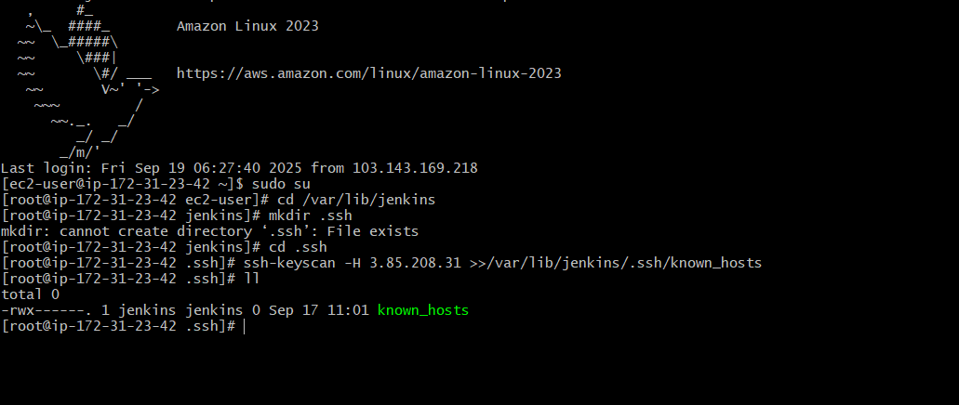
Jenkins-master : public ip: 34.207.82.178 private ip : 172.31.23.42
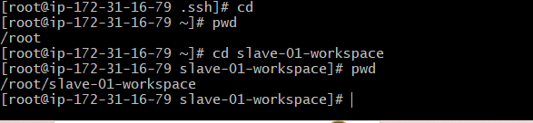
Slave-01 : public ip → 3.85.208.31
Private ip : 172.31.16.79

Steps on Jenkins GUI
Go to Manage Jenkins → Manage nodes and clouds → New node
Give it a name → slave-01
Select permanent agent
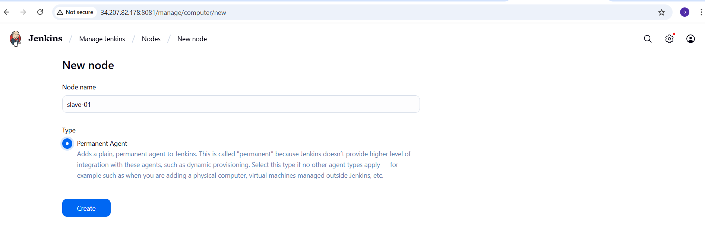
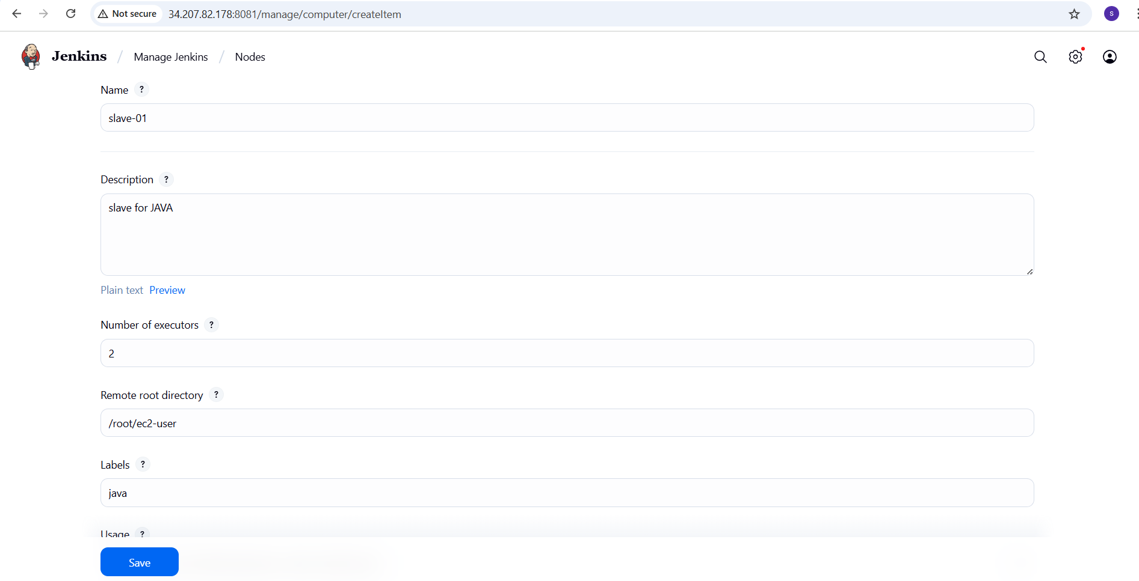
Save and test connectivity
- Jenkins master should connect to the slave machine via SSH.
- If successful the node status will be in Online
Remote root directory will not be in root
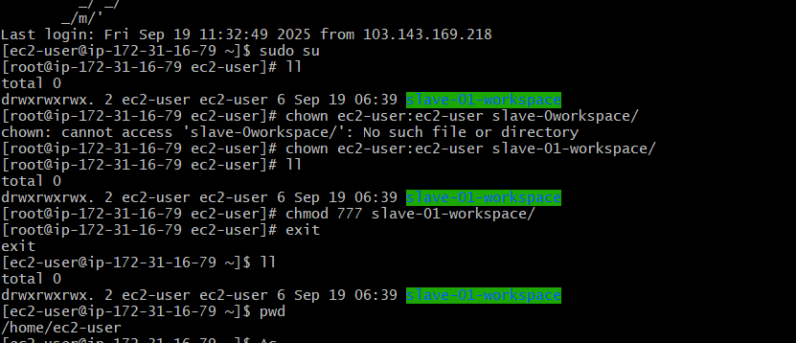
Slave-01 : public ip : 3.85.208.31
Private ip : 172.31.16.79
- In pwd the path is /home/ec2-user
Now add this path to remote root directory of created node (slave-01)
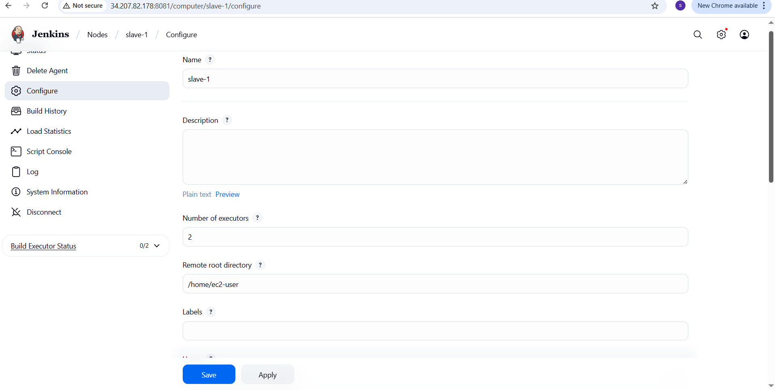

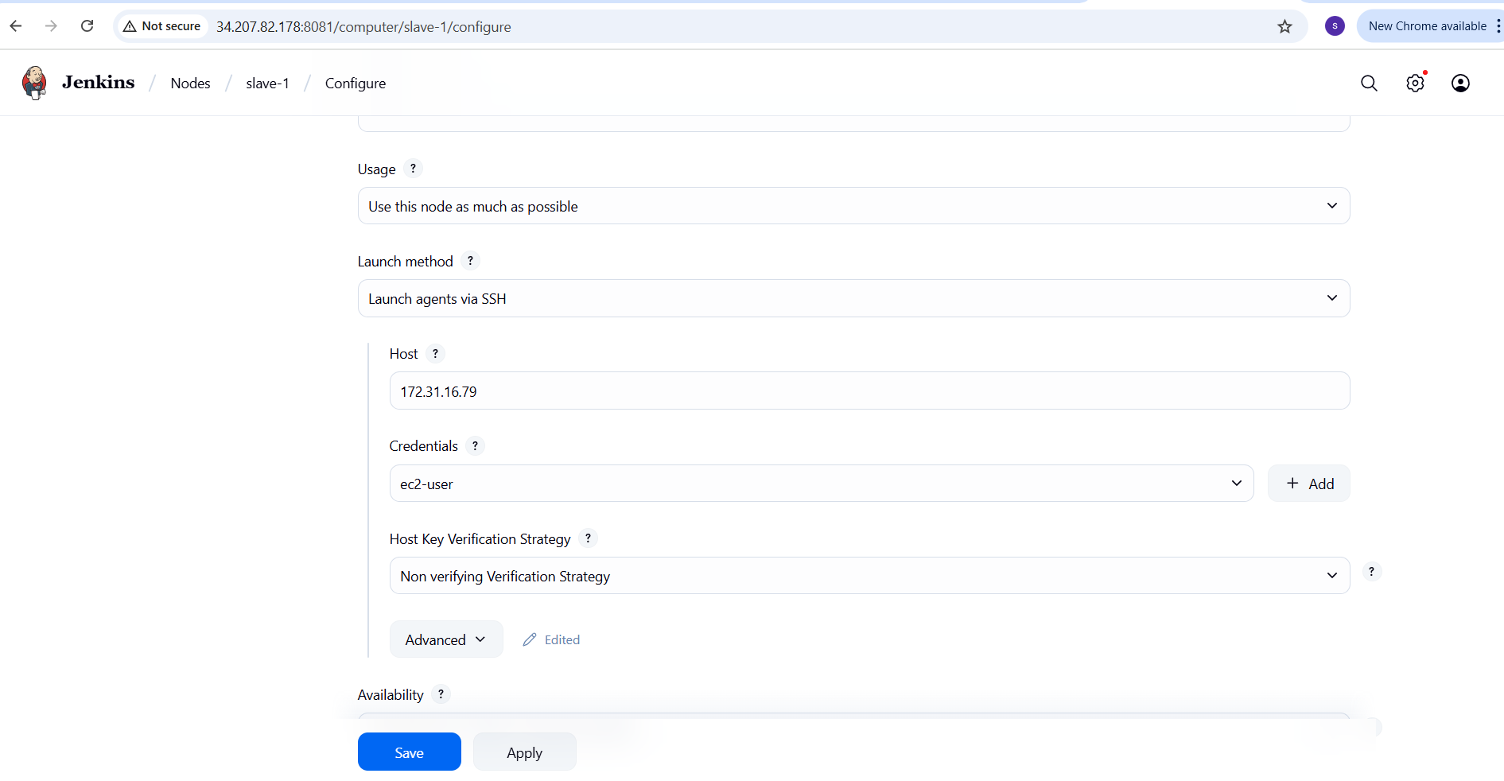
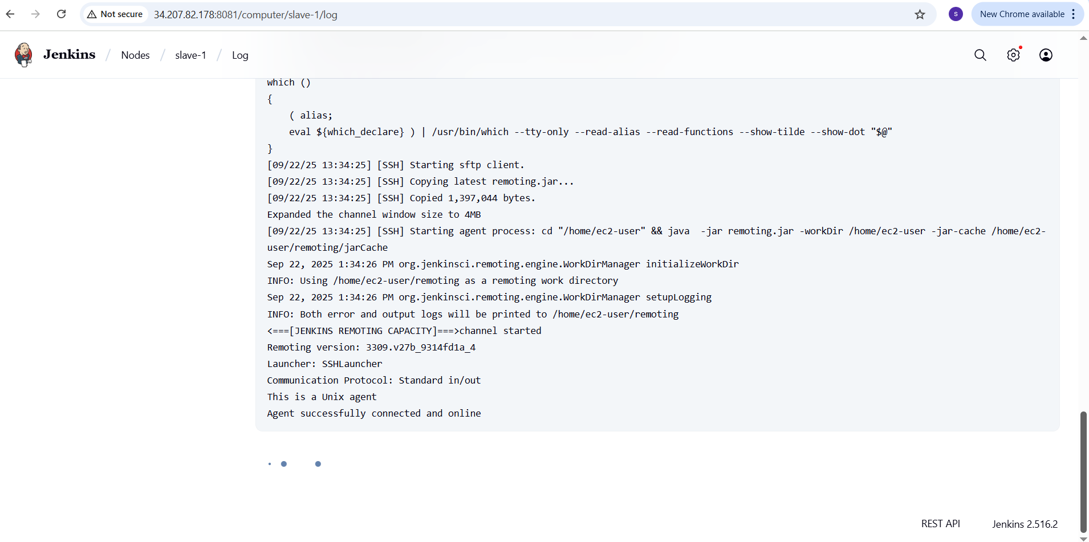
Create a job slave-1 and configure it in java label
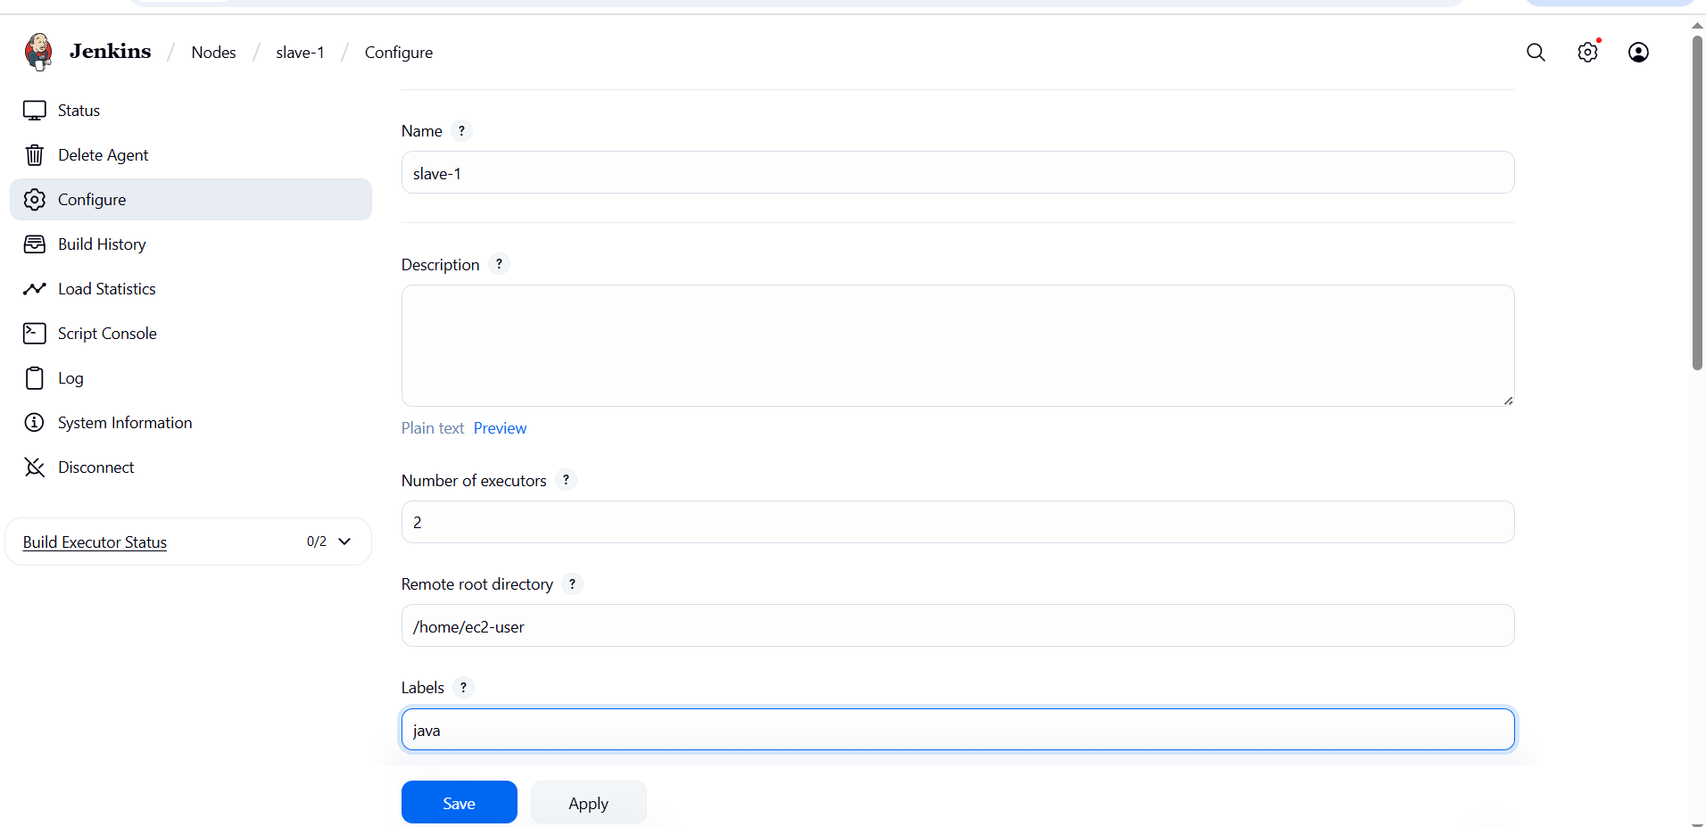
Create a job: slave-1
Select free-style project → click ok
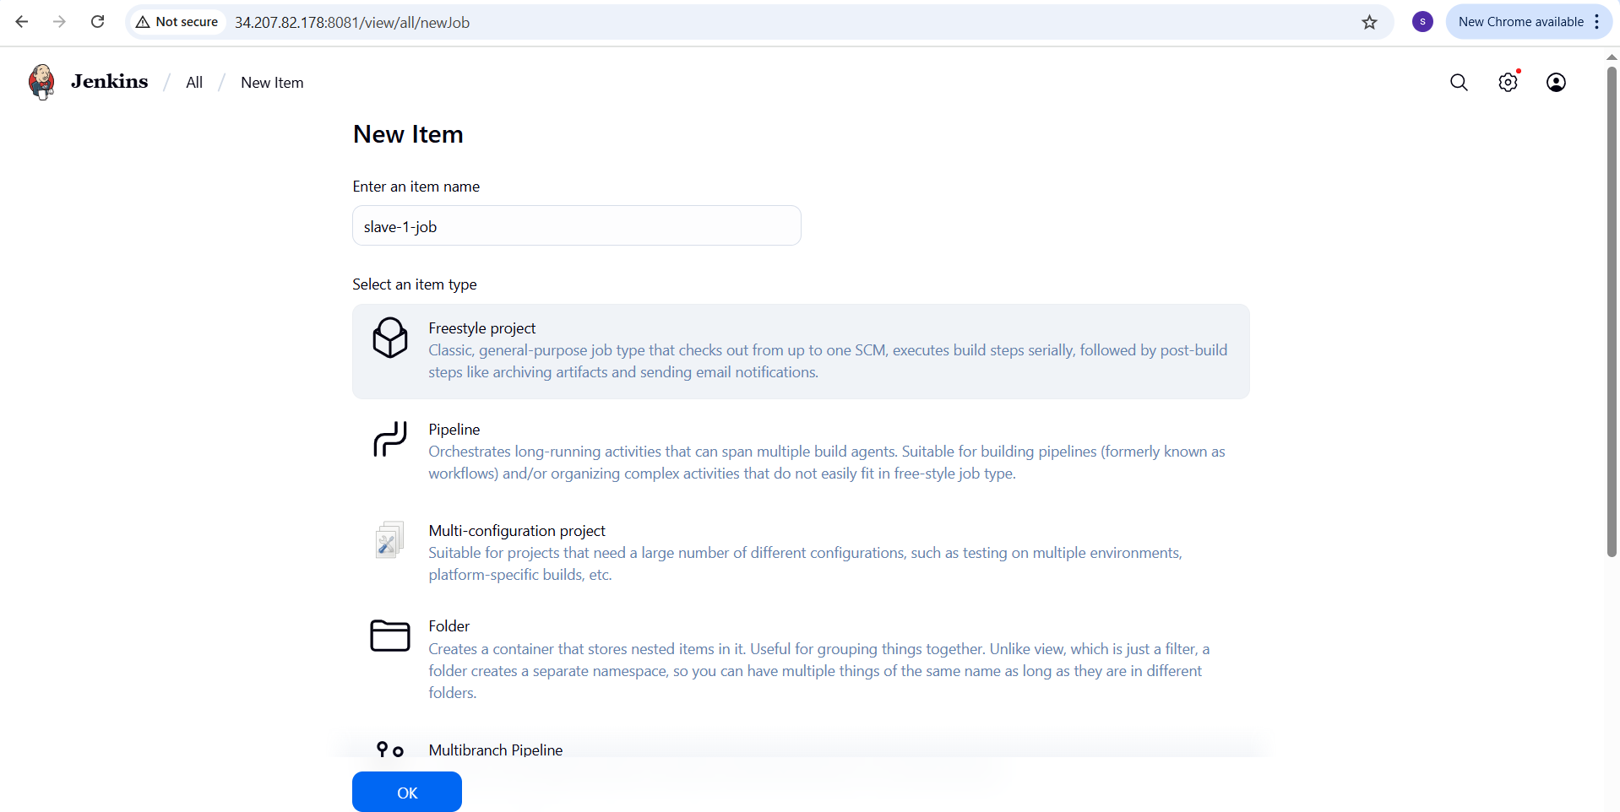
Tie a job to slave:
In job configuration → scroll to Restrict where the project can be run
Enter the lable : java
This ensures the job to run on slave
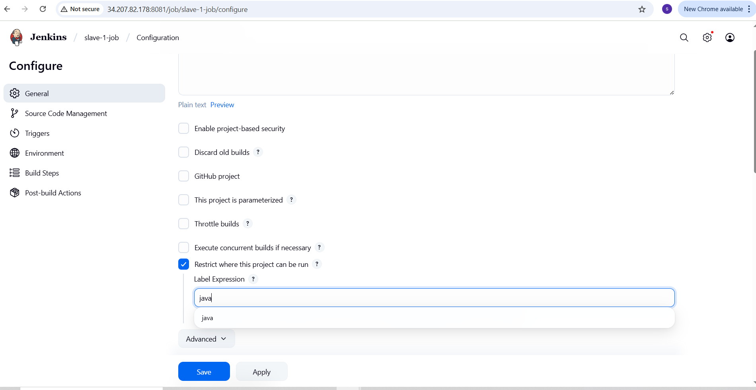
Save and build
Go to console output → we can see java from slave-1 and hostname conforming it ran successfully.
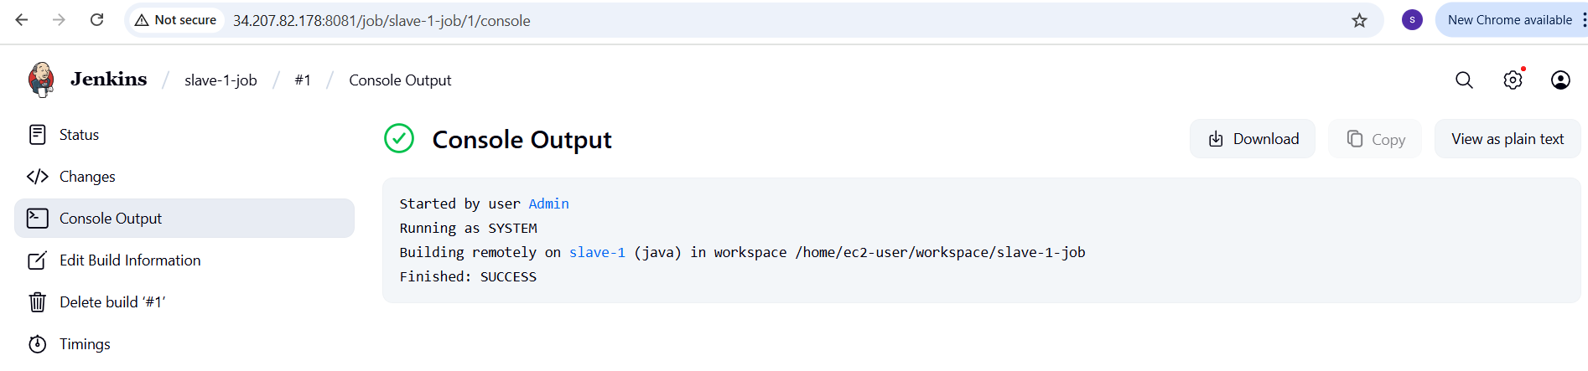 Similarly create the node of slave-2 agent
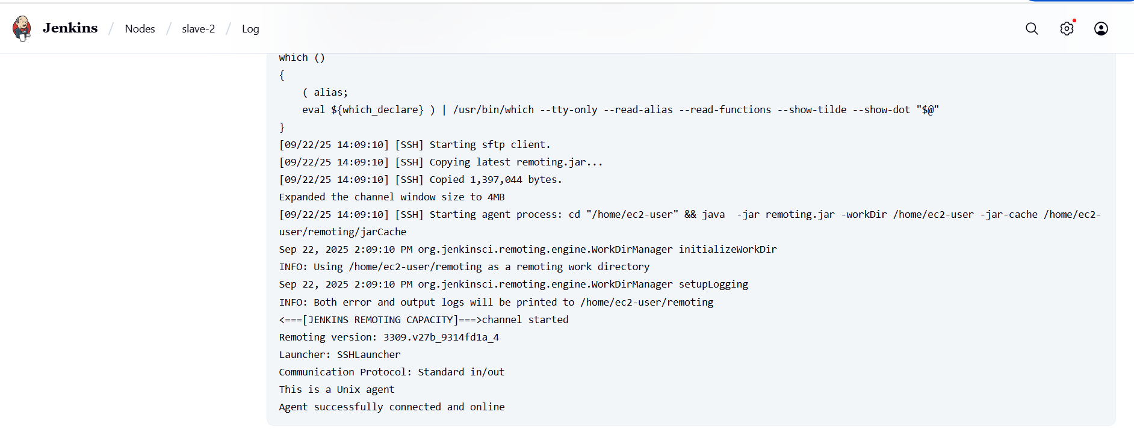
Now we can see 1 master node and 2 slave nodes.
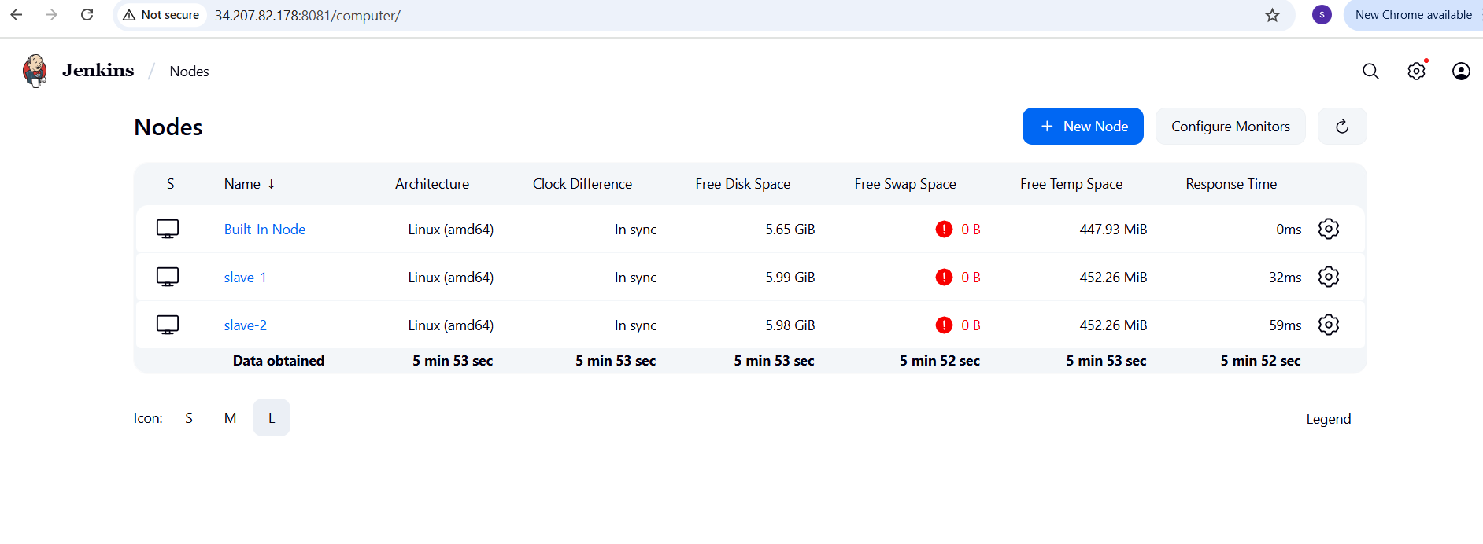
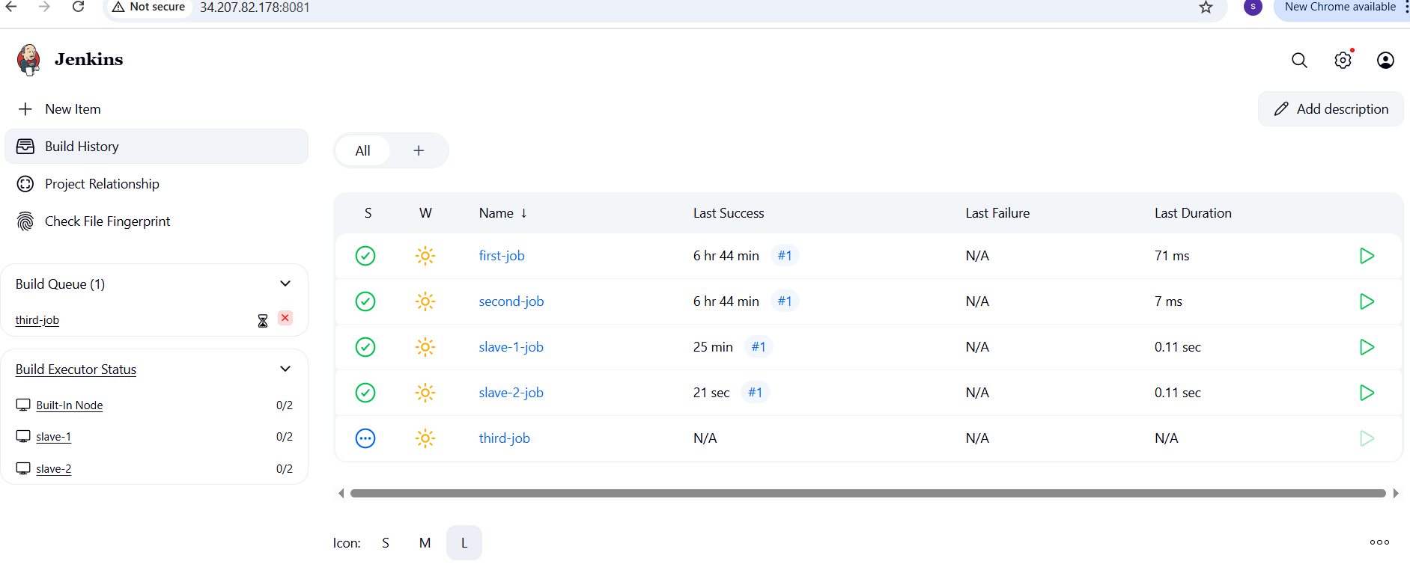
- Configure webhooks to Jenkins job.
Go to github repo → settings → webhooks → payload URL
( http://34.207.82.178:8081//github-webhook/) → content type(Application/json) → Select send me everything → Click add webhooks.
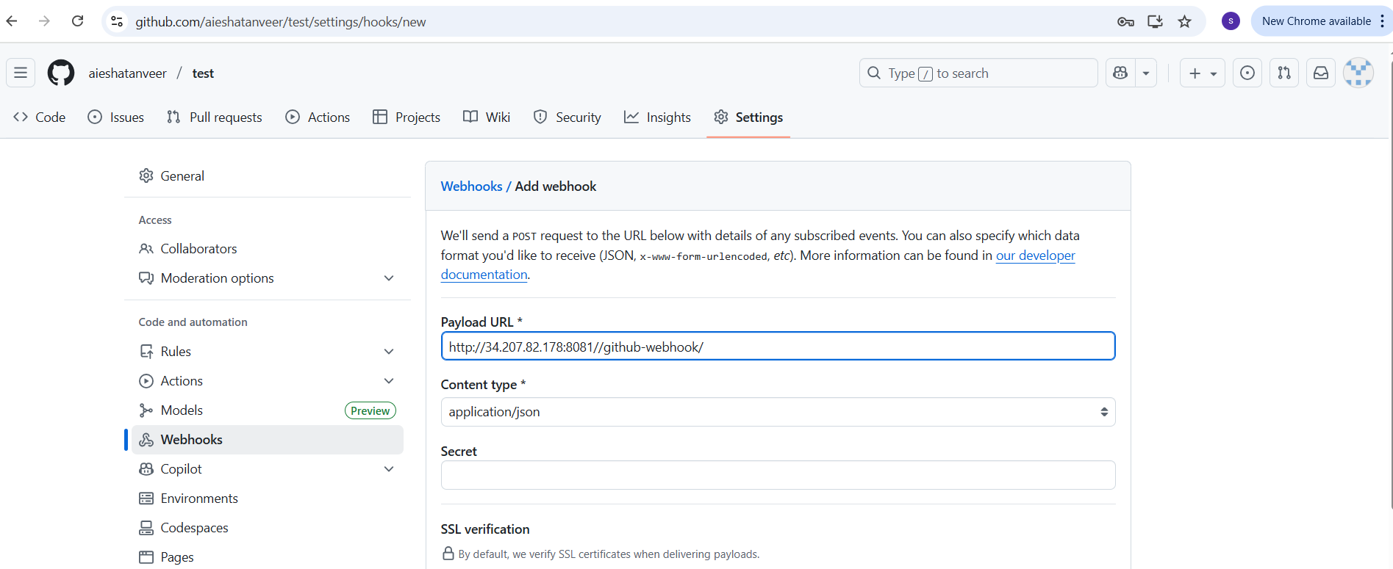
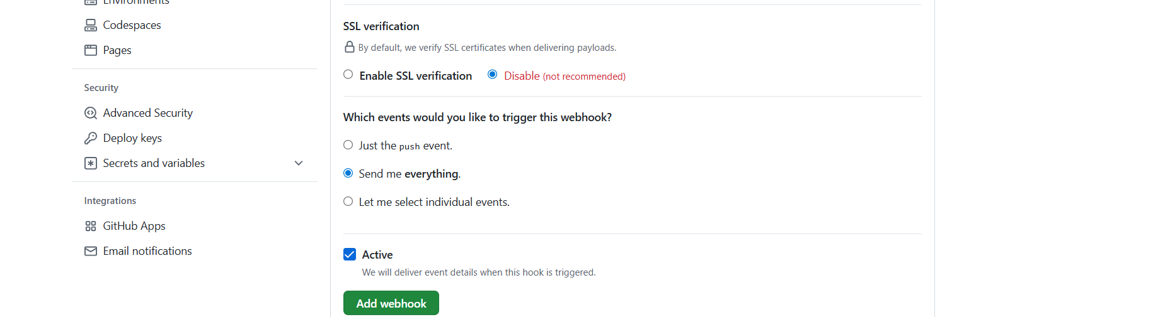
Go to Jenkins → select your job (first-job) → add Github URL in git repository → Select Poll SCM in Triggers → To keep sleep 60 in Execute Shell → Click Save
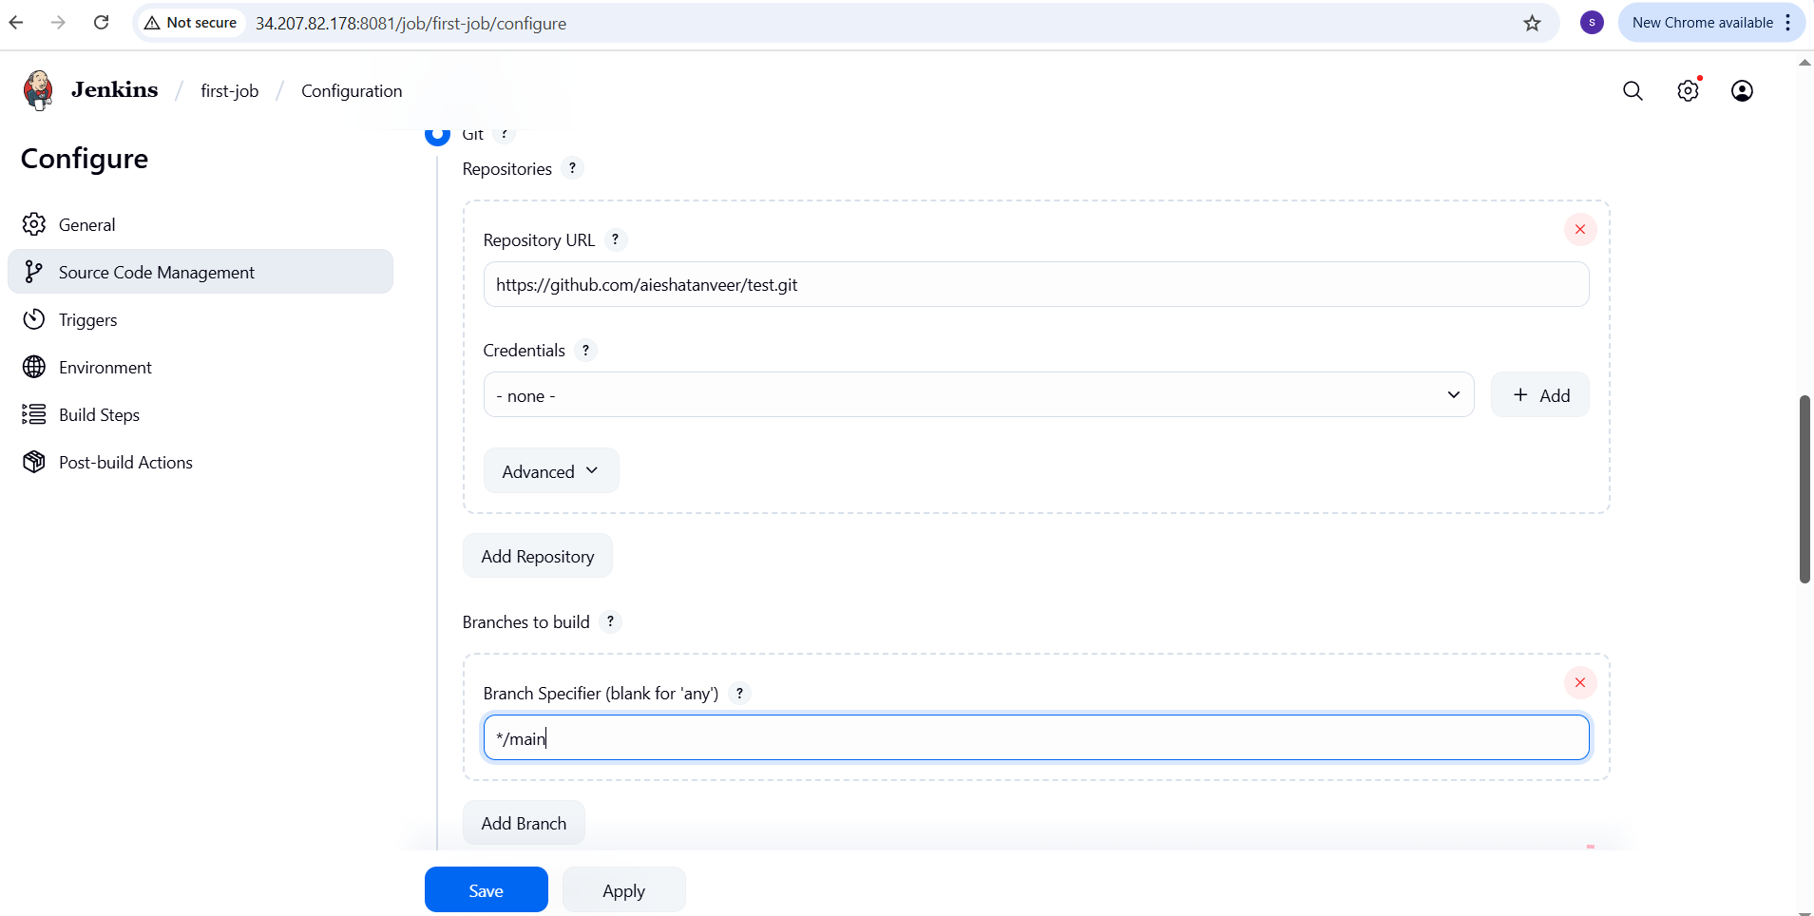
Go to Github repo and change or edit or update any of the source code and commit.

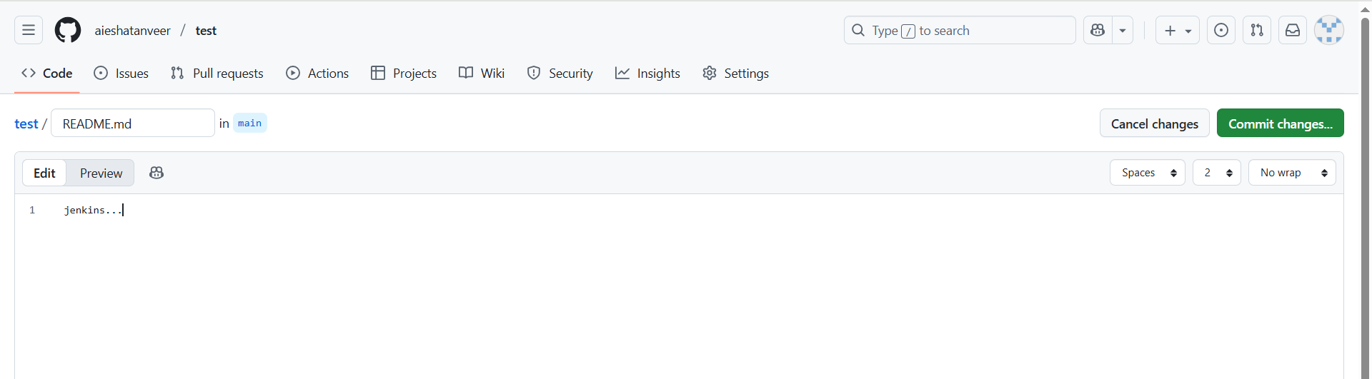
We see job triggers automatically in Jenkins.
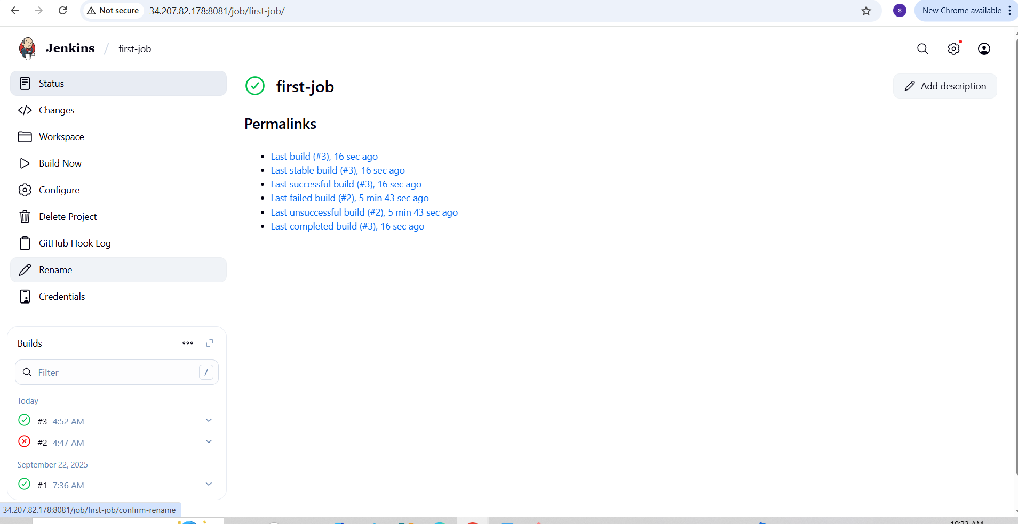
- Configure poll scm and build periodical options in Jenkins job.
To configure poll scm in Jenkins job:
Go to Jenkins → Select your job (first-job) → Add Github URL in git repository → Select in triggers → To keep sleep 15 in Execute shell → Click save.
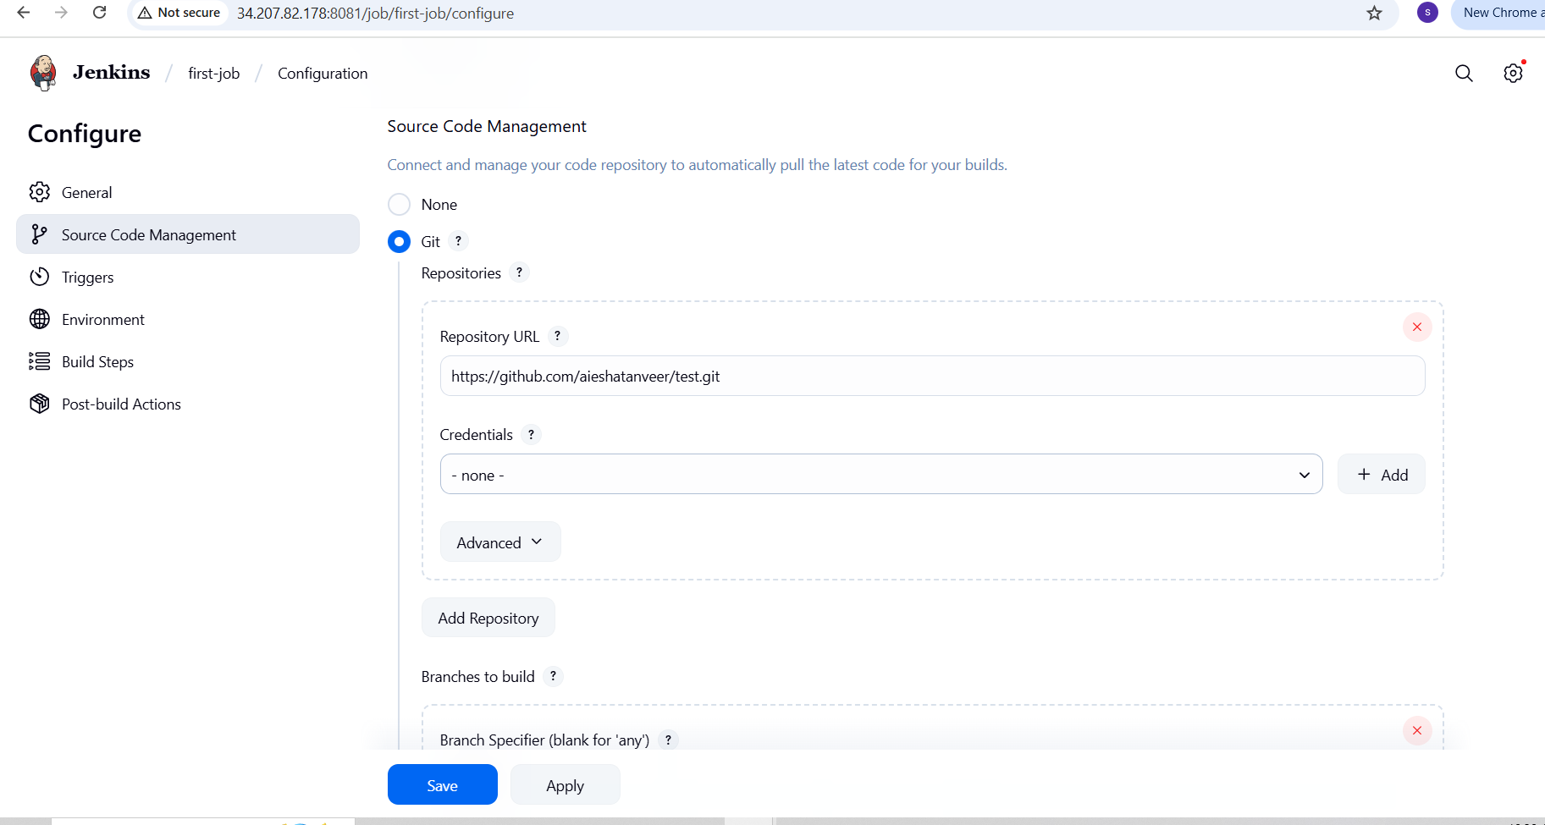
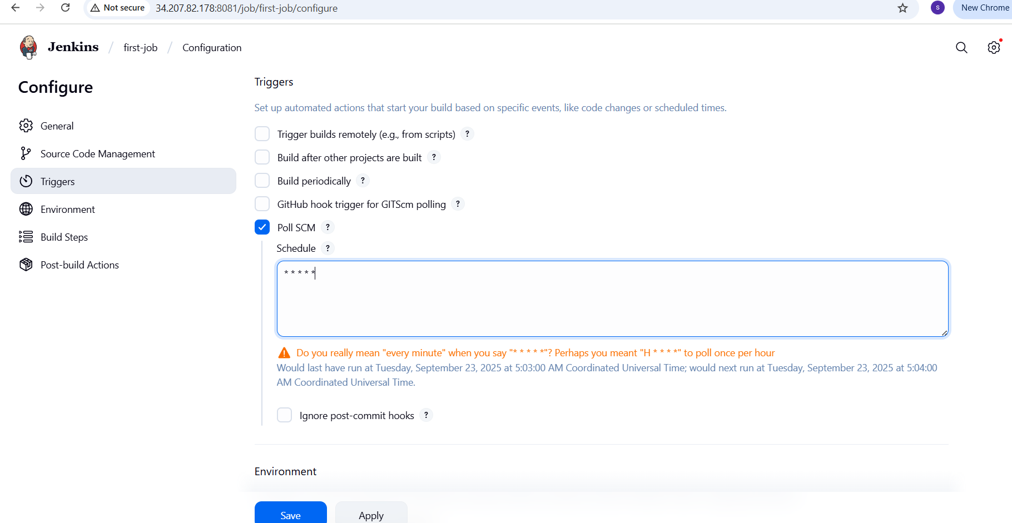

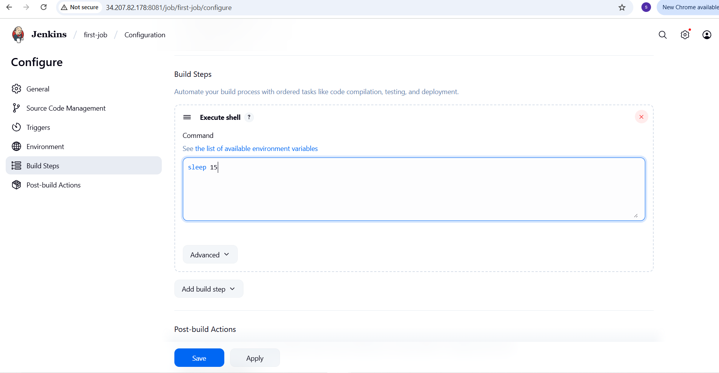
Go to github and commit changes

We see the job trigger in Jenkins
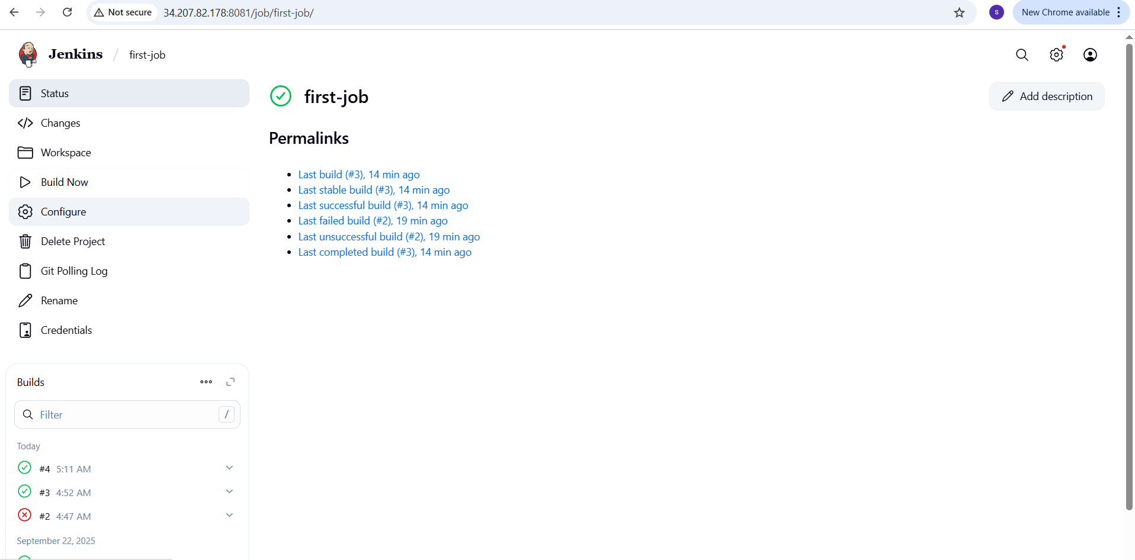
To configure build periodical options in Jenkins job
Go to Jenkins → select the first-job Add github URL in git repository → Select Build periodically in triggers → To keep sleep 15 in Execute shell → Click save
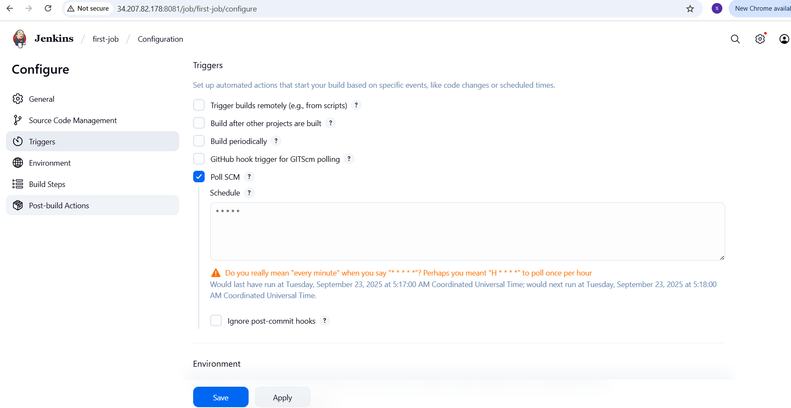
Then we see triggers continuously without commit changes.
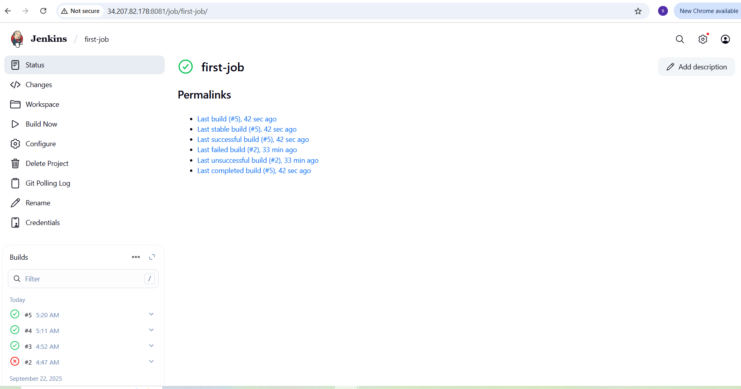
- Take backup of Jenkins server by using bash script.

Create a script

Vi Jenkins-backup.bash
#!/bin/bash
BACKUP_DIR=”/backup/Jenkins”
JENKINS_HOME=”/var/lib/jenkins”
DATE=$(date+%F-%H-%M)

mkdir -p $BACKUP_DIR
tar -czvf $BACKUP_DIR/Jenkins-backup-$DATE.tar.gz $JENKINS_HOME
echo “Backup completed: $BACKUP_DIR/Jenkins-backup-$DATE.tar.gz”
Give permission → chmod 700 backup.bash

./backup.bash
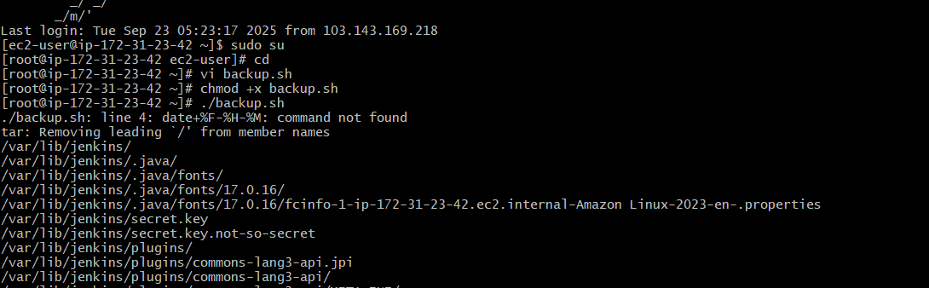
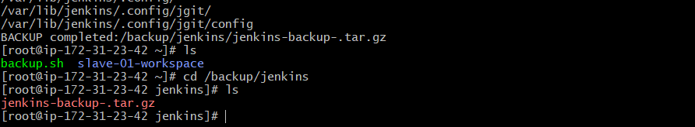
- Take backup of Jenkins using rethin backup plugin.
Install thinbackup from plugin in Jenkins
Go to Jenkins → Manage Jenkins → plugin
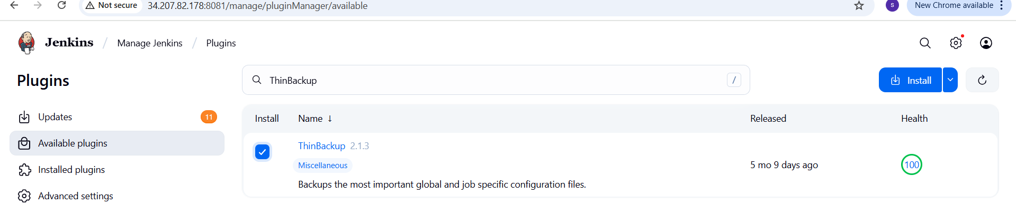
In Tools and actions we get Thinbackup
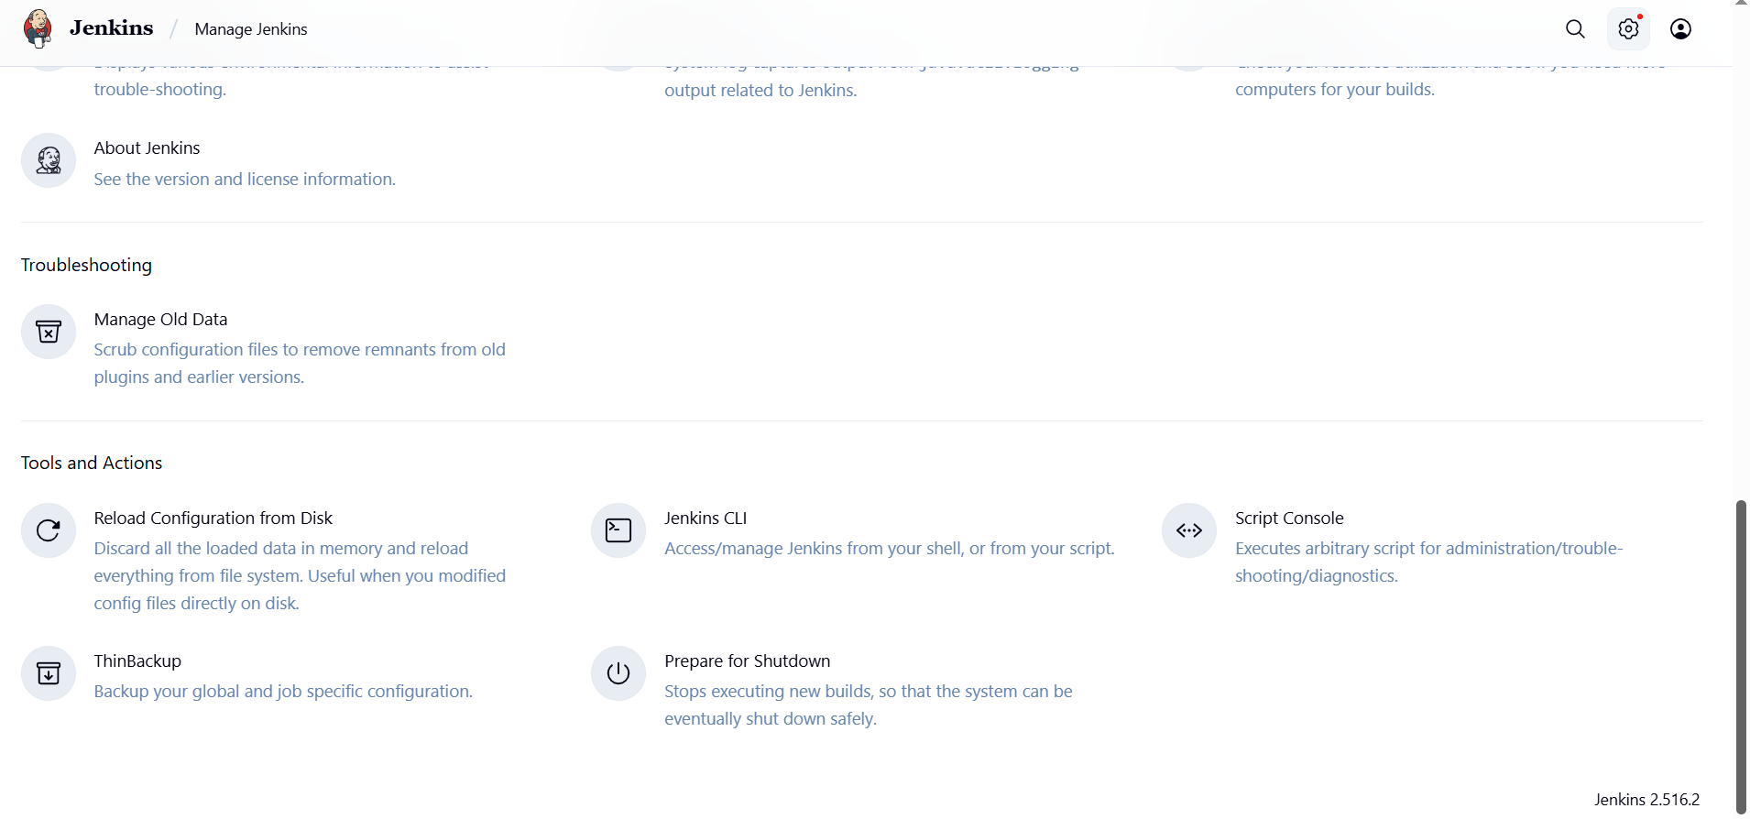

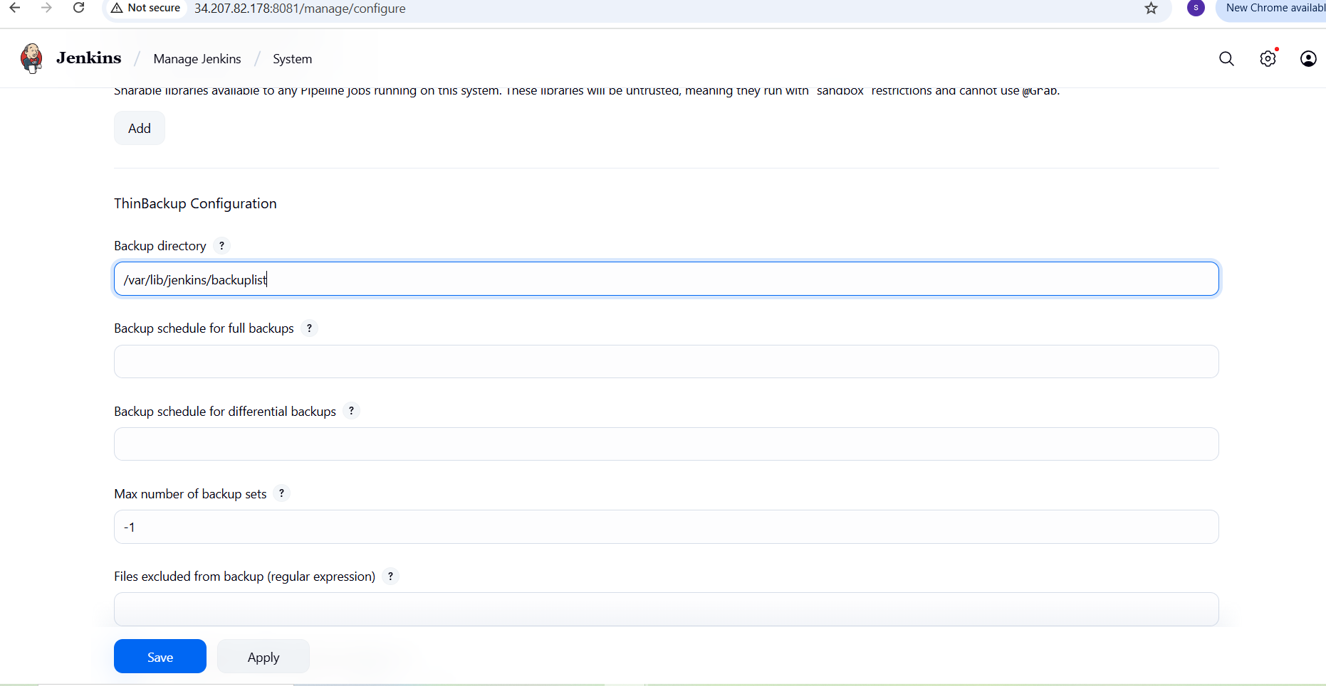
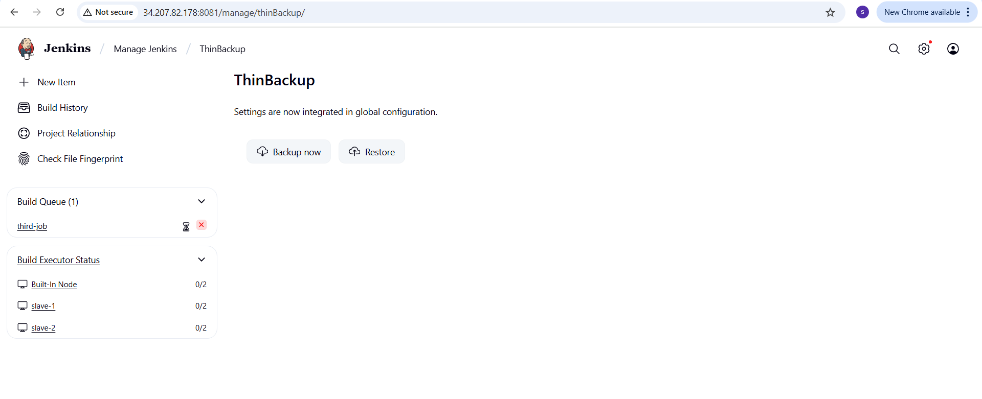
6.Setup a new Jenkins server and dump the backup taken in task4.
Launch a new EC2 instance (Backup-jenkins-master)

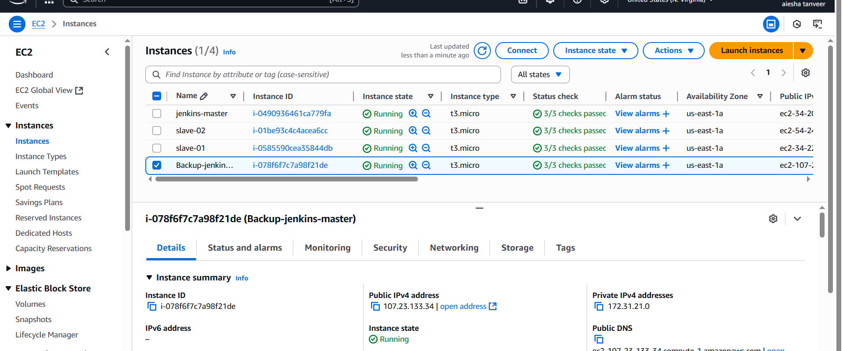
Install Java : Sudo dnf install -y java-17-amazon-corretto
Add Jenkins Repository : Sudo wget -O /etc/yum.repos.d/Jenkins.repo
https://pkg.jenkins.io/redhat-stable/jenkins.repo
sudo rpm --import https://pkg.jenkins.io/redhat-stable/jenkins.io-2023.key
Install Jenkins : sudo yum install Jenkins -y
Systemctl enable Jenkins
Systemctl start Jenkins
Systemctl status jenkins
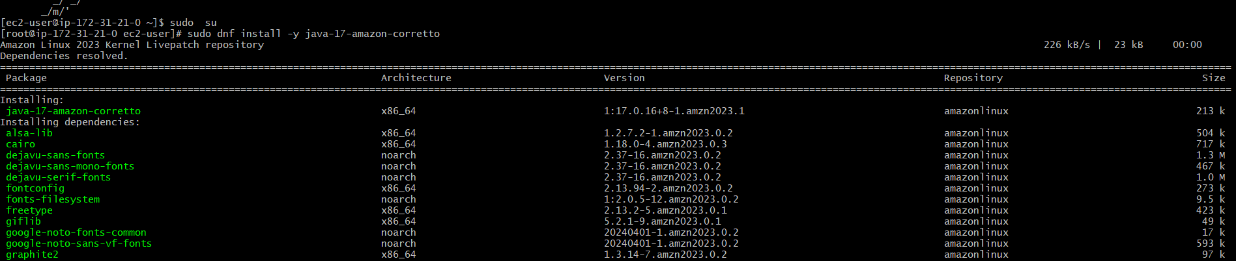
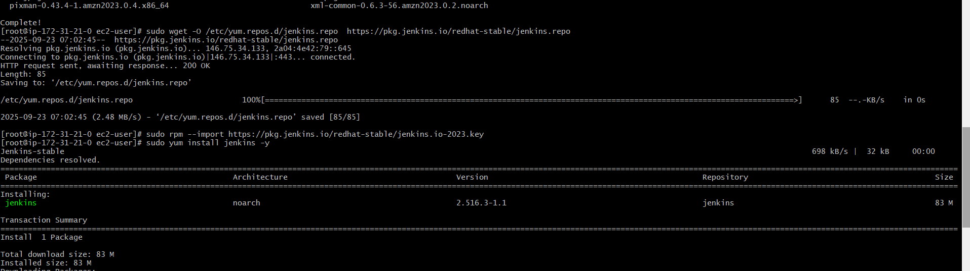
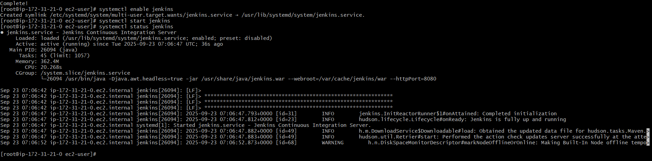
Copy the backup to new server
Login to old Jenkins server where backup is taken
Create an test.pem file where we copy our pem key of new Jenkins server and paste it in old server.
Scp -I test.pem backup.tar ec2-user@ 107.23.133.34:/tmp
Test.pem → New server pem key
Backup.tar → backup file
Ec2-user@ 107.23.133.34 → public ip of new server
/tmp → It is the location in new server where we send our backup tar file
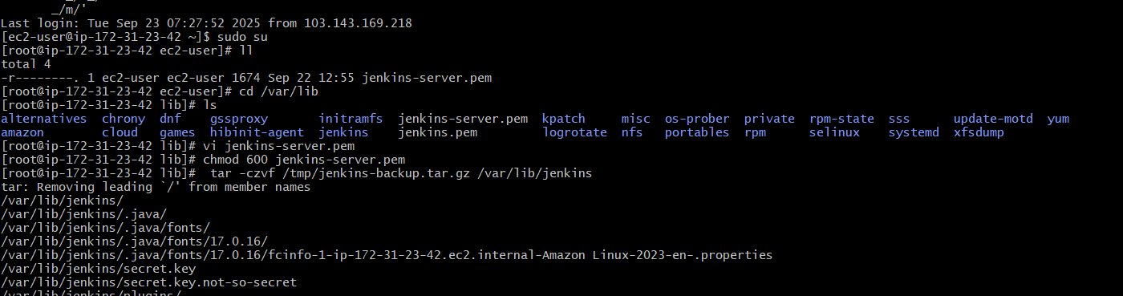
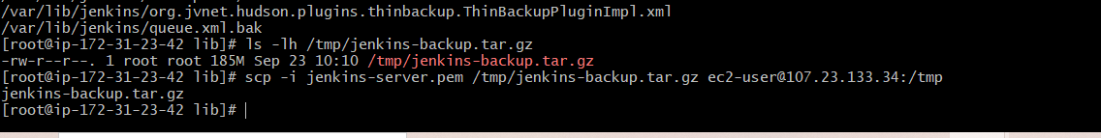
Login to new server and check the file in /tmp
Copy the file from tmp to /var/lib
Cp Jenkins-backup.tar.gz
Tar xvf Jenkins-backup.tar.gz
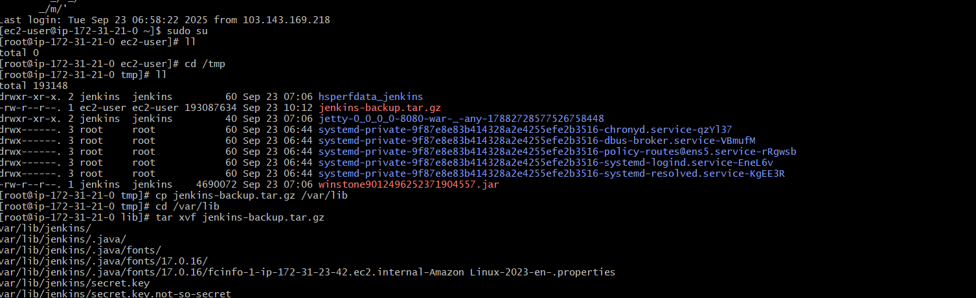

Sudo systemctl start Jenkins
Sudo systemctl status Jenkins
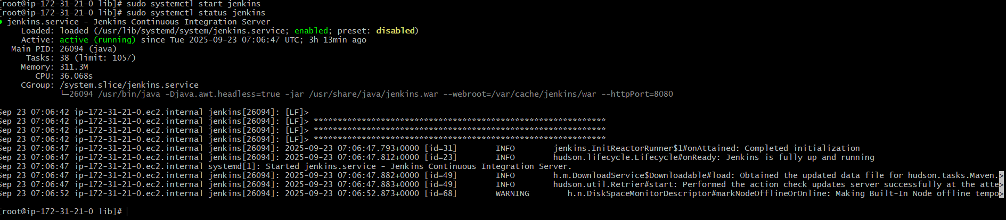
Verify in browser → http://<EC2-Public-IP>:8080

