Kubernetes-04
- Deploy an application using a Deployment with 3 replicas and a rolling update strategy.
Step 1 – create a deployment YAML
Save this as deployment .yaml

apiVersion: apps/v1
kind: Deployment
metadata:
name: my-app
spec:
replicas: 3
selector:
matchLabels:
app: my-app
strategy:
type: RollingUpdate
template:
metadata:
labels:
app: my-app
spec:
containers:
- name: my-app
image: nginx
ports:
- containerPort: 80
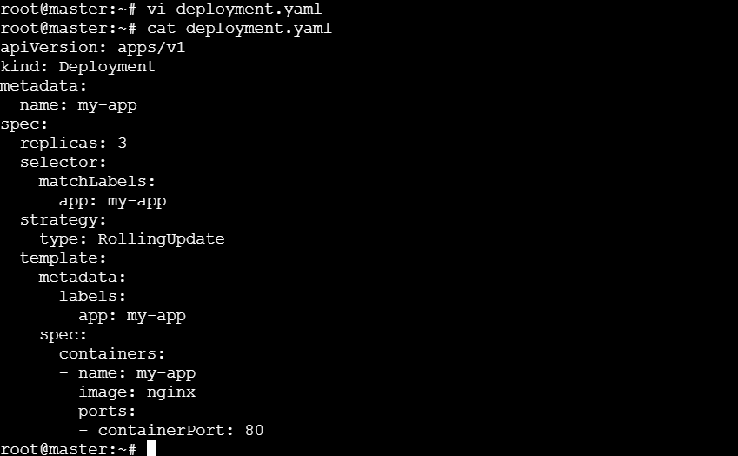

Step 2 – Apply the Deployment
Kubectl apply -f deployment.yaml
Step 3 – check if pods are running
Kubectl get pods

We must see 3 pods.
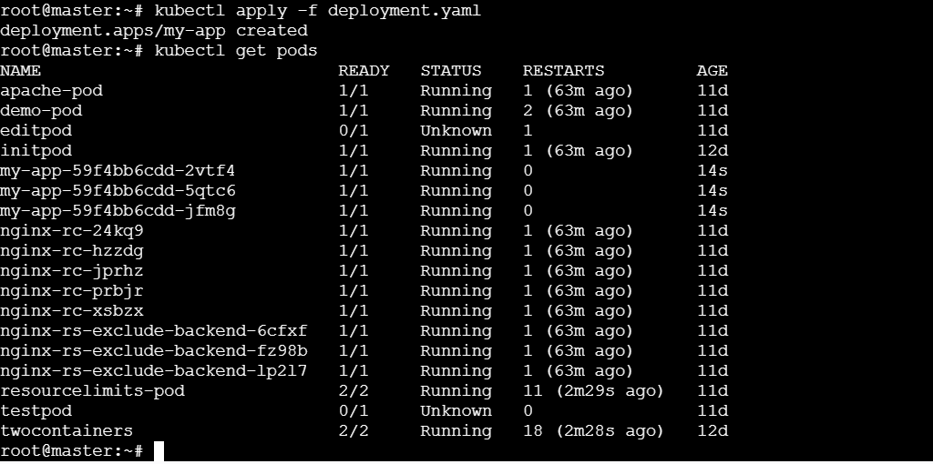
Step 4 – check the deployment details
Kubectl get deployment my-app
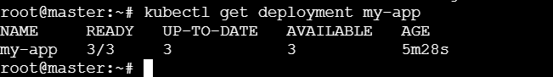

Step 5 – Test Rolling Update (update image)
Update the deployment automatically triggers rolling update:
Kubectl set image deployment/my-app my-app=nginx:1.25
Step 6 – Watch the rollout
Kubectl rollout status deployment/my-app

Now we will see the pods updating one by one (rolling update).
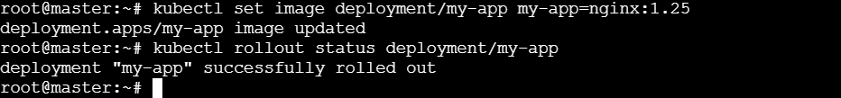

Step 7 – More Details about the Rolling Update
Kubectl describe deployment my-app
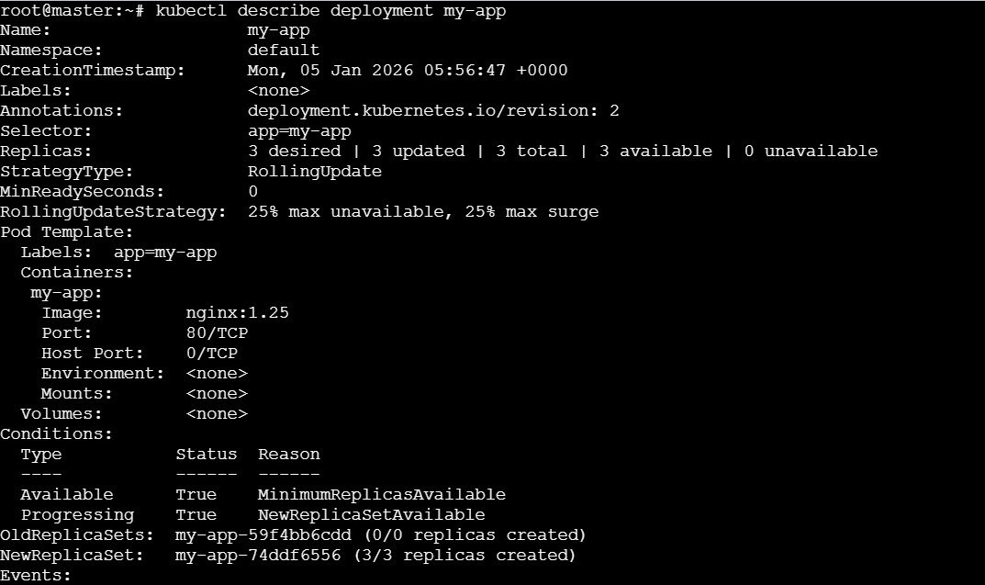

- Configure a Deployment with a Recreate strategy and observe the downtime.
Step 1 – Create a Deployment YAML
Save it as recreate -deployment.yaml:

apiVersion: apps/v1
kind: Deployment
metadata:
name: my-app-recreate
spec:
replicas: 2
strategy:
type: Recreate # IMPORTANT
selector:
matchLabels:
app: my-app-recreate
template:
metadata:
labels:
app: my-app-recreate
spec:
containers:
- name: my-app
image: nginx:stable
ports:
- containerPort: 80
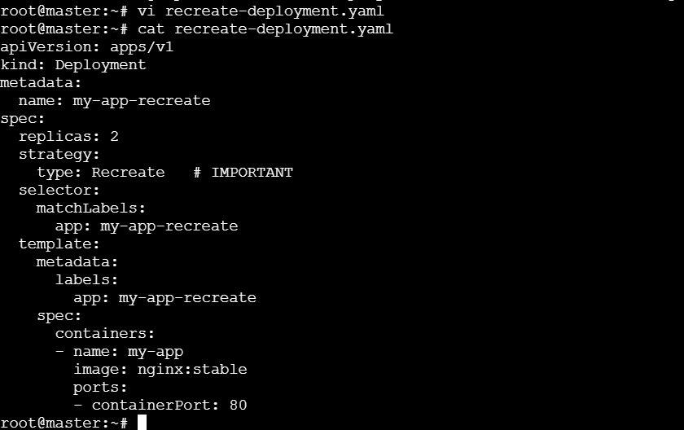

Step 2 – Apply the Deployment
Kubectl apply -f recreate-deployment.yaml
Step 3 – Check pods
Kubectl get pods -I app=my-app-recreate

We will see 2 running pods.
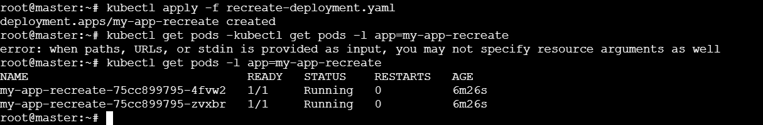

Step 4 – Update the image (to trigger arollout)
This will cause Recreate strategy → old pods get deleted first → new pods starts later → downtime.
Kubectl set image deployment/my-app-recreate my-app=nginx:1.25

Step 5 – Observe downtime
Run this command in another terminal:
Kubectl get pods -w
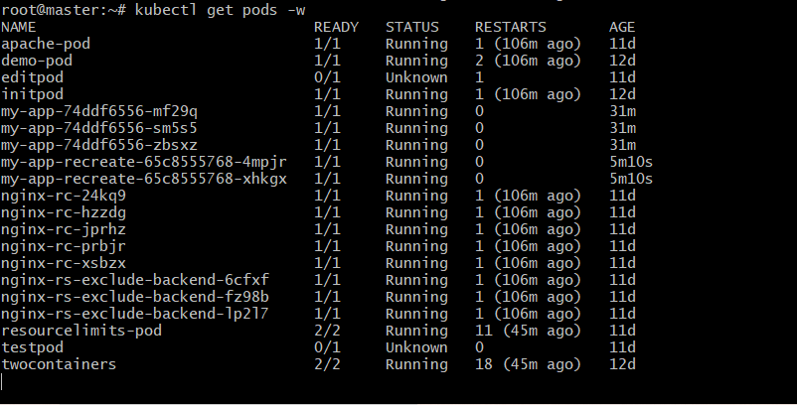

Step 6 – to verify the strategy used:
Kubectl describe deployment my-app-recreate | grep StrategyType

- Update an existing Deployment and perform a rollback to the previous version.
step 1 - Check current Deployment
Kubectl get deployments
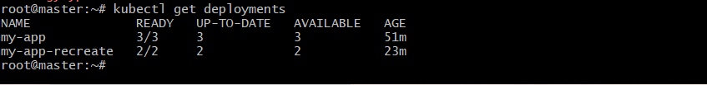

Step 2 – Check the current image version
Kubectl describe deployment my-app| grep -i image

Step 3 – Update the Deployment
Update the deployment to a new image version (ex:nginx:1.27.0)
Kubectl set image deployment/my-app my-app=nginx:1.27.0

Step 4 – Check Rollout Progress
Kubectl rollout status deployment/my-app

Step 5 – View Rollout History
Kubectl rollout history deployment/my-app
Now, we will see Revision numbers (ex: Revision 1, Revision 2).
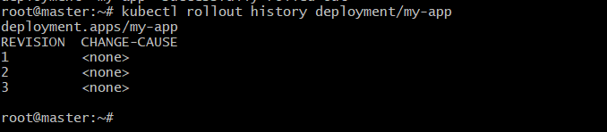

Step 6 – Rollback to previous version
Rollback to the last working version:
Kubectl rollout undo deployment/my-app
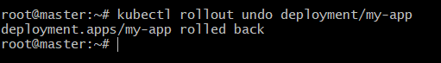

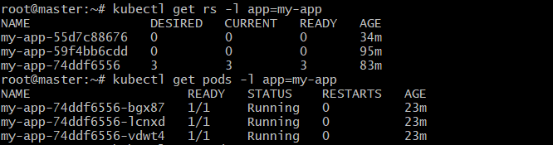
We will see only the running pods.
- Modify a Deployment to add resource requests and limits for CPU and memory.

Step 1 – open the Deployment file for editing
Vi deployment.yaml

Step 2 – Add resource requests & limits inside the container section
Find the section:
Containers:
-name: my-app
Image: nginx

Modify it like this:
Containers:
name: my-app
containers:
- name: my-app
image: nginx
resources:
requests:
cpu: "100m"
memory: "128Mi"
limits:
cpu: "300m"
memory: "256Mi"

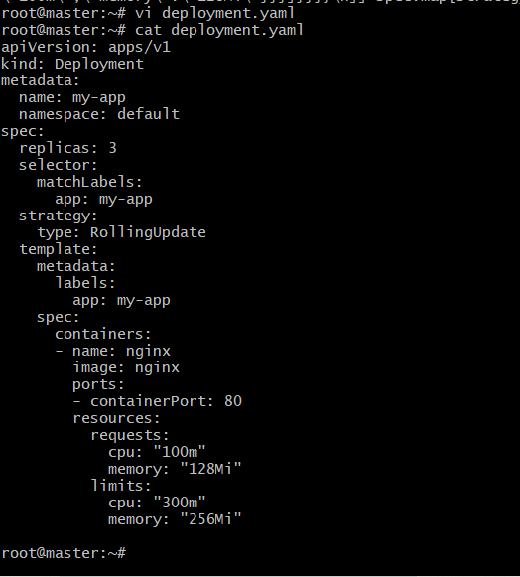

Step 3 – Apply the Updated Deployment File
Kubectl apply -f deployment.yaml

Step 4 – Check if a Rolling Update is started
Kubectl rollout status deployment my-app
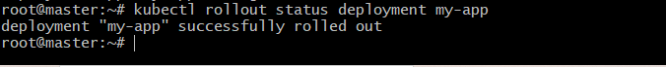
Step 5 – Verify the Resource & limits are applied
Check the Deployment:
Kubectl describe deployment my-app | grep -A5 “Limits”
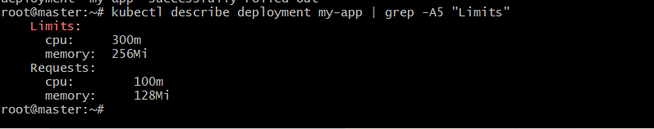

- Create a Deployment with MaxSurge and MaxUnavailable configurations.
Step 1 – Create the Deployment YAML
Run:
Vi nginx-surge-deploy.yaml
Paste this in YAML:
apiVersion: apps/v1
kind: Deployment
metadata:
name: nginx-surge-deploy
spec:
replicas: 4
selector:
matchLabels:
app: nginx-surge
strategy:
type: RollingUpdate
rollingUpdate:
maxSurge: 2
maxUnavailable: 1
template:
metadata:
labels:
app: nginx-surge
spec:
containers:
- name: nginx
image: nginx:1.23
ports:
- containerPort: 80
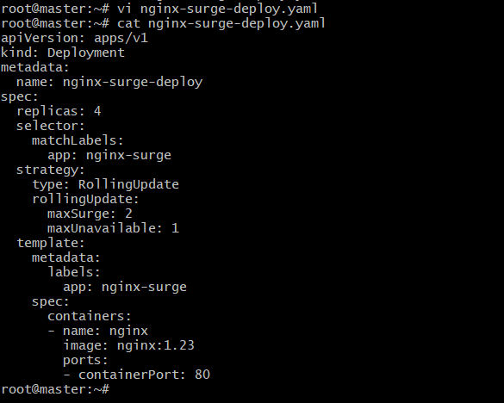

Step 2 – Apply the Deployment
Kubectl apply -f nginx-surge-deploy.yaml
Step 3 – Check Deployment status
Kubectl get deployments
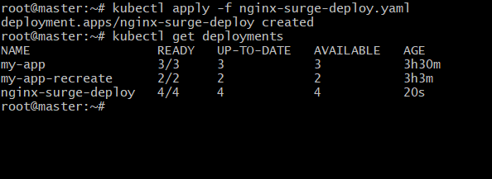

Step 4 – Watch the Rollout
Kubectl rollout status deployment/nginx-surge-deploy
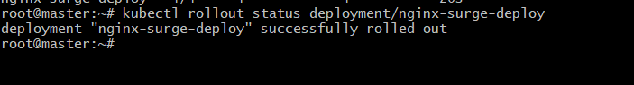

Step 5 – List Pods
Kubectl get pods -l app=nginx-surge -o wide
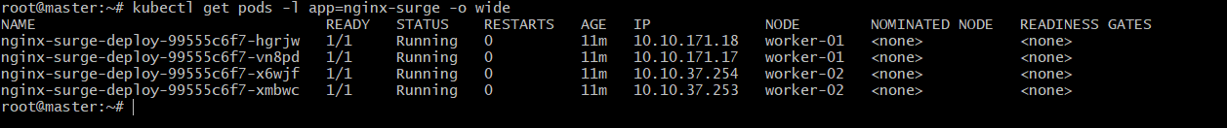

Step 6 – Test Rolling Updates Behavior
Update the image to trigger a rollout:
Kubectl set image deployment/nginx-surge-deploy nginx=nginx:1.24
Watch the rollout:
Kubectl rollout status deployment/nginx-surge-deploy
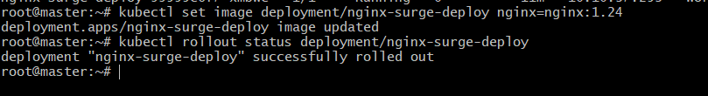
During update we will observe:
- Up to 6 pods running
(4 desired + 2 maxSurge)
- Up to 1 pod unavailable
(maxUnavailable: 1 allows 1 pod to be down)
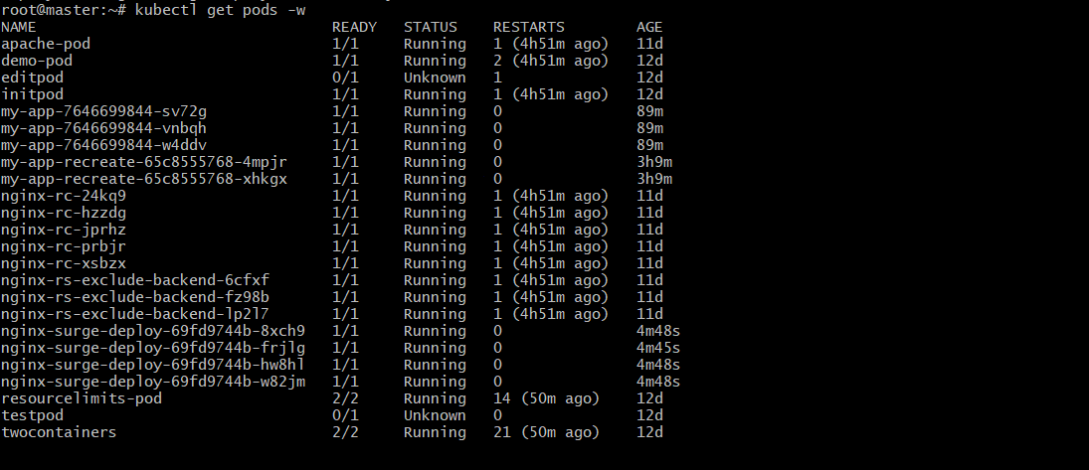

Step 7 – Verify the Strategy Configuration
Kubectl desceibe deployment nginx-surge-deploy | grep -A3 StrategyType
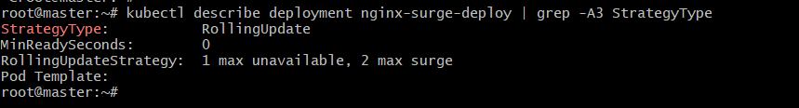

6.Set up a Deployment with a custom revision history limit.

Step 1 – Create the Deployment YAML
Run:
Vi nginx-history-deploy.yaml
Paste the YAML content:
apiVersion: apps/v1
kind: Deployment
metadata:
name: nginx-history-deploy
labels:
app: revision-demo
spec:
replicas: 3
revisionHistoryLimit: 2 # Keep only last 2 revisions
selector:
matchLabels:
app: revision-demo
strategy:
type: RollingUpdate
rollingUpdate:
maxSurge: 1
maxUnavailable: 1
template:
metadata:
labels:
app: revision-demo
spec:
containers:
- name: nginx
image: nginx:1.25.0
ports:
- containerPort: 80
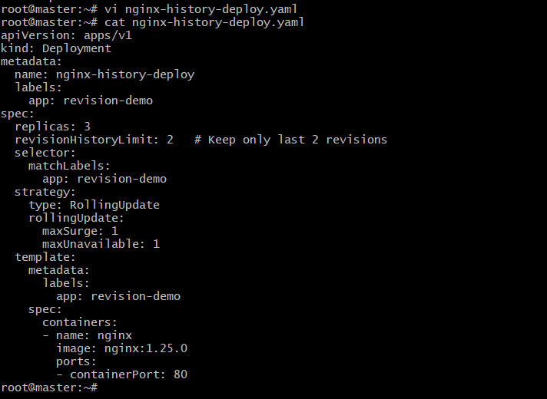

Step 2 – Apply the Deployment
Kubectl apply -f nginx-history-deploy.yaml
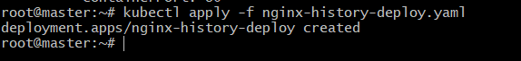

Step 3 – Update the deployment multiple times to generate revisions
(Important: Use --record so revision history logs the command.)
Kubectl set image deployment/nginx-history-deploy nginx=nginx:1.26 --record
Kubectl set image deployment/nginx-history-deploy nginx=nginx:1.27 --record
kubectl set image deployment/nginx-history-deploy nginx=nginx:1.28 --record
Each command creates a new revision.

Step 4 – Check rollout history
Kubectl rollout history deployment/nginx-history-deploy
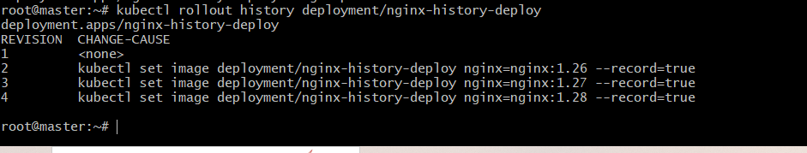

7.Pause a deployment during an update, and then resume it.
Step 1 – Create the Deployment YAML
Run:
Vi pause.yaml
Paste this YAML content:
apiVersion: apps/v1
kind: Deployment
metadata:
name: pause-app
labels:
app: pause-demo
spec:
replicas: 3
revisionHistoryLimit: 2
strategy:
type: RollingUpdate
rollingUpdate:
maxSurge: 1
maxUnavailable: 1
selector:
matchLabels:
app: pause-demo
template:
metadata:
labels:
app: pause-demo
spec:
containers:
- name: nginx
image: nginx:1.27
ports:
- containerPort: 80
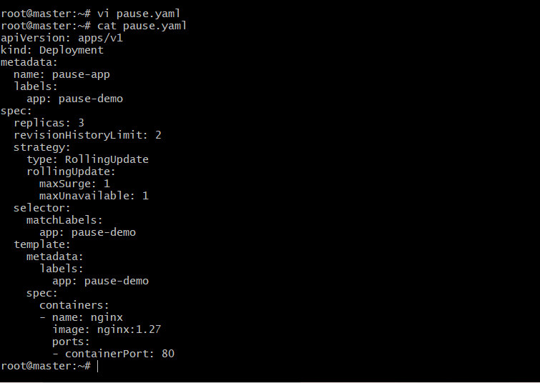

Step 2 – Apply the Deployment
Kubectl apply -f pause.yaml
Verify:
Kubectl get deployments
Kubectl get pods -l app=pause-demo
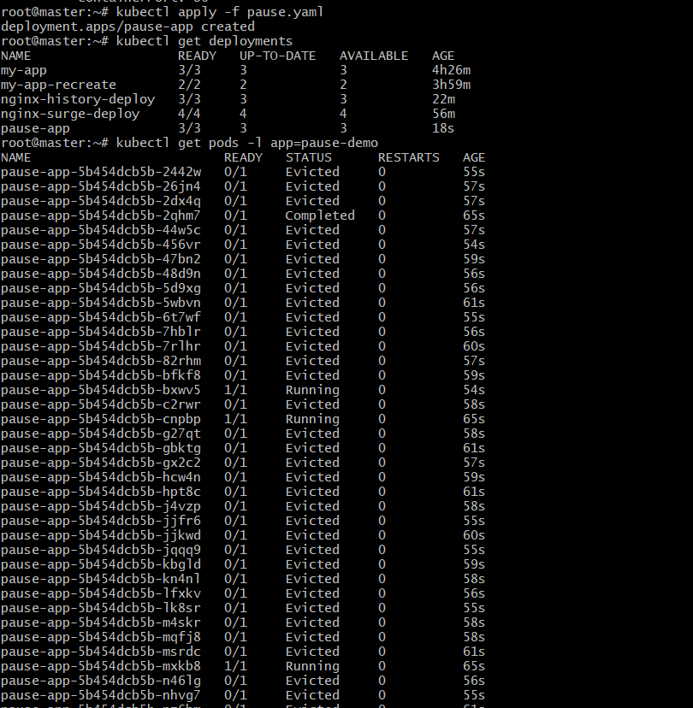
To see only running pods, use:
kubectl get pods -l app=pause-demo --field-selector=status.phase=Running
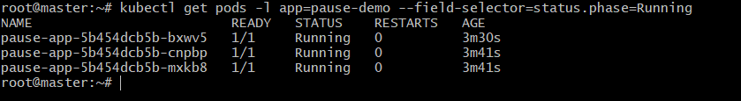

Step 3 – Pause the Deployment
This prevents new rollouts from progressing.
Kubectl rollout pause deployment/pause-app
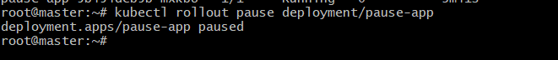

Step 4 – Update the Deployment (while paused)
This will create a new revision, but rollout will not start yet.
Kubectl set image deployment/pause-app nginx=nginx:1.28
Check status:
Kubectl rollout status deployment/pause-app
Output: NO progress because it is paused.

Step 5 – RESUME the Deployment
Kubectl rollout resume deployment/pause-app
Now the update starts.
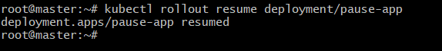

Step 6 – Watch the rollout progress
Kubectl rollout status deployment/pause-app
We will see the pods being updated normally.
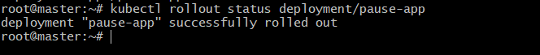

Step 7 – Check final pod state
Kubectl get pods -l app=pause-demo
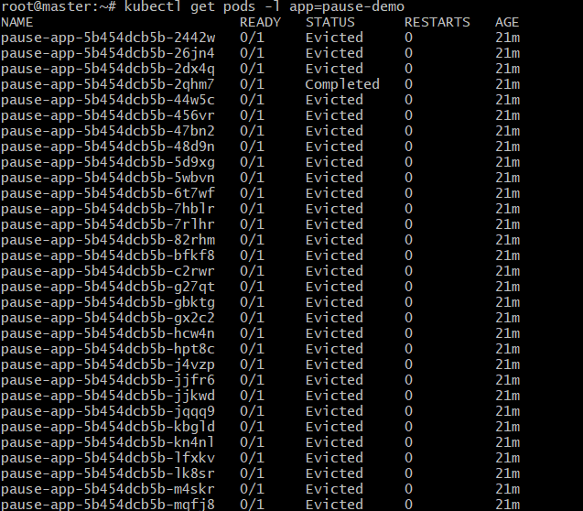
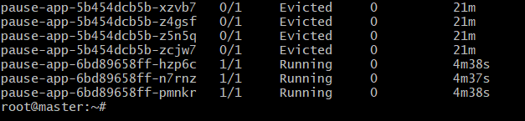
To see only running pods use:
kubectl get pods -l app=pause-demo --field-selector=status.phase=Running
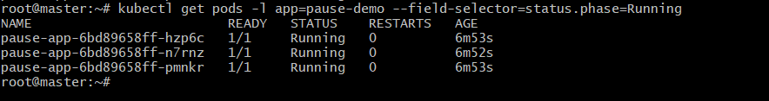

All pods should now using:
nginx:1.28

8. Create a pod using resource requests for memory and CPU, and observe how the scheduler assigns it to a node.

Step 1 – Create the pod YAML
Run:
Vi resource-pod.yaml
Paste the YAML content:
apiVersion: v1
kind: Pod
metadata:
name: resource-demo-pod
labels:
app: resource-demo
spec:
containers:
- name: nginx
image: nginx:1.28
resources:
requests:
memory: "200Mi"
cpu: "200m"
limits:
memory: "400Mi"
cpu: "500m"
ports:
- containerPort: 80
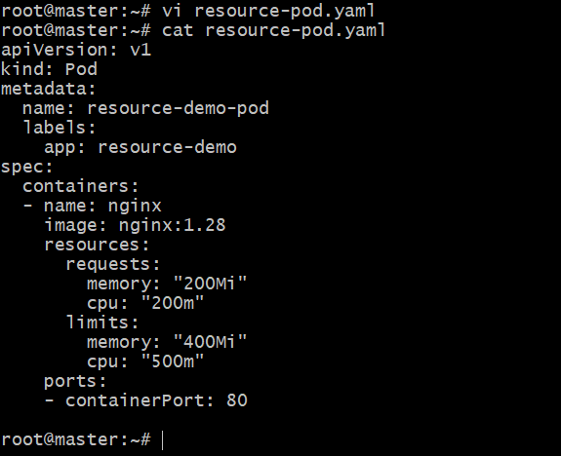

Step 2 – Apply the pod
Kubectl apply -f resource-pod.yaml
Check pod status:
Kubectl get pods -o wide –field-selector=status.phase=Running
Observe which node the scheduler chose.
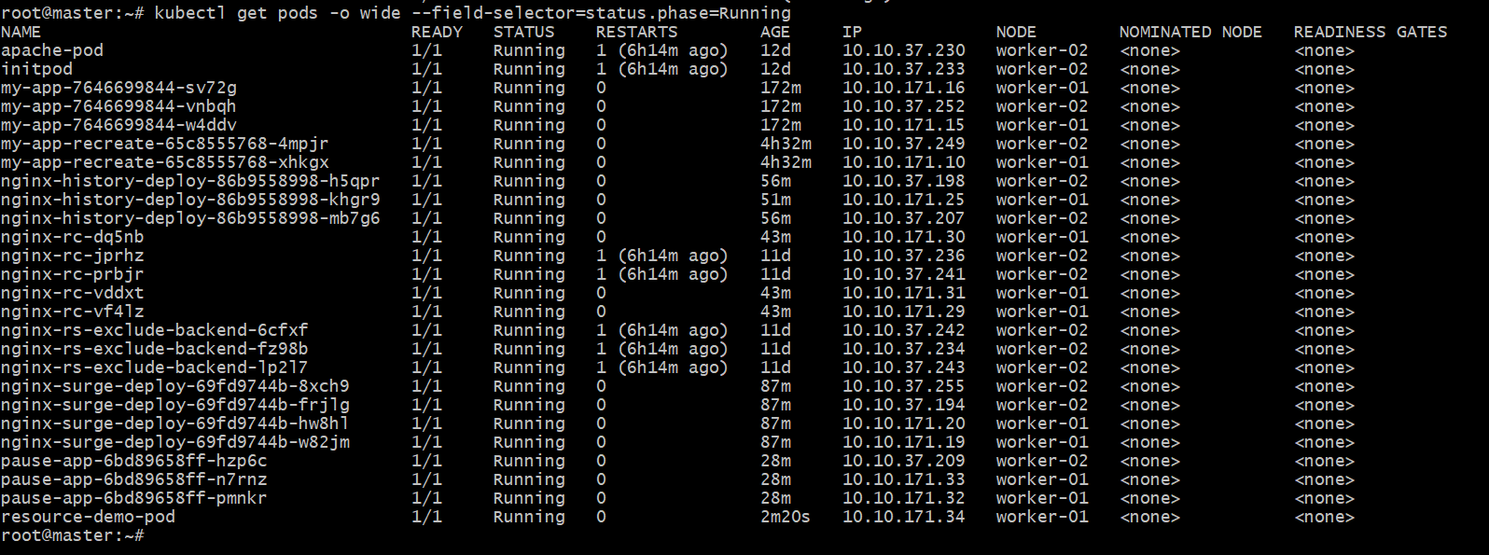

Step 3 – check pod’s Assigned Resources
Kubectl describe pod resource-demo-pod | grep -A5 “Limits”
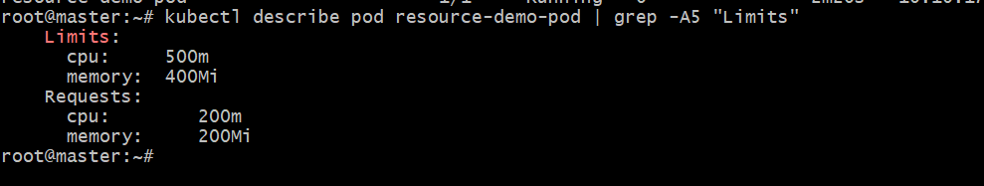

Step 4 – Check Node Resource Availability
First get your node name:
Kubectl get nodes
Pick a node and run:
Kubectl describe node<node-name> | grep -A10 “Allocated resources”
