Kubernetes-06
- Create a ConfigMap from a directory containing multiple files and inject the variables into a pod as environment variables.

→ Here I have created the directory as config-dir --> echo
“environment=production”>config-dir/app.env --> echo “version=1.0.0”>config-dir/version.env
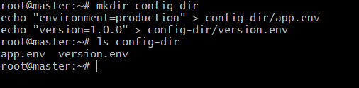

→ Now create config-map from directory --> kubectl create configmap my-config --from-file=config-dir/
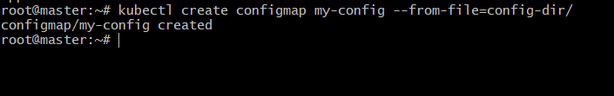

→ check the details :
Kubectl describe configmap my-config
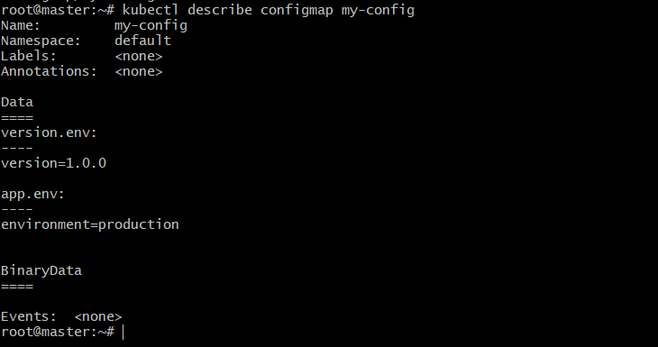

→ Create the YAML file:
Vi cm-env-pod.yaml

Paste the content in YAML file:
apiVersion: v1
kind: Pod
metadata:
name: cm-env-pod
spec:
containers:
- name: demo-container
image: busybox
command:
- /bin/sh
- -c
- env | grep environment && env | grep version && sleep 3600
envFrom:
- configMapRef:
name: my-config
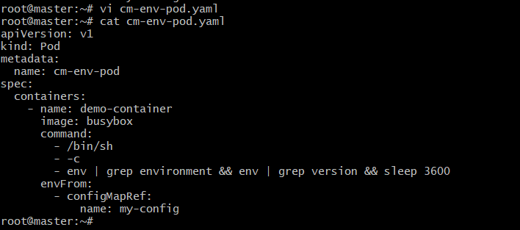

→ Apply it:
Kubectl apply -f cm-env-pod.yaml
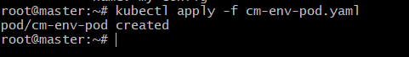

- Create a configmap from a file and mount it as a volume inside a pod, ensuring the configuration data is available as files.

In the existing directory config, create:
Kubectl create configmap my-config --from -file=config-dir/
→ check the command:
Kubectl get configmaps
Kubectl describe configmap my-config
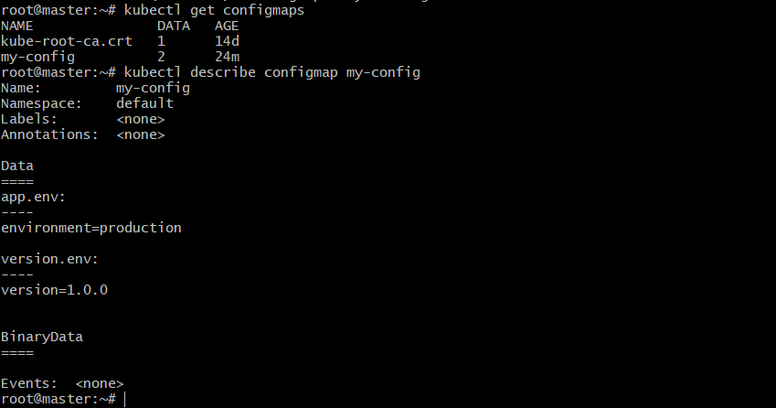

→ Create the YAML file:
cm-volume-pod.yaml
paste it in YAML file:
apiVersion: v1
kind: Pod
metadata:
name: cm-volume-pod
spec:
containers:
- name: demo-container
image: busybox
command:
- /bin/sh
- -c
- sleep 3600
volumeMounts:
- name: config-volume
mountPath: /etc/config # files will appear here
volumes:
- name: config-volume
configMap:
name: my-config
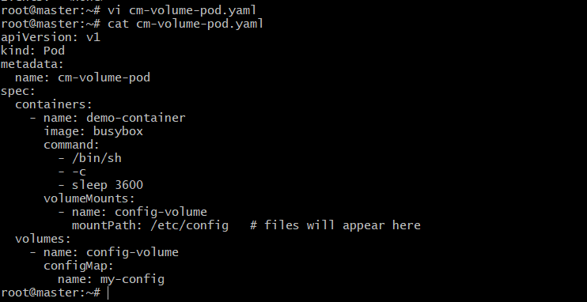

→ Apply it:
Kubectl apply -f cm-volume-pod.yaml

→ Check the pods:
Kubectl get pods

→ move into volume
Kubectl exec -it cm-volume-pod -- sh
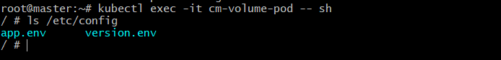

→ run:
Kubectl exec -it cm-volume-pod -- ls /etc/config
Kubectl exec -it cm-volume-pod -- cat /etc/config/app.env
Kubectl exec -it cm-volume-pod -- cat /etc/config/version.env
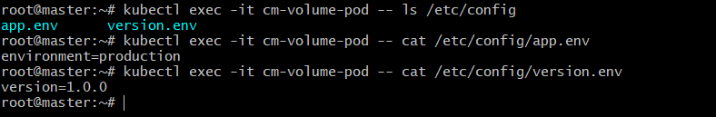

3.Create a Secret with sensitive information (username and password) and inject it into a pod as environment variables.

→ Create a secret:
Kubectl create secret generic my-secret \
--from-literal=username=admin \
--from-literal=password=’p@ssw0rd’
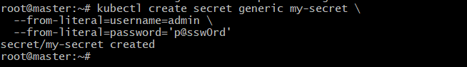

→ Now check:
Kubectl get secrets
Kubectl describe secret my-secret
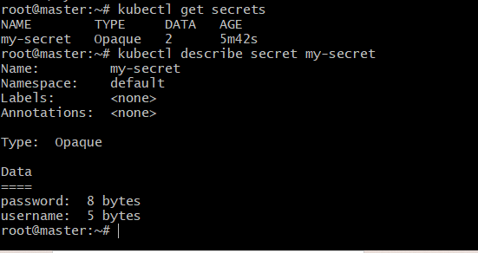

→ Create the YAML file:
Vi secret-env-pod.yaml

Paste the content in YAML file:
apiVersion: v1
kind: Pod
metadata:
name: secret-env-pod
spec:
containers:
- name: demo-container
image: busybox
command:
- /bin/sh
- -c
- env && sleep 3600
env:
- name: APP_USERNAME
valueFrom:
secretKeyRef:
name: my-secret
key: username
- name: APP_PASSWORD
valueFrom:
secretKeyRef:
name: my-secret
key: password
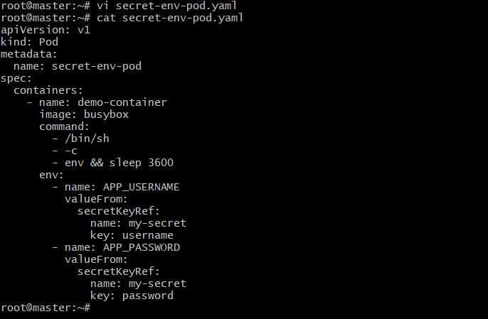

→ Apply it:
Kubectl apply -f secret-env-pod.yaml
Kubectl get pods

→ now move into the secrets and run :
Kubectl exec -it secret-env-pod – sh
→ echo $APP_USERNAME
→ echo $APP_PASSWORD
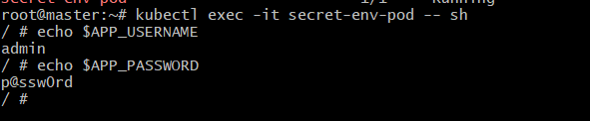

4.Create a Secret using a YAML file, mount it as a volume in a pod, and verify the specific secret valuesare available as files.

→ Create YAML file:
Secret-volume-pod.yaml
Paste the content in YAML file:
apiVersion: v1
kind: Pod
metadata:
name: secret-volume-pod
spec:
containers:
- name: demo-container
image: busybox
command:
- /bin/sh
- -c
- sleep 3600
volumeMounts:
- name: secret-volume
mountPath: /etc/secret-data
readOnly: true
volumes:
- name: secret-volume
secret:
secretName: my-secret
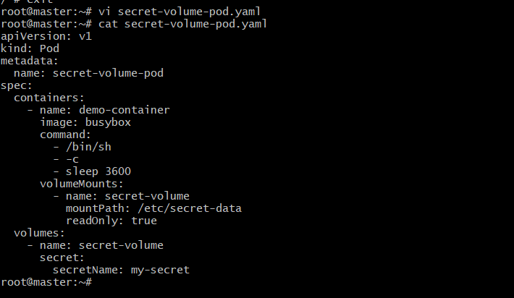

→ Apply it:
Kubectl apply -f my-secret.yaml
Kubectl get secrets
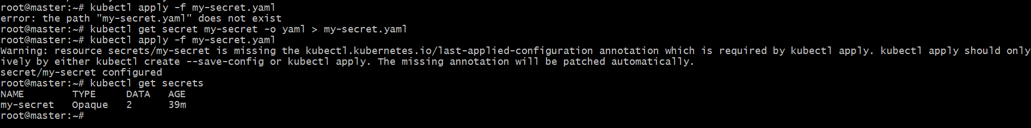
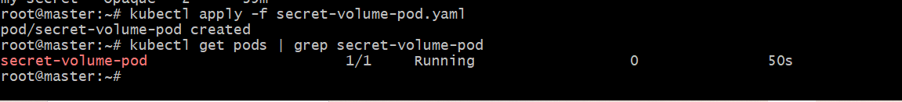
→ Now move into the secrets:
Kubectl exec -it secret-volume-pod -- sh
→ ls /etc/secret-data
→ cat /etc/secret-data
→ cat /etc/secret-data/password
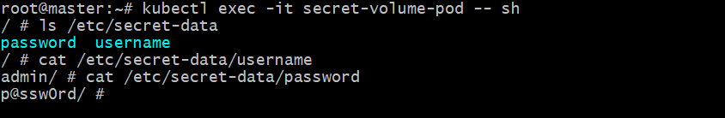
5. Inject a ConfigMap as environment variables and a secret as files into the same pod, ensuring both are accessible within the pod.

→ Create a configmap:
Kubectl create configmap app-config \
--from-literal=ENVIRONMENT=production \
--from-literal=VERSION=1.0.0
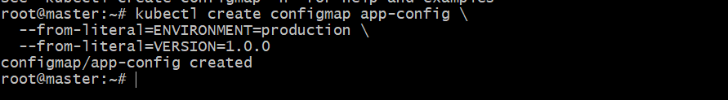

→ verify:
Kubectl get configmap
Kubectl describe configmap app-config
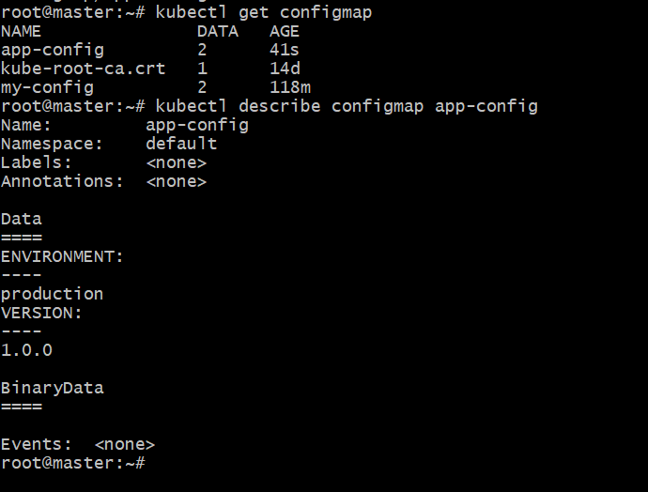

→ Apply it:
Kubectl apply -f my-secret.yaml
Kubectl get secrets

Here I got error. So, Get the latest version:
kubectl get secret my-secret -o yaml > my-secret.yaml

Edit the YAML content:
Vi my-secret.yaml

Paste the content in the YAML file:
apiVersion: v1
kind: Secret
metadata:
name: my-secret
namespace: default
type: Opaque
data:
username: YWRtaW4=
password: cEBzc3cwcmQ=
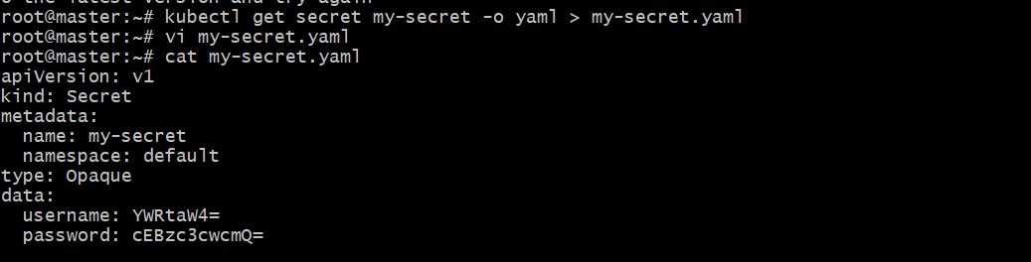

→ Now Apply it.
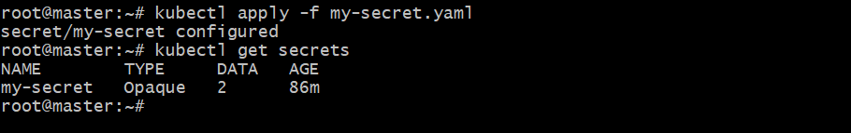

→ Create the pod:
Configmap-secret-pod.yaml

Paste the content in yaml file:
apiVersion: v1
kind: Pod
metadata:
name: configmap-secret-pod
spec:
containers:
- name: demo-container
image: busybox
command:
- /bin/sh
- -c
- env && ls /etc/secret-data && sleep 3600
envFrom:
- configMapRef:
name: app-config
volumeMounts:
- name: secret-volume
mountPath: /etc/secret-data
readOnly: true
volumes:
- name: secret-volume
secret:
secretName: my-secret
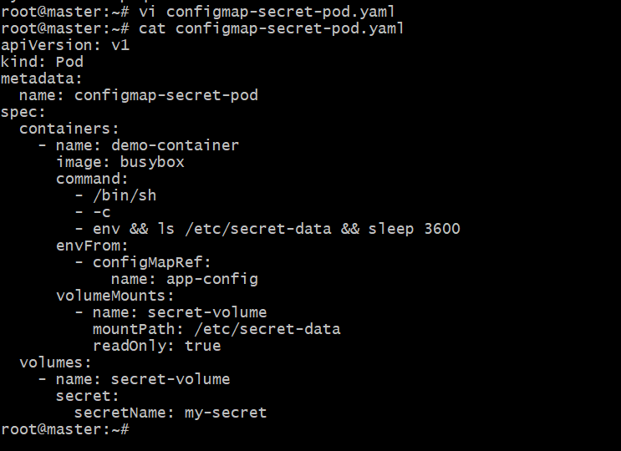

→ Apply it:
Kubectl apply -f configmap-secret-pod.yaml
Kubectl get pods
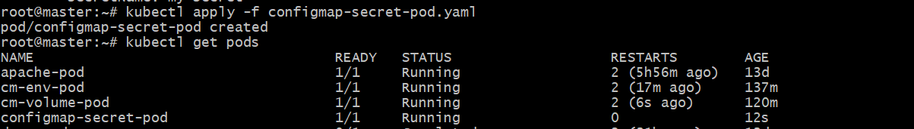

Now move into secrets:
Kubectl exec -it configmap-secret-pod -- sh
→ echo $ENVIRONMENT
→ echo $VERSION
→ ls /etc/secret-data
→ cat /etc/secret-data
→ cat /etc/secret-data/username
→ cat /etc/secret-data/password
