Challenge-2
- Use case: Setting up Transit Gateway and VPC Endpoints for a Multi-VPC Architecture.
Scenario:
- A large organization is migrating its on-premises infrastructure to the AWS cloud.
- The organization’s architecture involves multiple VPCs for resources.
- The IT team needs to design and implement a scalable and efficient network architecture to accommodate the organization’s growth and ensure robust connectivity between VPCs and external services. Different departments and applications, each requiring secure communication with centralized services and external.

Objectives:
- Design and deploy a scalable network architecture using AWS Transit Gateway to simplify network connectivity between multiple VPCs.
- Configure VPC Endpoints to securely access AWS services without internet gateways or NAT gateways, ensuring data privacy and minimizing exposure to external threats.
Note:
- Create 4 VPCs in 4 different regions and set up Transit Gateway.
- Do not use default VPCs.
- Prepare a document with all the screenshots and push it to a Github repo, then share the URL.
Solution:
Create 4 VPCs in 4 different regions with non-overlapping CIDRs
- N.vir-vpc → 10.1.0.0/16
- Ohio-vpc → 10.3.0.0/16
- N.california → 10.2.0.0/16
- Oregon → 10.4.0.0/16
→ Create atleast one public and one private subnet for each VPC in different regions.
→ Create Route table and attach to subnets
→ Create IGW to the n.vir-vpc only
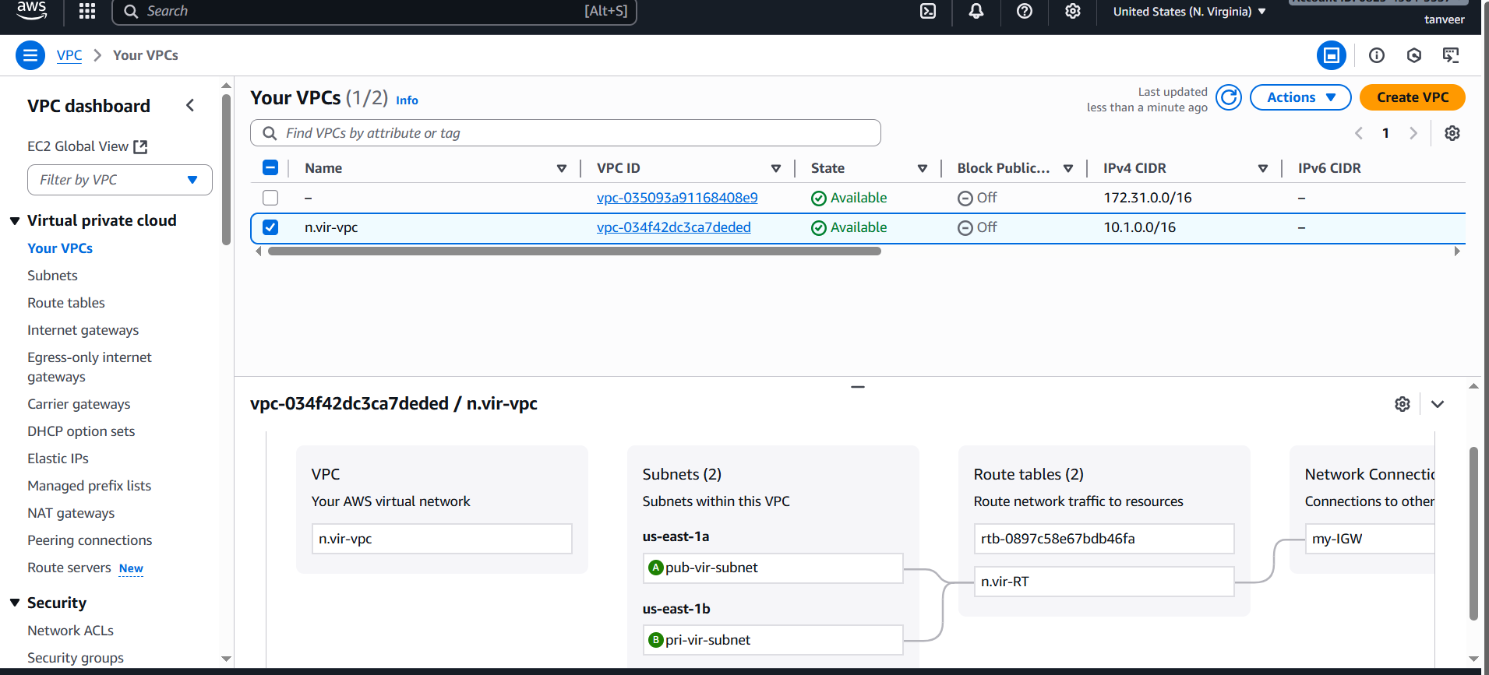
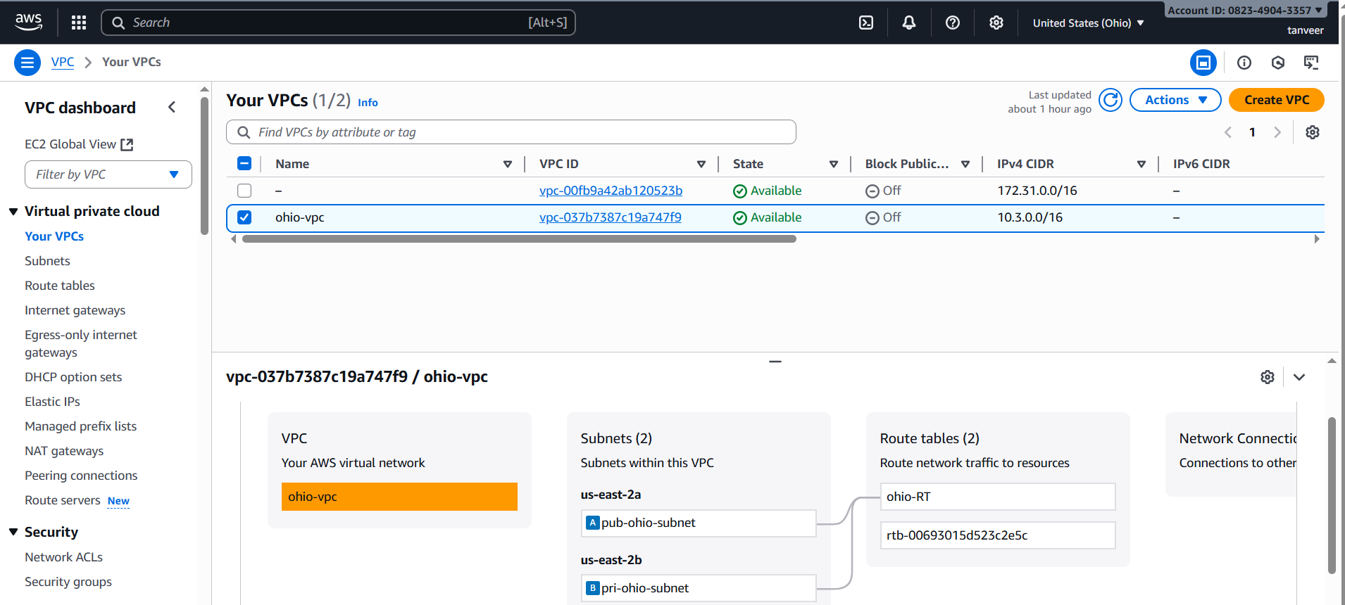
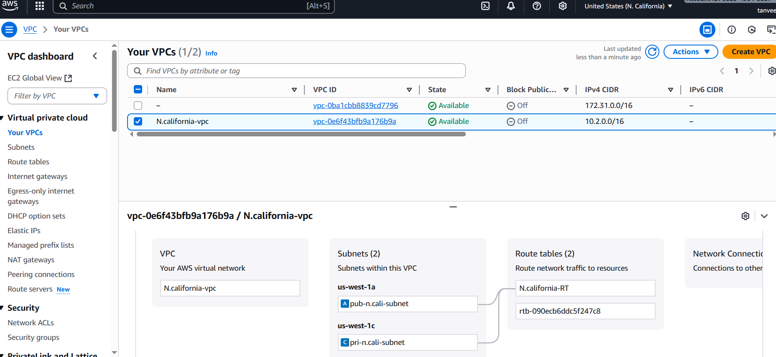
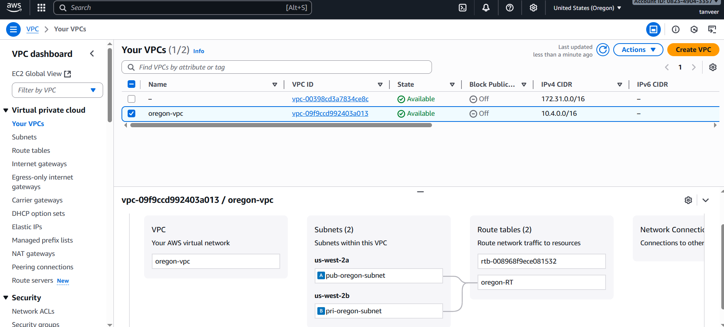
Create Transit gateway in 4 regions.
- Go to VPC Console → transit gateways → Create transit gateways → Attach each VPC to its regional TGW.

. TGW VPC attachment with the private subnets.
. Associate the attachment with TGW route table in that region.
. Enable route propogation from that attachment into the TGW route table (or) add static routes.
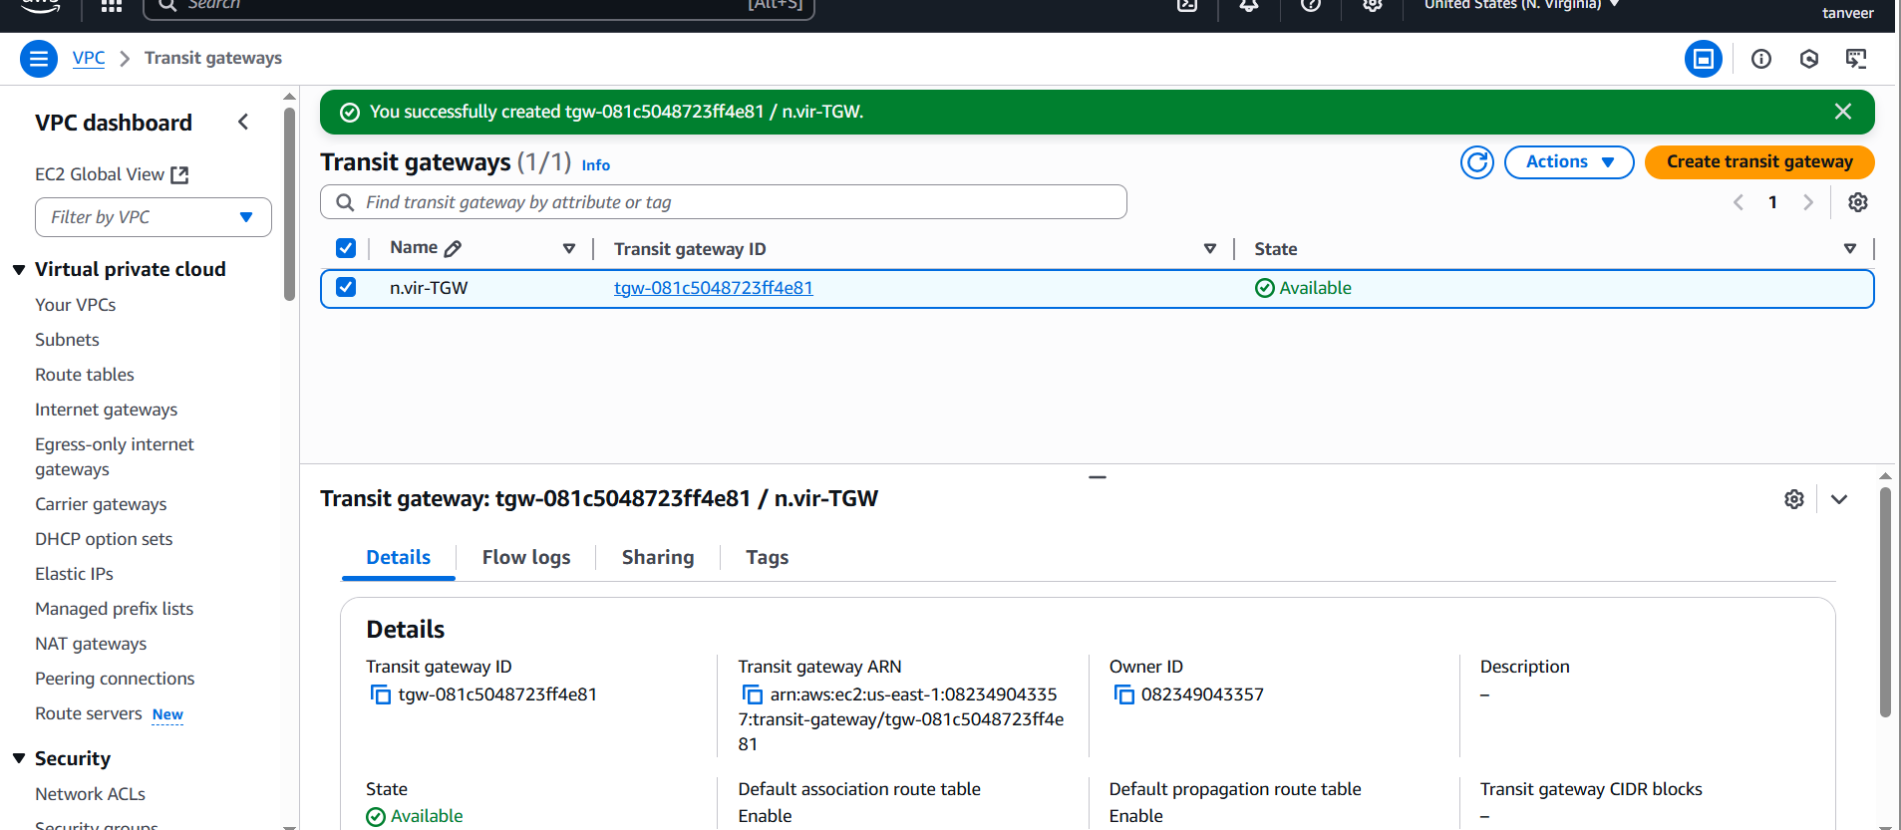

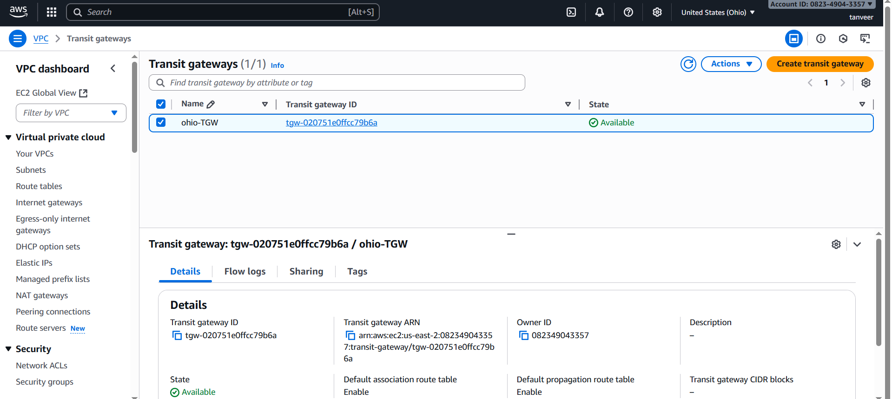
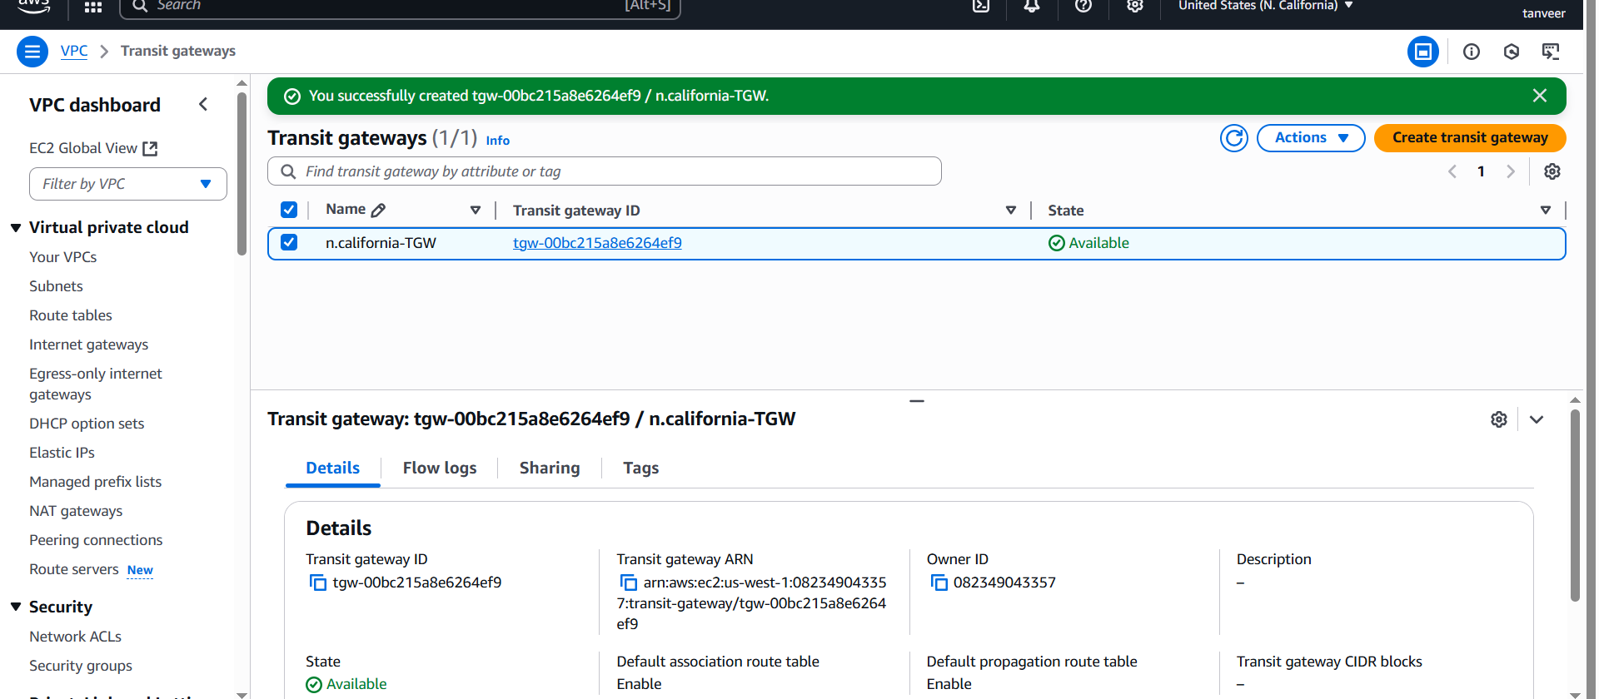
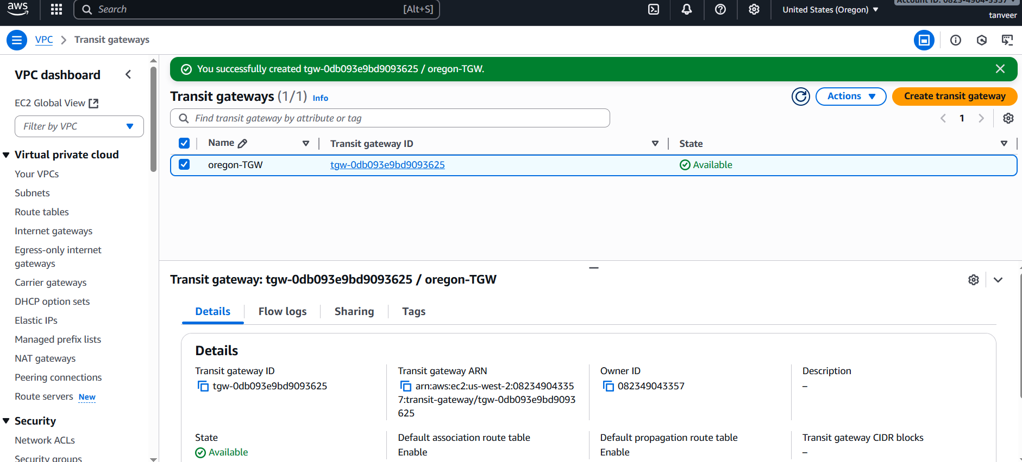
Create the TGW attachment in region-1 and connect peering connection.
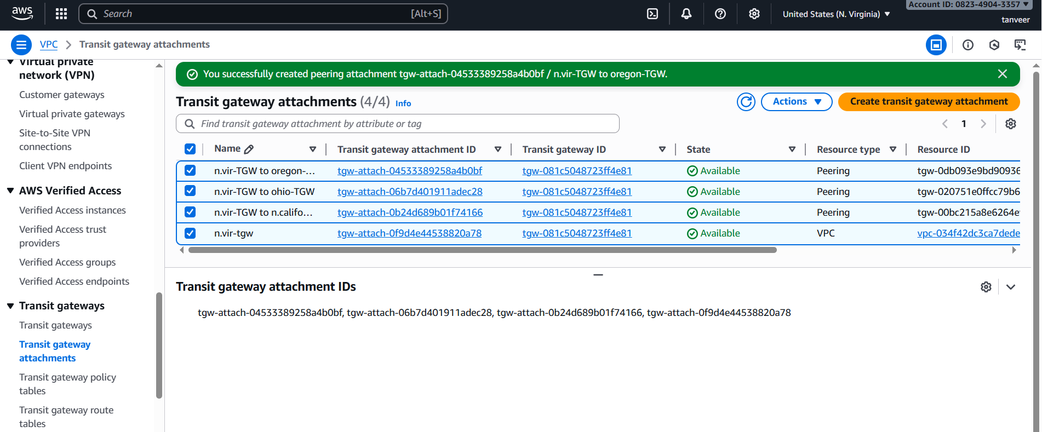
Create TGW attachment in other regions.
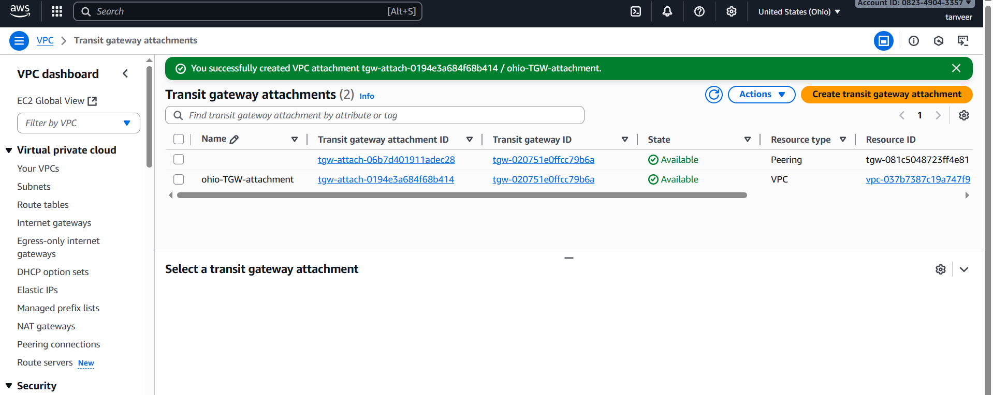
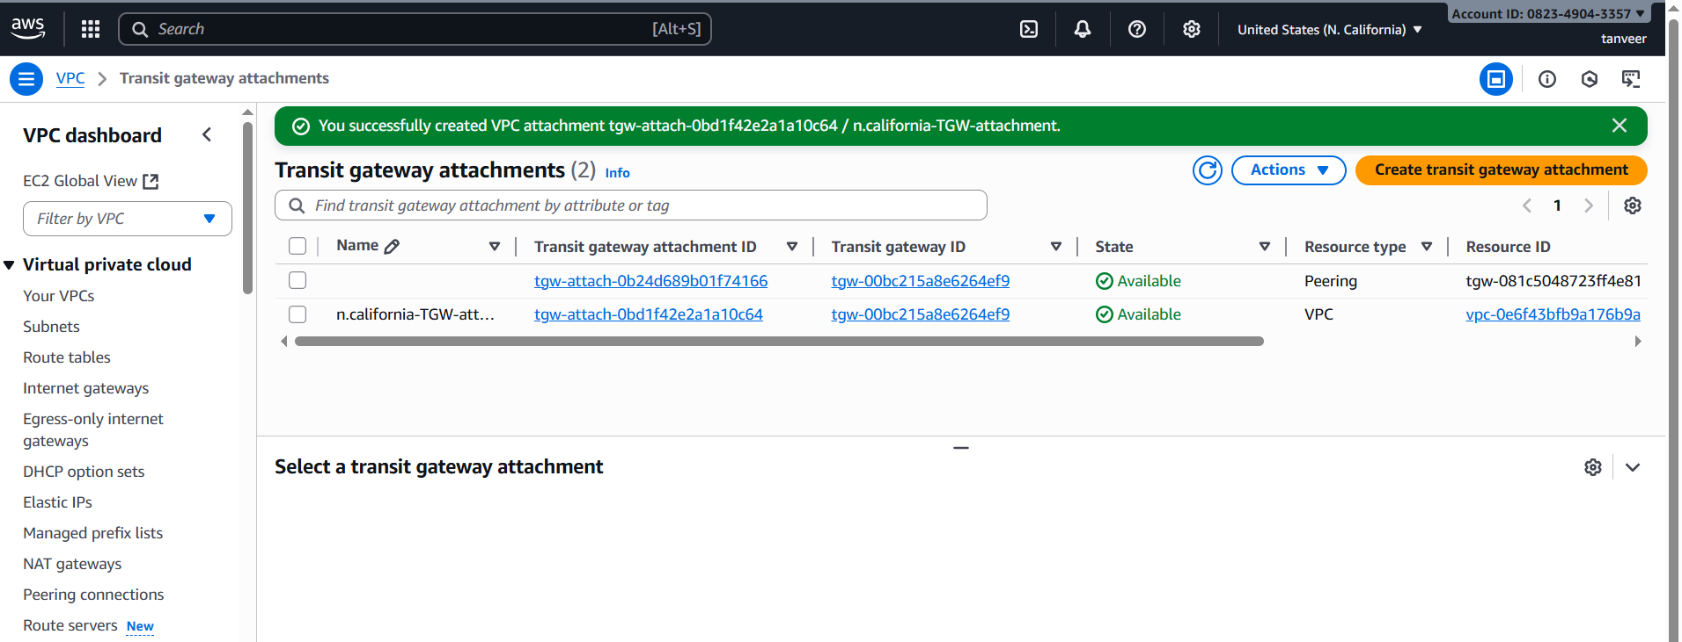
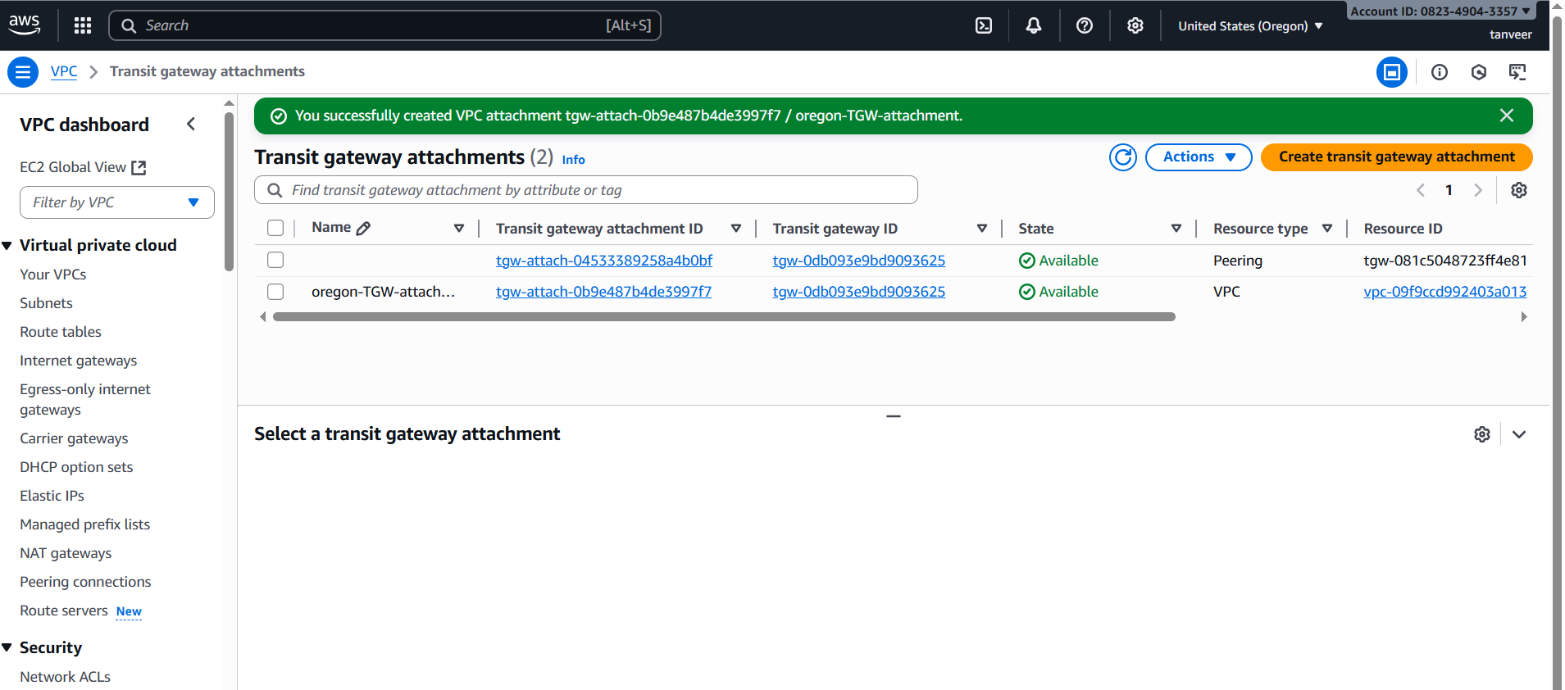
In n.virginia region create Associations with 3 regions.
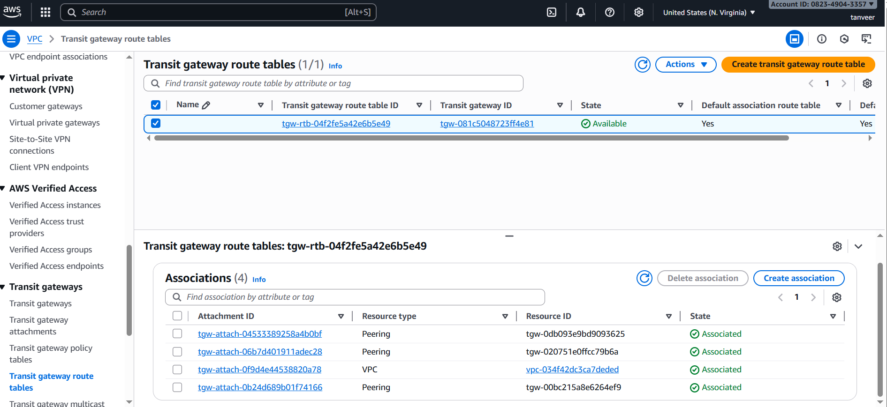Create Static Route table to 4 regions with region-1 (i.e: n.virginia)
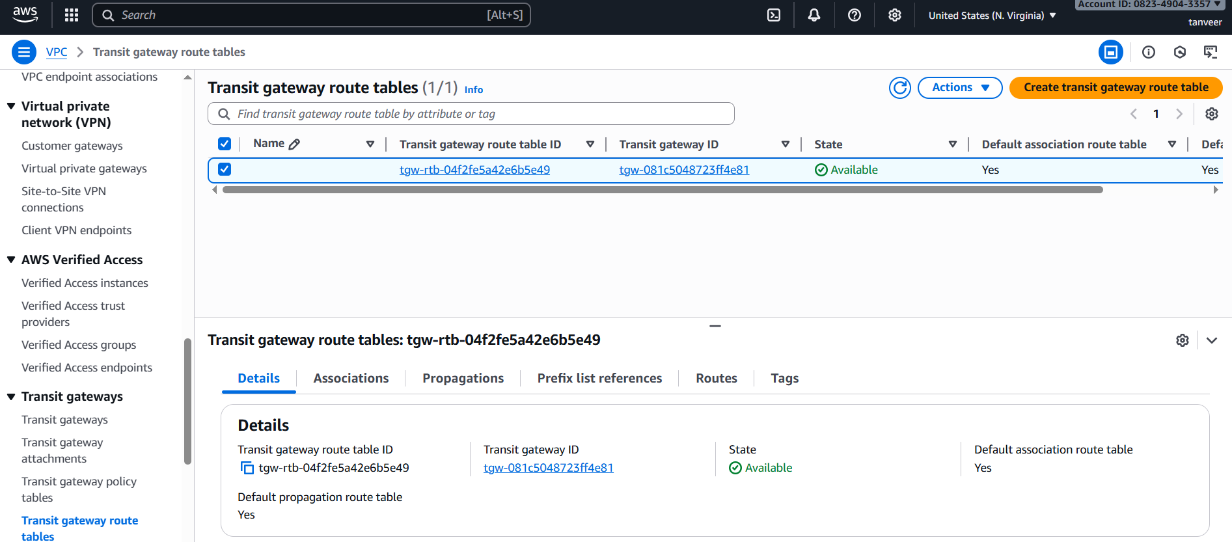
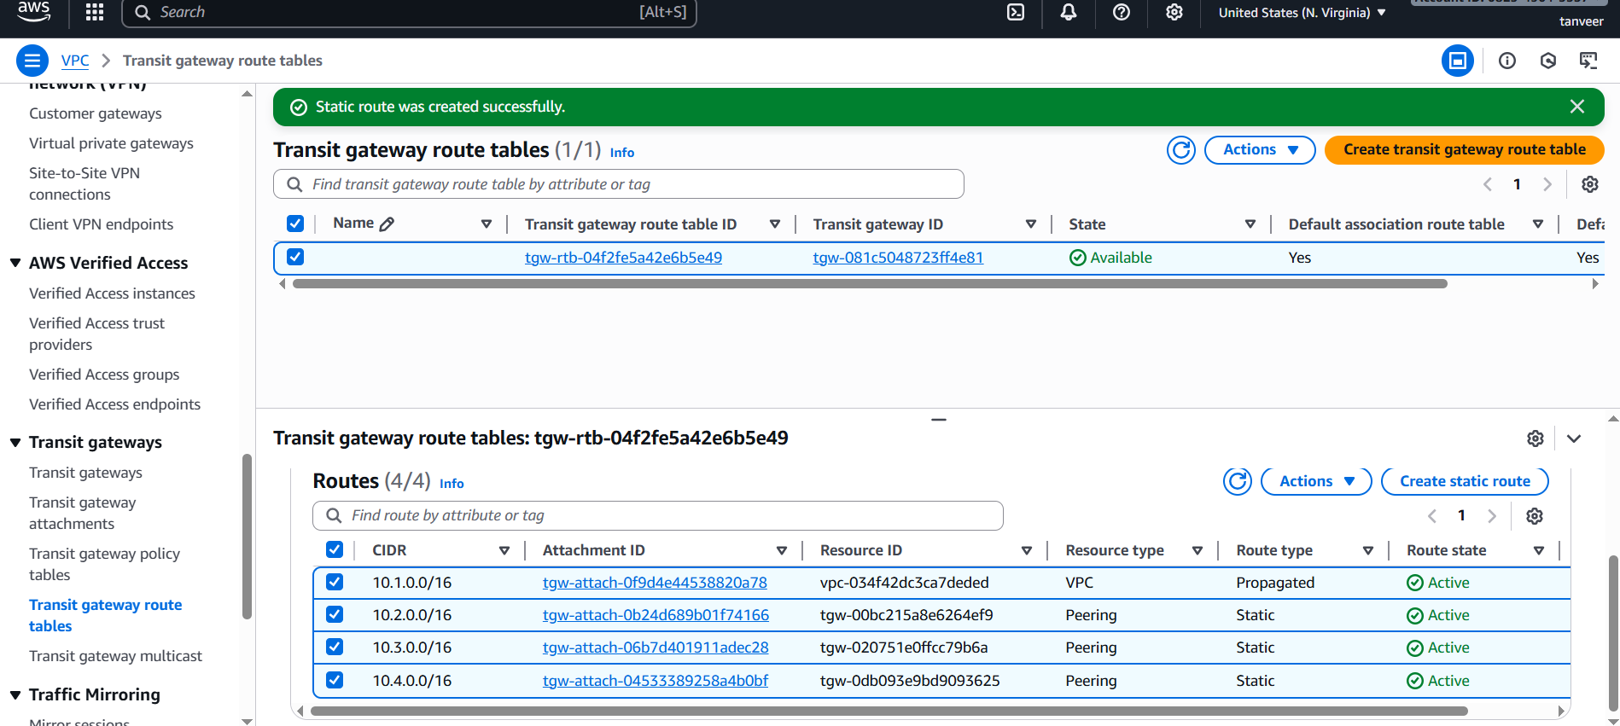
In VPC Route table attach CIDRs for 3 regions in region-1.
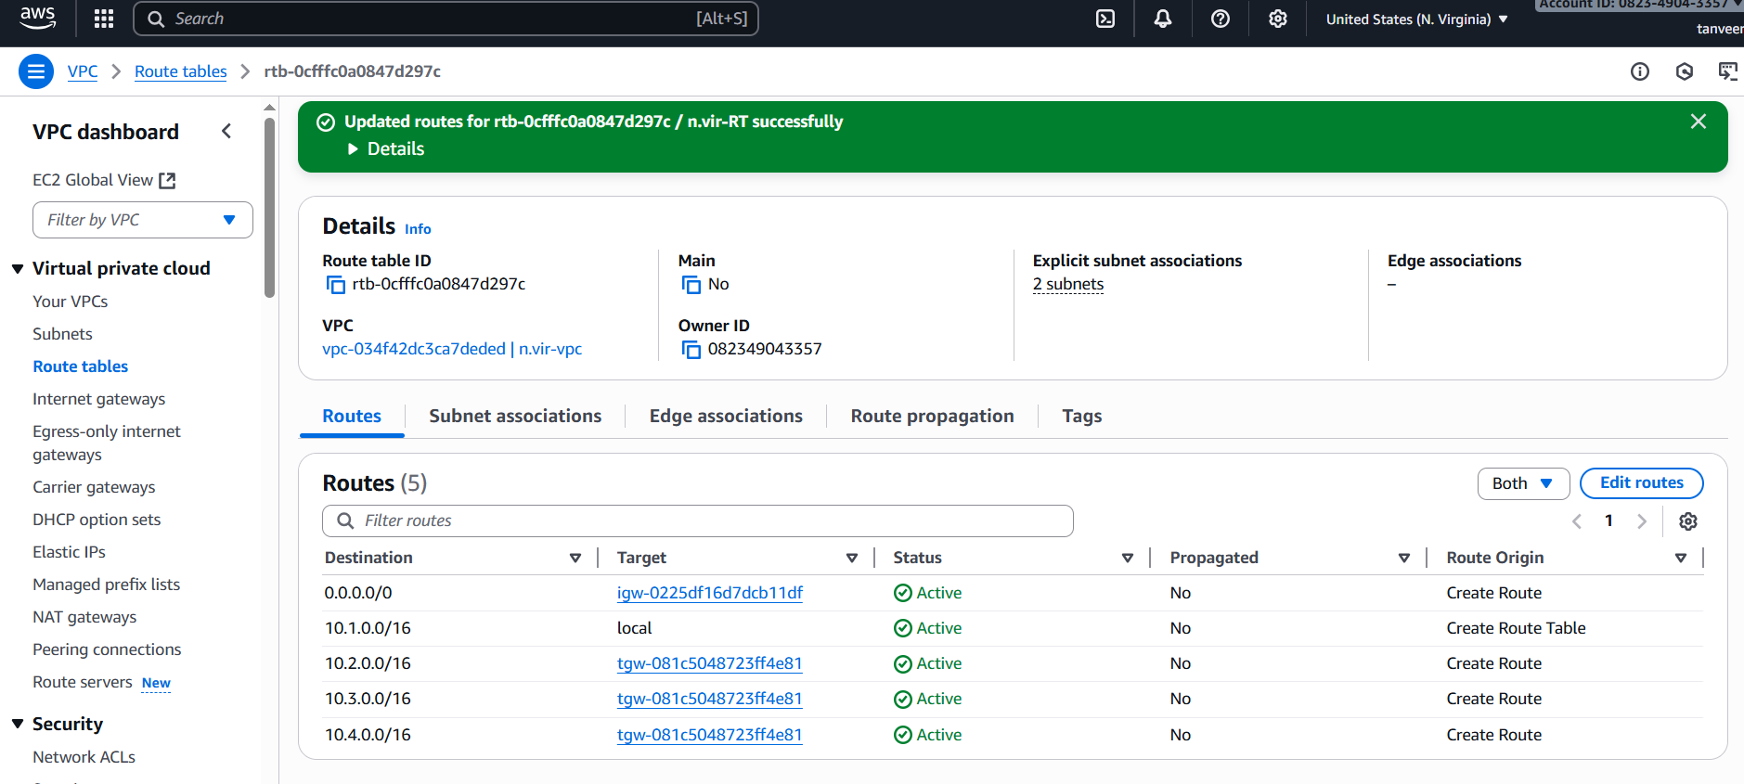Now we need to edit Routes in all regions.
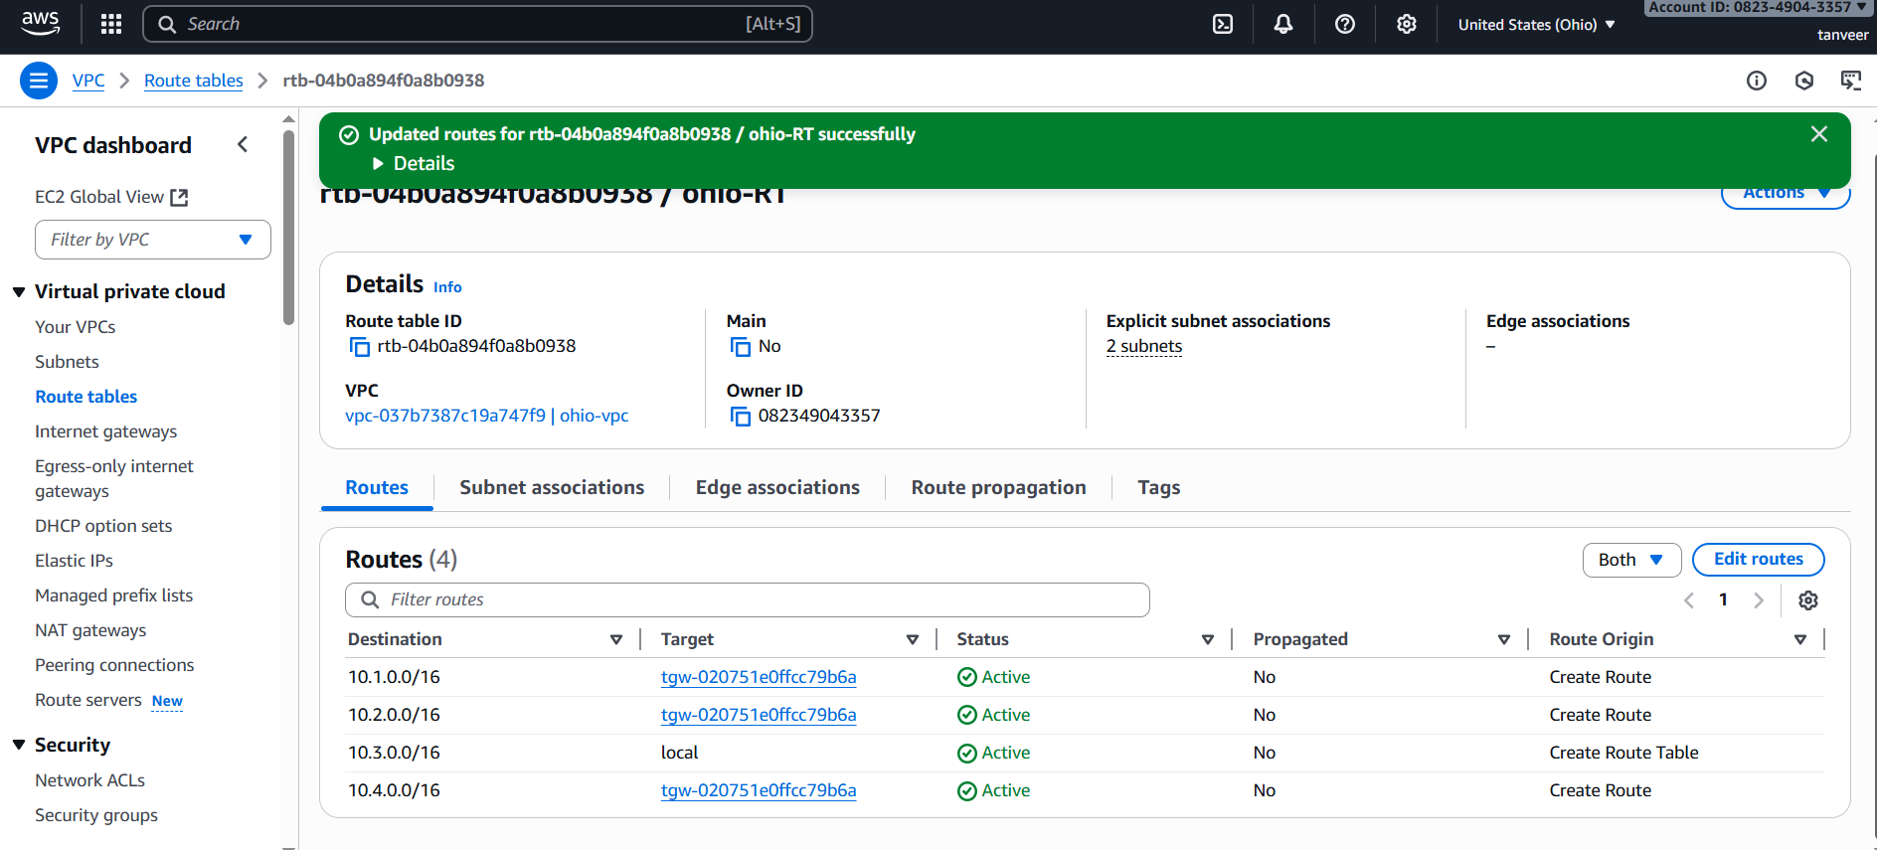
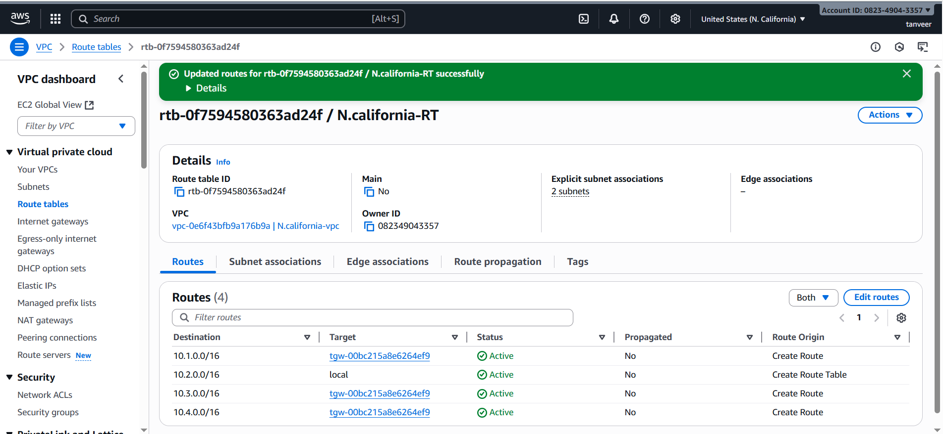
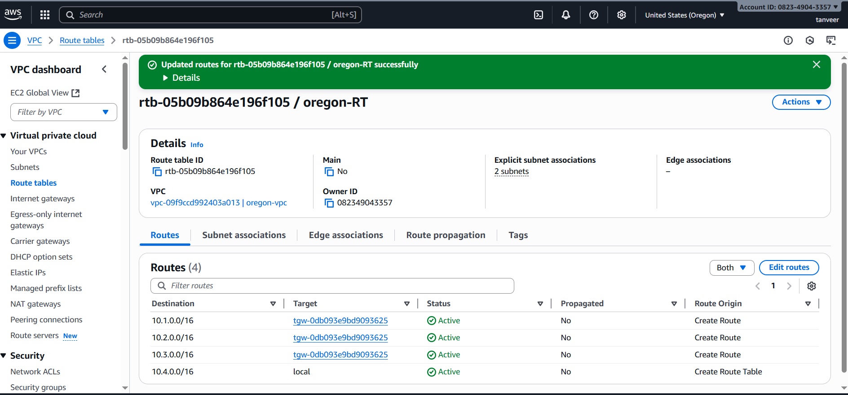
Create 4 instances in 4 different regions.
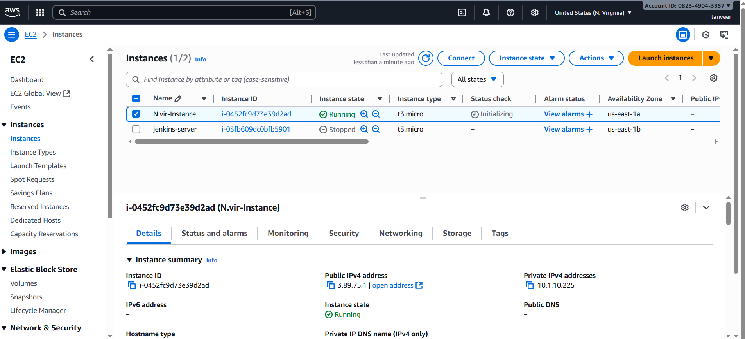
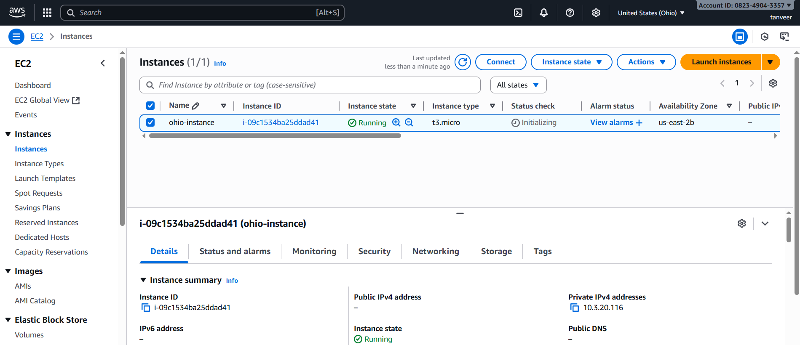
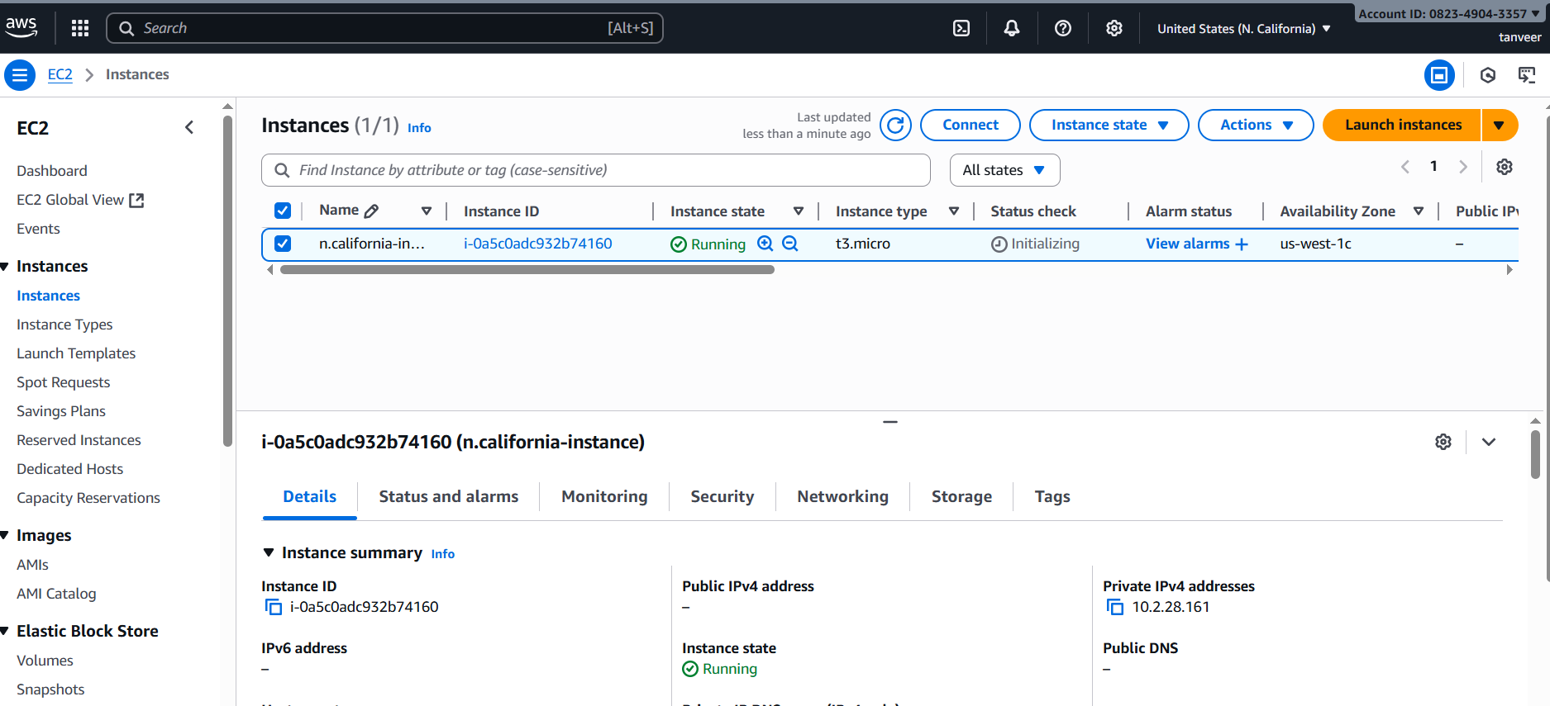
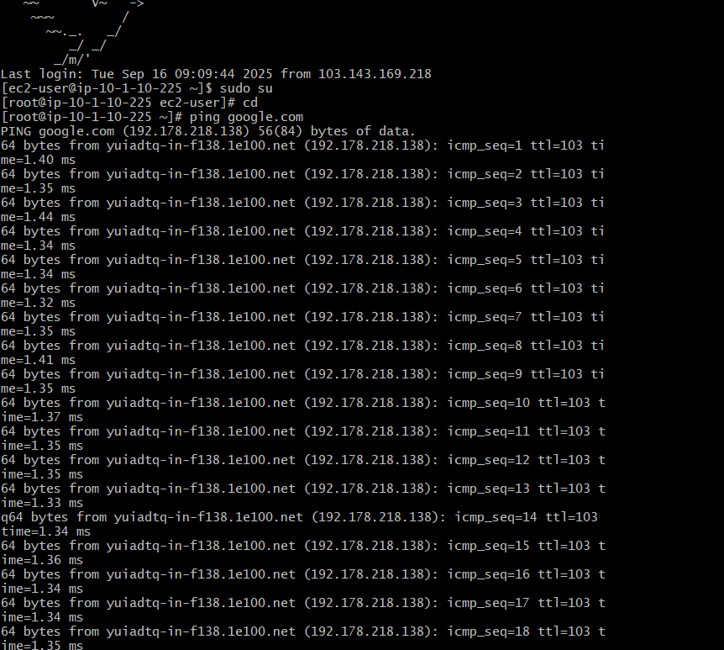
Now ping the private ipv4 addresses of instances in other regions.

