Docker-02
- Create a tomcat container on 8080 and deploy sample application in tomcat.
1.pull tomcat image
docker pull tomcat:latest
2.Run tomcat container on port 8080
docker container run -itd -p 8081:8080 tomcat:latest
check if it’s running:
docker ps

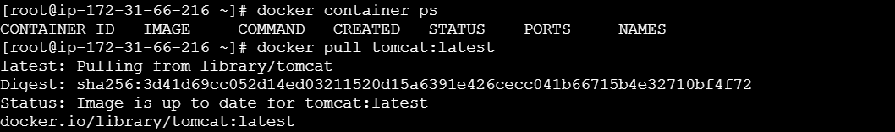

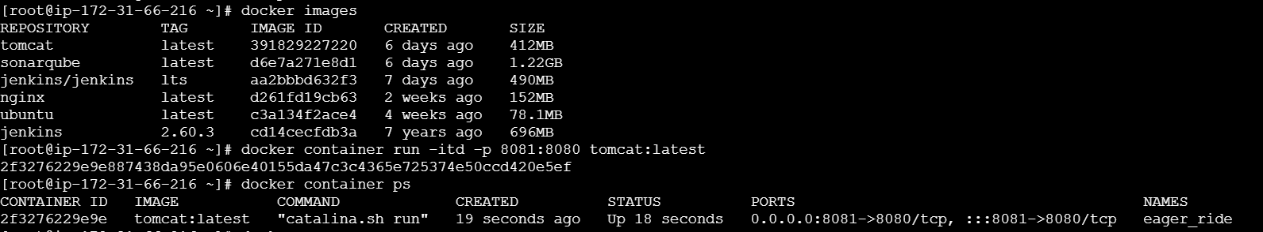

3.Deploy sample application.(WAR file)

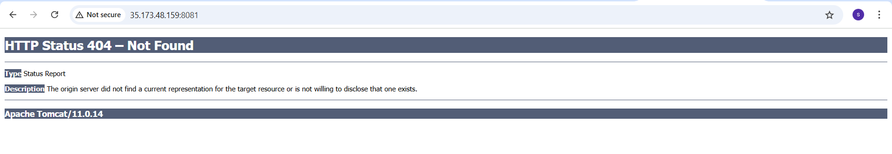
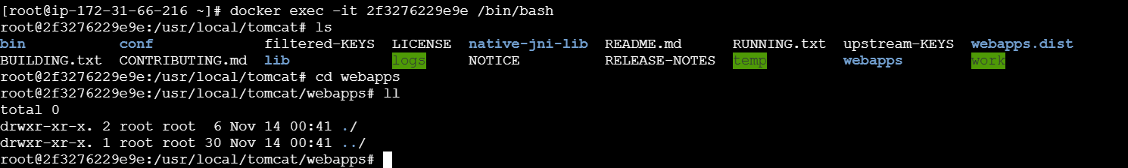

No files are available in webapps. So, for this reason we got HTTP status 404.
So download sample application.

I got wget command is not found.
So this command will never work unless i install wget:
So download sample.war in pc.
From local machine run:
scp mykey.pem sample.war root@<your-server-ip>:/root/

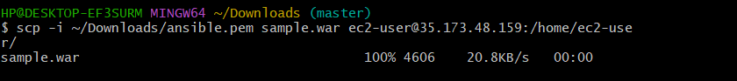

Now copy the sample.war file into tomcat webapps.
And restart container.

As I have uploaded sample.war file to the EC2
So, no need to download sample application. And check the long listing (ll) command to check sample.war was uploaded or not.

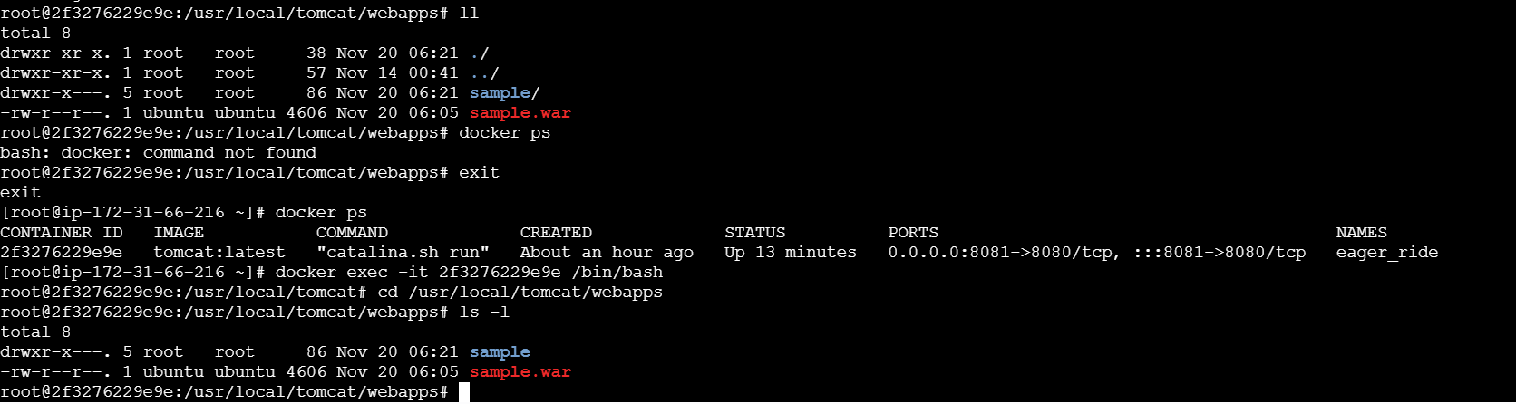

Verify in browser:
http://<EC2-Public-IP>:8081/sample

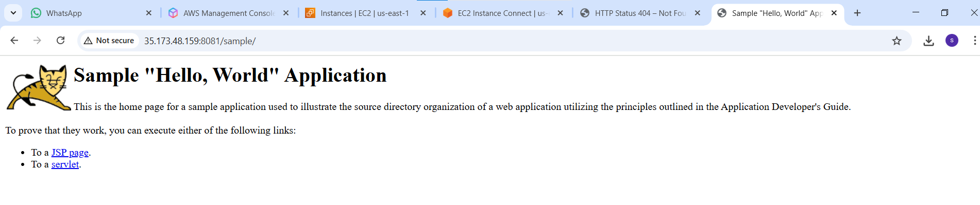
- Create volume and deploy tomcat container on port 8081.
1.create docker volume
docker volume create doc-volume
This creates a named volume doc-volume.
/var/lib/docker/volumes

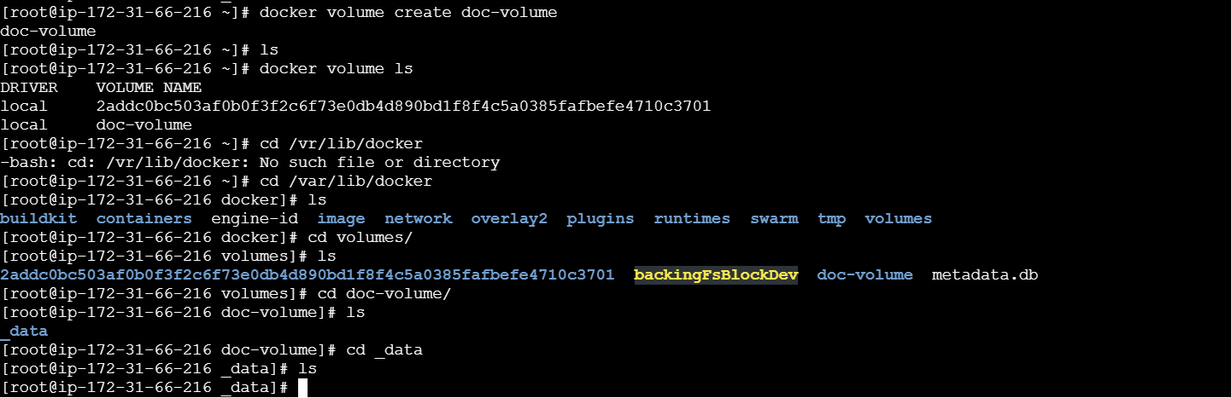

2.deploy sample application
Inside the /var/lib/docker/volumes/doc-volume/_data
Deploy the sample war file in _data

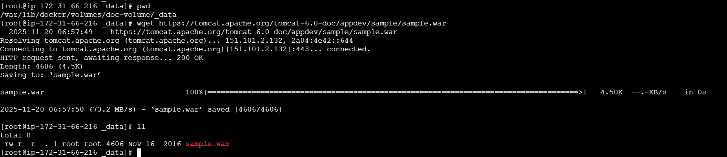

3.Run the tomcat container on port 8083 with volume.

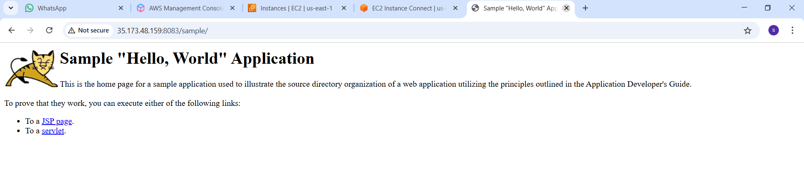

- Limit the nginx container to 500 MB.
docker run -itd -p 8082:80 --memory=500m nginx
Breakdown:
- -i → interactive mode
- -t → allocates a pseudo- TTY.
- -d → runs in detached mode (in background)
- -p 8082:80 → maps host port 8082 to container port 80.
- --memory=500m → limits container memory to 500 MB.
- nginx → image name (latest)

I have created nginx container with 500MB limit.
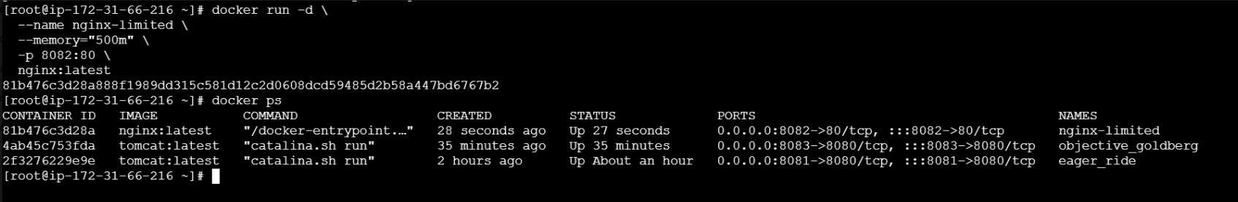

docker stats

Check in browser:
http://<ec2_server_ip>:8082

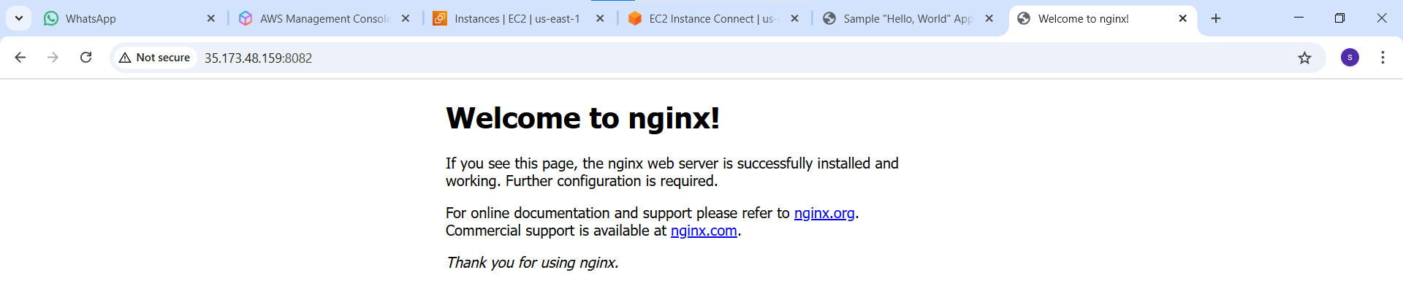
- create sample docker file using below instructions.
- Base module as amazonlinux:latest
- Maintainer you name
- Install nginx
- COPY one index.html file to image
- Expose on port 80
- Command to start the nginx container.

1.create a dockerfile with the above contents.
2.place index.html in the same directory as the dockerfile.
Create a index.html file
vi index.html
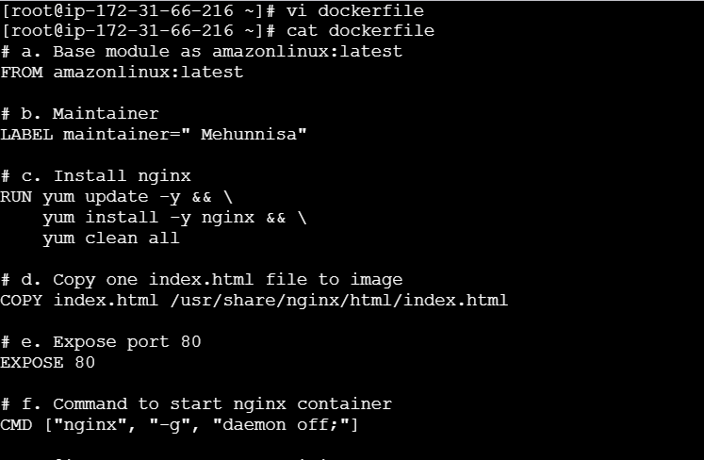

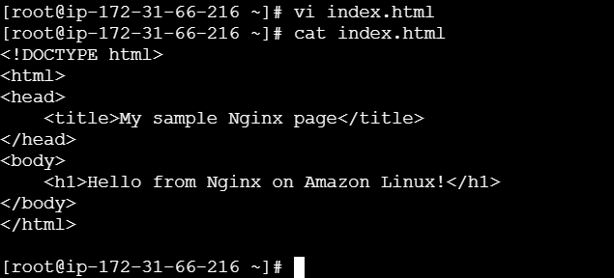

1.Build the image.
docker build -t test-nginx
2.Run the container.
docker run -d -p 8084:80 test-nginx
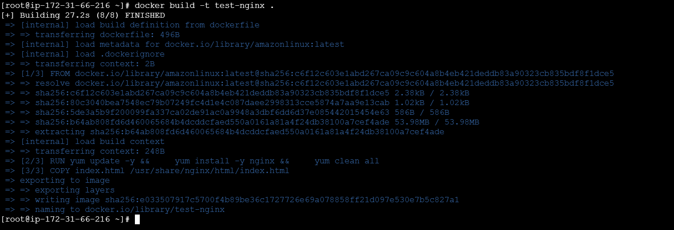
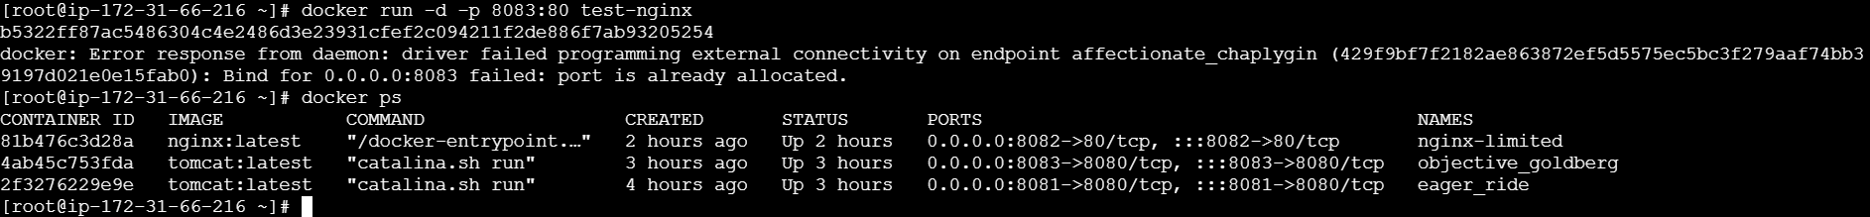
Here I got error that 8083 port was already allocated.
so I have changed the port to 8084.

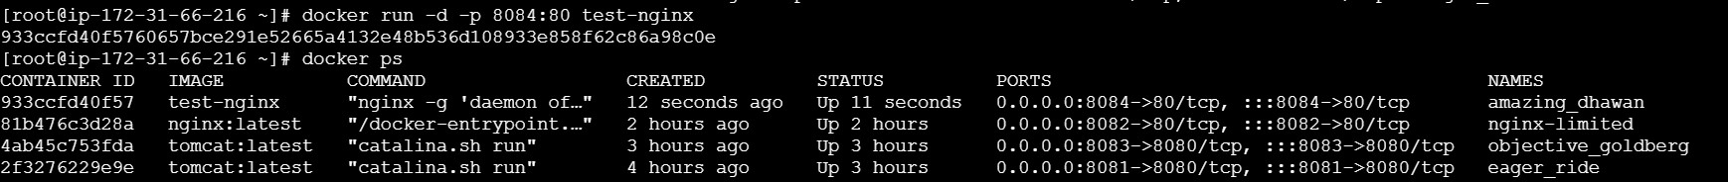
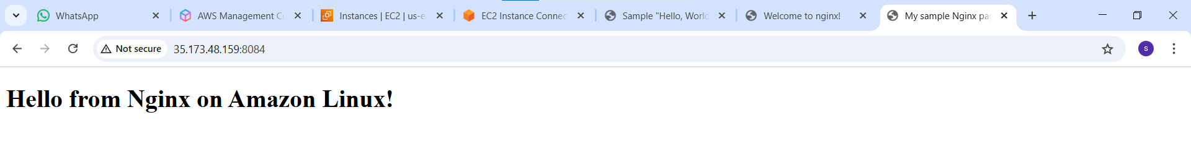
- Push image to docker hub.
1.Docker login:
Enter your Docker hub username and password when prompted.
(if you don’t have an account → create one here).

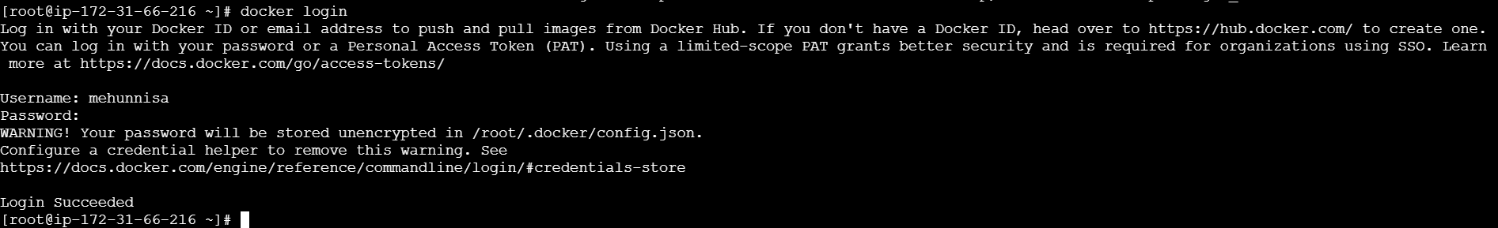

2.Tag your image:
I have built an image as test-nginx. So I need to tag it with docker hub
Username and repo name:

Docker tag test-nginx <your-dockerhub-username>/test-nginx:latest
docker tag test-nginx mehunnisa/test-nginx:latest

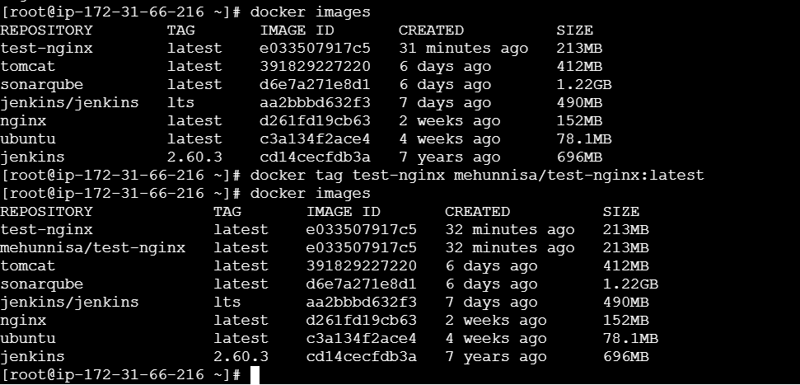

3.push the image
docker push <your-dockerhub-username>/test-nginx:latest
docker push mehunnisa/test-nginx:latest

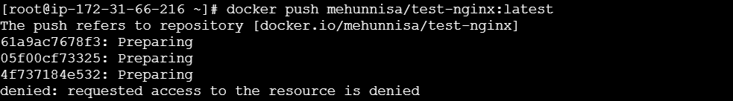

I have not created a repository in dockerhub. So for that reason push was denied.
So create a repo in dockerhub (test-nginx)

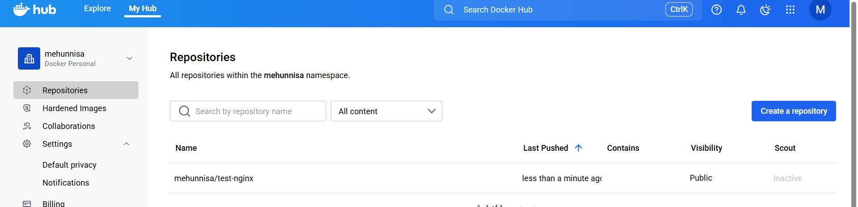
Now push the image as:
docker push mehunnisa/test-nginx
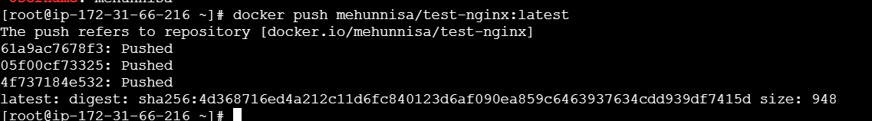

Now check in the repo whether the image was pushed or not.

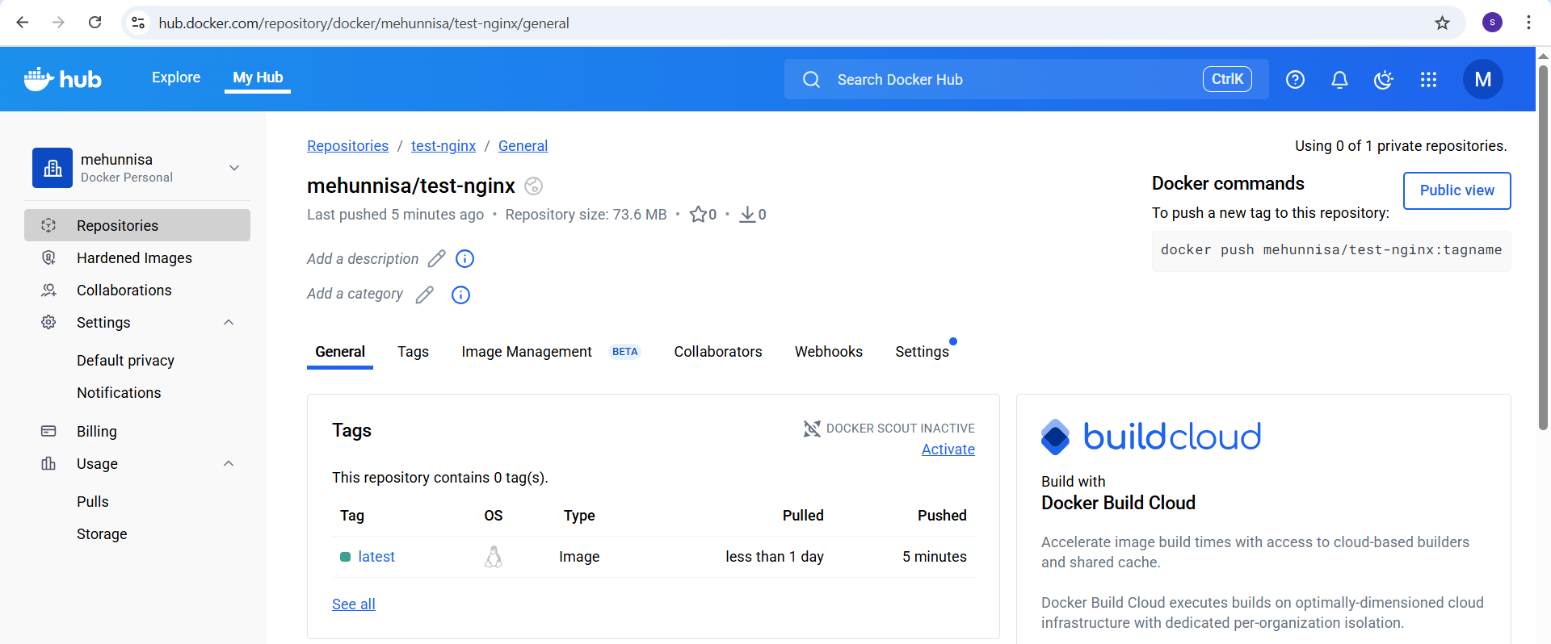
- Push the image to AWS ECR
1.AWS Configure
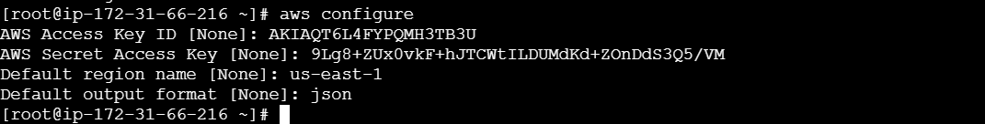

2.create an ECR Repository
Aws ecr create-repository --repository-name test-nginx --region us-east-1

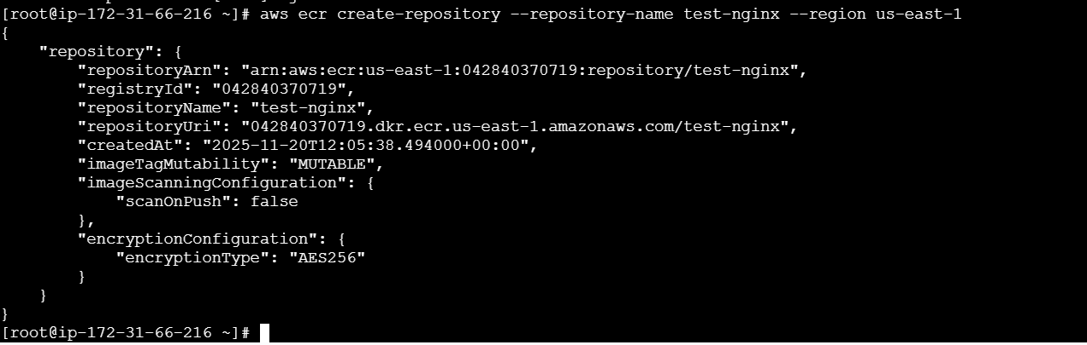

It will create an ecr repo in aws.
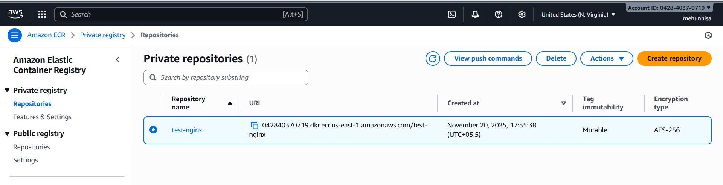
Authenticate docker with ECR
Run the following command to get login password and pipt itto Docker:
Replace the command with ECR repo uri
→ aws ecr get-login-password –region us-east-1 | docker login –username AWS
--password-stdin 042840370719.dkr.ecr.us-east-1.amazonaws.com/test-nginx

Tag your local image
My image is test-nginx. So tag it with the ECR repo URI:
docker tag test-nginx:latest 042840370719.dkr.ecr.us-east-1.amazonaws.com/test-nginx

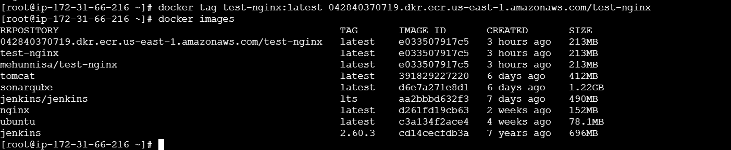

Push image to ECR
Docker push 042840370719.dkr.ecr.us-east-1.amazonaws.com/test-nginx
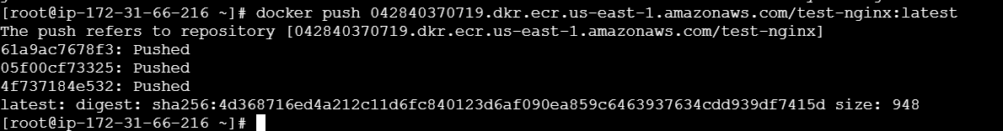

Verify
We can verify the image in Aws console.
Go to ECR → repositories → test-nginx
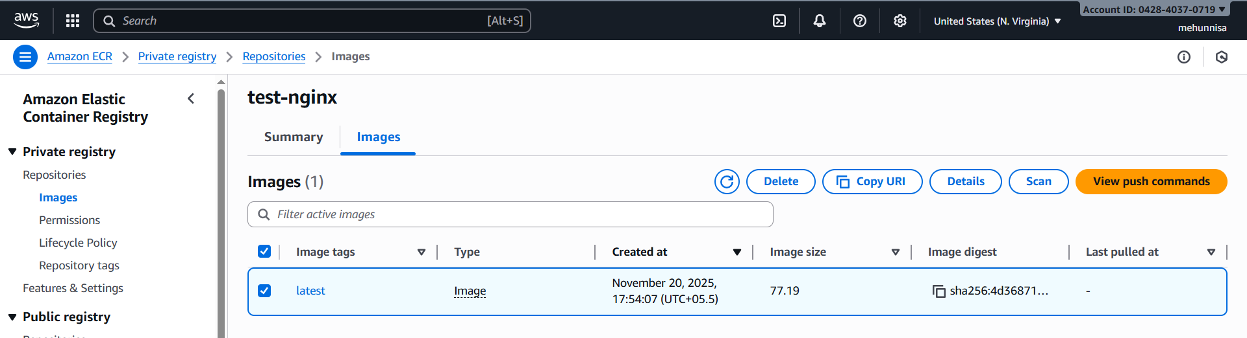
We can also verify via CLI:
Aws ecr list-images –repository-name test-nginx –region us-east-1

