Terraform-7

- Create VPC.
- Create internet gateway.
- Create customer route table
- Create subnet
- Associate subnet with route table.
- Create security group to allow port22,80,443.
- Create a network interface with an ip in the subnet that was created in step 4
- Assign an elastic IP to the network interface created in step 7
- Create ubuntu server and install/enable apache2.
This configuration builds a basic networking setup in AWS:
- VPC
- Subnet
- Internet Gateway
- Route Table
- Route Table Association

Step 1: create VPC
In terraform
Main.tf
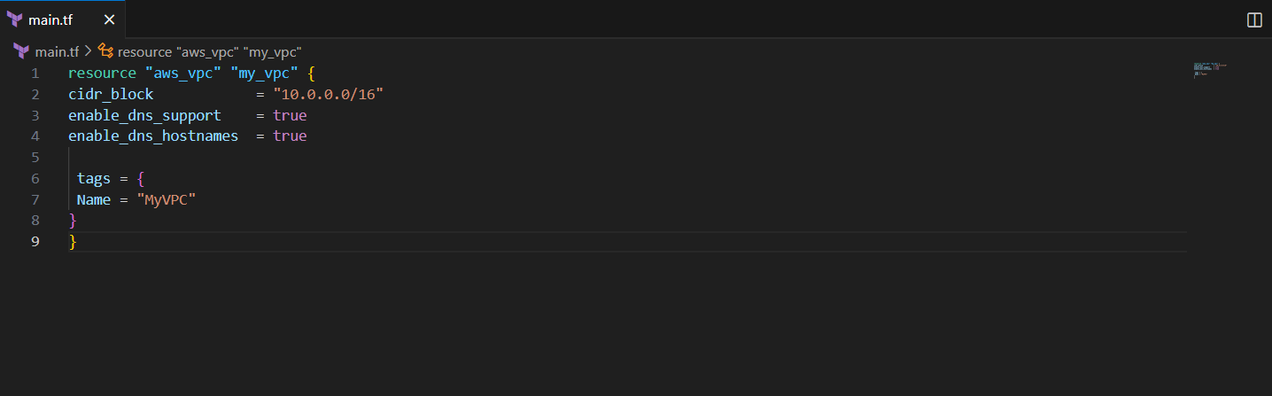
Terraform init
Terraform apply
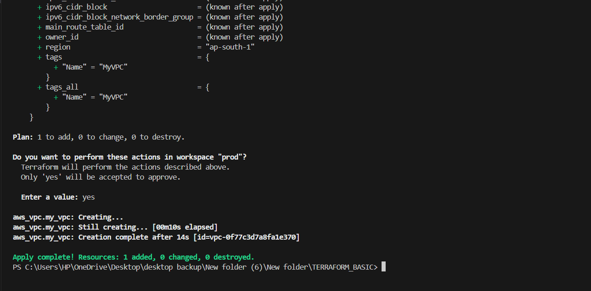

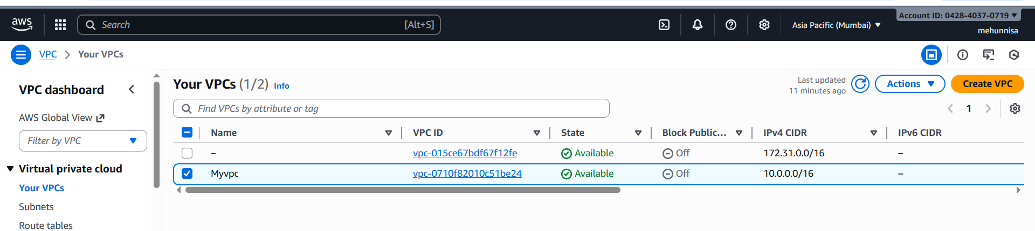

Step 2: create subnet
Step 1 & step 2
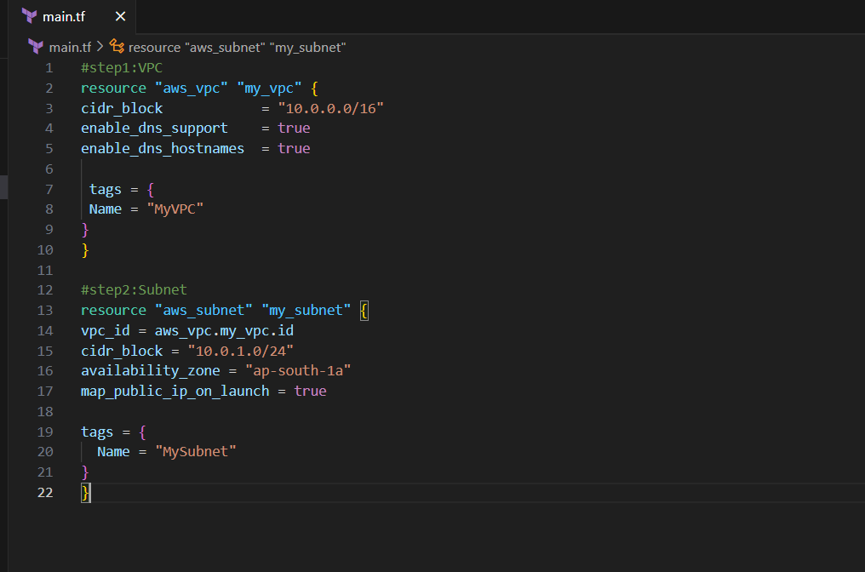
Terraform apply -auto-approve
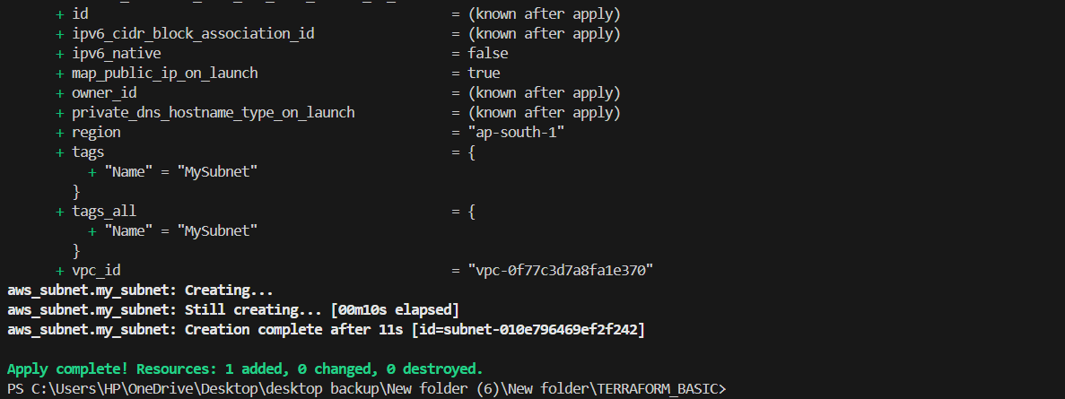

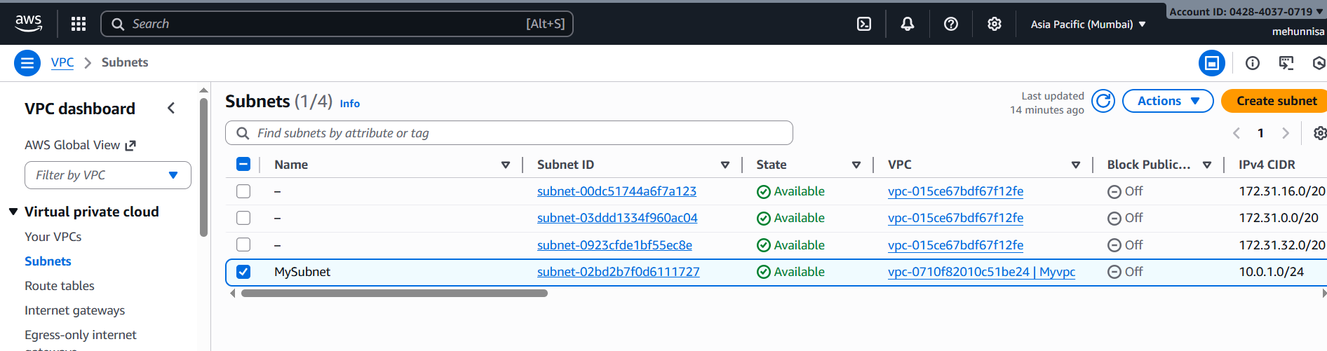
Step 3: create Internet Gateway
Step 1, step 2, and step 3
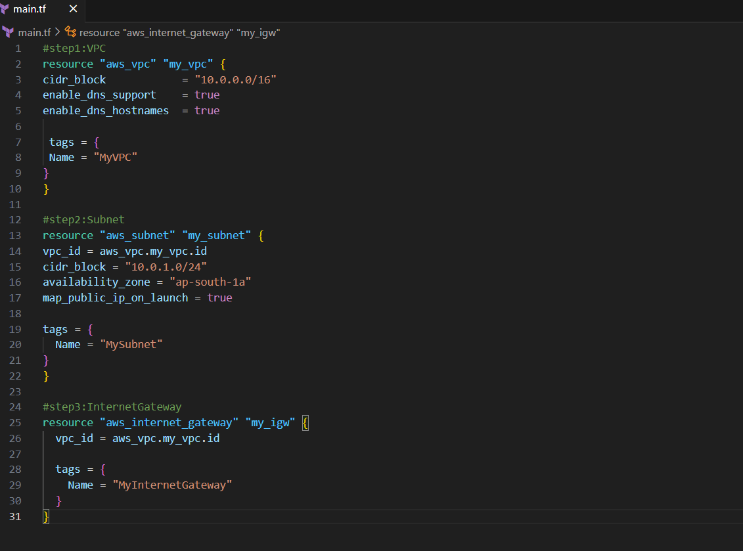
Terraform apply -auto-approve
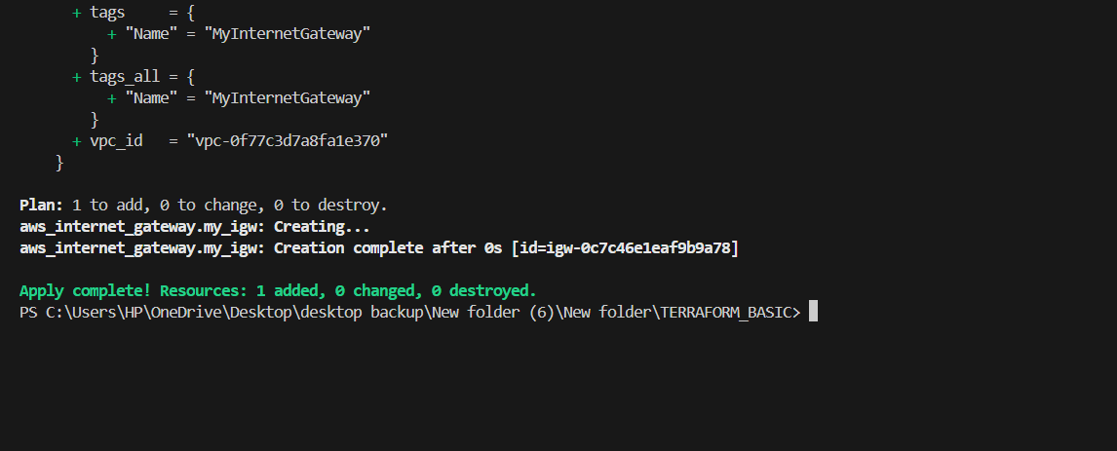

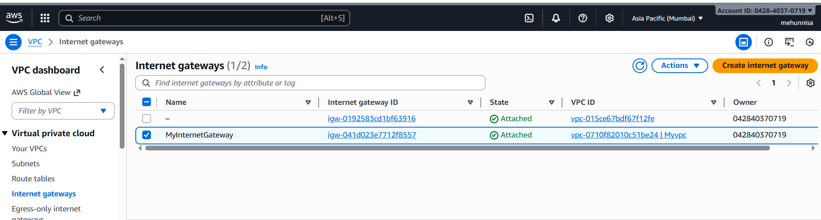
Step 4: create Route Table
Step 1, step 2, step 3 and step 4
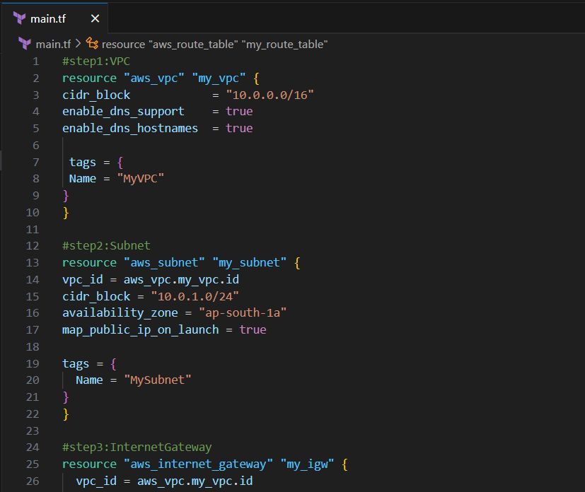

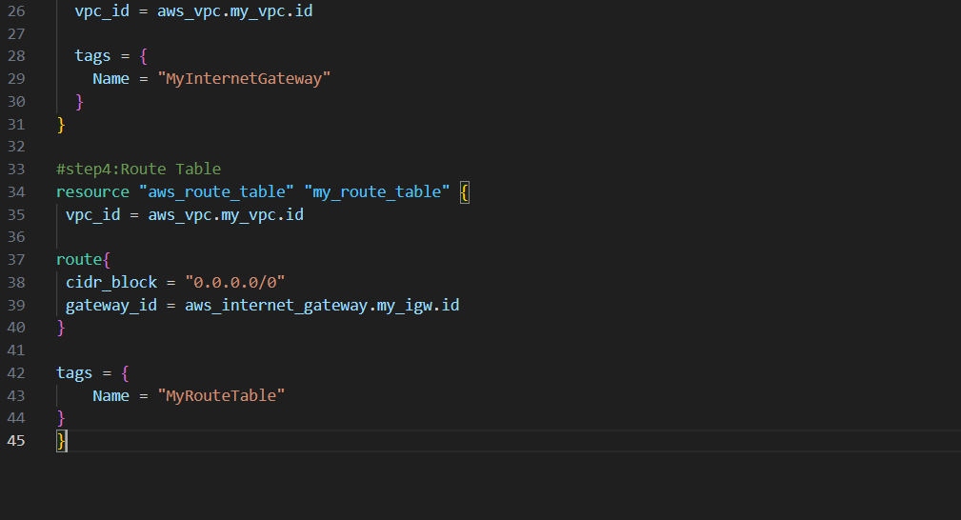

Terraform apply -auto-approve
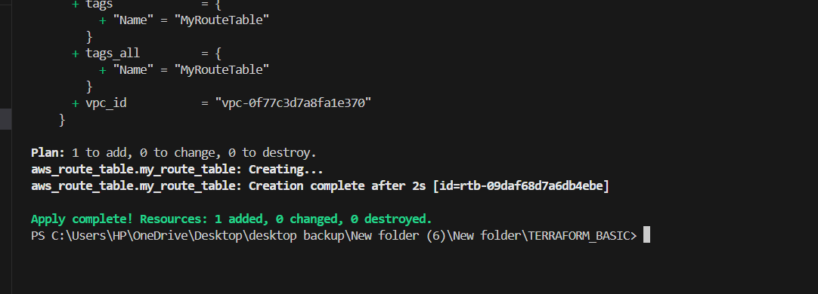
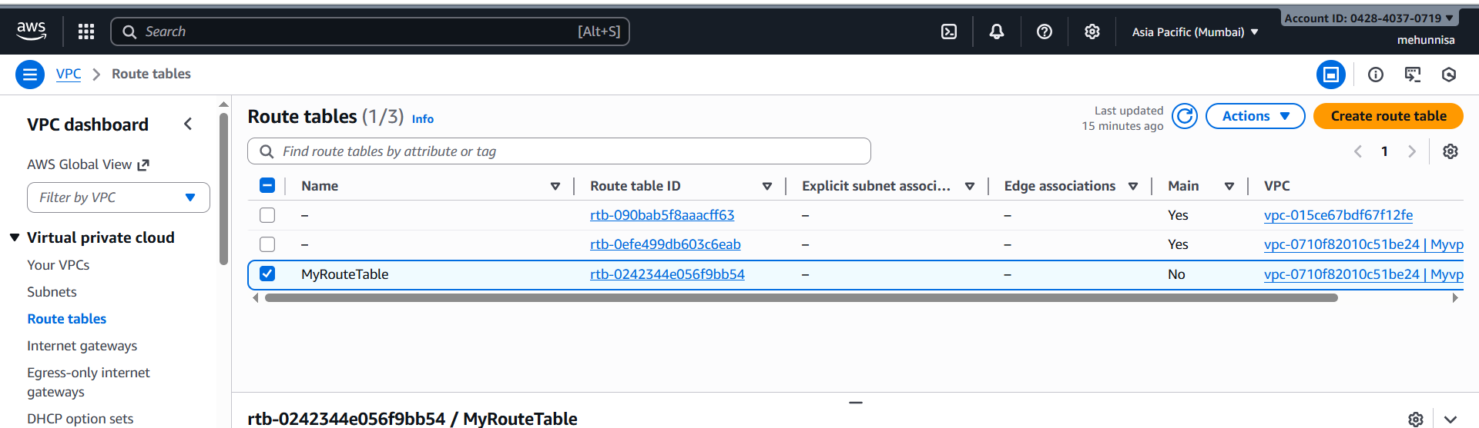

step 5:Associate Route Table with Subnet
step1, step2, step3, step4 and step5
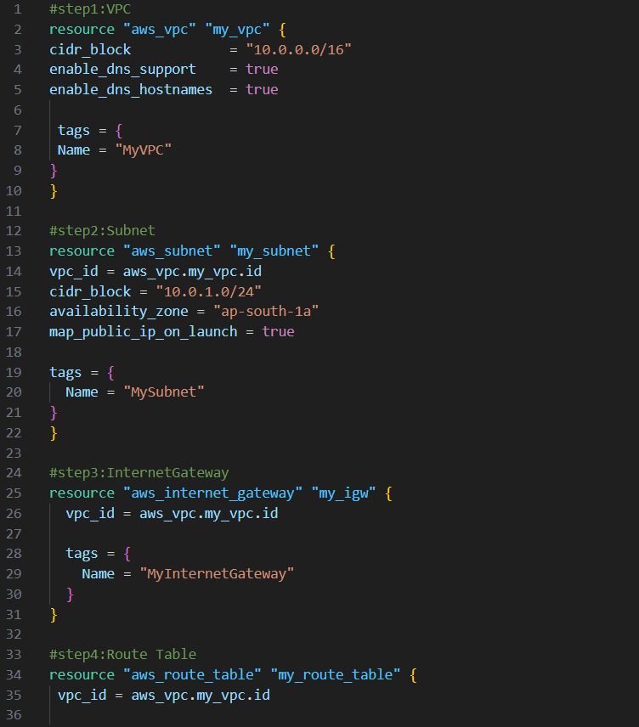
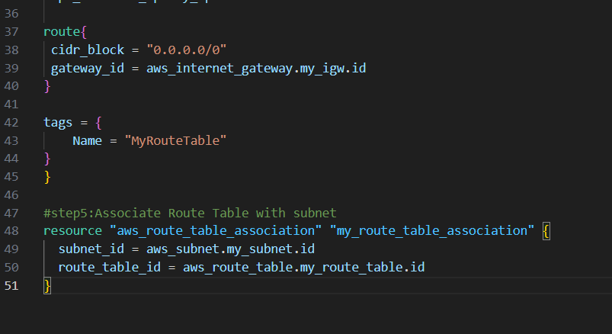
Terraform apply -auto-apply
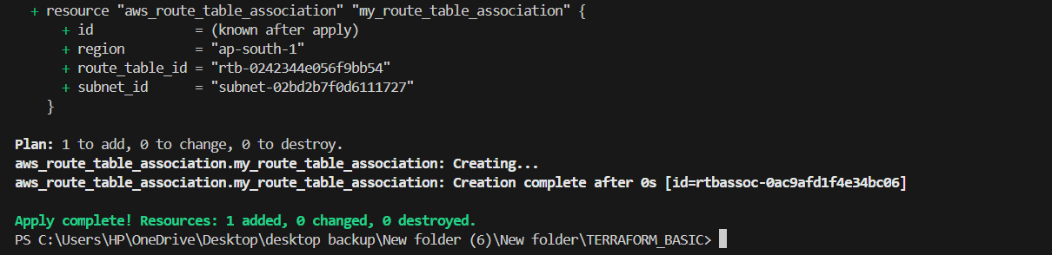
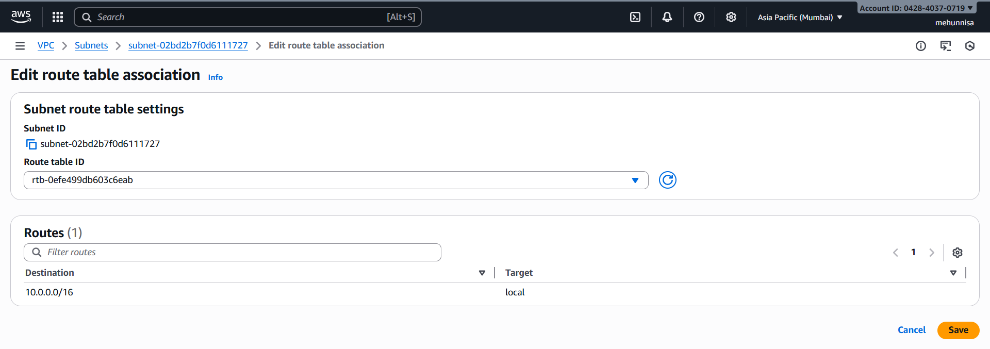
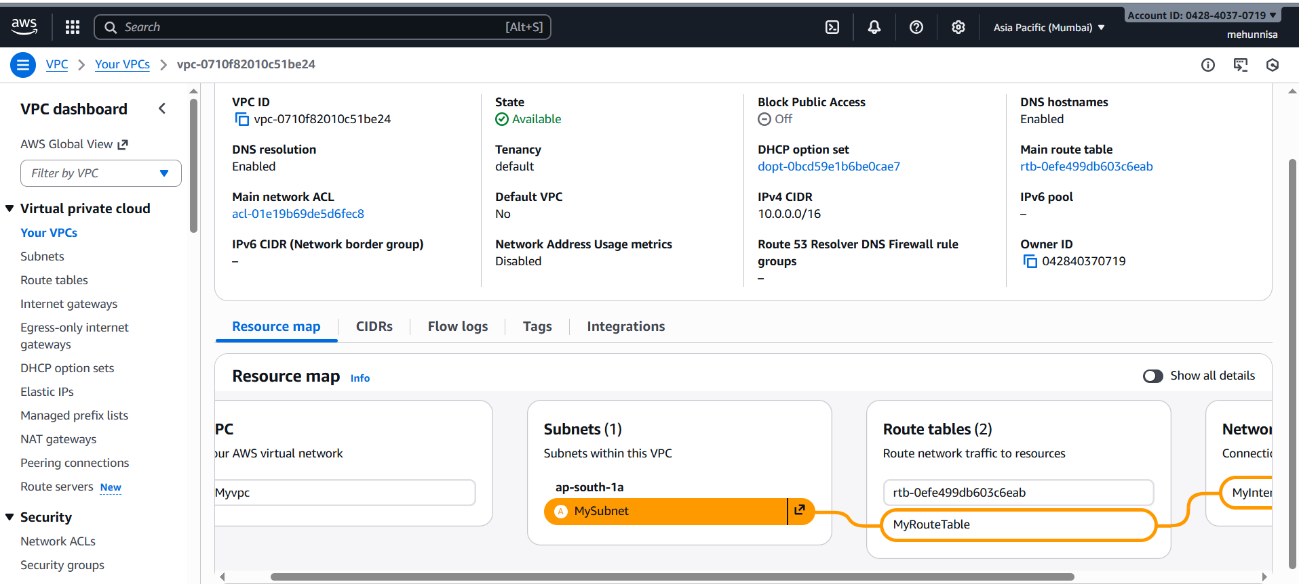

step 6: create security Group to allow port 22, 80, 443
Create main.tf and terraform.tfvarfs
We should have default VPC
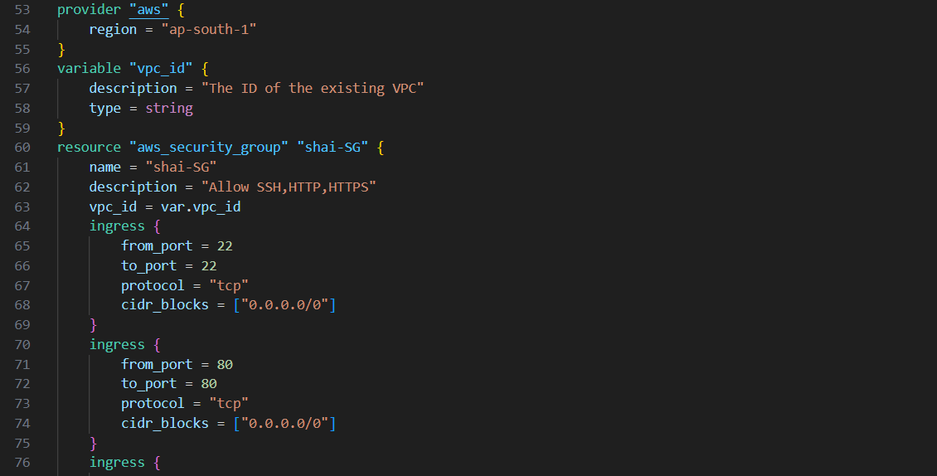
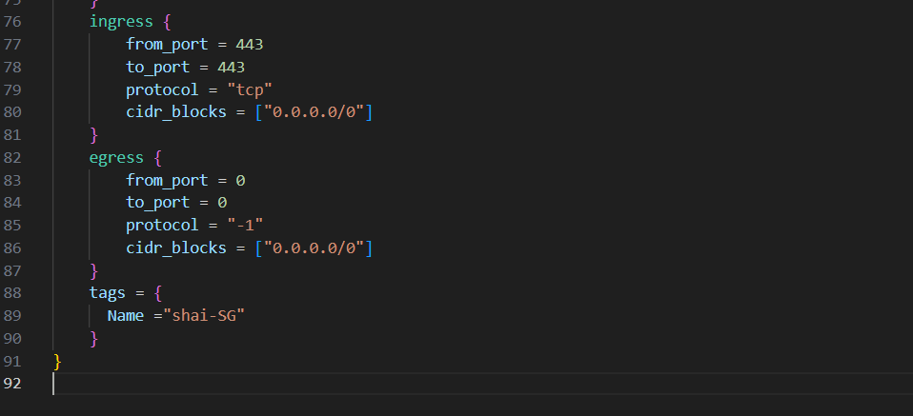

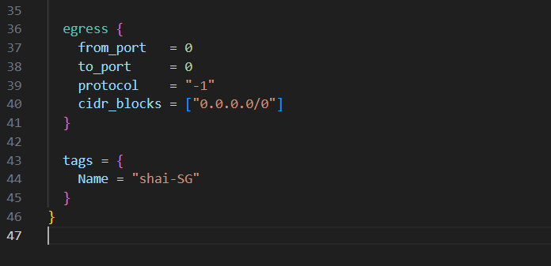
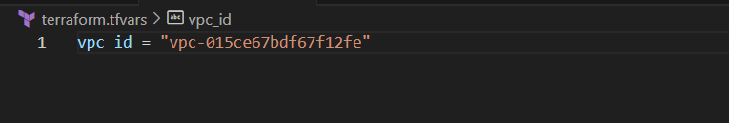
Terraform init
Terraform apply
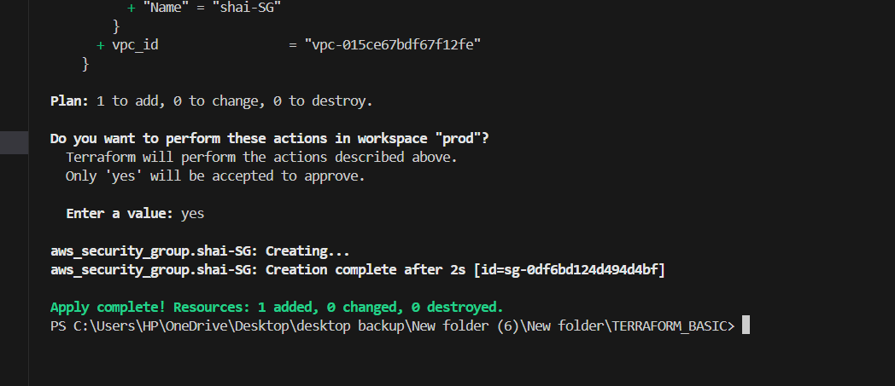

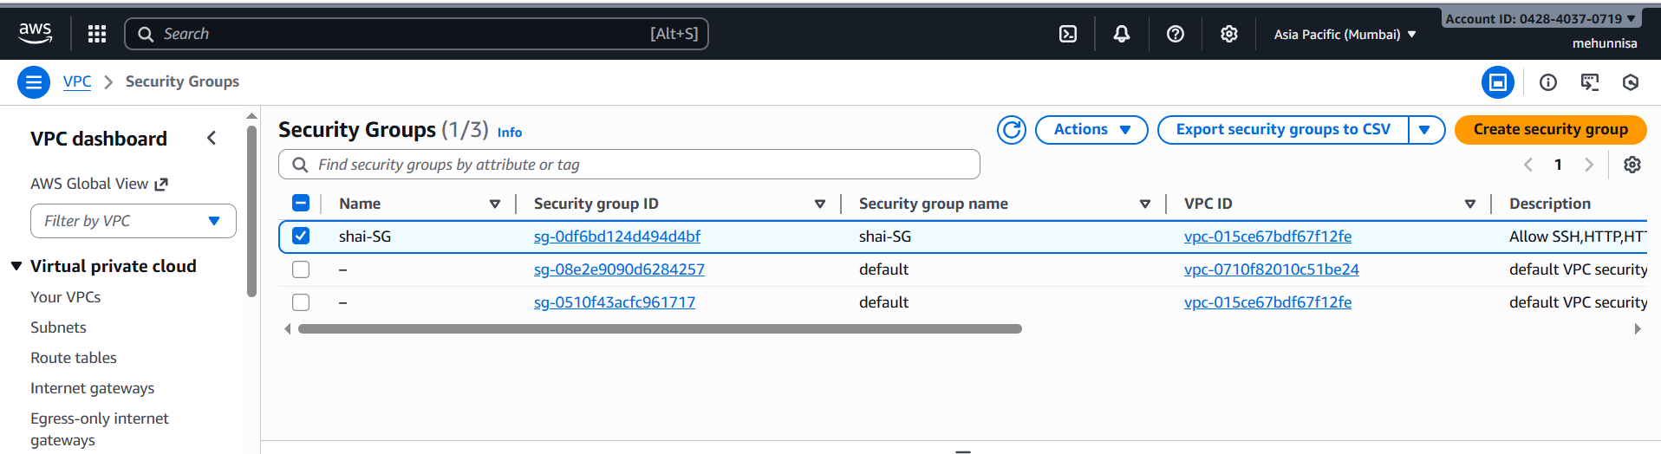
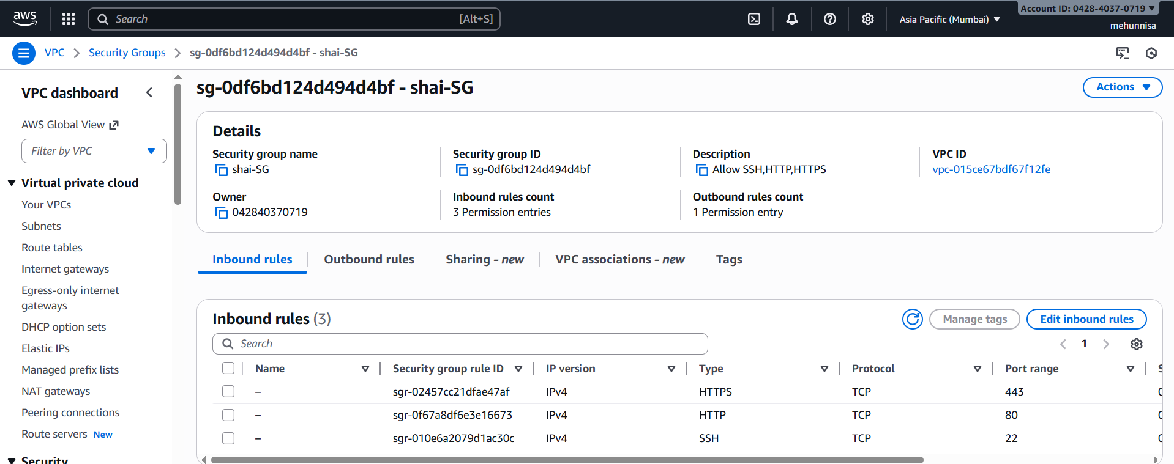

Step 7: create network interface with an ip in the subnet that was created in step4

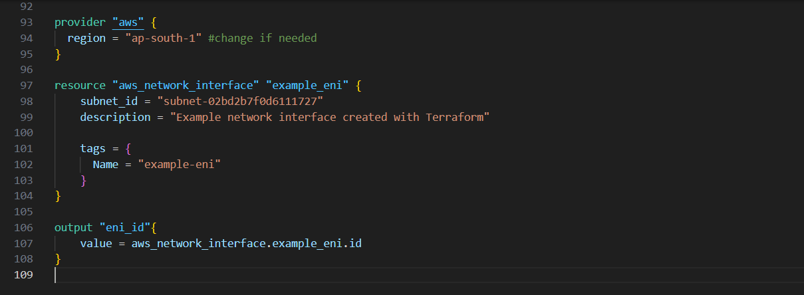

Terraform apply
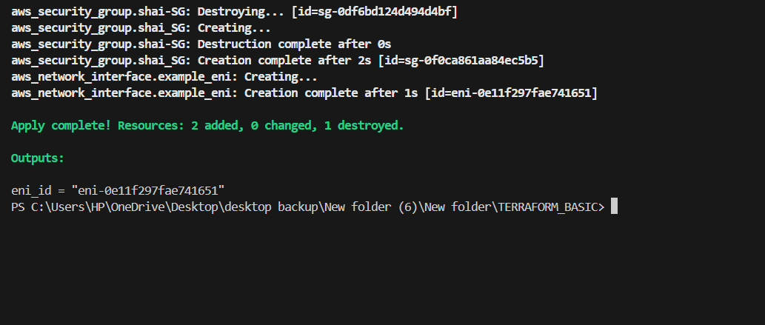
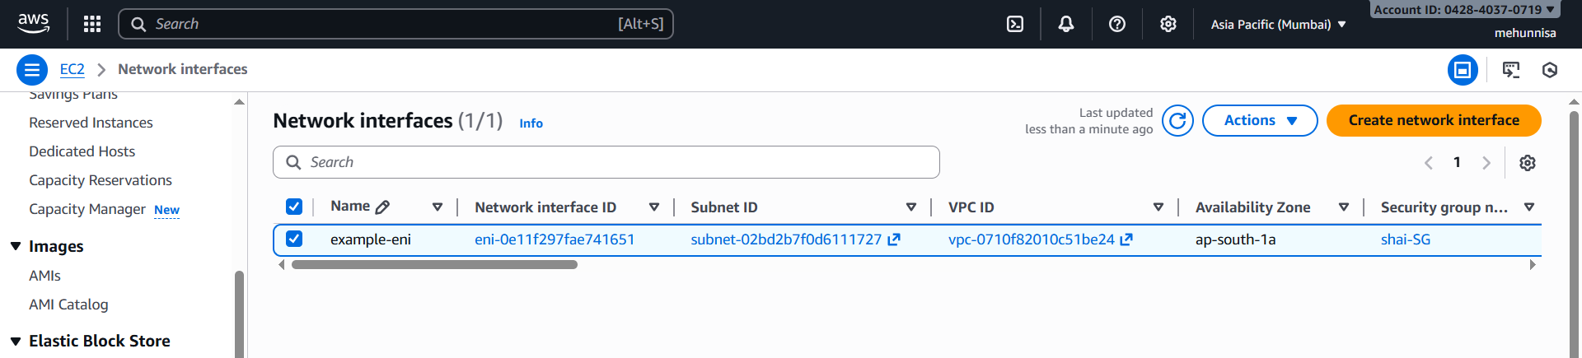
Step8: Assign an elastic IP to the network interface created in step 7

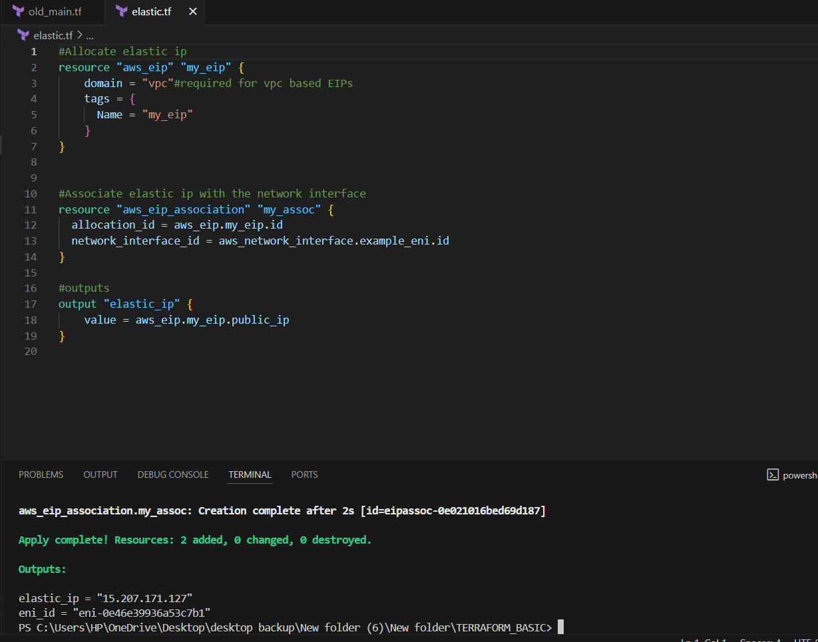

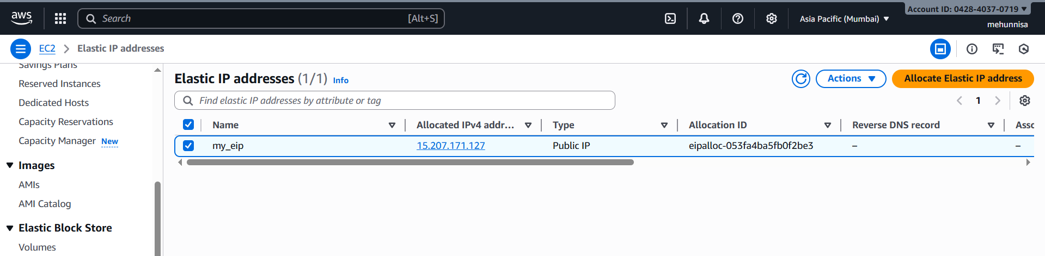
step9: create ubuntu server and install/enable apache2
Here I have taken created subnet_id and security_group using terraform.
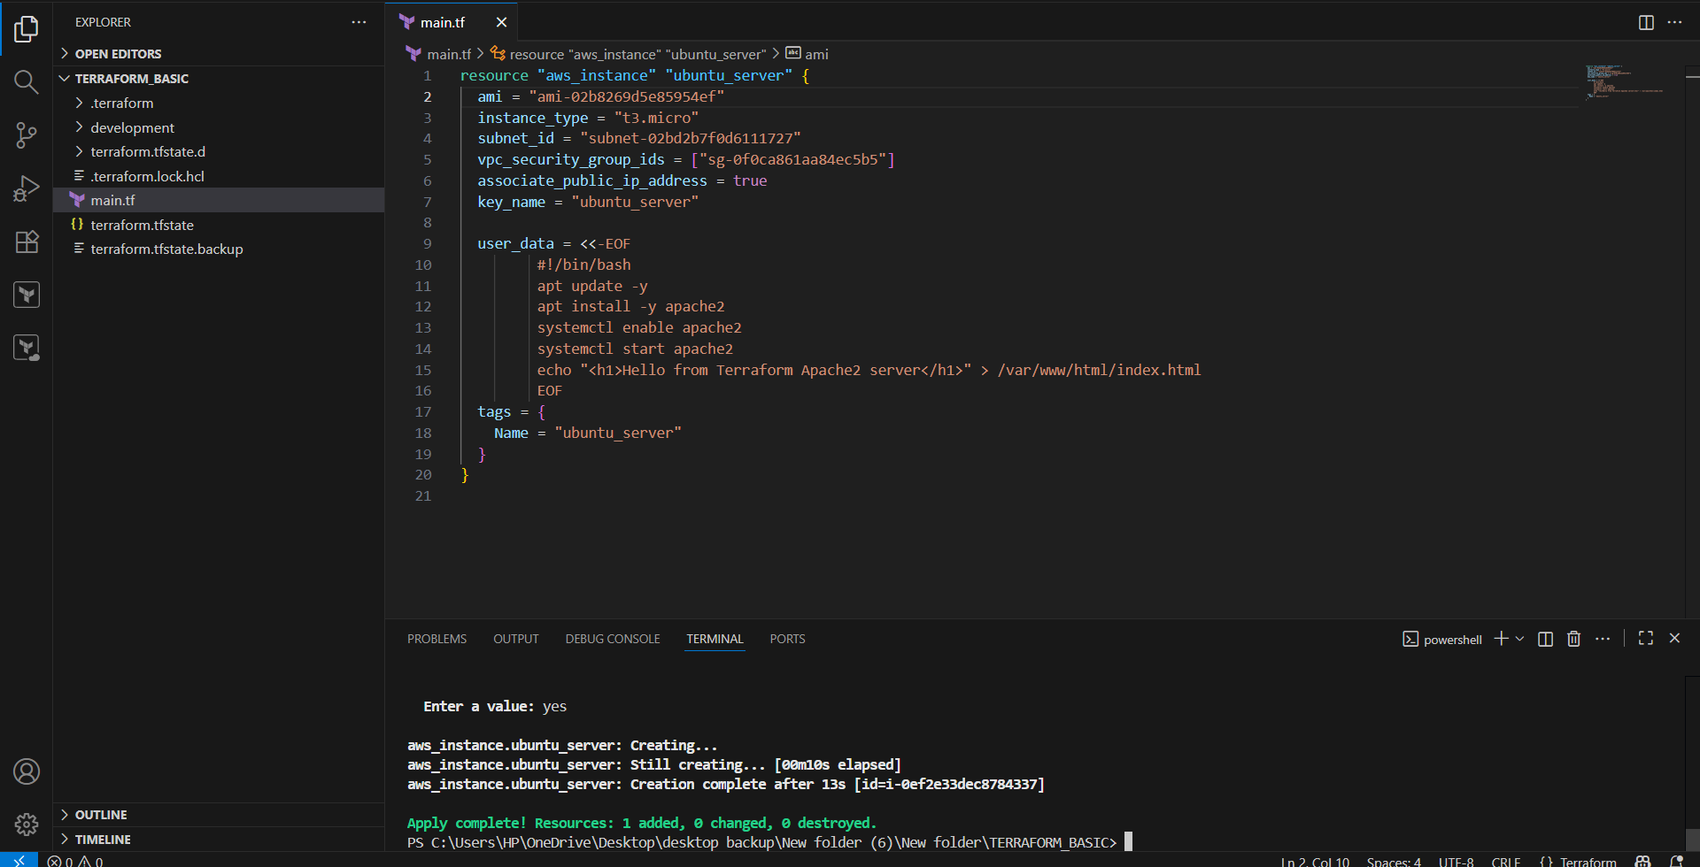

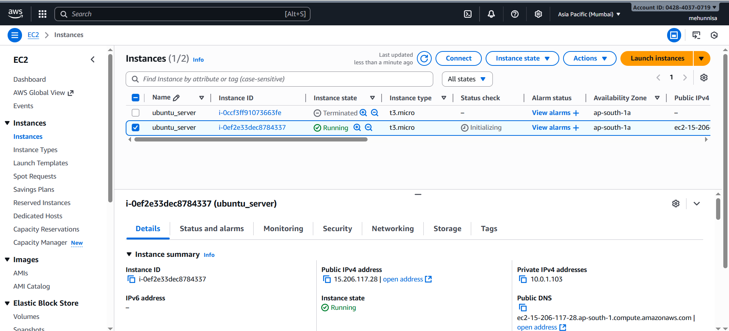
Check in browser whether apache2 is running or not by using public_ip

http://<public_ip>
