- Watch the terraform-05 video.
Completed.
- Execute the script shown in the video.
Create s3 using terraform.
terraform init
terraform apply.

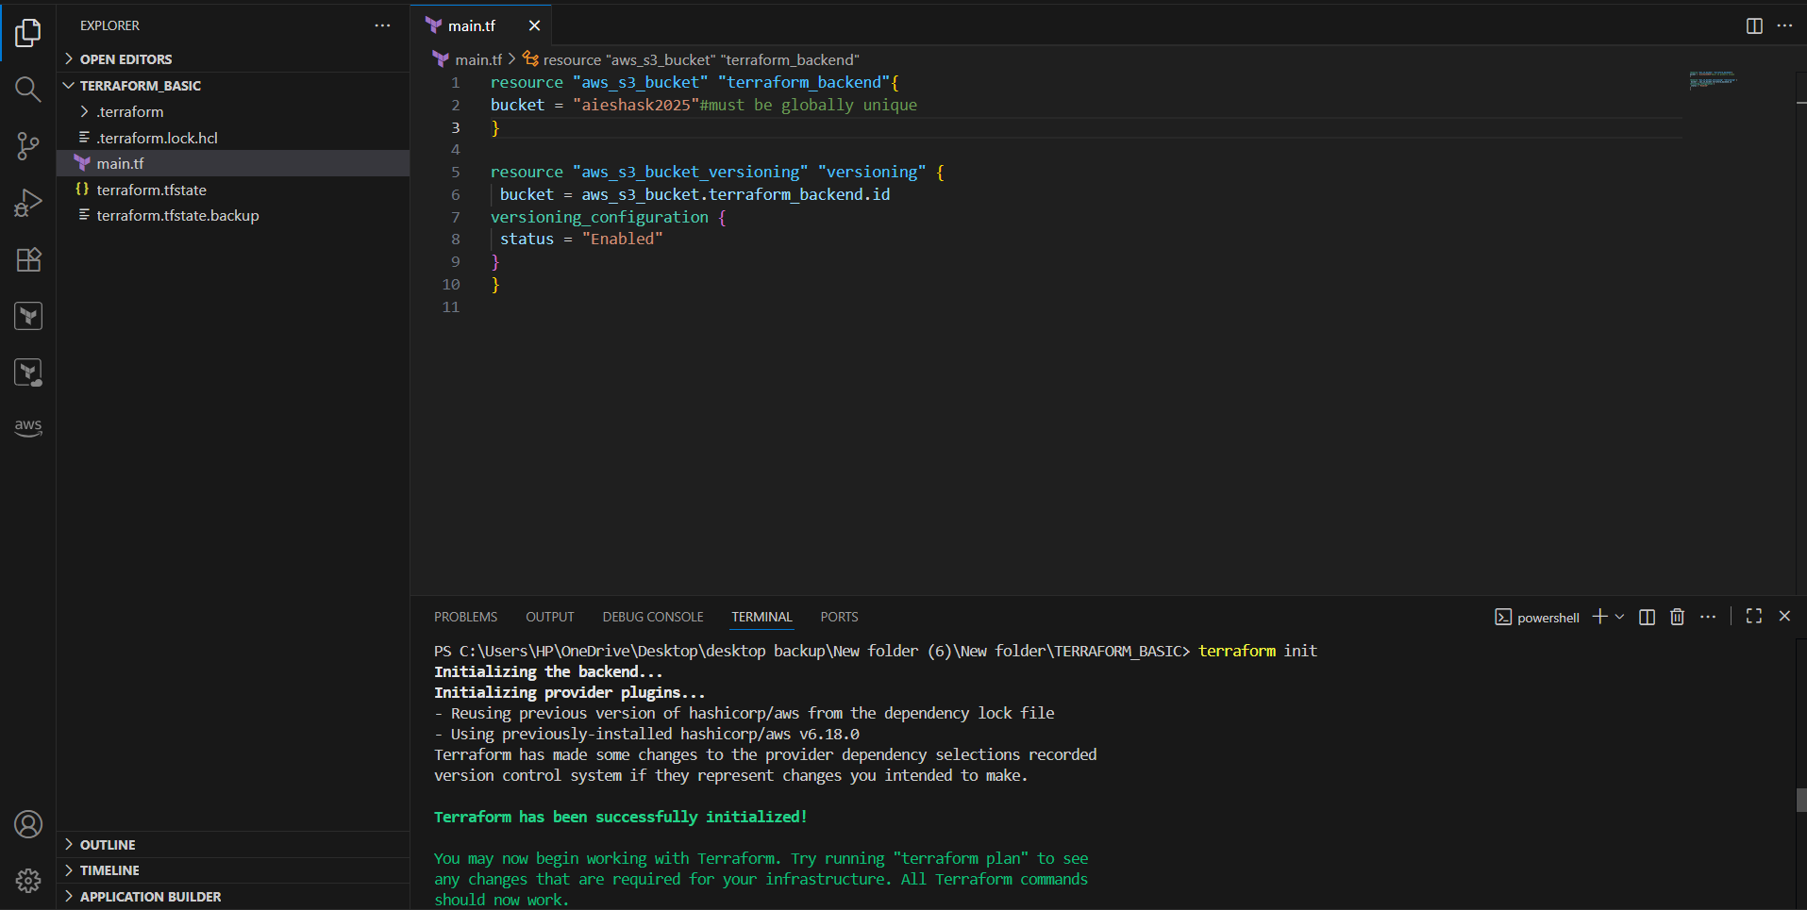
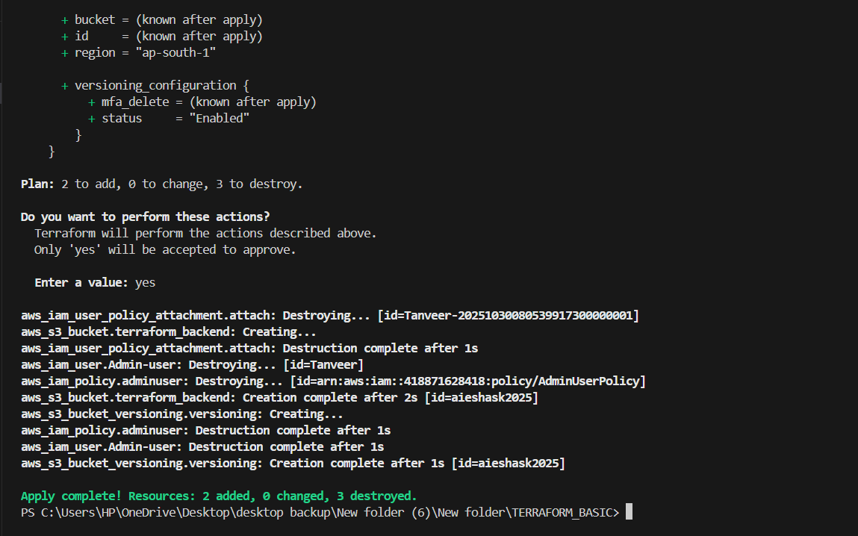

Go and see in aws that created bucket in s3 console.

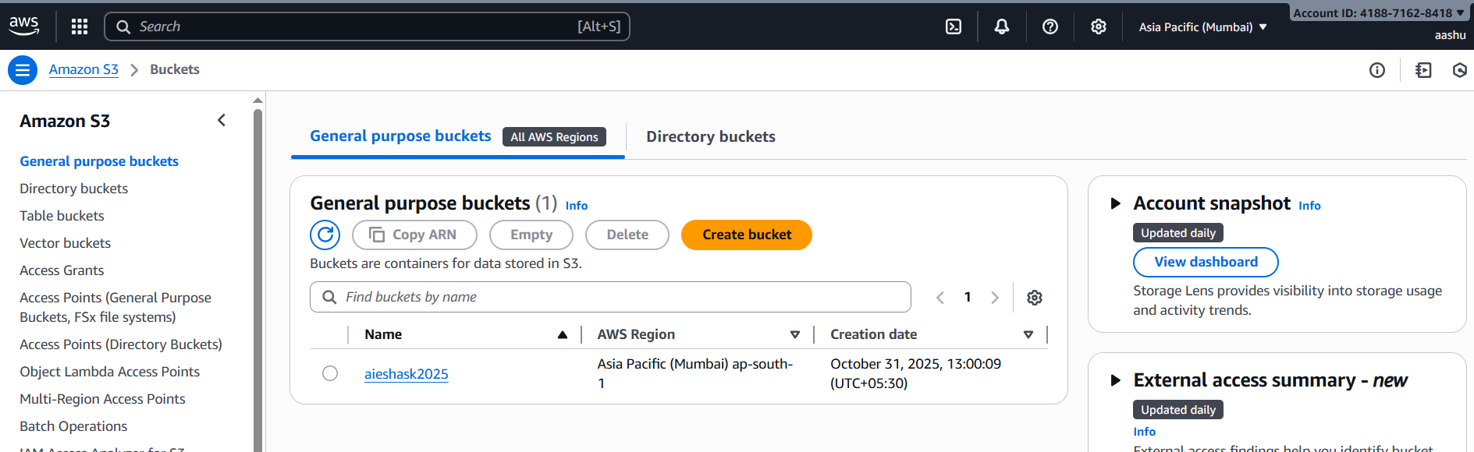
Create dynamo db using terraform.
terraform init
terraform apply

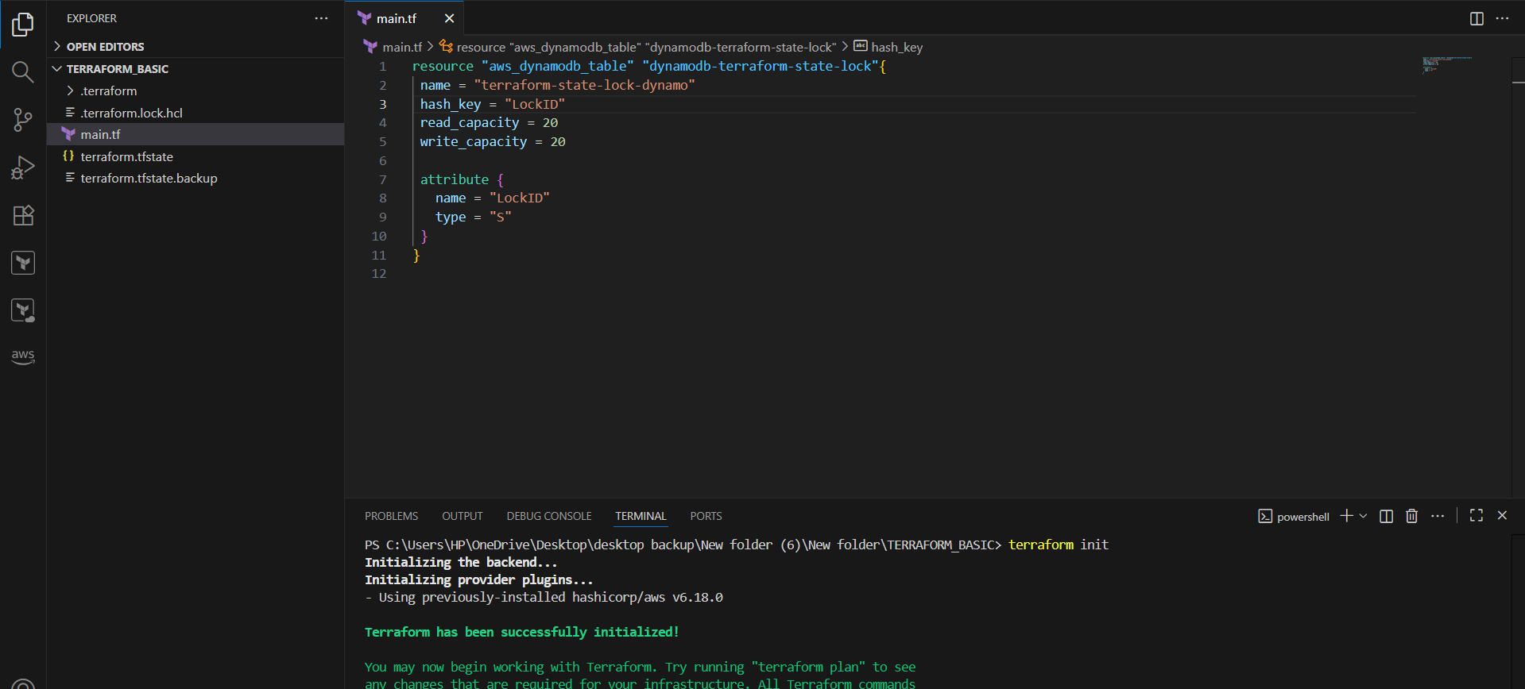

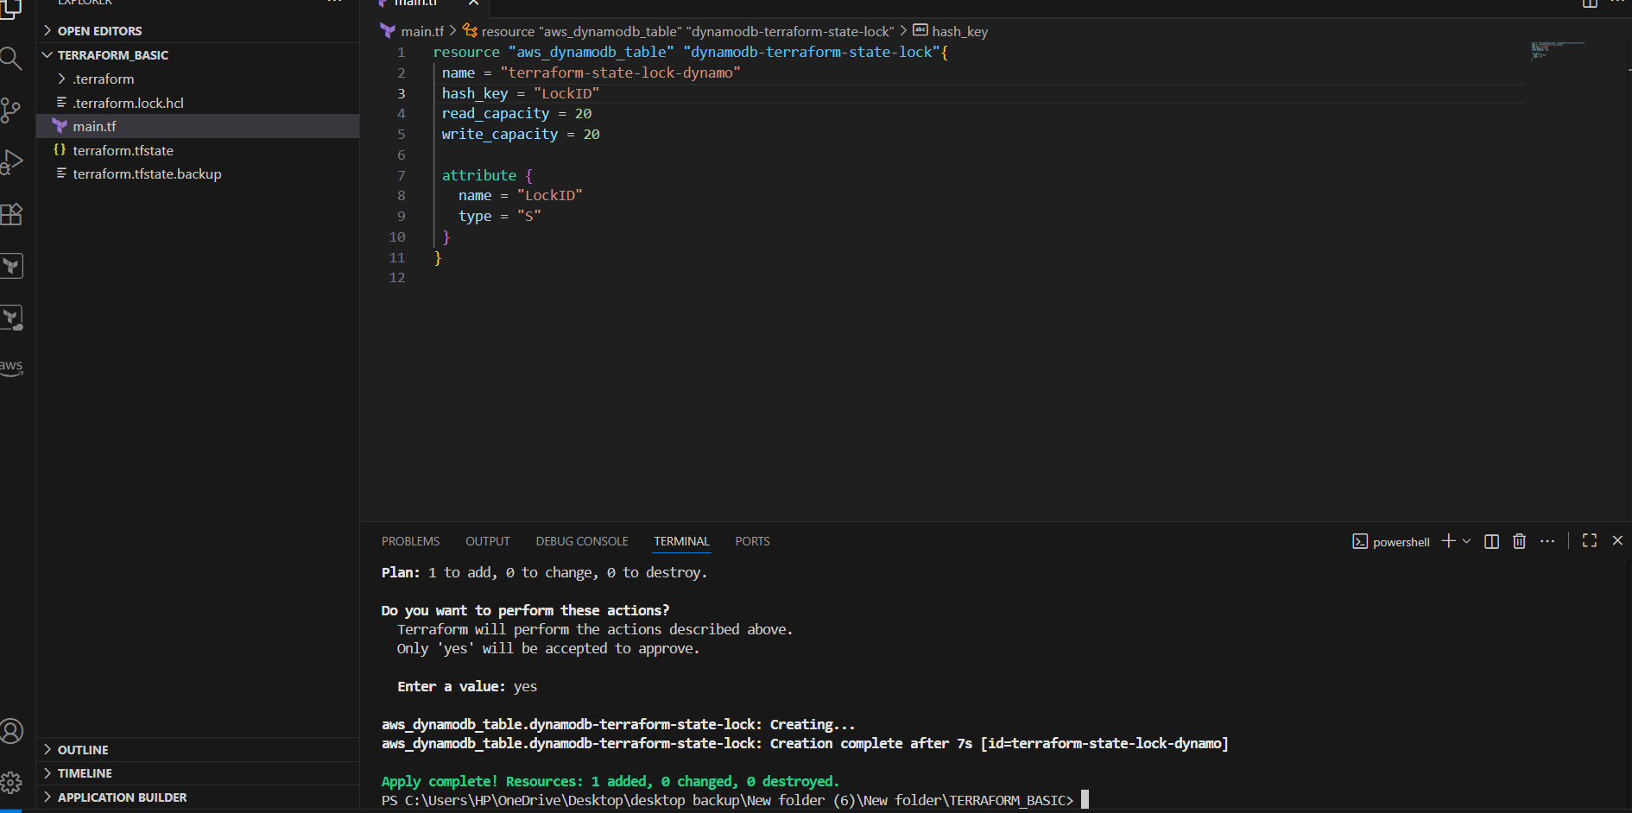

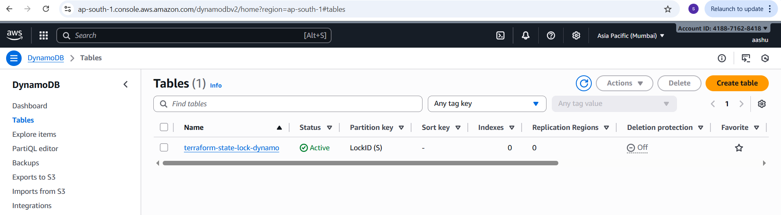
S3 as backend for terraform.tfstate file:
terraform init
terraform apply
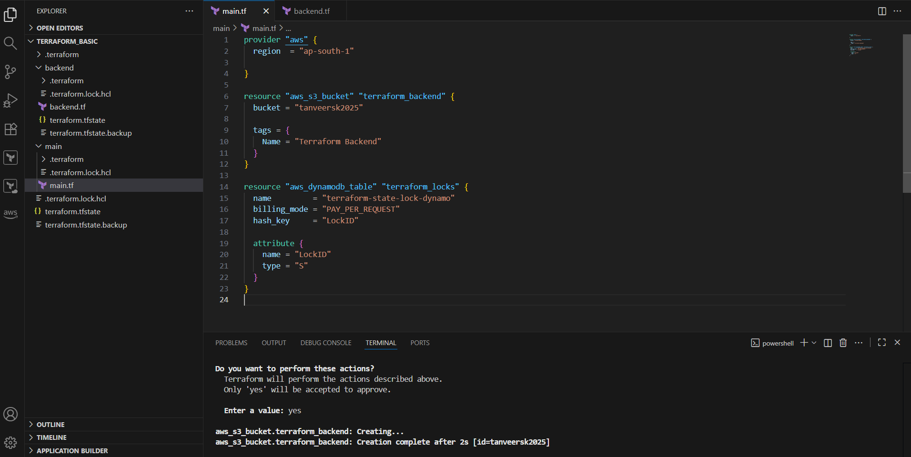

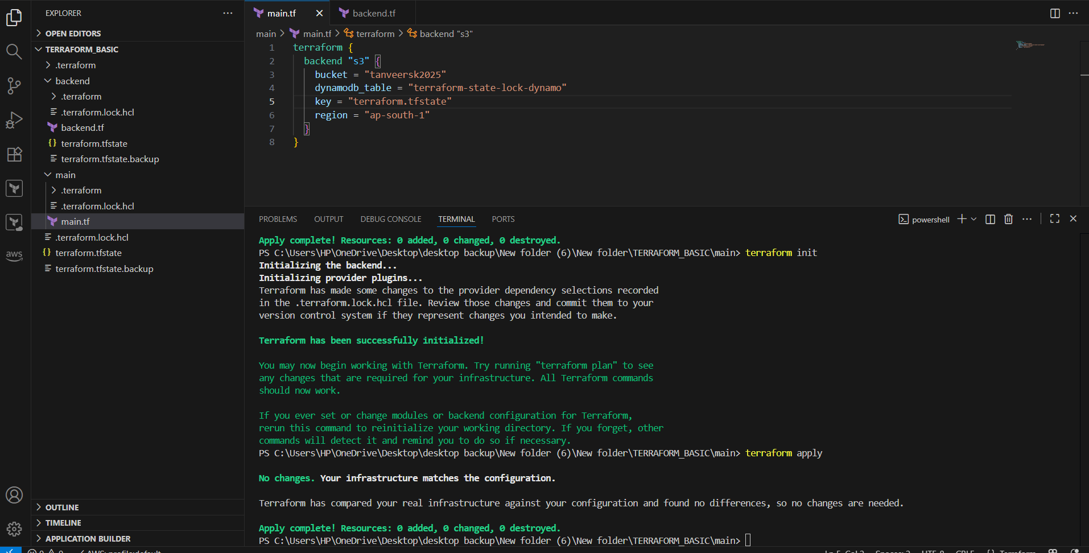
Statefile created in s3.
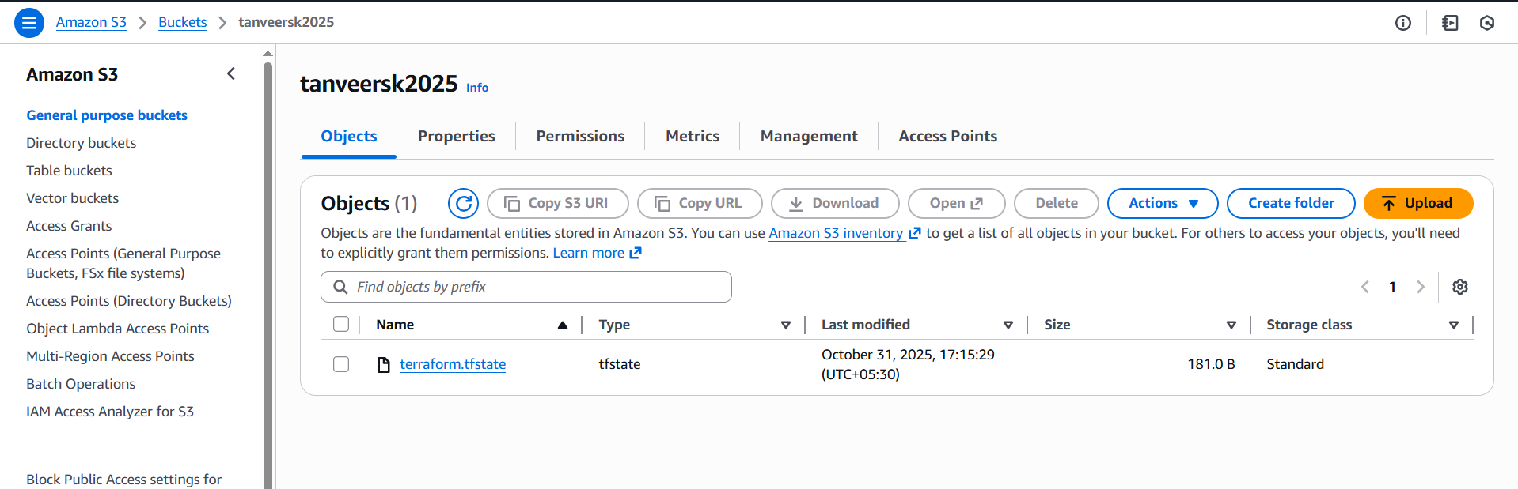
Created Lock ID in DynamoDB
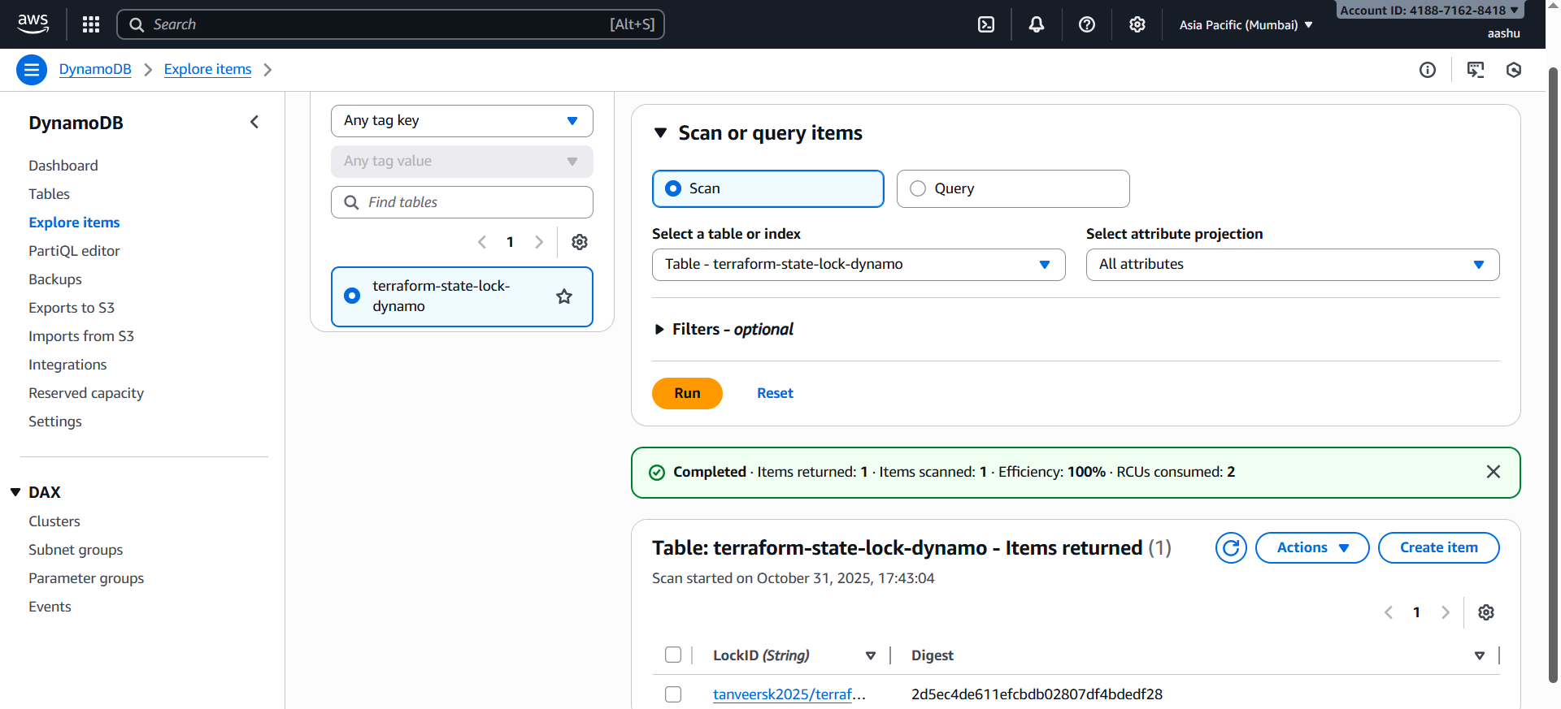
I added one provider
terraform init
terraform apply
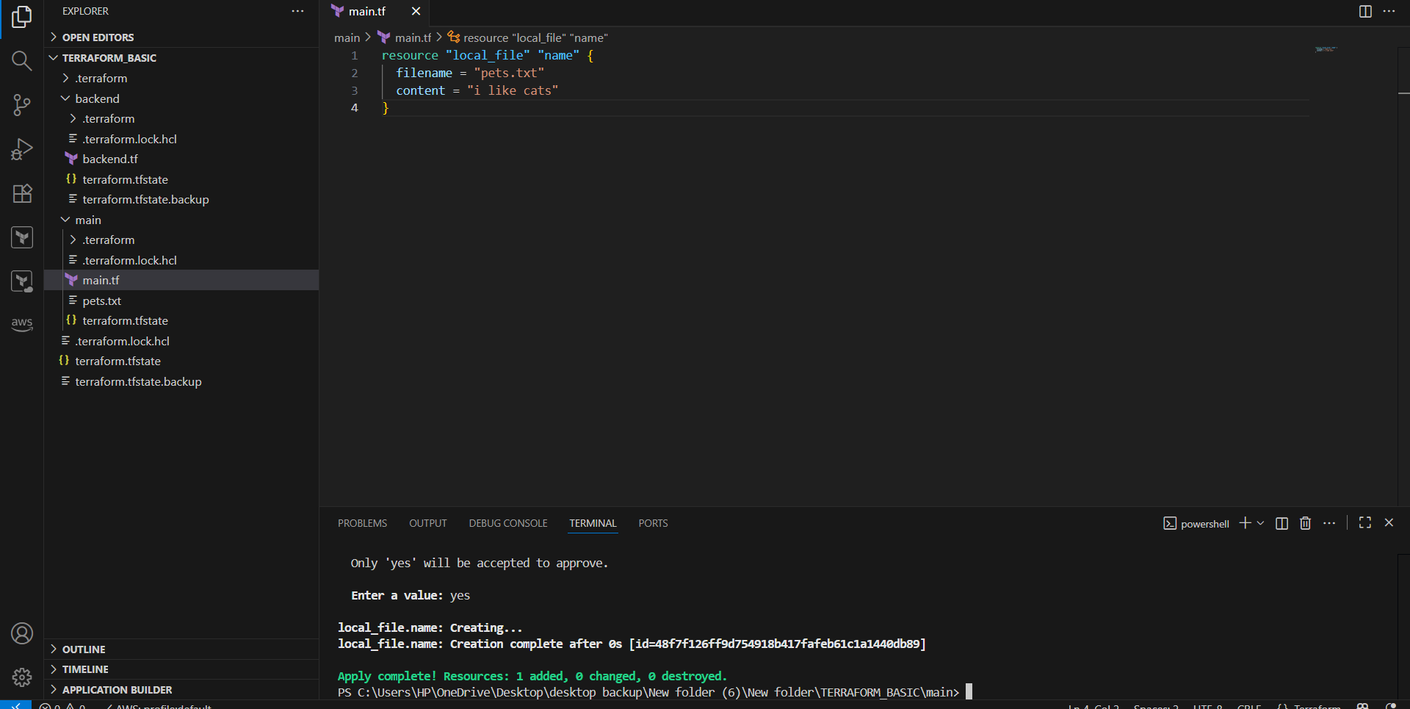
Terraform provisioners
Creating EC2 using local provisioners.
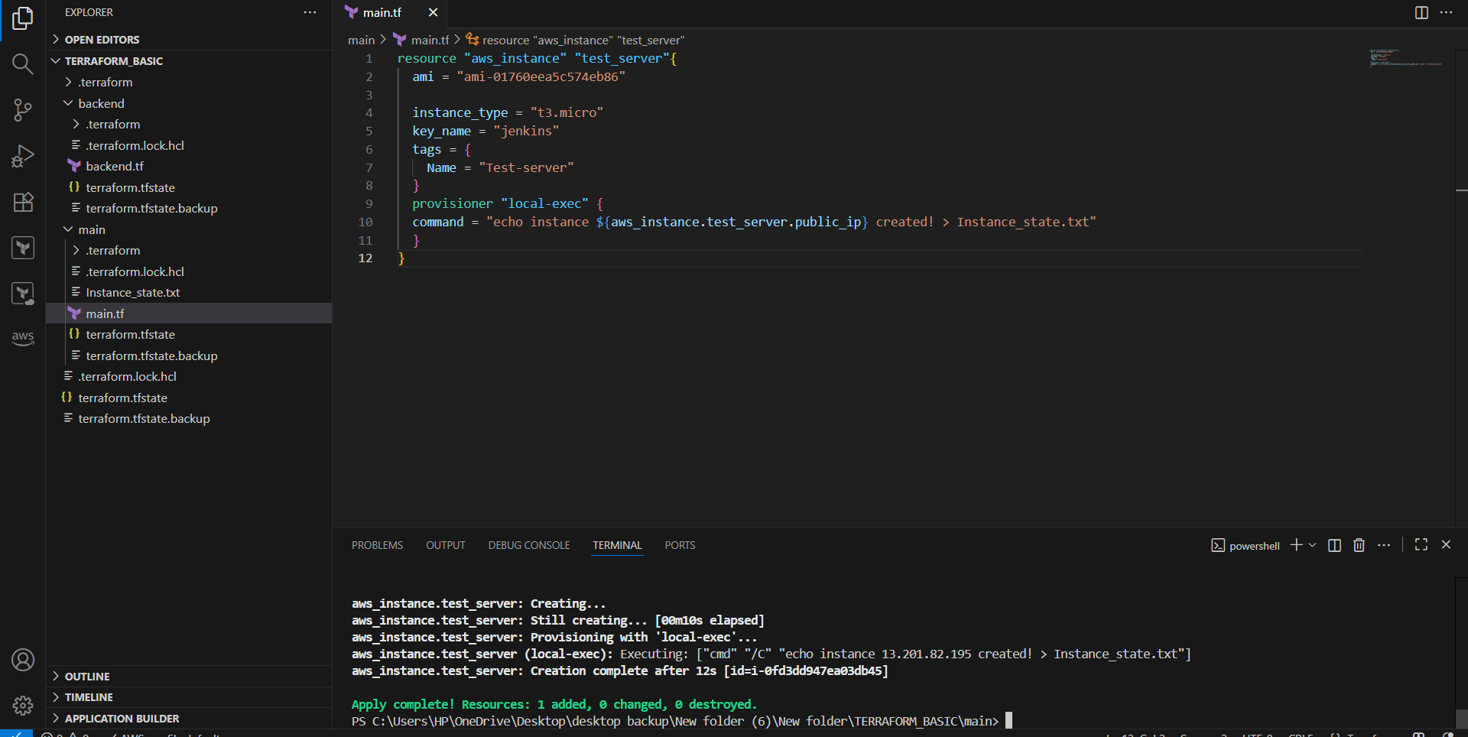
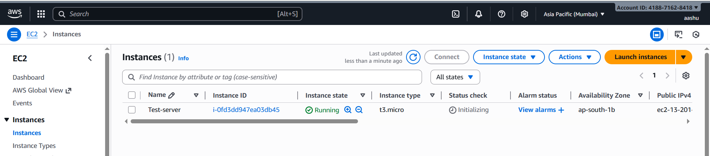
Destroy:
terraform destroy
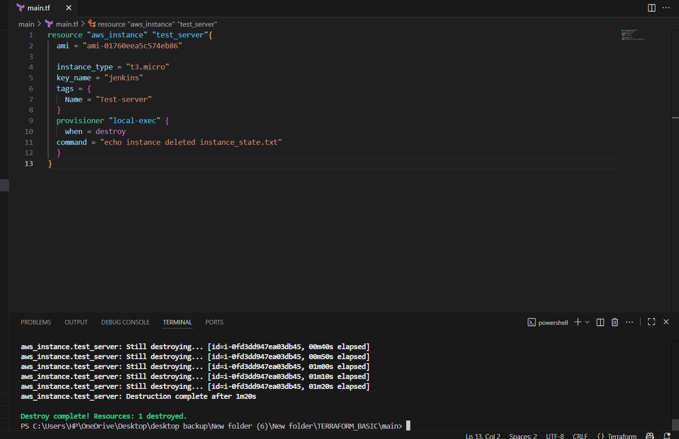
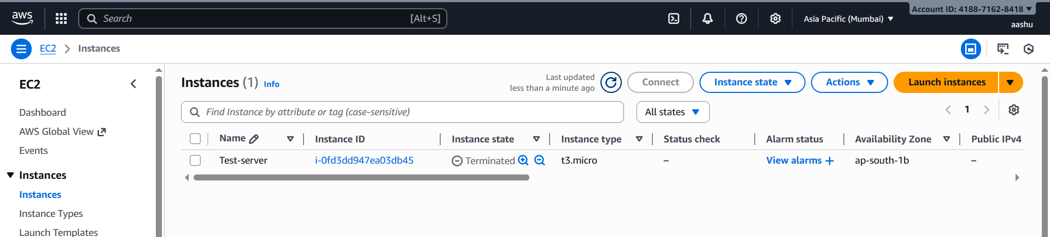
3. Create one EC2 instance with httpd installed using a terraform script.
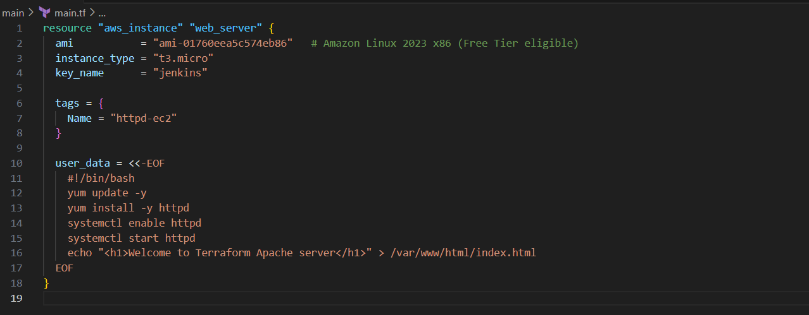
terraform init
terraform plan
terraform apply
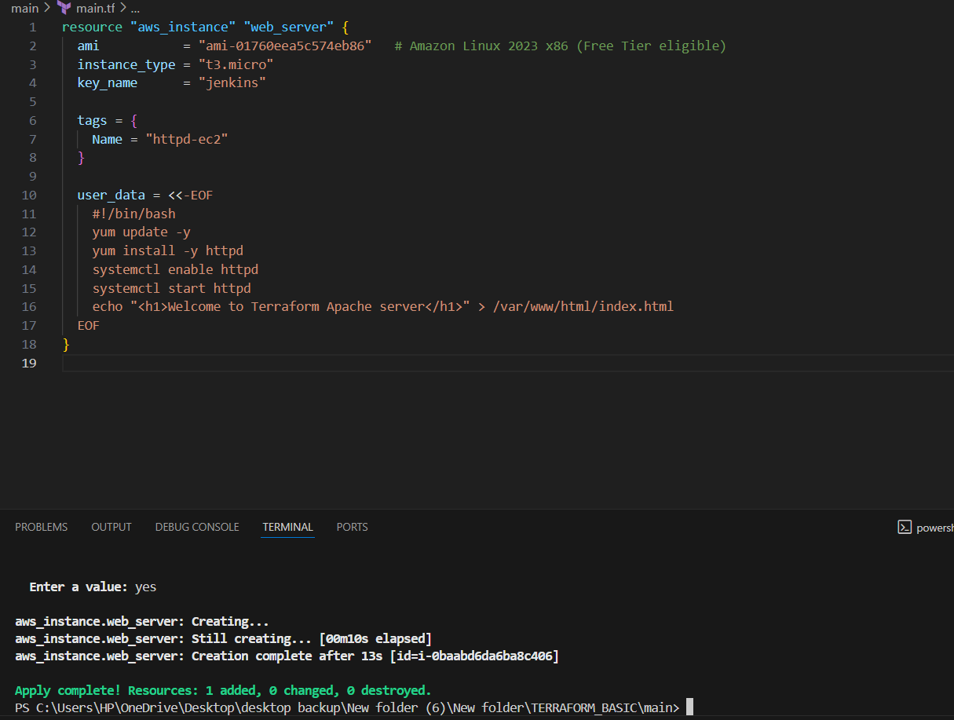
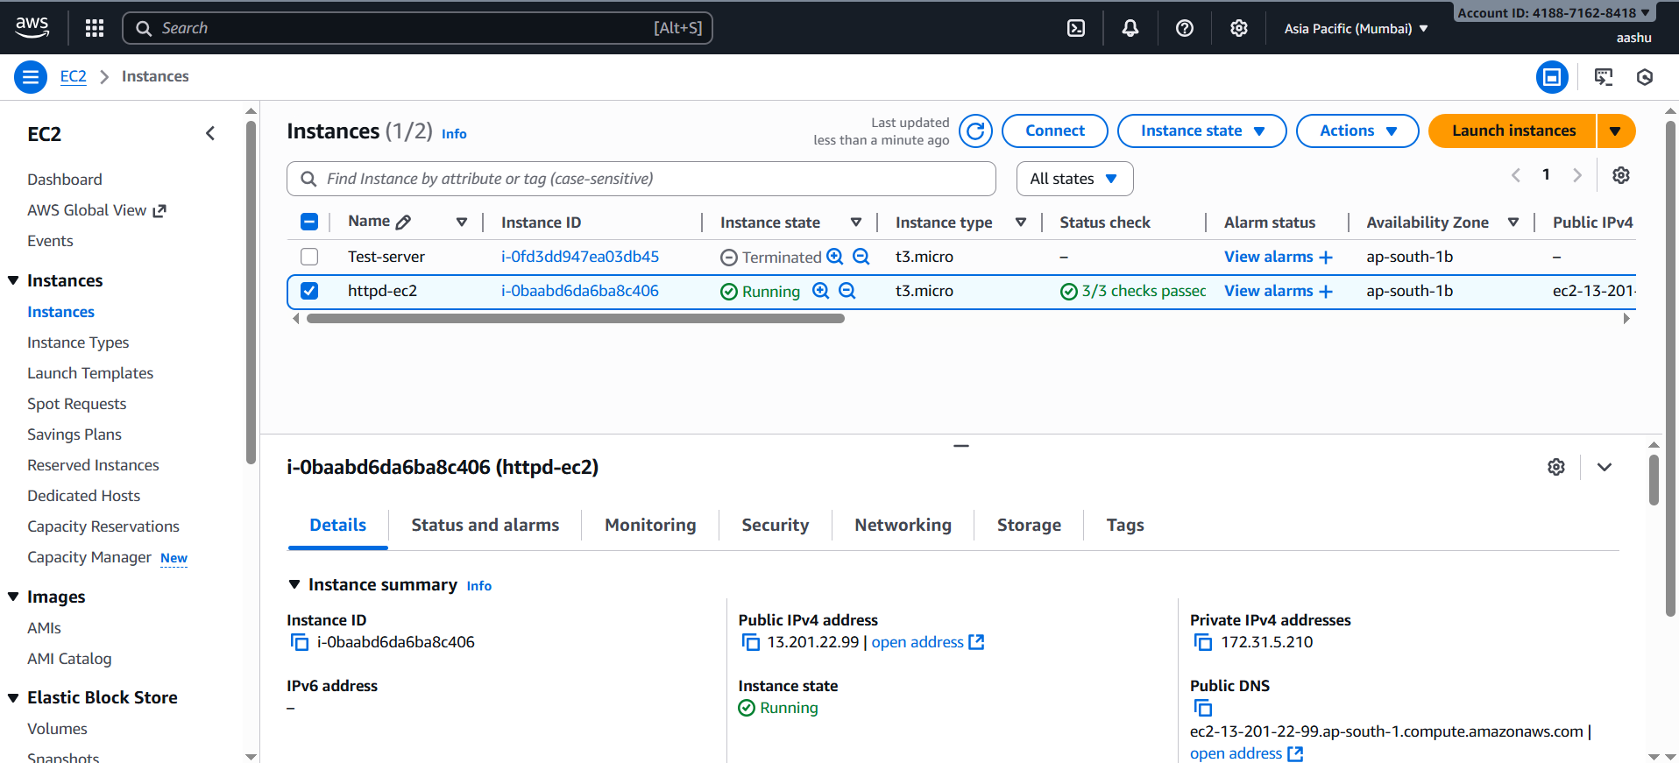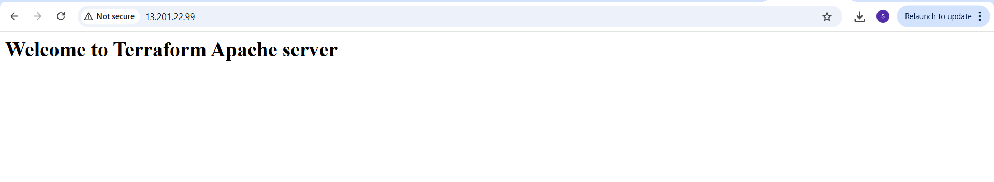
- Setup s3 backend for task3.
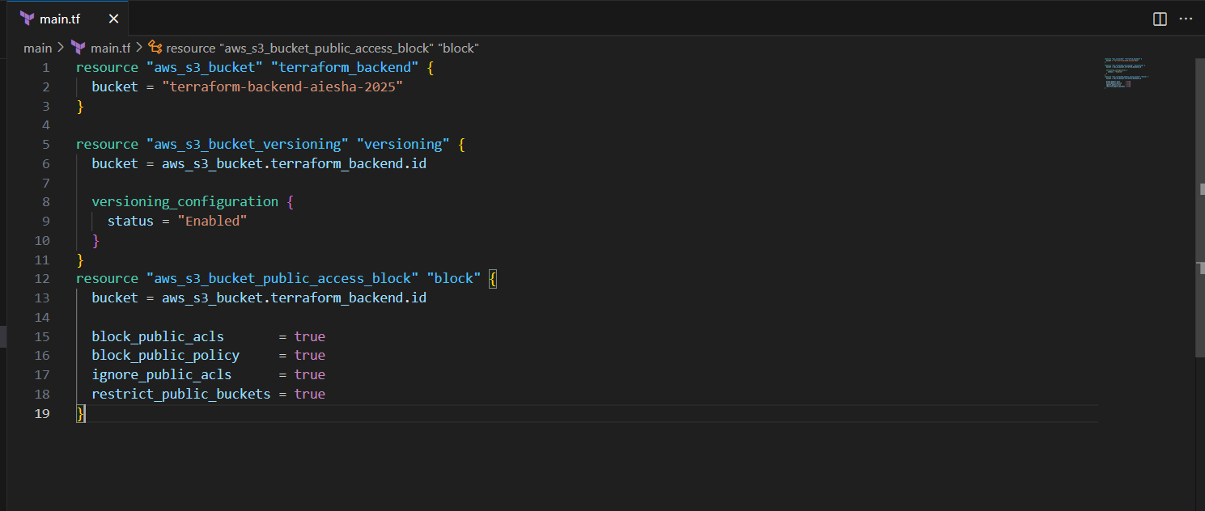
terraform init
terraform plan
terraform apply
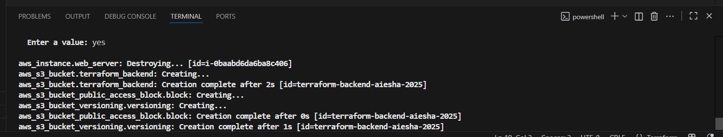
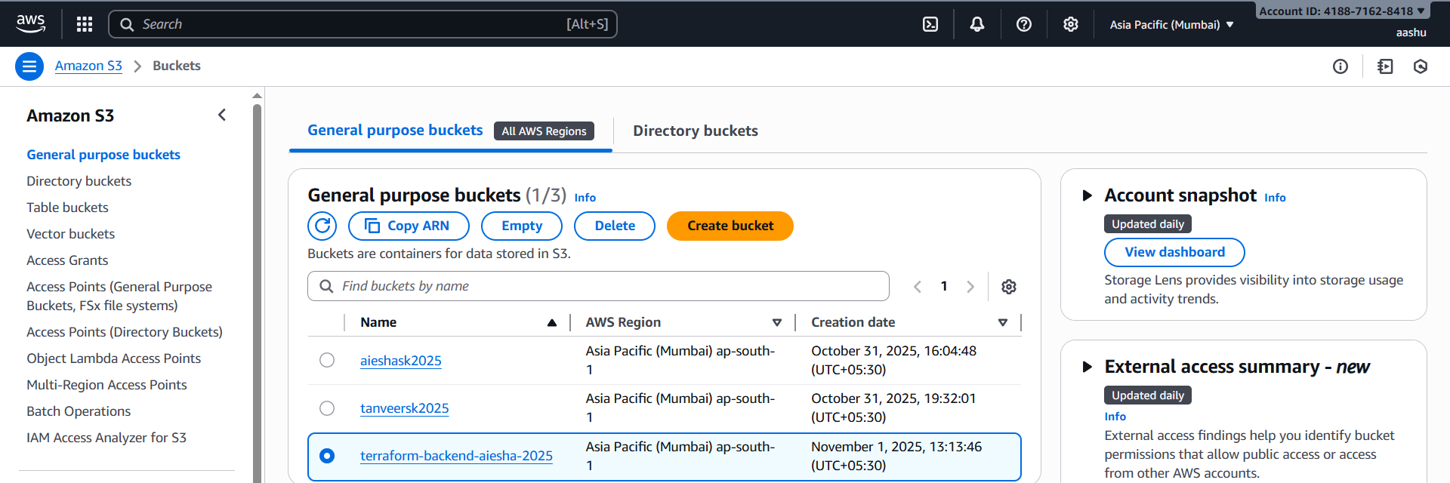
- Setup DynamoDB locking for task3.
Add extra configuration in main.tf to create DynamoDB
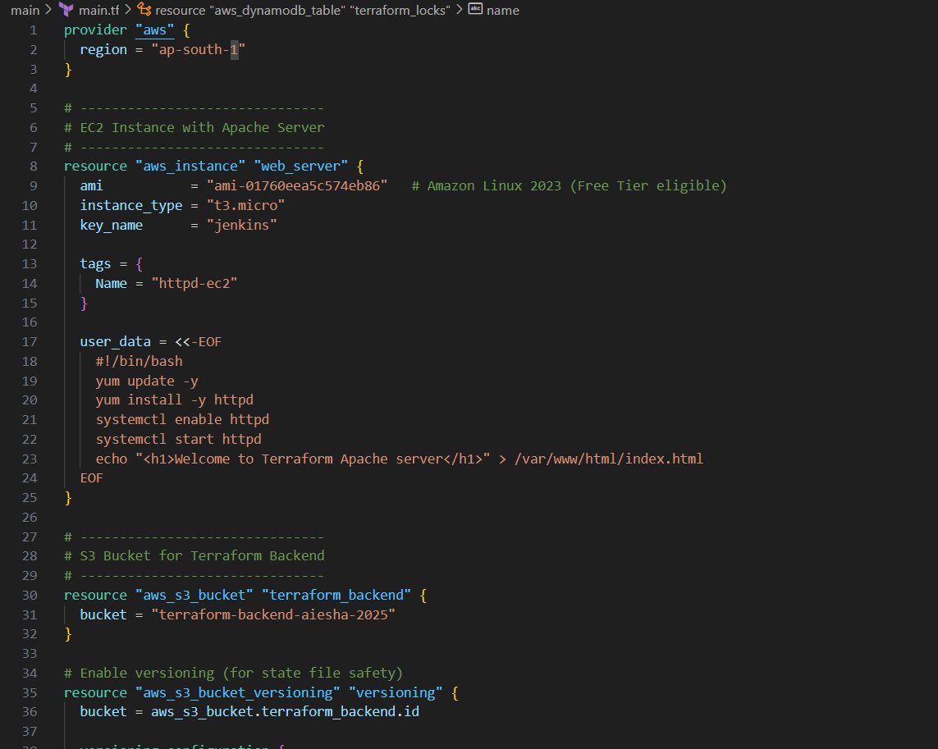
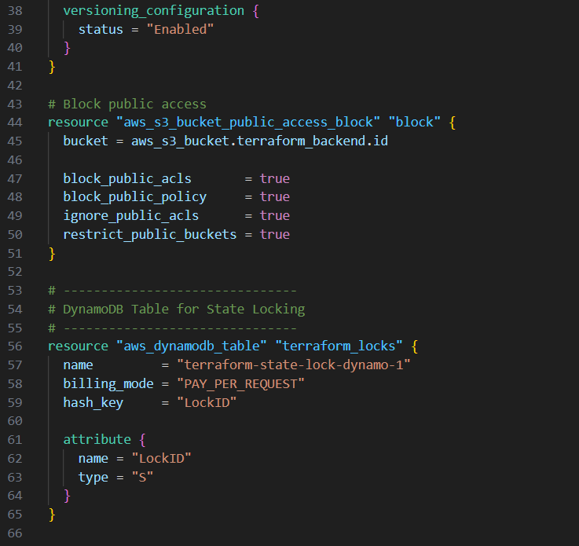
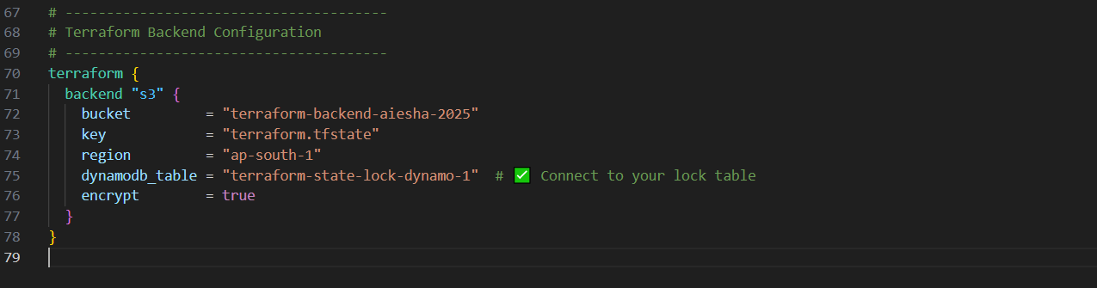
terraform init
terraform plan
terraform apply
