- Watch the terraform-06 video.
Completed.
- Execute the script shown in the video.
Here iam using azure account instead of aws.
Create 2 folders → Azure_VM, and development.
Azure_VM/main.tf
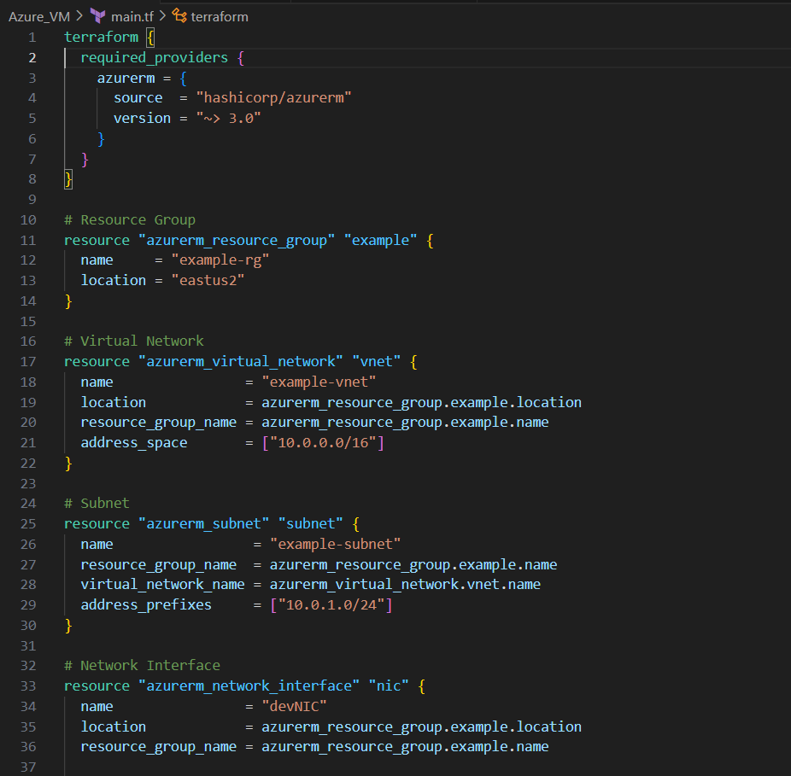
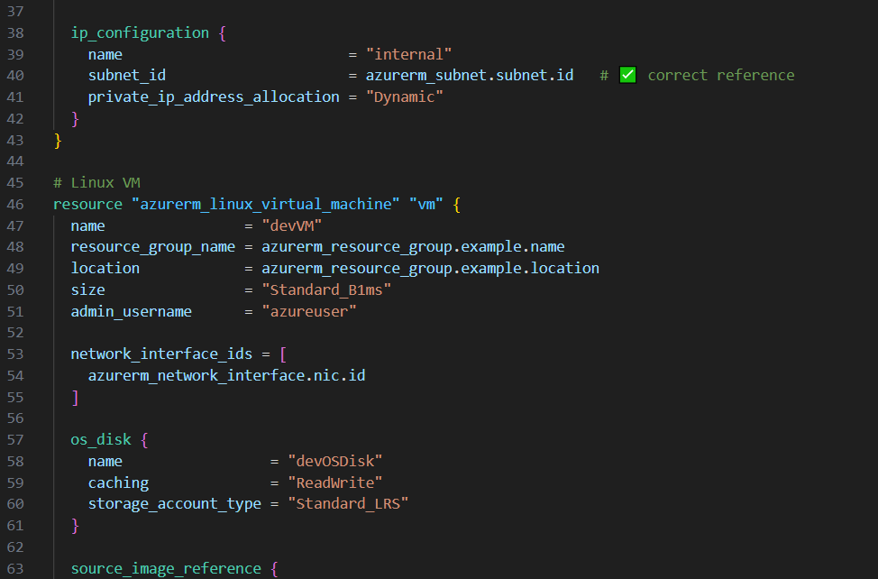

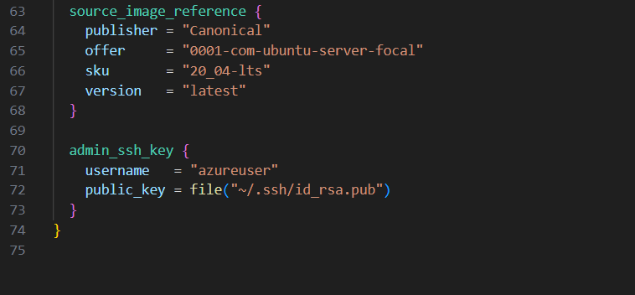

Azure_VM/variables.tf
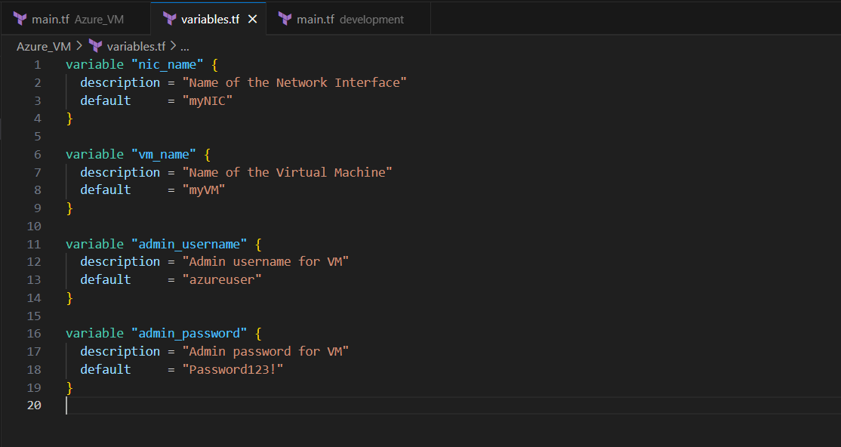
development/main.tf
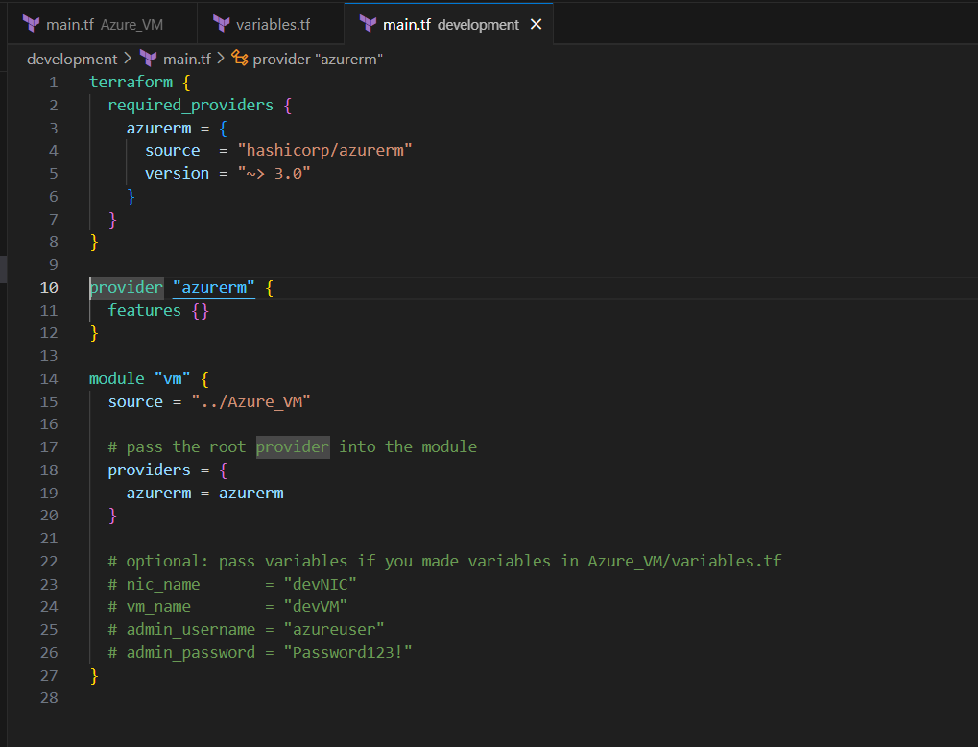
In terminal → switch to development folder.
To open development in terminal → right click on the development folder → click on “open in integrated terminal”.
terraform init
terraform plan
terraform apply.

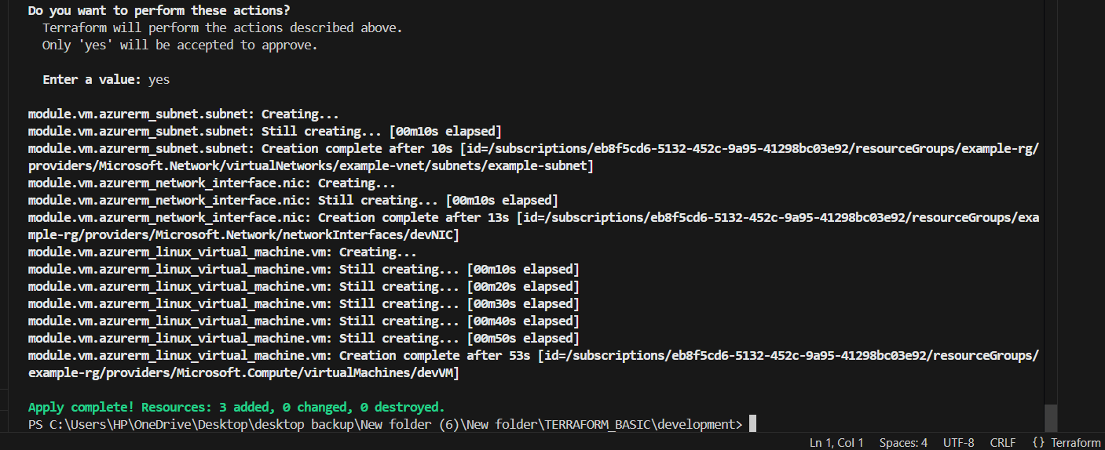

Check the VM created in Azure.
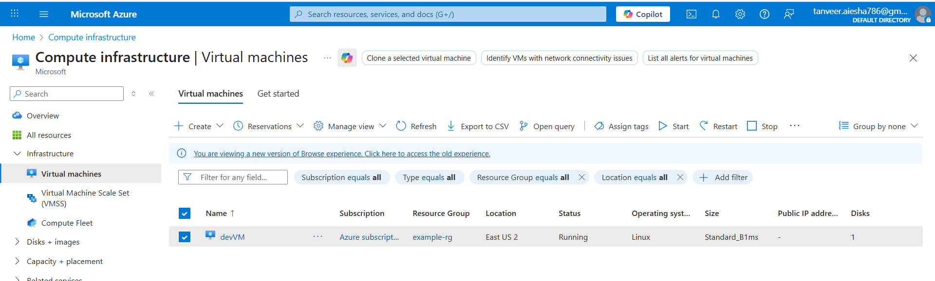
Terraform workspace
- Create a new workspace
Terraform workspace new projectA
Terraform workspace list
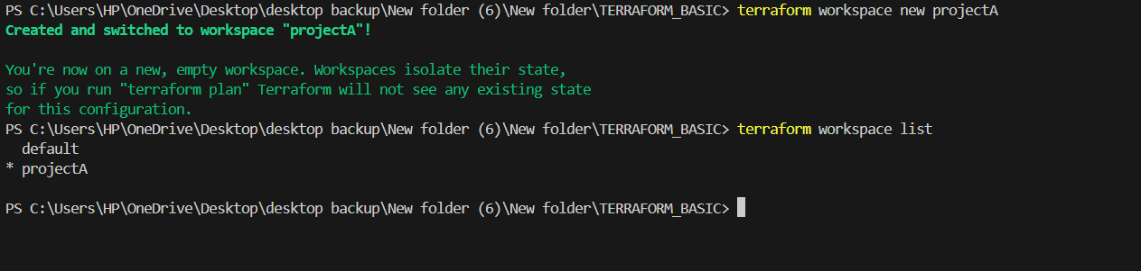
- Switch to any workspace

Terraform workspace select default
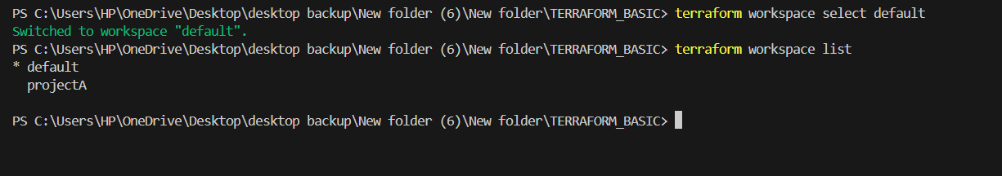

Hence we have switched to default workspace, if we create min.tf and variable.tf
And run terraform apply → then a default VM will get created.

If we switch to projectA then a VM will get created with projectA

- Provision EC2, S3, and VPC using terraform modules.

Hence iam using azure , I need to provision VM, Storage, Vnet.
Create modules, vnet, storage, VM folders and files of main.tf, variables.tf, output.tf
Root modules:
Main.tf
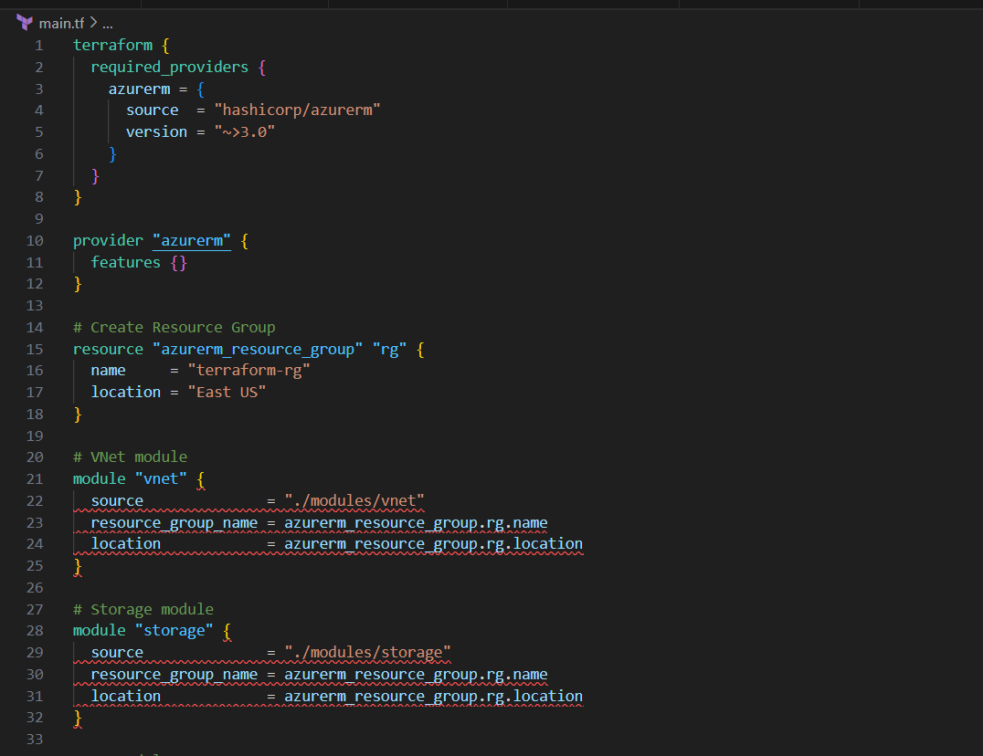
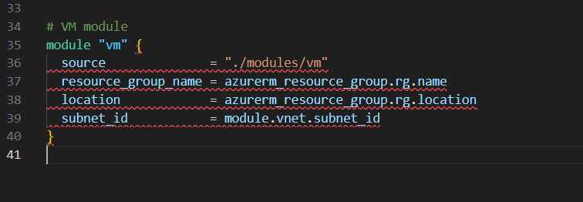
Variables.tf
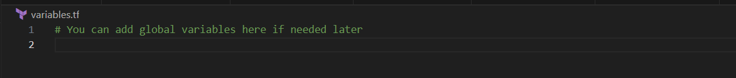
Output.tf
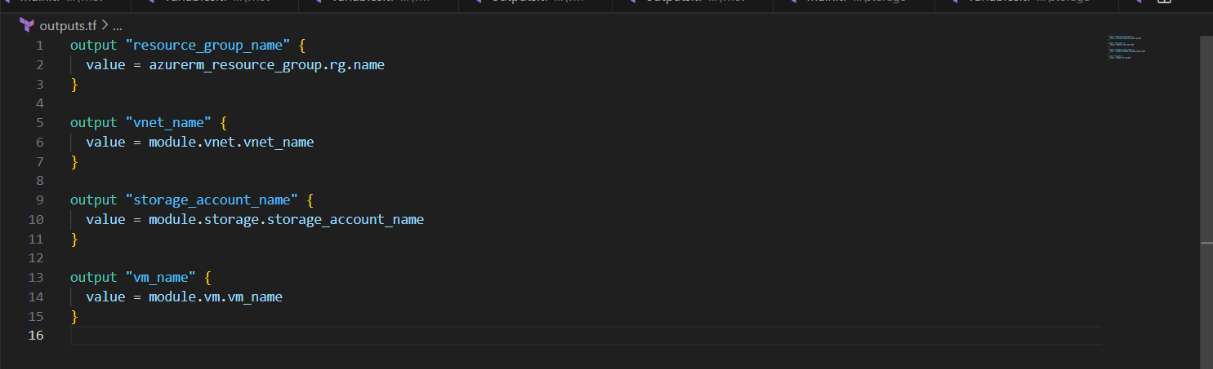
modules/vnet/main.tf
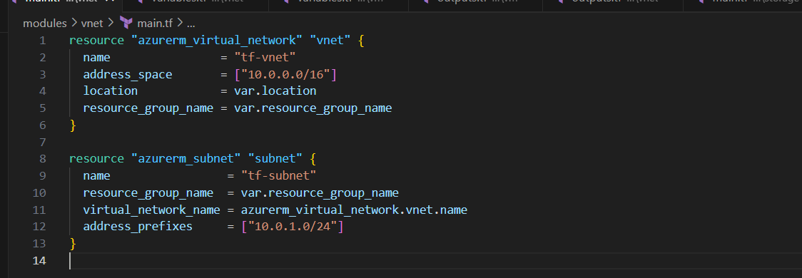
Variables.tf
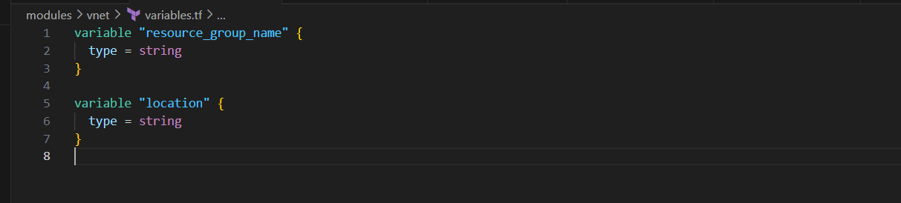
Output.tf
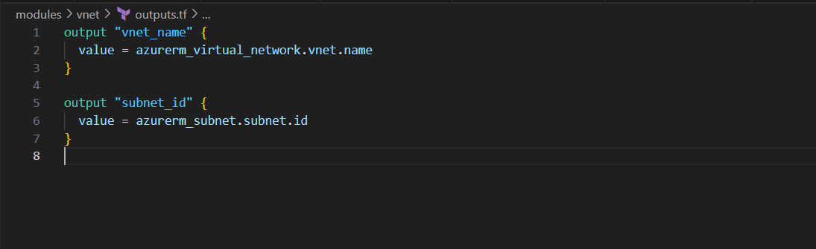
modules/storage/main.tf
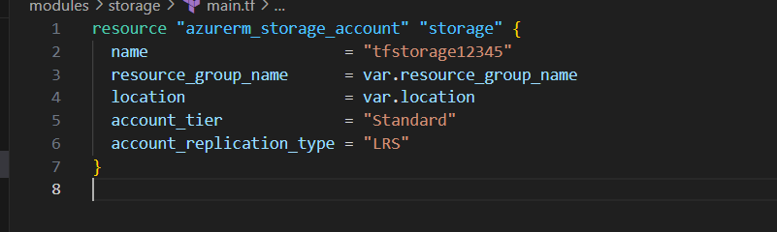
Variables.tf
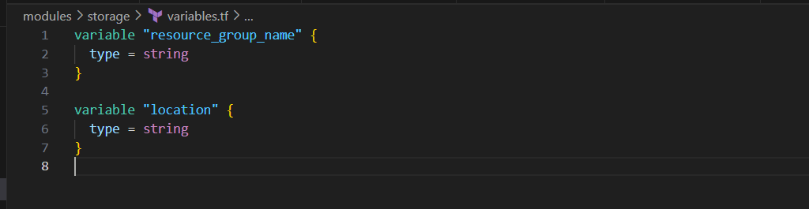
Output.tf
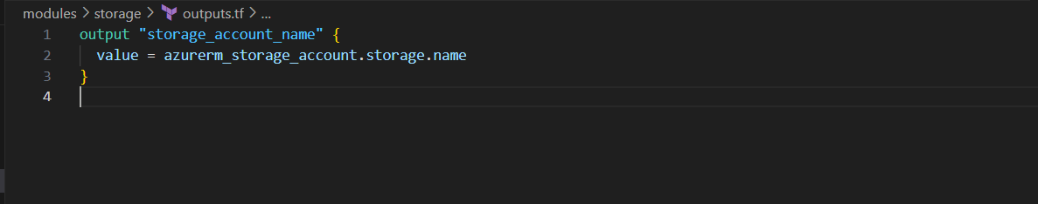
modules/vm/main.tf
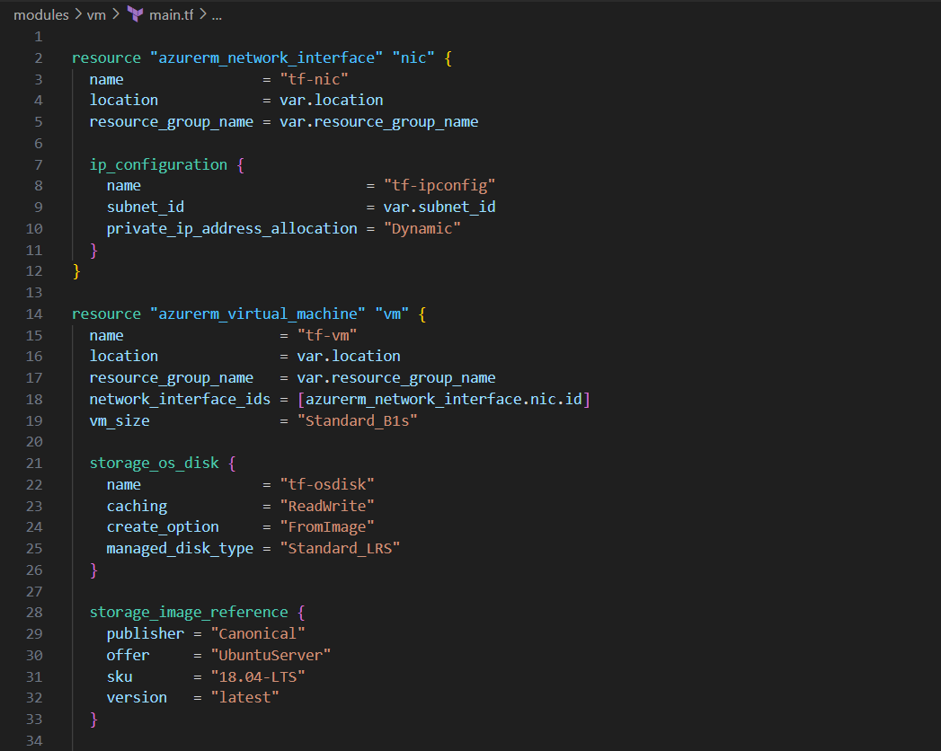
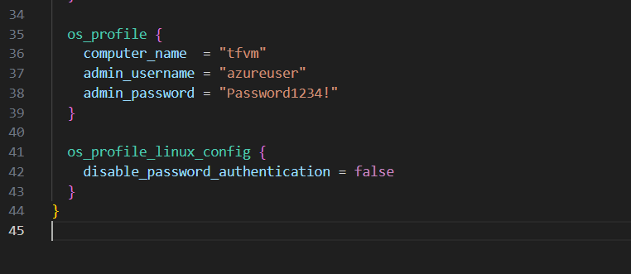
Variables.tf
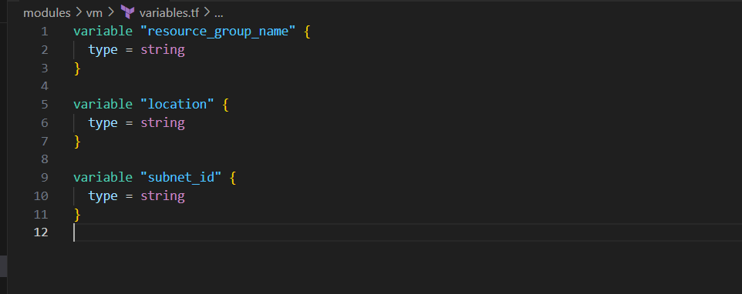
Output.tf
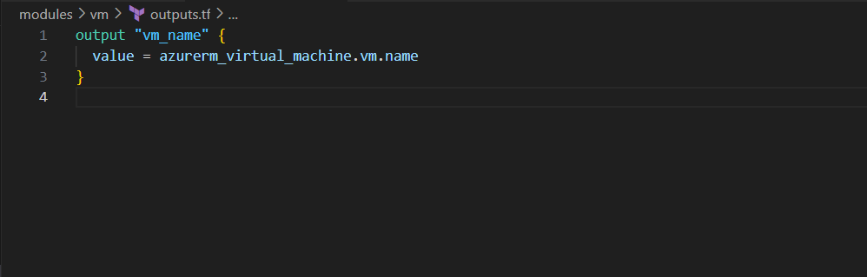
Modules/resource_group/
Main.tf
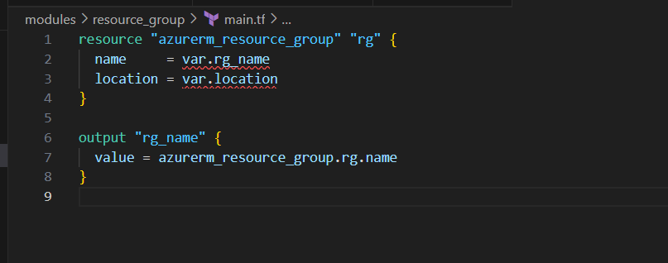
Variables.tf
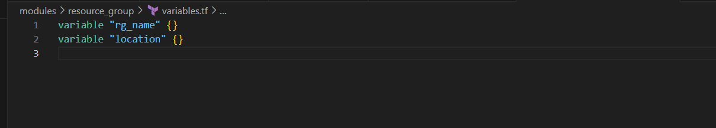
Terraform init
Terraform plan
Terraform apply
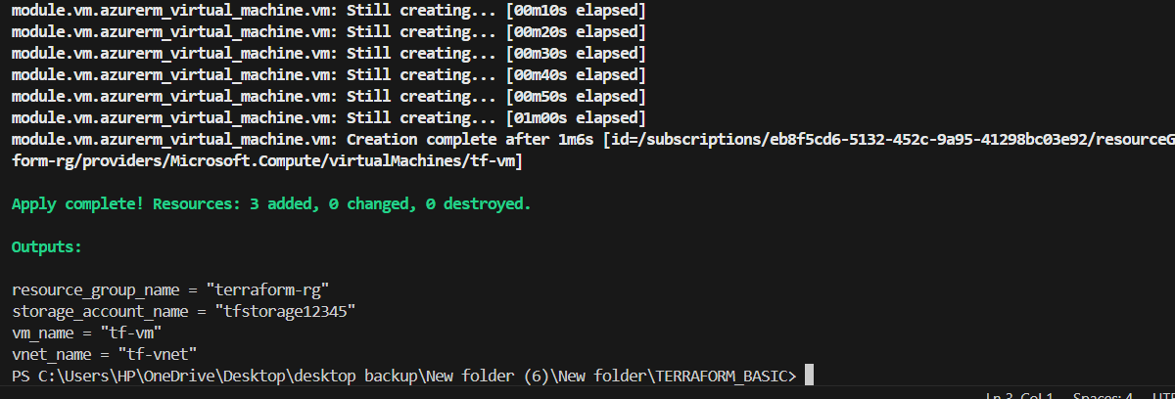

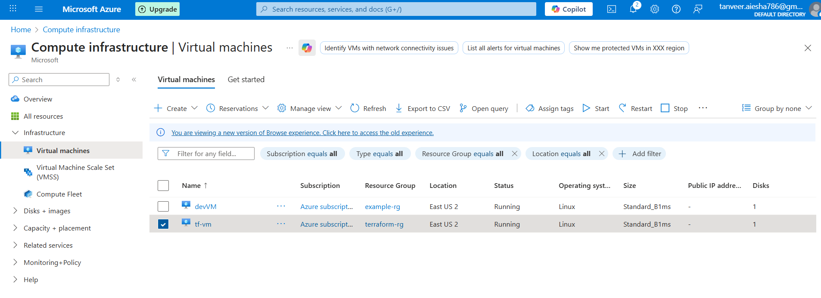
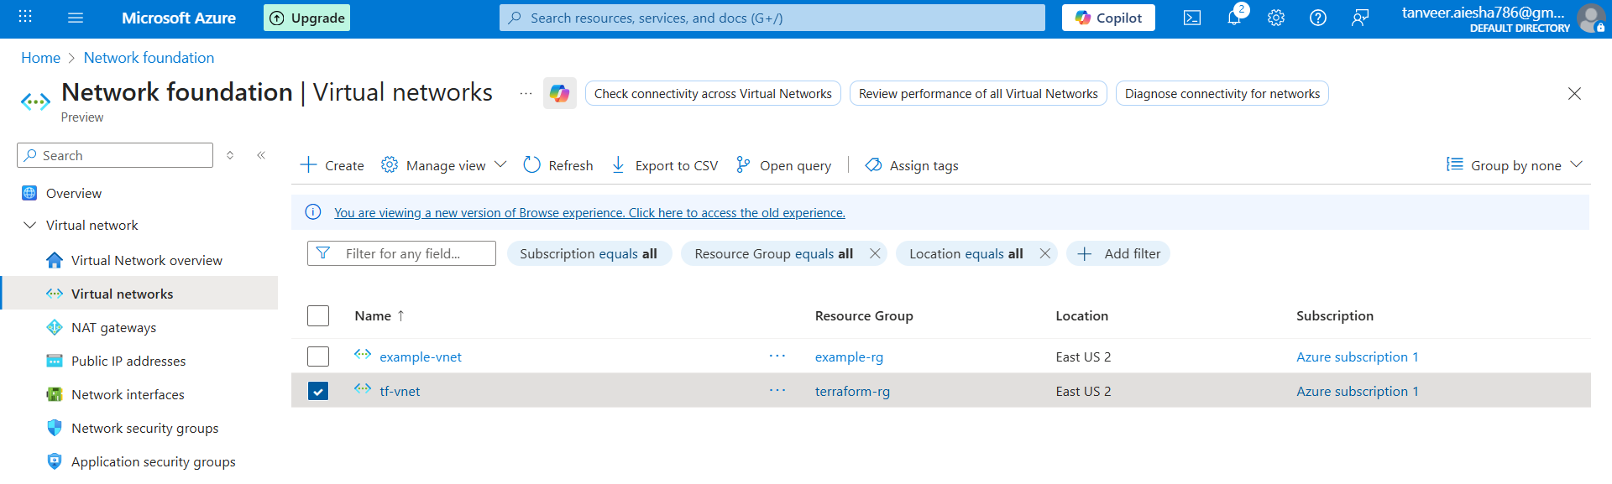

- Provision EC2 for 3 different environments (Dev, Staging, and Prod) using Terraform workspaces.
Create a folder like this:
TERRAFORM_BASIC/
│
├── main.tf
├── variables.tf
├── outputs.tf
├── terraform.tfvars
main.tf
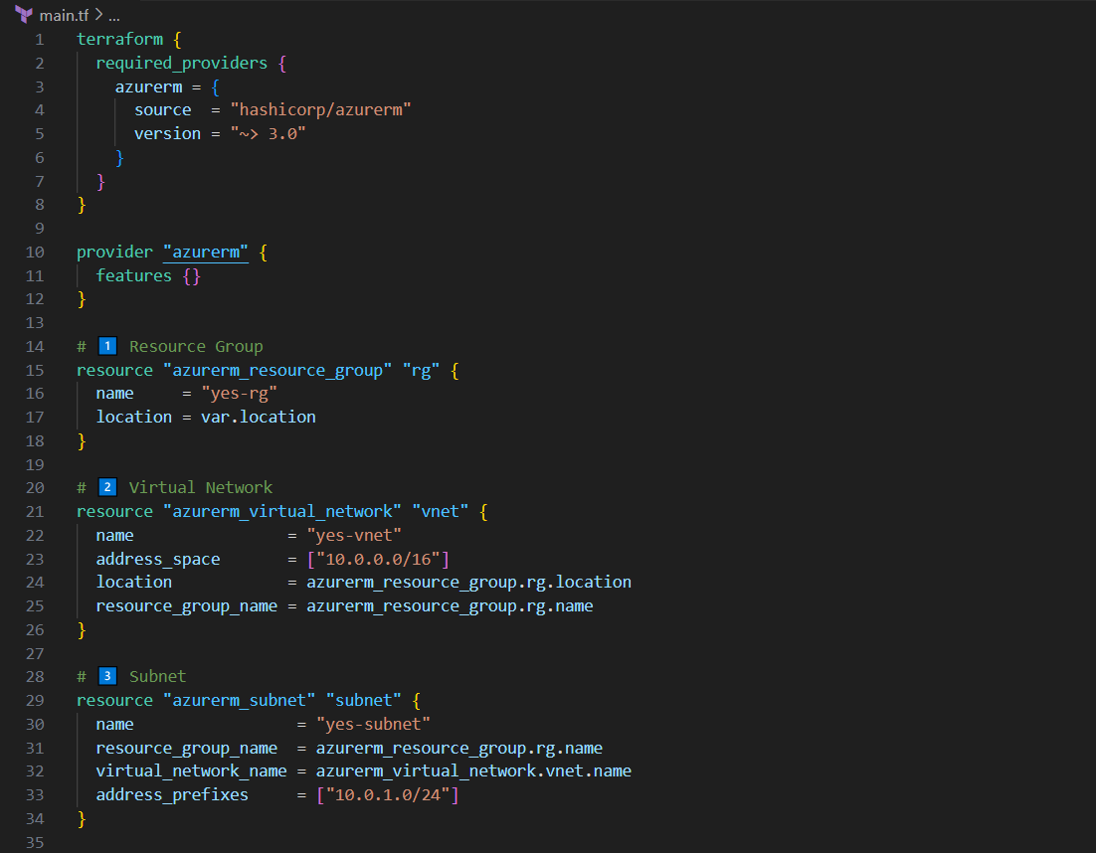
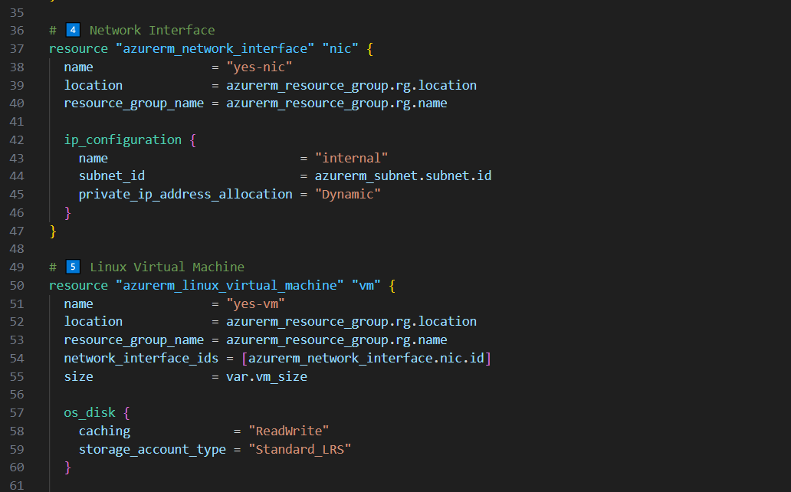
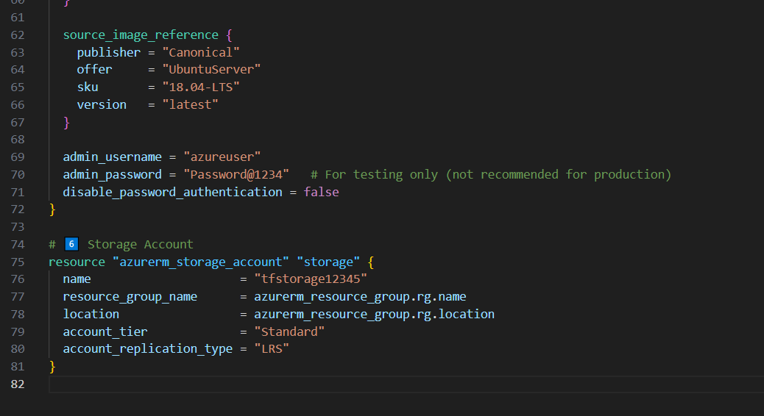
Variables.tf
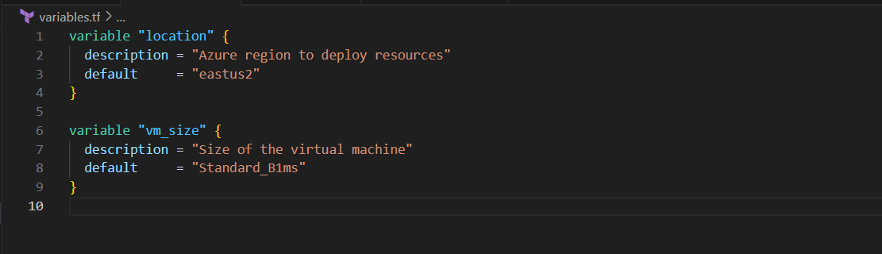
Terraform.tfvars
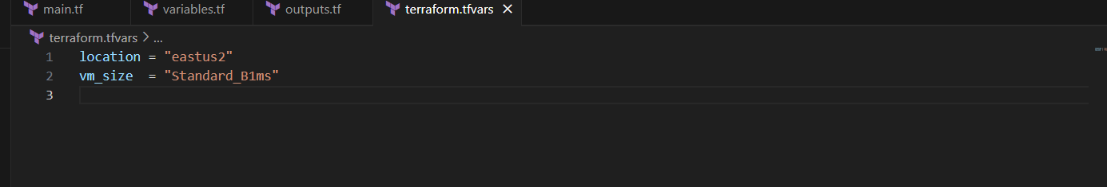
Output.tf
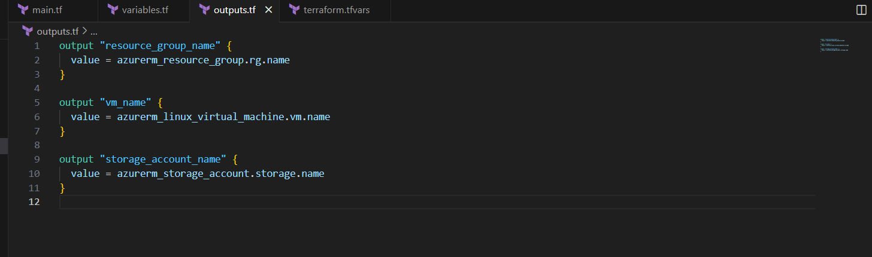
Terraform init
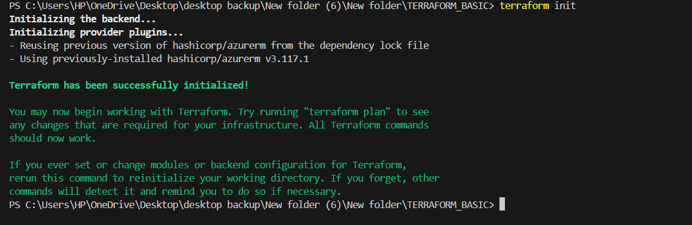
Create workspaces:
terraform workspace new dev
terraform workspace new staging
terraform workspace new prod
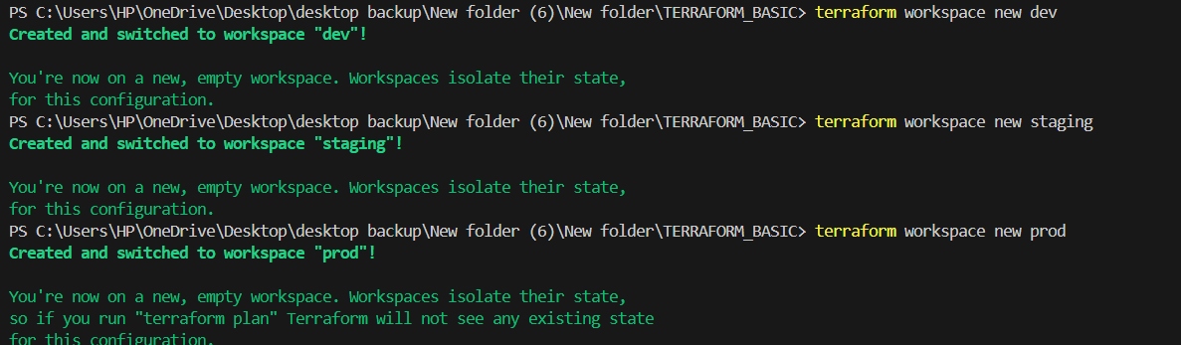
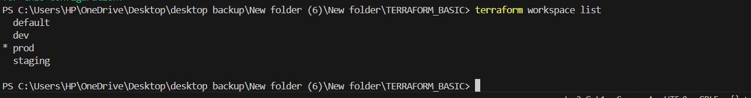
Terraform workspace select dev
Terraform apply.
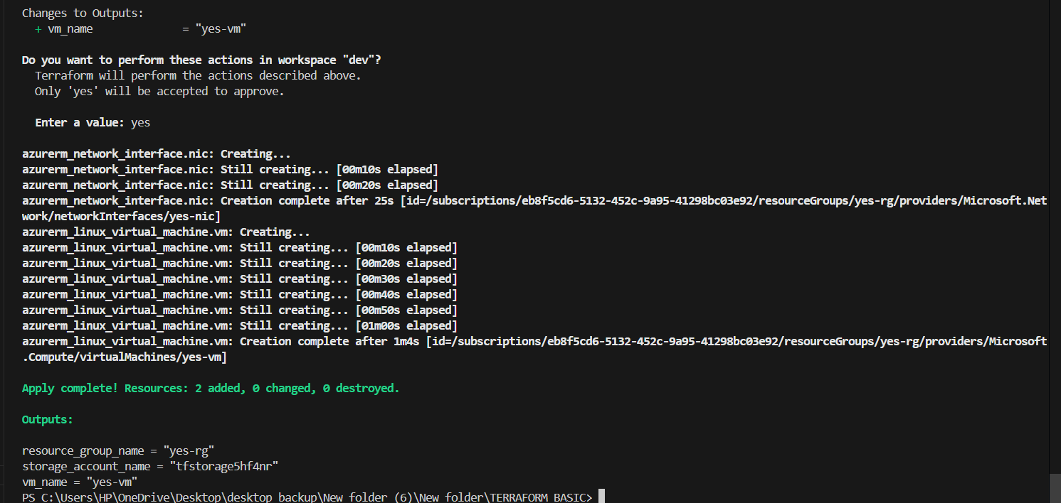

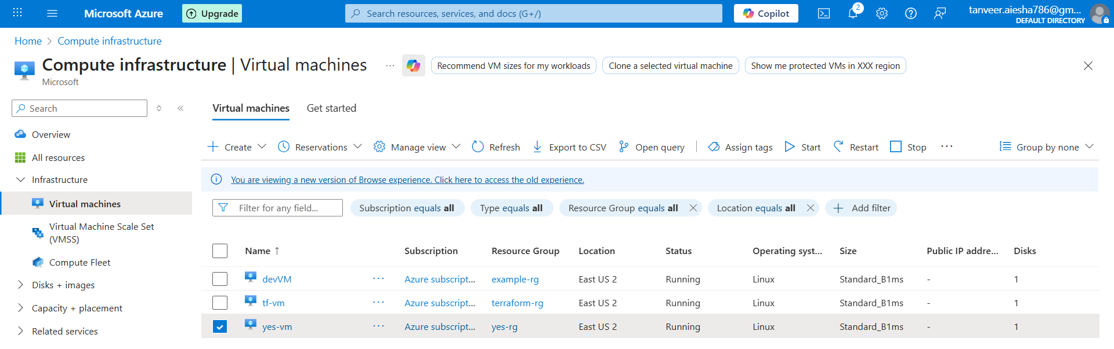
Switch workspace to staging as :
Terraform workspace select staging
Terraform apply.
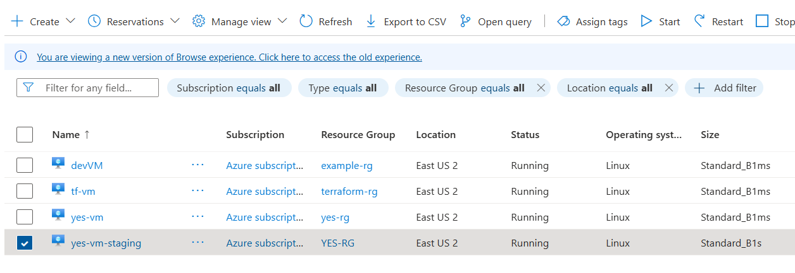
similarly , switch the workspace to prod as:
Terraform workspace select prod
Terraform apply.
Check in azure that the “yes-vm-prod” VM has been created or not.

