Ansible-04
1.Create ansible playbook to create ansible vault.
Create ansible-vault.yml playbook
---
- name: Create a full Ansible Vault file
hosts: localhost
connection: local
gather_facts: false

vars_prompt:
- name: vault_password
prompt: "Enter vault password"
private: yes

- name: secret_value
prompt: "Enter the secret value"
private: yes

tasks:
- name: Write vault password to a temporary file
copy:
content: "{{ vault_password }}"
dest: "./vault_pass.txt"
mode: "0600"

- name: Create plain YAML with secret
copy:
dest: "./vault-plain.yml"
content: |
my_secret: "{{ secret_value }}"
mode: "0600"

- name: Encrypt the plain YAML file into a vault file
command: >
ansible-vault encrypt --vault-password-file ./vault_pass.txt ./vault-plain.yml
args:
removes: "./vault-plain.yml"

- name: Rename encrypted file to vault.yml
command: mv vault-plain.yml vault.yml

- name: Remove temporary vault password file
file:
path: "./vault_pass.txt"
state: absent

run playbook:
ansible-playbook ansible-vault.yml
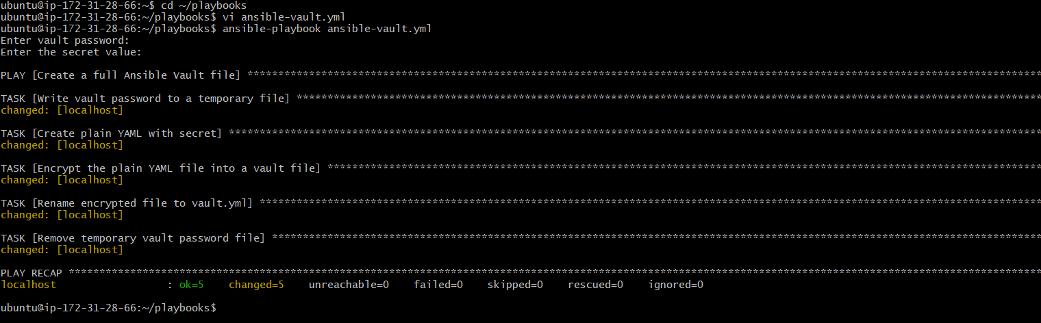
We are creating ansible playbook , purpose is to create an ansible-vault file.
The playbook asks for:
- Vault password → used to lock the file
- Secret value

Then playbook:
- Encrypts file using ansible-vault encrypt with the password.
- Produces a vault.yml file which is encrypted
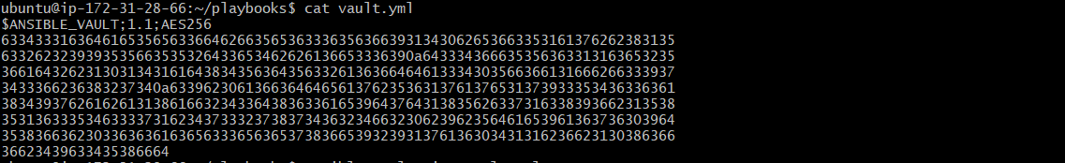
Finally, we get password-protected vault file (i.e: ansible-vault.yml) which stores secret values.
Now we can view the exact vault file as:
Ansible-vault view vault.yml
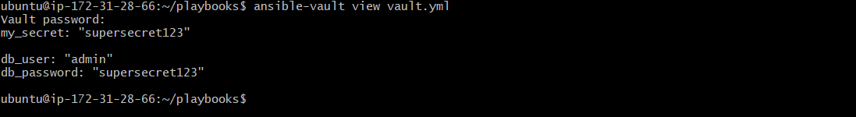
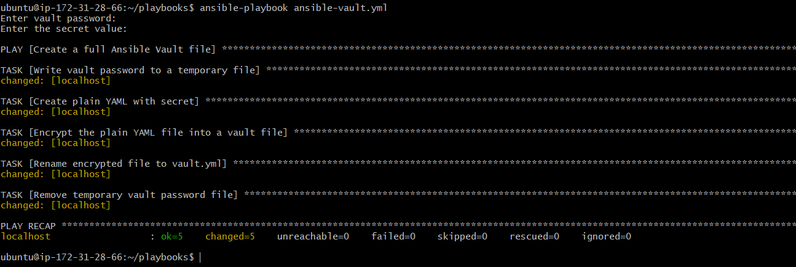

2.write a ansible playbook to install apache in linux and ubuntu machine by using when condition.
Create install-apache.yml playbook

---
- name: Install Apache on Linux (RedHat/CentOS) and Ubuntu/Debian
hosts: all
become: yes
gather_facts: yes

tasks:
- name: Install Apache on RedHat/CentOS
yum:
name: httpd
state: present
when: ansible_os_family == "RedHat"

- name: Start and enable Apache on RedHat/CentOS
service:
name: httpd
state: started
enabled: yes
when: ansible_os_family == "RedHat"

- name: Update apt cache on Debian/Ubuntu
apt:
update_cache: yes
when: ansible_os_family == "Debian" and inventory_hostname != "localhost"

- name: Install Apache on Debian/Ubuntu
apt:
name: apache2
state: present
update_cache: yes
when: ansible_os_family == "Debian" and inventory_hostname != "localhost"

- name: Start and enable Apache on Debian/Ubuntu
service:
name: apache2
state: started
enabled: yes
when: ansible_os_family == "Debian"

I have 3 ec2 instances. 1 is controller and 2 worker nodes (ubuntu ami)
now ssh th the nodes and check the service:
sudo systemctl status apache2.

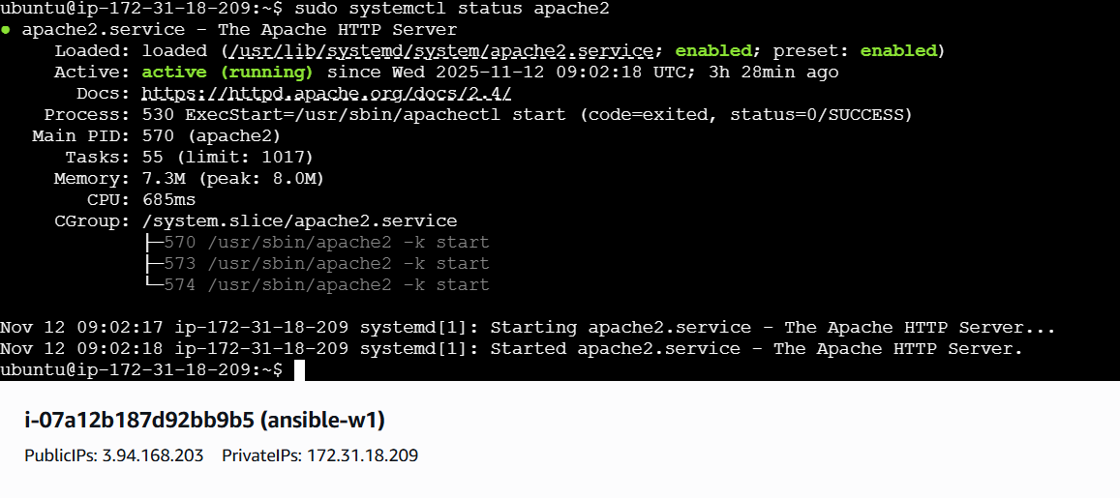
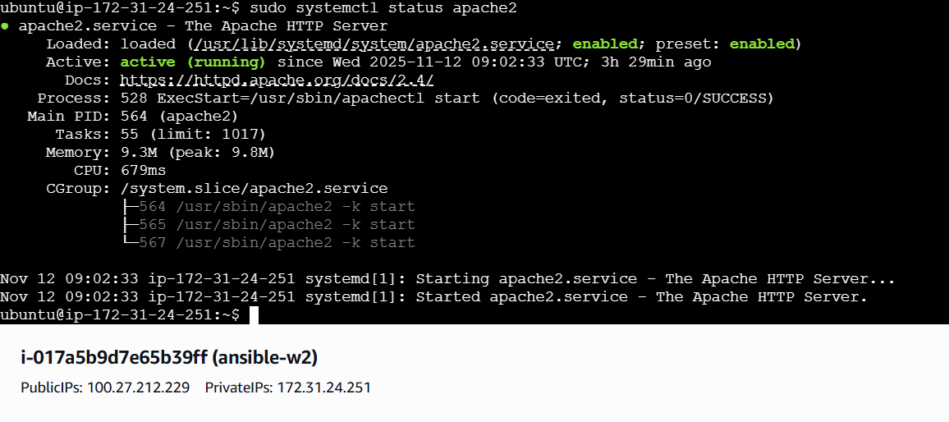

3.create ansible playbook using roles to configure LAMP stack.
Directory structure:
Ansible project should look like this:

lamp-playbook/
├── site.yml
├── inventory
└── roles/
├── apache/
│ └── tasks/main.yml
├── mysql/
│ └── tasks/main.yml
├── php/
│ └── tasks/main.yml
└── common/
└── tasks/main.yml

LAMP stack is a popular open-source software used to build and run dynamic websites and web applications.
1.LAMP = Linux + Apache + MySQL/MariaDB + PHP
→ basically it is a web server setup.
2. Ansible Playbook
A YAML file describing steps to install and configure software automatically.
3. Ansible Roles
→ Best practice to organize playbooks by splitting tasks into logical groups.(like one role for apache, one for mysql, one for PHP.
→ Each role contains its own tasks, files, templates, variables, etc.
This makes the playbook modular and reusable.
i.write ansible playbook that includes multiple roles.
ii.create roles for :
common → system updates / basic setup.
Apache → install and configure apache web server.
Mysql → install and configure mysql database.
Php → install and configure PHP and extensions.
iii.Run the playbook on a target server(like ec2 instance or VM)
- After running, the server should be ready with working LAMP stack.
- We should be able to open the browser and check apache (index.html) and PHP(info.php)
Steps to configure LAMP stack with ansible roles
Step-1: create project
mkdir lamp-playbook
cd lamp-playbook

step-2: create roles structure
mkdir roles
cd roles
ansible-galaxy init
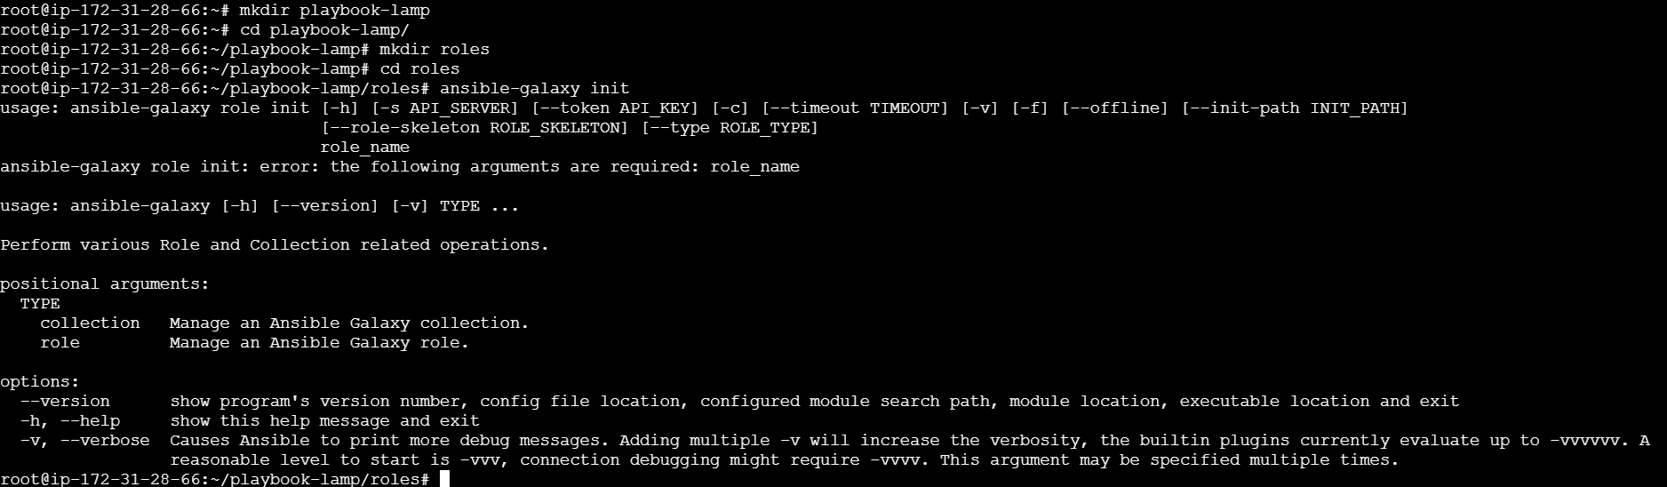
ansible-galaxy init common
ansible-galaxy init apache
ansible-galaxy init mysql
ansible-galaxy init php
this generates the older tree for each role.
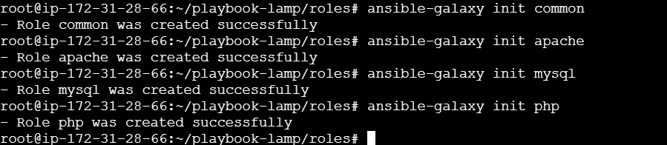
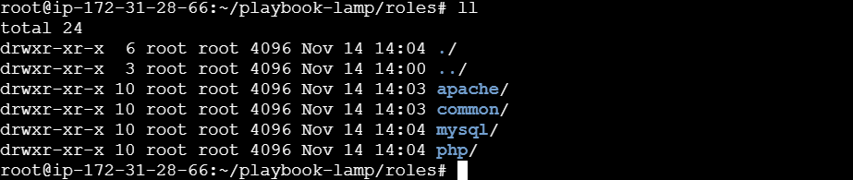
Configure each role:
Apache(roles/apache/tasks/main.yml)
---
- name: Install Apache
apt:
name: apache2
state: present
update_cache: yes

- name: Start and enable Apache service
service:
name: apache2
state: started
enabled: yes

- name: Deploy test index.html
copy:
dest: /var/www/html/index.html
content: |
<h1>Welcome to Apache on LAMP Stack</h1>

Mysql (roles/mysql/tasks/main.yml)
---
- name: Install MariaDB server
apt:
name: mariadb-server
state: present
update_cache: yes

- name: Start and enable MariaDB service
service:
name: mariadb
state: started
enabled: yes

- name: Ensure pip is installed
apt:
name: python3-pip
state: present
update_cache: yes

- name: Install PyMySQL with pip
pip:
name: PyMySQL
executable: pip3
php(roles/php/tasks/main.yml)
---
# tasks file for php

- name: Install PHP and extensions
apt:
name:
- php
- libapache2-mod-php
- php-mysql
- php-cli
- php-gd
- php-xml
state: present
update_cache: yes

- name: Restart Apache to load PHP module
service:
name: apache2
state: restarted

- name: Deploy PHP test file
copy:
dest: /var/www/html/info.php
content: |
<?php
phpinfo();
?>
Common(roles/common/tasks/main.yml)
---
# tasks file for common

- name: Update system packages on Ubuntu
apt:
update_cache: yes
upgrade: dist
create main playbook file
vi site.yml
---
- name: Configure LAMP Stack
hosts: your_target_hosts
become: true

roles:
- apache
- mysql
- common
- php
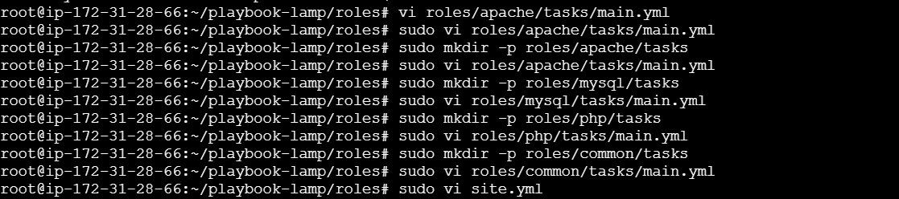
Create inventory file
Vi inventory
Add worker servers


Run: ansible-playbook -i inventory site.yml
After running playbook i got an error that my hostnames are not matched
So, I have removed roles and created basic task files so that ansible won’t fail.
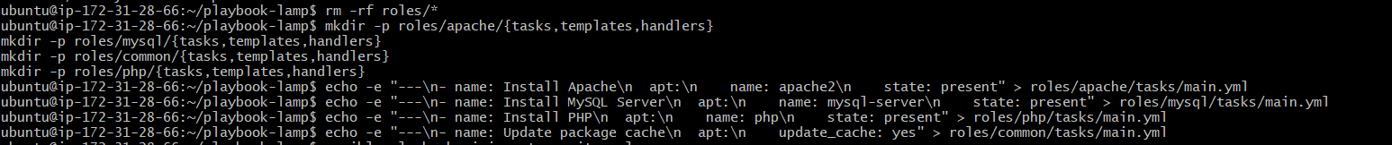
Now re-run playbook:
Ansible-playbook -I inventory site.yml
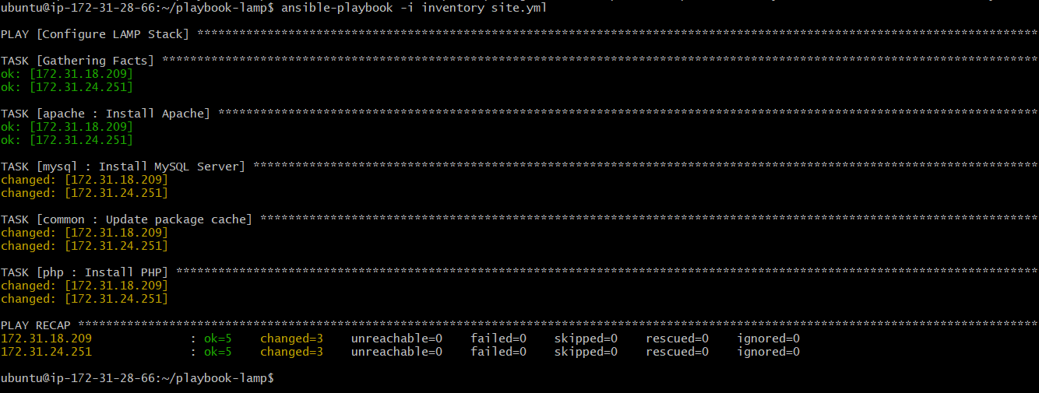
Now check in host-servers whether apache, mysql , php are installed or not.
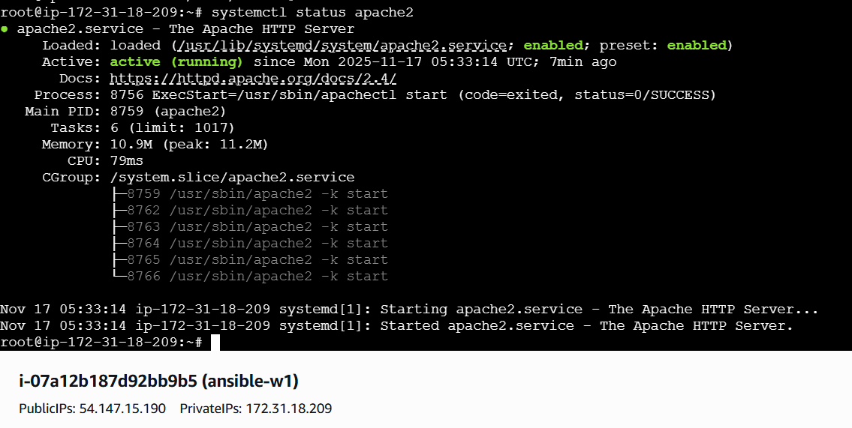
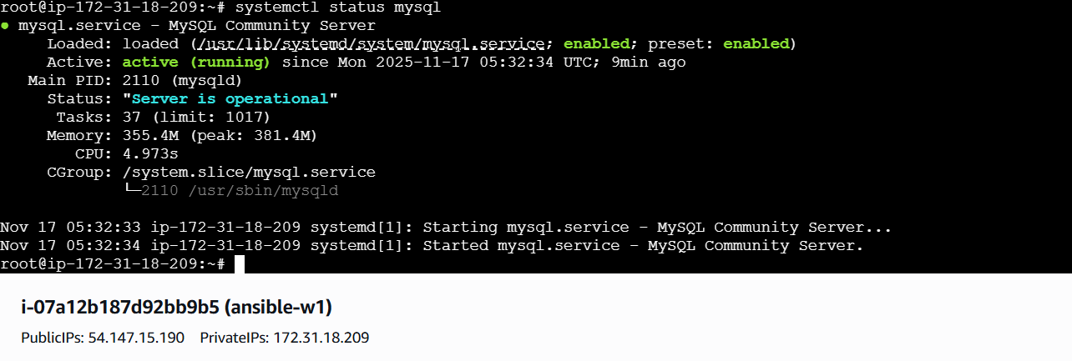

4.Setup ansible AWX and explore the options.
Step-1: Launch ec2 instance
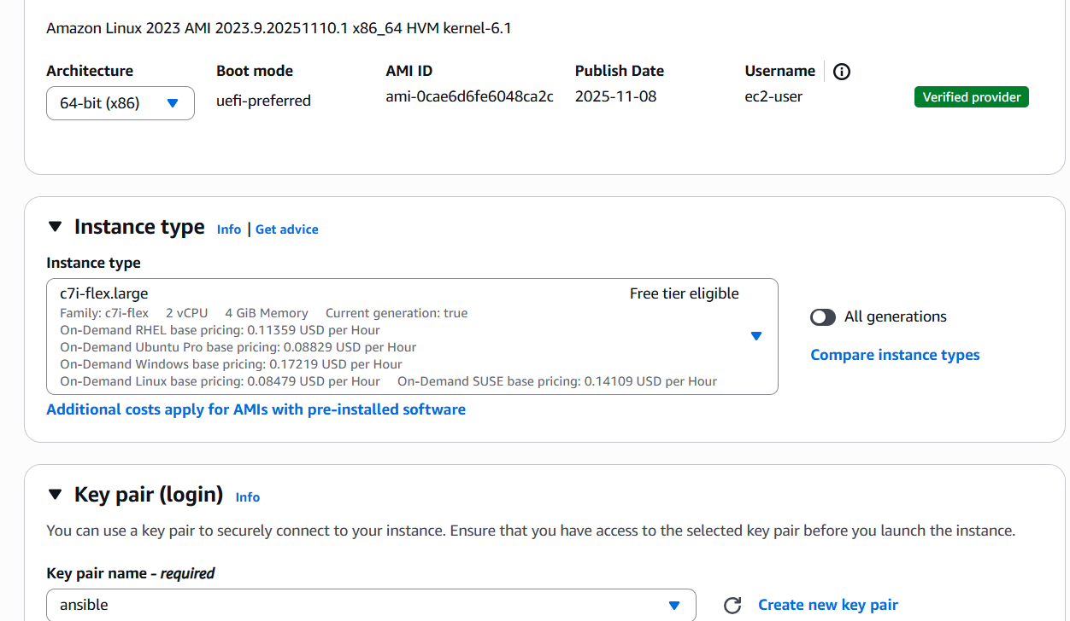
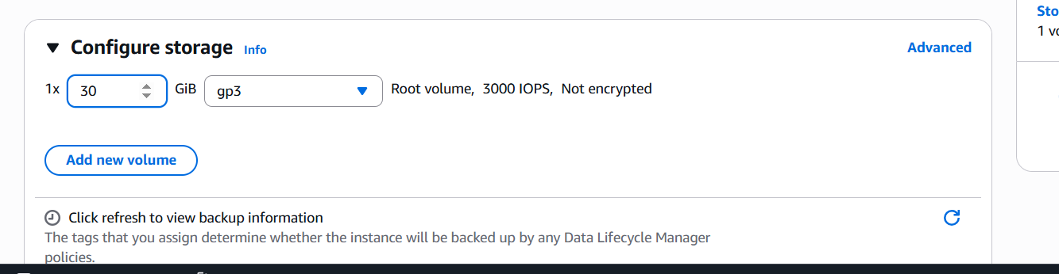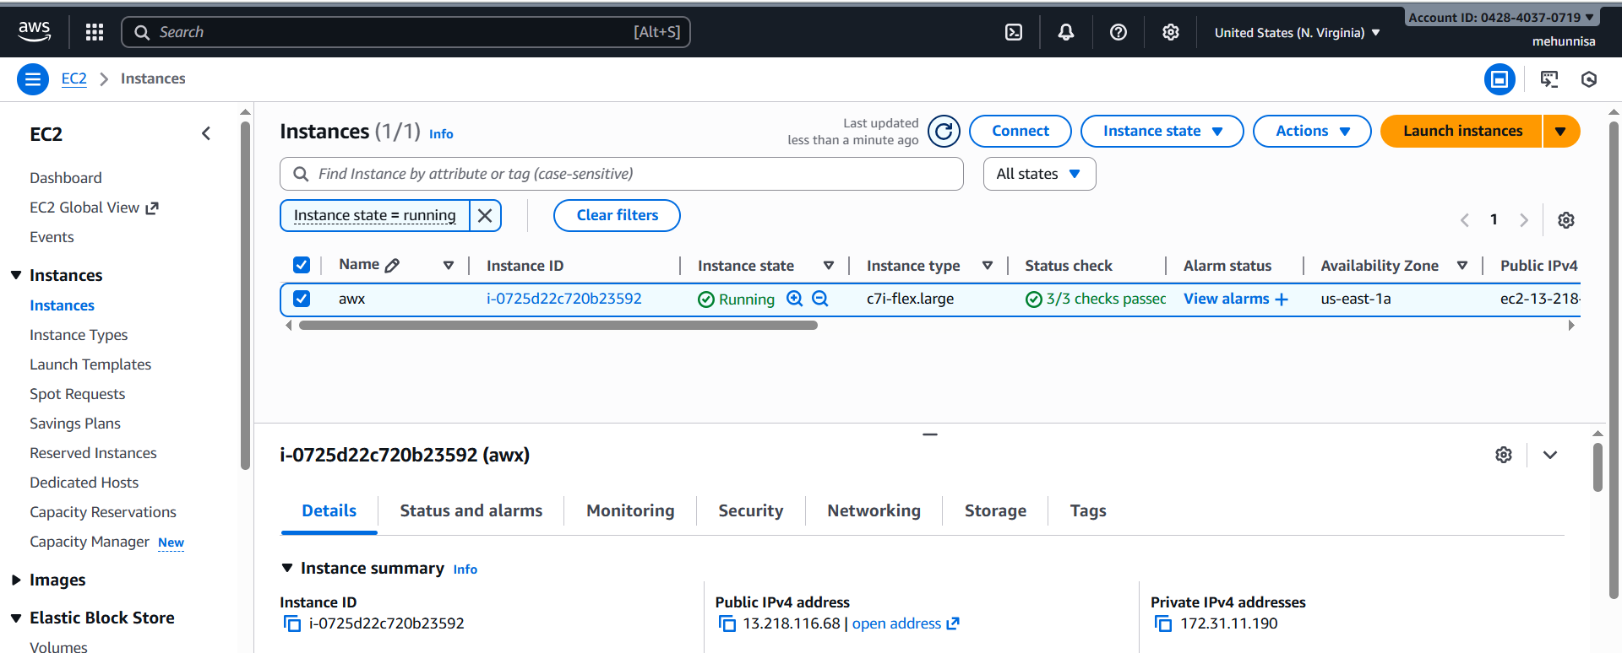
Step-2: update
Yum update -y
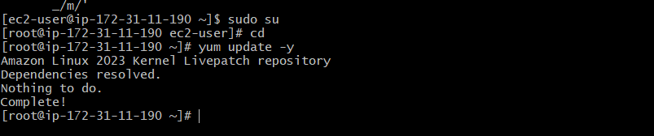
Step-3: Install ansible
Yum install ansible -y
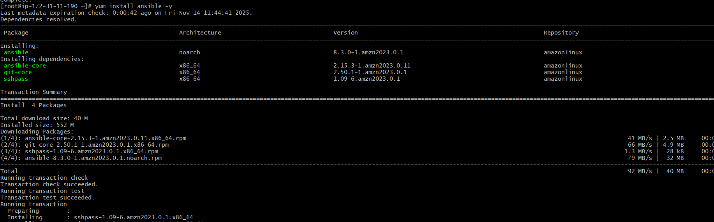
Ansible –version
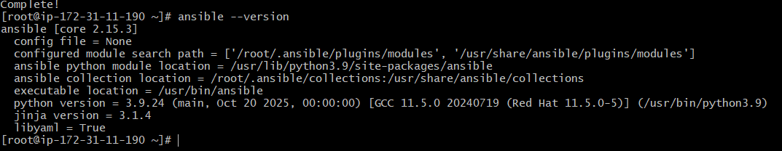
Step-4: Install required packages
Yum install docker -y
Sudo systemctl start docker
Sudo systemctl enable docker
Sudo systemctl status docker
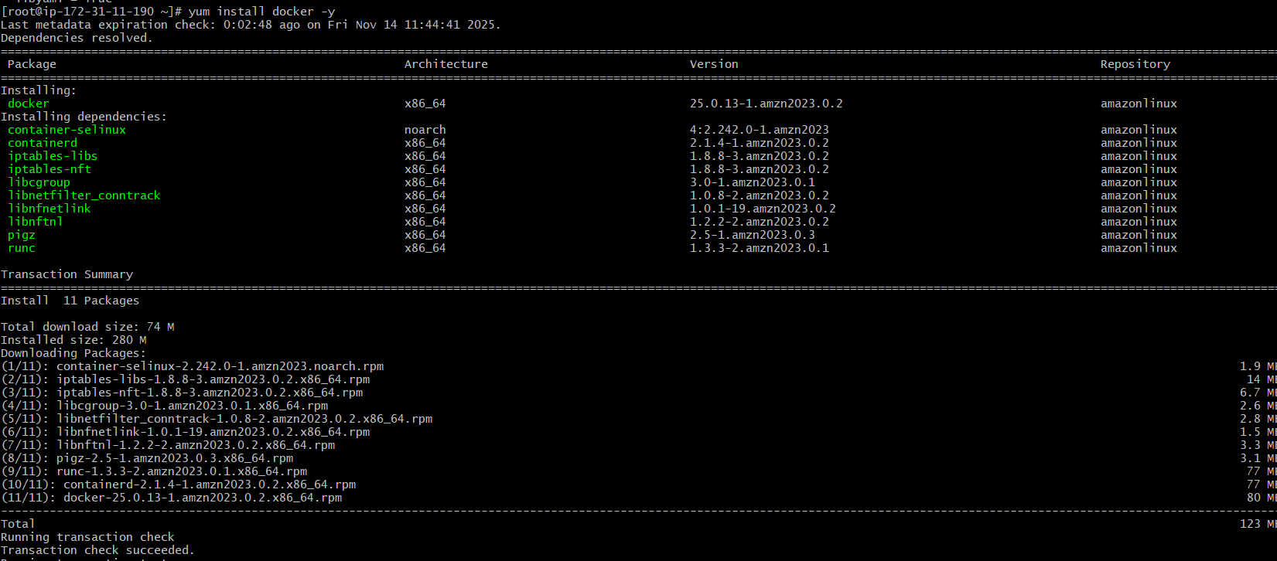
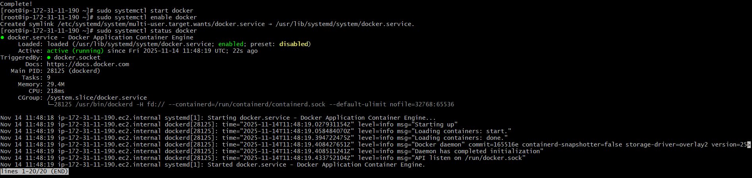
Install docker compose:
Amazon linux2 doesn’t include docker compose by default, so we need to install it manually.
Check if it is already installed:
If not, we need to download it using:

sudo curl -L "https://github.com/docker/compose/releases/download/docker-compose-$(uname -s)-$(uname -m)" -o /usr/local/bin/docker-compose

sudo chmod +x /usr/local/bin/docker-compose
docker-compose –version
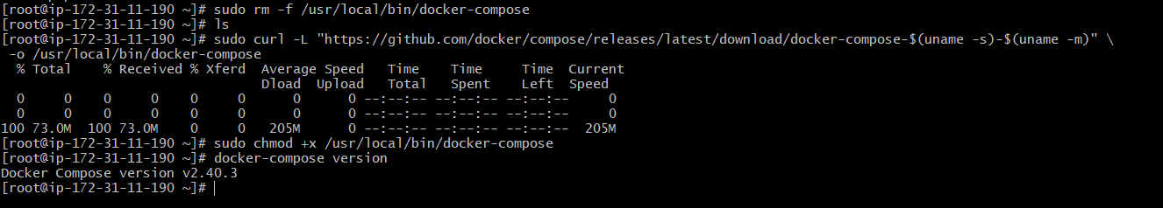
Step-5: Clone AWX Repo
Cd ~
git clone -b 17.1.0 https://github.com/ansible/awx.git
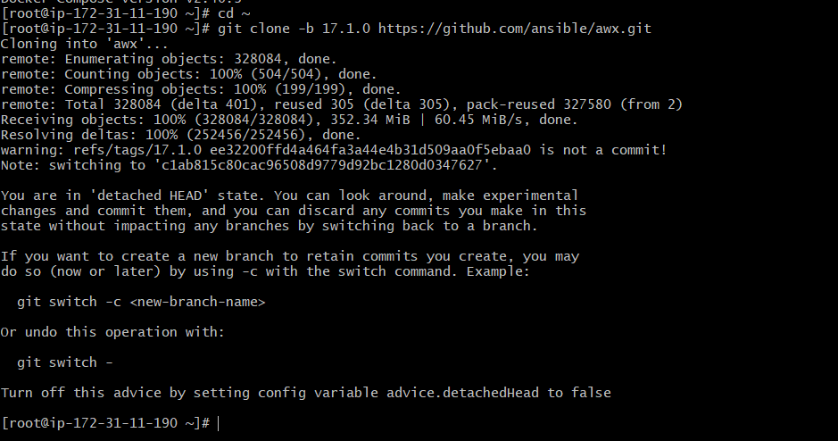
Cd awx/installer
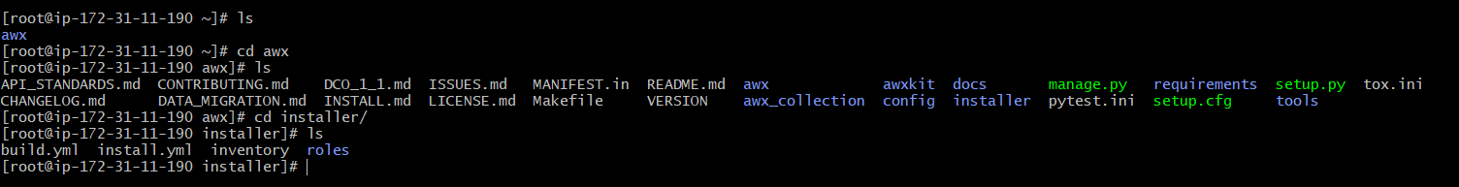
Configure AWX Inventory
Open inventory file to define your AWX credentials, database settings, and network configurations.

Vi inventory
Add the data in inventory:

localhost ansible_connection=local

[all:vars]

admin_password=Admin@123
secret_key=Admin@123

pg_host=localhost
pg_port=5432
pg_username=awx
pg_password=Admin@123
pg_database=awx

awx_alternate_dns_servers="8.8.8.8,8.8.4.4"
docker_compose_dir="/var/lib/awx/awxcompose"
project_data_dir="/var/lib/awx/projects"

dockerhub_base=ansible

Install AWX by running the Ansible playbook
ansible-playbook -i ~/awx/installer/inventory ~/awx/installer/install.yml
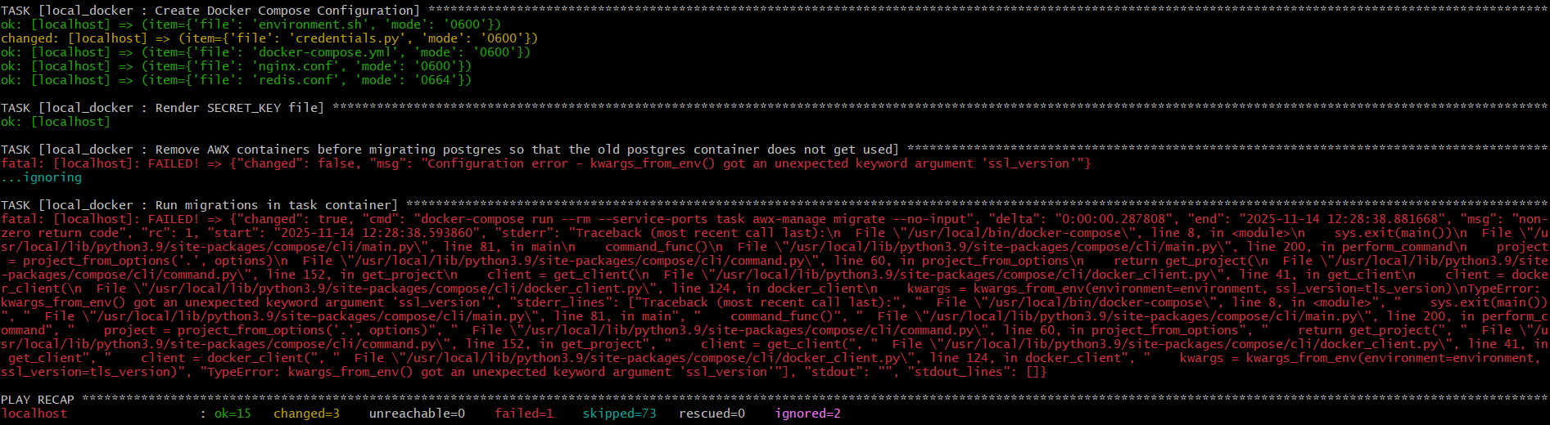
I got an error here.
So I removed old packages and installed:

pip3 install docker==4.4.4 –no-deps

pip3 install docker-compose==1.29.2 –no-deps

pip3 install dockerpty==0.4.1 –no-deps
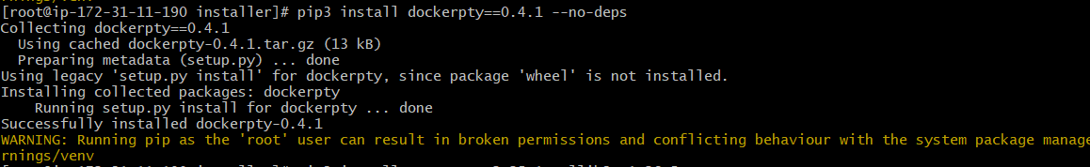

pip3 install requests==2.25.1 urllib==1.26.5
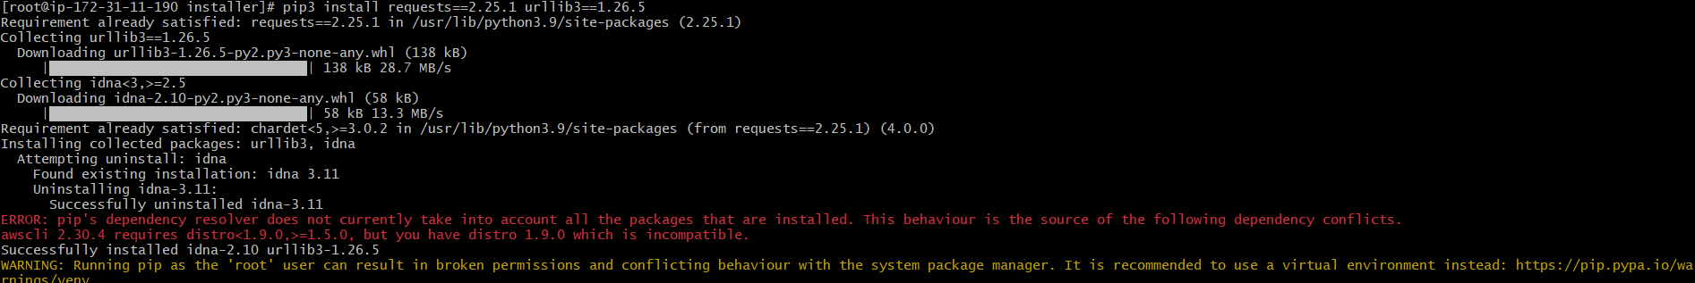

Now check the versions:
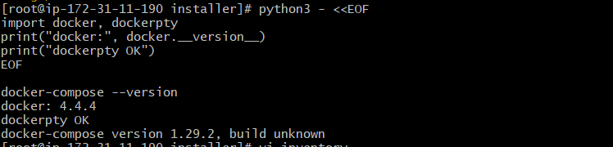
Now run :
ansible-playbook -i ~/awx/installer/inventory ~/awx/installer/install.yml
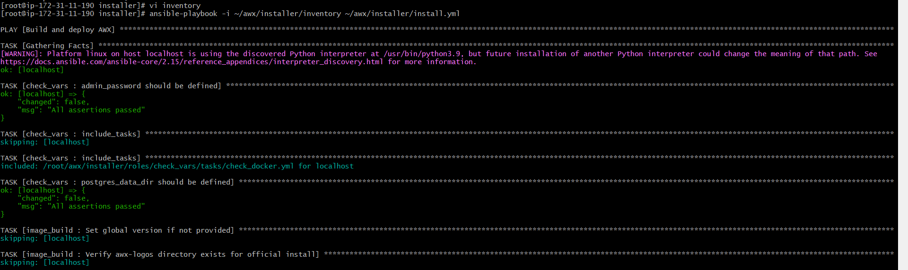
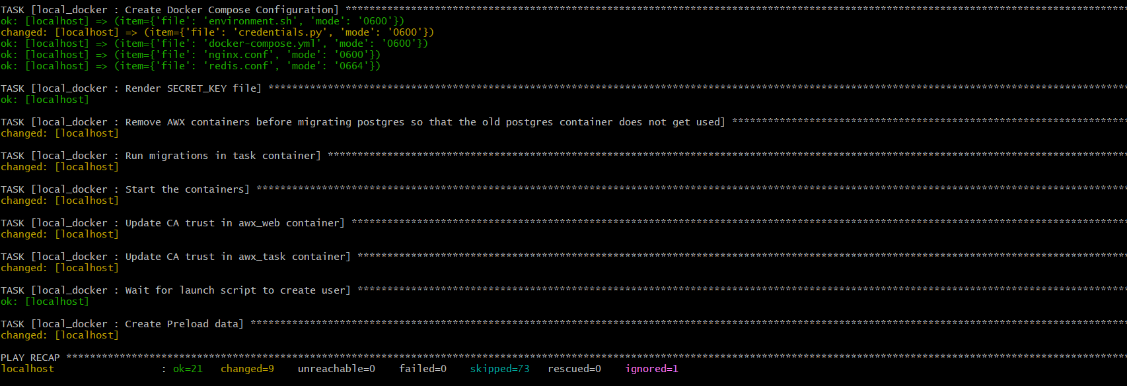

Check docker ps
Access AWX
- Open in browser: http://<ec2_public_ip>
- Login
- Username: admin
- Password: Admin@123
