Ansible-03
1 . write a single ansible playbook which will install apache and nginx.
Note:playbook should not be hardcoded and pass the variables from different file.

Create var.yml


Create playbook (install_web.yml)
---
- name: Install and configure Apache & Nginx on Ubuntu/Debian
hosts: all
become: yes
vars_files:
- vars.yml # This file must contain apache_port and nginx_port

tasks:
# -------------------------------------------------------------
# Stop services if running
# -------------------------------------------------------------
- name: Stop Apache if running
service:
name: apache2
state: stopped
ignore_errors: yes

- name: Stop Nginx if running
service:
name: nginx
state: stopped
ignore_errors: yes

- name: Kill remaining Apache processes
shell: pkill apache2 || true
ignore_errors: yes

- name: Kill remaining Nginx processes
shell: pkill nginx || true
ignore_errors: yes

# -------------------------------------------------------------
# Clean old configs
# -------------------------------------------------------------
- name: Remove old Apache vhost configs
file:
path: /etc/apache2/sites-enabled/
state: absent
ignore_errors: yes

- name: Recreate Apache sites-enabled directory
file:
path: /etc/apache2/sites-enabled/
state: directory

# -------------------------------------------------------------
# Install packages
# -------------------------------------------------------------
- name: Update apt cache
apt:
update_cache: yes

- name: Install Apache
apt:
name: apache2
state: present

- name: Install Nginx
apt:
name: nginx
state: present

# -------------------------------------------------------------
# Deploy test pages
# -------------------------------------------------------------
- name: Deploy Apache test page
copy:
dest: /var/www/html/apache/index.html
content: "<h1>Apache works on {{ inventory_hostname }}:{{ apache_port }}</h1>"

- name: Deploy Nginx test page
copy:
dest: /var/www/html/nginx/index.html
content: "<h1>Nginx works on {{ inventory_hostname }}:{{ nginx_port }}</h1>"

# -------------------------------------------------------------
# Configure Apache
# -------------------------------------------------------------
- name: Set Apache listen port
lineinfile:
path: /etc/apache2/ports.conf
regexp: "Listen"
line: "Listen {{ apache_port }}"
notify: Restart Apache

- name: Configure Apache vhost
copy:
dest: /etc/apache2/sites-enabled/000-default.conf
content: |
<VirtualHost *:{{ apache_port }}>
DocumentRoot /var/www/html/apache
<Directory /var/www/html/apache>
AllowOverride All
Require all granted
</Directory>
</VirtualHost>
notify: Restart Apache

# -------------------------------------------------------------
# Configure Nginx
# -------------------------------------------------------------
- name: Configure Nginx default site
copy:
dest: /etc/nginx/conf.d/default.conf
content: |
server {
listen {{ nginx_port }};
server_name _;
root /var/www/html/nginx;
index index.html;
}
notify: Restart Nginx

# -------------------------------------------------------------
# Validate configs
# -------------------------------------------------------------
- name: Test Apache configuration
command: apachectl configtest
register: apache_test
failed_when: apache_test.rc != 0
changed_when: false

- name: Test Nginx configuration
command: nginx -t
register: nginx_test
failed_when: nginx_test.rc != 0
changed_when: false

# -------------------------------------------------------------
# Start and enable services
# -------------------------------------------------------------
- name: Start and enable Apache
service:
name: apache2
state: started
enabled: yes

- name: Start and enable Nginx
service:
name: nginx
state: started
enabled: yes

# -------------------------------------------------------------
# Health checks
# -------------------------------------------------------------
- name: Check Apache test page
uri:
url: "http://localhost:{{ apache_port }}/"
return_content: yes
register: apache_check
failed_when: "'apache works on' not in apache_check.content | lower"

- name: Check Nginx test page
uri:
url: "http://localhost:{{ nginx_port }}/"
return_content: yes
register: nginx_check
failed_when: "'nginx works on' not in nginx_check.content | lower"

# -------------------------------------------------------------
# Handlers
# -------------------------------------------------------------
handlers:
- name: Restart Apache
service:
name: apache2
state: restarted

- name: Restart Nginx
service:
name: nginx
state: restarted
run playbook
ansible-playbooks install_web.yml

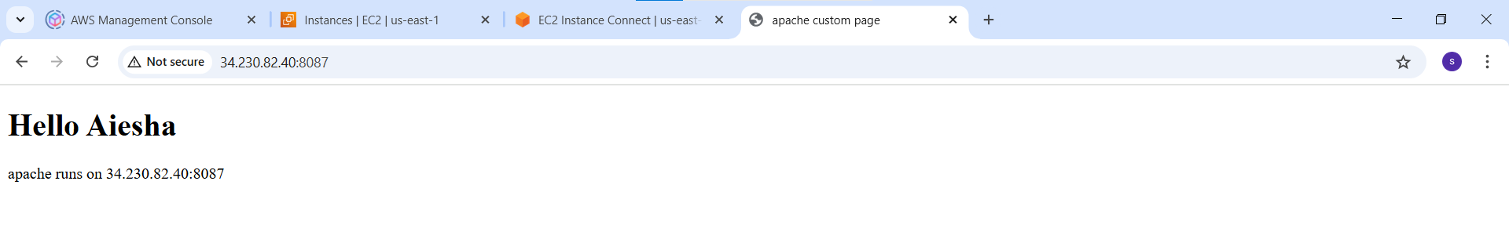

2. Ansible playbook to create 10 different directories with minimal code and directory names should be passed as variables.

Create variables file (vars_dirs.yml)
dir_list:
- dir1
- dir2
- dir3
- dir4
- dir5
- dir6
- dir7
- dir8
- dir9
- dir10
Base_path:/home/ubuntu/test_dirs #Base path where directories will be created.
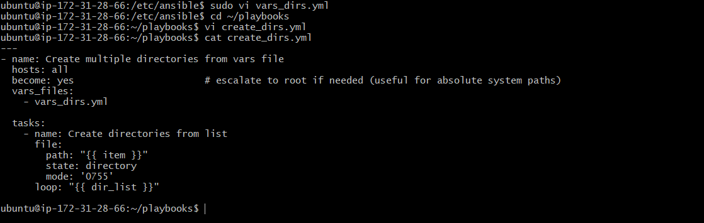

Run playbook:
Ansible-playbook create_dirs.yml
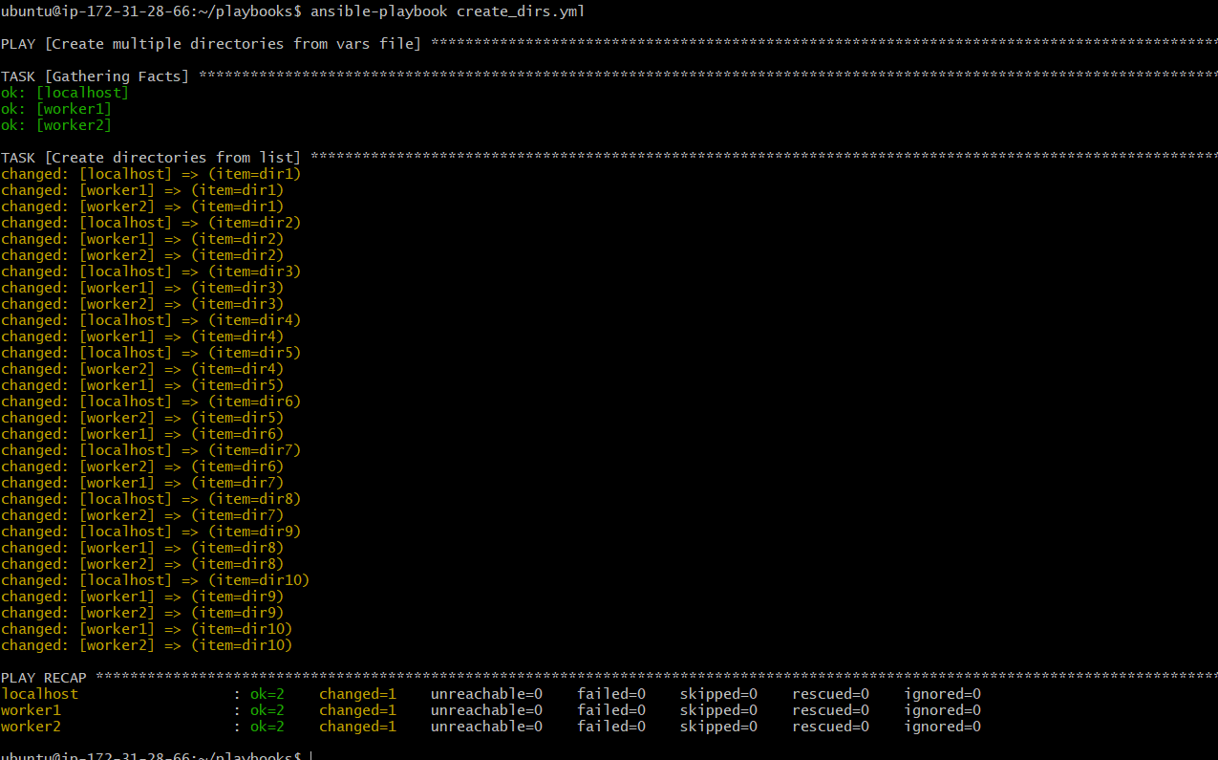
Worker1
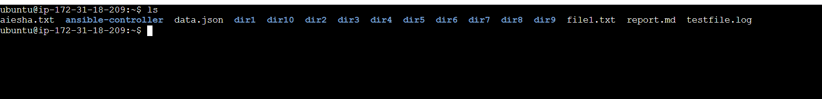
Worker2
3. Ansible playbook to copy ssh-keygen from master to worker nodes.
Note:
a)provision new 3 ec2 machines, one master and two worker nodes.
b)create common user called ansadm and provide sudo privileges on 3 ec2 instances.
c)create ssh_keygen in master and your playbook should copy the keygen making it passwordless authentication.

Install AWS Collections on ansible controller.
Ansible-galaxy collection install amazon.aws
Pip install boto3 botocore
Create playbook and add below script
Example: vi test.yml

---
- name: Configure existing EC2 cluster with private IPs
hosts: localhost
connection: local
gather_facts: false

vars:
region: us-west-1
keypair: aws
aws_ssh_user: ec2-user
private_key_path: "/home/ubuntu/.ssh/id_ed25519"
master_private_ip: 172.31.28.66
worker_private_ips:
- 172.31.18.209
- 172.31.24.251

tasks:
- name: Ensure PEM key exists
stat:
path: "{{ private_key_path }}"
register: pem_file

- name: Fail if PEM key not found
fail:
msg: "Private key {{ private_key_path }} not found!"
when: not pem_file.stat.exists

- name: Set PEM permissions
file:
path: "{{ private_key_path }}"
mode: "0400"
when: pem_file.stat.exists

- name: Add master to in-memory inventory
add_host:
name: "{{ master_private_ip }}"
groups: master
ansible_user: "{{ aws_ssh_user }}"
ansible_ssh_private_key_file: "{{ private_key_path }}"
ansible_ssh_common_args: "-o StrictHostKeyChecking=no"

- name: Add workers to in-memory inventory
add_host:
name: "{{ item }}"
groups: launched
ansible_user: "{{ aws_ssh_user }}"
ansible_ssh_private_key_file: "{{ private_key_path }}"
ansible_ssh_common_args: "-o StrictHostKeyChecking=no"
loop: "{{ worker_private_ips }}"

- name: Configure ansadm user and passwordless sudo
hosts: launched + master
become: yes
tasks:
- name: Create ansadm user
user:
name: ansadm
groups: wheel
append: yes
create_home: yes
shell: /bin/bash

- name: Allow ansadm passwordless sudo
copy:
dest: /etc/sudoers.d/ansadm
content: "ansadm ALL=(ALL) NOPASSWD: ALL\n"
mode: "0440"

- name: Generate SSH key on master
hosts: master
become: yes
become_user: ansadm
tasks:
- name: Ensure .ssh directory exists
file:
path: /home/ansadm/.ssh
state: directory
owner: ansadm
group: ansadm
mode: "0700"

- name: Generate SSH key for ansadm if not exists
openssh_keypair:
path: /home/ansadm/.ssh/id_rsa
type: rsa
size: 2048
state: present
force: no

- name: Read master public key
slurp:
src: /home/ansadm/.ssh/id_rsa.pub
register: master_pub_key

- name: Set master public key fact
set_fact:
master_pub_key_decoded: "{{ master_pub_key.content | b64decode }}"

- name: Distribute master SSH key to workers
hosts: launched
become: yes
vars:
master_pub_key: "{{ hostvars[groups['master'][0]].master_pub_key_decoded }}"
tasks:
- name: Ensure .ssh directory exists
file:
path: /home/ansadm/.ssh
state: directory
owner: ansadm
group: ansadm
mode: "0700"

- name: Push master public key for passwordless SSH
authorized_key:
user: ansadm
state: present
key: "{{ master_pub_key }}"

- name: Verify master → worker connectivity
hosts: master
gather_facts: no
become: yes
become_user: ansadm
tasks:
- name: Ping all workers from master
ansible.builtin.ping:
delegate_to: "{{ item }}"
loop: "{{ groups['launched'] }}"
register: ping_results

- name: Show ping results
debug:
var: ping_results.results

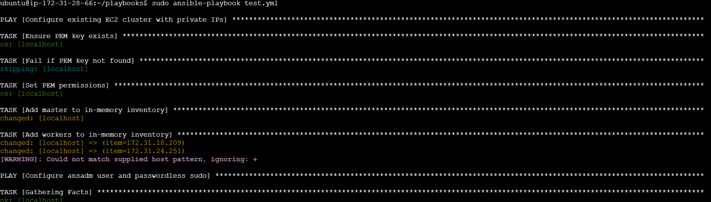
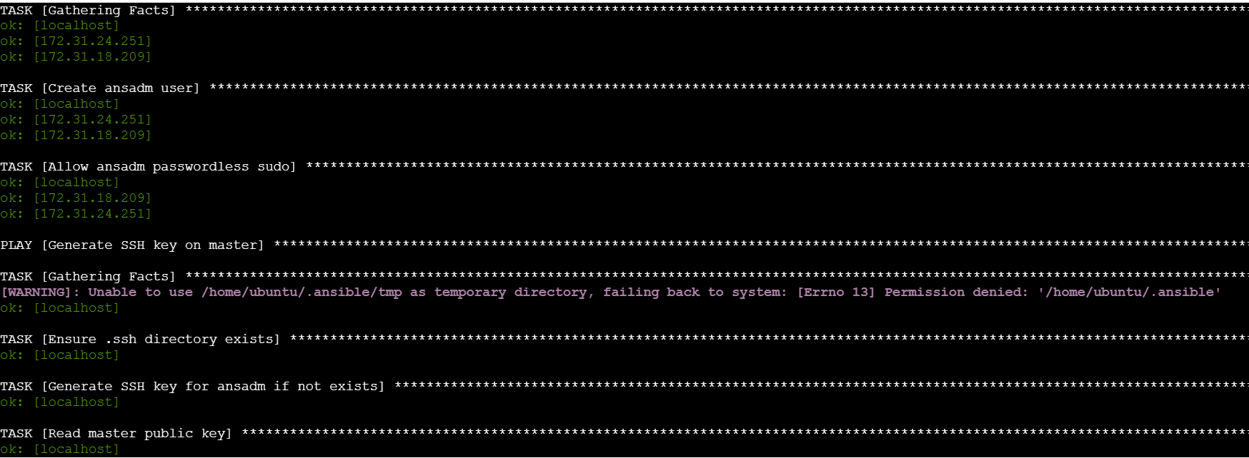
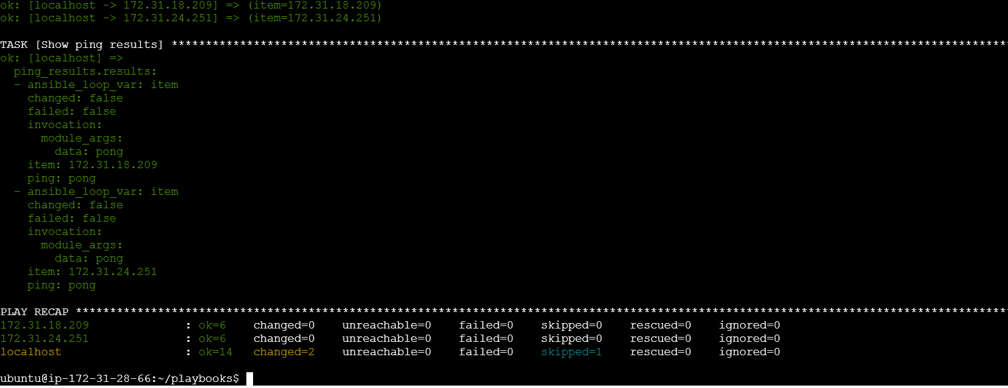
Worker1
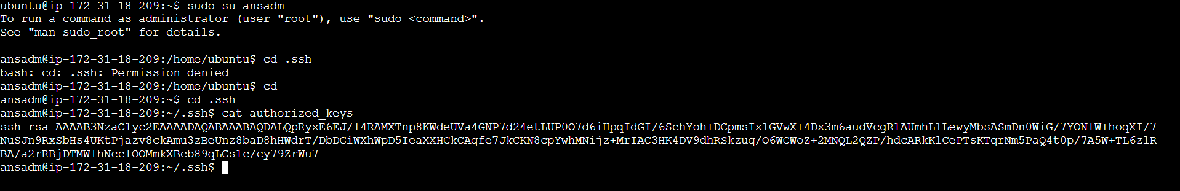
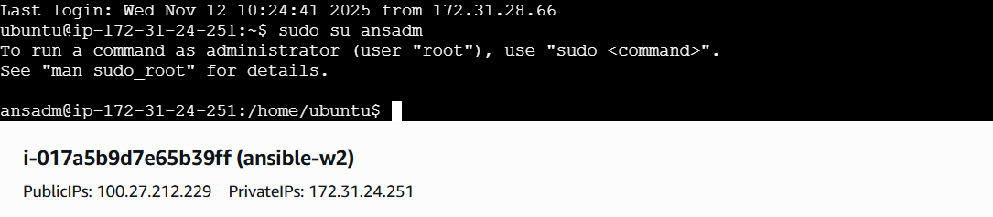
Check ping from master
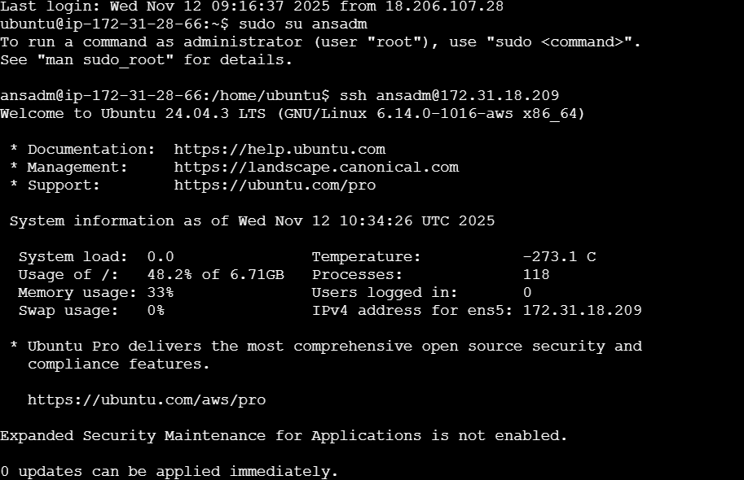

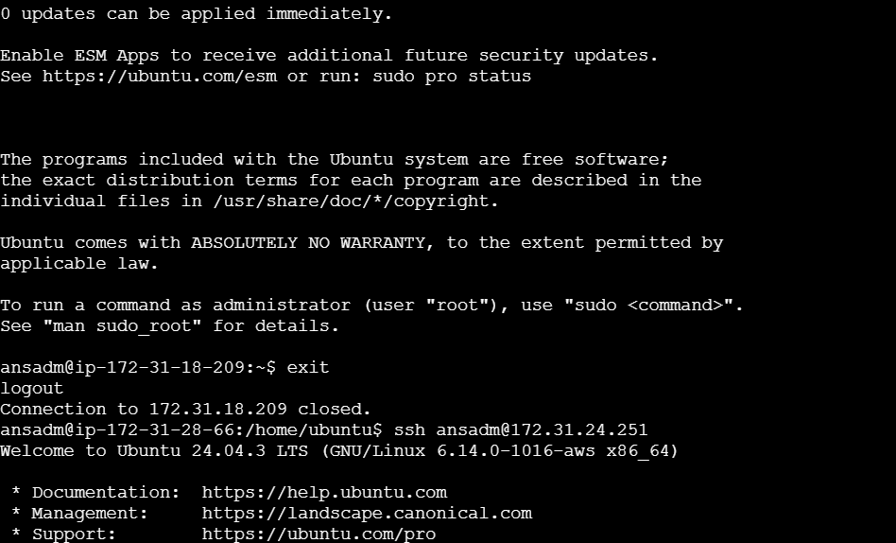

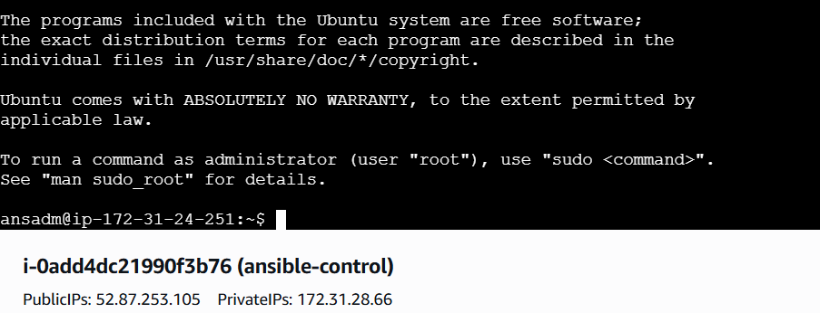
4. Ansible playbook to inject ansible vault variables.

Create secrets.yml
Add the contents
Vault_db_user: “admin”
Vault_db_password: “supersecret123”

Now the vault_vars.yml is encrypted.
We can check whether it is encrypted or not as cat vault_vars.yml
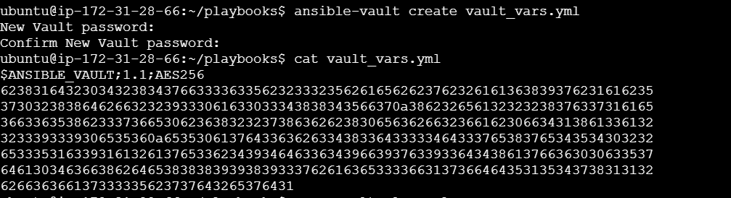

Create vault playbook and add below content
---
- name: Test vault variables
hosts: all
vars_files:
- vault_vars.yml

tasks:
- name: Show vault-protected variables
debug:
msg:
- "Vault DB User: {{ vault_db_user }}"
- "Vault DB Password: {{ vault_db_password }}"

Verify both the files exists in same directory:
ls -l vault_play.yml vault_vars.yml

Run playbook with vault password:
Ansible-playbook vault_play.yml --ask-vault-pass
