- Install Terraform on your PC
Method 1: Manual Installation
Download Terraform
Search for terraform installation on windows → select windows installation.
Download windows (AMD64) ZIP file.
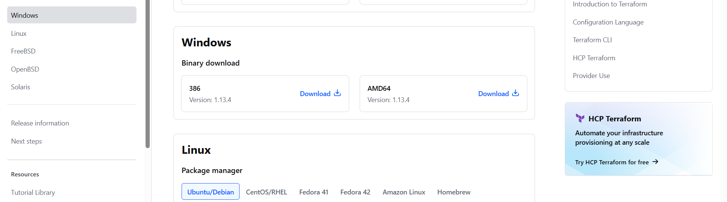Extract ZIP file
Right-click → extract all
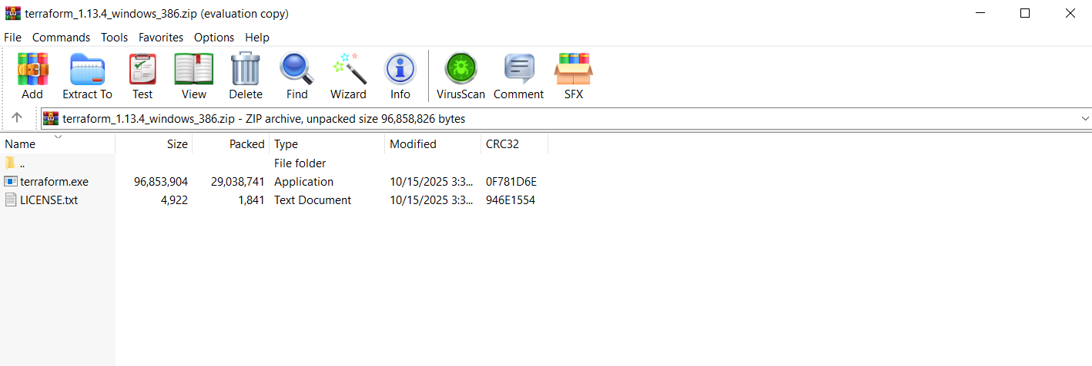we’ll find terraform.exe
Move terraform.exe
Copy terraform.exe to a folder → ex: C:\TerraformTemp\
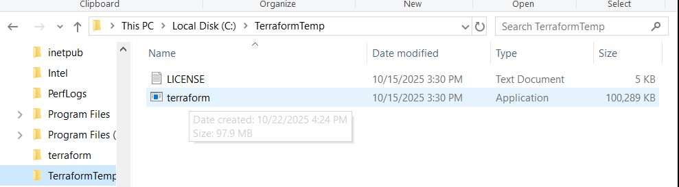Set Environment Variables (Path)
Go to Advanced Environment variables.
Under system variables → Select path → Edit → New
Add: C:\TerraformTemp\
Verify Installation
Run: Terraform -version
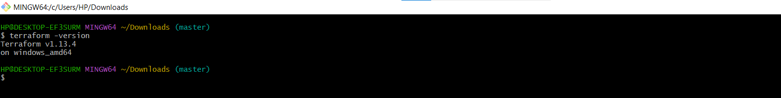

- Execute all the templates shown in video.
Sample Template:

Resource “local_file” “my_pet”{
Filename=”pets.txt”
Content=”I really love all my pets”
}

Initializing Terraform in Visual studio.
In terminal Terraform init
Prepare your working directory by initializing the backend , downloading providers, and installing modules.
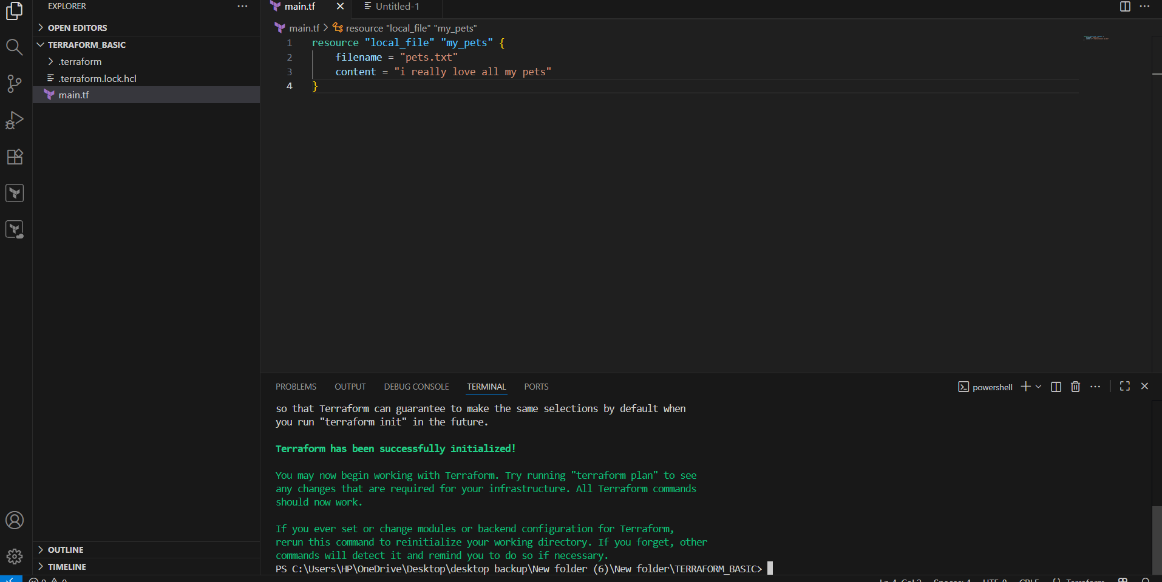

Terraform plan
Generate and review an execution plan to see what changes will be made.
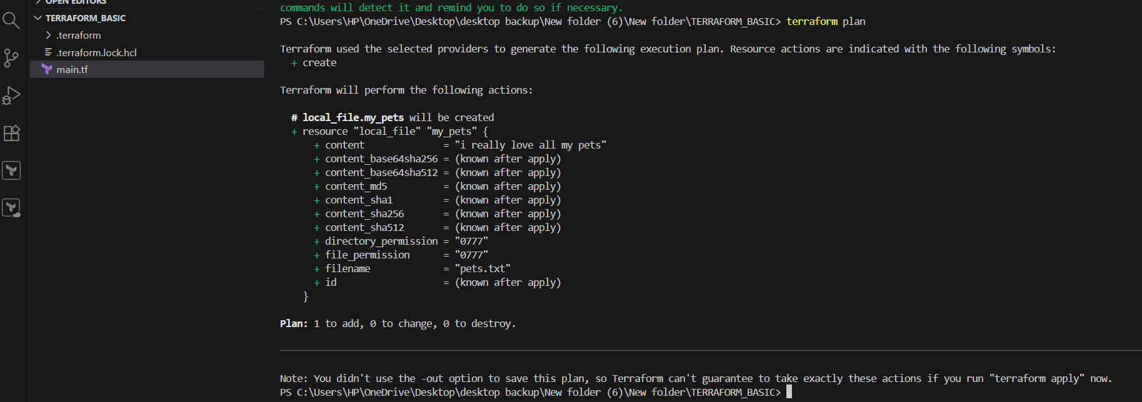
terraform Apply
Execute the plan to make the changes to your cloud infrastructure.
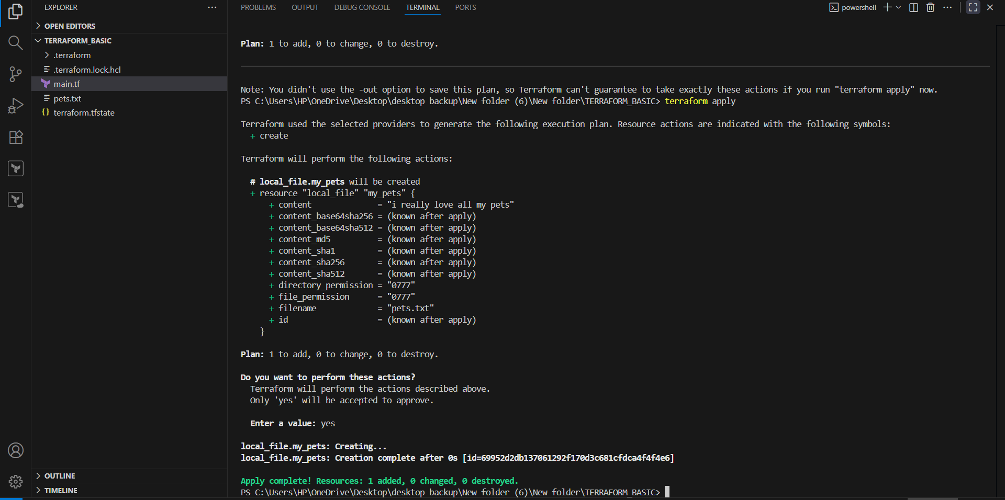Here terraform.tfstate containing all information.
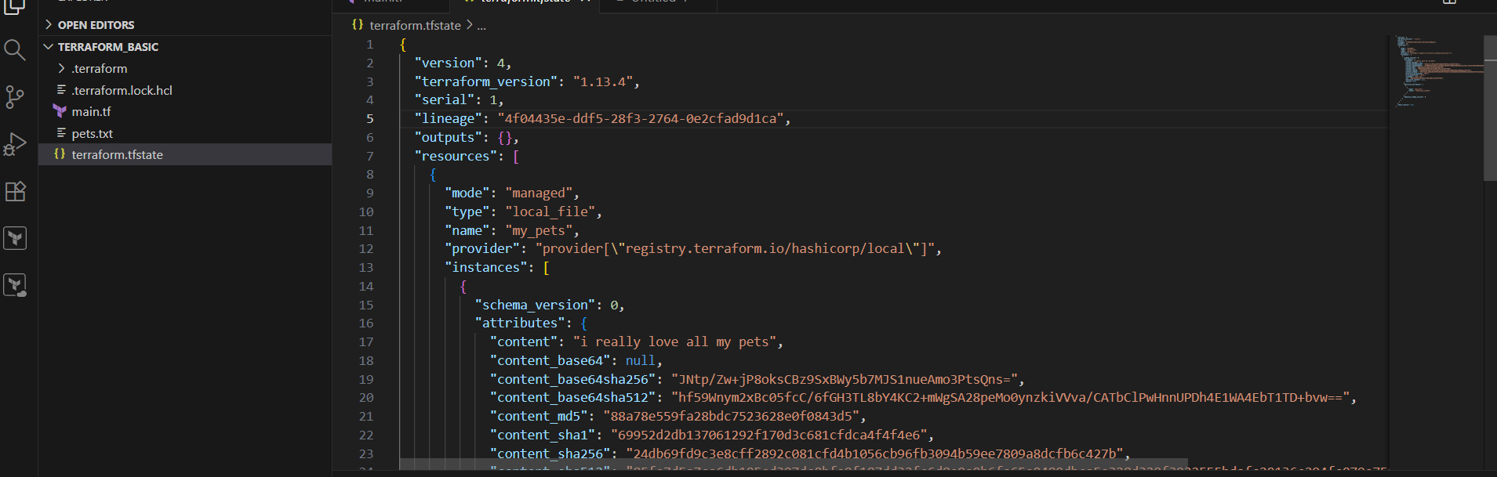
terraform destroy
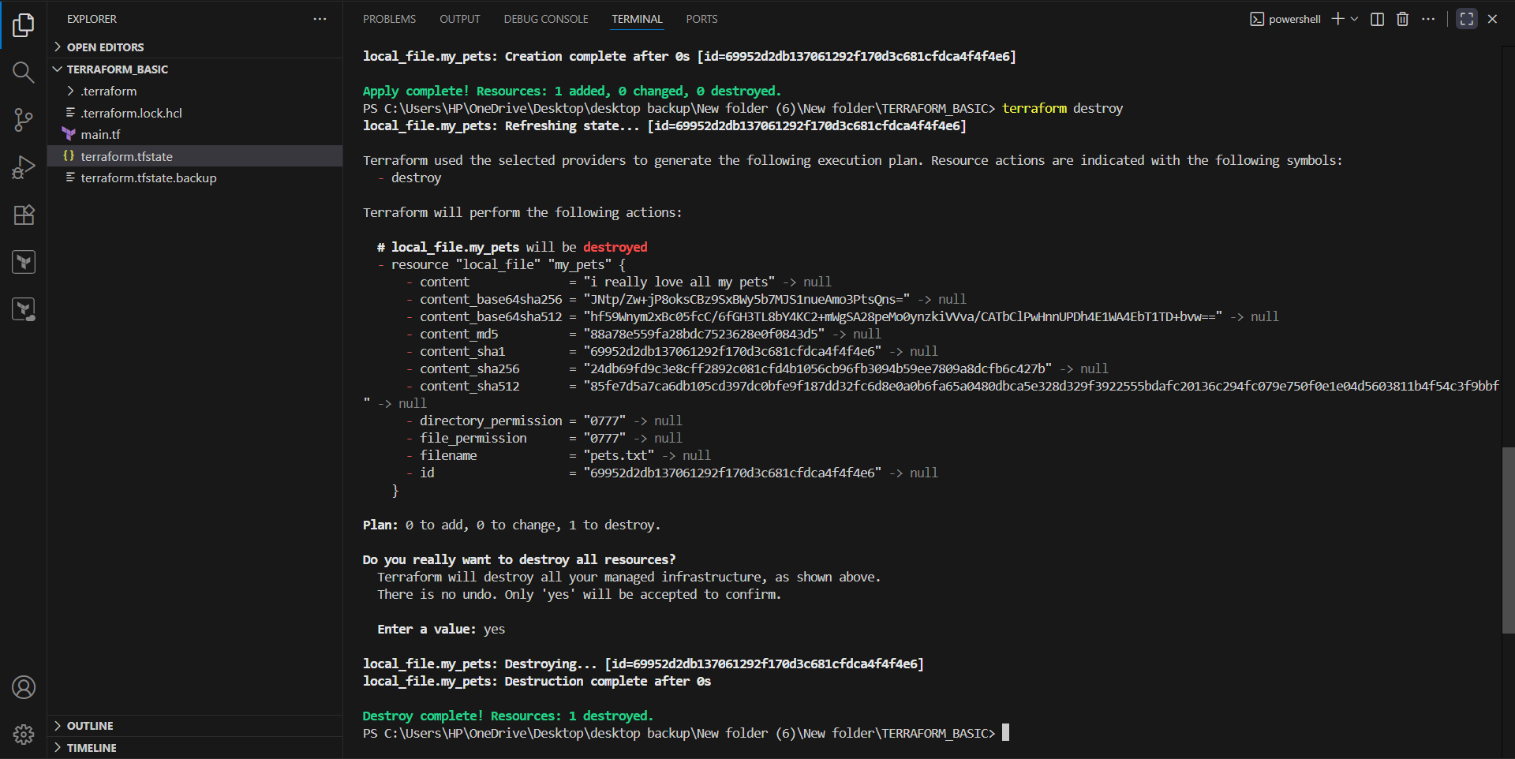
Create one more resource
Apply Terraform init → terraform plan → terraform apply
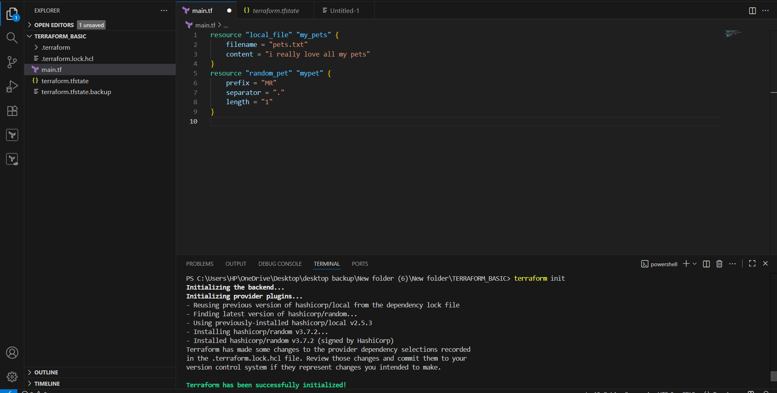
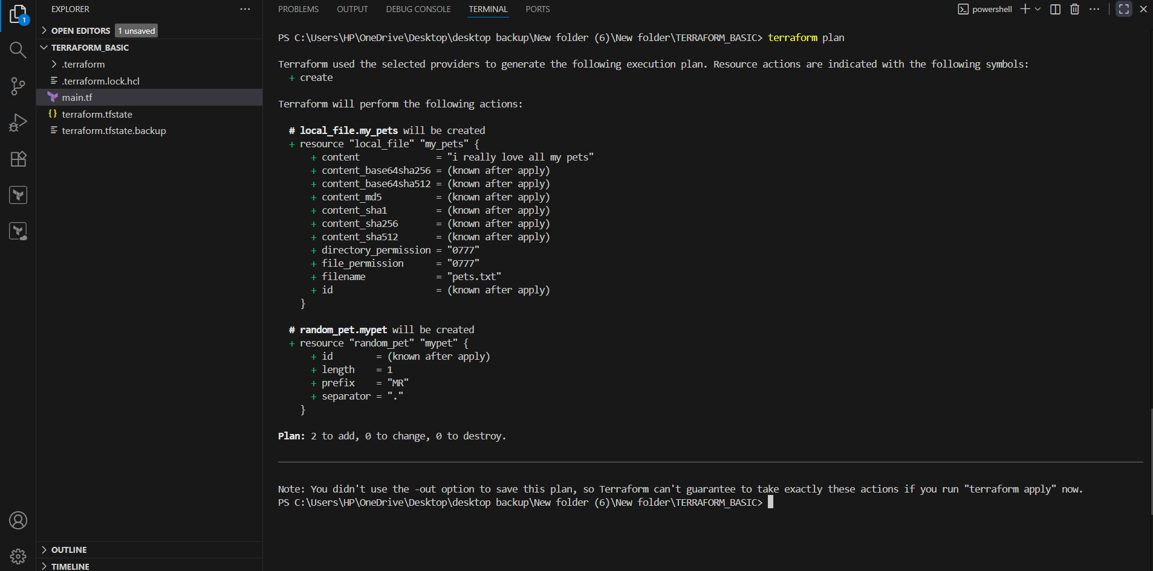
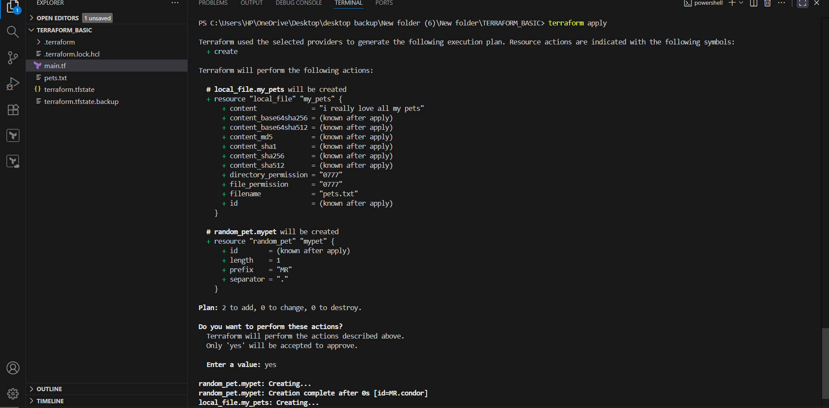
Terraform fmt
Will format or organize code
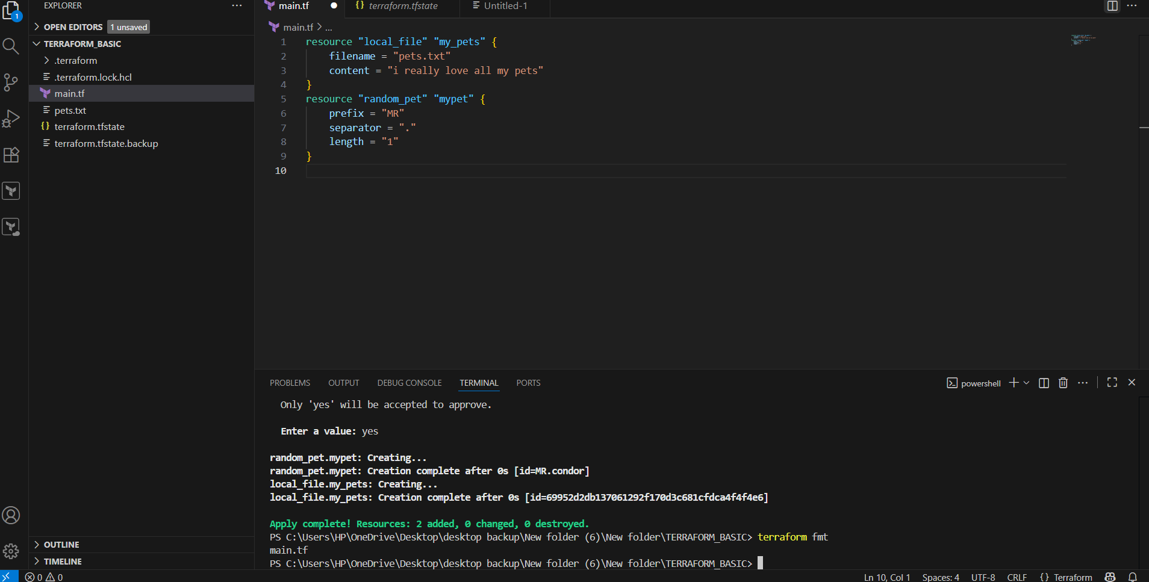
- Note down below points.
Terraform init
- You only need to run terraform init once per project.(or whenever you add new providers/modules or backend).
- Safe to run multiple times: it won’t destroy anything.
- I must be run before plan or apply.

Terraform plan
Terraform plan is important because
- Acts as a Preview before making changes.
- Helps to catch mistakes before applying.
- Safe to run at any time.

Terraform Apply
- It is the Execution step → makes real changes to infrastructure.
- It should always run after the terraform plan to avoid mistakes.
- It is safe, but Destructive changes(like deleting resources) requires careful review.

Terraform provider
Providers are important –
- Without providers terraform will not know what resources to create.
- Providers are the core building blocks that make terraform manage any service.
It is a complete package of API calls to communicate with our resource.
- Integrate a sample terraform template in Jenkins.
First we have to install terraform in Jenkins instance .
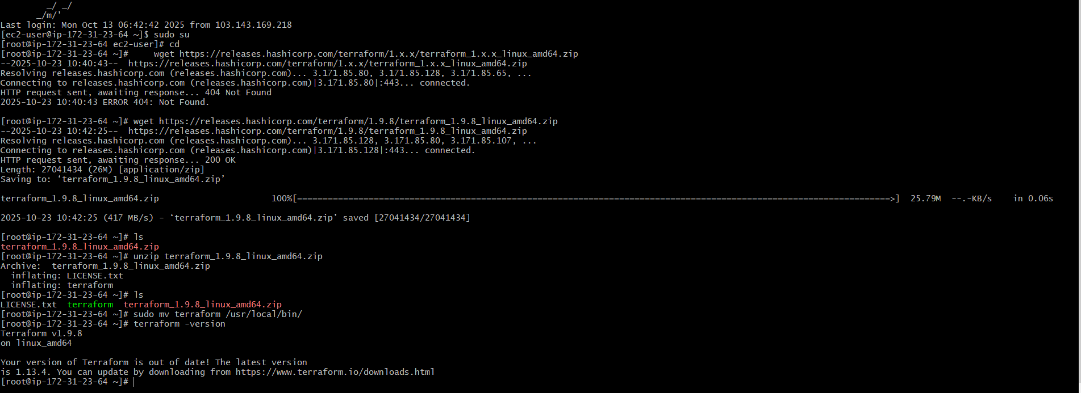
Go to security credentials in AWS and create Access keys.
Access key and secret access key are generated.
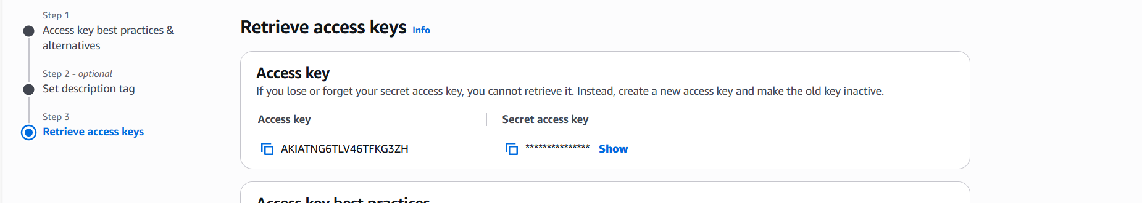Create a repo in github
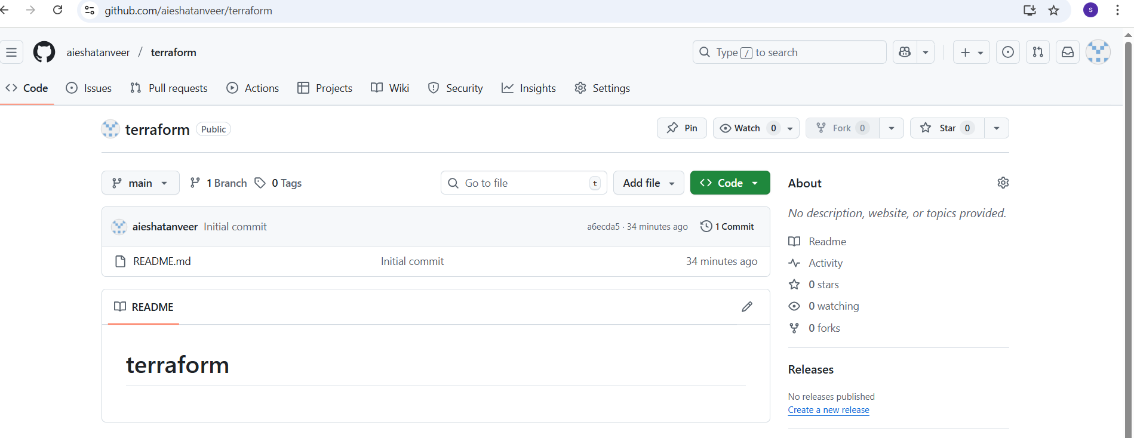In terraform repo create Jenkinsfile and main.tf
- Update Jenkins file with the following below script.
pipeline {
agent any
environment {
AWS_ACCESS_KEY_ID =credentials('Access_key')
AWS_SECRET_ACCESS_KEY = credentials('secret_key')

stages {
stage('checkout code') {
steps {
git url: 'https://github.com/aieshatanveer/terraform.git', branch: 'main'
}
}
stage('terraform init') {
steps {
sh 'terraform init'
}
}
stage('terraform plan') {
steps {
sh 'terraform plan'
}
}
stage('terraform Apply') {
steps {
sh 'terraform apply --aauto-approve'
}
}
}
}
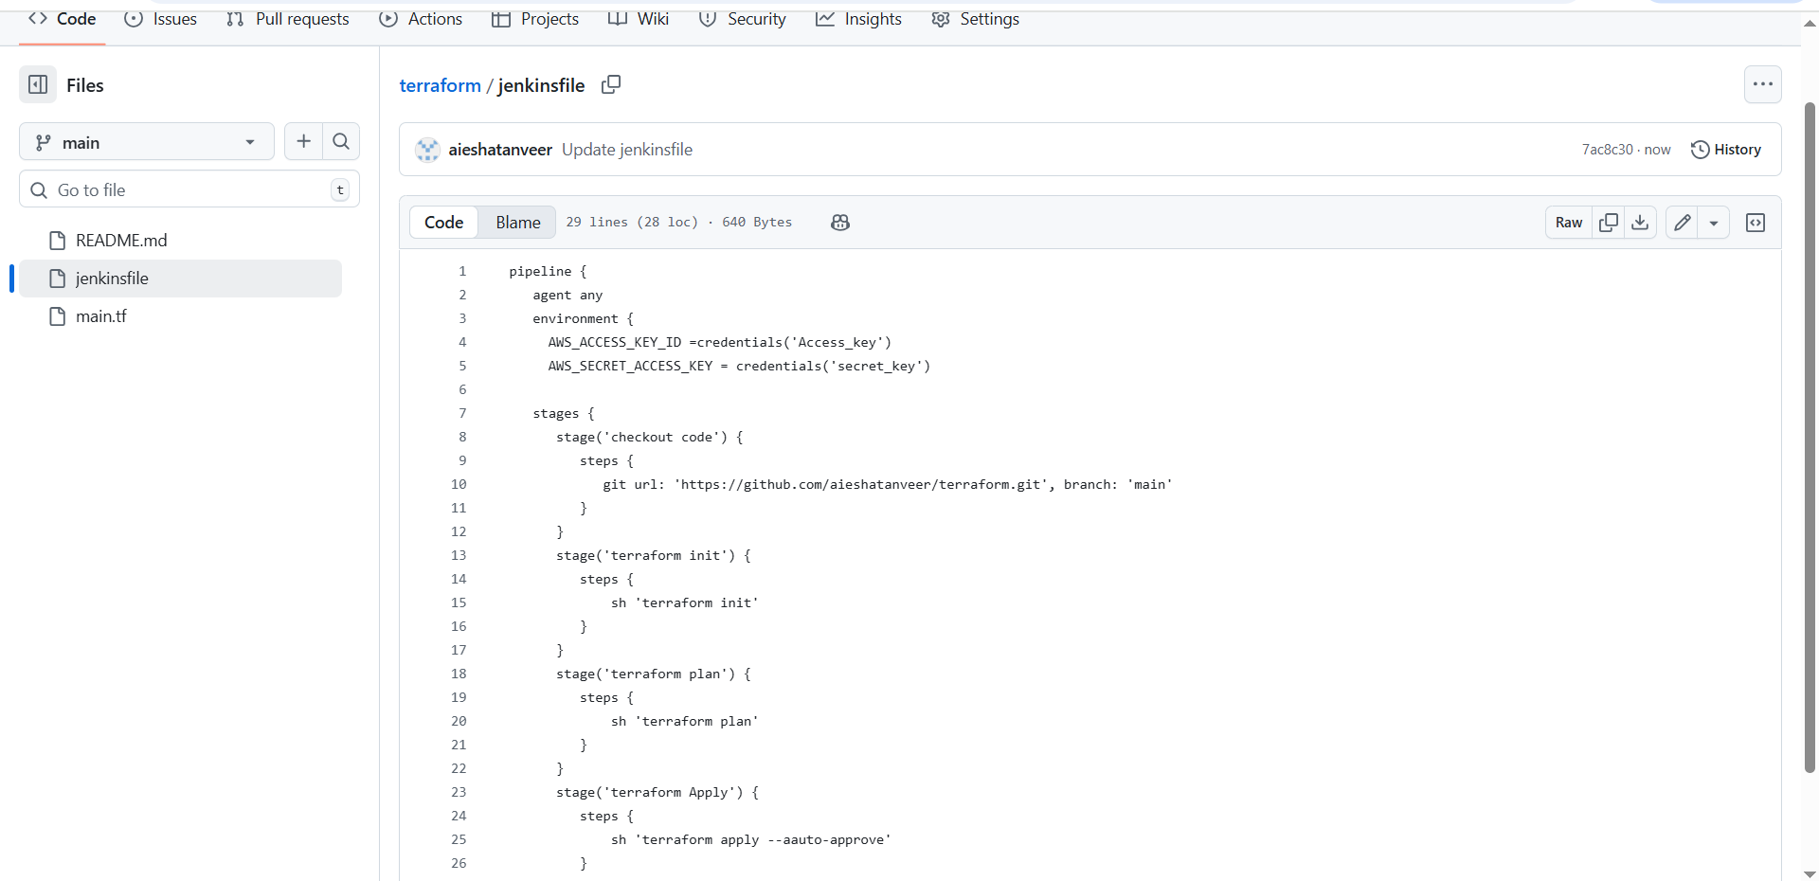
In main.tf use the below script and update.
resource "local_file" "my_pet"{
filename = "pets.txt"
content = "i really love all my pets"
}
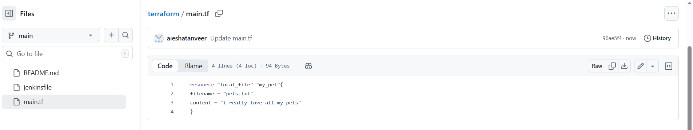Go to Jenkins and create terraform-job with pipeline type.
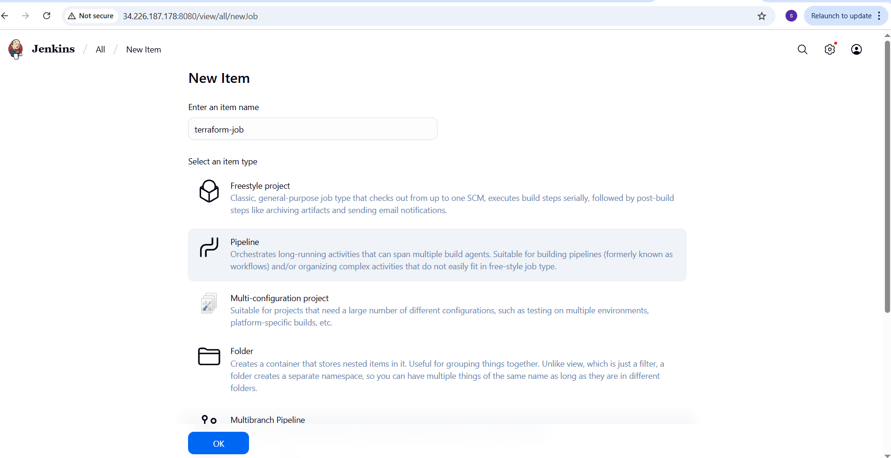
Go to Jenkins → Manage Jenkins → plugins →Terraform
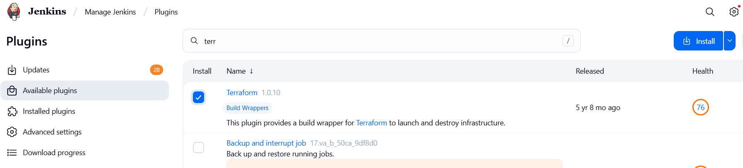
Add credentials in Jenkins
Go to manage Jenkins → credentials → system → Global credentials (unrestricted)
Add Access key and secret access key.
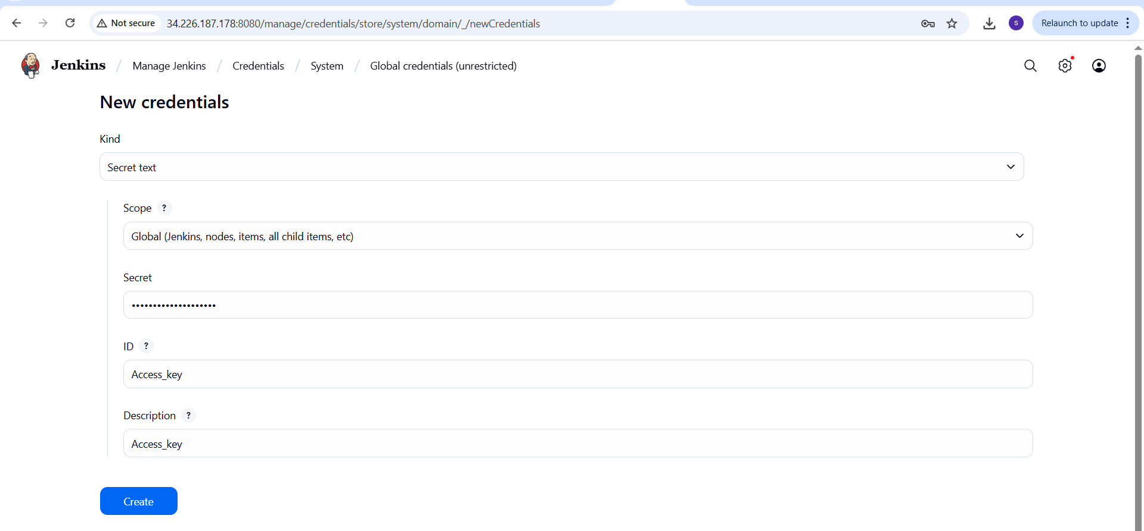
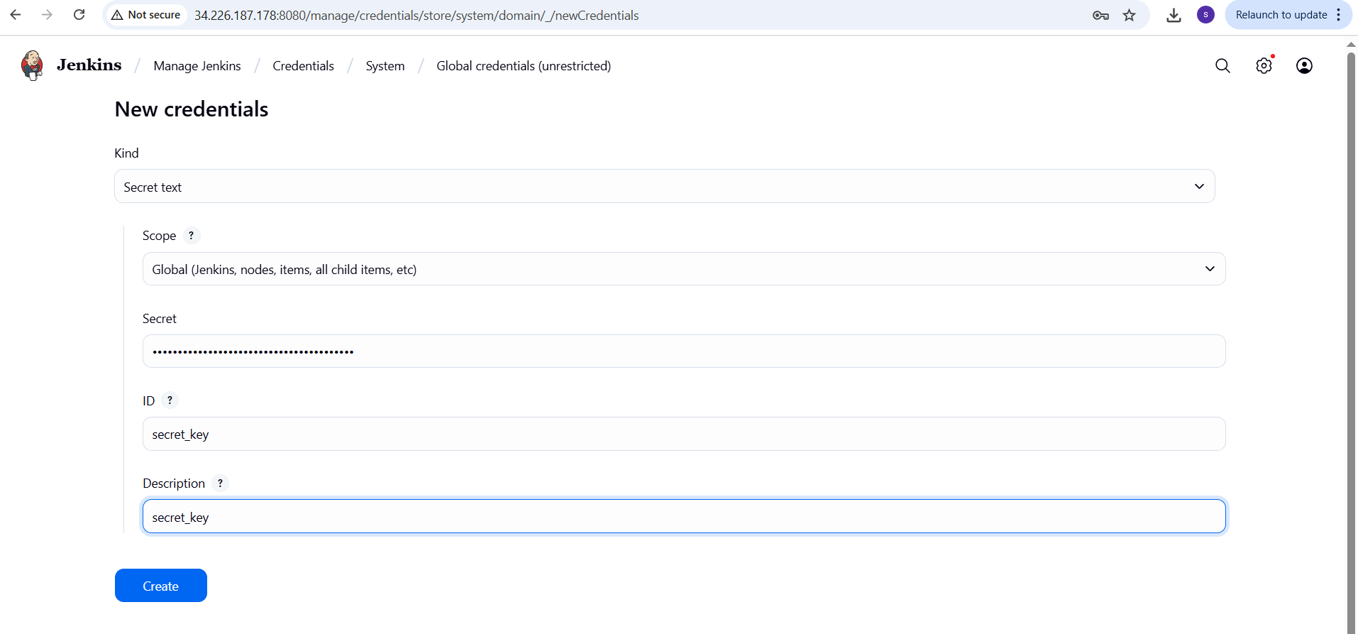
Now go to jekins → Terraform-job → configuration
Go to pipelines in configuration
Select definition: pipeline script from SCM & Add Repo URL
Select branch : main
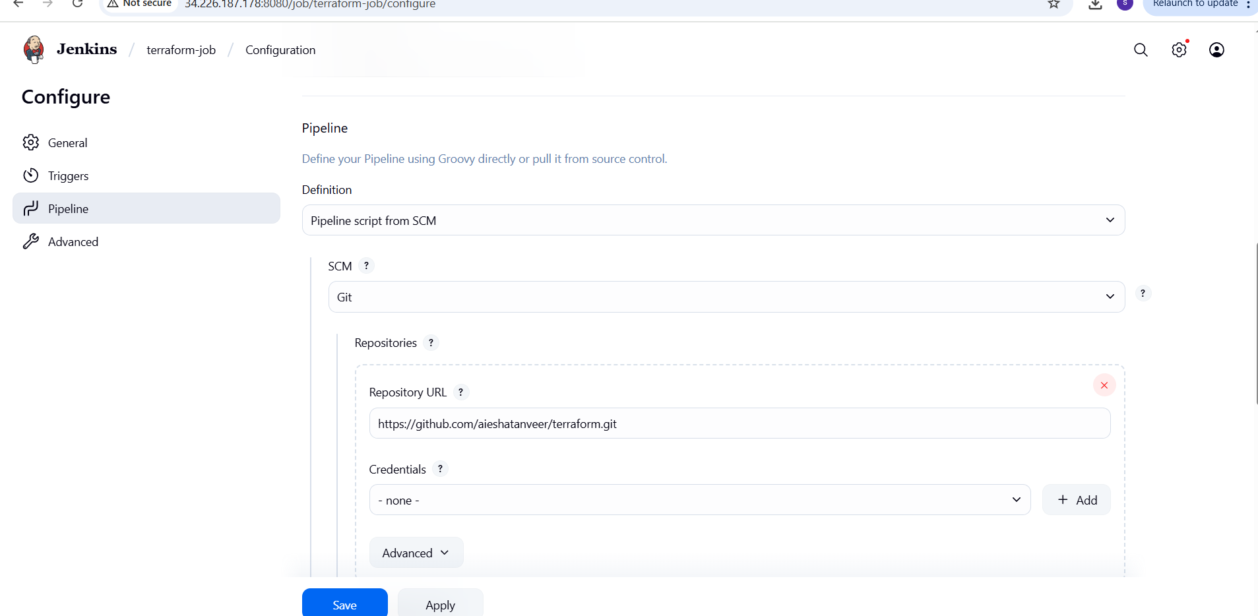
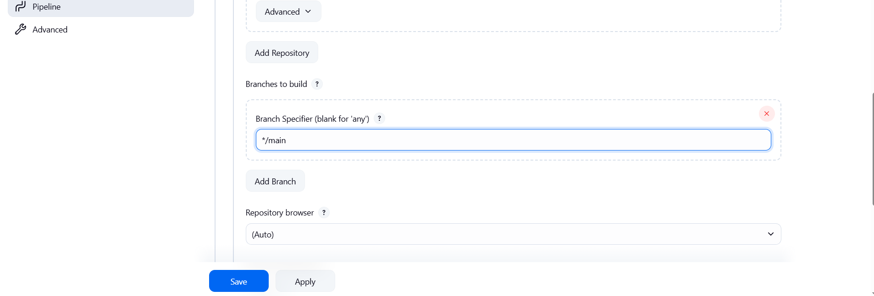
Save and build.
