1.Watch the terraform-02 video.
Completed.
2. Execute all the templates shown in video.
We have destroyed everything to do new executions.
Terraform destroy
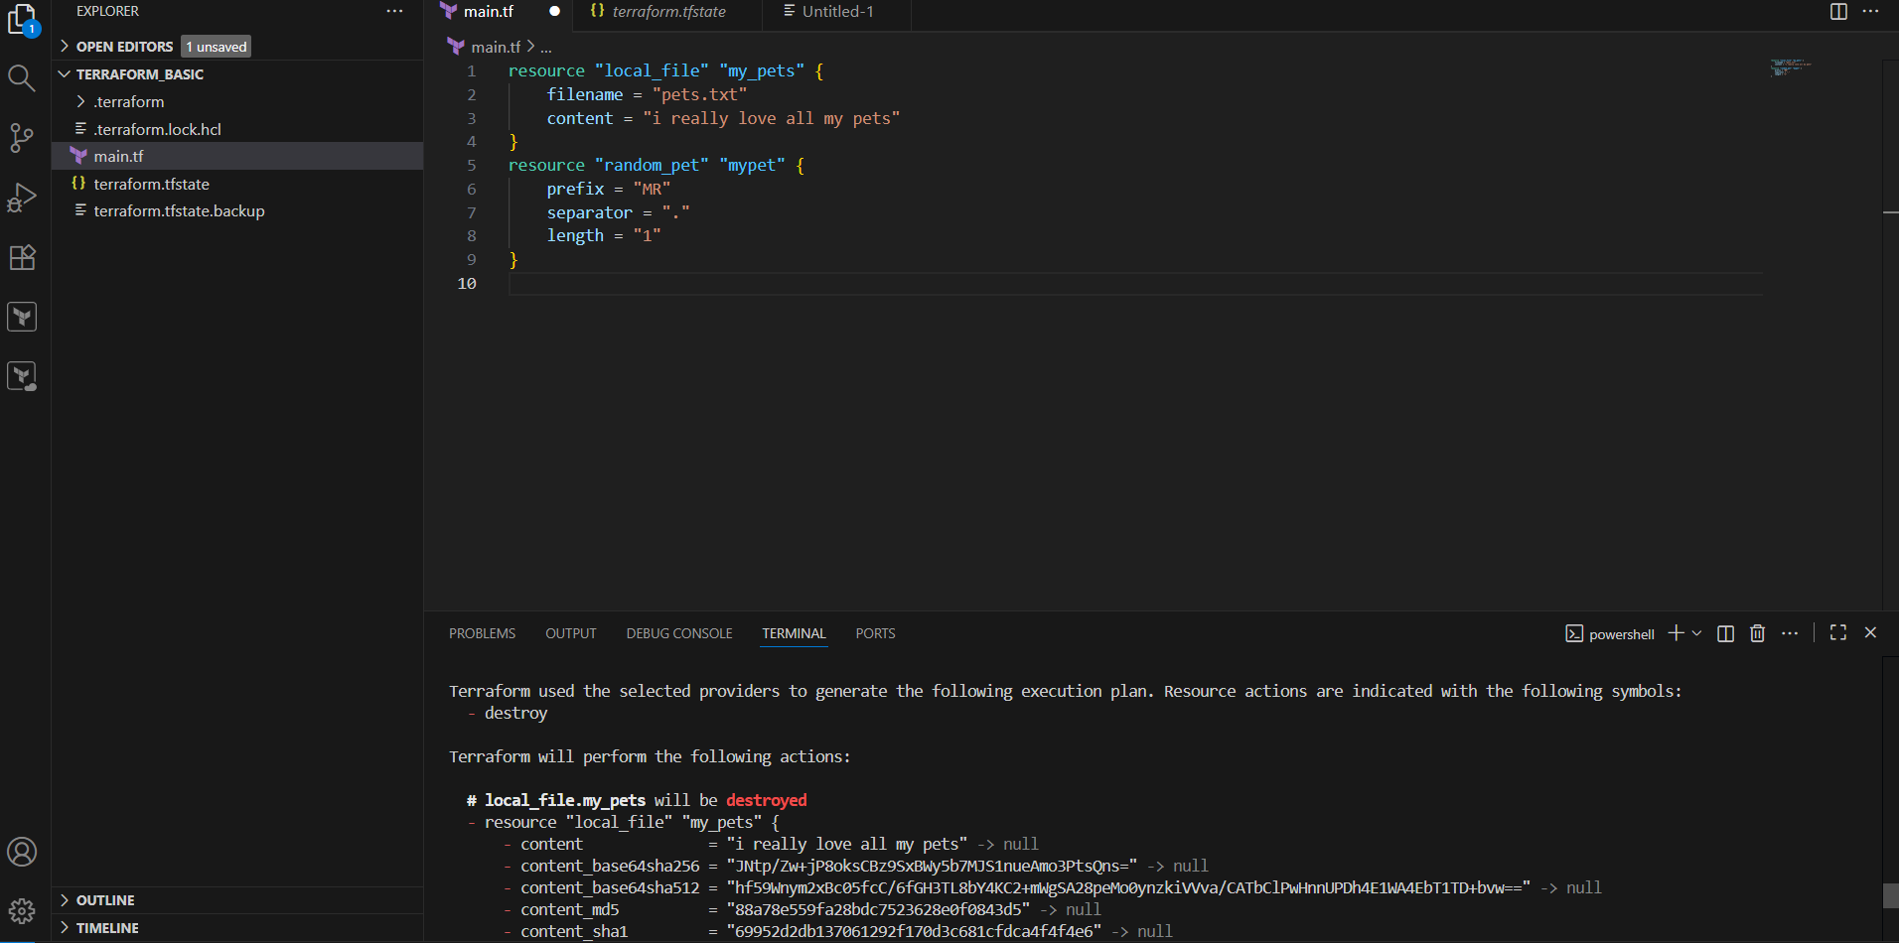
Now we need add resource and give command terraform init
And it will initialize the backend and provide plugin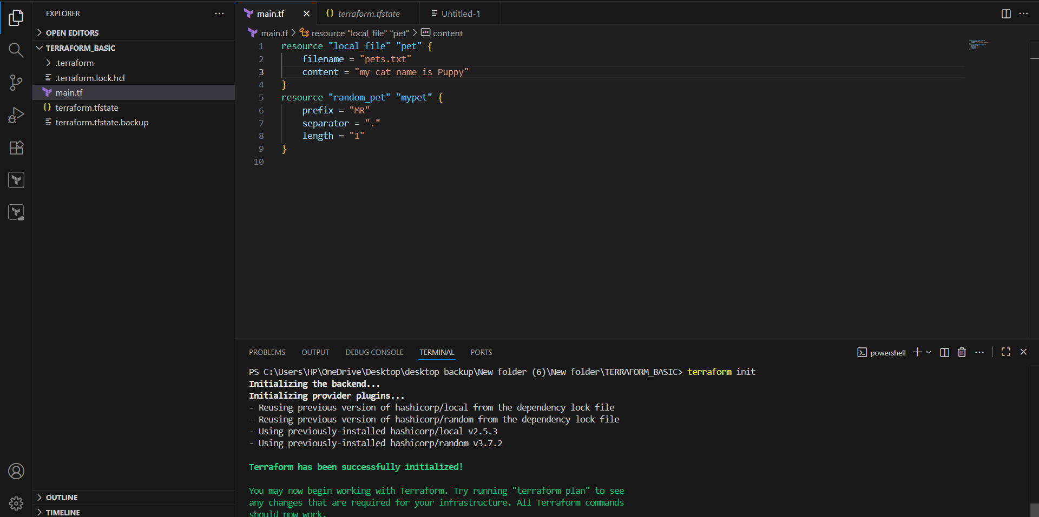
Whenever we execute terraform init command it will create a .terraform directory. And have providers as local and random.
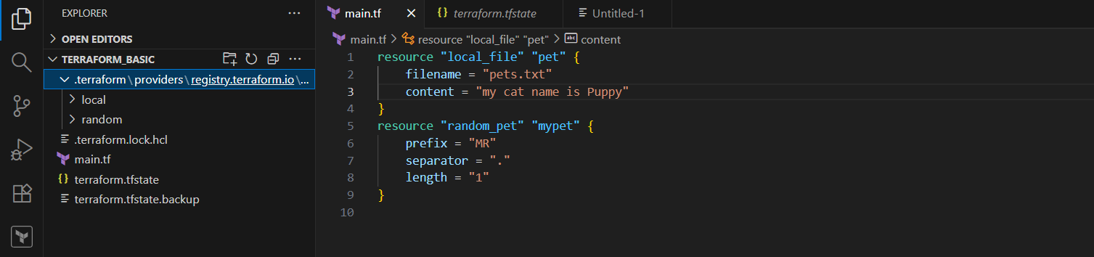
- Whenever we execute terraform apply it will create terraform.tfstate file. It will have complete metadata of our resource file (like which version, what is the file name, file content etc…)
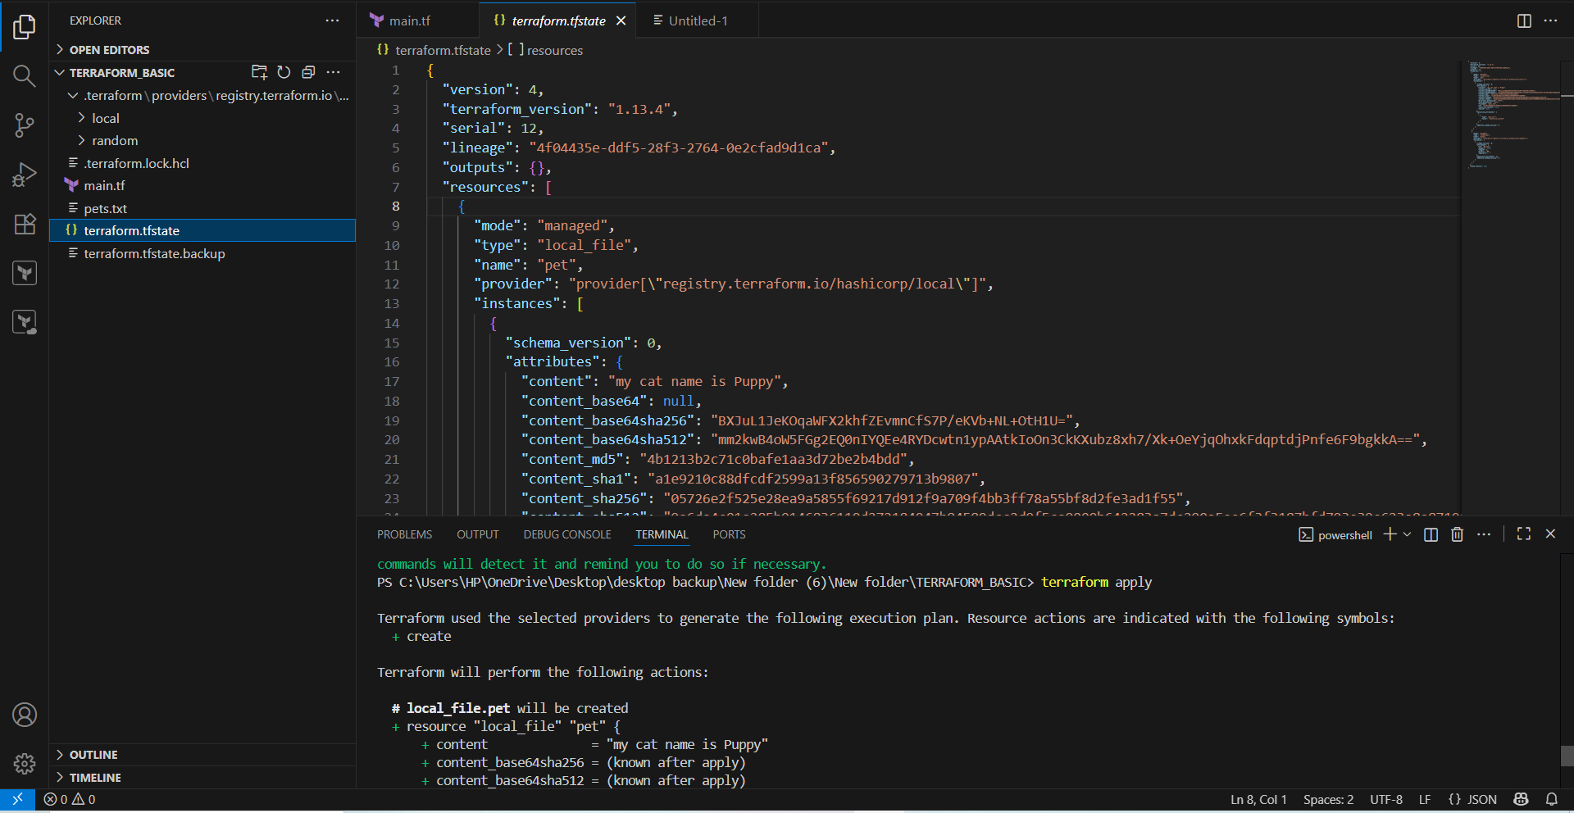
- Now change the name of pet from puppy to Hen and execute terraform apply
From terraform.tfstate the name of the pet change and the content will change.
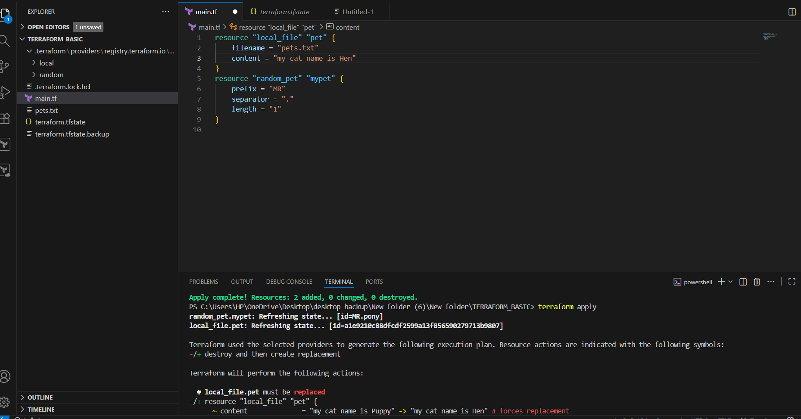
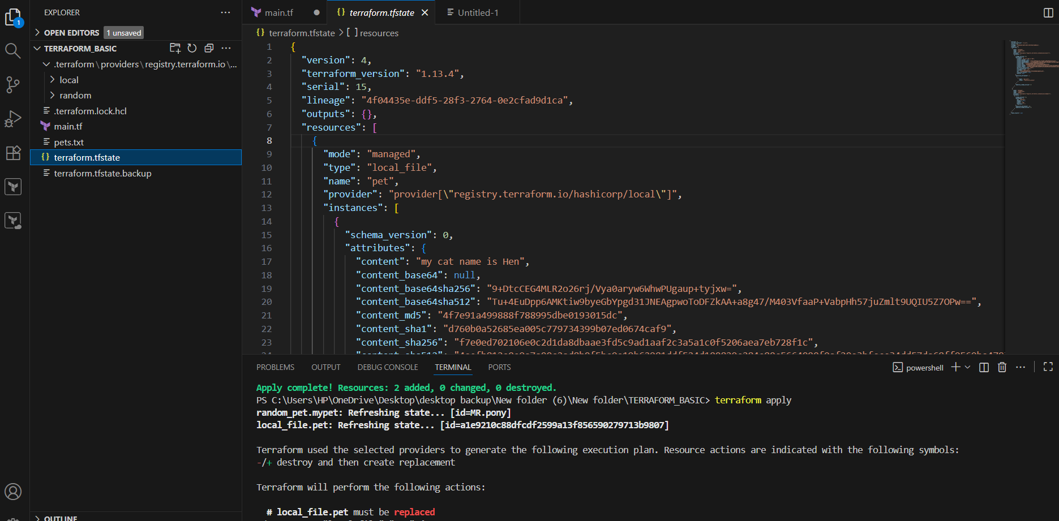
Lifecycle rules:
- We can configure lifecycle rules to our resuce file.
- Terraform will destroy the file before creating a new file by default.
- We can create a file before destruction by using the lifecycle rule.

We can add content as
lifecycle {
prevent_destroy = true
}
We can’t destroy the existing resource when giving terraform apply command
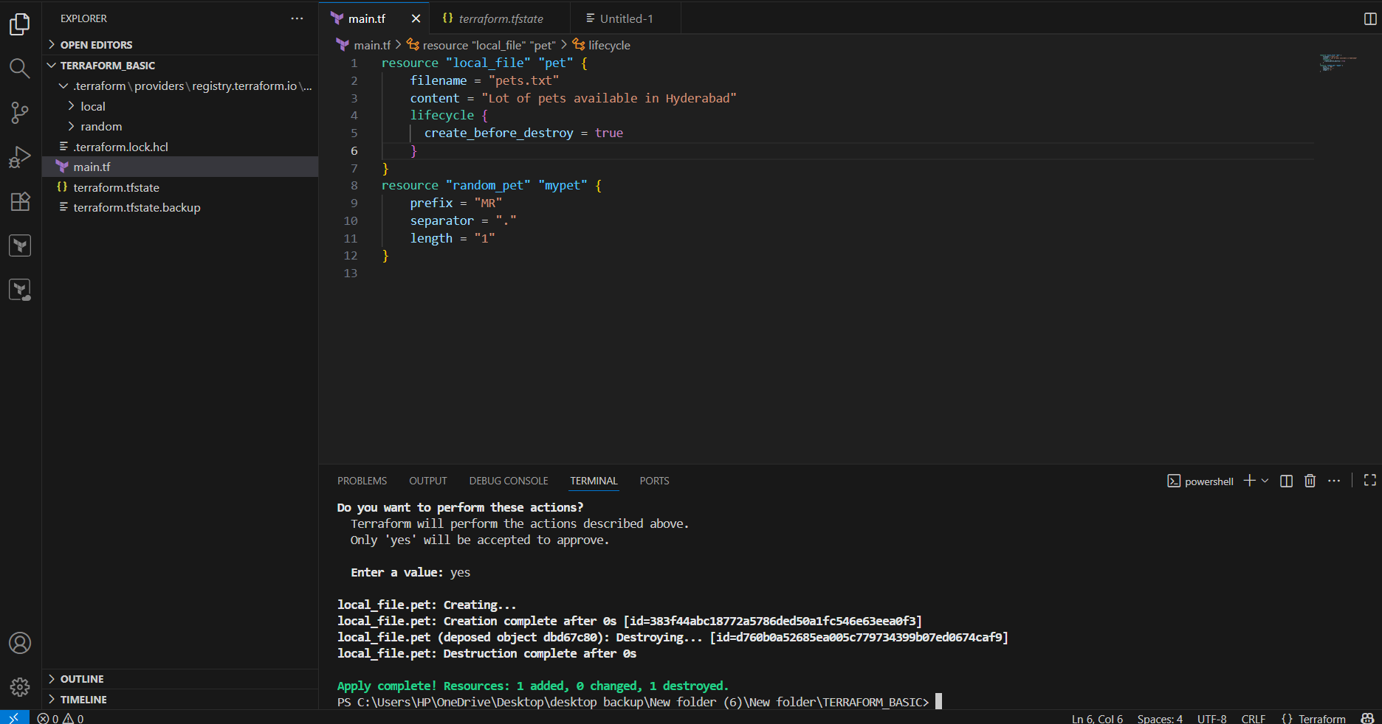
Now add the content as
lifecycle {
prevent_destroy = true
}
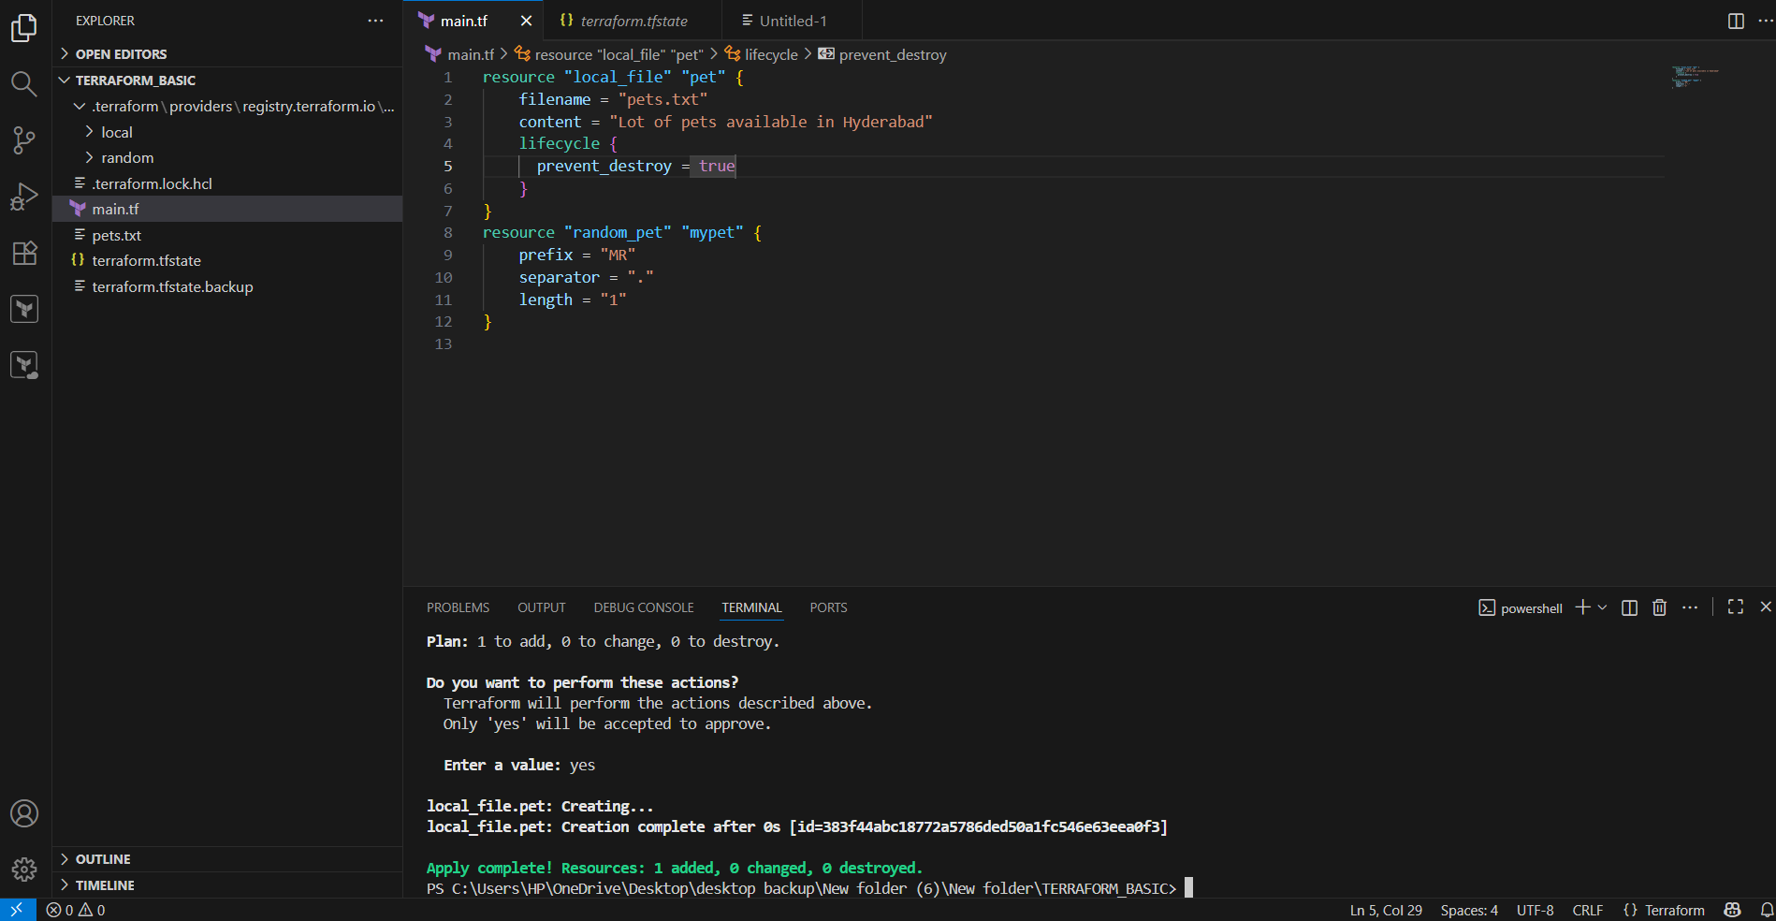
Now add the content as
lifecycle {
ignore_changes = [content]
}
After changing the content , it won’t get any change of content . it will get the previous terraform.tfstate
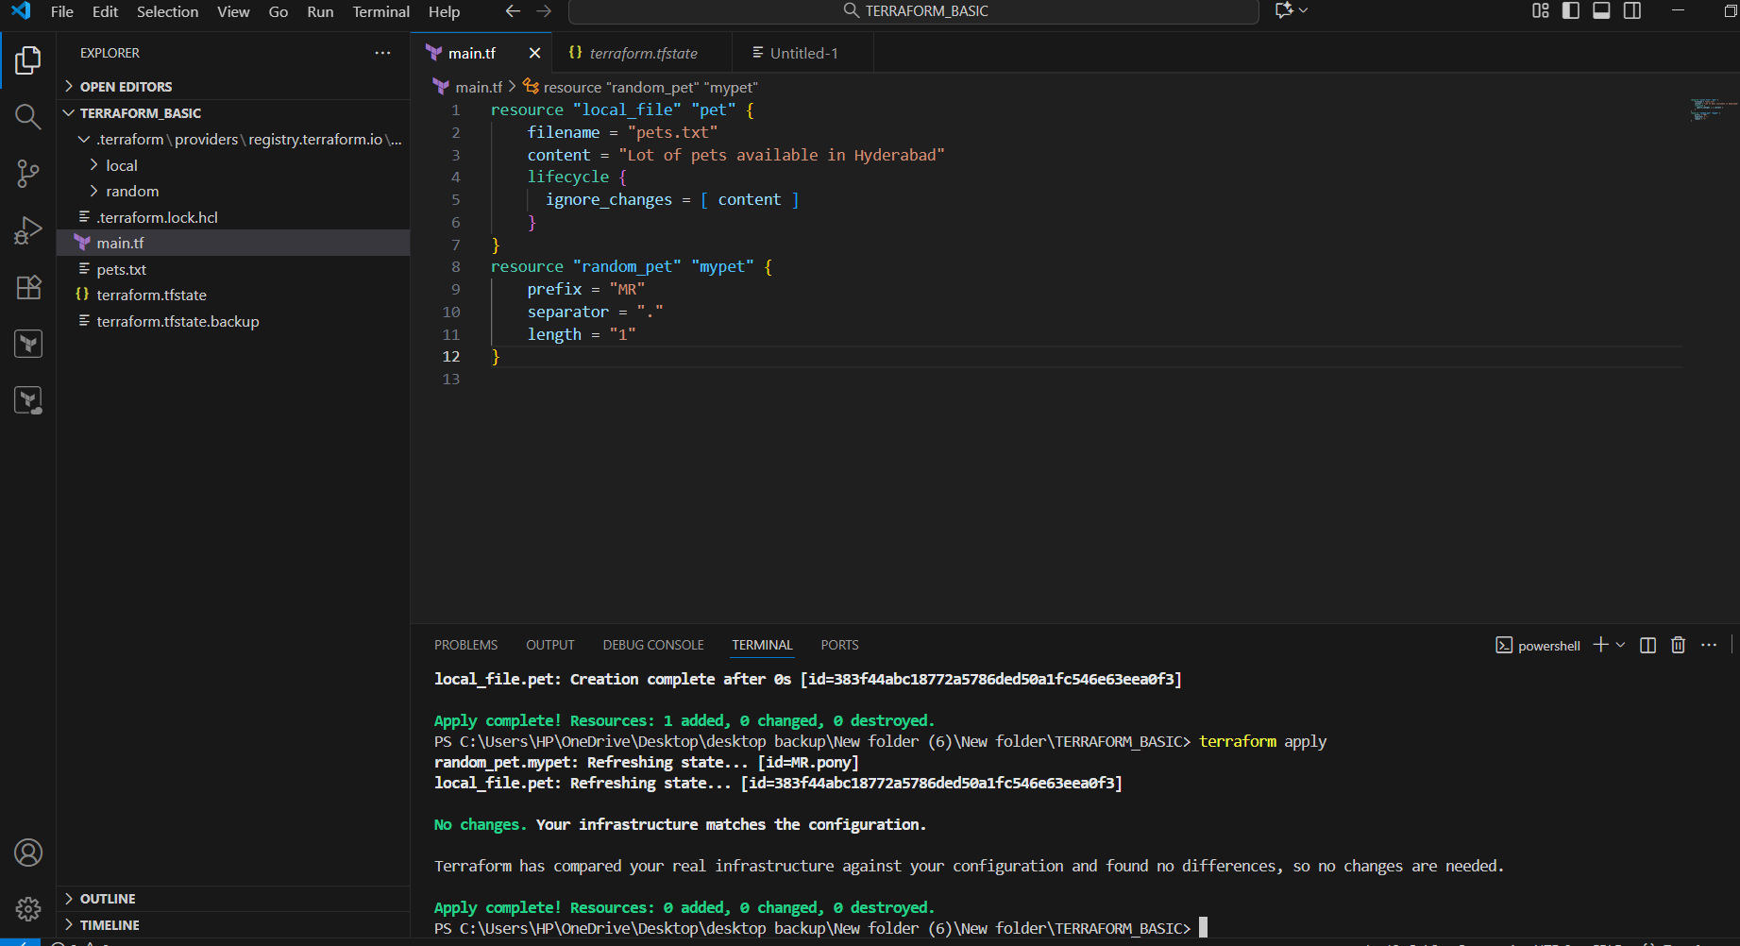
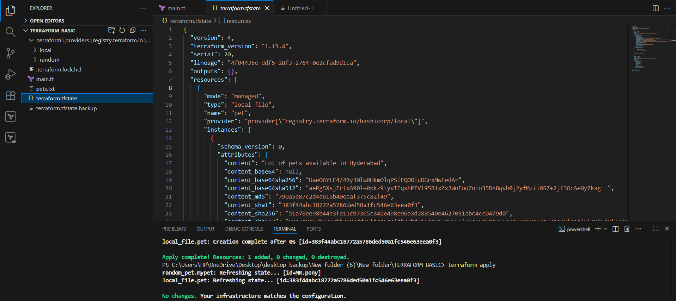
Variables:
main.tf
resource “local_file” “pet”{
filename = var.filename
content = var.content
}
Resource “random_pet” “petname”{
prefix = “MR”
separator = “.”
Length = “1”
}

variable.tf
variable “filename”{
default = “animals.txt”
type = string
}
Variable “content”{
default = “I love cats”
type =string
}
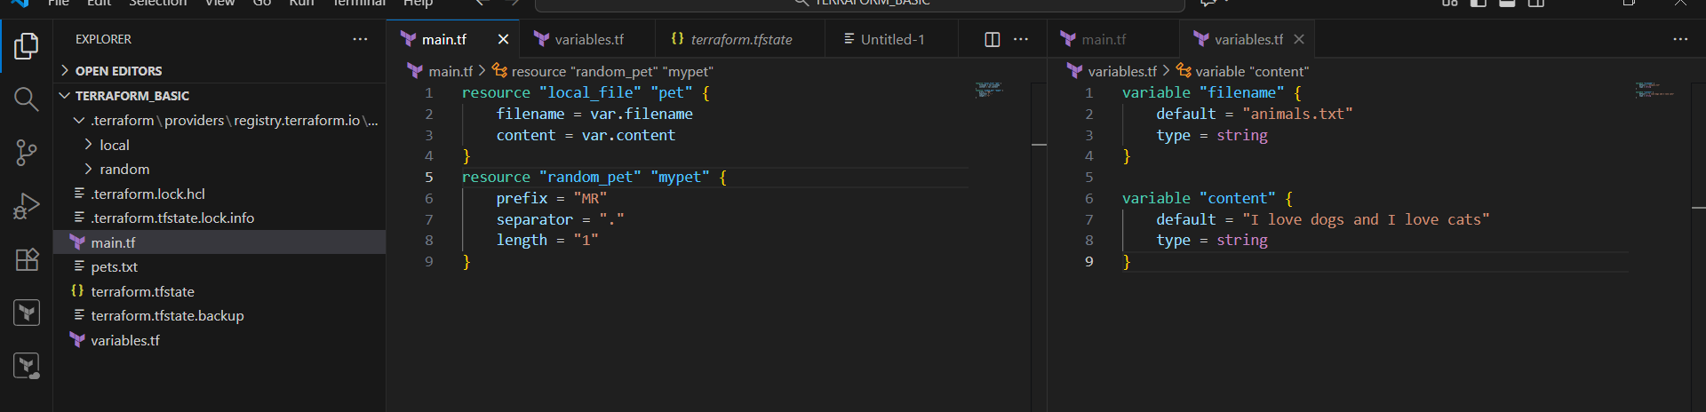
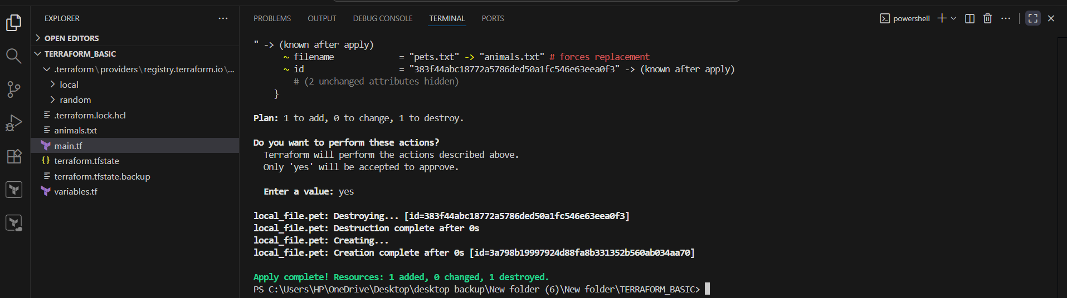
Taking user input:
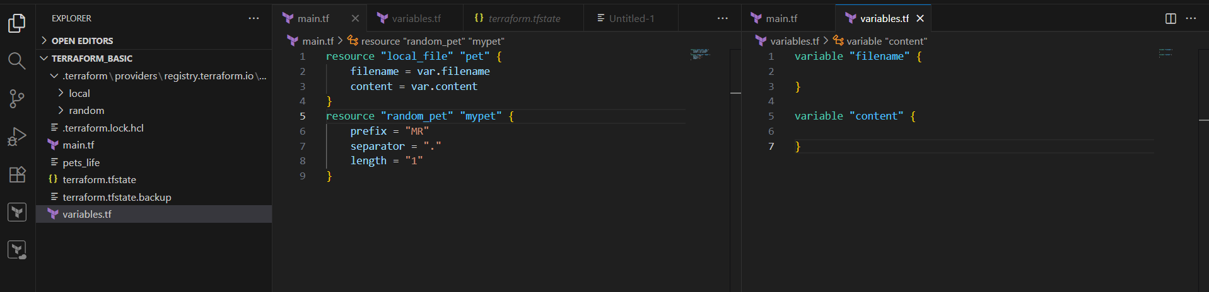
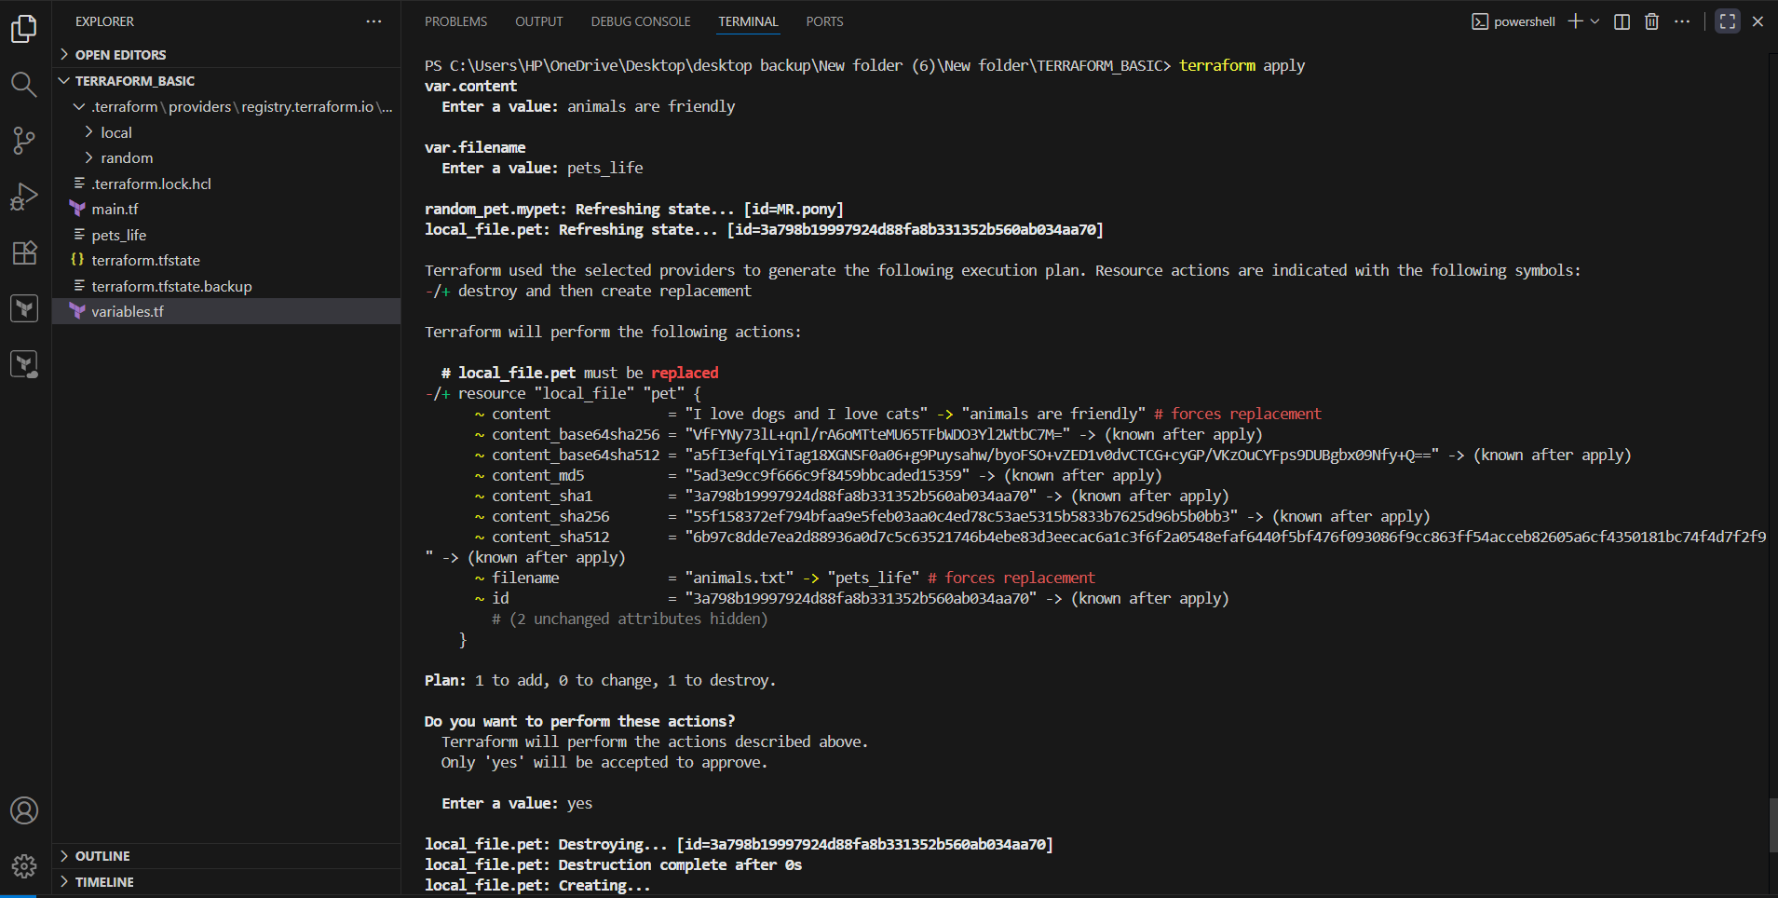Passing values using command:
Terraform apply -var “filename = pets.txt” -var “content = some of the pets are cats,chicks”
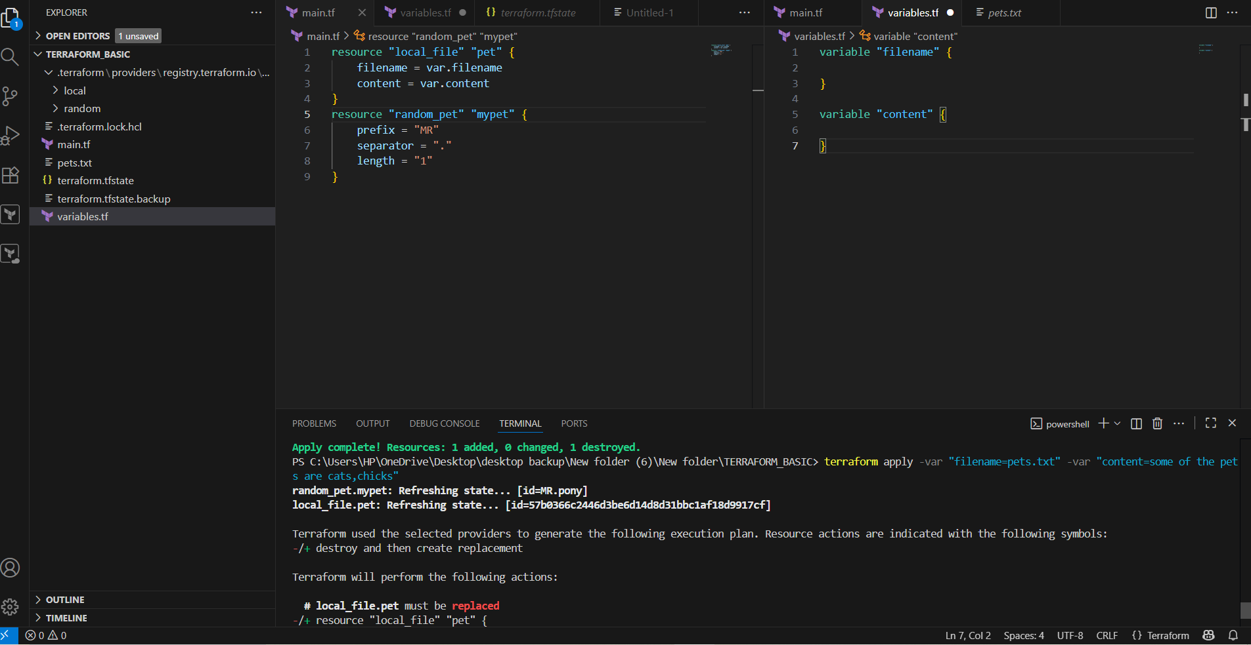check in pets.txt , we get
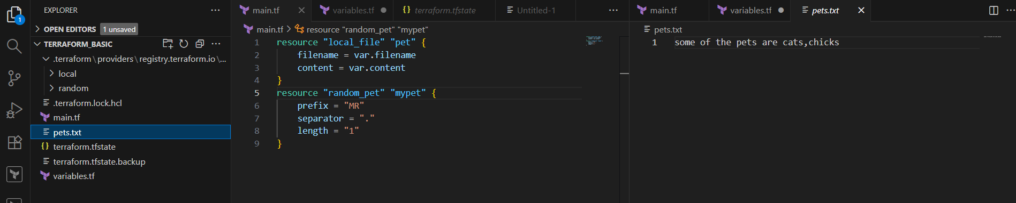
Terraform apply -var “filename=animals” -var “content=earth running with huge no.of animals”
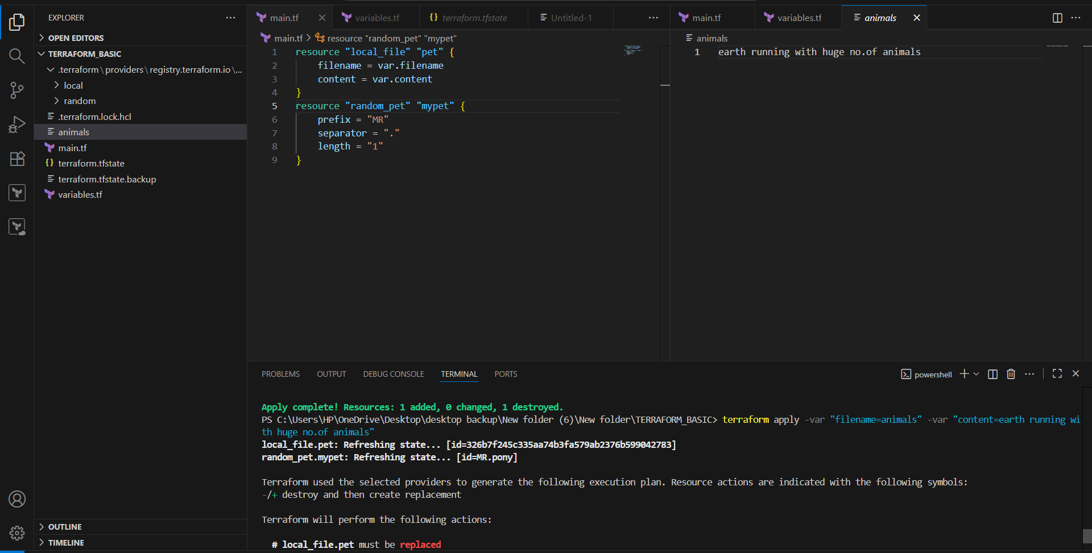

3. Integrate terraform in Jenkins using terraform plugin.
* Install terraform on Jenkins
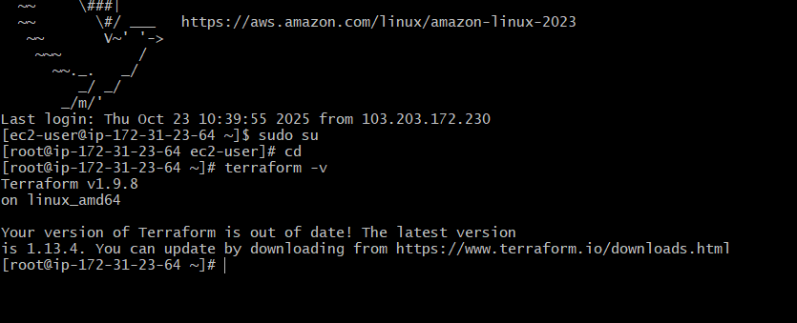
- Install terraform plugin in Jenkins
Go to manage Jenkins → plugins → available plugins
Search for “terraform plugins”.
Install it.
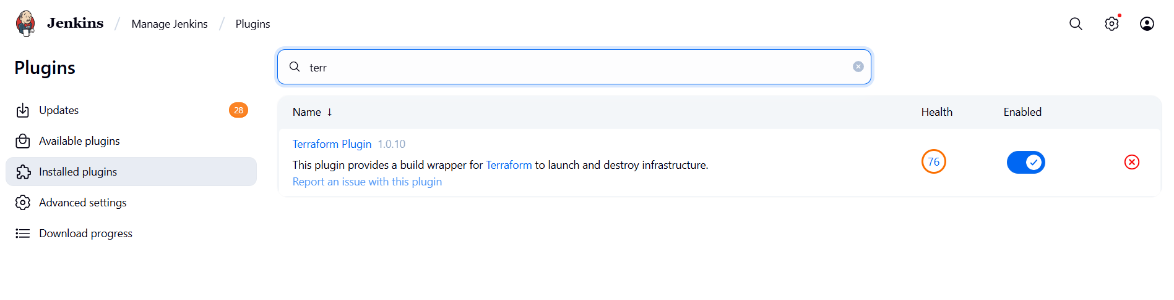
- Configure terraform in Jenkins
Go to manage Jenkins → global tool configuration
Go to terraform section → add terraform installation → give name: terraform-1.8.5
and path if manually installed.
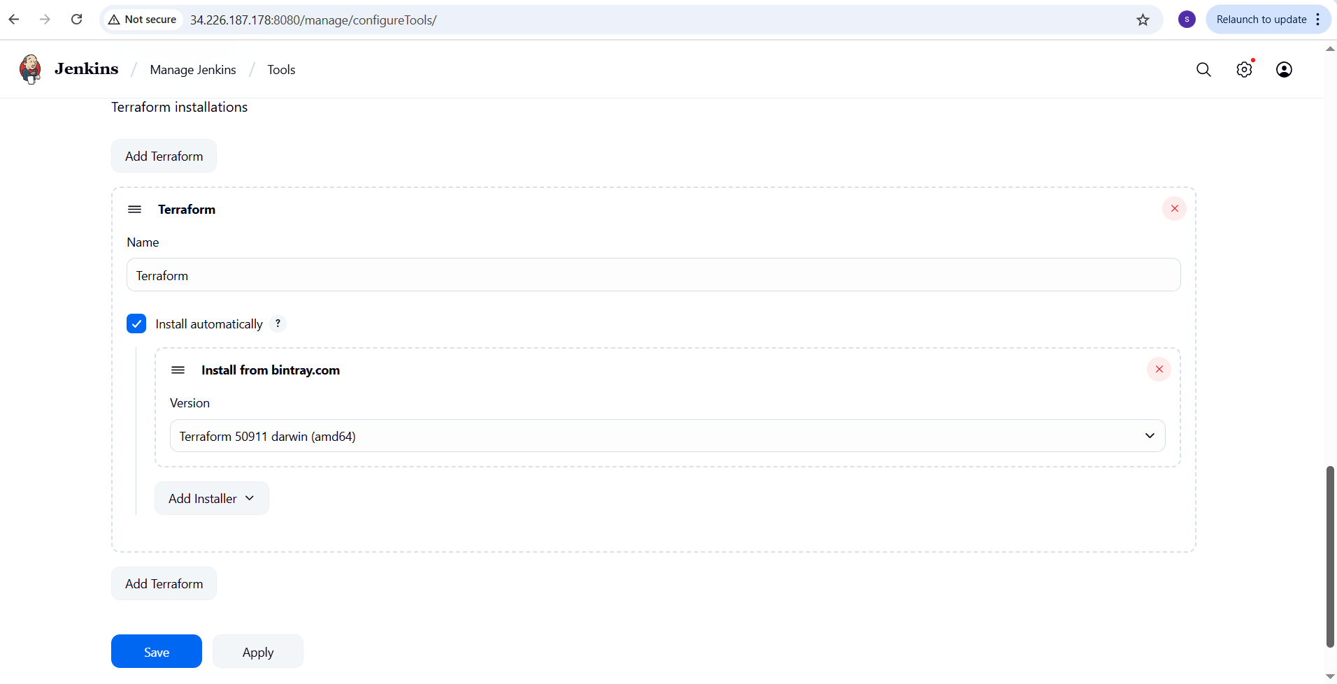
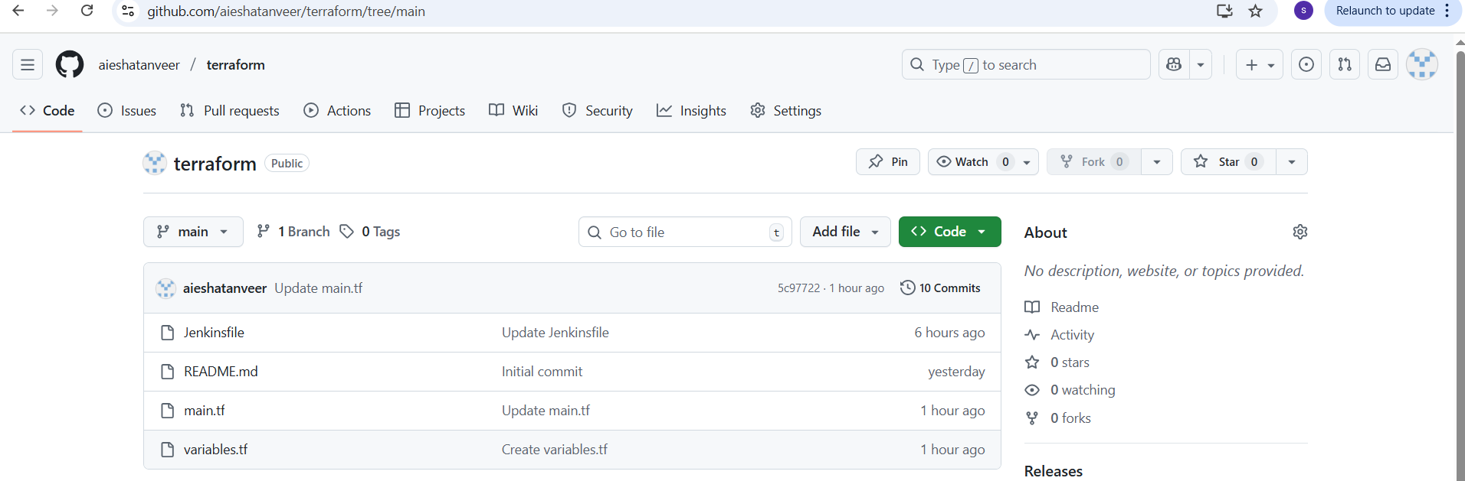main.tf 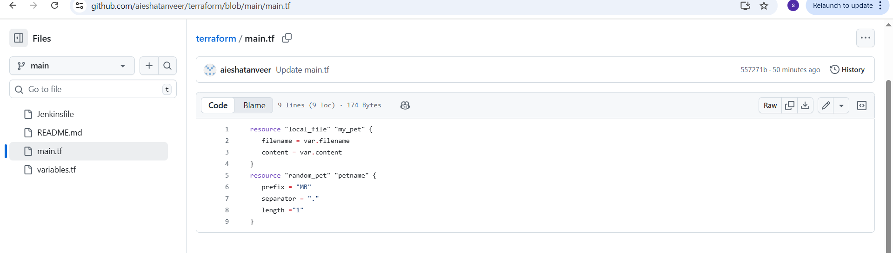variables.tf
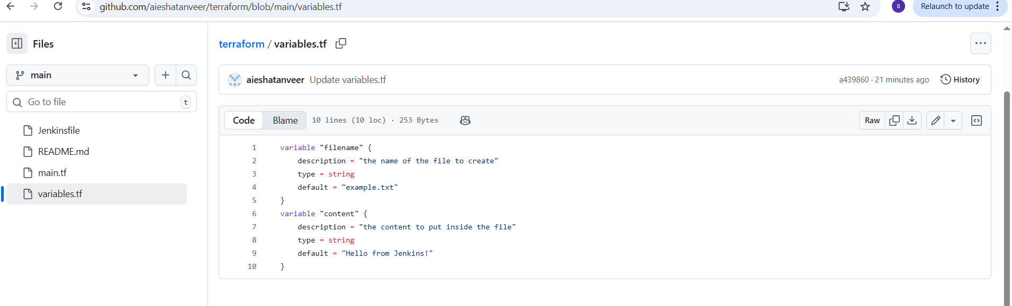

Jenkinsfile:
pipeline {
agent any

stages {
stage('checkout code') {
steps {
git url: 'https://github.com/aieshatanveer/terraform.git', branch: 'main'
}
}

stage('Init') {
steps {
sh 'terraform init'
}
}

stage('Validate') {
steps {
sh 'terraform validate'
}
}

stage (plan') {
steps {
sh 'terraform plan'
}
}

stage ('Apply') {
steps {
sh 'terraform apply -auto-approve’
}
}
}
}

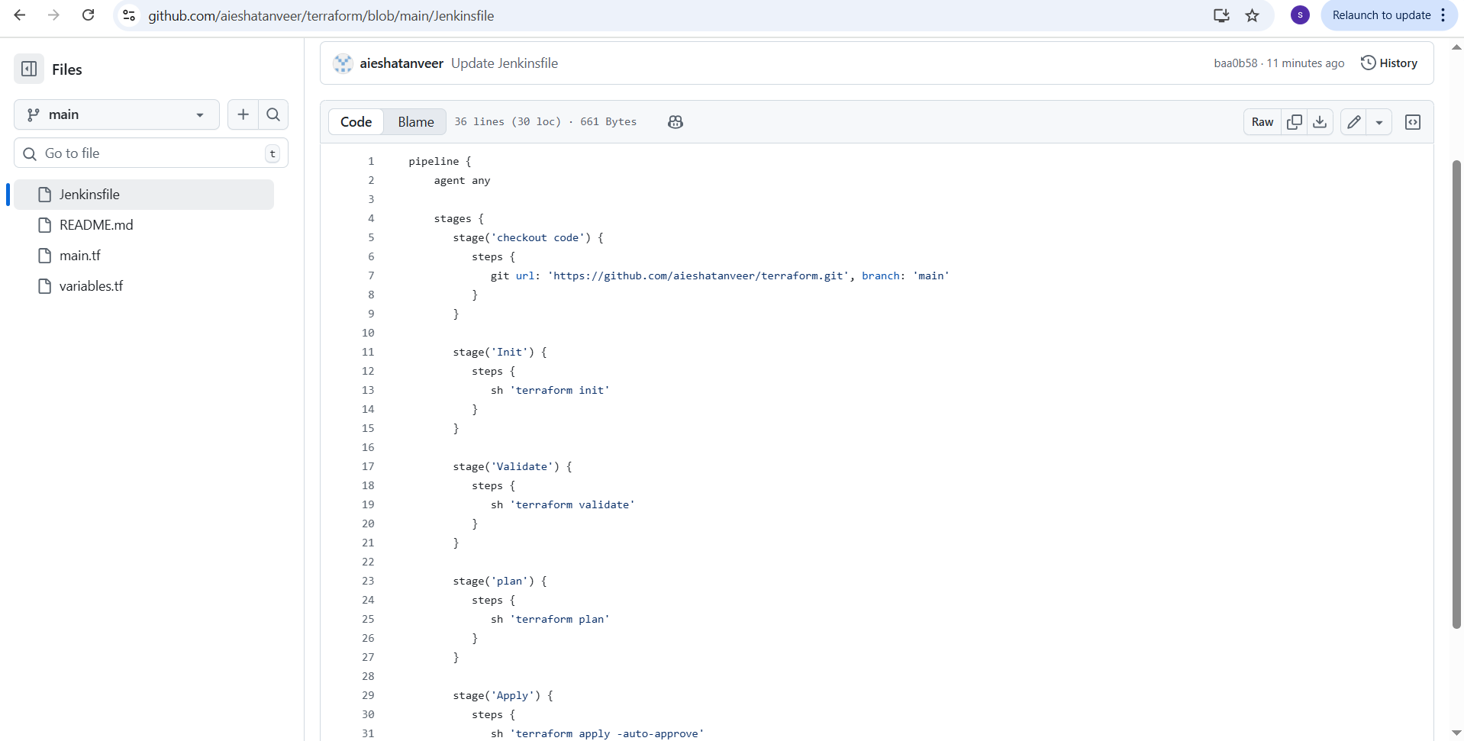
Go to Jenkins → build the job
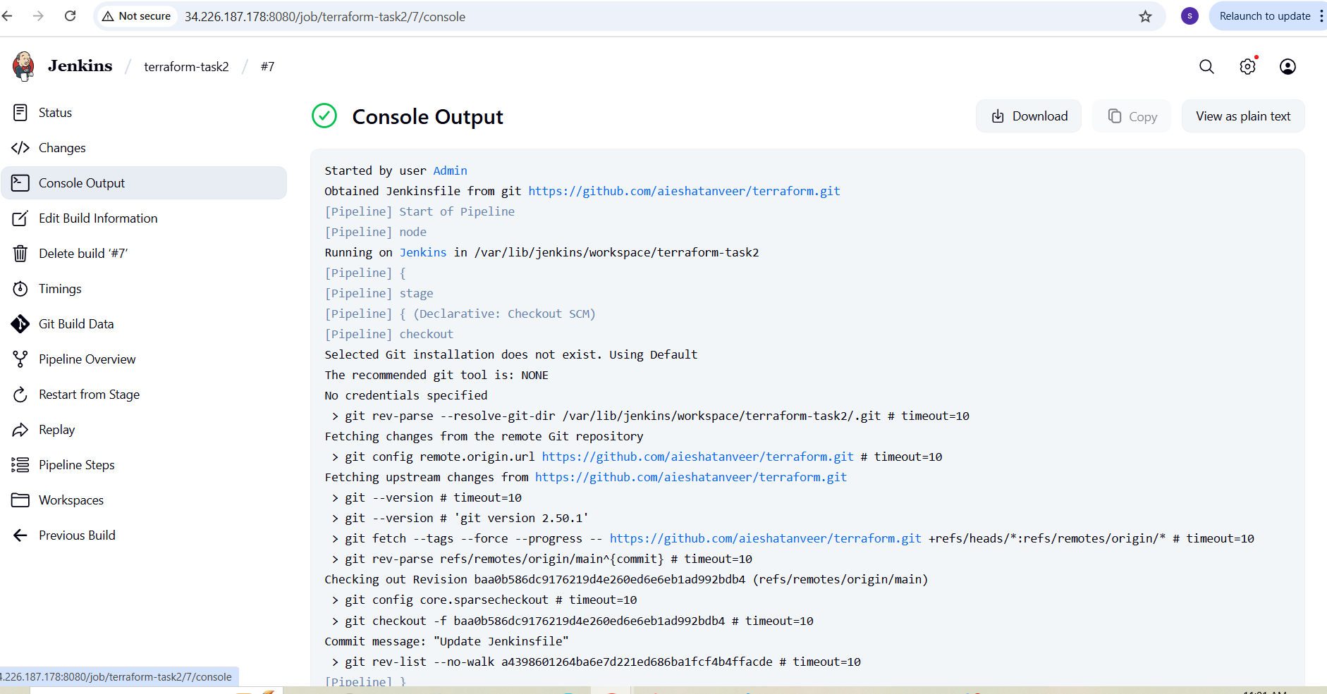
Go to Jenkins instance and check
Cd var/lib/Jenkins/workspace
