- Watch the terraform-03 video.
Completed.
- Execute the script shown in the video.
Using variables:
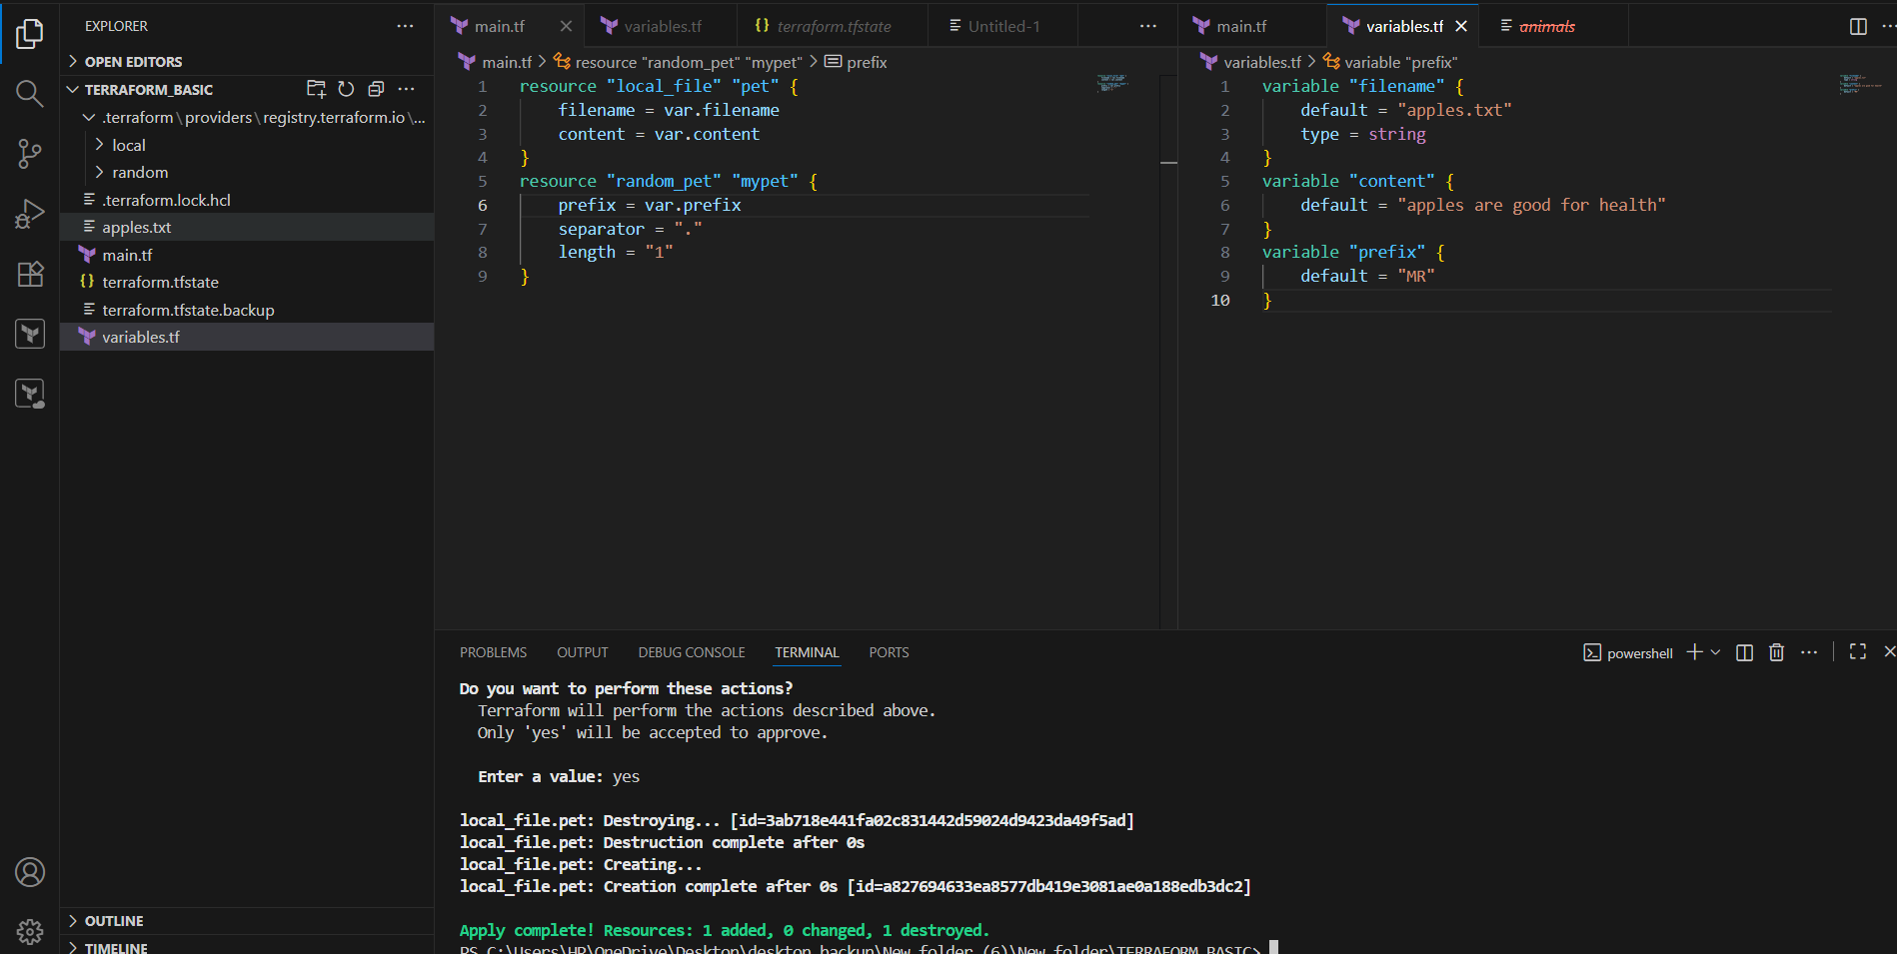
When we apply terraform apply the variables send parameters and required apples.txt is created.
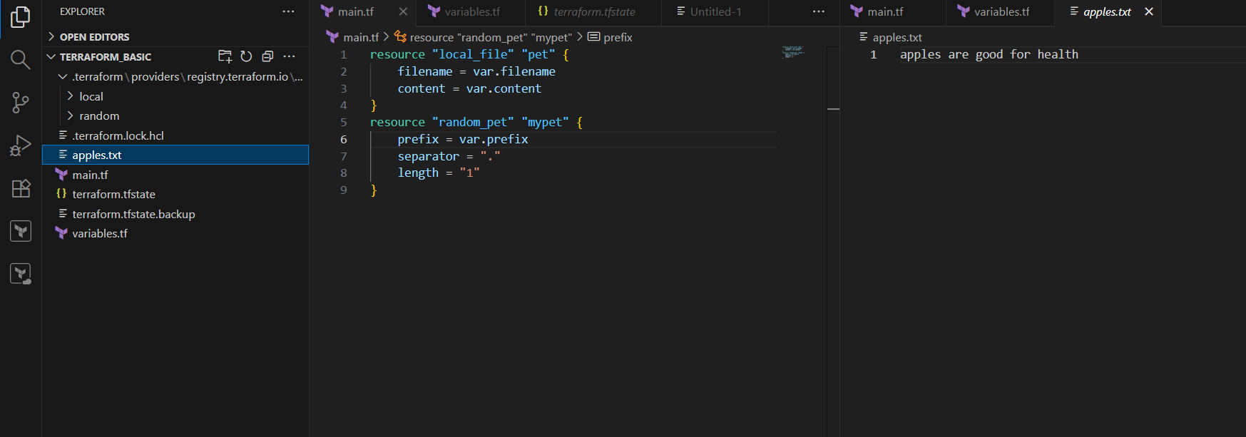
Interactive way for passing variables:
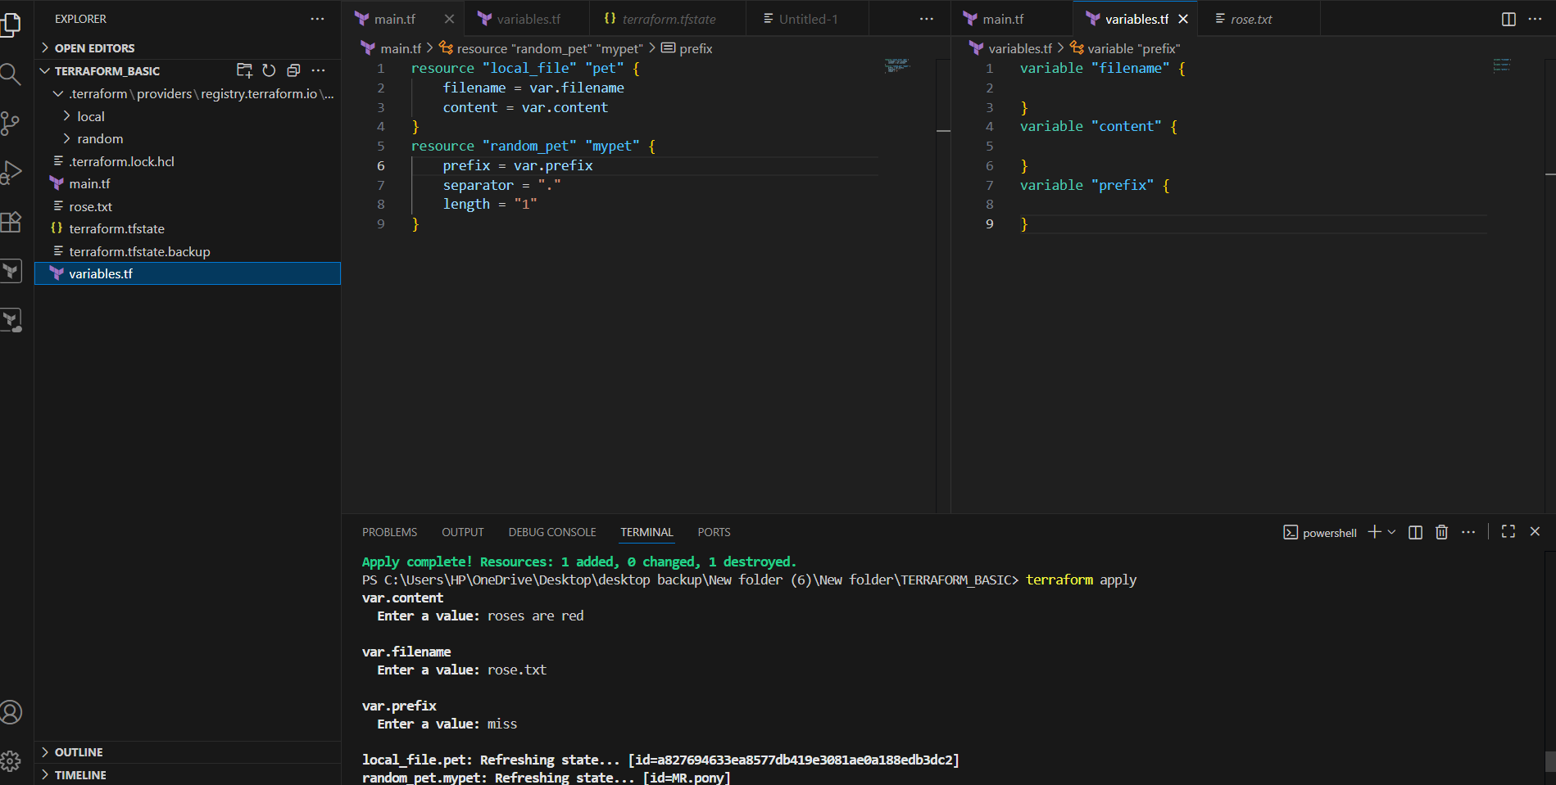
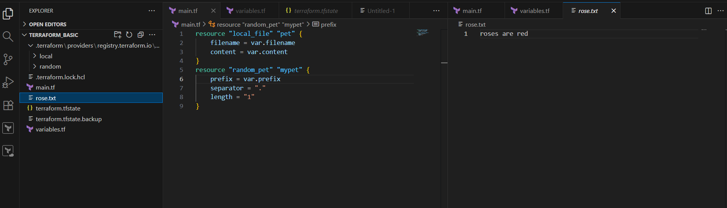
Command line flags:
Terraform apply -var “filename=cherry.txt” -var “content=cherries are good -var “prefix=Mr”
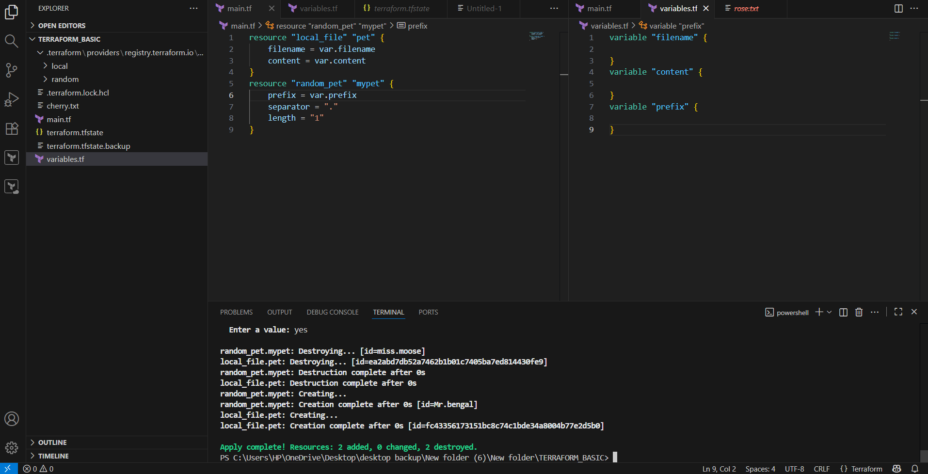
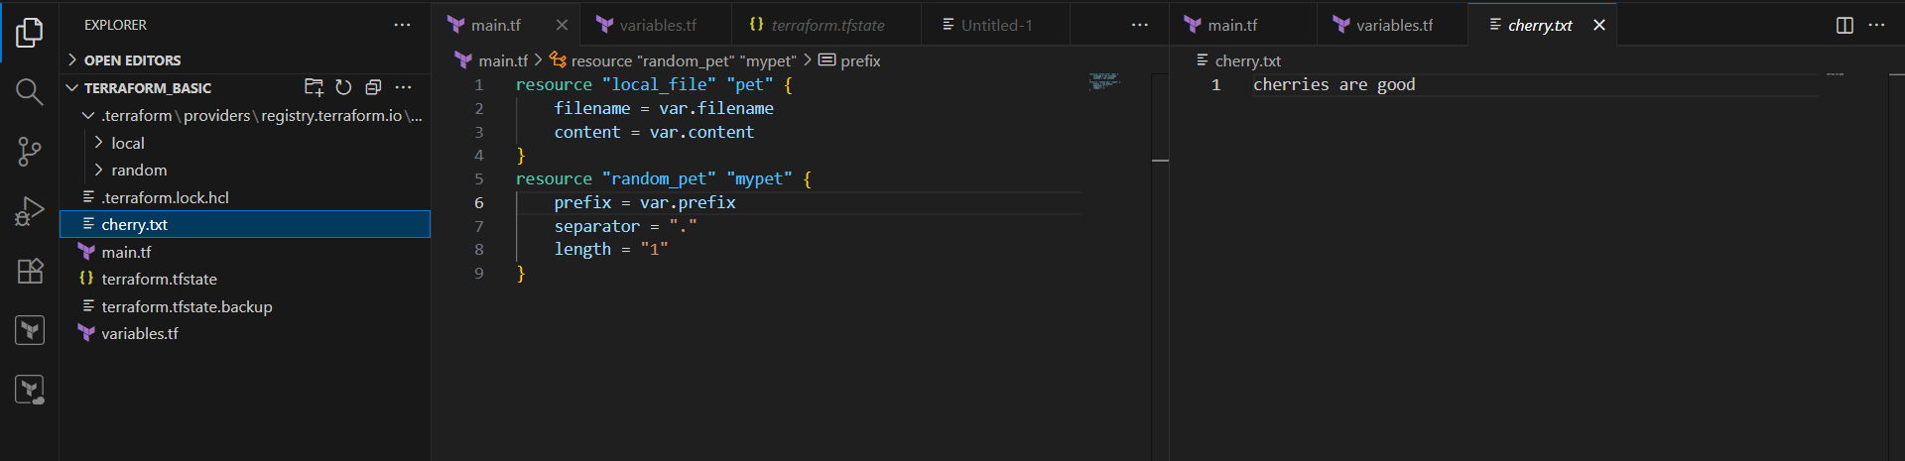
Environment variables:
Set-Item -path env:TF_VAR_filename -value “apple.txt”
Set-Item -path env:TF_VAR_content -value “royal Fuji is one type of apple”
Set-Item -path env:TF_VAR_prefix -value “Mr”
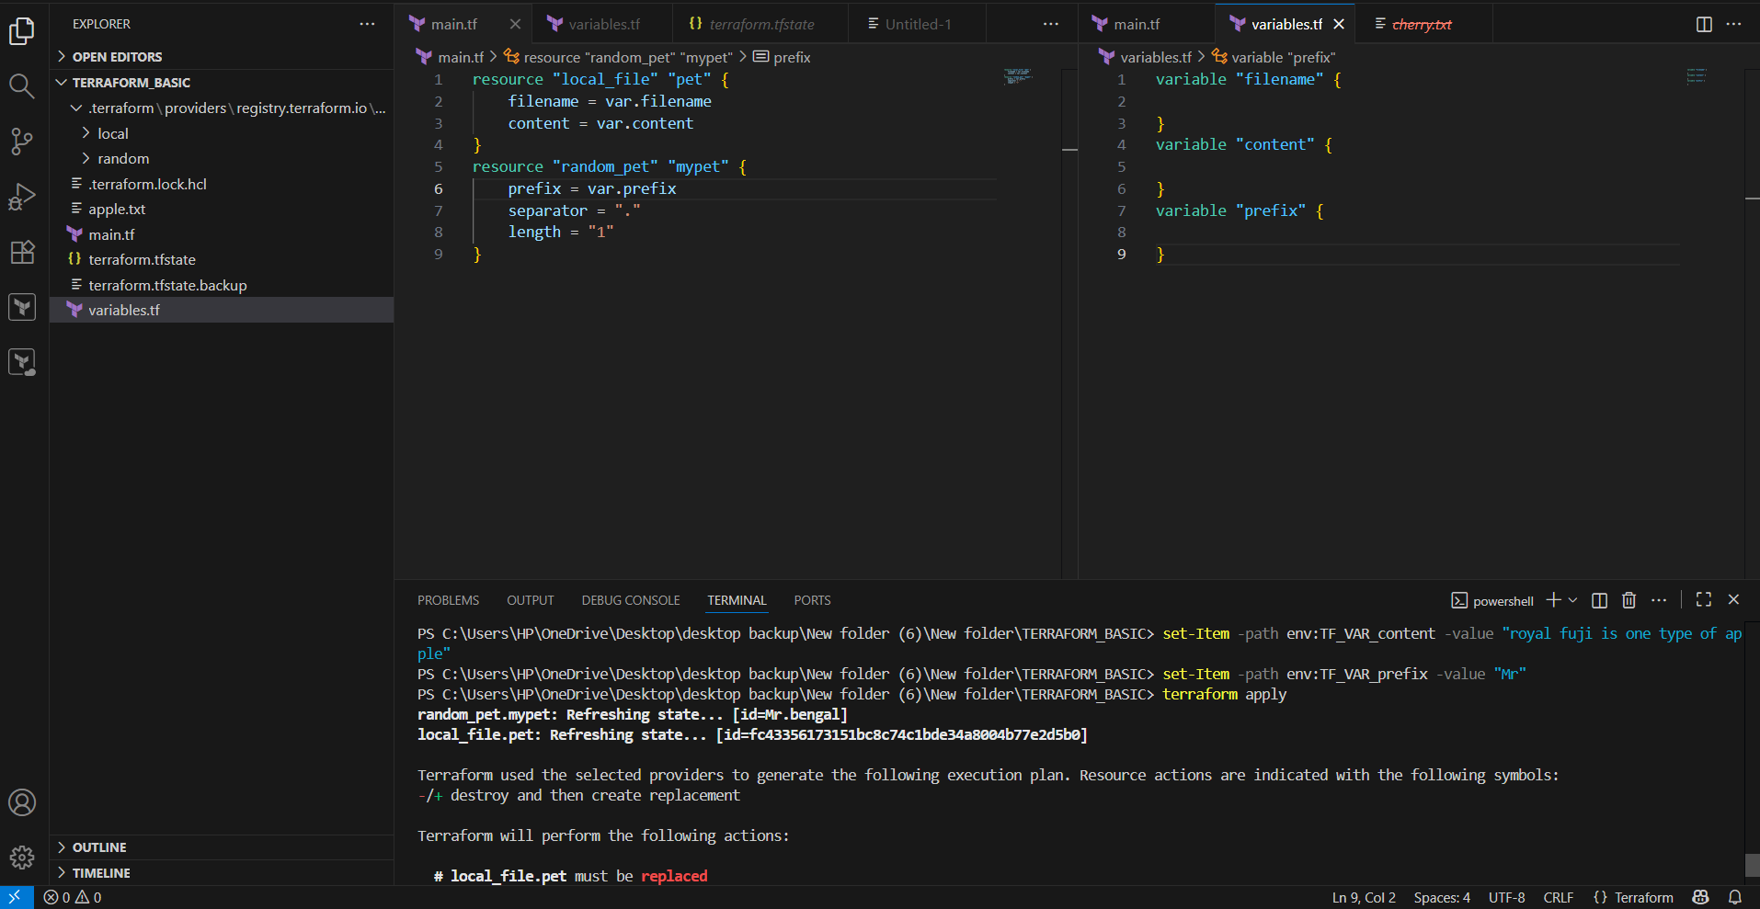
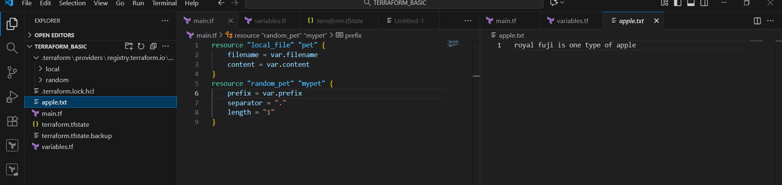
Resource attributr (Implicit behaviour):
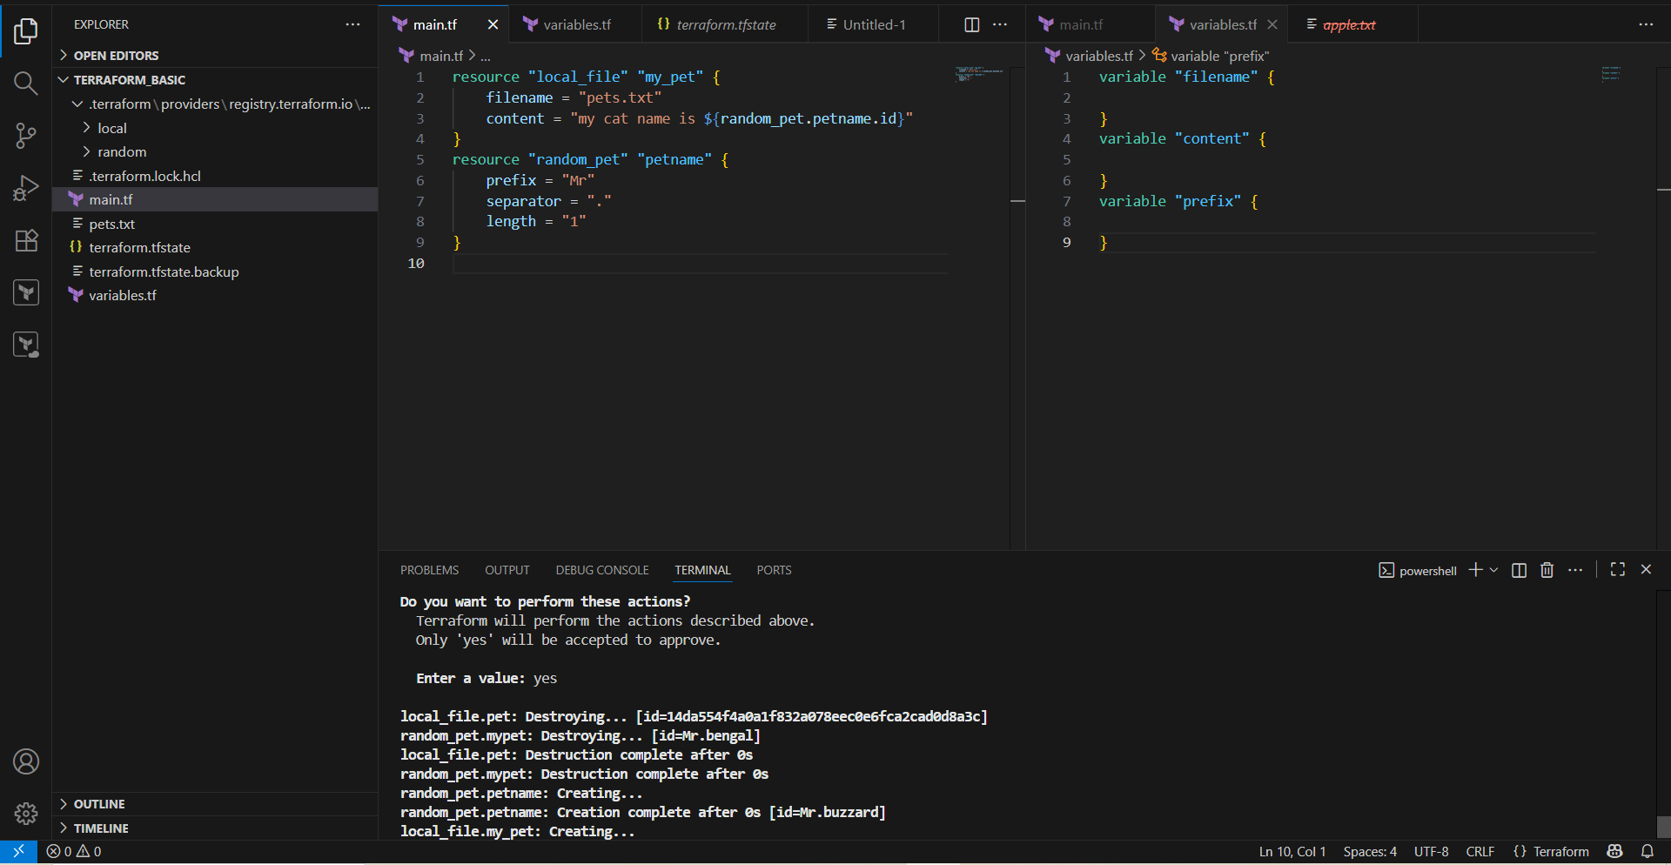
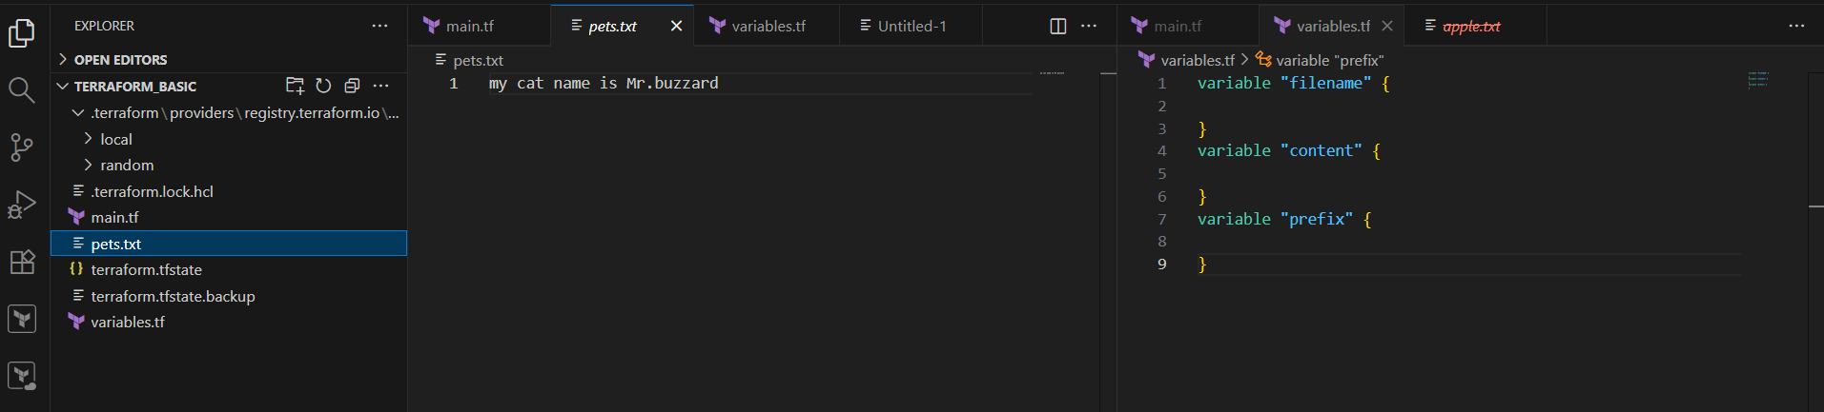
State file locking:
No multiple users can execute terraform in same template at the same time.
- Integrate Terraform in Jenkins using the Terraform plugin.
To Install terraform plugin in Jenkins ,
Go to Jenkins → Manage Jenkins → Tools → go to terraform installations
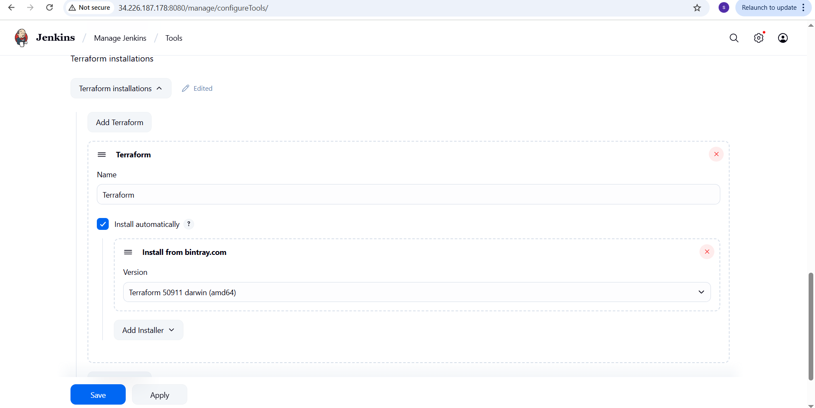In my repository https://github.com/aieshatanveer/terraform.git
Added main.tf ,variables.tf, Terraform.tfvars, Jenkinsfile
main.tf
resource "local_file" "my_pet" {
filename = var.filename
content = var.content
}
resource "random_pet" "petname" {
prefix = "MR"
separator = "."
length ="1"
}
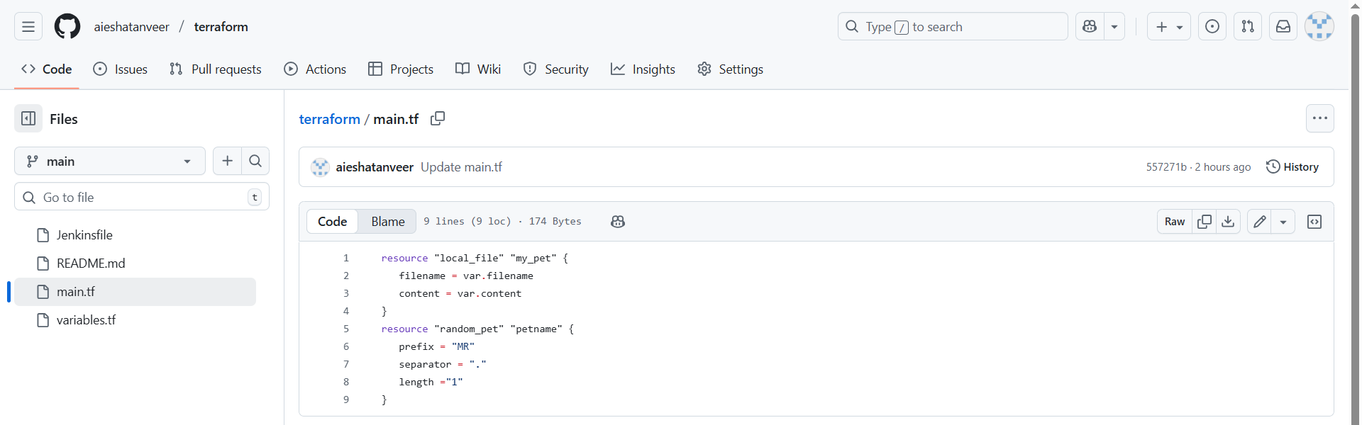variables.tf
variable "filename" {
description = "the name of the file to create"
type = string
default = "example.txt"
}
variable "content" {
description = "the content to put inside the file"
type = string
default = "Hello from Jenkins!"
}
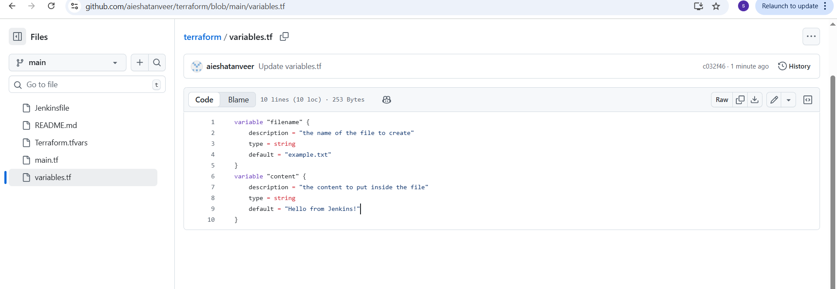 Terraform.tfvars
filename = "apple.txt"
content = "royal fuji is one type of apple"
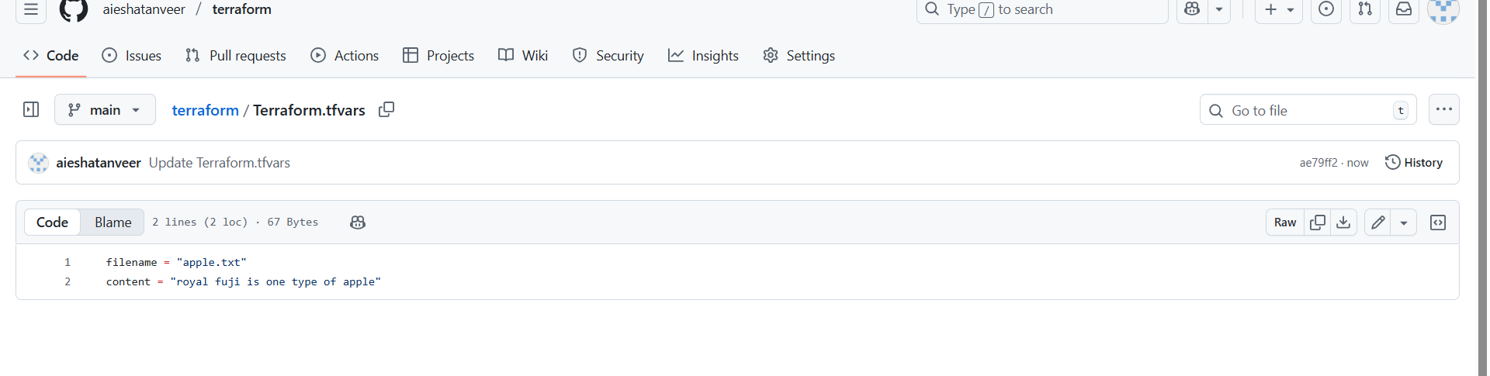Jenkinsfile
pipeline {
agent any

stages {
stage('checkout code') {
steps {
git url: 'https://github.com/aieshatanveer/terraform.git', branch: 'main'
}
}

stage('Init') {
steps {
sh 'terraform init'
}
}

stage('validate') {
steps {
sh 'terraform validate'
}
}

stage('terraform plan') {
steps {
sh 'terraform plan'
}
}

stage('terraform Apply') {
steps {
sh 'terraform apply -auto-approve'
}
}
}
}
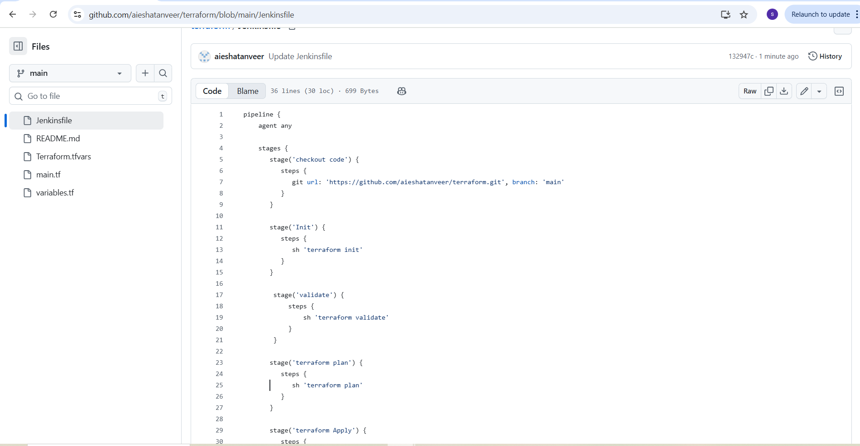
In Jenkins create job (terraform-3) pipeline type
Go to Jenkins job → configure → In pipeline section: select pipeline script from SCM
Add github URL &Branch : */main
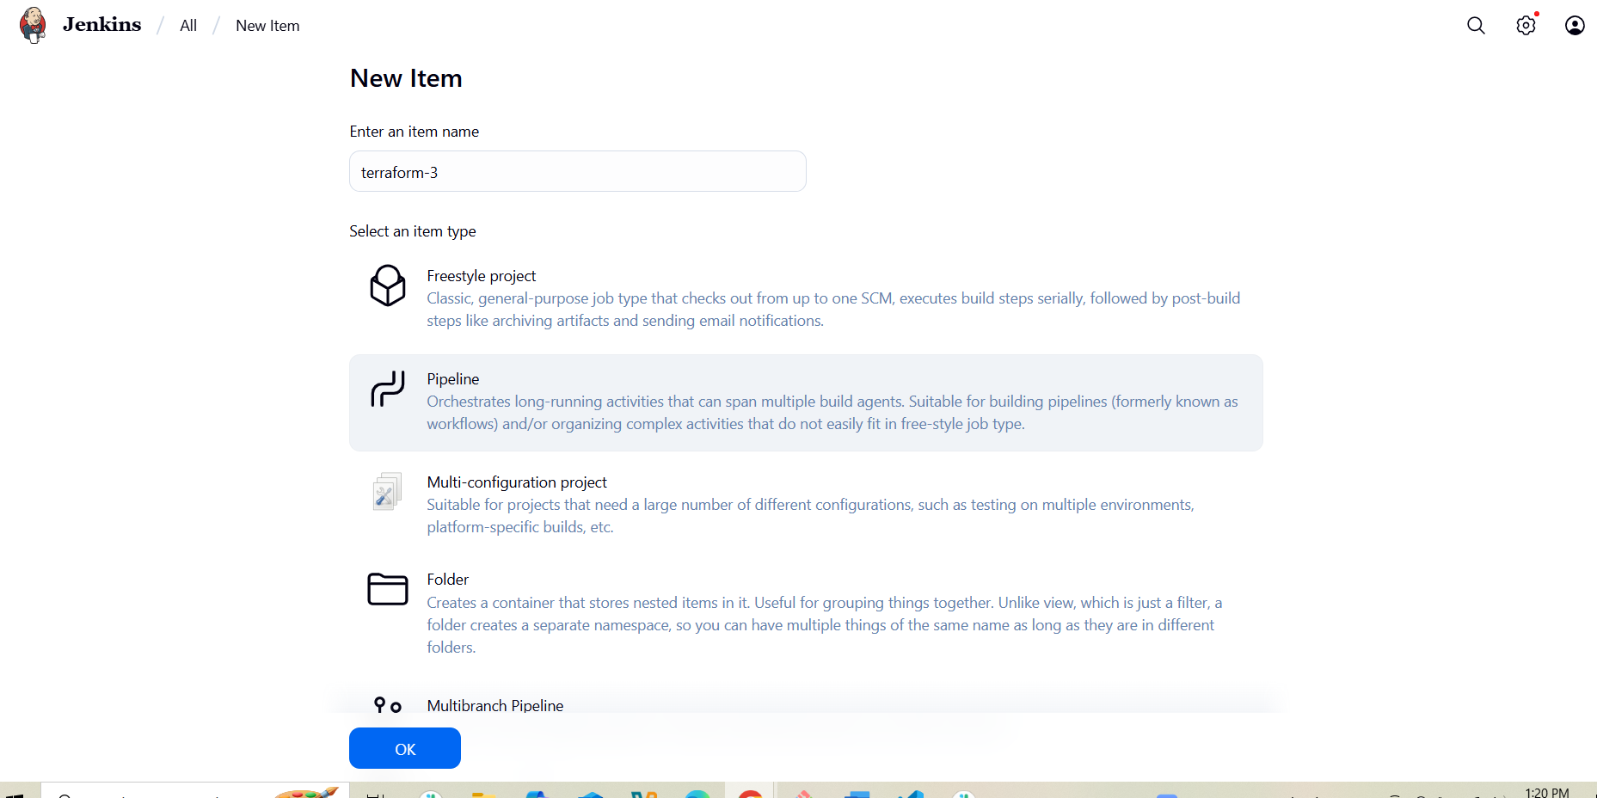
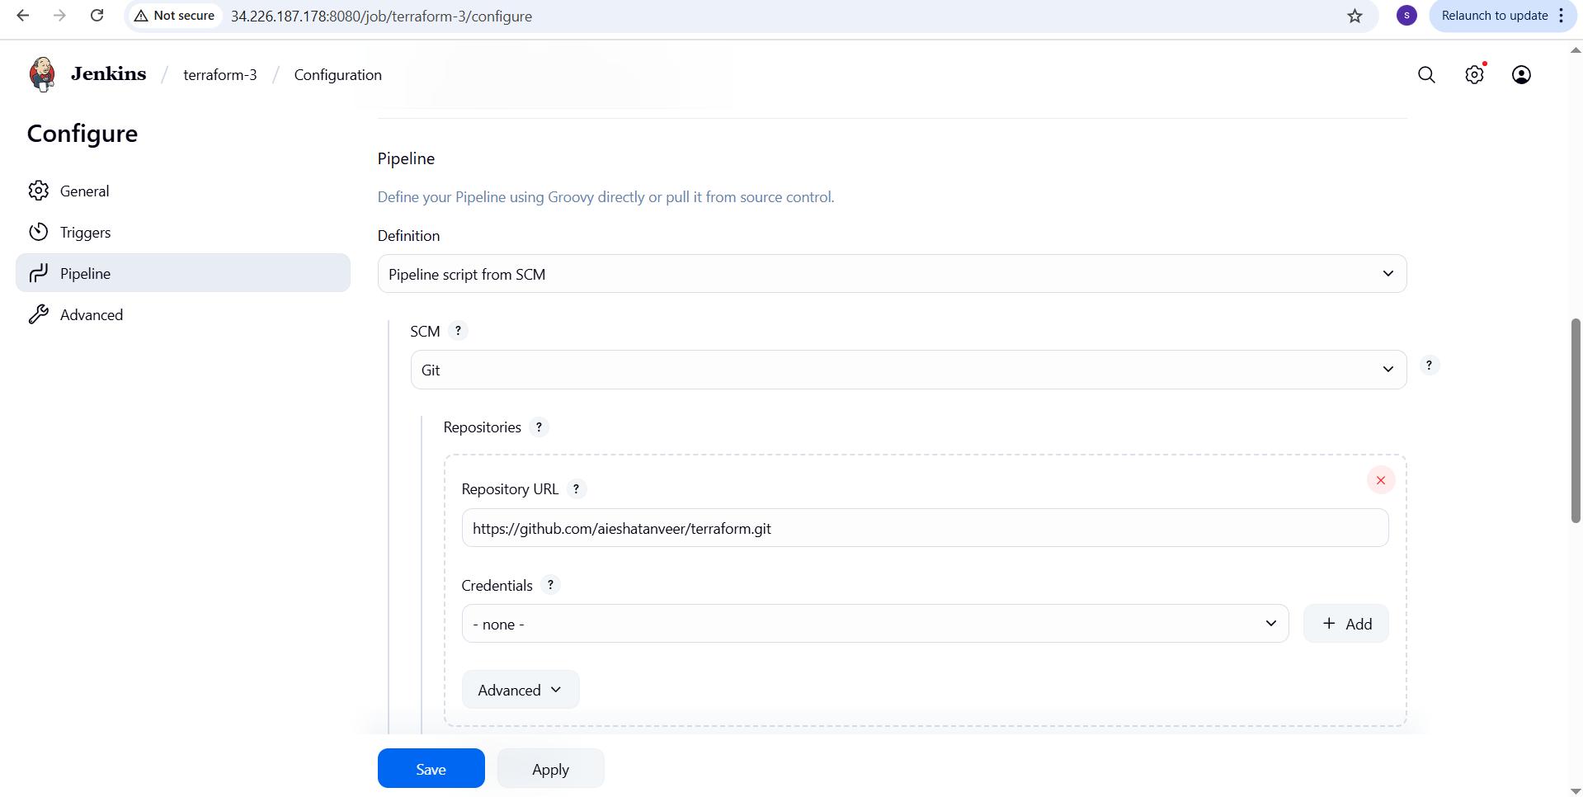
Save and build job.
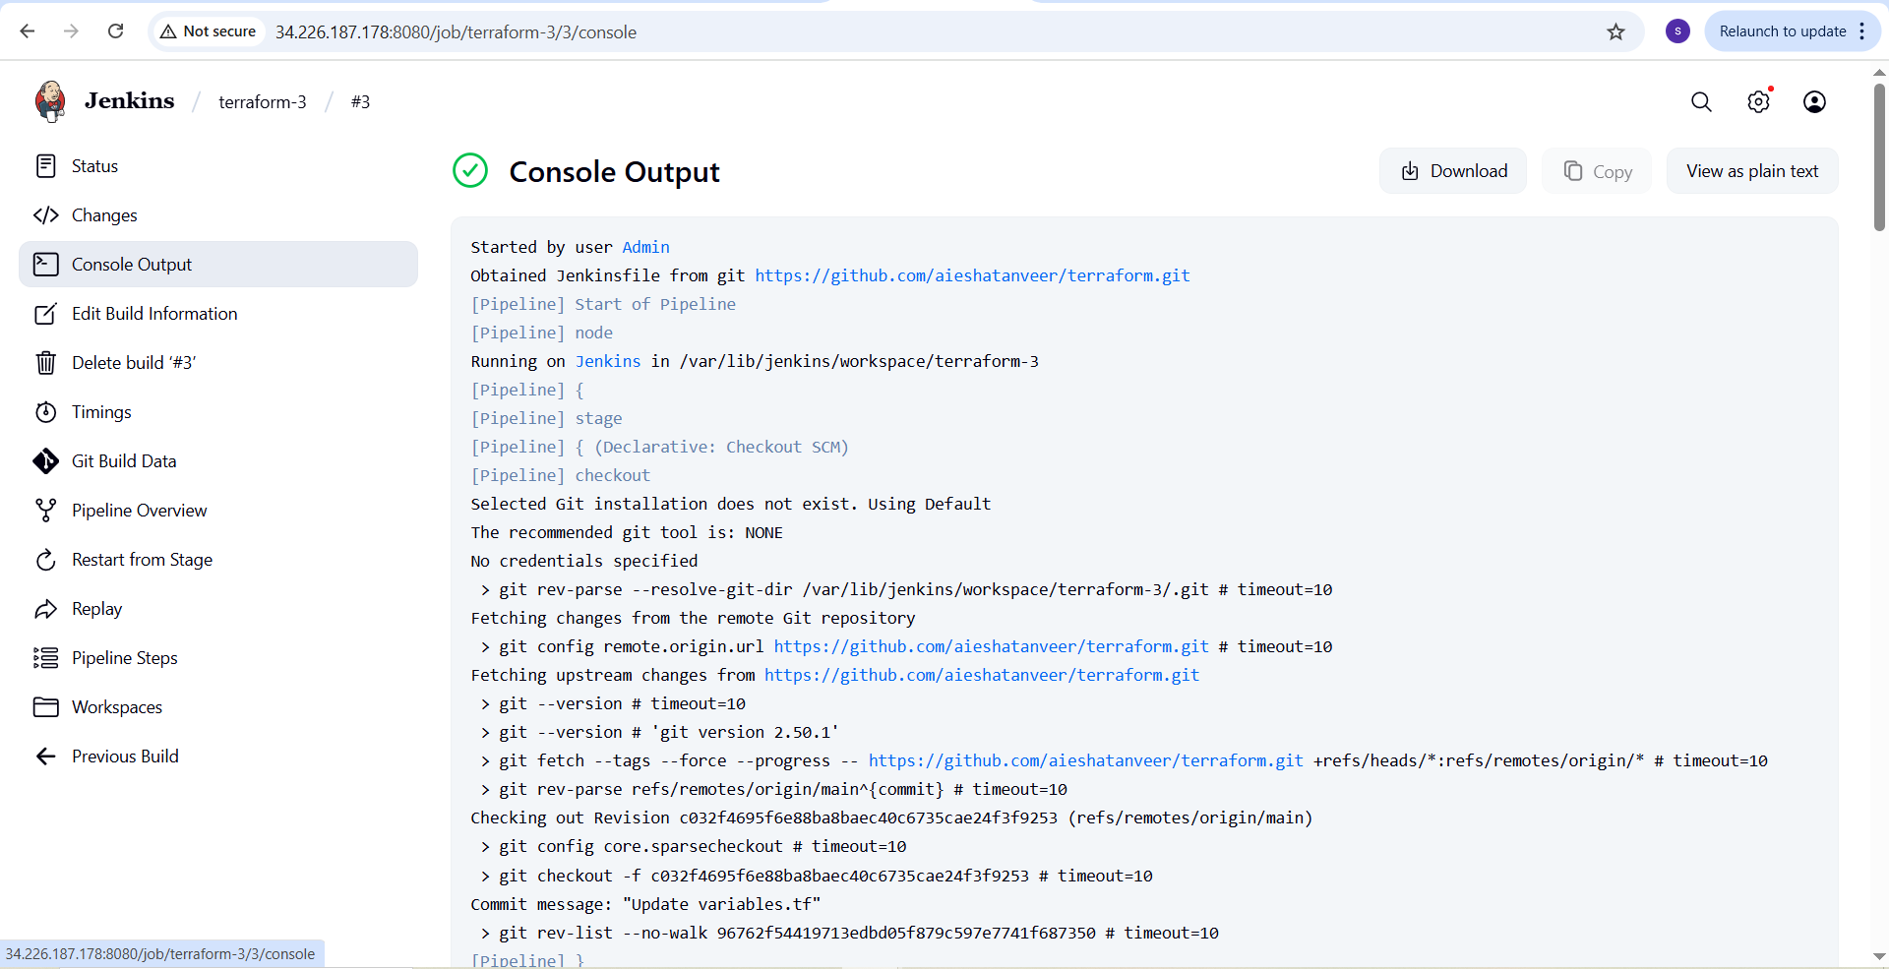
- Create one Jenkins job using Maven project for the code below with two stages.
- Stage 1: Git clone
- Stage 2: Maven
Compilation code: https://github.com/betawins/java-Working-app.git
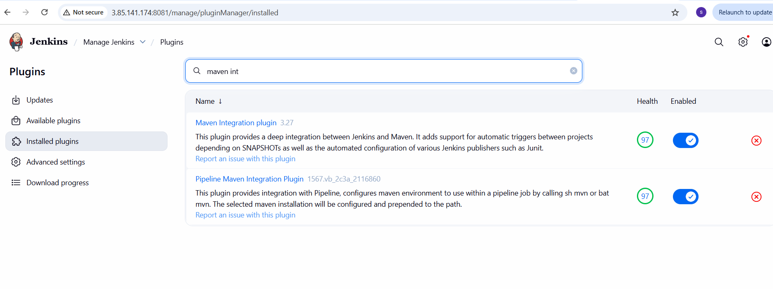To check maven -version in Jenkins server which is already installed.
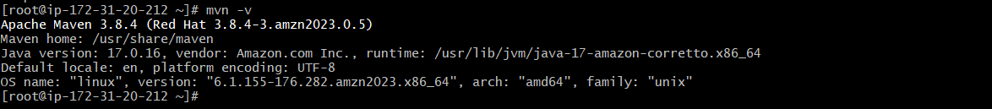
Go to Jenkins → Manage Jenkins → Tools → To add maven version
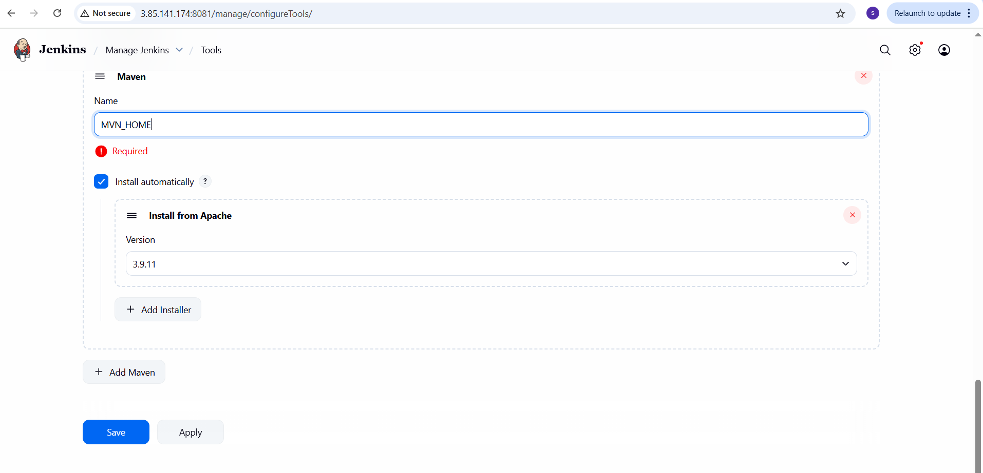
To create Maven project type job (terraform-maven)
Create a new job:
Click “New Item”.
Enter a name → EX: terraform-maven.
Select pipeline → click ok.
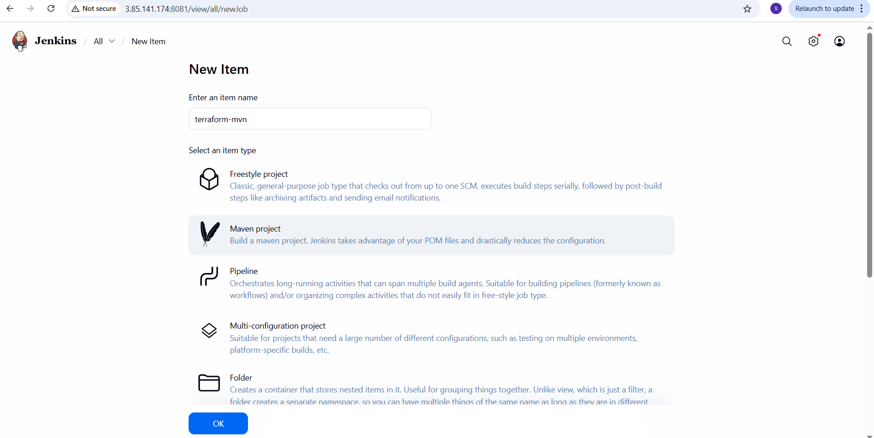To configure job:
Pipeline configuration:
- Under pipeline section, select pipeline script from SCM
- SCM :Git
- Repo URL: https://github.com/aieshatanveer/hiring-app.git
- Branch : main
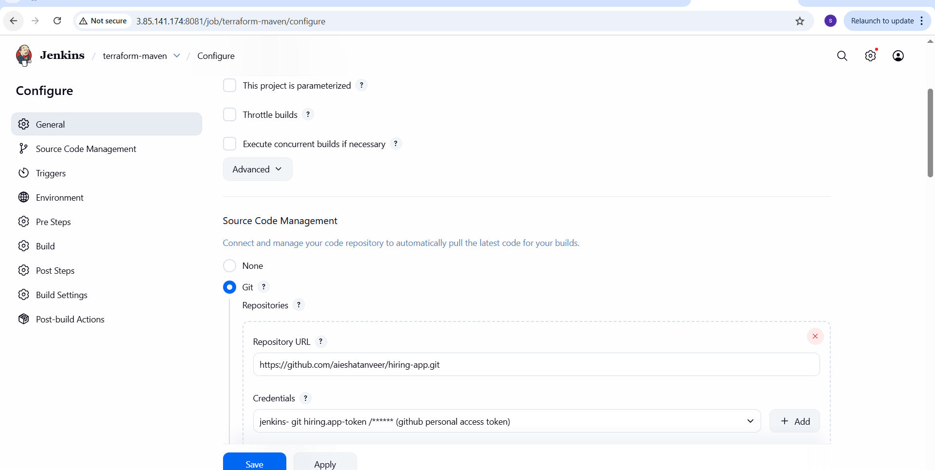
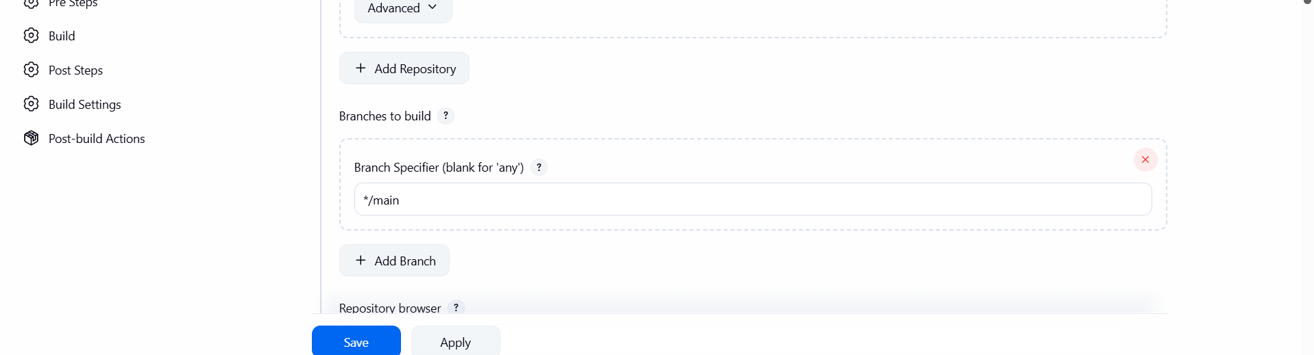
Save and build the job.
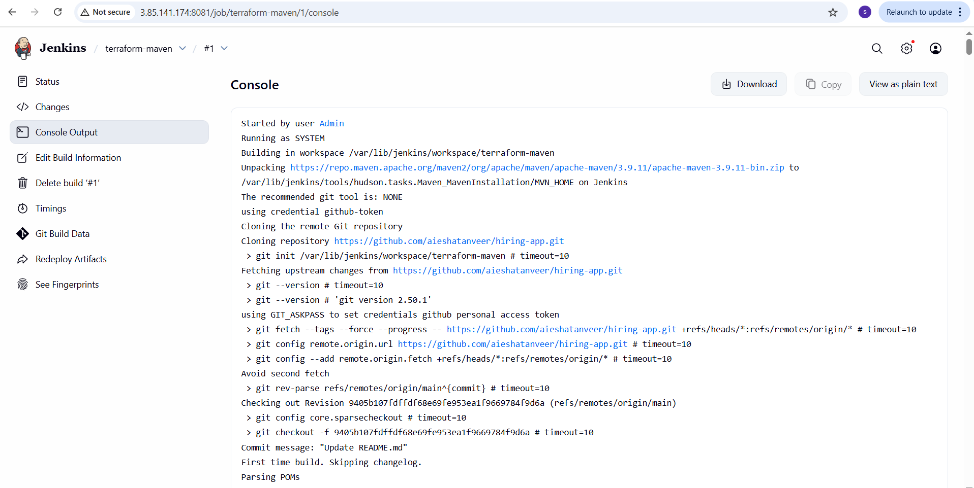
Now check /var/lib/Jenkins/workspace/terraform-maven in Jenkins server.

- Use the same code and create a parameterized job in Jenkins
With:
- Stage 1: Git clone
- Stage 2: Maven
Compilation code: https://github.com/betawins/java-Working-app.git

Install maven in Jenkins server.
I have already installed maven in Jenkins server.
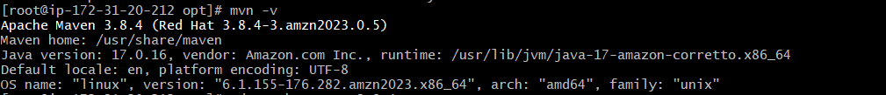
Plugin the maven integration in jenkins
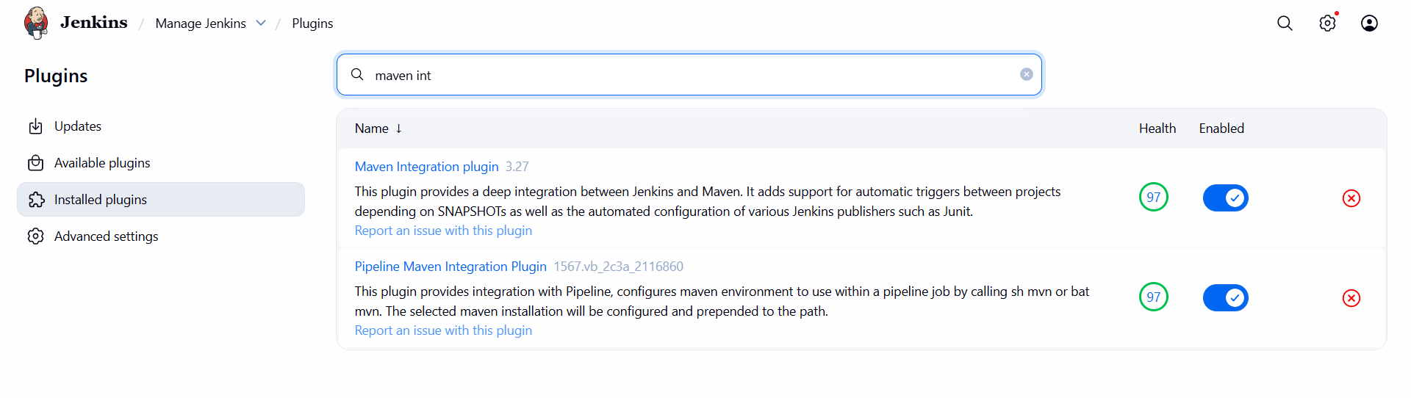
Go to Jenkins → manage Jenkins → tools → Add maven version
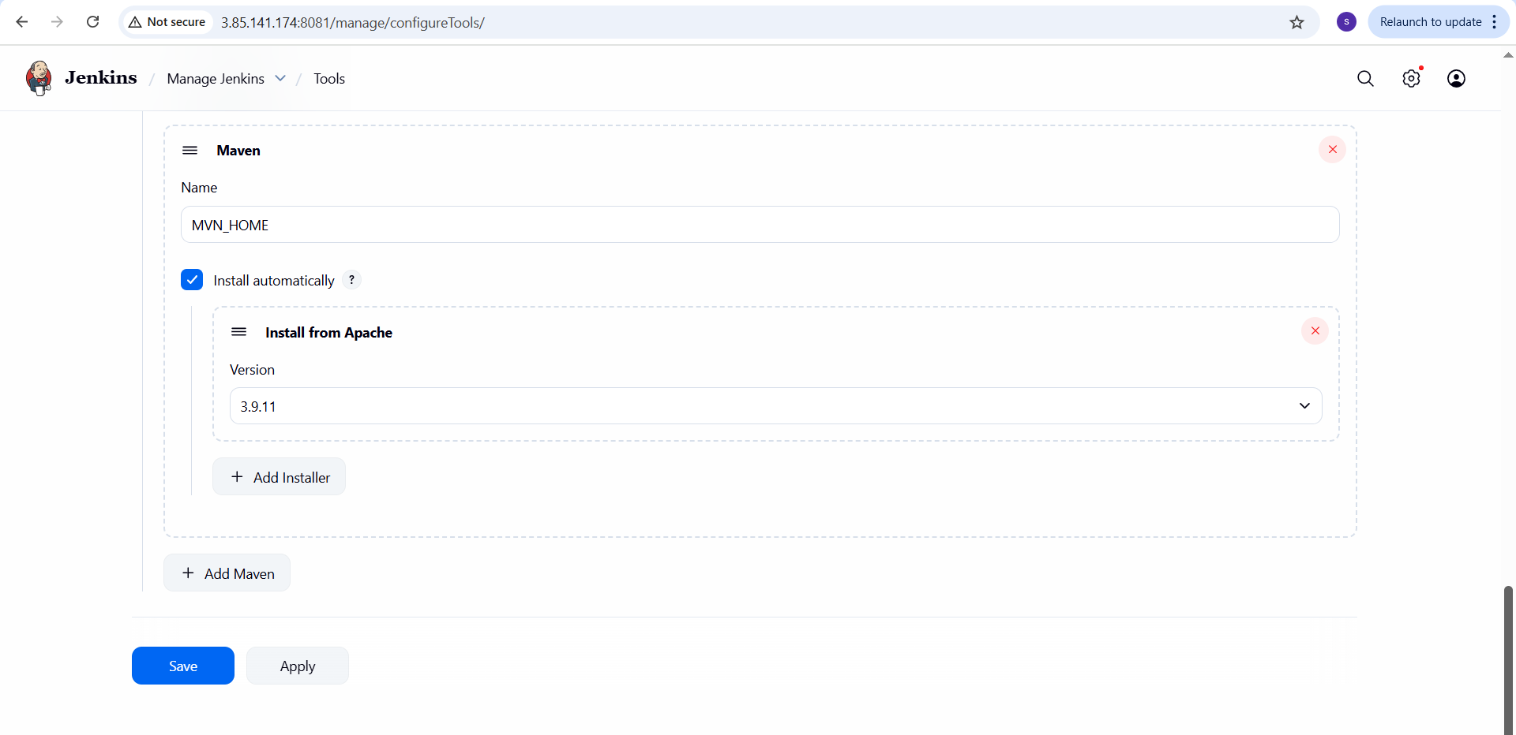
Go to Jenkins → manage Jenkins → tools → add terraform version
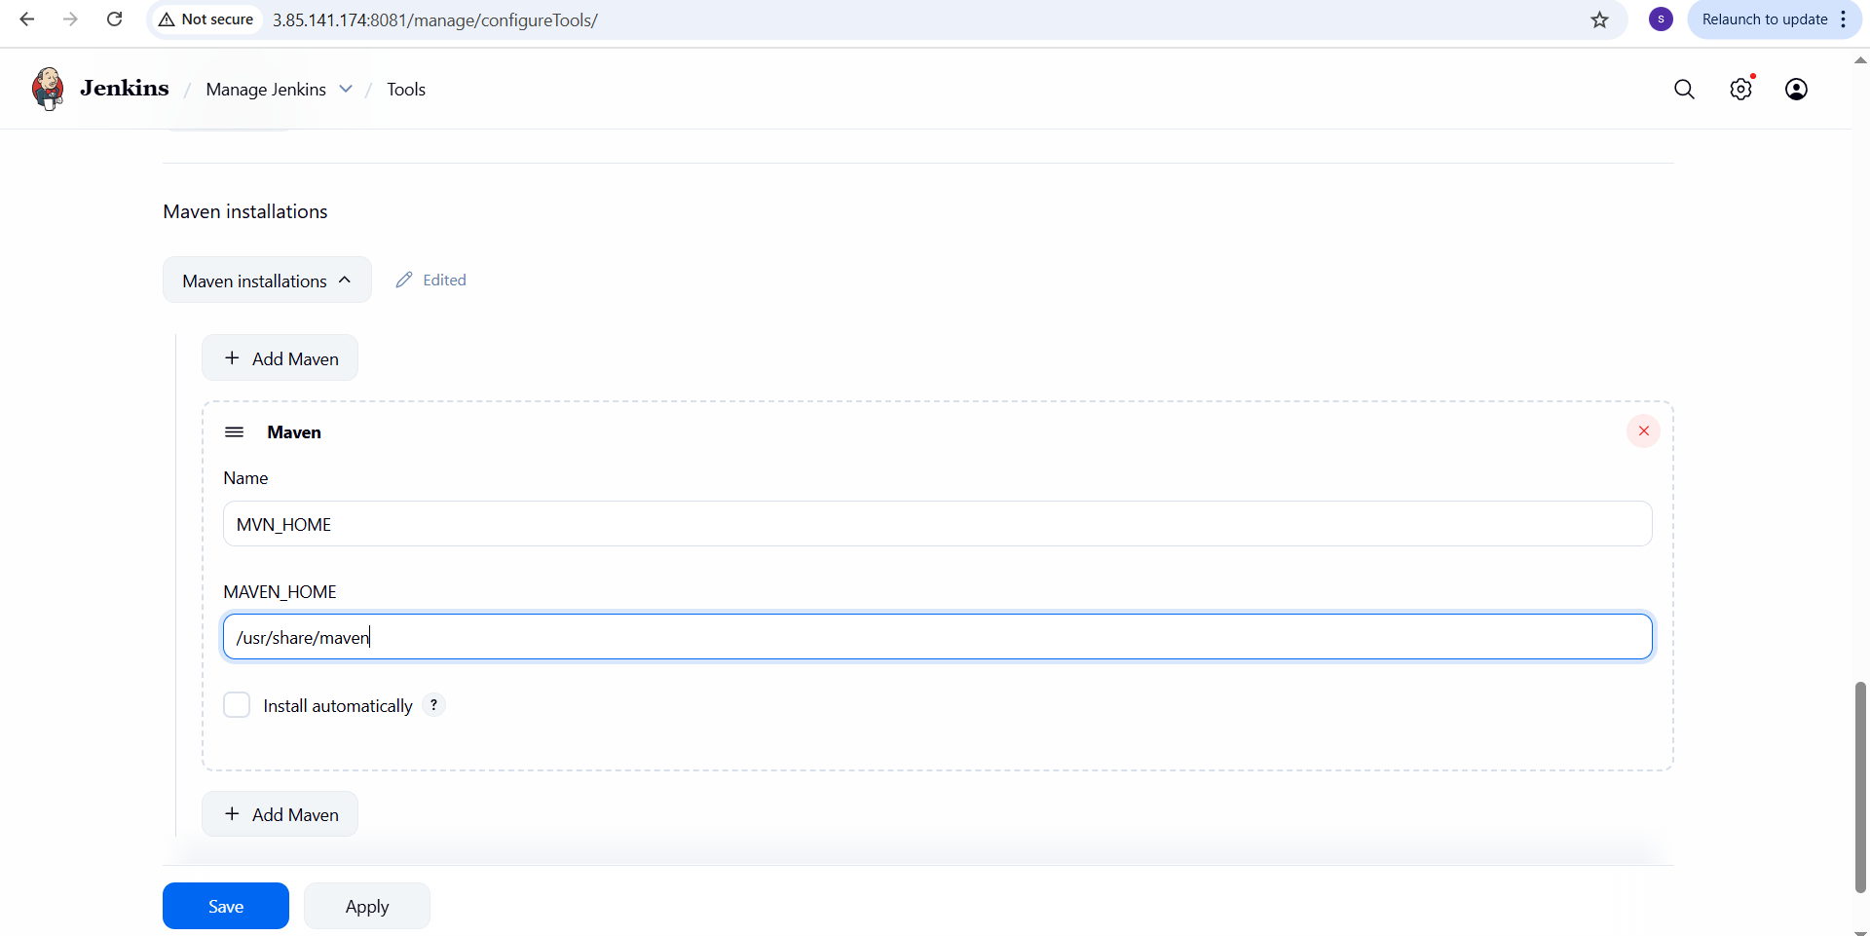
Go to Jenkins → manage Jenkins → tools → add terraform version.
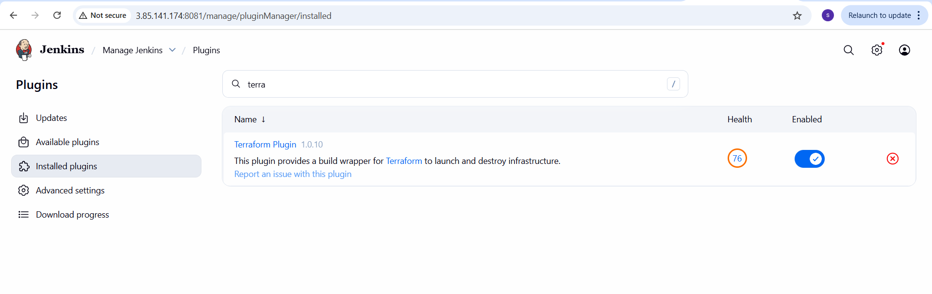 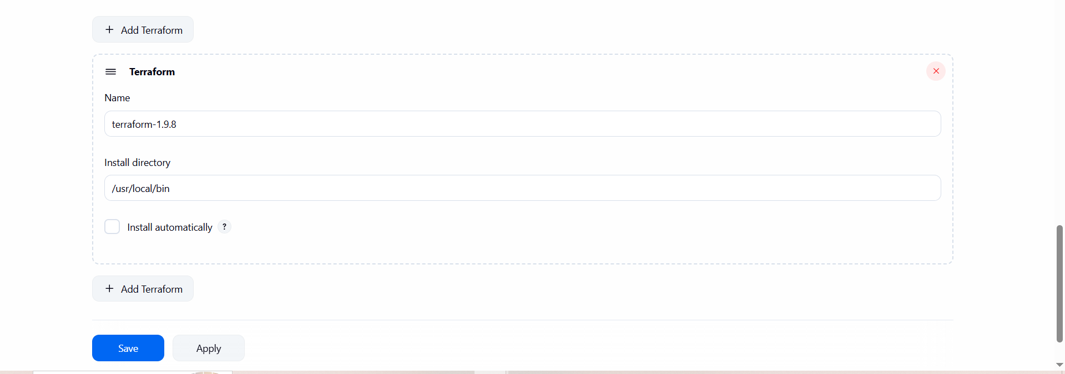click save.
To create freestyle project type job:
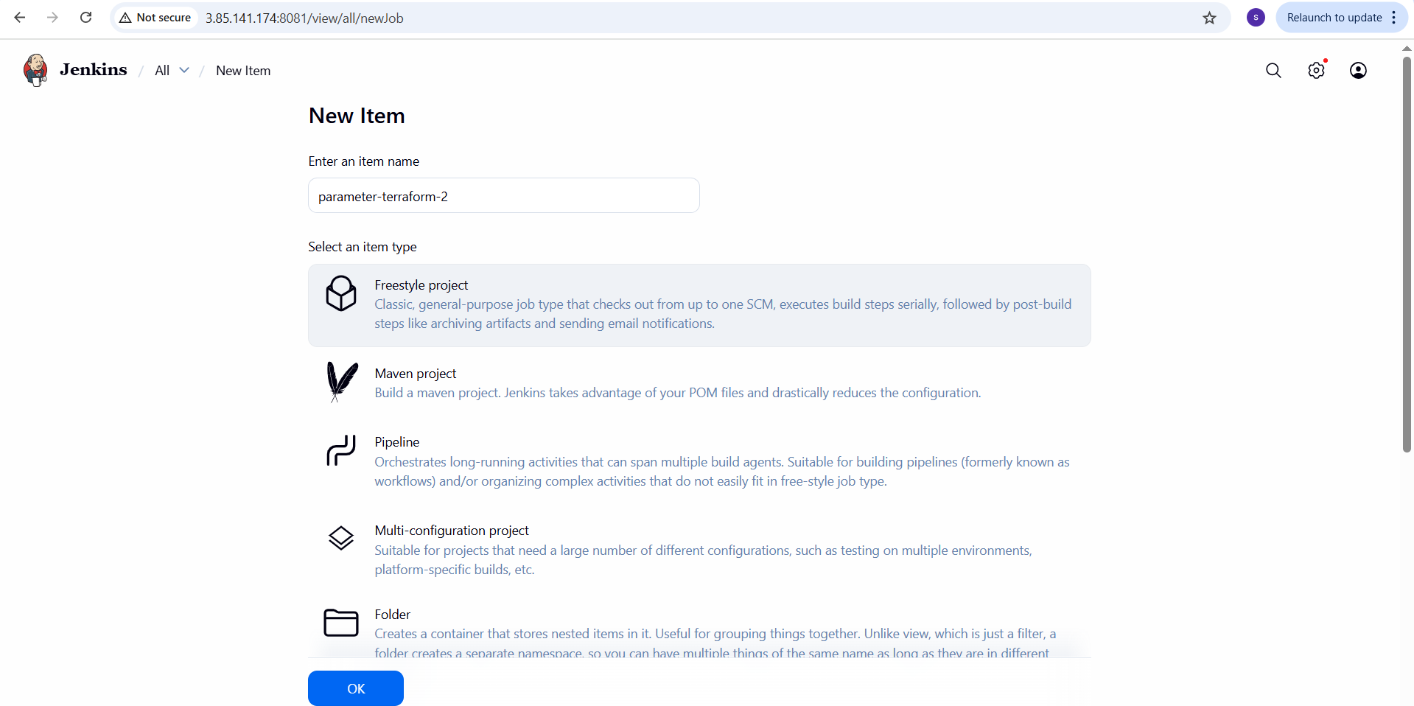
Add git URL: https://github.com/aieshatanveer/hiring-app.git
branch:main
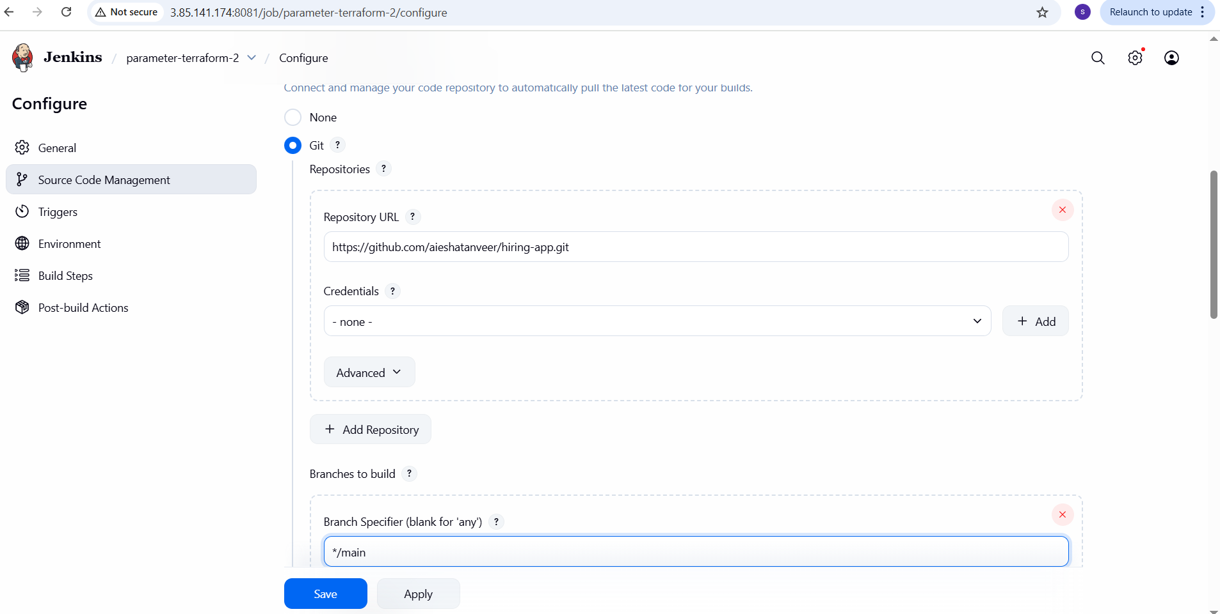
Save and build the job.
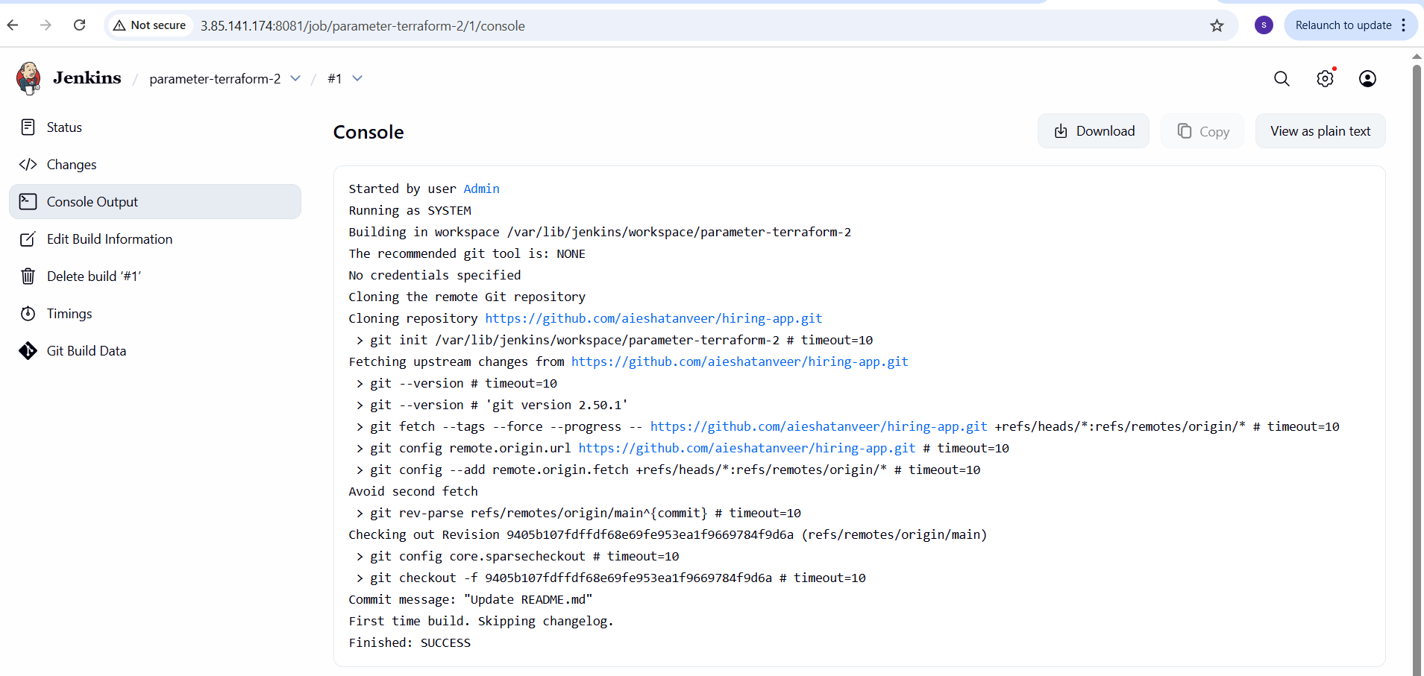
Check the created job in Jenkins server.
- What are global variables in jenkins.
- Jenkins Environment Variables
These are provided automatically by Jenkins during a job/pipeline run.
Some important ones are:
• BUILD_NUMBER → The current build number.
• BUILD_ID → The unique build ID (often a timestamp).
• BUILD_URL → URL of the current build.
• JOB_NAME → Name of the Jenkins job.
• JOB_BASE_NAME → The short name of the job without path.
• WORKSPACE → Path to the workspace directory.
• JENKINS_URL → Root URL of the Jenkins instance.
• NODE_NAME → Name of the agent/node where the job is running.
• EXECUTOR_NUMBER → Executor number of the build on the node.
• GIT_COMMIT → Commit ID of the current build (if using Git plugin).
• GIT_BRANCH → Branch name being built.
b. Pipeline Global Variables
In Declarative/Scripted Pipelines, Jenkins exposes some built-in global variables:
• env → Access to environment variables (env.BUILD_NUMBER, env.WORKSPACE, etc.).
• params → Access to parameters defined for the job
(params.BRANCH).
• currentBuild → Provides details about the current build (status, display name, etc.).
• scm → Refers to the SCM configuration of the job.
• pipeline → For pipeline-level configuration in declarative syntax.

