Ansible-01
- Watch ansible-01 video and write down notes.
Completed.
- Setup one master and two worker nodes in ansible.
Step-1: Launch EC2 instance.
- Go to AWS EC2 console
- Launch 3 ubuntu AMI instances. 1 for master (control)
2 for workers (managed nodes)
- Use the same key pair for all three.
- Security Group: Allow atleast SSH (port 22) between them.
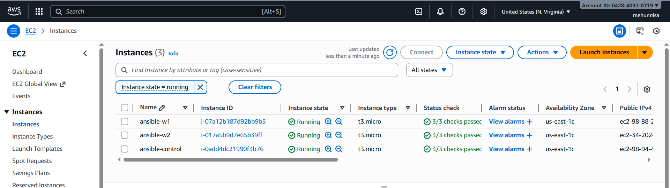 Step-2:
Connect to master (control node)
Sudo apt update -y
Sudo apt install ansible -y

here, by default we have no cfg file.
By default, ubuntu does not create /etc/ansible/ansible.cfg or /etc/ansible/hosts
We have to create our own config and inventory in our project directory.

Sudo mkdir -p /etc/ansible
Sudo vi /etc/ansible/ansible.cfg

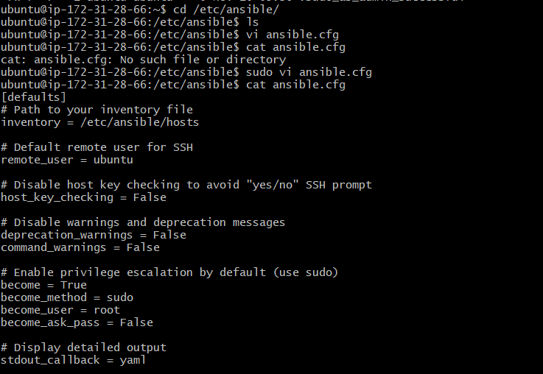
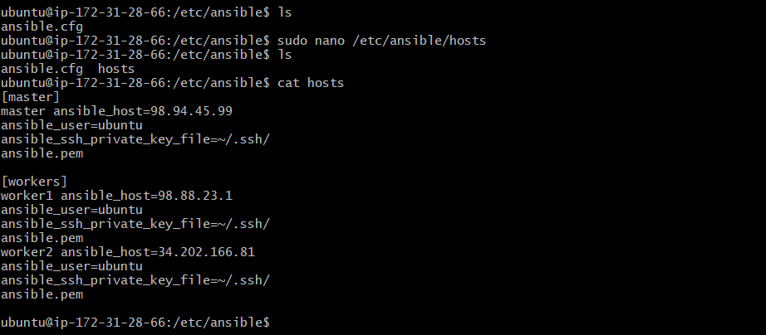
check ping:
Ansible all -m ping
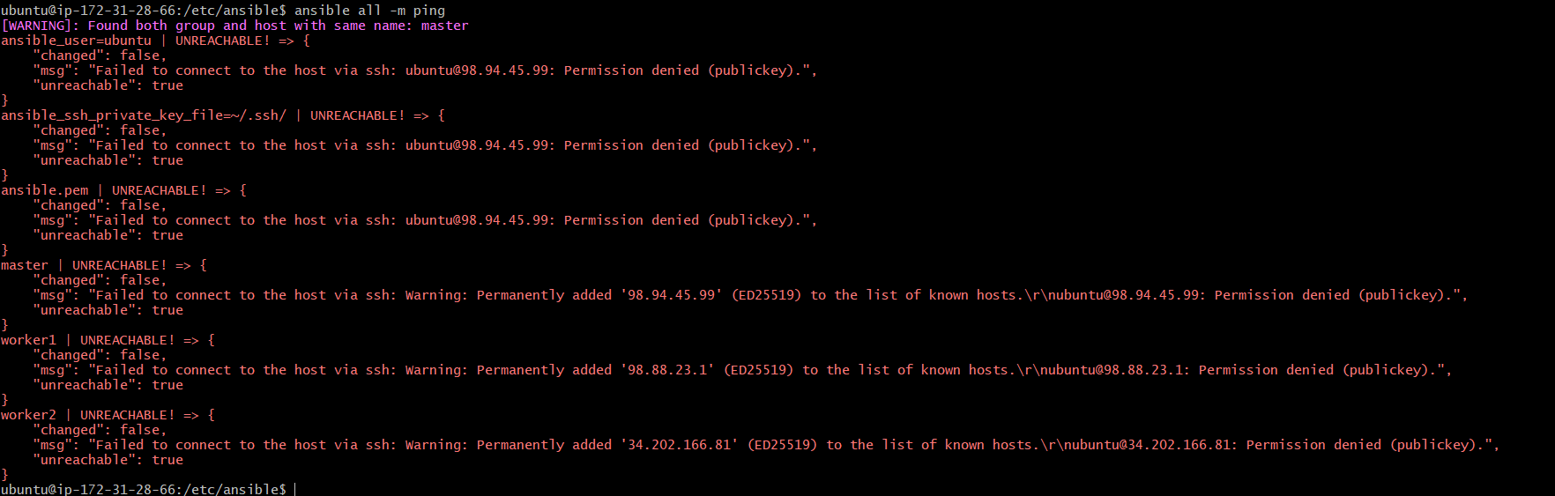

Permission denied:
Here ansible is trying to connect with ubuntu user. But, the SSH key is missing or not setup properly between master and workers nodes.
Fix SSH access between master & workers.

Do SSH-key-gen from master server:
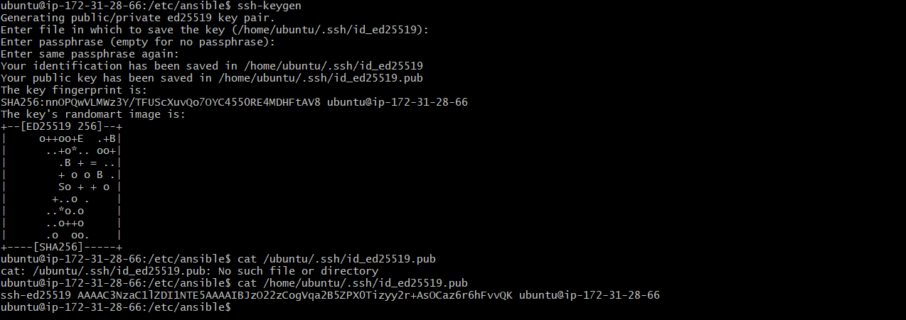
ssh-ed25519 AAAAC3NzaC1lZDI1NTE5AAAAIBJzO22zCogVqa2B5ZPX0Tizyy2r+AsOCaz6r6hFvvQK ubuntu@ip-172-31-28-66

Login to worker-1 using public_ip
Create .ssh folder: mkdir -p ~/.ssh
Chmod 700 ~/.ssh
Open authorized_keys using:
Nano ~/.ssh/authorized_keys
now go back to master server can run the command : cat ~/.ssh/id_ed25519.pub
we will get a key copy it and past it in worker-1 nano file and save it.

Now test in master server as ssh ubuntu@private ip of worker-1
We can see that master server worker-1 is connected successfully.

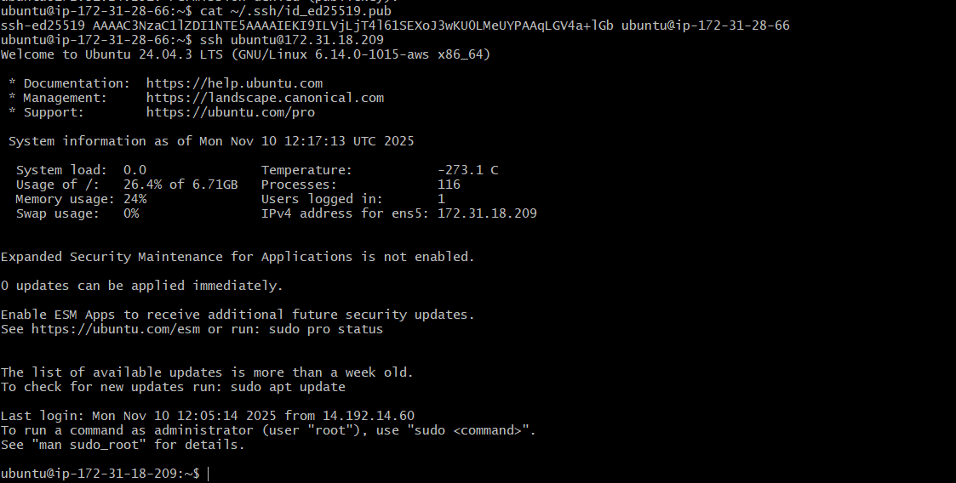
In the same way connect to worker-2

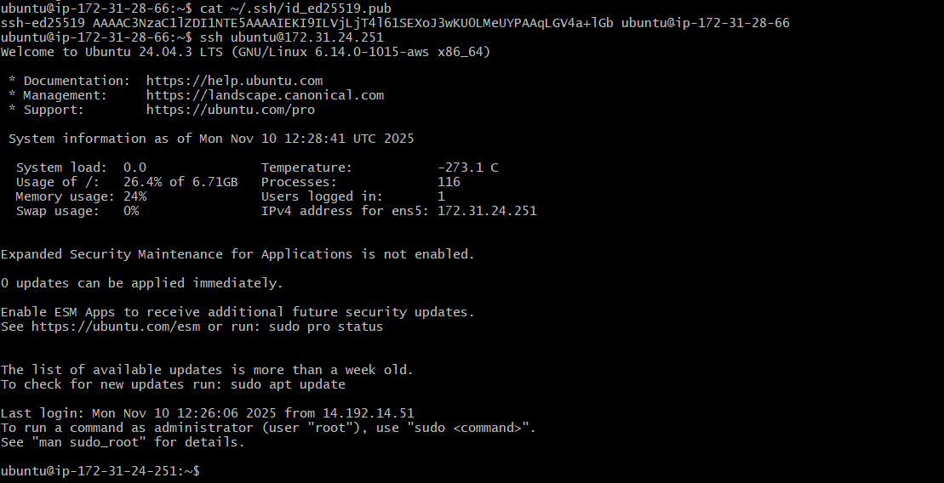

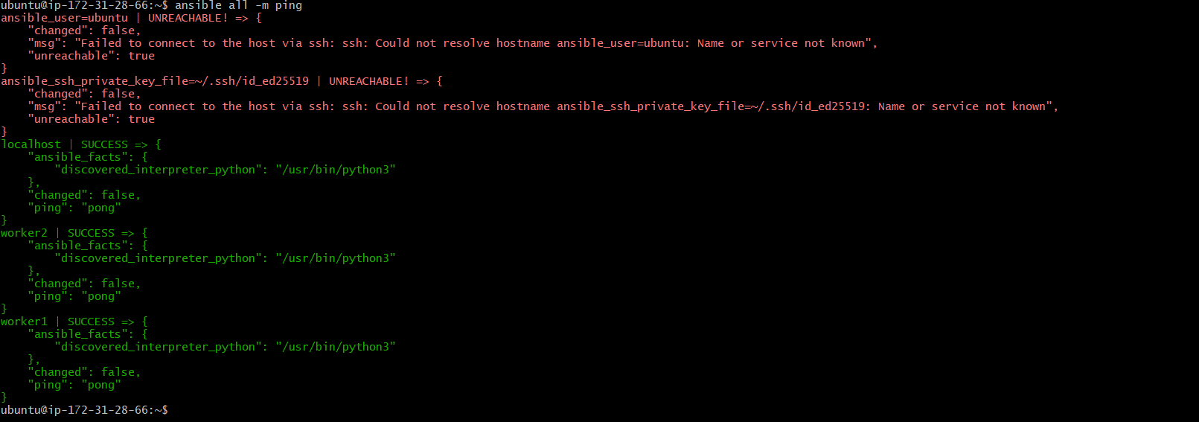

- Execute all the adhoc command shared in #dvps-cloud-documents-14 channel.
Ansible all -m ping


Ansible worker1 -m ping


Ansible worker1 -m ping -vvvv

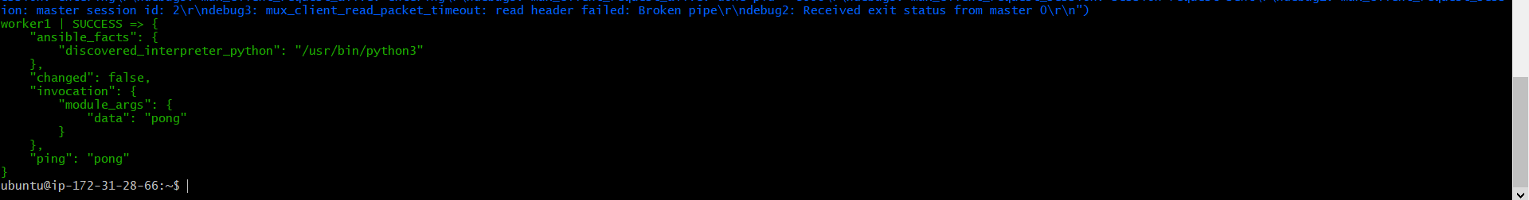

Ansible all -m uptime
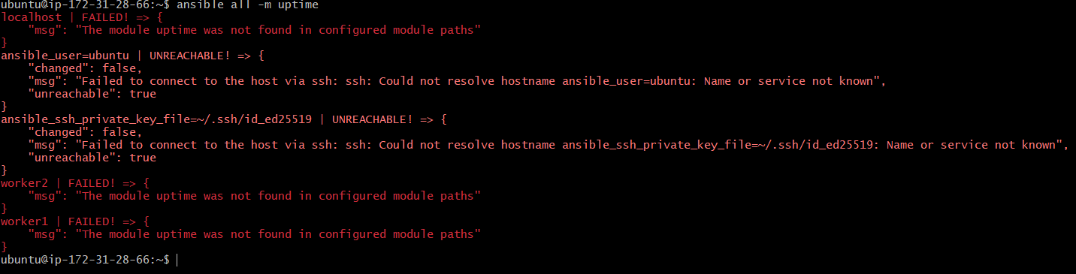

Ansible all -m shell -a uptime
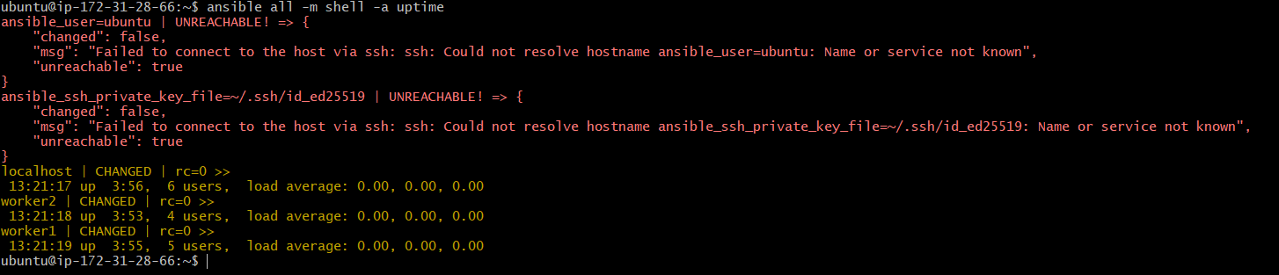

Ansible all -m shell -a “mkdir ansible-controller”
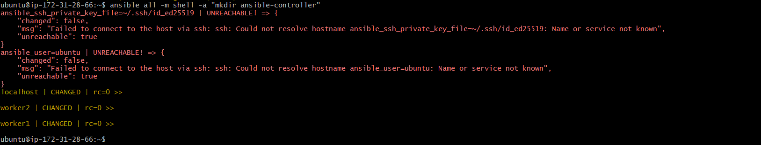

Ansible all -m shell -a “ps -ef”
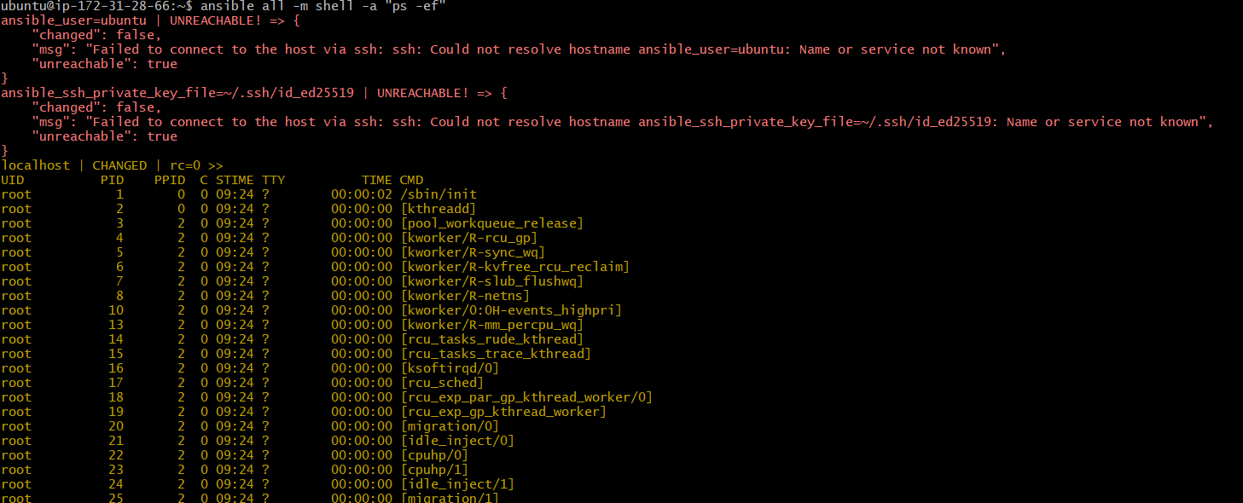

How to gather facts of slave machine
Ansible all -m setup
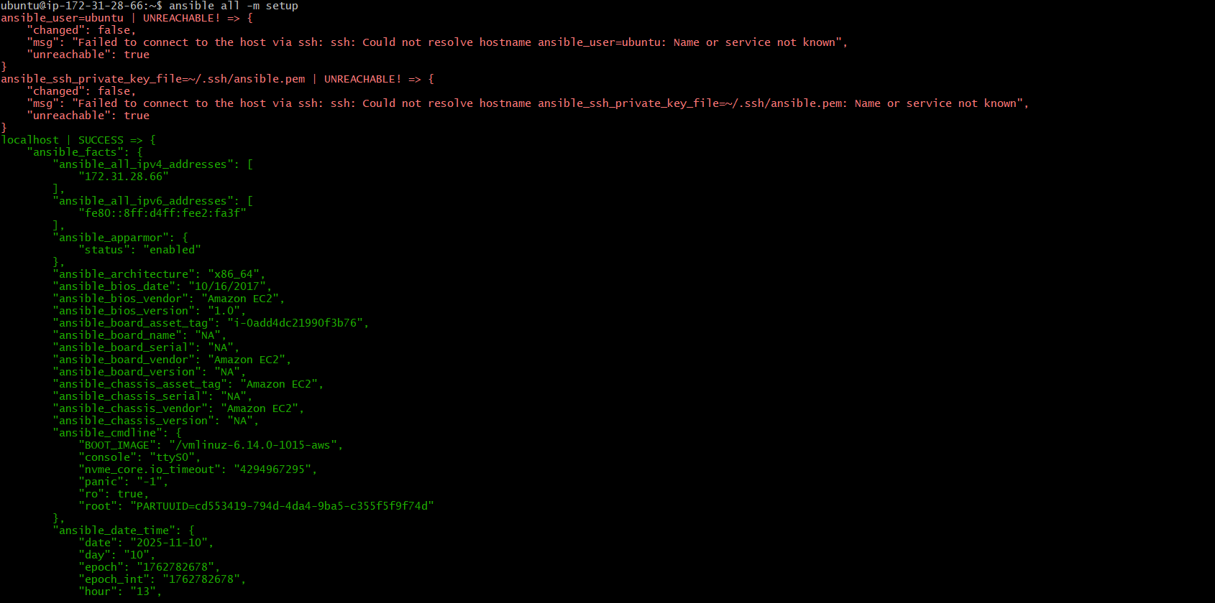
Install a package using apt command
Ansible all -m apt -a “name=httpd state=latest”
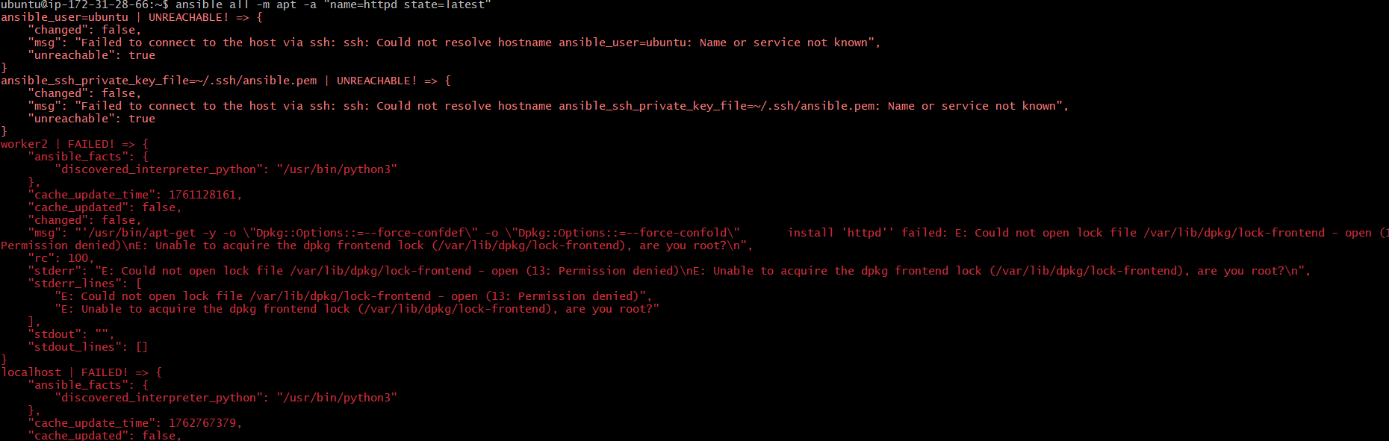
Check in worker ec2 whether able to install or not
I have login to worker1

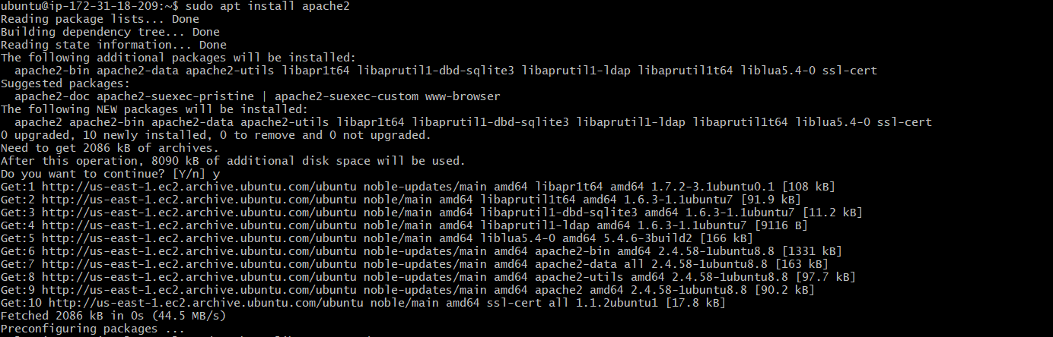
Update in master
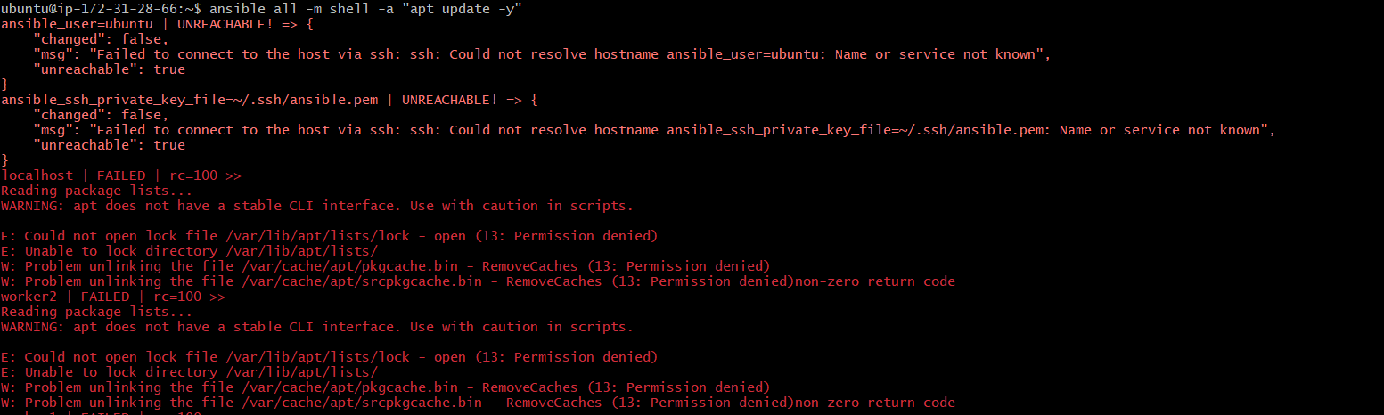
Ansible all -m apt -a “name=apache2 state=latest”
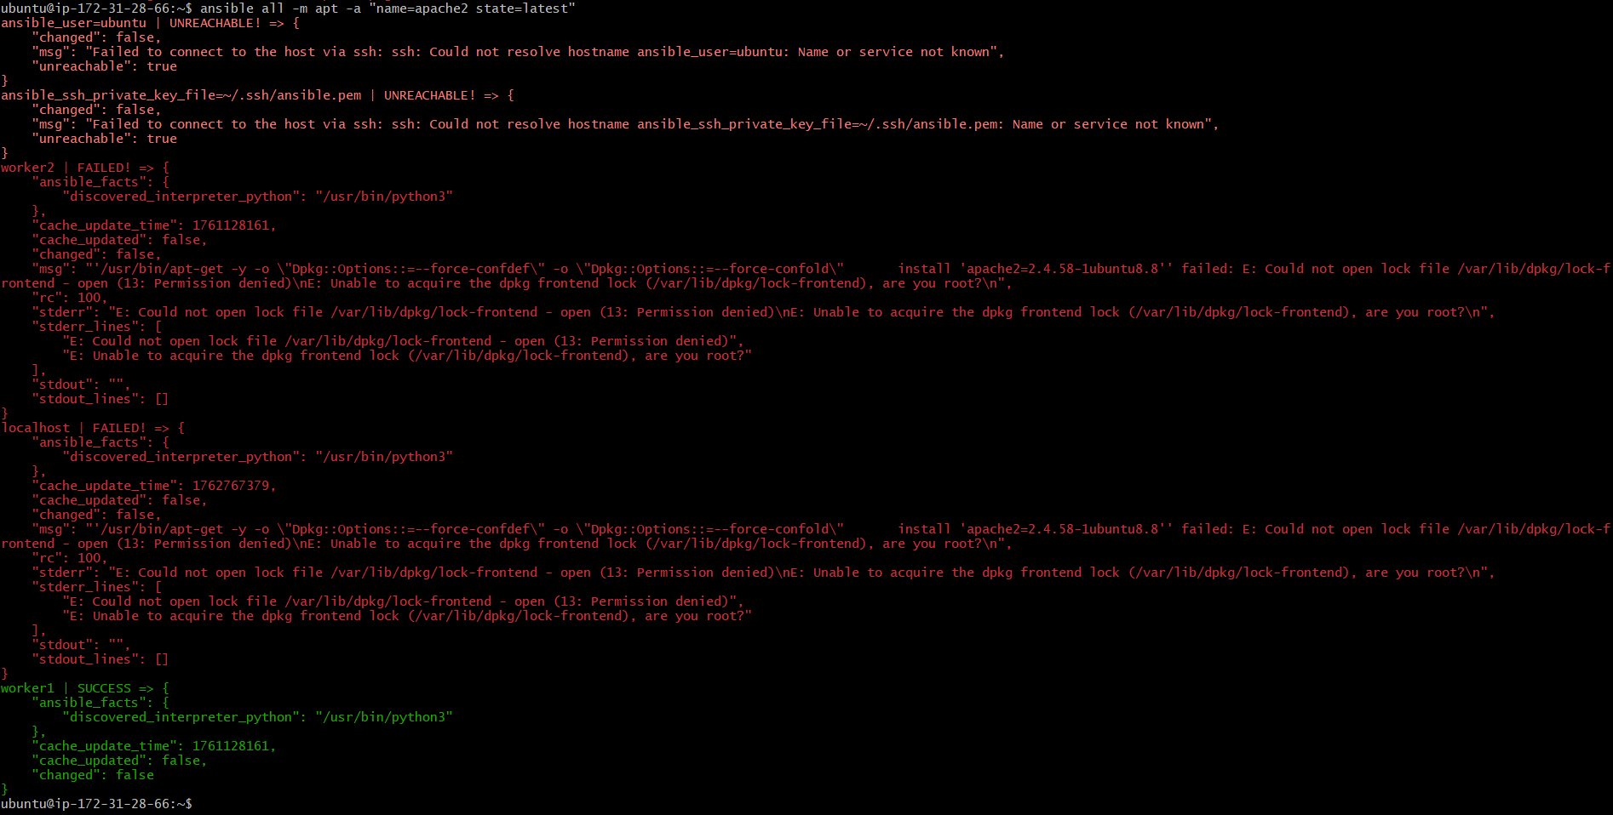
Check the status and connection in worker ec2
