Ansible-02
- Watch ansible-02 video and write notes.
Completed.
- Install httpd using ansible playbook, use handlers, notifiers.
Step 1:
I have already launched 3 instances using ubuntu.
1 is ansible-control and 2 ansible-w1, ansible-w2.
On control node ansible is already installed. Do ssh-keygen and copy the key from ubuntu user.
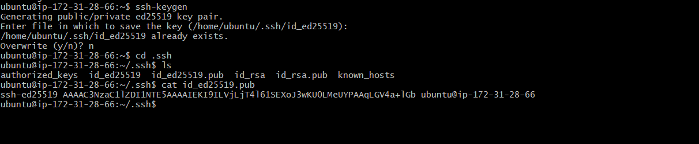

Now copy the public key to targeted nodes: ansible-w1 and ansible-w2.
Ansible-w1
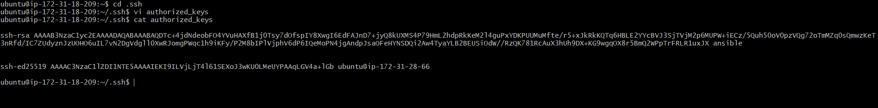

Ansible-w2

Check the ping from controller ec2
Sudo ansible all -m ping
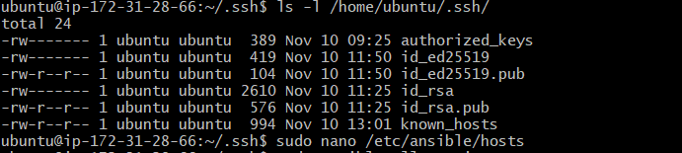
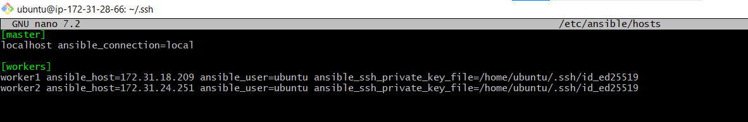
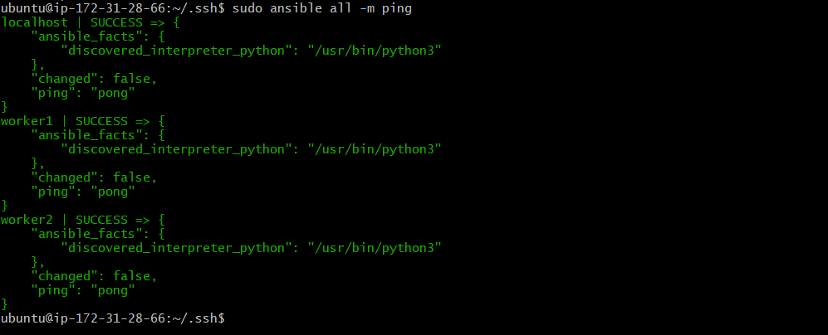
Step 2: Create playbook folder
mkdir~/playbooks
cd~/playbooks
inside, create your playbook file:
vi apache yml
write the playbook (apache.yml)
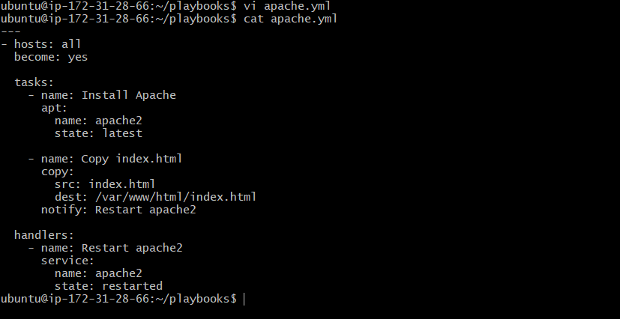
Step 3: create index.html file
Cd playbooks
Vi index.html
Add the content: Hello Aiesha copied from ansible controller
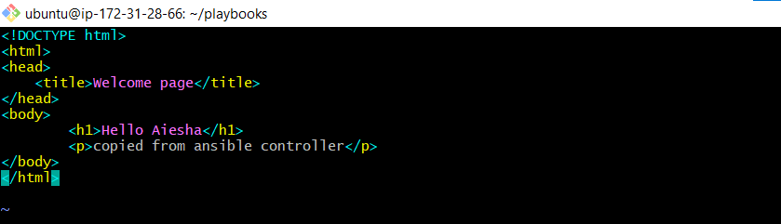

Step 4: Validate playbook before running
from inside ~/playbooks
check YAML syntax
ansible-playbook apache.yml –syntax-check
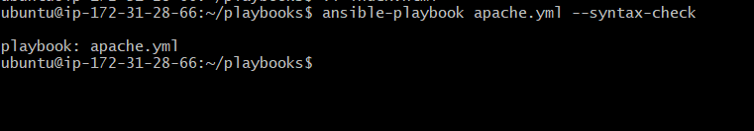
if no syntax errors
Dry run (no changes, just simulation)
ansible-playbook apache.yml --check

run playbook for real
ansible-playbook apache.yml
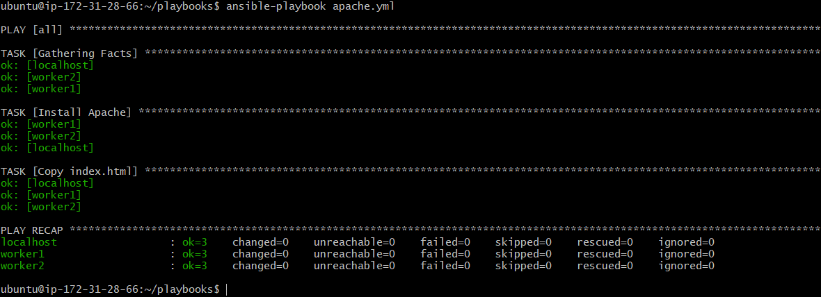
Verify installation
Ansible-w1
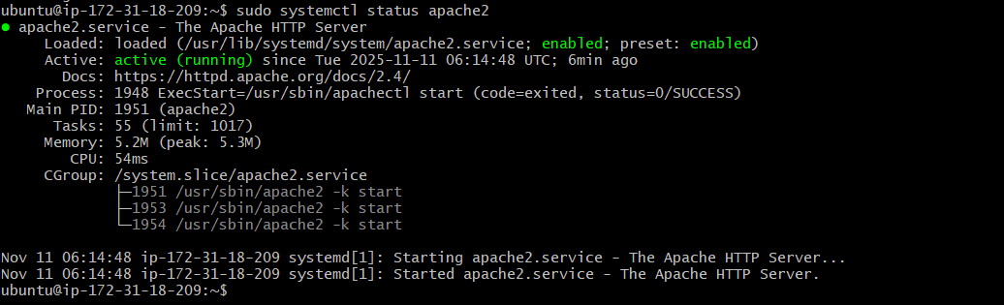
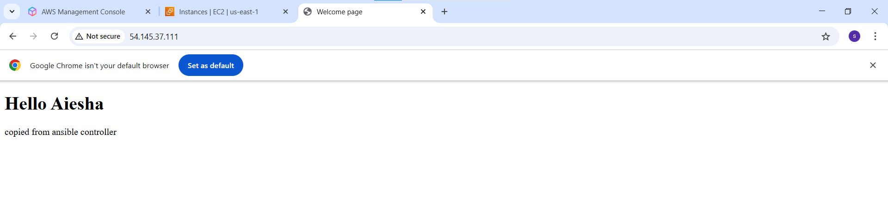Modules:
- apt → Manages packages on Ubuntu/Amazon Linux.
→ apt :
→ name: httpd
→ state: present
Installs httpd if not present.
- Copy → Copies files from control node → target node
→ Copy:
→ Src: index.html
→ dest: /var/www/html/index.html
- Service → Manages services (start, stop, restart)
→ service:
→ name: httpd
→ state: restarted

Handlers & Notify
→ notify: Tells Ansible to trigger a handler if the task changes something.
→ Handlers: Special tasks that run at the end of the playbook, only if notified.
Example:
- If httpd is installed → notify: start httpd.
- If index.html changes → notify: restart httpd
- write a ansible playbook to install Apache tomcat.
Go to root
Create Ansible project folder
mkdir ~/playbooks
cd ~/playbooks
write playbook (tomcat.yml)
vi tomcat.yml
---
- hosts: all
remote_user: root
tasks:
- name: Install Java (required for Tomcat)
apt:
name: default-jdk
state: present
update_cache: yes

- name: Ensure /opt directory exists
file:
path: /opt
state: directory
mode: '0755'

- name: Ensure /opt/tomcat directory exists
file:
path: /opt/tomcat
state: directory
mode: '0755'

- name: Download Tomcat 9.0.109 tar.gz to /tmp
get_url:
url: https://archive.apache.org/dist/tomcat/tomcat-9/v9.0.109/bin/apache-tomcat-9.0.109.tar.gz
dest: /tmp/apache-tomcat-9.0.109.tar.gz
mode: '0644'

- name: Extract Tomcat into /opt/tomcat
unarchive:
src: /tmp/apache-tomcat-9.0.109.tar.gz
dest: /opt/tomcat
remote_src: yes
creates: /opt/tomcat/apache-tomcat-9.0.109

- name: Create systemd service file for Tomcat
copy:
dest: /etc/systemd/system/tomcat.service
content: |
[Unit]
Description=Apache Tomcat 9
After=network.target

[Service]
Type=forking
Environment=CATALINA_HOME=/opt/tomcat/apache-tomcat-9.0.109
Environment=CATALINA_BASE=/opt/tomcat/apache-tomcat-9.0.109
ExecStart=/opt/tomcat/apache-tomcat-9.0.109/bin/startup.sh
ExecStop=/opt/tomcat/apache-tomcat-9.0.109/bin/shutdown.sh
User=root
Group=root
Restart=always

[Install]
WantedBy=multi-user.target

- name: Reload systemd to recognize new service
systemd:
daemon_reload: yes

- name: Enable Tomcat service
systemd:
name: tomcat
enabled: yes

- name: Start Tomcat service
systemd:
name: tomcat
state: started

check before run
ansible-playbook tomcat.yml –syntax-check
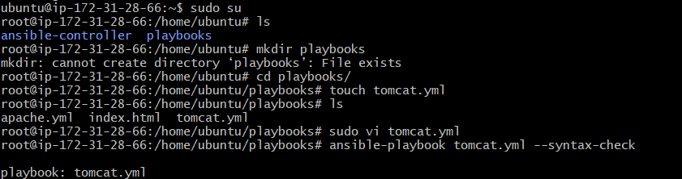

ansible-playbook tomcat.yml –check
ansinle-playbook tomcat.yml
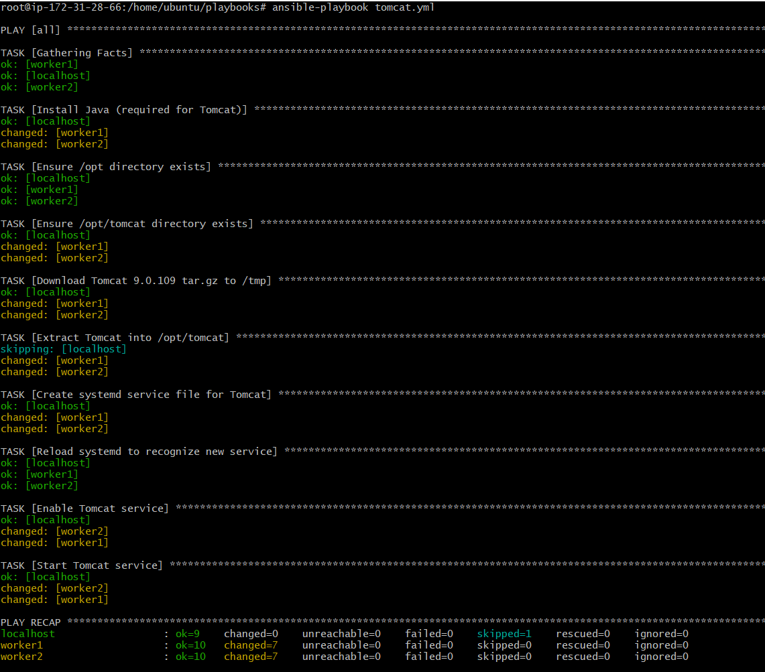
Verify tomcat service
On target server: systemctl status tomcat
ansible-w1
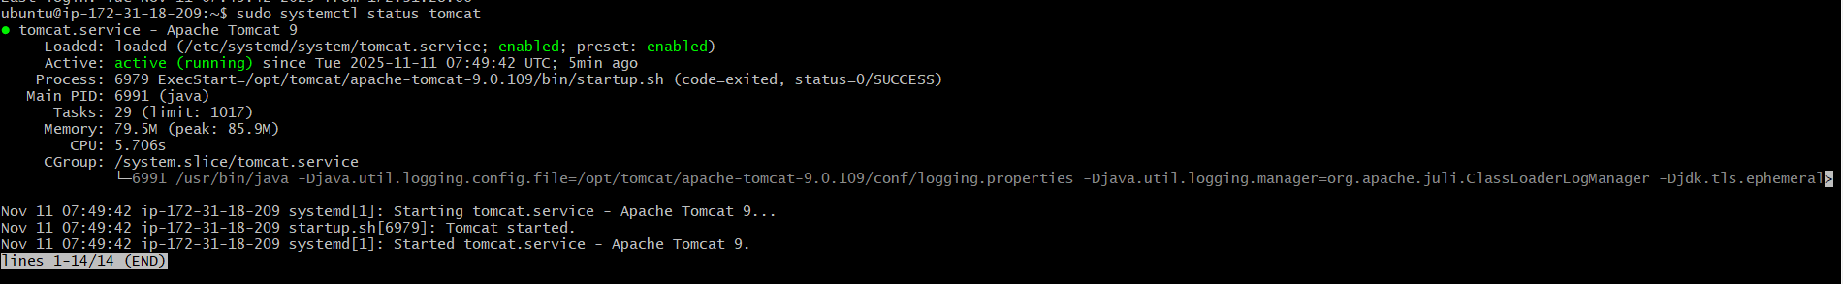
Test in browser :
http://<server-ip>:8080
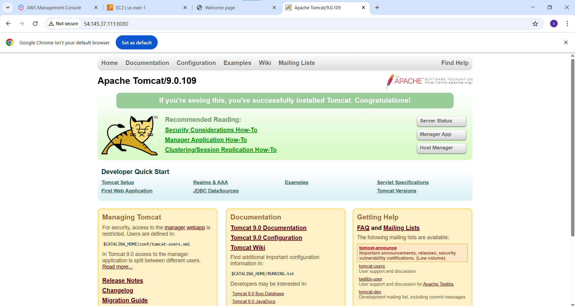

ansible-w2
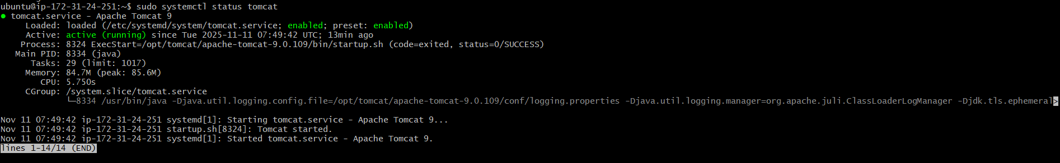
Test in browser:
http://<server_ip>:8080
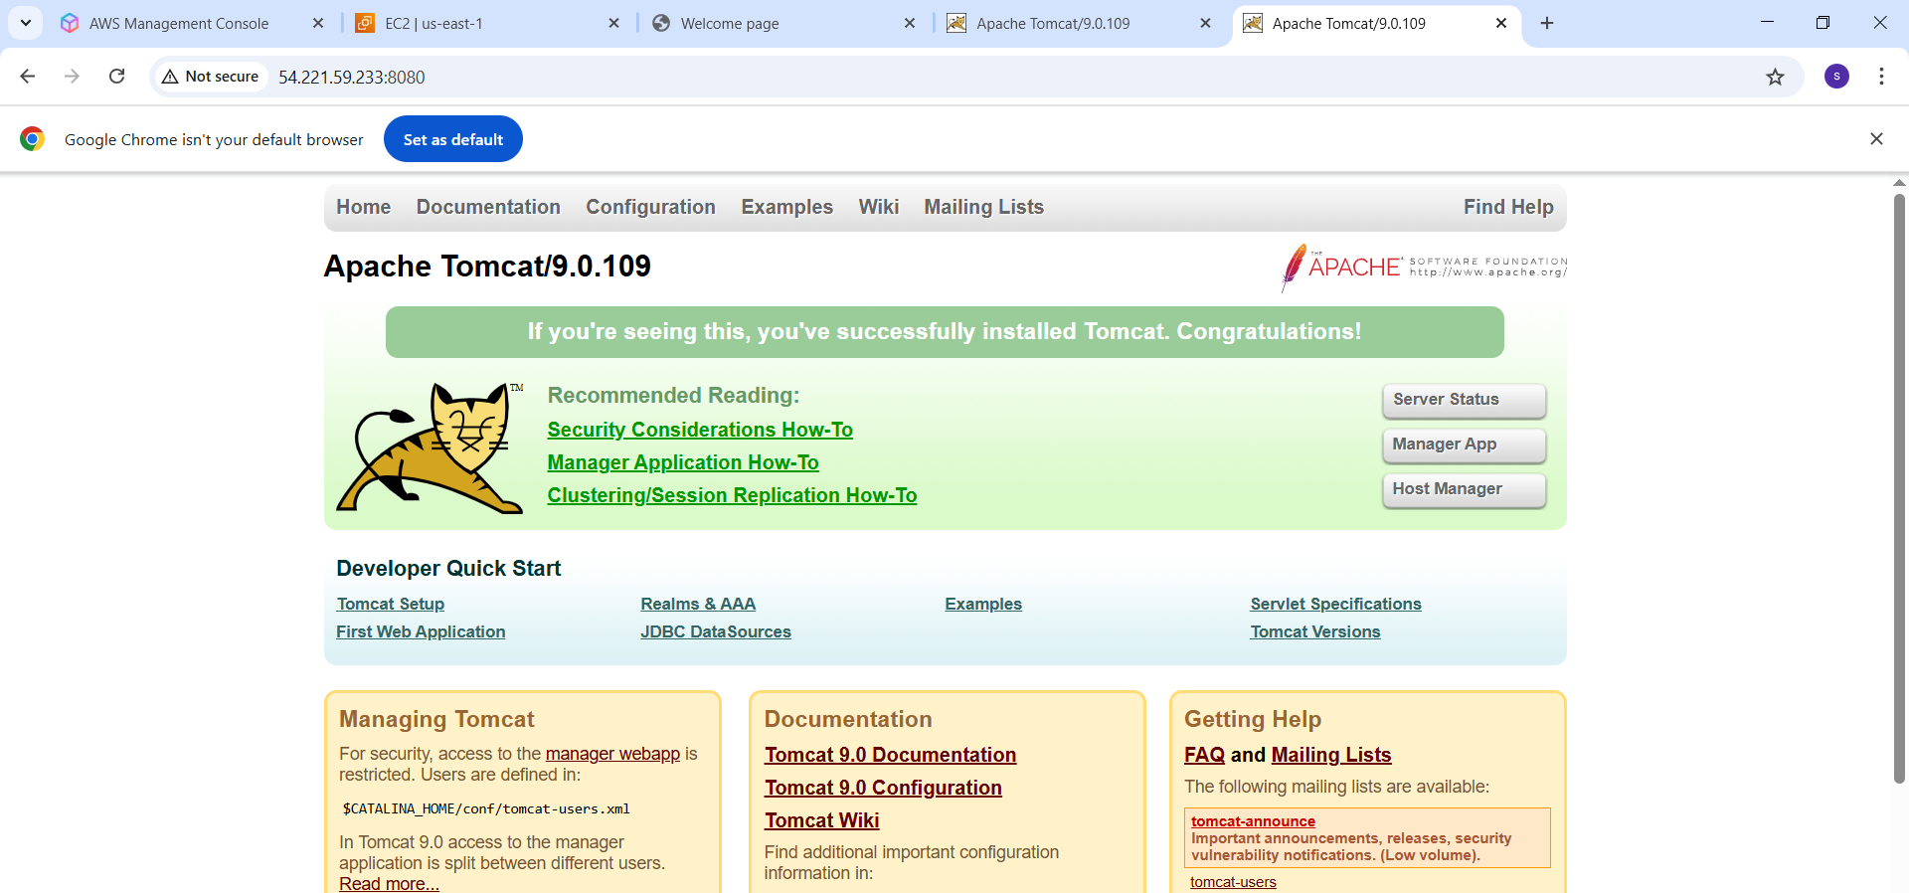

- write a ansible playbook to provision one ec2 on aws.
Pre-requisites:
1.Install boto3 & botocore (Ansible needs them to talk to aws)
Apt install -y python3-boto3 python3-botocore
2.Ensure Ansible collections are installed
Ansible-galaxy collection install amazon.aws
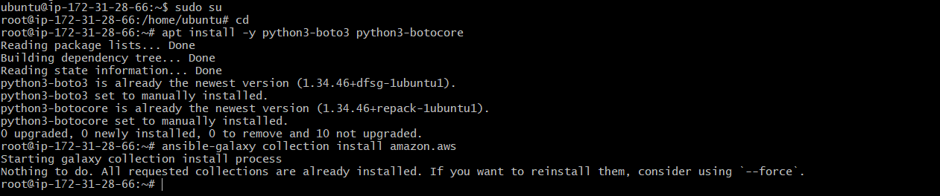

3.Configure AWS credentials
AWS configure
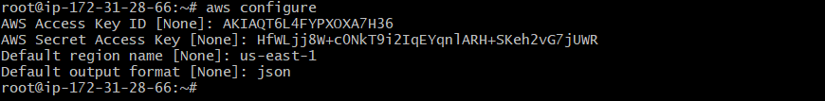

4.write playbook(ec2.yml)
Inside playbook create ec2.yml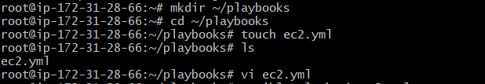
---
- name: Provision EC2 instance in AWS
hosts: localhost
connection: local
gather_facts: false

tasks:
- name: Launch EC2 instance
amazon.aws.ec2_instance:
name: "ansible-demo-instance"
key_name: "new"
instance_type: t3.micro
image_id: ami-0cae6d6fe6048ca2c
region: us-east-1
wait: true
count: 1
security_group: default
register: ec2

- name: Show instance info
debug:
var: ec2.instances
5.run playbook
Check syntax first: ansible-playbook ec2.yml –syntax-check
Dry-run: ansible-playbook ec2.yml –check
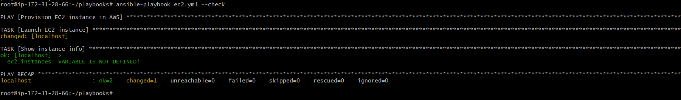
Execute: ansible-playbook ec2.yml
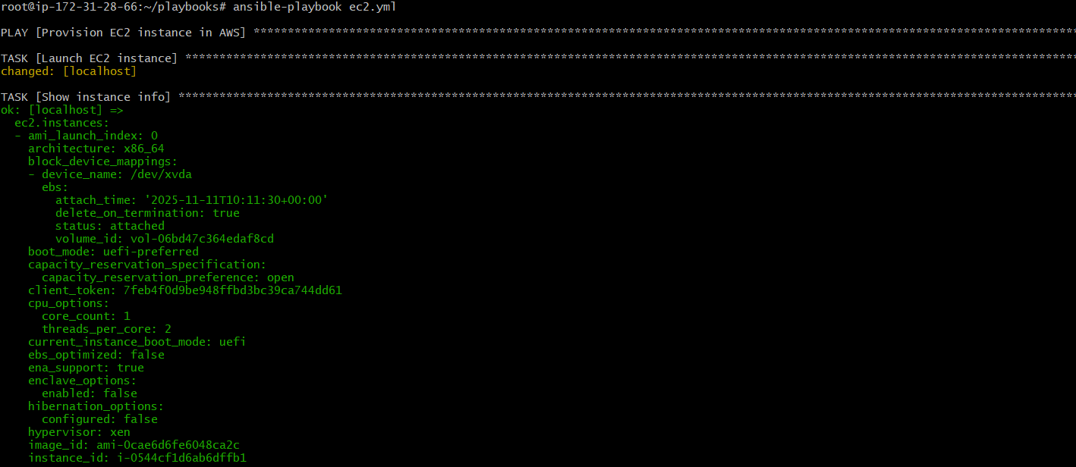
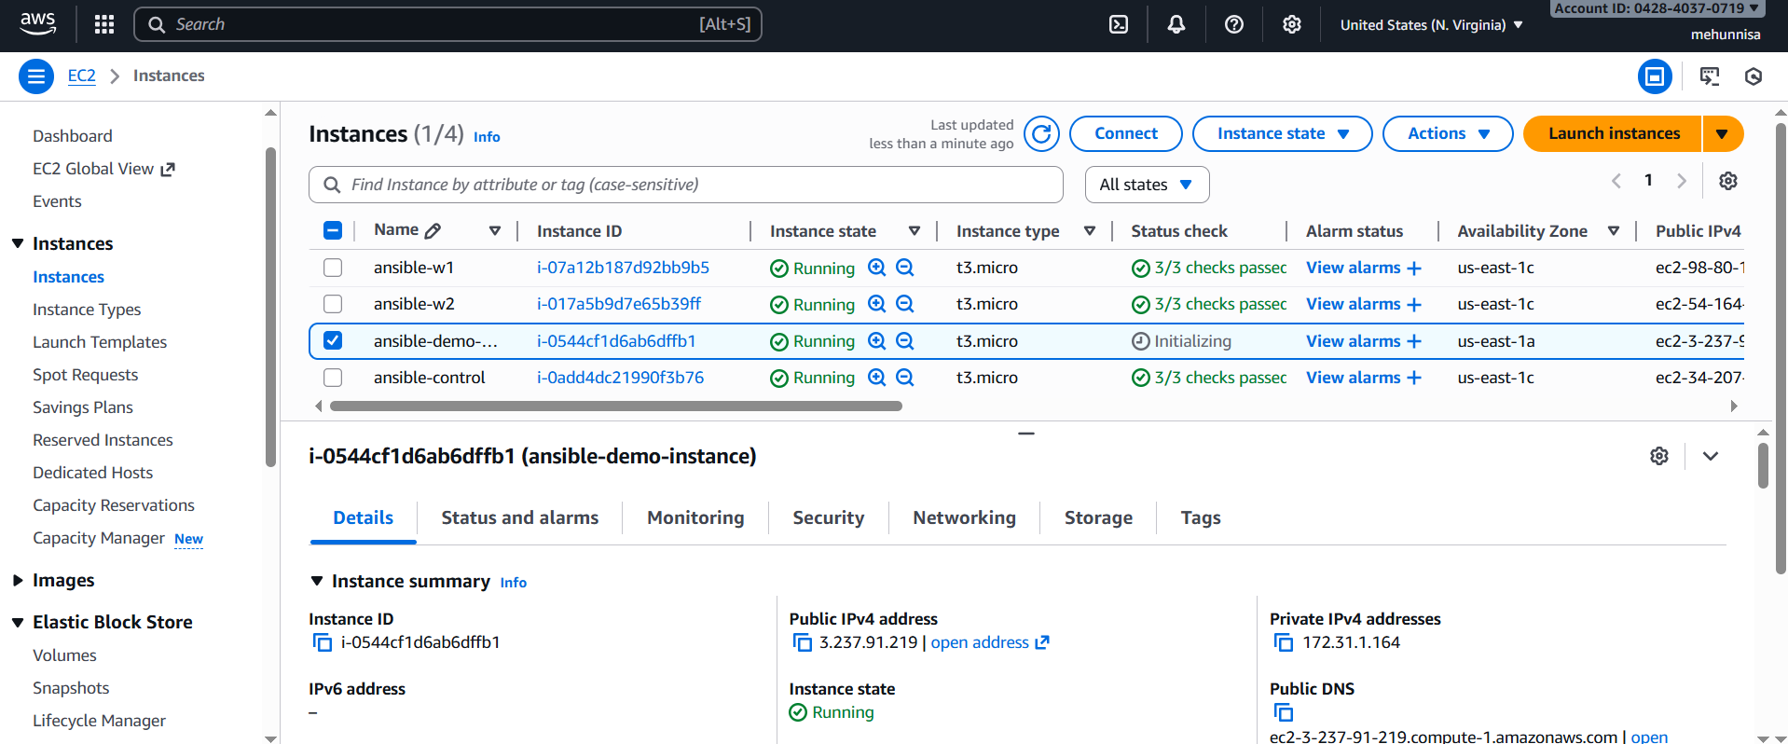
5. write a ansible playbook to copy one file from node-1 to node-2.
By default, ansible’s copy module copies from controller → node,
But not node to node.
To move files between nodes, we need to:
1.Fetch the file from node-1 to the controller.
2.Copy the file from the controller to node-2.

Step-1: Create a file in worker1
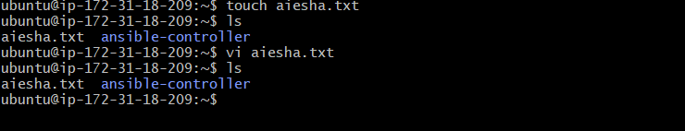
Step-2: create copy.yml in playbook
---
- name: Copy file from node-1 to node-2
hosts: [worker-01]
gather_facts: no
tasks:
- name: Fetch file from node-1 to controller
fetch:
src: /home/ubuntu/aiesha.txt # file on node-1
dest: /tmp/ # store on controller
flat: yes # keep same filename

- name: Copy file from controller to node-2
hosts: [worker-02]
gather_facts: no
tasks:
- name: Copy file to node-2
copy:
src: /tmp/aiesha.txt # file stored on controller
dest: /home/ubuntu/aiesha.txt # where to place on node-2

ansible-playbook copy.yml
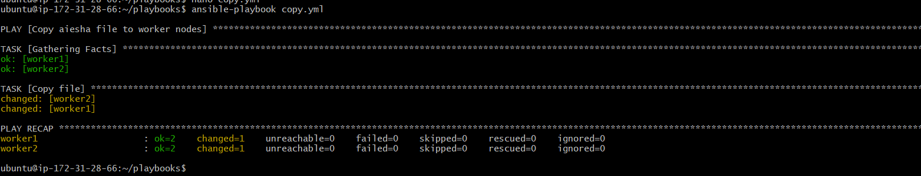
Check the file in /tmp location
Check in the worker2
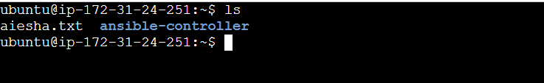

- write a ansible playbook to create different files with different names using single playbook.
nano create_files.yml
- name: Create multiple files on worker nodes
hosts: workers
become: yes

tasks:
- name: Create different files
copy:
content: "This is {{ item }}"
dest: "/home/ubuntu/{{ item }}"
owner: ubuntu
group: ubuntu
mode: '0644'
loop:
- file1.txt
- aiesha.txt
- testfile.log
- data.json
- report.md

ansible-playbook create_files.yml
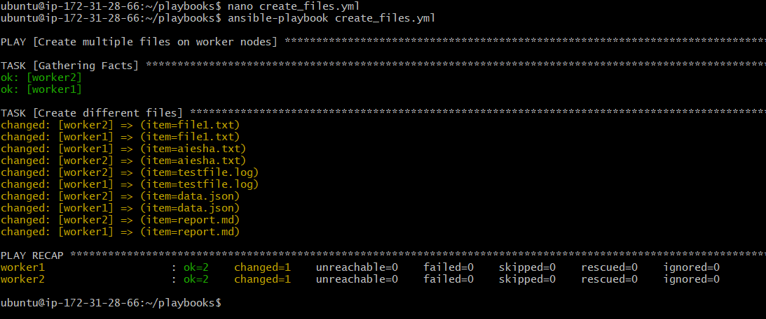

Worker1

Worker2
