- Execute all yaml files shown in video.
A. Kubectl get pods
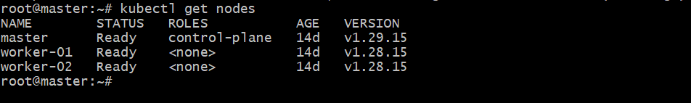

B. kubectl taint nodes worker-01 special=true:NoSchedule
Kubectl describe node worker-01 | grep Taints
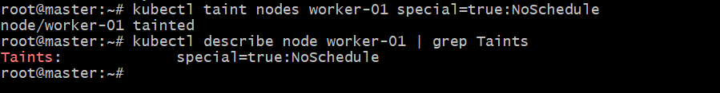

C. kubectl get pods -o wide
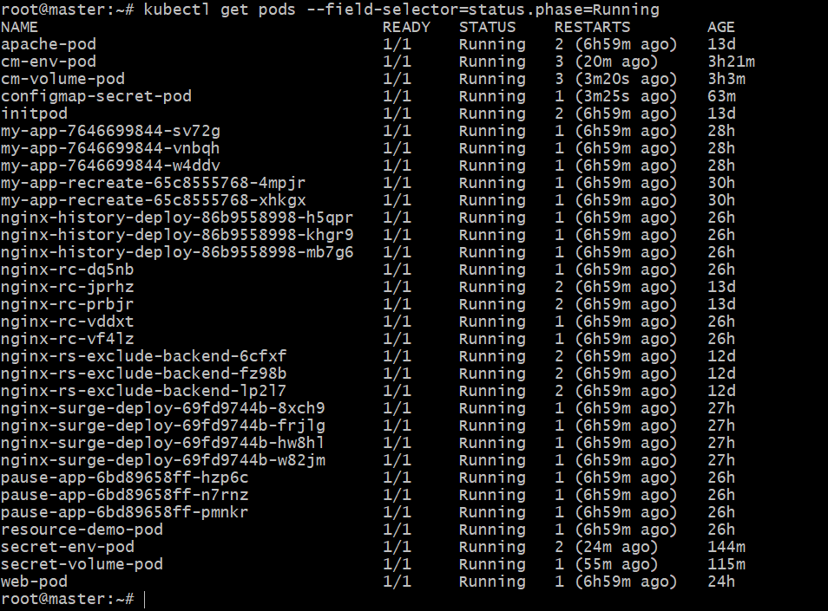

D. kubectl taint nodes worker-01 special=true:NoSchedule-

E. kubectl get nodes -o wide

F. kubectl delete pods --all
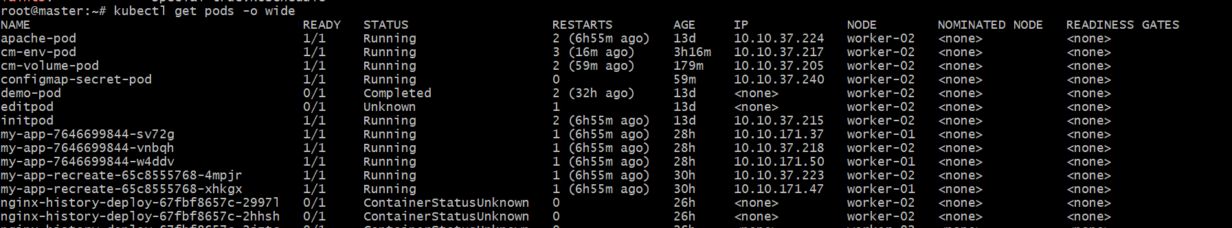

G. kubectl get pods
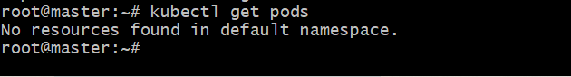

- Taint a Node and schedule a Tolerant pod Taint a node with special =true:NoSchedule. Create a pod with a toleration that matches the taint, allowing it to be scheduled on the tainted node.
H. Verify the tainted by command:
Kubectl taint nodes worker-01 special=true:NoSchedule
Kubectl describe node worker-01 | grep -i taints
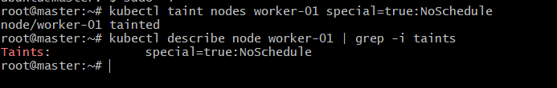

I.create the YAML file as:
Vi tolerant-pod.yaml

paste the content in YAML file:
apiVersion: v1
kind: Pod
metadata:
name: tolerant-pod
spec:
containers:
- name: demo-container
image: busybox
command: ["/bin/sh", "-c", "sleep 3600"]
tolerations:
- key: "special"
operator: "Equal"
value: "true"
effect: "NoSchedule"
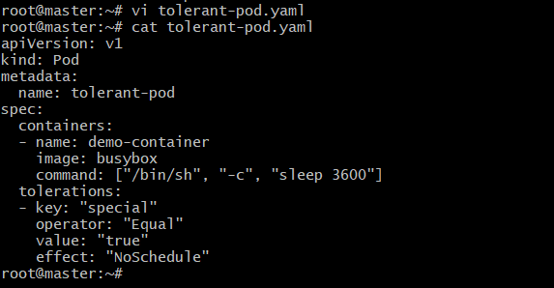

J. run:
Kubectl apply -f tolerant-pod.yaml
Kubectl get pods -o wide
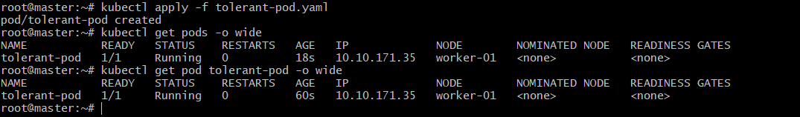

K. verify:
kubectl describe pod tolerant-pod | grep Node:

- Use NodeSelector to Schedule a pod on a specific Node Label a node with env=dev. Create a pod with a nodeSelector that schedules it only on the node labeled env=dev.
- Verify worker-02:
Kubectl label nodes worker-02 env=dev
Kubectl get nodes --show-labels

- Create YAML file as:
node-selector-pod.yaml

Paste the content in YAML file:
apiVersion: v1
kind: Pod
metadata:
name: node-selector-pod
spec:
containers:
- name: demo-container
image: busybox
command: ["/bin/sh", "-c", "sleep 3600"]
nodeSelector:
env: dev
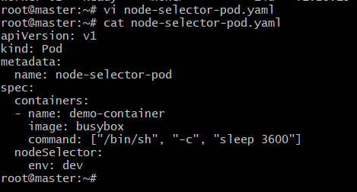

- Run:
Kubectl apply -f node-selector-pod.yaml
Kubectl get pods -o wide
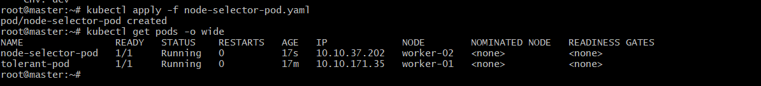

- Kubectl get pods
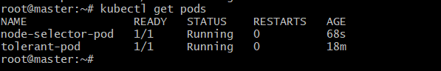

- Check the pods:
Kubectl describe pod node-selector-pod | grep -A5 Events
Kubectl describe pod node-selector-pod
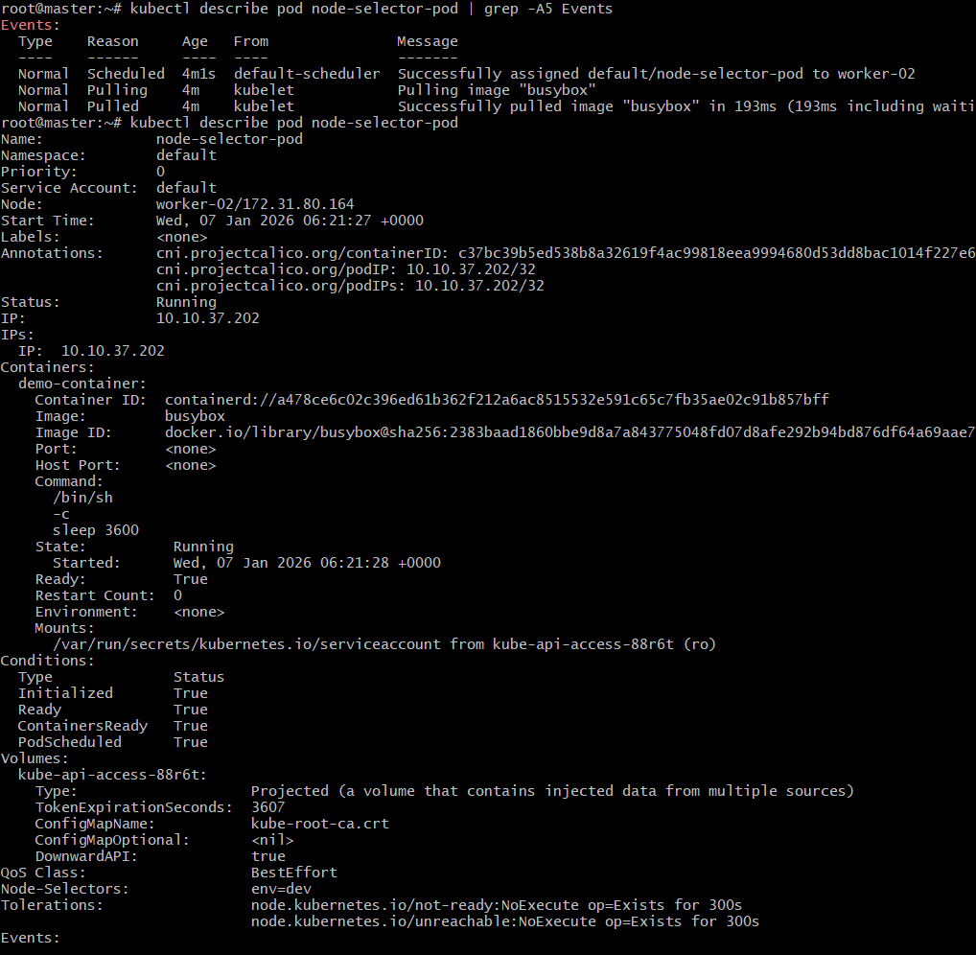
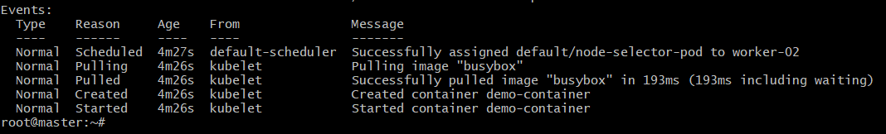

- Use Node Affinity with Soft Scheduling Label a node with env=test. Create a pod with
preferredDuringSchedulingIgnoredDuringExecution node affinity, preferring to schedule it on a node labeled env=test. Remove the label and verify the pod continues to run.

- Check everything is working or not by using:
Kubectl get nodes
Kubectl get nodes --show-labels
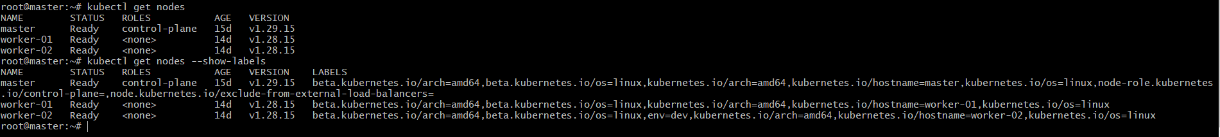

- Create YAML file:
soft-affinity-pod.yaml

paste the content in YAML file:
apiVersion: v1
kind: Pod
metadata:
name: soft-affinity-pod
spec:
containers:
- name: nginx
image: nginx
affinity:
nodeAffinity:
preferredDuringSchedulingIgnoredDuringExecution:
- weight: 1
preference:
matchExpressions:
- key: env
operator: In
values:
- test
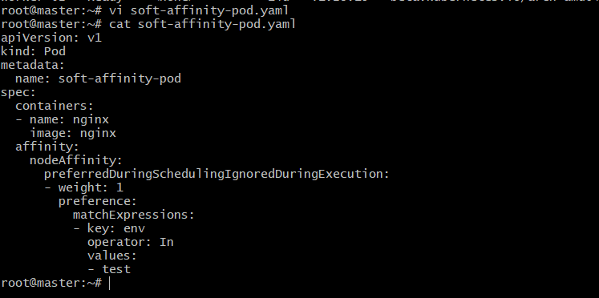

- Run:
Kubectl apply -f soft-affinity-pod.yaml

d. kubectl get pod soft-affinity-pod -o wide

e. remove the label by using the command:
kubectl label node worker-01 env-
kubectl get nodes --show-labels

- Kubectl get pods
Kubectl describe pod soft-affinity-pod
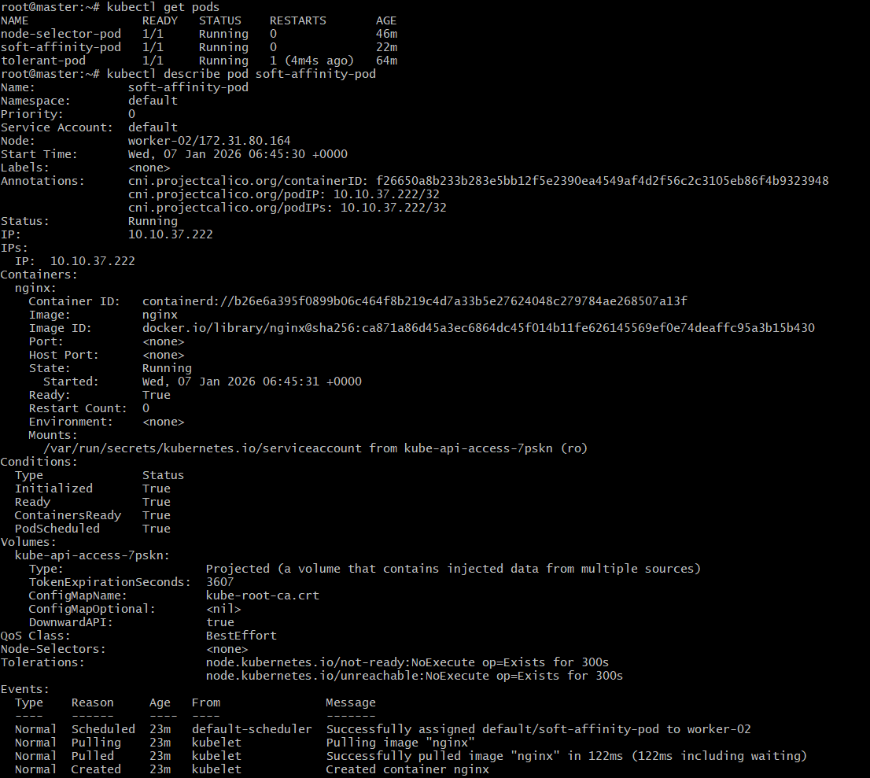

- So, Here soft-ni=ode-affinity allowed scheduling on the preferred node but does not enforce eviction when the label is removed.

5. Implement Node Affinity with Hard Scheduling. Create a pod with RequiredDuringSchedulingIgnoredDuringExecution node affinity, ensuring it will only be scheduled on a node labeled env=prod. Verify the pod cannot be scheduled if no node has the env=prod label.

- Verify the nodes:
Kubectl get nodes

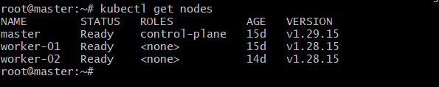

- Create an yaml file:
hard-affinity-pod.yaml

paste the content in yaml file:
apiVersion: v1
kind: Pod
metadata:
name: hard-affinity-pod
spec:
affinity:
nodeAffinity:
requiredDuringSchedulingIgnoredDuringExecution:
nodeSelectorTerms:
- matchExpressions:
- key: env
operator: In
values:
- prod
containers:
- name: nginx
image: nginx
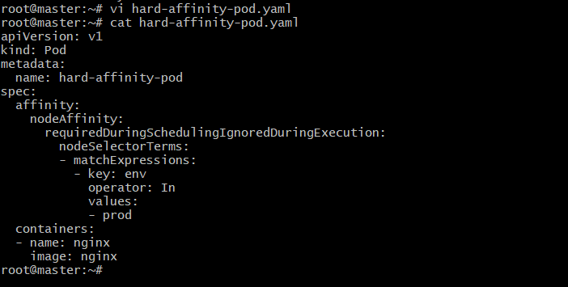

- Now apply it:
Kubectl apply -f hard-affinity-pod.yaml
Kubectl get pods
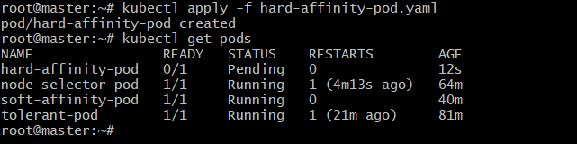

- Check the events by using:
Kubectl describe pod hard-affinity-pod | grep -A5 Events

- Label the node:
Kubectl labelnode worker-01 env=test
Kubectl get nodes --show-labels

- Kubectl get pods -o wide
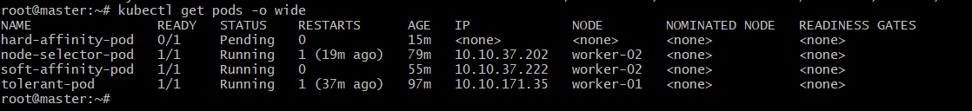

6.Taint a Node and Use NoExecute with Toleration Seconds Taint a node with special=true:NoExecute. Create a pod with a tolerationSeconds field (e.g., 60 seconds) and observe it gets evicted after 60 seconds on the tainted node.

- Verify the pods:
Kubectl get nodes
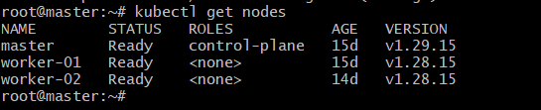

- Taint to worker-01 by:
Kubectl taint nodes worker-01 special=true:NoExecute
Kubectl describe node worker-01 | grep Taints -A2
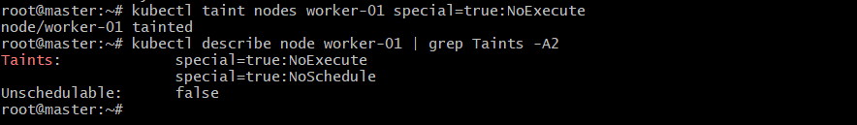

- Create the yaml file as:
toleration-pod.yaml
paste the content in yaml file:
apiVersion: v1
kind: Pod
metadata:
name: toleration-pod
spec:
containers:
- name: nginx
image: nginx
tolerations:
- key: "special"
operator: "Equal"
value: "true"
effect: "NoExecute"
tolerationSeconds: 60
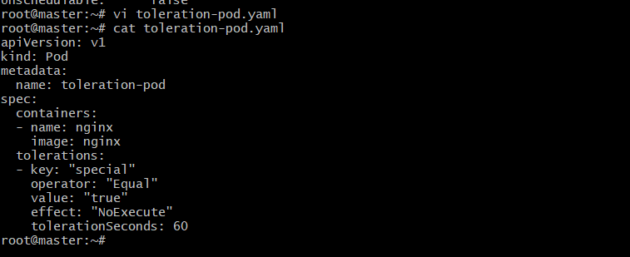

- Apply it:
Kubectl apply -f toleration-pod.yaml
Kubectl get pods -o wide
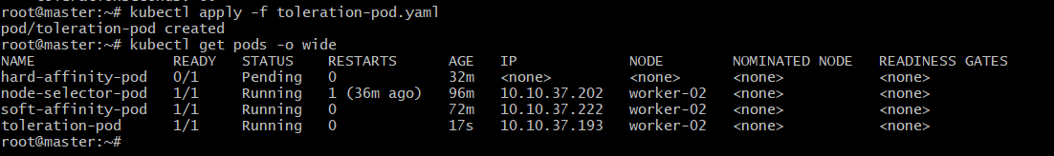

- Check the pods after 60 seconds by using the command:
Kubectl get pods
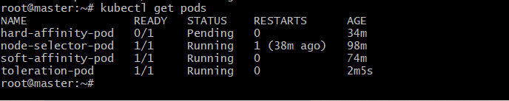

- Check with full details:
Kubectl describe pod toleration-pod
